Fresh Rain
Latter Rain Ministry

Preparing a Bride without  spot or wrinkle |  | February 2021

Can You Hear Me Now?

The Lord gave me this newsletter title in January. At the time He gave it to me, my feeling was that things would not go as planned or prophesied as I had hoped as well as many others. The reason is because the preachers and teachers in the church just are not listening or changing what they teach in order to come in line with the word of God. They will not receive the love of the truth and will not allow their strongholds of false beliefs to be pulled down and thus discipline and judgment will befall us as the church. Judgment starts in the house of the Lord and He will gather out of His kingdom all who offend and all workers of iniquity. The present day gospel has created such a lukewarm environment that allows evil to run rampant in the homes of believers and thus the country as well. As the church goes, so goes the country. There may be a season where you will feel the full effects of your lukewarm environment and the impact of the rampant sin the church leadership has allowed and promoted amongst those the Lord died for in order to set them free from slavery to sin.
And thou shalt speak my words unto them, whether they will hear, or whether they will forbear: for they are most rebellious.

For the last several weeks the Lord has been silent and it has troubled me. I can’t stand it and I had to be alone to press in to seek Him and ask why. He finally spoke saying, “My people’s ears have become dull of hearing. Why speak when they will not hear and take heed? Their ears have waxed gross.” In other words, their ears are terribly clogged with wax build up. One evening after work I turned on the TV to watch the news. A miracle ear commercial came on. It spoke of those not being able to hear well, not because of damage to the ear, but because of a great deal of wax build up in the ears. As I watched this, the Lord anointed it and I knew He was punctuating what He had been trying to show me. One night I had a dream. I was in a doctor’s office along with others and a dropper with a mixture of oil and water were placed in our ears and the mixture released. A tube of wax about 4 or 5 inches in length softened and rose up out of the ears. I was astounded at the size and length of these tubes of wax as there was no way something so large could be inside a human ear, naturally, and the Lord was stressing the magnitude of the wax build up in the ears of His church. We no longer have ears to hear or eyes to see and a heart that understands the things of God in order to move on to maturity and receive the keys to the kingdom where the supernatural gifts of the spirit are used through the mature sons of God.
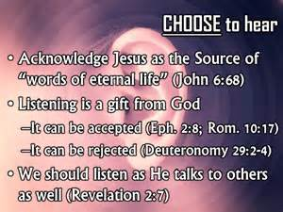
Heb. 5:11 About this we have much to say, and it is hard to explain, since you have become dull of hearing”. This passage was spoken to the church of believers. Paul wanted to teach them more about God and the deeper things of Christ and Him crucified, yet he couldn’t because they became dull in hearing. They hadn’t started out that way. It was something they became. How did they get that way and how do we make sure we do not become this way as well? I don’t know about you but this is something I want to avoid. I can’t stand it when the Lord is silent and I am not learning something new. It makes me want to press in harder and find out why and seek His face and sometimes I have to be alone to do this. Paul couldn’t expound more on the things of God because they couldn’t grasp the more complex aspects of God because of their dullness in hearing.

A person dull in hearing no longer communicates God’s way in any fashion by deed or speech; he cannot “talk the talk” or “walk the walk”! Nor are his ears open and attentive to God’s Word. As Jesus says in Matthew 13:15:

For the heart of this people has grown dull. Their ears are hard of hearing, and their eyes they have closed, lest they should see with their eyes and hear with their ears, lest they should understand with their heart and turn, so that I should heal them.

Perhaps that is why we don’t see more healings and the miraculous. The heart, ears and eyes are dull, hard and closed and if they were to be opened, they would see, understand and be healed. This is what a person like this looks like and they are all in the church of the “fallen away” or the church that has departed from the faith as the bible states the church will do in the last days. They don’t go back into the world. They are just a church that has moved little by little away from the truth, one step at a time, so that you don’t even realize you have moved. Kind of like the frog in the pot of water that warms up slowly until it is boiling and the frog dies. The gospel we were commanded by Christ to preach was the gospel of the Kingdom of God or submission to the King. Jesus fulfilled the law by empowering us not to sin, which no one had until His death, resurrection and sending of the Holy Spirit at Pentecost. That is why there is no more sacrifice for sin. Today’s church has the “say your little prayer without any repentance involved or any intention of turning from your sin” gospel as it pronounces you saved and eternally secure, while people indulge in all sorts of sins and have all kinds of idol in their lives that they place above God. They continue to practice willful sin while believing they are saved and eternally secure because they said a prayer and they have never been taught that holiness is not an option, it is required and submission to the King, Jesus, is not an option to entering the Kingdom of heaven. It is required. The departing or fallen away church has a form of Godliness but they deny or reject the power thereof. Having the power to not sin is even an option to them instead of a requirement. Symptoms of a dull of hearing person include:

They are neglecting the great salvation they claim to have.

Their hearts are hardening to the truth of God’s word.

Their conversation is losing its spiritual urgency.

Their ears are dull and they don’t hear from the Lord or experience the God of the word in their lives.

They are losing their desire to press on to maturity and thus will not be given the keys to the kingdom or the supernatural gifts.
They are weak, sluggish and asleep

So what is this wax and how did it get so built up so that the truth is not heard or received? We are a church with itching ears and a church that wants its flesh patted and ears tickle instead of pricked. They don’t want to hear about repentance, dying to self, picking up their cross, submitting to a King and being in Him by obeying His word. They don’t want to hear that Jesus has to be Lord in order to be Savior. Why do we call Him Lord, Lord and not do what He says? They want the easy say your little prayer and don’t ask anything of me gospel where Jesus is a vending machine Genie that hops to it every time you perform or confess, or declare something. They want the “how can Jesus benefit me” gospel. It is all about me, me, me and what I can get from the deal, not what can I give Jesus in return for what He gave me. The answer to that by the way is “everything”. Jesus didn’t die on the cross to sweep our sin under a carpet pretending it isn’t there while we sit and watch porn and sow to the flesh all the while believing we are eternally secure because we recited a little prayer. Nowhere in the bible did the church get saved by reciting a prayer and Jesus even turned away the rich young ruler when he came to Him asking what he had to do to be saved. Jesus told him to give up his idol, money, and follow Him. I have a whole wonderful teaching on this at my web site www.latter-rain.net that is very encouraging by the way. We are a church that wants to hear the prosperity gospel and we prostitute the things of God for money. “If you send in this or that amount for your prayer clothe, CD’s or whatever, God will heal you by purchasing with your money what Jesus died to freely give you with His blood. Replacing money instead of believing in the blood and what He purchased with it. Prostituting the gospel. Every single time I have seen Ichabod written over a church and it started to dry up, financially and attendance wise, it was over money and a building program where the program or ministry became more important than the needs of the people. Placing the vision above the flock. God always sent several people to warn a pastor before Ichabod was written, but their ears had waxed gross because they thought, “Surely God wants us to have this ministry to further His kingdom”, all the while the kingdom sitting in this pastor’s pews are starving and being robbed. God takes the sheep to greener pastures with a shepherd who loves the sheep that won’t fleece them and leave them in the cold. When the anointing leaves, so do the sheep and who does the anointing? The same one who sent the person to warn you that you rejected.

Anyway, back to the ear wax build up and how to remove it. First comes the washing in the water of the word which is part of what is in the ear dropper. This is mixed with the anointing of the Holy Spirit which is the oil of the Spirit. The word without the Spirit is dead. The water without the oil is dead. Then we go back to the basics and lay the foundational teachings back underneath the church. Hebrews again goes back to say that the Lord cannot go on with more mature teaching because they are hard to be uttered or spoken, seeing you are dull of hearing. For when for the time, ye ought to be teachers ye have need that one teach you again which be the first principles of the oracles of God and are become such as have need of milk, and not of strong meat. For every one that useth milk is unskillful in the word of righteousness for he is a babe. But strong meat belongeth to them that are of full age (or mature) even those by reasons of use have their senses exercised to discern both good and evil.

Do you love the truth? Are you willing to have your mental strongholds of false beliefs that you have had from your beginnings, torn down with the truth in an end time church where Jesus warned the most about deception and believers not having a love for the truth in order to be saved. A stronghold is a false belief you have been taught. A stronghold is highly fortified and defended and the person only accepts scripture to confirm their bias while rejecting scripture that negates their bias. Therefore, God sends them what they want which is strong delusion. If you don’t think you could be deceived and you won’t search the scriptures, you are deceived.
Being a horse person, I watched one of the three major horse races of the year on TV. I can’t remember which race or what year but the Lord was saying the exact same thing in a different way and He kept bringing this back to me to add to this newsletter.

There were two champion race horses picked to win the race. Both were of equal athletic ability. One horse responded to the jockey’s verbal commands doing whatever the jockey told him to do. Very few physical cues had to be given to the horse in order for the horse to do as the jockey commanded. Cues are the touch of the leg or use of the reigns to direct the horse. You could see the horse’s ears turn to hear the voice of the jockey amid the roar of the crowd and distractions. His full intent was on hearing and obeying the rider and nothing distracted him from his focus.

The other horse, however, entered the track in order to be led to the starting gate. His ears were plugged with wads of cotton and his head was turning to and fro because he was highly distracted by his surroundings. This kind of horse is the one you put blinders on. I once had a beautiful young stallion I used to ride when I lived in Texas who was easily distracted by the scent of a female horse miles away. We would have to put Vicks Vapor Rub around his nostrils before I took him out on trail rides. You have to deal with their distractions on these kinds of horses at this level of maturity because they would forget all about you and your safety if they got distracted because they wouldn’t listen at all to any verbal or physical cues. Anyway back to Mr. ears wadded up with cotton about to run a high stakes race. It was a fight to get him in the starting gate because he wanted to see everything his eyes could take in. The race started and this horse did not have a good start because the horse was distracted. The more the horse was distracted, the more physical cues the jockey used and out came the crop. Whack, whack, whack on the rump which sure got the horses attention as he ran harder taking longer strides. Now you could see his real athletic ability start to shine. There was purpose in the pain and that was to get the horse over the finish line and hopefully in first place. You might remember this horse who was a winner. His name was American Pharaoh. American Pharaoh is an American Thoroughbred racehorse who won the American Triple Crown and the Breeders' Cup Classic in 2015. He was the 12th Triple Crown winner in history, and in winning all four races, became the first horse to win the Grand Slam of Thoroughbred racing. So you see the distraction removal and rump whacks brought out the best in the ability of this type of horse. If that is what it takes, that is what God will do if we don’t hear Him now. Don’t let the name of the horse be lost on you either. Egypt is symbolic of the world. Pharaoh was the leader of the world and American Pharaoh is symbolic of the leadership in the American world and worldly churches.
See his ear plugs?

Many or most of the church and its leaders are like this horse. They aren’t listening and until you do, the distractions are going to go away, literally, as last year showed, and the discipline is going to become more intense in order to get you and the church over the finish line. Those who refuse to listen will be taken out of the race all together because people are going to hell and their blood will be on your hands because of false teaching in the church and you are held more accountable. Behold the kindness and severity of the Lord. To those who fell, severity, but to you who listen, kindness if you continue in His kindness, otherwise you also will be cut off. So much for the damnable heresy of eternal security which is the main reason people are still slaves to sin. Or just recite your little prayer and ask Jesus into your heart and pronounce people as saved and eternally secure when they are not saved at all because nowhere in the bible is that given as a way to be saved. Then they are told they are eternally secure. Really? I would hate to be the teacher or preacher who stands before God and be held accountable for all the souls that have gone to hell because you have taught that lie. Broad is the path that leads to destruction and many are found therein. Narrow is the path that leads to eternal life and few there be that find it. Are you preaching the broad path where everyone is saved or the straight and narrow path that few are on?

So the Lord is saying “Can you hear Me now”? He will do what it takes to get your full attention in order for the church to finish the race. If that means using for good what the devil meant for harm with the lock down and removing all your distractions and idols to get you focused on hearing Him, so be it. He will allow more to come until we do start listening. Let’s not be the horse with the wadded up ears full of cotton that needs to be whacked multiply times to get us refocused on Him and hearing his voice and submitting to His will.

My question then becomes, “Will we allow the Lord to remove our ear wax so that we have ears to hear what the spirit is saying to the churches”?

The whole purpose is to hear those sweet words “Well Done My Good and Faithful Servant”. Our gifts and talents are to be used to grow the kingdom of God. If we don’t put them to use for that while He is away, we will be disciplined, which is an act of His mercy, in order to bring out the best of our abilities, like American Pharaoh, in order to have us finish the race and have those we lead finish the race as well.

4 For the kingdom of heaven is as a man travelling into a far country, who called his own servants, and delivered unto them his goods.

15 And unto one he gave five talents, to another two, and to another one; to every man according to his several ability; and straightway took his journey.

16 Then he that had received the five talents went and traded with the same, and made them other five talents.

17 And likewise he that had received two, he also gained other two.

18 But he that had received one went and digged in the earth, and hid his lord's money.

19 After a long time the lord of those servants cometh, and reckoneth with them.

20 And so he that had received five talents came and brought other five talents, saying, Lord, thou deliveredst unto me five talents: behold, I have gained beside them five talents more.

21 His lord said unto him, Well done, thou good and faithful servant: thou hast been faithful over a few things, I will make thee ruler over many things: enter thou into the joy of thy lord.

22 He also that had received two talents came and said, Lord, thou deliveredst unto me two talents: behold, I have gained two other talents beside them.

23 His lord said unto him, Well done, good and faithful servant; thou hast been faithful over a few things, I will make thee ruler over many things: enter thou into the joy of thy lord.

24 Then he which had received the one talent came and said, Lord, I knew thee that thou art an hard man, reaping where thou hast not sown, and gathering where thou hast not strawed:
25 And I was afraid, and went and hid thy talent in the earth: lo, there thou hast that is thine.

26 His lord answered and said unto him, Thou wicked and slothful servant, thou knewest that I reap where I sowed not, and gather where I have not strawed:

27 Thou oughtest therefore to have put my money to the exchangers, and then at my coming I should have received mine own with usury.

28 Take therefore the talent from him, and give it unto him which hath ten talents.

29 For unto every one that hath shall be given, and he shall have abundance: but from him that hath not shall be taken away even that which he hath.

30 And cast ye the unprofitable servant into outer darkness: there shall be weeping and gnashing of teeth.

People in the church are remaining enslave in sin. We have a form of godliness but deny the power thereof. From such teachers and preachers we are to turn away from them. They don’t blatantly deny the power which comes through the baptism of the Holy Spirit but they say things like “You have all of the Holy Spirit you will ever need when you first believe” and they totally disregard Acts 19 where Paul asked believers if they had received the Holy Ghost since they first believed. They replied that they hadn’t and Paul water baptized them in the name of Jesus and laid hands on them and they received the Holy Ghost and they spake with tongues and prophesied. The bible doesn’t contradict itself so of course there is more to receive after you first believe with believing being the first step and not the end all. When you first believe you are sealed or given an earnest or deposit of the Holy Spirit with the intent by the Lord to fully redeem and occupy you. If the deal falls through and the deal isn’t closed as the bible teaches, with the appropriate response, the deposit is returned, just as one would put a deposit on a house with the intent to purchase and fully occupy. Sealing in the Holy Spirit is just the earnest or deposit and that is the translation. You still have to move forward beyond putting a deposit down and follow through with the full redemption and occupancy by the Holy Spirit through baptism in the Holy Spirit and believing is just the first step.

TRUE APOSTLES & PROPHETS ARE COMING TO DRAIN THE SWAMP IN THE CHURCH!!

WE ARE SAVED THROUGH SANCTIFICATION OF THE HOLY SPIRIT AND BELIEF IN THE TRUTH

This was spoken to believers. The Lord was warning about deception being so great and cleaver IN THE CHURCH that even the elect could be deceived. He warned about the church being so apostate that it had fallen away from the one true faith taught by the apostles and Jesus which is the gospel of self-denial, death to sin and self and picking up your cross and following Him. It goes way beyond “just believe” which is only the first step not the end all in being a follower of Jesus as the Way. We must do as He did and all He commanded which He has empowered us to do through the baptism of the Holy Spirit which wasn’t available until after the resurrection. Now we are without excuse.

TO BELIEVERS ABOUT APOSTATE BELIEVERS in the end times:

“And with all deceivableness of unrighteousness in them that perish; because they received not the love of the truth, that they might be saved. And for this cause God shall send them strong delusion, that they should believe a lie: That they all might be damned who believed not the truth, but had pleasure in unrighteousness. But we are bound to give thanks always to God for you, brethren beloved of the Lord, because God hath from the beginning chosen you to salvation through sanctification of the Spirit and belief of the truth:”
2 Thessalonians‬ 2:10-13‬ KJV‬‬‬‬‬‬‬‬‬‬‬‬‬‬‬‬‬‬‬‬‬
‬
What you believe and choose to believe after Jesus was faithful to bring you truth in your deception after first believing determines your eternal destiny. To reject truth is to reject Jesus whom we claim to trust for our salvation. If we trust Him for our salvation that means we should be examining ourselves to see if we are in the faith according to the Bible and not hold on to deception He exposes with truth so the Father doesn’t give you what you want which is strong delusion so that you will believe the lies or damnable heresies taught by the apostate church in the last days. Rejection of the truth is the rejection of the one you claim to trust for your salvation. You have to endure until the end to be saved the Bible says. You are not saved when you first believe. Eternal life is received in the end Romans 6:22 and we are to work out our salvation with fear and trembling. You have a part to play in responding appropriately as outlined in the Bible and in working out your salvation with fear and trembling. Jesus doesn’t work it out for you. You don’t work out what you already have. Paul told Timothy to lay hold of eternal life. You don’t lay hold of something you already have.

Jesus said if you don’t allow me to wash you then you have no part with me. No part means no part. Sanctification and being washed in the water of the word and receiving that word and walking according to it is absolutely necessary for salvation. That is why Jesus told the disciples “Now you are clean through the words I have spoken”! Why? Because they believed and received it which resulted in sanctification. Without transformation or sanctification there is no salvation. Most claiming to be Christians do not even read the word themselves which is spending time with Jesus each time they do because Jesus is the word John 1. So the word or Bible and renewing your mind and being changed by it because you receive the word is absolutely vital to sanctification which leads to salvation. It is only through receiving truth in your deception that you are sanctified.

“Sanctify them through thy truth: thy word is truth.

Pastors must do as Jesus did. And for their sakes I sanctify myself, that they also might be sanctified through the truth. Neither pray I for these alone, but for them also which shall believe on me through their word;”
John‬ 17:17, 19-20‬ KJV‬‬‬‬‬‬‬‬‬‬‬‬‬‬‬‬‬‬‬‬‬
‬
If you can’t be lost because you believe deception taught in an apostate end time church of today that has fallen away from the one true faith, then how could damnable heresies or lies that will damn you be brought into the church? These verses are to believers as a warning not unbelievers.

So let’s go over the pattern of salvation that Jesus followed, that can be found throughout the whole Bible, and which the foundation of the church should rest on as listed in Hebrews 6.
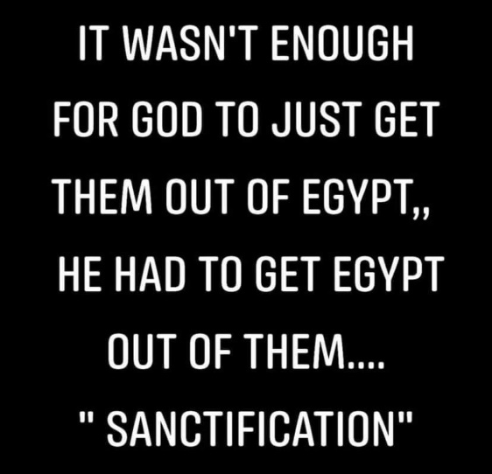
The Israelites were enslaved in Egypt. Egypt is symbolic of the world. The word came to them that they would be set free from slavery just as we are saved by being set free from slavery to sin. Were they saved when they first believed? No! Believing aligned them to follow Moses just as our believing should align us to follow Christ as the Way. Next they painted the blood of a lamb on the doorposts of their homes. Jesus is our sacrificial lamb who shed His blood for us. If the Israelites came out from under the blood through disobedience then the same judgment that was sent to the world, Egypt, would come upon them. Your disobedience brings you out from under the blood of Christ. Confessing and repenting of your sin restores you under the blood in the new covenant. Sin that is denied, justified, rationalized or explained away, which is the opposite of repenting and confessing, is throwing the conviction back in the face of the Holy Spirit, which is the definition of blasphemy, and that sin you defended will not be forgiven you ether in this world or the next. Binding and loosing are in this context. When you go to restore a brother caught in a sin and if they repent and confess it, they are loosing that sin and the punishment for it from them. If they defend it or cover it up, that sin is bound to them along with the judgment for it. The bible says a believer is beaten with many stripes where an unbeliever is beaten with few for the same sin. That sin is bound to them and not forgiven either in this world or the next because they blasphemed or threw the conviction of their sin back in the face of the Holy Spirit. No one fears the Lord any more. That is going to change because the fear of the Lord is going to return to His house. How you respond to correction, or the truth will either be used as a testimony against you or for you

Next the Israelites were led to the Red Sea where they were water baptized. What baptized them also slammed down and destroyed what used to enslave them. Next they were led through the wilderness of life by the Holy Spirit just as we are to be led and controlled by the Holy Spirit through our wilderness walk in life through the baptism in the Holy Spirit. Jesus only baptizes those in the Holy Spirit who will obey, so those looking for loop holes as to why water baptism is not needed are automatically disqualified. There is something deeply wrong in your heart if you search for scriptures to get you out of obeying. You will be damned. Some of the Israelites died in the wilderness even after water baptism and being led by the Holy Spirit because of disobedience, as an example to us the Bible says. If that can’t happen to us, how can it be an example? The purpose of the Holy Spirit was to get them to the Promised Land where they would inherit eternal life.

In the new covenant we first believe and believe is a verb or action word not a passive noun as the present day apostate church teaches. That means an actionable response from you is needed. That response is to repent and be baptized every one of you. Not some of you but every one of you. You don’t need a pastor or priest to do this. We are to be doing this to each other. In water baptism you are being baptized into the body of Christ and pledging to be dead to sin and self IN ORDER THAT you be raised as Christ was raised. Your resurrection in Christ is dependent on being baptized into the body of Christ through full immersion as an adult and leading a life of death to sin and self. A baby cannot make the decision to be dead to sin and self. Being baptized in the Holy Spirit empowers you to keep that pledge. You receive this gift of the Holy Spirit through faith and obedience and it is no more works salvation then confessing with your mouth. Now we are to be led and controlled by Holy Spirit in our wilderness walk in life, who is to lead us to the promised land where we receive eternal life in the end Romans 6:22 based on not falling away or coming out from under the blood covering of Christ through sin. Sin you defend, justify, minimize or pull the cloak over to cover your sin is not forgiven. You will be beaten with many stripes as a believer the Bible says more than an unbeliever for that same sin. It will be punished. Only the sin that is acknowledged, repented of and confessed after believing is forgiven. He is faithful and just to forgive the sin that is repented of and confessed. If the Father sends someone to restore you, which entails confronting your sin or deception and you tell them not to judge, you will be judged for that sin and it will be used as a testimony against you the Bible says. You are using your false beliefs about what the scriptures say to dismiss your sin rather than repent of it. Those led and controlled by the Holy Spirit are commanded to restore such a one caught in practicing sin and that is not judging. Jesus told us not to judge hypocritically doing the same thing we are confronting the other on. We are commanded to judge those within the household of faith.

The Lord showed it to me this way. A rich man gives two believers a gift of a trillion dollars. The first guy believes the rich guy is good for the money and shoves the check in his pocket and goes about his business. This guy has faith but not the saving kind of faith. Even Satan believes. The next guy believes the rich guy is good for the money and he endorses the check through water baptism and deposits the check through baptism in the Holy Spirit so he can access the provision at a time of need because it is right there. Endorsing the check and depositing it doesn’t make the gift any less free. This guy’s faith was the saving kind because he acted upon what he believed. Faith without works isn’t the saving kind of faith. It was Abraham’s obedience because of his faith that was counted unto him as righteousness. Can you picture the Israelites standing at the parted Red Sea with the Egyptians pursuing them saying, “I am not going to cross because God is supposed to do it all and I am to do nothing or that is “works salvation”! Their little feet had to get moving in the right direction in order to be saved or delivered from slavery just as we have to act upon what Jesus said in order to be delivered or “saved” from slavery to sin, which was the purpose of His death. That is precisely what the church of today is doing and has been taught by false apostate teachers and preachers. Jesus does it all and nothing is required of me! “If you” verses are throughout the whole Bible with Jesus saying about half of the “If you” then I will, and a promise is connected to the action of the believer. Most of the church thinks they are “entitled” to the promises just because they “believed” as a noun, which is giving mental ascent to who Jesus is and what He did, in the same way we do about George Washington. Believing in George Washington doesn’t make me a disciple or follower of him yet that is how we teach people to become born again. You can’t find that in the bible. Believe and obey are synonymous.

Grace isn’t the license to sin but the power of God given to you not to through the baptism of the Holy Spirit. Your freedom in Christ comes from no longer being a slave to sin but a slave to righteousness instead. All who are in Christ Jesus this way have ceased from a lifestyle of sin. The Bible says those living a lifestyle of sin are still under the law because the law is for sinners. Those who are under grace are no longer under the law because they have ceased from a lifestyle of sin through the baptism of the Holy Spirit and choosing to yield to Him. Therefore we are not under the law but grace. If you are still living a lifestyle of sin, you will be judged by the law. It doesn’t matter if you said a little prayer which is nowhere in the Bible as a way to be saved. You receive Grace, or empowerment not to sin, through faith. Grace is translated empowerment in all but two places.

We are not saved when we first believed and we need to stop telling people that. It makes it sound like a done deal and it is a lie leaving people with a false sense of security that does not exist. I feel the Holy Spirit grieve so hard every time someone uses that term wrongly like saying “We had so many salvations at the revival”! Did all at the revival die then because you are not saved until the end of your life based on how you worked out your salvation? We have got to stop referring to people as being saved, which is different than being born again of water and the Holy Spirit in baptisms which the Bible says is the ONLY way to enter the kingdom of heaven.

The Bible says without holiness no one shall see the Lord and only those that do the will of the Father enter the kingdom of heaven. You can’t do the will of the Father if you don’t know what it is because you don’t read the Bible and without being empowered to do so through the baptism of the Holy Spirit.
Narrow is the way that leads to eternal life and few there be that find it. Broad is the way that leads to destruction. The more we tell people they must endure until the end to be saved and we equip them to do so, the more they will be inclined to do so. If you are preaching a broad gospel where everyone gets in by just believing or giving mental ascent to what Jesus did on the cross, you are deceiving people who will go to hell and their blood is on your hands and you will be held accountable for the deception you choose to teach after being given the truth. The true definition of faith and believe are verbs or action words that are ongoing until the end of their life and if they truly trust Jesus for their salvation they will realize that He is going to bring truth in their deception and their belief in a lie determines their eternal destiny after first believing. People have no clue what it even means to trust Jesus for their salvation. How is that fleshed out in everyday life? How does that look and how do we apply that scripture? Who is teaching believers how to do this because they are clueless and they think trusting Jesus for their salvation means to just believe as a noun or give mental ascent. Believe as a verb means an ongoing operation of Him in your life to lead you out of deception into truth, which requires something on our parts. It is healing and restoration as well as sanctification with truth.

We must allow Jesus to wash us and receive truth in our deception if we say we trust Him for our salvation. Otherwise we really don’t do we? It is all lip service that does not produce works that reveal they believe what they say they do.

Jesus said if you don’t allow me to wash you then you have no part with me. No part means no part.

Now share this with as many as you can saving them from the devil’s snare hating even their garments that are spotted by the flesh. He is coming for a glorious church without spot or wrinkle and the bride will make herself ready Rev. 19. The foolish virgins will be left behind. Let the Lord find you a good and faithful servant using your ability to grow the kingdom by sharing this when He returns.

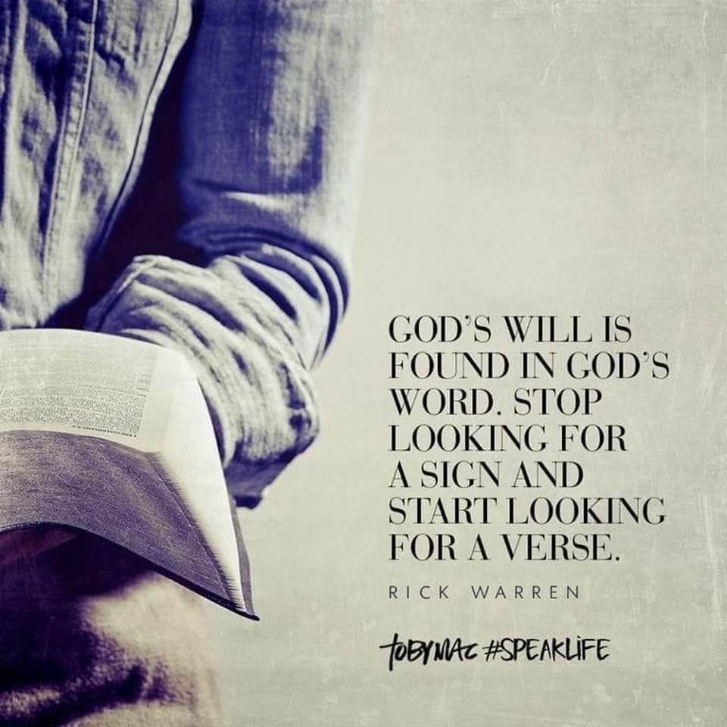

The bible says it is the word that will judge us in the end. If you reject the truth Jesus is faithful to bring you in your deception, then it is used as a testimony against you. If you receive it, you are clean through the word He has spoken. What you do with the word determines your eternal destiny. The word will either
free and clean you or condemn and judge you based on what you do with it. There are a whole lot of people claiming to trust Jesus for their salvation that have no clue what that means or how He is manifesting that in their everyday life. They believe it is a one-time act of believing and not a life time of trusting their spiritual state to Him. They have no idea how that is fleshed or walked out because it is not being taught, which probably means those teaching the word have not had this revealed to them either. You can’t teach what you yourself do not know or have rejected yourself.
God’s moral law has not and never will be done away with! The God of the Old Testament is the same God of the New Testament. He died as a lamb but is returning as the Lion to destroy His enemies.

YOU ARE ONLY A FRIEND OF JESUS IF YOU DO WHATSOEVER HE COMMANDS

“Ye are my friends, if ye do whatsoever I command you. Henceforth I call you not servants; for the servant knoweth not what his lord doeth: but I have called you friends; for all things that I have heard of my Father I have made known unto you.”
John‬ 15:14-15‬ KJV‬‬‬‬‬‬‬‬‬‬‬‬‬‬‬‬‬‬‬‬‬
‬
There are a whole lot of people singing that song “I am a friend of God” who aren’t because they don’t do as Jesus commanded, especially after He equips you to do so through the baptism of the Holy Spirit. They are deluded. They have no clue what the Lord is up to. Being His friend through obedience is a requirement to Him revealing to you what He heard of the Father.

Even Satan believes but he does not obey. How is your believing different than Satan’s? How is your believing different than the biblical definition of believe which is a verb or action word that is ongoing until the end, requiring a specific response from you in order to enter the kingdom of heaven.
Narrow is the way that leads to eternal life and FEW there be that find it. Broad is the way to destruction and most people claiming to be Christians are on that path. Examine yourself to see if you are in the faith biblically.
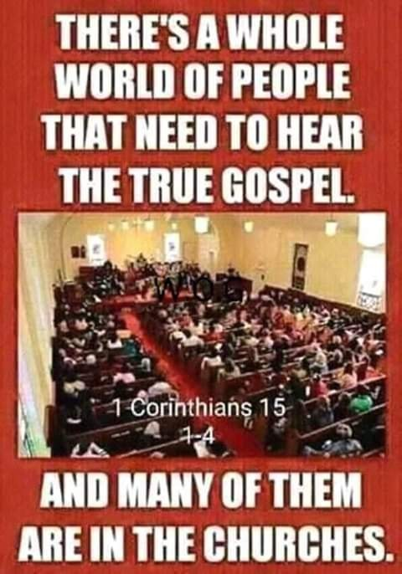

HOW TO KEEP YOURSELF IN THE LOVE OF GOD

“Keep yourselves in the love of God, looking for the mercy of our Lord Jesus Christ unto eternal life.”
Jude‬ 1:21‬ KJV‬‬‬‬‬‬‬‬‬‬‬‬‬‬‬‬‬‬‬‬‬
‬
Notice eternal life is something not yet received but you are looking for it. Romans 6:22 says it comes in the end. Paul told Timothy to lay hold of eternal life. You don’t lay hold of something you already have.

“As the Father hath loved me, so have I loved you: continue ye in my love. If ye keep my commandments, ye shall abide in my love; even as I have kept my Father's commandments, and abide in his love.”
John‬ 15:9-10‬ KJV‬‬‬‬‬‬‬‬‬‬‬‬‬‬‬‬‬‬‬‬‬
‬
How is this not clear? You cannot live however you want and believe grace saves? Grace teaches us to live godly in this present world. Grace is translated empowerment in all but two verses. Make sure your definition of grace is the biblical one. Read the Bible for yourselves. Don’t rely on man or a pastor. You are the one who keeps yourself in the love of God and does the abiding. Jesus doesn’t do that for you. That requires obedience.

Everyone thinks they are going to heaven, because no one reads their Bible.

Receiving God’s Prophets

As I watch Christian leaders condemn those who prophesied Trumps win, I was reminded about the warning regarding doing that to God’s true prophets and that to receive a true prophet is to receive his reward. They will not and they will be held accountable for their rebuke of the Lord’s prophets because they see only the carnal delusion the enemy serves up before their eyes. I have been in prayer about this and finally got this word because I don’t want to be deceived above anything else.

The Rhema word was that those who accuse His prophets are like the 10 with the bad report about taking the Promised Land. Only two had a report that agreed with the word of the Lord and only they were able to enter into that promise because they believed what the word of the Lord said that they could win against the giants in the land and take it. The Lord likened these quitters to the Israelites who left Egypt in hope, only to complain when they faced the Red Sea and believed only what their eyes saw believing it to be the end. The Red Sea only stood as an obstacle or end because they did not know the Lord and were not a friend and thus not privy to His plan which He shares with His friends. The Red Sea served to baptize the Israelites in water and crash down upon what used to enslave them but some only saw it as an obstacle of defeat. Only Moses heard from the Lord and stretched his arms out in faith to see the sea part. It is easy to criticize others when you think you see defeat when they prophesied a victory because you think a battle is over and it is not. Was it over the first time Pharaoh rejected Moses request to set the people free? You would think the battle is over in the Christian community because the religious leaders are rebuking the prophets who prophesied a victory because they believed the FIRST report of Pharaoh who only made the situation of the Israelites worse for requesting to be set free. That reveals who are true and close to the Lord and who are not. Religious leaders condemning and stoning prophets is nothing new as I read yet another disgusting rebuke of them in Charisma magazine today. Even if they did miss it and apologize, they are proving themselves to be submissive to the Lord and correction and no longer worthy of public ridicule and rebuke and whoa to them that do this to them. They will be vindicated and they have proven themselves to be of God where you have not who condemn His prophets because you have not seen the end which is not finished and you believe the bad report. You are carnal and cannot even see the obvious things before your carnal eyes let alone know what is happening in the spiritual realm to take down principalities and powers in high places. My true prophets will be vindicated says the Lord and the rebuke will turn on you for believing the bad report that the giants are too big and we are like grasshoppers as you turn from the battle and thus reject the promise. The season upon us is revealing the wheat from the tares, the true from the false and those who actually know God and those that say they do. Hidden in plain sight and you do not have eyes to see it. Signing blank executive orders. Insurrection act. You don’t know your constitution and think what you see is real. It will be you who mock my true prophets that will be mocked in the end. God will not be mocked. You will reap what you sow. The storm will destroy anything not founded upon the rock and your forefathers wrote the constitution under the Lord’s direction for such a time as this.

The battle is mine saith the Lord and I win. When I come, will there be real faith upon the earth? Real faith that doesn’t believe the evil report and what their carnal eyes see. I am only beginning and I will use those you think not worthy because I have found those in my church lacking and believing the lies which will discredit you before world in the same way you seek to discredit my prophets. The storm is here and you have lost your reward because of how you treated the true prophets. Whoa to those who pressured my prophets to recount my word, thus calling me a liar.
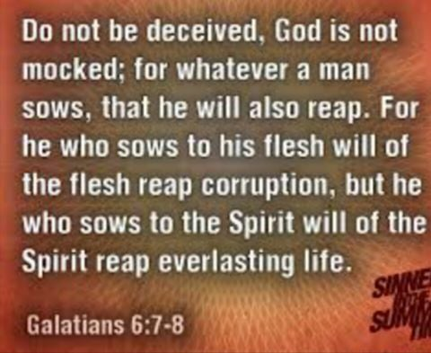

IS JESUS MANIFESTING OR REVEALING HIMSELF TO YOU?
This is why He may not be. You were probably duped by the devil into believing obedience is works salvation. Disobedience actually reveals your lack of love for the Lord and you loving darkness more than light and you won’t come to the light that your deeds could be reproved that they were wrought in darkness. You cover and defend your disobedience and even look for scripture to back up your false belief as to why you are not required to obey. I see that a lot with water baptism which Jesus and the disciples commanded. There is something very wrong with your heart if you believe or look for scripture as to why you don’t have to obey. Your interpretation of scripture is wrong because your heart is and you want prayers answered? You want to be in a relationship with Jesus? Jesus must be Lord in order for Him to be savior. A relationship requires participation on the part of both parties. Ours is to follow doing all He commanded and doing what He did as our example.

“He that hath my commandments, and keepeth them, he it is that loveth me: and he that loveth me shall be loved of my Father, and I will love him, and will manifest myself to him.”
John‬ 14:21‬ KJV‬‬‬‬‬‬‬‬‬‬‬‬‬‬‬‬‬‬‬‬‬
‬
Then you must keep yourself in the love of God!!! What? I thought God’s love was unconditional?! Is that what the Bible says? Do you read it?

Keep yourselves in the love of God, looking for the mercy of our Lord Jesus Christ unto eternal life.” Jude‬ 1:6, 21‬‬‬‬
‬
This is another scripture showing eternal life is not received when you first believe but is received in the end Romans 6:22. Separate yourselves from the present day apostate church and come out from among her. Jesus biggest warning in end time was about deception. We are saved through sanctification of the Holy Spirit and belief in the truth. What you believe matters and most today don’t love the truth so as to be saved and as a result, God sends them strong delusion.

The path is broad that leads to destruction which most are on. Narrow is the path that leads to eternal life and FEW there be that find it!

This is the result of the present day gospel being preached by today’s church leaders.
Are you one of them? This might be your last warning as judgment will start in the house of the Lord and He will gather out of His kingdom ALL WHO OFFEND and ALL workers of iniquity. That doesn’t sound like eternal security to me. The word iniquity is translated “You knew it was wrong and you did it anyway” and the damnable heresy of once saved always saved has reinforced this kind of willful sin since there is no consequence and enduring until the end is not required. It is against what Jesus died to do, which was to set people free from slavery to sin and thus the judgment of it. It is “antichrist or against Jesus and what He died to do.
.
Robert Weller
BORN AGAIN AGAIN

The prodigal was alive while with the father. When apostate (prodigal) he was DEAD and LOST.
When he came to his senses (repentant) and went home, he was alive AGAIN and FOUND.

For this son of mine WAS DEAD and has come to life AGAIN; he was lost and has been found.’ And they began to celebrate. Lk.15:24 If he remained in the pig pin, he would have remained DEAD and LOST.

TO REJECT ANY OF THE WORD OF GOD IS TO REJECT THE FATHER

You can’t cherry pick which scriptures you want to believe and which ones you don’t and expect to enter the kingdom of heaven. The word “word” here is translated an individual, collective or specific utterance, topic or command.
Let me ask you this. What scriptures are you using to justify not doing what Jesus commanded, like repenting or water baptism for instance. The very word, command or topic you reject and call “works salvation” is the very word the Father will use to judge you with in the last days. Be very careful in rejecting what Jesus commanded or making excuses not to obey it. Be very careful in remaining in your sin when grace empowers us not to sin and teaches us to live godly in this present world.

“He that rejecteth me, and receiveth not my words, hath one that judgeth him: the word that I have spoken, the same shall judge him in the last day. For I have not spoken of myself; but the Father which sent me, he gave me a commandment, what I should say, and what I should speak. And I know that his commandment is life everlasting: whatsoever I speak therefore, even as the Father said unto me, so I speak.”
John‬ 12:48-50‬ KJV‬‬‬‬‬‬‬‬‬‬‬‬‬‬‬‬‬‬‬‬‬
And I know that his COMMANDMENT is life everlasting. Whatsoever I speak therefore, even as the Father said unto me, so I speak.

You must be a doer of the word and not a hearer only deceiving yourself.

The Bible says that only those who do the will of the Father enter the kingdom of heaven and Jesus only spoke what He heard from the Father. Therefore, to reject Jesus’ commands is to reject the Father and not do His will. Disobedience is not an option if you want to be on the narrow path that leads to eternal life and few there be that find it.
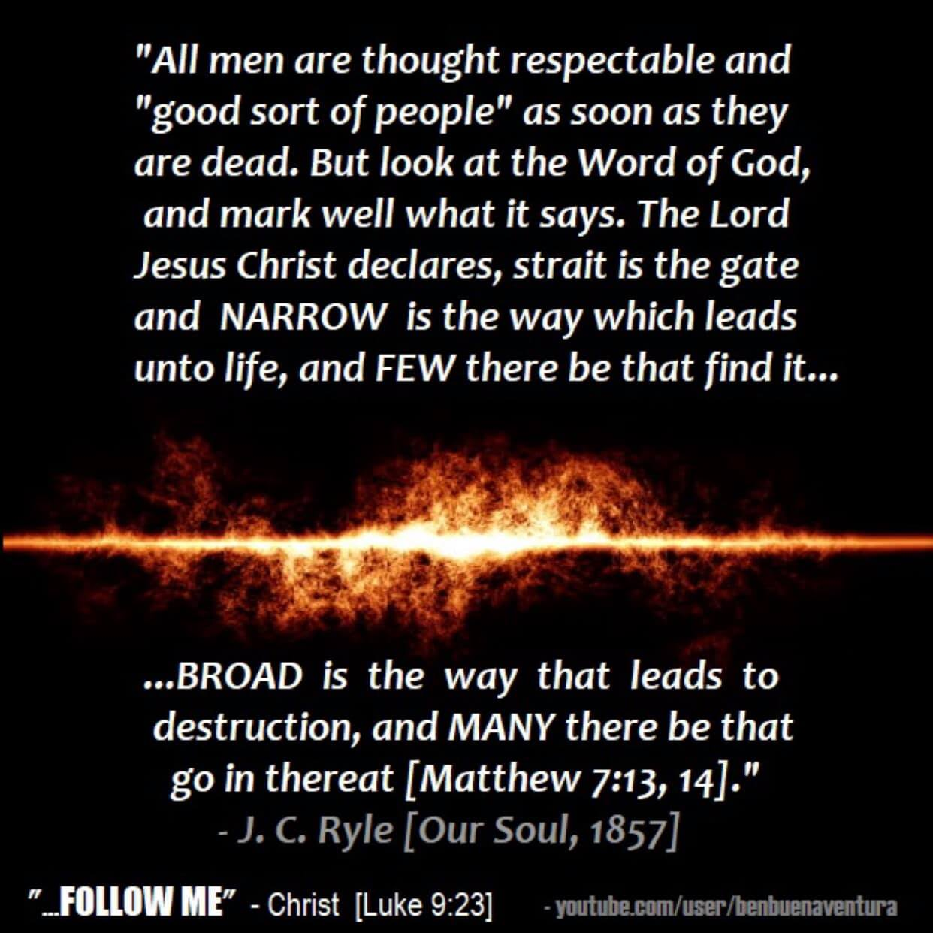
As I prayed over the newsletter, I let it alone for a few days to see if the Lord wants anything added. I used to release it too soon. Sure enough, regarding rejecting His word, He brought me back to this post I did in October. There are those who look for excuses not to receive the word or do it just like there are those who look for excuses not to obey. This really reveals something drastically wrong with their heart and the lack of love they have for the Lord. Some use the excuse that it was sent through a woman because they twist scripture to mean something it doesn’t to silence those the Lord would use to speak through. The word is clear that sons and daughters will prophesy and that word prophesy is translated, to speak under divine inspiration. That might come in the form of a newsletter, like the writers of the bible wrote under divine inspiration. The devil will have a person focus on the external so they won’t receive the word. Don’t be one of those people because it is not me you are rejecting. Here is what the Lord gave me to include regarding the disciples not receiving a word from a woman.

UPBRAIDED? No one has seen Jesus face to face after the resurrection?
What does the word say? “Afterward he appeared unto the eleven as they sat at meat, and upbraided them with their unbelief and hardness of heart, because they believed not them which had seen him after he was risen.”
Mark‬ 16:14‬ KJV‬‬‬‬‬‬
That is pretty clear isn’t it? Biblical definition of upbraid is pretty harsh. It is translated to defame, to rail at, chide, taunt, gnash on with your teeth, to revile, to reproach, to disgrace, to cast doubt on one’s calling, character and authority. Jesus did this. So much for nice, gentle Jesus that many have a false image (idol) of. They don’t know the God of the word. He upbraids.
This is Jesus’ attitude toward people who discredit those He has appeared to and sent back to others with a message. You will be upbraided for the hardness of your heart and unbelief for not believing those He sent. I don’t want to be upbraided do you?
That doesn’t mean we aren’t to try the fruit and word of anyone claiming to come in Jesus name. It must not contradict the word. If you have a belief that contradicts the word, you are either lacking some knowledge or understanding or completely misinterpreting the word. Don’t discount anyone based on the fact that they have seen Jesus face to face after the resurrection though because you think that is unbiblical. It isn’t. That might get you UPBRAIDED!

Does the gospel you preach and teach make the path broad where everyone is saved because they believe, just as Satan believes or are you preaching a gospel where the gate is straight and narrow and few there be that find it? You will be held more accountable for the people who think they are on the narrow road, only to find they are on the broad path that leads to destruction and many there be that go in thereat.
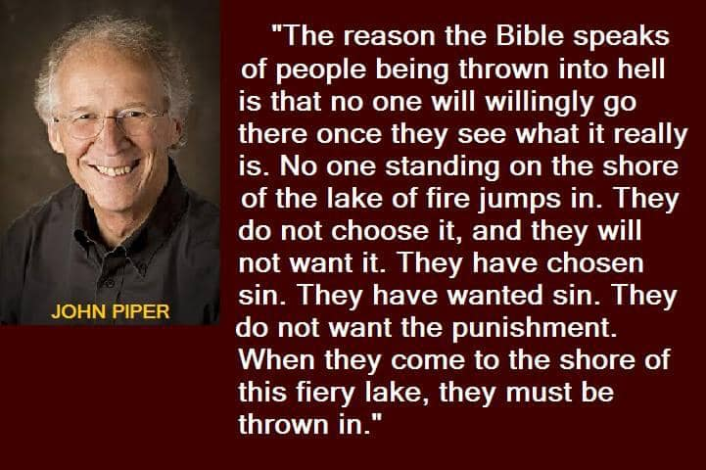
I get up early on weekdays to read the Bible and pray and give out what the Lord gives me before even getting in the shower and going to work. On weekends is my real quality time with the Lord before I shower and doing a more in-depth teaching He gives me. Nothing is going to get in the way of that. NOTHING! He has to find His servants using their gifts and talents to grow the kingdom when He comes, not hiding it because they want to go to the beach or do what they want. I take that very seriously as time is short, I am not getting any younger and I can’t be every body’s personal tour guide on weekends and do things when they think I should as they think I should do it. My days of bowing down to controlling people are gone. I have a work that he has given me and I must work the works of the Lord who sent me. A lot of people talk about dying to self but few even do that. The Lord told me one time, what if you didn’t spend that time with me and give out what I wanted for that one person out there that was going to die that day because you wanted to go to the beach and they passed away into eternity in hell because you refused to die to your will and way and pick up your cross to follow Me? Their blood will be on your hands. Many want the anointing and answers to prayer but few are willing to pay the price to get it. We are left upon this earth for one reason and that is to preach the kingdom of God and grow it. You have to set boundaries with people and guard your time and heart and not let others tell you what to do and how to do it outside of work. The problem is you have 25 people demanding your time or attention and all 25 think they are the only one asking for your time. Your phone rings at all hours of the day or night, most from people with perverted motives. Don’t get offended folks when people have to set boundaries. You may be the distraction the devil sends to have that one person go to hell because the person you demand of their time didn’t have boundaries and they didn’t die to their will and way in order to post what the Lord was giving them. How lukewarm are you if you are not willing to die to self, your will and way in order to do the works of Him who sent you? Kingdom first. People want the anointing but don’t want to pay the price.
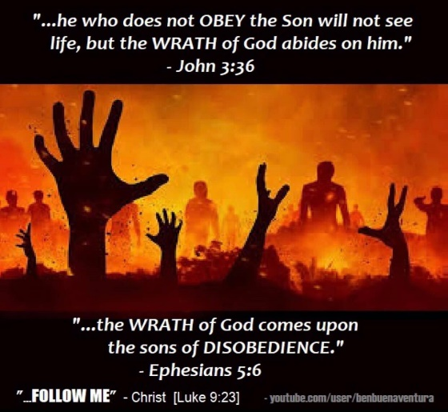

WE BELIEVE WE ARE SOMETHING WE ARE NOT

Here is wisdom:
Pay attention to what bothers you or makes you irritated or impatient. It reveals something inside of you and should be a red flag to you that this is when you need to access the power and fruit of the Holy Spirit in order to respond in love toward people. It is not about the other person. What irritates you can also help you understand other people you would tend to criticize when they get irritated and help you empathize not judge.
I will be transparent here. I work full time. I get up early to read the word and pray every day. I still have to find time to get groceries, do my laundry, clean the house, maintain the yard and house repairs, get the proper rest, exercise, deny self to do the newsletter the Lord wants me to get out when I would rather be doing something else etc. My plate is full and I only have so much time and physical energy. Therefore, when things interrupt my time or cause me to have to go back and redo something, I get irritated. My irritation is something in my heart that needs addressing when dealing with the thing or person who is causing it. I need the fruit of the Holy Spirit when interacting with the person or thing I want to blame for causing it or I will walk in the flesh. When people see me accessing that power or fruit, I am demonstrating that I care about them. I look for that in other people as well because it demonstrates they care about me.
Example: My boss is like the Tasmanian Devil we used to watch in cartoons when we were young. He is high energy and a brilliant businessman with a packed schedule. He comes in the office like a whirlwind doing this and that with very little time for small talk or conversation. He is a lot like me in that he doesn’t like fluff in the conversation and gets to the point immediately. Fluff and small talk require him to tap into that patience when I sometimes think out loud in his presence. I see that big smile cross his face which tells me he would rather be anywhere but there and I need to shut up. It also demonstrates to me that he cares enough to grant me the time while pretending to listen and be patient and he is exercising self-control because he cares. I have learned to do the same. If you know a person well and you see an internal battle going on and they would rather flee, but choose to stay so as to not offend you, they are demonstrating that the relationship is important and they care about you. That is what it means to pick up your cross and follow Jesus. It doesn’t mean don’t have boundaries. We all need boundaries. It just means you need to recognize ways people show they care and appreciate it and demonstrate it in your relationships as well by accessing the power and fruit of the Holy Spirit. I know how difficult it is for my boss to do that when he takes the time to listen rather than thinking about the other 8 things he needs to do. Therefore, I recognize he does it because he values the relationship. I shut up for the same reason when I see that. Don’t always look for the pat on the back or praise. Access the Holy Spirit when your emotions tell you something about yourself that requires you to access Him in order to walk in the spirit instead of being controlled by your feelings.
I love where I work. We are like family. My boss and his wife have been very good to me and I deeply respect them for all their gifts and talents. They are incredible people. Sometimes the Lord shows me strengths in them to address things I need to address in myself like the example I gave above.
Let’s all start walking in the spirit and stop the mocking and putting down of one another because we choose to be controlled by our feelings. It causes division, strife and every evil thing. How you feel and treat others says more about you and something in your own heart that needs to be addressed. The fivefold ministry needs to start equipping people to do this in their daily lives instead of having a form of godliness but deny the power thereof. What good is the power if you don’t know how to access it and put it to use. Grace is translated power that we are saved by.

I am finding a lot of people can agree with you on scripture but have no earthly clue that they are not doing what they say they agree with. Most Christians are consumers, watching this favorite TV preacher and spending time on social media getting caught up in the drama when people are going to hell and multitudes dying every minute and they give them not a thought because their focus is on self and they are clueless. If it doesn’t affect them or their life, they don’t care. Who and how have you been concerned today about where someone will spend eternity? What have you done about it if you are even concerned at all? Do you even realize how you are NOT dying to self and you spend most of your time doing what you want because you are earthly minded instead of eternally minded and people are going to hell that you could have reached today if you weren’t sitting there consuming your favorite TV preacher. Wake up. We live in end times. Let the Lord find you using your talents to grow the kingdom at His return, not consuming and hiding your talents while people slip into eternity damned because you were too preoccupied with watching your favorite whatever. No wonder lukewarm make Jesus vomit and most lukewarm people don’t think they are.
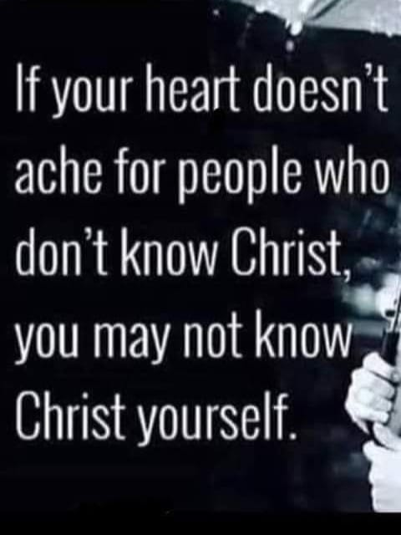
Many people don’t know the real Jesus because they have received a different gospel preaching another Jesus not found in the bible.

MY SHEEP HEAR MY VOICE

As I read and prayed today, the Lord kept bringing me to John 10:28. He said many people are deceived and believe they are in my hand or the hand of the Father’s when they are not. They use that verse to prove eternal security after believing when IN CONTEXT it is about hearing and following. Many sheep have the hirelings which are not of my flock and therefore not in my hand or the Father’s. They do not love truth. They do not hear my voice when I bring truth in their deception because they are not of my flock and aren’t in my hand to begin with. They have been deceived by the enemy into believing they are.

The weight of the Lord’s words were heavy when speaking this to me. How many are deceived? Will Jesus even find true biblical faith when He returns? When the rapture happens or when He comes, many who think they know Him don’t. They have believed a different gospel preaching a different Jesus. They are not of His flock fold. They do not HEAR His voice and they do not OBEY or FOLLOW it. They have entered the flock fold another way by being told all they need to do is merely believe as a noun, instead of being born again of water and of the Holy Spirit through baptism in both.

So let me ask you, DO YOU HEAR ME NOW? What other distractions do I need to remove to get you to pay attention and do as I command? Which horse will you be like? How much of the crop of discipline needs to be applied to the rump of disbelief and rebellion in order to keep you even in the race, let alone get you to the finish line as a church leader. I said I would gather out of my kingdom ALL who offend and ALL workers of iniquity. How much longer will you offend me and allow those to perish for a lack of knowledge because you missed the hour of your visitation. There will be no revival without repentance and preaching the true gospel as outlined, laying down the true foundational teachings of the church. I will only confirm the true gospel with signs following.

People are more likely to endure until the end when told they must in order to be saved, rather than to be told the ear tickling lie that they are saved and eternally secure if they just believe by giving mental ascent. Even Satan believes and by the churches definition of believe, Satan is a believer and eternally secure. Anyone not hearing the Lord’s voice and obeying it are not of His flock and they are not even in His hand. They have followed the voice of a hireling and entered the flock fold by another way.

Some people are easily distracted from the Lord and don’t hear His voice and respond only to painful circumstances or disasters that get them back on track and back into the race in order to get them to finish the race. Without enduring until the end they won’t be saved so they must finish their race and not fall away. If you don’t like the painful circumstances you are in, get your focus back on the Lord and He has to be #1 in your life. The painful circumstances are for your own good to keep you in the race and have you finish well. Don’t listen to hirelings that bring in damnable heresies into the church. Don’t be tossed about by every wind of doctrine. Read the Bible for yourselves and be a doer of the word because only those that are doers of it have their house remaining during the storm. The rest go through the painful circumstances of watching everything fall in order to refocus the attention back on the Lord. Repent of ALL known sin. Testing and trials are to show what is in you that is unpleasing to the Lord that must be removed. Not all who believe themselves to be Christians actually are. Only those who follow Christ, hear His voice and obey it, are the ones not plucked from His hand or the Father’s. The sheep follow Him in OBEDIENCE because they know His voice and follow. If you have anyone telling you that you don’t have to obey what Jesus commanded they are not of His flock. Obedience and believe are the same word in translation. The thief comes in another way into the flock fold not having people obey but only give mental ascent to what Jesus did on the cross in a passive way. Even Satan believes in this way. That is not the saving kind of faith. You are entering the flock fold through the wrong door. Satan comes to deceive. Jesus said His people perish for a lack of knowledge. Shall be, will be saved are all future tense. You are not saved when you first believed. Now you must follow Jesus doing all He commanded which the baptism in the Holy Spirit empowers you to do.

The work of the fivefold ministry is to equip the church for their ministry to go out into the world to spread the gospel. If you are not doing the equipping or teaching the bride to make herself ready, all those who are left behind, you will be held more accountable for. Not all Christians are raptured. Only the bride who made herself ready. Jesus is coming for a glorious church without spot or wrinkle. Only those whose names were found in the book of remembrance will be raptured. The Lord revealed that to me in 2013 and I have been preaching that ever since. Read that verse in Malachi in context. You are not raptured because you claim to have believed. Only those who fear the Lord and obey. Knowing that, you prepare yourself waiting for His glorious appearing. Trust me, you don’t want to be left behind.

So let me ask you, “Do you hear Me now or do more distractions need to be removed that take you away from putting Jesus first and following Him. How much more of the crop beating on the butt is required to get you to the finish line in order to be saved? In the end we receive eternal life Romans 8:22. Grace isn’t the license to sin but the power of God given to you not to through the baptism of the Holy Spirit. Your freedom in Christ comes from no longer being a slave to sin but a slave to righteousness instead. Grace teaches us to live godly in this present world. If you don’t see godly living you can be sure that person has not received the biblical definition of grace that saves.

There is coming a severe purging in the body of Christ and the fear of the Lord is going to return to His temple. Those who turn His bride into a business and make His house a den of thieves instead of a house of prayer will receive the severity of the Lord instead of His kindness if they don’t repent. Those teaching demonic doctrines that strengthen sin instead of freeing people from it will be removed if they don’t repent. There will be great tribulation upon the earth amidst great revival and His glory will be upon those who obey and teach the true gospel that teaches people how to endure until the end in order to be saved by accessing the power Jesus gave as a gift to do so.

I have had tsunami dreams since around 2013 where people are playing with their toys on the beach totally oblivious to the tsunami mounting and moving toward them. I stand and start warning them as I face the mountainous wave rapidly approaching. They do not have ears to hear. The wave crashes down upon them and rips their toys and all their belongings away and out to sea while the people stood there devastated and in shock at having lost it all. That is when we who heard His voice move in to minister to those people because that is what it will take for some people to “Hear Him now”. How about you? If you are in ministry, are you going to repent and equip the people to be free from sin, laying down the foundational teachings of the church under them starting with repenting and being born again of water and the Holy Spirit in baptisms? Are you going to equip them for the work of their ministry to be sent out into the end time harvest? Are you preparing them to be without spot or wrinkle and ready for the Lord’s return. How has the present day gospel you have been preaching working for you and growing the kingdom while impacting the world or has the gospel you have been preaching producing lukewarm Christians that make Jesus sick to His stomach enough to want to vomit. Therefore, the gold and wealth must be tried in fire.

WITCHCRAFT IN THE CHURCH

Just a brief reminder to those who might not know but have prayed that the Lord would keep them from deception and may not have read my teaching on this. What is the difference between witchcraft wrapped in Christianese or biblical terminology and being led and controlled by the Holy Spirit? Witchcraft is about power and control and having what you want. A spirit of divination, which counterfeits the Holy Spirit and operates in the false gifts of the spirit, has brought a teaching into the church that sounds biblical to the undiscerning and has been presented in the church under various forms, but it is witchcraft 101. Think of a witch that recites an incantation. Evil spirits now go forth to perform what the witch recited. In the church it has been presented as the name it and claim it, blab it and grab it, declare and decree it, have whatsoever you say because there is life and death in the power of the tongue, or pray back God’s word because He watches over His word to perform it. It is the equivalent of making the spirit world your little genie based on what you say, even using God’s word. The only word God watches over to perform is His Rhema word. By all means if you get a specific word from the Lord, speak it forth if He tells you. He may tell you not to and to hold on to it. Angels only respond to what God says, not you reciting what God said so you can get Him to do something. Your angels are there to obey God’s word for your life, not your will. Reciting the word expecting the spirit realm to just hop to your request is witchcraft 101 and the equivalent of divination or reciting an incantation so the spirit realm does your will. We are to be led and controlled by the Holy Spirit. We do not lead and control the spirit realm except to cast an evil spirit out or conduct spiritual warfare. Trust me your angels are not bored. If you could see how many ways they just kept you alive today you would dispel that notion real fast. Especially if you are serving the Lord. They are plenty busy because you are a handful. Don’t let the devil twist scripture to you to mean something God never intended to open your life up to a spirit of divination. A spirit of divination is called a python spirit that wraps itself around its victim and crushes it before devouring it. Poverty is a manifestation of this spirit. Once you have opened the door to it, it is tenacious in trying to remain or come back and will move on to a family member if you discern and overcome it. Porn is also a manifestation of this spirit because the bible says a peeping Tom is a manifestation of a spirit of divination. Porn is watching someone from a hidden place in order to derive pleasure. That basically describes a peeping Tom only porn is the modern day version of it.

I use the word of God when I pray but it is in a form of thanksgiving and petitioning the Lord. For instance as I pray for a person who has fallen away or who does not know the Lord I pray, “I thank you Lord that me and my house shall be saved. I ask that you give so and so the gift of repentance and that the Father would draw them to Jesus. I ask that you give them the revelation and knowledge of salvation and the spirit of reconciliation so that they may come to know you”. I never “recite” the word expecting the spirit realm to hop to performing the word because God watches over His word to perform it and the angels harken to His word. That IS witchcraft. Sounds good to a Christian but it is not from the Holy Spirit but His counterfeit that flips the script. Please receive this word and repent of it since you have prayed and asked the Lord to not let you be deceived. This was put in here specifically because YOU ASKED!

Regarding the future, people are so divided in this country. The Lord is allowing things to happen to show those who were brainwashed and deceived by the left that the right was right and what they warned about is coming to pass in order to get everyone on the same page and out of the division. Tragedy and loss seem to unify people and draw them toward the Lord and if that is what it takes as the crop to the butt to get the attention of the easily distracted in order to get them back in the race and focused on the finish line and finishing well, that is what God will use, unless you heed the word of the Lord here so that you are not turned over to strong delusion. He is trying to expose evil that you want to not have to deal with because it is so vile and evil. Sticking your head in the sand will only leave you dying of suffocation and perishing for a lack of knowledge. The church has not stepped up to the plate to bring unity. The church has been passive in influencing the country because they have this false notion that they should stay out of politics. God has never remained out of politics and He expects us to occupy until He comes. Passivity while believing yourself to be on fire for the Lord seems to be a common delusion of the church. That is why the eye salve has to be applied because the Laodecian church will not apply it herself because she does not think she needs it. She thinks she is “woke” when she is living in greater darkness, blindness and powerlessness in the history of the church age. There is coming such tribulation and people are unprepared for what is about to not only happen, but the evil that is to be revealed. Watch who even the church leaders try to silence and discredit, because that is who you may want to listen to. Watch who the fake media takes down and silences, because they are a threat to the kingdom of darkness even if the church leaders have not yet recognized it because adequate eye salve has not yet been applied. Everything that can be shaken will be shaken and that includes the church structure and how it has operated, which the Lord will no longer wink at. You will have to have need of things because what you relied upon that left you thinking you had need of nothing will be gone. Your gold and wealth will be tried in fire. Are you prepared for this? Are you preparing your people for this and teaching them how to tap into the power of God’s grace for what it is they need when they need it. The modern day apostate church has produced people enslaved to sin and idolatry who can’t even give up their porn or cell phones, let alone their heads in martyrdom. They will take the mark of the beast or turn in other Christians as Jesus warned regarding end times, because they believe they are saved and eternally secure so what difference does it make. Do you even know how or do you have a form of godliness but deny that power by teaching people to be passive in thinking Jesus did it all and they have nothing on their part to do. God help you if you cannot access that power and cannot teach others to when needed. That is when you will realize that you have need of things because the tribulation will be so great that your human limitation will be stretched and will run out. Where will you be then? Where will the flock you lead be then? There is no greater way to get people to admit they need something than to put them in a position to realize they do not possess what they need. If you have so much that you trust in, that will have to be removed in order to trust in what you say you already do (Jesus) but really don’t, those things you trust in reality will have to go away in order to expose the fact that you really don’t trust in Jesus for your salvation and deliverance. We are a deluded bunch, the church of today, believing themselves to be something we are not, which the Lord will expose through discipline, in order to get us from where we are to where we need to be. Discipline is a demonstration of His love so don’t despise it. Be changed by it. Those who refuse to, get removed so others do not perish.

When I go to speak, I have a baptismal available. I don’t wait. If people want to be born again the biblical way, I do it the way Jesus commanded by explaining the purpose of water baptism and subsequent baptism in the Holy Spirit as I have outlined here and they get baptized in the Holy Spirit as a result. I don’t baptize anyone who is not willing to repent or live a holy life pleasing to the Lord by obeying Him. I have a pool at my home for that purpose. No longer do I wait for a church to have enough people who want to be baptized to justify filling the baptismal in water and heating the baptismal in order for people to be born again of water and the Holy Spirit the biblical way. The Lord has provided a home with plenty of room because people are going to need it and He brought someone here already and we have had close to $400 in groceries just show up by mistake and the store told us to keep the groceries because they couldn’t take them back because of Covid. There was baby formula, food and other items in the grocery order which I was going to donate until the Lord told me not to because He sent the provisions ahead of the family in need who He would send to my home. I had to go out and buy a new refrigerator/freezer today for the garage to start storing food because we have so much as well as other supplies of toilet paper and cases of water. All during Covid lockdown, the Lord has provided for me supernaturally. I could write a book on all the ways He has and has manifested Himself to me and supplies for those He sends to me. All this starts with hearing His voice and acting upon what He says in obedience so I am not like the horse who has to have the crop or whip of discipline applied to my backside to keep me in the race and finishing it well. How about you?

Do you hear Me now says the Lord or will stronger discipline need to be applied? The spirit or anointing of Elijah has come to restore all things before the Lord returns as an act of His mercy because He wishes that none would perish. Will you be one who will not receive the love of the truth in order to be saved and be sent STRONG DELUSION?

A VOICE CRYING OUT IN THE WILDERNESS MAKING STRAIGHT THE PATHS! COMING IN THE SPIRIT OF ELIJAH! AS IT WAS THE FIRST TIME, SO IT IS THE SECOND!

For speaking engagements call 813-393-9384. Our website is www.latter-rain.net

Joanne Armstrong
Latter Rain Ministry
Introductory YouTube Video below with more to follow:

https://youtu.be/E_PrFVmefXc

