
  Fresh Rain
  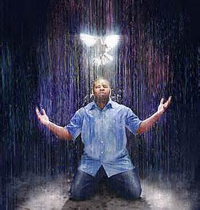
  Latter Rain Ministry
Preparing a Bride without  spot or wrinkle |  | July 2021
How Saved Are We?

To answer that question, we must first know what the definition is ACCORDING TO THE BIBLE because the word is thrown around so loosely that it includes people who aren’t born again of water and of the Holy Spirit or true believers by the biblical definition and by declaring people saved who aren’t, we are deceiving them. Definition or translation of the word save in the Bible: to make whole, to heal, to do well, to protect, to deliver (from slavery to sin).

How SAVED are we by the biblical definition and not the definition the apostate end time church uses? The Israelites believed they would be saved while still enslaved in Egypt. Were they saved when they first believed? No! Believing aligned them to follow Moses just as our believing should align us to follow Christ. Next God led them to the Red Sea where they were ALL water baptized and they were led through the wilderness of life by the Holy Spirit just as we are to be led and controlled by the Holy Spirit through our wilderness walk through life, who is to get us to the promised land where we receive eternal life Romans 6:22 in the end. Some died in the wilderness as an example to us the Bible says. If the same thing can’t happen to us, how could it be an example? This is all found in the New Testament if you will read it. This pattern of salvation is found throughout the whole Bible and Jesus and the disciples followed and taught this pattern. The modern day apostate church does not. So how saved are we if we are not following the pattern Jesus followed and He is the way, and aren’t we deceiving people by telling them they are saved when they are not just because they believed. Even Satan believes so by the churches definition, he is saved. You don’t have to be a rocket scientist to know that isn’t true.
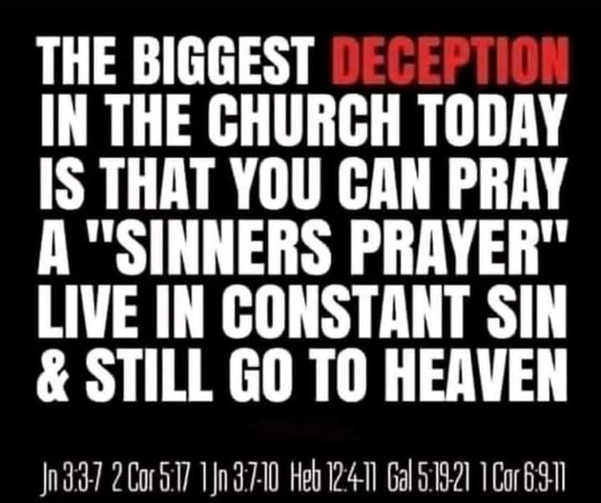
Believe is a verb in the Bible and not a noun. Your little feet should be moving to the Red Sea of water baptism and being led and controlled by the Holy Spirit in order that you be delivered from slavery to sin. Wouldn’t we call someone delusional if they professed freedom and salvation while still enslaved in Egypt or to sin.? Yet today’s believers are delusional for the most part because we falsely proclaim them as “saved” because they just believe and yet are still living enslaved to sin. We act as if their salvation is a done deal and they have nothing to work out with fear and trembling in order to receive eternal life in the end Romans 6:22 and enter into the promised land. Satan has deceived the masses by telling them they are saved when they first believed in order that they do not work out their salvation with fear and trembling. I hope you aren’t doing that and grieving the Holy Spirit. Then he tells them water baptism and baptism in the Holy Spirit are not necessary for being saved. Unless you are born again of water and of the Holy Spirit in baptisms in this way, you won’t enter the kingdom of heaven. Your believing should lead to obedience and to following Christ, which is the definition of Christian. If you are not following you aren’t one. You are just a believer still enslaved in sin just as the Israelites were before leaving Egypt. Many believers are not Christians or following Christ and are not born again biblically.

So how saved are we? How saved are you? Are you deceiving the people? You will be held accountable!
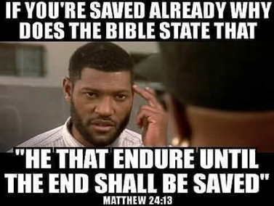
“Moreover, brethren, I would not that ye should be ignorant, how that all our fathers were under the cloud, and all passed through the sea; And were all baptized unto Moses in the cloud and in the sea; And did all eat the same spiritual meat; And did all drink the same spiritual drink: for they drank of that spiritual Rock that followed them: and that Rock was Christ. But with many of them God was not well pleased: for they were overthrown in the wilderness. Now these things were our examples, to the intent we should not lust after evil things, as they also lusted. Neither be ye idolaters, as were some of them; as it is written, The people sat down to eat and drink, and rose up to play. Neither let us commit fornication, as some of them committed, and fell in one day three and twenty thousand. Neither let us tempt Christ, as some of them also tempted, and were destroyed of serpents. Neither murmur ye, as some of them also murmured, and were destroyed of the destroyer. Now all these things happened unto them for ensamples: and they are written for our admonition, upon whom the ends of the world are come.” 1 Corinthians‬ 10:1-11‬ ‬‬‬‬‬‬‬‬‬‬
So we can also be overthrown in our wilderness walk through life, even if we are water baptized and baptized in the Holy Spirit. You can fall away from the faith. That is why the bible lists the things of the flesh that is said to believers, that if they do, they will not inherit eternal life or enter the kingdom of heaven.

So believing is the first step that aligns you to follow Christ as our example just as the Israelites believing aligned them to follow Moses out of slavery. Were they saved or delivered when they first believed? Absolutely not! They would be delusional to call themselves saved or delivered while still in slavery, yet that is precisely what the church does to new believers. We act like it is the end all and a done deal already when it is not. Believing is a verb as is faith and it is ongoing until the end and not a one time act of believing. Shall be and will be saved are all future tense.
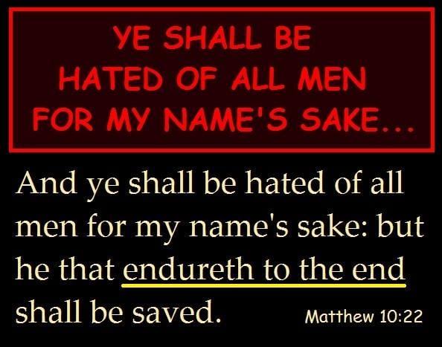

IN WORKS THEY DENY HIM

“They profess that they know God; but in works they deny him, being abominable, and disobedient, and unto every good work reprobate. ”Titus‬ 1:16‬ ‬‬‬‬‬‬‬‬
‬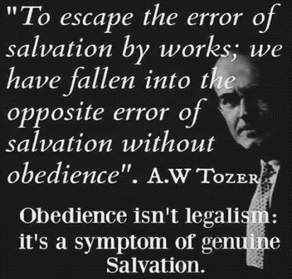
There are many people professing to be Christians because they “believed” and they confess or profess Jesus with their mouth and profess to know Him but they don’t obey Him and their works and lifestyle deny Him. Faith without works is dead or is NOT the saving kind of faith. Faith is a verb or action word that is ongoing until the end. It is not a one time act of believing and now you think you are saved like the apostate church teaches today.

If you are still enslaved in sin you are not “saved” or delivered from it and will thus be subject to the judgment of it if Jesus supplied everything we need to live godly in this present world. That is what the Bible says grace teaches us. If a person is not living in godliness in this present world, they have not received the biblical definition of grace which is to be utilized in empowering us not to sin. Many sins stem from a wound. Unless that wound is healed, which is the root cause of that sin, that sin will continue which is why being made whole is an aspect of “being saved” that delivers us from slavery to sin. So acknowledging and healing wounds is part of what Jesus died to do to deliver us from slavery to sin. If you always have people pointing the finger at the sin, instead of having revelation of the wound that is the root of it, people may change their external behavior for a season but the internal heart condition is never healed and they are never really “saved” or delivered from it. Satan knows this which is why he places those self-righteous finger pointers as his ministers of righteousness and angels of light in the church. They will be pointing out the external or how things look, instead of how things really are inside the person. They are constantly pointing out how people dress, tattoos, hair and so on. They never asked themselves why a person is doing what they are doing in order to minister healing to a wound, so that they are delivered from slavery to sin that manifests from that wound. Ever ask yourself why a woman might dress for attention? Doesn’t take a rocket scientist to figure out that it is because she never got the proper healthy love and attention from a father or man. Of course there are plenty of men out there who will exploit her in her wounds by giving her the wrong kind of attention because she feels invisible.

Men SILENCING women in the church or talking women out of their feelings instead of actually listening without fixing the women, only makes them feel more invisible and makes them more prone to seek attention through other unhealthy ways. Some attention is less painful than none. You are actually setting up your wife or daughter for temptation in unhealthy behavior because you have made her feel invisible instead of listening and accepting her feelings, rather than explain them away. Feelings are not right or wrong and it is what makes a person who they are so to reject and explain away someone’s feelings, wants, needs or desires, always believing you are fixing the problem, is to reject and ignore them while setting them up for Satan to bring along a persons who gives the woman the attention she needs because she has been made to feel invisible and unimportant. Most husbands have no clue. They think they are just “helping” and throwing water on the fire when in fact it was gasoline. They have actually created a wound that gives sin a launching pad in their marriage or in their children’s lives. Men are to love their wives like Christ loves the church and give himself for her. Not fix her, which makes her feel constantly inadequate and invisible. Your wife should be more holy or “without spot or wrinkle” because of you loving her as Christ loves the church in this way. Does Jesus negate you as a person and silence you, making you feel inadequate constantly? Husbands will be held accountable for the condition of their wives’ heart. She should be without spot or wrinkle not more wounded and thrust into temptation or have repressed anger from unresolved issues in your marriage because you explain away her feelings by giving your intent, rationalizing, explaining or defending your behavior. As a result she must constantly fight off the devil’s agents sent to her that give her the attention when you make her feel invisible. Or your family members will constantly have repressed anger from unresolved issues that never get addressed because they are explained away. Fight for your families. Give your daughters healthy fatherly love and attention. If you don’t know what that looks like, find out from a good Christian counselor. The hearts of the father’s need to turn in this midnight hour. Being held accountable for the condition of your wife’s heart should be a sobering thought that makes you less selfish and more attentive to the woman God entrusted in your care. You can always tell the integrity of a man by the countenance of his wife.

By the same token I see women who say they have found Jesus while their actions shout that they haven’t. Take the woman at the well who had many husbands and was living with the last guy. Jesus told her that what she was seeking after in attention, love and being listened to can only be found in Him. So ladies if you are still chasing men looking for what Jesus can only provide, have you really “found Jesus” or do your works deny Him?

This is what I mean by healing the wound and the sin goes away. Jesus died to do this and if you are constantly causing wounds to someone then that person’s healing and deliverance may not come unless you are removed from their life. The Bible rebukes pastors who heal the wounds of the people slightly or doesn’t address them at all. I will, because that is what Jesus died to do in order to deliver us from slavery to sin or “save” us so that we do not endure the judgment of those sins.

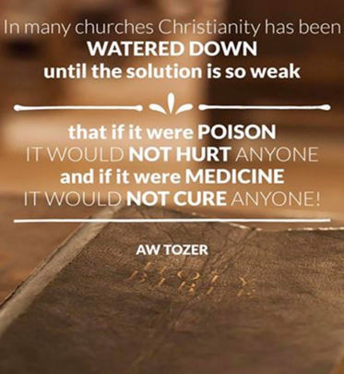

Salvation is something you work out and you don’t work out what you already have.

The Lord kept having me stay in this “deny Him through their works” area throughout the week, because I pray over these newsletters and wait on Him to see if there is something else He would like to say. He brought me back to pastors who do this by telling people to have faith in God’s provisions while lacking faith in God for the same and thus start to manipulate the people through the word to give because of their fear and lack of faith for His provision. In your works you deny Him. If God is your provider and not man, why do you manipulate man to give? The people are told to go to God when they have a financial need, and the pastor goes to the people when he is in need. All forms of manipulation are controlling and come from a spirit of witchcraft. Fear is the launching pad of manipulation and control. You say one thing and live another or different rules apply to you. Manipulating people carnally, causing them to give in order to get is of the flesh, and an abomination to God. Let the Holy Spirit search your heart to show you just where you profess that you know Him but in your works deny Him.

Too many people professing that they know God but deny Him through their works being reprobate, disobedient and ABOMINABLE. Abominable is translated detestable and idolatrous (because of the love of something else over God, love of self). That word reprobate is translated rejected by God, unapproved, castaway or thrown back like the bad fish caught in the fishnet of evangelism. So who is warning these people who deny Him in works and lifestyle as they profess Christ and believe they are saved and eternally secure? Whose hands will their blood be upon? I am clean. How about you? How many people sitting in our pews are we warning, who are going to hell, unless we bring this to their attention and show examples so they can apply it? Or are we going to keep telling them they are saved and eternally secure and can live as they like?

The elect acknowledged the truth which is after godliness or godly living. They allow Jesus to do what He died to do in their lives and throughout their lives in an ongoing fashion and this is what it means to trust Jesus for our salvation or deliverance from slavery to sin, being made whole and healed so that sin in our lives is eradicated and we are sanctified or made holy as He is holy because without holiness no one shall see the Lord and only those that do the will of the Father enter the kingdom of heaven. Are you being made holy which is what is means to be saved and are you doing the will of the Father instead of being reprobate, abominable, disobedient unto every good work, while professing to know God but deny Him in works. Faith without works isn’t the saving kind of faith. The Bible says you can believe in vain or to no saving effect. Is that you? People sitting in your pews? Therefore, believing is not what causes one to be saved but is the first step onto a path of obedience. Otherwise, your believing is in vain or to no saving effect. If the righteous scarcely be saved, what becomes of the disobedient, ungodly and sinners who remain in their sins believing they are saved and eternally secure, when Jesus died to deliver them from slavery to sin. He did so by empowering and equipping them not to, and to be ministers of healing and righteousness to the wounded? Binding up the broken hearted, so their sins stemming from that wound no longer remain.

Truth is after godliness or produces godliness. If you believe in a different gospel preaching another Jesus that has you remaining in your sins because you believed and are now eternally secure, you have believed the wrong gospel and are deceived and the Bible says to let those people be accursed. Save some with fear hating even their garments that are spotted by the flesh. Accepting Jesus and asking Him into your heart is nowhere in the Bible as a way to be saved. Repent and be baptized every one of you is. You must be born again of water, being baptized into the body of Christ, pledging to be dead to sin IN ORDER THAT you be raised as Christ was raised. Water baptism being symbolic is a lie. You are being baptized into the body of Christ, identifying with His death to sin and self and alive unto righteousness. This places you “In Christ”. What water baptized the Israelites in the Red Sea also slammed down and cut off what used to enslave them. I have started to water baptize people in my pool (because I am a doer of the word and not a hearer only) and saw demons start to manifest because they have to go! I command them to shut up and go, water baptized the person who was a drug addict, and they stepped to the side to let the next person in to be baptized and they raised their hands to thank the Lord and He baptizes them in the Holy Spirit right there. I was going to lay hands on them to receive the baptism of the Holy Spirit after water baptism but the Lord did it immediately. Being baptized in the Holy Spirit empowers you to keep that pledge of being dead to sin and self. In the end you receive eternal life based on how you worked out your salvation with fear and trembling, utilizing this free gift given you through faith. Most people in the church today are ever learning and never able to come to the knowledge of the truth. Even Satan believes. We have got to stop lying to people and telling them they are saved when they first believe. They aren’t. Not scriptural. Believing should align them to follow, in obedience, to being born again of water and the Holy Spirit in baptisms. These are foundational doctrines of the church that the apostate church leaves out because Satan has deceived them. The hardest people to get to become born again biblically are the people who think they already are. Their works deny Him while they profess to know Him. Anyone who claims to know Him while remaining in sin is a liar and the truth is not in them the Bible says. Is that you? Are you teaching that? That is the fruit, though, of the present day gospel the apostate church is teaching today. I wouldn’t want to be a preacher or teacher today preaching a gospel that has people remaining in their sins believing they are eternally secure. Those teachers and preachers are held more accountable. Jesus died to deliver them from slavery to sin in order to have them not incur the judgment of it.

“Paul, a servant of God, and an apostle of Jesus Christ, according to the faith of God's elect, and the acknowledging of the truth which is AFTER GODLINESS; In HOPE (you do not yet possess what you hope for) of ETERNAL LIFE, which God, that cannot lie, promised before the world began;” (promised to the elect who acknowledges the truth which is after godliness and lives in accordance to it in obedience) Titus‬ 1:1-2‬ ‬‬‬‬‬‬
‬‬
So how saved are we based on the word of God? We have got to stop lying to people telling them they are saved when they first believe because in telling them that, we almost ensure that they never will be because they will not participate in the process of being saved and working out their salvation with fear and trembling.
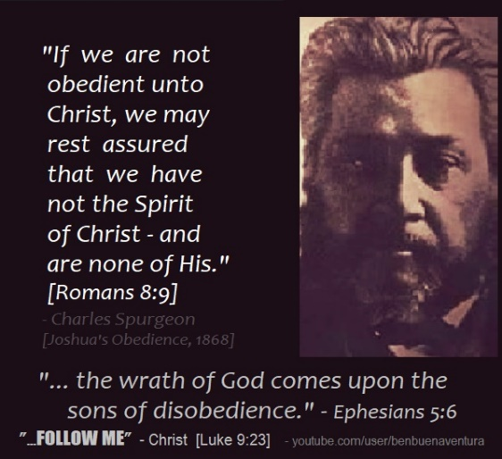

HOW SHALL WE NEGLECT SO GREAT A SALVATION

These words are spoken to believers in the church about believers. The word angels is translated messengers, which John the Baptist was called in the Bible. He was called an angel or messenger of God. It is not always referring to invisible winged beings. Notice that the word is steadfast or never changing under any covenant. Every transgression and disobedience receives just recompense of reward. Prefix trans means down or away so transgression is to move down or away from righteousness. Disobedience means you know what is right and made a choice not to do it. Therefore, you receive the wages or recompense of reward for that, which is death. How shall we WHO ARE BELIEVERS escape receiving the same wages if we neglect so great a salvation?

You can become apostate and fall away through sin or deception. Grace isn’t the license to sin but the power of God given to you not to through the baptism of the Holy Spirit. Your freedom in Christ comes from no longer being a slave to sin but a slave to righteousness instead. The law is for sinners the Bible says. Those under grace have ceased from a lifestyle of sin by utilizing this empowerment and are therefore not under the law but grace received by faith. We are to work out our salvation with fear and trembling and in the end we receive eternal life Romans 6:22.

How shall we escape the wages of sin which is death if we neglect so great a salvation? And most Christians today aren’t taught this and are deceived and part of the end time apostate church that Jesus spoke about before He returns.

“Therefore we (believers) ought to give the more earnest heed to the things which we have heard, lest at any time we (believers) should let them slip. For if the word spoken by angels was steadfast, and every transgression and disobedience received a just recompense of reward; How shall we (believers) escape, if we neglect so great salvation; which at the first began to be spoken by the Lord, and was confirmed unto us by them that heard him;” Hebrews‬ 2:1-3‬ KJV‬‬‬‬‬

HEART MATTERS

You will find with the things I preach and teach, which the Father gives me, I expose the true condition of our hearts because our own hearts are wicked above all things and our own hearts deceive us. We all want to think we are something we are not. Satan is more than happy to oblige us in deceiving us to believe we are something we are not. If it focuses on the external it is not God. It is from God if it exposes the true condition of our hearts. This is never for condemnation which many will hear that way. It is just Jesus doing what He died to do, which is change us and you cannot change what is not brought to the light. Many love darkness more than light and will not come to the light that their deeds or beliefs can be reproved or tested to show they were wrought in darkness. They won’t look at their hearts in truth in order to be changed. Jesus said if you don’t allow me to wash you then you have no part with me. No part means no part. Thus the exposing of the true condition of our hearts. You must cooperate, participate and submit to the washing process or you have no part with Him. Who is telling that to believers?

We must worship Him in spirit and in TRUTH which is who He is. To reject truth is to reject Jesus. As the bride of Christ who made herself ready, you have a responsibility in making yourself ready after being given by Jesus everything you need to do so. He can supply the toothpaste and tooth brush, but you do the brushing. Otherwise you don’t have a relationship do you, which is where both are participants?

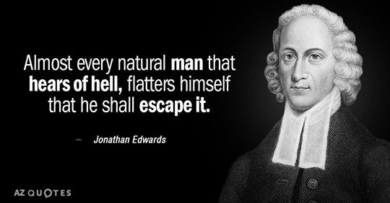

HOW ARE WE SAVED?

By the washing of regeneration and renewing of the Holy Spirit. No transformation, no salvation. Believing and being baptized in water and the Holy Spirit are just the beginning that equips us to run the race and make it to the end because His grace is sufficient, not the end all. They are means to get you to your final hoped for destination of receiving eternal life which is unattainable any other way. Eternal life is received in the end. Not when you first believe according to the Bible. Paul told Timothy to lay hold, obtain, attain and apprehend eternal life. You don’t obtain what you already have.

“But after that the kindness and love of God our Savior toward man appeared, Not by works of righteousness which we have done, but according to his mercy he saved us, by the washing of regeneration, and renewing of the Holy Ghost; Which he shed on us abundantly through Jesus Christ our Savior;” Titus‬ 3:4-6‬ ‬‬‬‬‬‬‬‬‬
‬
We are made heirs according to the HOPE (you don’t yet possess it) of eternal life.

“But we are bound to give thanks always to God for you, brethren beloved of the Lord, because God hath from the beginning chosen you to salvation through sanctification of the Spirit and belief of the truth:” 2 Thessalonians‬ 2:13‬ ‬‬‬
‬
‬Notice salvation comes through sanctification (being made holy) and belief of the truth. You can’t do this without the baptism of the Holy Spirit. Jesus only baptizes those in the Holy Spirit who will obey. Obedience is not optional.

Not yielding to the sanctification process and believing false teachings taught in the apostate church today where all you have to do is believe and you are saved, will damn you! Even Satan believes so according to the gospel preached today, even Satan is saved. It doesn’t take a rocket scientist to realize that is not true and something is desperately wrong with that theology. Jesus said if you don’t allow me to wash you then you have no part with me. No part means no part.

“For the grace of God that bringeth salvation hath appeared to all men, Teaching us that, denying ungodliness and worldly lusts, we should live soberly, righteously, and godly, in this present world; Looking for that blessed hope, and the glorious appearing of the great God and our Savior Jesus Christ; Who gave himself for us, that he might redeem us from all iniquity, and purify unto himself a peculiar people, zealous of good works. These things speak, and exhort, and rebuke with all authority. Let no man despise thee.”Titus‬ 2:11-15‬ ‬‬‬‬‬‬‬‬
‬The biblical definition of grace teaches us to deny ungodly and worldly lusts and to live righteously and godly in this present world.

Notice that Christ died in order to deliver us from slavery to willful sin (iniquity) and to PURIFY His people who would be zealous and not lukewarm of good works. To those who continue in willful sin or iniquity, He says depart from Me you worker of iniquity.

“The Son of man shall send forth his angels, and they shall gather out of his kingdom all things that offend (cause others to stumble or remain in sin), and them which do INIQUITY;” Matthew‬ 13:41‬ ‬‬‬‬‬‬‬‬‬
‬
These are people in His kingdom. Your name can be removed from the Lamb’s book of life. So much for once saved always saved which doesn’t exist if you are not saved when you first believe. Satan has so duped the church. Jesus died to deliver us from slavery to sin and the once saved always saved, eternally secure doctrine has people remaining in their sin and denying Him through their works and lifestyle while professing Him with their lips. There is no consequence for remaining in their sin if all sins, past, present and future are already forgiven and they are eternally secure and pronounced saved just because they believe. There is no expectation of following or obeying with this apostate gospel that preaches another Jesus.

Jesus doesn’t sweep our sin under the rug and overlook it. The expectation is that those who believe will be obedient in doing all He commanded starting with repenting, water baptism and baptism in the Holy Spirit which empowers us not to sin and to be transformed or sanctified in order to receive the HOPED FOR salvation and eternal life in the end Romans 6:22.

Remaining in your sins when He has given you everything to live godly in this present world (grace), gets you cast out, judged and cut off.

Spoken to believers about believers in the end time apostate church:

“And with all deceivableness of unrighteousness in them that perish; because they received not the love of the truth, that they might be saved. And for this cause God shall send them strong delusion, that they should believe a lie: That they all might be damned who believed not the truth, but had pleasure in unrighteousness.” 2 Thessalonians‬ 2:10-12 ‬‬‬‬‬
‬
Notice what they are deceived about is unrighteousness, which they have pleasure in. They think all they have to do is believe and they are now eternally secure and all their past, present and future sins are forgiven and they can live as they like as a result. These people will be referred to as sons of perdition just as Judas was and that is what is being revealed (because it is plural in this chapter) in the end time church that is apostate. This is revealed just prior to the return of Christ for His bride who made herself ready. Not all Christians are raptured. Many are foolish virgins who ran out of oil because the Holy Spirit departed from them. It is revealed to give them the opportunity to repent, believe the truth and be saved. Once being given the truth you are now accountable.

Grace isn’t the license to sin but the power of God given to you not to through the baptism of the Holy Spirit. Your freedom in Christ comes from no longer being a slave to sin but a slave to righteousness instead. All who are in Christ Jesus, where there is no condemnation, have ceased from a lifestyle of sin. The Bible says those remaining in a lifestyle of sin are under the law, even if they believe, and they will be judged by it. There is condemnation for those who walk according to the flesh. Those who are under grace or empowerment are utilizing the empowerment not to sin and are therefore not under the law but grace or empowerment.


Therefore I exhort, speak and rebuke to get biblically born again of water and the Holy Spirit through baptisms in both and repent of your sins so that you are not believing the lies of the present day apostate church who has fallen away from the one true faith. They are not even close to what Jesus or the disciples taught. Our biggest harvest field is in the church and the blood of those going to hell will be on the hands of these deceived pastors and teachers. God is faithful to bring truth to them. Once given, they are now held accountable. The fact that truth is being given is proof judgment is on the way depending on what you do with the truth, who is Jesus. To reject truth is to reject Jesus. Judgment starts in the house of the Lord. Behold the kindness and severity of God. Look at both He is saying.
We become born again of water and the Holy Spirit in order to be transformed into His image and likeness and sanctified. Washed in the water of the word. The Bible says He gives us POWER to BECOME sons of God. What you do with the power is up to you. You are not a son or daughter when you first believe.

Let’s stop telling people they are saved when they first believe. That is a bold faced lie and I feel the Holy Spirit grieve inside me every time someone even says that. The purpose of being born again of water and the Holy Spirit is to get them saved, transformed, sanctified, made holy and delivered from slavery to sin in order that they might obtain eternal life in the end. They won’t cooperate with what Jesus died to do in their life in delivering them from slavery to sin if they believe salvation is a done deal instead of something they must work out with fear and trembling. Once born again of water and the Holy Spirit through baptisms, they must be equipped and matured which is the job of the fivefold ministry. Rampant sin in the church only points to the failure of the fivefold ministry who will be held accountable.

I pray you seek God for the truth and only want the truth and that you allow the truth to pull down your highly fortified stronghold of false beliefs so that He won’t send you strong delusion that you might be damned. That is how important what you believe and teach are to God.


HOW TO BE FULLY EQUIPPED

Read the Bible because the Lord speaks to you through it. It is alive, powerful and sharper than any two edged sword dividing asunder or apart and separating what is of the spirit and what is of the flesh. All scripture is inspired by God. Scripture thoroughly furnishes or equips you the Bible says. It is a weapon against the devil and not God. You don’t pray scripture back to get what you want believing God is your genie in a bottle. That is witchcraft 101 brought into the church by a spirit of divination who counterfeits the Holy Spirit. It is profitable for doctrine, for reproof which is translated to show strong hatred for sin, for correction, and for instruction in righteousness.
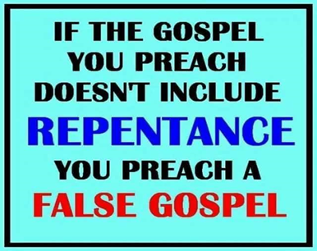
So why are many so called Christians defeated and still enslaved to sin and not set free from slavery to sin so that they may receive eternal life in the end Romans 6:22? They don’t read the Bible. They don’t receive correction and they shout “don’t judge”. The Bible tells us to judge. Especially those of the household of faith. We are to judge righteously and not hypocritically. If anyone preaches reproof, which means to show strong hatred for sin, we claim they are being unloving instead of loving you enough to warn you, even if it means you rejecting them. No one likes confrontation. They are warning you of the consequence of your sin in order to seek and save you from the eternal consequences. That is love, not judging. Scripture is given for instruction unto righteousness or right living. We are to be washed in the water of the word. Now we are clean, only if we receive it and put the instruction to use. All this so we can be perfect, which is translated complete or mature, and thoroughly furnished or fully equipped unto all good works.

We are to preach the word or scripture and be able to do it instantly. Reprove or show strong hatred for sin. Rebuke and exhort people to flee from sin and submit themselves to God and do it with long suffering and doctrine. Why? Because the time is coming when people will not endure sound doctrine but will heap upon themselves teacher having itching ears who will tell them what they want to hear instead of what they need to hear. The fact that people seek out these preachers and teachers is exactly why we need to rebuke and exhort people to flee from sin. Don’t be one of those teachers that enable sin. The word endure is translated to hold oneself up against or be accountable to sound doctrine, or put up with. Many church leaders won’t endure sound doctrine or preach sound or uncorrupted doctrine because people will stop giving and they love money more than the people and God. They are hirelings and not true pastors and God says He will bring upon them swift destruction and the blood of all those they taught who go to hell will be on their hands. They will receive greater judgment. People will turn their ears from the truth. They will not receive the love of the truth that they might be saved and these people sit in all our churches each week. If you are truly born again of water and the Holy Spirit in baptism that should concern you. If you don’t care about the deceived and lost, you are probably deceived and lost as well.

How saved are we then if we will not receive correction, rebuke, reproof, instruction unto righteousness, truth and sound doctrine that fully equips us to enforce the devils defeat, become free from slavery to sin which Jesus died to do, so that we don’t receive the judgment of that sin. All who are in Christ Jesus where there is no condemnation, have ceased from a lifestyle of sin because they are utilizing the empowerment or grace not to sin, which is sufficient. The law is for sinners. You can believe but believe in vain or of no saving effect the Bible says because you remain in slavery to sin and are thus under the law. How can you be saved if you don’t receive the truth and won’t be instructed unto righteousness and you won’t endure sound doctrine? You can’t be. Christians today have received a different gospel preaching another Jesus and the Bible says let them be accursed.

We all need to get back to enduring sound doctrine that rebukes, reproves, corrects and instructs unto righteousness if you want to be saved and fully equipped. I pray you are not of those wanting teachers who will tickle your little ears and tell you what you want to hear. Those people are ever learning and never able to come to the knowledge of the truth that will save them because of who they listen to preaching while not reading the scriptures for themselves. They don’t receive correction. They will not receive the love of the truth that they might be saved and this is said of end time believers in an apostate church before Jesus returns for His bride.

Jesus biggest end time warning was to not be deceived. You will be if you are not fully equipped. It is the job of the fivefold ministry to equip the Saints but you must read the word for yourself as well and get out of churches that are not equipping you with sound doctrine that instructs unto righteousness and lay down the foundational doctrines of the church found in Hebrews 6:1-2 .
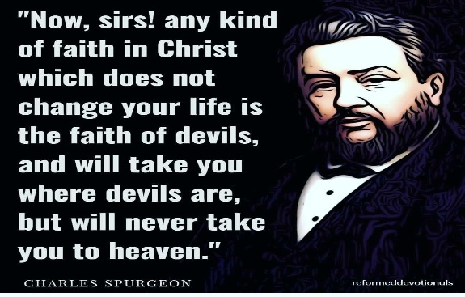

THE LAST DAYS

2 Timothy 3 broken down by translation: Let’s make sure you are not one of these people being spoken of here that makes these times perilous.

Men will be selfish and put themselves and their wants and needs above others. They will long after things and money and pursue them over God. They will brag about the things they have done and not give God the glory. A man who lifts up himself seeks his own glory and not the glory of God who works through man. One guy on FB claims to be the one healing people and not God. Call him out on it and he gets vicious.

They will be appearing above others. Haughty. I thank you God I am not covetous or like this or that sinner over there as they point out tattoos, make up, how much you have, or pick a fault they want to harp on that particular day to exalt themselves above other “sinners”. They rail against man and God. Did you know when you rail against man you are being blasphemous. We will be judged for all unprofitable words. The word blasphemous is also translated “to throw back in the face of”. When God convicts you of your sin or sends someone to you in order to bring you to repentance and you defend, minimize, deny, give your intent or explain it away or say “don’t judge” you are throwing that conviction back in the face of the Holy Spirit or the person confronting you and that sin will never be forgiven you either in this world or the next. That is how serious blasphemy is. Yet people claiming to be Christians do this daily with no fear of God and no confessing and repenting of that sin in order for it to be forgiven. This is what the apostate church has produced with its heresies and watered down gospel that doesn’t deliver man from sin which is what Jesus died to do. It comes from the against Christ or anti-Christ spirit.

They are disobedient to parents and do not honor them. Therefore they do not receive the promise of long life. They are not thankful and are always complaining. Always bringing a bad report that brings fear. They are unholy. This is talking to believers because unbelievers are incapable of being holy as He is holy. We have been empowered to be holy. They are without natural affection. That is translated hard hearted toward your kindred or children. To not have parental love that would keep you from aborting your own child. They are truce breakers or not honoring of their vows, particularly in marriage. They are false accusers who do not accept responsibility for their part in the truce or marriage being broken. It is always someone else’s fault. They are incontinent or lack self-control. Look at all the addictions and how people are controlled constantly by their feelings as they spout off and argue online and everywhere else. They are always right. That is incontinent. They are fierce as a result of being incontinent. They despise those that are good or are hostile toward virtue is the translation. They believe grace is license to sin instead of the power given to you not to through the baptism of the Holy Spirit. Therefore they falsely accuse those who don’t deny the power to become holy as legalistic heretics. They believe all future sins are forgiven and they can live as they like and still be saved. Not what the Bible says. Point out the scriptures to them and they become fierce false accusers who blaspheme. They have a form of godliness but deny the power thereof. From such we are to turn away.

They are heady or rash which is also translated that they fall forward or headlong like Judas. They claim to be brethren but will betray you in a heartbeat if you disagree with them or don’t do what they want. They are high minded which is translated, and I think this translation is funny, they blow a lot of smoke or envelope with smoke or inflate their sense of importance with titles, degrees or thinking to highly of themselves. God is going to remove or greatly humble these people because no flesh shall glory in His presence. People will be lovers of pleasure MORE than lovers of God. It doesn’t say they don’t love God. It says they love their porn, addictions and pleasure more. They are ever learning and never able to come into the knowledge of the truth because they won’t allow God to pull down their mental strongholds of false beliefs with the truth. They have corrupt minds and are reprobate of the faith. That word reprobate is translated unapproved by God, rejected, worthless because they have believed in vain or to no saving effect, or castaway as the bad fish caught in the fishnet of evangelism were thrown back. 
We are not saved when first believe. You receive eternal life in the end Romans 6:22 based on how you work out your salvation with fear and trembling after being empowered not to sin. Grace is translated empowerment in all but two places or I will supply that which is needed. It could be strength in times of weakness or truth when we are deceived. This is what it means to trust Jesus for our salvation in an ongoing way throughout our lives until the end. It is up to us to receive and utilize it in an ongoing fashion throughout our entire life. Believe and faith are verbs and not nouns as the present day apostate church teaches. That means it is ongoing until the end of your life and not a noun or one time act of believing. You must endure until the end and not fall away, become apostate or err from the one true faith through sin or deception. The apostate church that does not receive the love of the truth that they might be saved and is a son of perdition as Judas was called and that is what is being revealed before Christ returns for His church in order to give those people a chance to repent.

So, how are you stacking up in being a participant in what makes these times today perilous? Search the scriptures because in them you THINK you have eternal life and you don’t. We are at the midnight hour. Many believe they are under grace when they are really under the law. We are saved by grace, translated empowerment that is received through an ongoing, until the end faith, which is a verb or action word, which utilizes the empowerment received.

“This know also, that in the last days perilous times shall come. For men shall be lovers of their own selves, covetous, boasters, proud, blasphemers, disobedient to parents, unthankful, unholy, Without natural affection, trucebreakers, false accusers, incontinent, fierce, despisers of those that are good, Traitors, heady, high minded, lovers of pleasures more than lovers of God; Having a form of godliness (not baptized in the Holy Spirit), but denying the power thereof: from such turn away. Ever learning, and never able to come to the knowledge of the truth. Now as Jannes and Jambres withstood Moses, so do these also resist the truth: men of corrupt minds, reprobate concerning the faith. But they shall proceed no further: for their folly shall be manifest unto all men, as theirs also was. Yea, and all that will live godly in Christ Jesus shall suffer persecution. But evil men and seducers shall wax worse and worse, deceiving, and being deceived.”
2 Timothy‬ 3:1-5, 7-9, 12-13‬ ‬‬‬‬‬‬‬‬‬‬‬‬‬‬‬‬
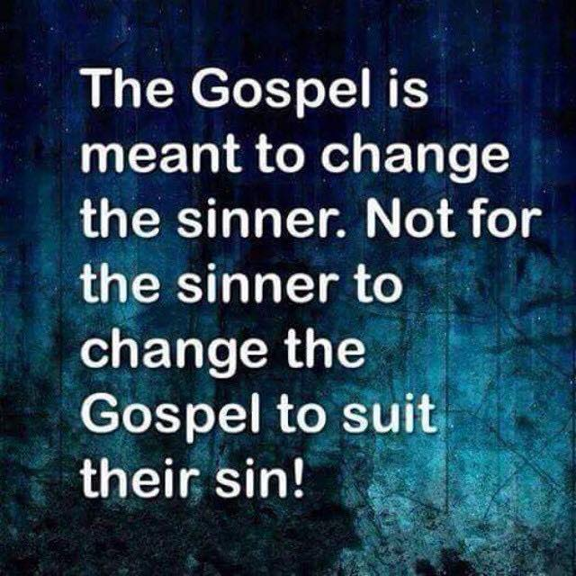‬‬

BINDING AND LOOSING ARE IN THE CONTEXT OF SINS

What is being bound is someone’s sins or trespasses. If the person does not confess and repent, after going to them alone, with two or three witnesses and before the church, that person’s sin and the punishment for it is bound to them. It is loosed if they confess and repent. This was done in the Old Testament and the New Testament church. Then they are put out of the church and considered judged as no longer being in the body of Christ.
When the woman was caught in adultery and they brought her to Jesus to test Him, this is what they were doing. Adultery was punishable by death. If Jesus was the Messiah and wrote the law, He would surely enforce the law He gave. Jesus came to seek and save the lost however. His response was to stoop down and write in the sand. What was He writing? He was writing down the sins of all those present. The purpose was to say “If you want to do judgment right here and right now, we can do that, but after we are done with her, we are moving on to you who set her up to be caught and use her to tempt God”. As they all looked at their sins written in the sand, they knew what the law said about judgment for theirs. That is why Jesus told them let you who is without sin cast the first stone. Then they were going to move on to the next guy for stoning starting with those having the most sins to those having the least. That is why they put down their stones and left starting with those who had the most to those who had the least. After they all left, Jesus asked the woman where her accusers were because judgment can’t take place unless you have two or three witnesses testifying against you. That is why He asked her that. Then He told her to go and sin no more. Most Christians have no clue this is what was going on here because they are ignorant of the word. What a brilliant way for Jesus to handle this. He didn’t negate the law He gave, nor did He negate the purpose for which He came and that was to seek and save the lost. Jesus said His people perish for a lack of knowledge. The present day apostate church is so far away from biblical truth it isn’t funny. Most Christians have no clue that this practice of judgment still stands today and if a person does not repent after the Lord sends people to them to confront their sin, their name is removed from the lamb’s book of life. Consider these newsletters as a means to have your sins loosed from you because you repent or bound to you because you blaspheme the Holy Spirit and throw the conviction back in His face and that sin will never be forgiven you, either in this world or the next.

“Moreover if thy brother shall trespass against thee, go and tell him his fault between thee and him alone: if he shall hear thee, thou hast gained thy brother. But if he will not hear thee, then take with thee one or two more, that in the mouth of two or three witnesses every word may be established. And if he shall neglect to hear them, tell it unto the church: but if he neglect to hear the church, let him be unto thee as a heathen man and a publican. Verily I say unto you, Whatsoever ye shall bind on earth shall be bound in heaven: and whatsoever ye shall loose on earth shall be loosed in heaven.”
Matthew‬ 18:15-18‬ ‬‬‬‬‬‬‬‬‬‬‬‬‬‬‬‬
Binding and loosing isn’t something you do to the devil. It is in the context of sin. If you confess your sins He is faithful and just to forgive us our sins and cleanse us of all unrighteousness. Sin is to be forsaken.
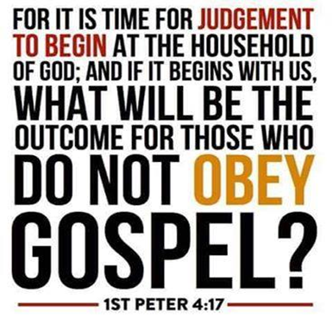
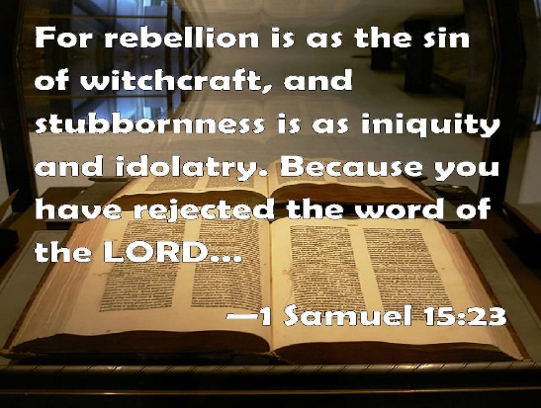

OUT OF CONTEXT

We need to stop taking scriptures out of context. When taken out of context you miss God’s whole point and you end up creating a god in your image or an idol. You don’t get to know the God of the word if you take a verse out of context and don’t go back to the original translation. For instance:

In Malachi the people being called God robbers were the priests and not the people. Malachi is speaking to the men and priests. The priests were to tithe food and bring it to the storehouse for the poor so they would be able to eat. They were not taking care of the poor, needy, widows, fatherless and strangers in the land. The Bible says if you give to the poor you give to God. Therefore, if you don’t provide for the poor you are robbing God. Today, the church leaders call the poor God robbers for not giving to them. If your church does not provide for the poor and needy, get out. Your finances will be cursed in order for God to curse the finances of the church leaders who rob God for not providing for the poor and calling them God robbers. If you want to give to God, provide for the poor and needy.

In Malachi where God says He hates divorce he was talking to men who physically abused their wives. The women had to cover the violence with their garments Malachi says. The Lord was telling the men to repent and stop dealing with their wives treacherously and he was rebuking the priests for ignoring the domestic violence. The Lord was telling the men He WOULD ALLOW divorce in the instance of domestic violence and He hates divorce, but He hates domestic violence more. That was His whole point that most people miss. God allowed divorce because of the hardness of the men’s hearts. In divorce the man had to provide a house and provide for the needs of the family because women didn’t work. Today people tell domestic abuse victims that God hates divorce so they must remain in a marriage they may be killed in so they can please God. Really people???!!!

You have to know the whole Bible to get God’s point and not take scripture out of context.

DO YOUR BELIEFS CONTRADICT THE WORD?

The word deny in the context of denying Christ is translated to contradict, reject, refuse. If your beliefs and actions contradict the word, which is who Jesus is (John 1) or if you reject truth in your deception when Jesus is faithful to bring it and you reject and refuse that truth, you are denying Christ. Jesus pulls down our mental strongholds with the truth. Truth is who Jesus is so to reject truth is to reject Jesus and in so doing, you are denying, rejecting and refusing Him. What is the consequence of doing that? He will deny you before the Father. The Father will give you what you want which is strong delusion (2 Thes 2:11) because you are now willfully deceived, and will not receive the love of the truth that you might be saved. This is said to believers about believers in the end time apostate church of today. Jesus warned the most about deception being great in the end time apostate church right before He comes for His bride who made herself ready Rev. 19. God sends them strong delusion that they should believe the deception they want to believe after truth is given, that they might be damned, who believe not the truth but had pleasure in unrighteousness. You have to be pretty deluded to think you can continue to practice sin which Jesus died to deliver us from, and enter the kingdom of heaven. Notice that these believers had pleasure in unrighteousness. They think that grace is license to sin instead of the power given to you not to through the baptism of the Holy Spirit. Their beliefs contradict the word of God and they are denying Christ as a result. The guy who practiced iniquity and died and thought he would go to heaven had this same mental stronghold of deception. He believed another gospel that preached a different Jesus than the one in the Bible. The word iniquity is translated you knew it was wrong and you did it anyway. You have to be pretty deluded to think you could willfully sin and expect His blood to cover it because you falsely believed all your sins, past, present and future are forgiven so you can live as you like. This guy did miracles in Jesus name yet Jesus told him to depart from me you worker of iniquity. I never knew you! He denied Jesus by having a lifestyle that contradicted the word and he had a Jesus he had created in his own mind that wasn’t the one of the Bible. This is an idol. If your Jesus doesn’t line up with the one in the Bible and you won’t even read the Bible, this might be your eternal outcome as well. What makes God good is that He is just and He judges sin and hates evil. All who name the name of Christ should depart from iniquity or willful sin.
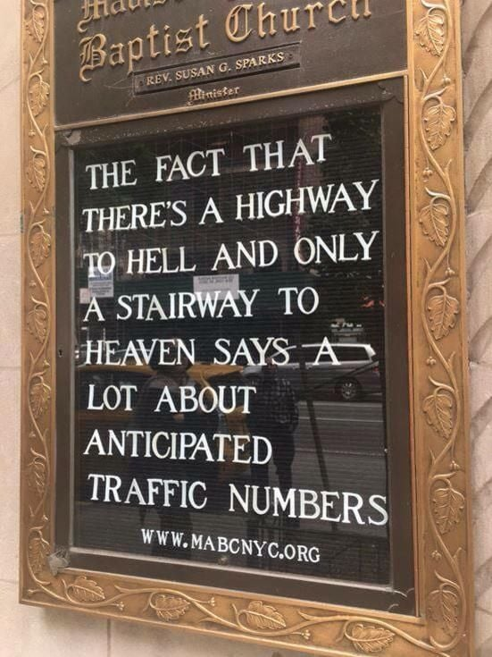
“Therefore I endure all things for the elect's sakes, that they may also obtain (they do not yet have it) the salvation which is in Christ Jesus with eternal glory. It is a faithful saying: For if we be dead (to sin) with him, we shall also live with him: If we suffer, we shall also reign with him: if we deny (contradict, reject, refuse) him, he also will deny us: Nevertheless the foundation of God standeth sure, having this seal, The Lord knoweth them that are his. And, Let everyone that nameth the name of Christ depart from iniquity.” 2 Timothy‬ 2:10-12, 19‬ ‬‬
‬‬‬‬‬‬‬‬‬‬
‬Repent now before it is too late and the Father gives you over to what you want anyway which is delusion in believing another gospel that preached a different Jesus. The Bible says let those people be accursed! Please don’t be one of them.
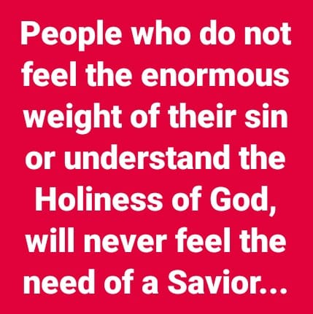

LAY HOLD OF ETERNAL LIFE

I thought that was received when we first believed? Not according to the Bible. You have a mental stronghold of false beliefs that you have had since your beginning which the Lord pulls down with the truth. In the end time apostate church, false demonic doctrine abound. The word apostate means departure from the one true faith originally taught by Jesus and the disciples. The present day church isn’t even close in teaching what they taught and following it, and will be the sons of perdition who received not the love of the truth that they might be saved. Son of perdition in 2 Thes. is plural and talking about a group of believers who don’t love the truth, which is who Jesus is, and they will not receive the truth that they might be saved. To reject truth is to reject Jesus, the one they claim to trust in for their salvation. When He is faithful to bringing truth in their deception in order to save them, they reject Him who they claim to have entrusted their salvation to. They have believed a different gospel preaching another Jesus and the Bible says let them be accursed. Like the Pharisees they don’t recognize the God of the word that they claim to love and worship. They honor Him with their lips but their heart is far from Him.

So let’s see how the Bible says to lay hold of eternal life which we are called to. Many are called. Few choose it or are chosen. Many follow the broad way that leads to destruction and damnation. If you are on the broad path where everyone who believes obtains eternal life when they first believe instead of in the end Romans 6:22 as the Bible teaches, you are on the wrong path. Narrow is the way that leads to eternal life and FEW there be that find it. That is what the Bible says. Make sure you are on the right narrow path and will allow the Lord you claim to entrust with your salvation to pull down your mental strongholds that are highly fortified and impenetrable and defended to the death or else you will not receive the love of the truth that you might be saved and this was said to believers about end time believers who became sons of perdition like Judas. The word son is translated mature child of God who goes off into damnation and destruction by rejecting Jesus who is the truth, not just the way and life. You must worship Him in spirit and in truth. You can’t accept Him as the way and reject Him as the truth and expect to receive His eternal life. He IS the WAY, the TRUTH and the LIFE. We are saved through sanctification of the spirit and belief in the truth the Bible says in 2 Thes. 2 so being made holy as He is holy, doing the will of the Father, and belief in the truth are all necessary to enter the kingdom of heaven. You are not saved until you are delivered from slavery to sin and continue walking in that empowerment that comes from the baptism in the Holy Spirit.

“For the love of money is the root of all evil: which while some coveted after, they have ERRED (fallen away, become apostate) from the faith (they were once in), and pierced themselves through with many sorrows. But thou, O man of God, flee these things; and FOLLOW AFTER righteousness, godliness, faith, love, patience, meekness. Fight the good fight of faith, LAY HOLD OF ETERNAL LIFE, whereunto thou art also CALLED, and hast professed a good profession before many witnesses. That thou keep this commandment (what to follow after and flee from) without spot, unrebukeable, until the appearing of our Lord Jesus Christ: Charge them that are rich in this world, that they be not high minded, nor trust in uncertain riches, but in the living God, who giveth us richly all things to enjoy; That they do good, that they be rich in good works, ready to distribute, willing to communicate; Laying up in store for themselves a good foundation against the time to come, that they may LAY HOLD ON ETERNAL LIFE. Timothy, keep that which is committed to thy trust, avoiding profane and vain babblings, and oppositions of science falsely so called: Which some professing have ERRED concerning the faith (they were once in). Grace be with thee. Amen.”
1 Timothy‬ 6:10-12, 14, 17-21‬ ‬‬‬‬‬‬‬‬‬‬‬‬‬‬‬‬
How could this be any plainer as a way to LAY HOLD OF, APPREHEND, OBTAIN, and ATTAIN eternal life in the end? Read through Acts through Revelations and see if the Bible teaches you receive eternal life when you first believe or if it is something YOU LAY HOLD OF, ATTAIN, OBTAIN or APPREHEND, as these are the words the Bible uses in reference to receiving eternal life IN THE END Romans 6:22 as you work out your salvation with fear and trembling after being empowered to no longer be a slave to sin but a slave to righteousness instead. You don’t OBTAIN, LAY HOLD OF, APPREHEND, WORK OUT or ATTAIN that which you already have which is salvation and eternal life. I feel the Holy Spirit bristle and grieve inside me when we tell people they are saved when they first believed. That is a lie from hell and causes people not to endure until the end and become free from slavery to sin. We are deceiving people and keeping Jesus from what He died to do in their lives and that is to destroy the works of the devil and free them from slavery to sin through the empowerment received through the baptism of the Holy Spirit. By freeing them from slavery to sin He has freed them from the wrath of God on their sin because they are walking according to the spirit and not according to the flesh as a result of utilizing that empowerment.

Believing is the first step and as a verb, it is expected that your believing will lead you to follow and act upon being born again of water through water baptism where you are being baptized into the body of Christ, pledging to be dead to sin and self in IN ORDER THAT you be raised as Christ was raised. Then you are baptized in the Holy Spirit who empowers you to keep that pledge. Unless your believing leads you to become born again in this way in obedience, you will not have the true knowledge of salvation. You can’t see it, understand it or enter into it the Bible says. The Bible says John Baptized people in water after they repented so that they may have the knowledge of salvation. Believers today have a false non biblical definition of grace that leads them to believe obedience is works salvation instead of empowerment not to sin. Baptism in the Holy Spirit is only given by Jesus to those who will obey. If you won’t obey because you think grace is a free gift that overlooks your sin instead of empowering you to walk in freedom from slavery to sin, you won’t be given the FREE GIFT of BAPTISM in the Holy Spirit who is called the gift. In the end time church Jesus warned the most about people in the church being apostate and having a form of godliness but denying this empowerment thereof because they only believed as a noun instead of a verb that produced works that demonstrated that they truly believed. From such deceived believers we are to turn away because their belief doesn’t lead them to obedience and in following Christ, which is the definition of Christian. We are correct in calling them believers but lying when calling them Christians or saved. They have believed in vain or to no saving effect.

IS OBEDIENCE OPTIONAL IN ORDER TO BE SAVED

“And being made perfect, he became the author of eternal salvation unto all them that OBEY him;” Hebrews‬ 5:9‬ KJV‬‬‬

‬HOLD FAST UNTO THE END

“If” in the Bible means the promise is conditional. Entering into the salvation and rest of the Lord is conditional after believing. Notice how many times in these verses it says you must hold fast, firm unto the end. You can fall away from the faith through sin or deception as the Israelites did in the wilderness, even though they were water baptized in the Red Sea and led by the Holy Spirit through the wilderness. You can depart from the living God.

“But Christ as a son over his own house; whose house are we, IF we hold fast the confidence and the rejoicing of the hope firm UNTO THE END. Wherefore (as the Holy Ghost saith, Today if ye will hear his voice, Harden not your hearts, as in the provocation, in the day of temptation in the wilderness: When your fathers tempted me, proved me, and saw my works forty years. Wherefore I was grieved with that generation, and said, They do always err in their heart; and they have not known my ways. So I swear in my wrath, they shall not enter into my rest.) Take heed, brethren, lest there be in any of you an evil heart of unbelief (obedience), in departing from the living God. But exhort one another daily, while it is called today; lest any of you be hardened through the deceitfulness of sin. For we are made partakers of Christ, IF we hold the beginning of our confidence STEADFAST UNTO THE END;”
Hebrews‬ 3:6-14‬ KJV‬‬‬‬‬‬

You must endure until the end to be saved. You are not saved when you first believed. It is the biggest deception of the end time apostate church telling people they are saved when they first believe and they are eternally secure in that salvation. You cannot lose what you do not yet possess. You work out your salvation with fear and trembling based upon being empowered not to sin through the baptism of the Holy Spirit that we are to be led and controlled by. Not our flesh.


IT IS FINISHED

What the law was designed to do was to show our inability to keep it. The Bible says the law is good. We are not. We don’t have the ability to be good which is the lesson the law was designed to teach. The Levitical/Mosiac law has been done away with but God’s moral law never will be. In fact the standard was raised with Jesus, not lowered. If you hate someone you are guilty of murder. If you look and lust you have committed adultery. What was God’s solution to this dilemma? Grace! Grace is translated empowerment or I will supply that which is needed. It is not earned but must be utilized by submitting yourself to God and resisting the devil or crucifying our old nature. After the law has done its work in revealing our inability to keep it, empowerment through the baptism of the Holy Spirit perfects or finished what the law could not do. Jesus wasn’t led into the wilderness to be tempted by the devil until He was first water baptized and baptized in the Holy Spirit. If He needed this empowerment in the face of temptation what makes us think we don’t. Jesus is our example that we are to follow as a Christian or follower of Christ. We have been given power to BECOME sons of God the Bible says.

All who are in Christ Jesus, where there is no condemnation, have ceased from a lifestyle of sin. Those who walk in the flesh and fulfill the lusts thereof are condemned. We have made a whole false doctrine out of half a sentence in Romans 8:1. There is therefore no condemnation for those who are in Christ Jesus WHO WALK NOT AFTER THE FLESH but AFTER THE SPIRIT. We are to be led and controlled by the Holy Spirit, not our flesh. Believing doesn’t put one “In Christ Jesus”. Obedience does.

The Bible says the law is for sinners. Those who are under grace have ceased from slavery to sin and are therefore no longer under the law but grace or empowerment. The apostate church of today doesn’t teach that. They have a form of godliness but deny this empowerment thereof and from such we are to turn away. That is most of the present day church who is on the broad path to destruction, which makes the church a tremendous harvest field of lost souls. There will be no revival without repentance.
When Jesus said it was finished, that word finished is translated perfected. What the law could not do except show your inability to keep it, grace or empowerment not to sin finished or perfected what the law could not. Since it is finished or perfected, we are without excuse in continuing in our sins. Willful sin is judged by the Father after the person has been warned because they are trodding under their feet the blood of Jesus and counting His blood as unholy. That word judge is translated crisis or the time it is determined whether that person will be cut off or severed completely from God and have their name removed from the Lambs book of life. Behold the kindness and severity of God. Kindness to those who continue in His grace and severity to those who fall away. It is a fearful thing to fall into the hands of the almighty.

So, the question is, has grace or empowerment perfected or finished in your life the lesson the law was designed to teach. If not, you need to repent and return before it is too late.

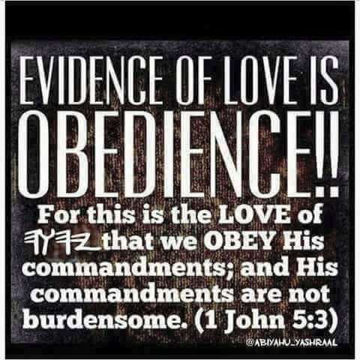

Robert Weller
·
ABIDE, CONTINUE, ENDURE, PRESERVER TO THE END IN ORDER TO BE SAVED

Most people teach that if a person is born-again, they are automatically saved. The bible does not teach this. Those who are born-again should or may have eternal life. Jn.3:15-17 & 36 The rebirth is our calling. MANY ARE CALLED, BUT FEW ARE ELECT. That is because they don’t put on the wedding garments. Mat.22:10-14 The rebirth gives us the power to become sons of God, but it is how we end the faith that determines whether we are saved or elect. Jn.1:12-13
THE END OF YOUR FAITH IS THE SALVATION OF YOUR SOUL. 1Pt.9 Repentance LEADS TO SALVATION. 2Cor.7:9-10, Ac.11:18 Our salvation is closer now than when we first believed (indicating you don’t yet have it). Those who are spiritually asleep or living in sin will not be saved if the Lord returns before they repent. Rom.13:11-14, 1Jn.2:18-19, Mk.13:35-37, Mat.13:25 & 41-43, Eph.5:14-17, 1Thes.5:1-9 Those who wake-up the sleeping church will save their soul (not their body) from eternal death. Ja.5:19-20

IT IS ONLY THOSE WHO ENDURE TO THE END THAT WILL BE SAVED. Mat.10:22 Many have gone through the narrow door which is the body of Christ, but only a FEW are going down the narrow road that ENDS IN ETERNAL LIFE. Mat.7:13-14 Because of the false doctrine that is ramped in America, MANY HAVE BELIEVED IN VAIN (of no saving value). 1Cor.15:1-2, 1Ths.3:5, 2Cor.6:1 It is a matter of continuing, abiding or remaining to the end. The word, “IF” is usually ignored. Col.1:21-23, Rom.11:19-22, Jn.15:1-10, Jn.8:31-32,
We are saved by grace through (because of) faith in the truth, Thy word is true.
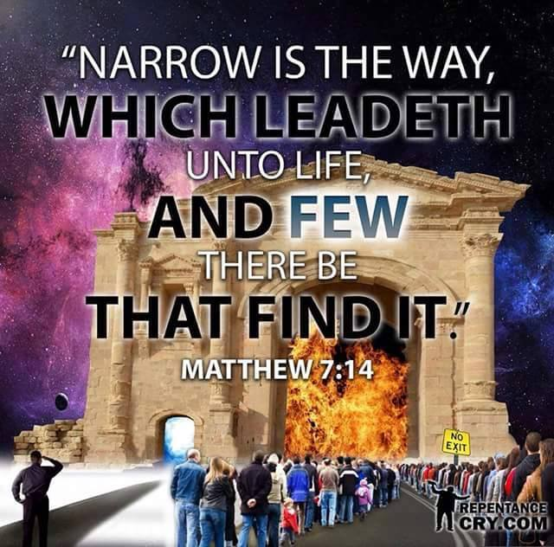

SALVATION SOMETHING HOPED FOR?

Reading through the Bible notice certain things. What you have been taught may not be biblical.

“But let us, who are of the day, be sober, putting on the breastplate of faith and love; and for a helmet, the hope of salvation. For God hath not appointed us to wrath, but to obtain salvation by our Lord Jesus Christ,”1 Thessalonians‬ 5:8-9‬ ‬‬‬‬‬‬‬‬‬‬
The HOPE of salvation is the helmet. Do you hope for something you already have? The word hope here is translated anticipate. Salvation is translated deliverance from sin or safety. You work out your salvation with fear and trembling. Do you work out what you already have? In the end you receive eternal life Romans 6:22. Telling people they are saved when they first believed is insinuating it is a done deal and it isn’t. They aren’t allowing Jesus to wash them and He said if you don’t allow me to wash you then you have no part with me. No part means no part. Jesus was washing Peter’s feet when He said this and what is being washed off is the world and things of the world. They wore sandals and walked everywhere so foot washing was symbolic of washing off the things of the world in order for them to be saved. If we do not allow, meaning we have to submit to it, Him to wash the things of the world off us, we have no part with Him. No part means no part. We have got to stop insinuating salvation is a done deal when someone first believes and instead help the bride make herself ready in order to render unto Jesus the just rewards of His sacrifice. Prepare the bride so that she is without spot or wrinkle and it starts with not telling them they are saved because they believed.

Which path are you on? Have you been biblically born again of water through water baptism as an adult and of the Holy Spirit through baptism in the Holy Spirit?

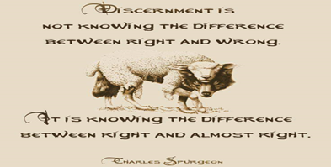 Start paying attention to words and the tenses in the Bible and you will find that salvation is something HOPED FOR as a result of walking in the power of the baptism of the Holy Spirit and submitting to Jesus as Lord. Jesus can’t be savior if He isn’t Lord.
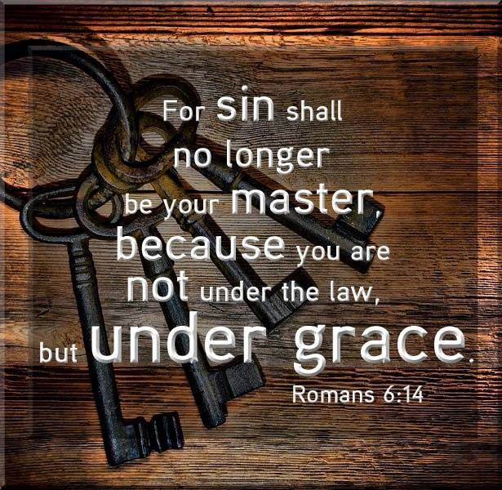I pray the god of this world stop blinding us to the truth in the word of God and we all become biblically born again of water and the Holy Spirit because nowhere in the Bible does it say accept Jesus or ask Him into your heart to be saved. 

You are not baptized in the Holy Spirit when you first believe Acts 19. You are sealed with the Holy Spirit and that word sealed is translated deposit or earnest like one would put down on a house with the intent to fully purchase and occupy. If the deal falls through the deposit is returned as is the case with the foolish virgins who ran out of oil and didn’t make the rapture. So the sealing of the Holy Spirit is the deposit with the expectation that you will follow through with what Jesus taught about water baptism and baptism in the Holy Spirit in order to enter the kingdom of heaven. Many will say some received the baptism of the Holy Spirit before water baptism and they like to point to the centurion and his household, but you can read in the gospels that Roman soldiers had repented and demanded of John what they must do to show forth their repentance in order for John to baptize them. It would stand to reason that their household did as well if these soldiers felt that strongly about being baptized by John. Same with the thief on the cross. You are making a false assumption in order to get out of what Jesus commanded. There is something desperately wrong with your heart if you look for scriptures to disobey what Jesus said to do. The thief went to paradise which is not heaven. Jesus told him this day you will be with me in paradise but three days later He told Mary not to touch Him because He had not yet ascended to the Father. Paradise was a place in the earth for departed souls that Jesus preached to for 3 days and nights. Read your Bible. It was referred to as Abraham’s bosom, Sheol, Hades etc. paradise wasn’t heaven.

So Paul stated regarding water baptism and identifying with Christ’s death to sin and self:

“Yea doubtless, and I count all things but loss for the excellency of the knowledge of Christ Jesus my Lord: for whom I have suffered the loss of all things, and do count them but dung, that I may win Christ, And be found in him, not having mine own righteousness, which is of the law, but that which is through the faith (faith is a verb or action word that is ongoing until the end) of Christ, the righteousness which is of God by faith: That I may know him, and the power of his resurrection, and the fellowship of his sufferings, being made conformable unto his death; If by any means I might attain (notice Paul had not yet attained) unto the resurrection of the dead. Not as though I had already attained, either were already perfect: but I follow after, if that I may
apprehend (take possession of) which also I am apprehended (take possession of) of Christ Jesus. Brethren, I count not myself to have apprehended: but this one thing I do, forgetting those things which are behind, and reaching forth unto those things which are before, I press toward the mark for the prize of the high calling of God in Christ Jesus.”
Philippians‬ 3:8-14‬ ‬‬‬‬‬‬‬‬‬‬‬‬‬‬‬‬
‬‬.
Read through the New Testament and see how many times Paul states he had not yet obtained, attained, laid hold of, apprehended or seized upon eternal life yet but was running the race for that prize. Your eyes 👀 will be opened to the lies the devil has brought into the modern day apostate church and the different gospel preaching another Jesus of today that teaches all you have to do is believe.

Noah and his family were saved BY water the Bible says. Jesus preached to the souls that wouldn’t listen to Noah for three days and night in paradise before His resurrection:

“By which also he went and preached unto the spirits in prison; Which sometime were disobedient, when once the longsuffering of God waited in the days of Noah, while the ark was a preparing, wherein few, that is, eight souls were saved BY water. The like figure whereunto even BAPTISM doth also now SAVE US (not the putting away of the filth of the flesh, but the answer of a good conscience toward God,) by the resurrection of Jesus Christ:”
1 Peter‬ 3:19-21‬ ‬‬‬‬‬‬‬‬‬‬‬‬‬‬‬‬
‬‬
The devil will try to convince you that water baptism and baptism in the Holy Spirit it is not required because it will equip you to enforce his defeat. Don’t dismiss that which the Lord stated you need in order to enter the kingdom of heaven.
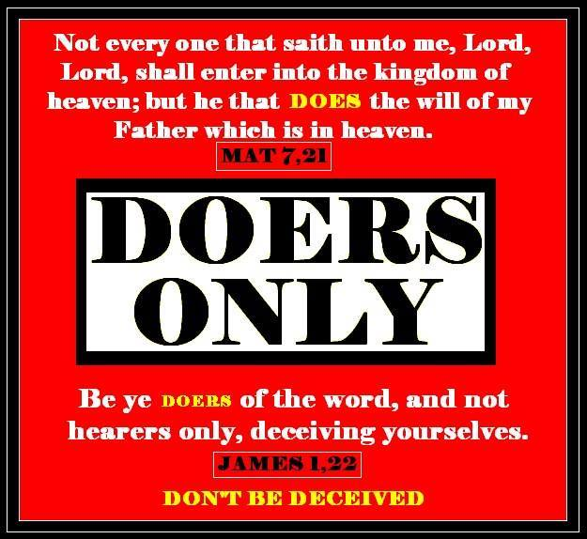
This is not works salvation but is salvation worked out with fear and trembling. A rich man gives a guy a check for a trillion dollars. The first guy believes the rich man is good for the money and shoves the check in his pocket and rides away. This is faith but not the saving kind of faith. The next guy takes the check and endorses it or puts his signature on it claiming it through water baptism and then deposits the check into his bank account, which is being baptized in the Holy Spirit and being full of Him, in order to access the funds or power in time of need. Endorsing the check and depositing it into your account doesn’t make the gift any less free. This is faith with works which is the saving kind of faith. When you believe something in your heart you act upon it and this kind of faith was imputed unto Abraham as righteousness. Faith without works is dead or not the saving kind of faith.
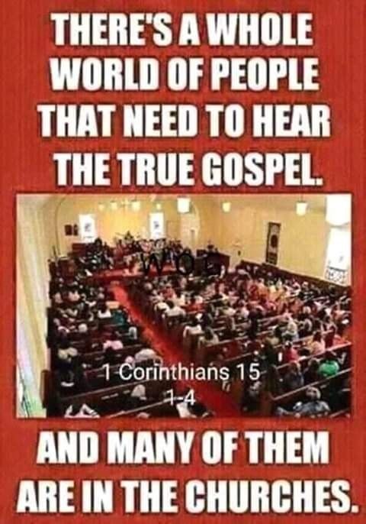
Nobody preaches this gospel anymore because the modern day church is so apostate or has fallen away from the one true faith. Pray about it my friends and get out of churches that preach damnable heresies or lies that will damn you if you believe them. Get out of churches that have a form of godliness but deny this empowerment thereof. From such we are to turn away. Be a light in a dark world and share this so others can be snatched out of the grips of hell.
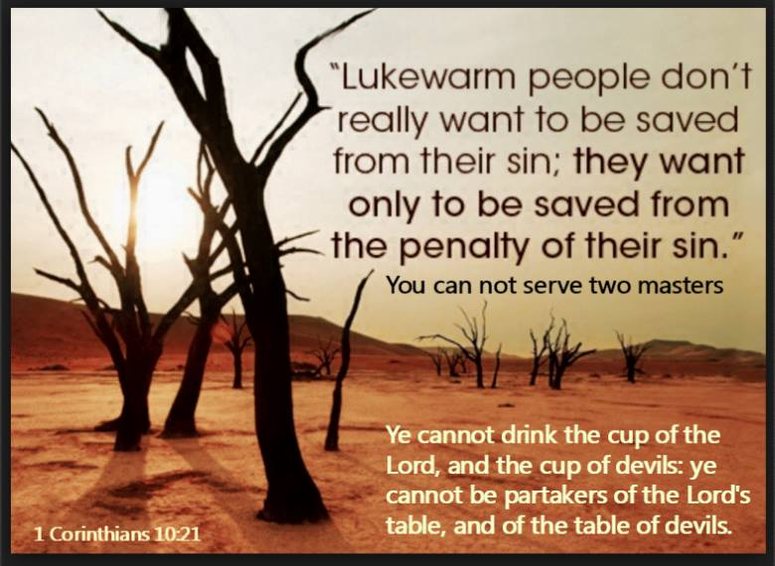

Some would say being water baptized and baptized in the Holy Spirit is works salvation. It is no more works then confessing with your mouth. It is a response of obedience to what Jesus and the disciples stated must be done in order to enter the kingdom of heaven. Heaven has a vetting process in order to get inside its borders.

Those churches who tell you that you receive all the Holy Spirit you will ever need when you first believe are deceived. Read Acts 19 where believers were asked if they received the Holy Spirit since they first believed. When you first believe you are sealed with the Holy Spirit. The translation of sealed is deposit or earnest like one would put down on a house with the intent to fully purchase and occupy it. If the deal falls through the deposit is returned. Baptism in the Holy Spirit is being fully filled and immersed in the Holy Spirit who you are now led and controlled by. Jesus performed no miracle until He was baptized in the Holy Spirit. Believers will not operate in the miraculous or gifts of the Holy Spirit until they are baptized in the Holy Spirit. About only 3% of professing Christians are baptized in the Holy Spirit and operating in the gifts. The rest have to explain away what they do not have and claim it is unnecessary. They have no clue what true salvation is because the knowledge of it is received through being born again of water and the Holy Spirit in baptisms.
Leave these churches and share what I have given. Most will not receive the love of the truth that they might be saved and God will give them what they want which is strong delusion. Seek ye first the kingdom of heaven and His righteousness first, which comes from utilizing the power not to sin and be led and controlled by the Holy Spirit from such there is no law.
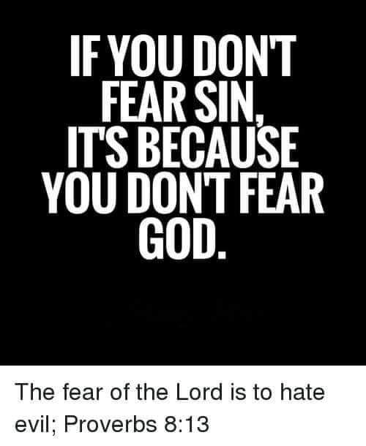
MANY COVENANTS. WHICH ONE ARE YOU UNDER?

Let me first describe the Abrahamic Covenant found in Galatians 4. Keep this in mind regarding identifying which covenant you are operating under. This is not a full teaching on this covenant but a short recap. When Sarah and Abraham stopped believing the promise of God that they would have a son, they developed a “Let’s help God bring forth the promise” mentality which led to them walking in the flesh in their own ability in order to bring forth the promise and move things along. We are not getting any younger so let’s get this parent thing going. Thus, Sarah offered her servant to Abraham in order to “help God”, which seems like a good thing right, in order to have that son. Anytime you “help God” you are operating in unbelief, in the flesh, impatient, self-focused and actually hindering God from moving on your behalf and delaying your promise. The minute you put your hands on something God removes His until you take your hands back off. This is how Ishmael was conceived, creating a history of war and evil between the children of Ishmael who are called children of the flesh and children of the promise who came from Isaac. So the flesh and spirit are always at war with one another just as the battle between the flesh and spirit are at war within us. The more you mature the less the battle and the more faith you have. Walk in the spirit and you will not fulfill the lusts of the flesh. Baby Christians are still under tutorship and like a servant or slave until they grow and mature into free sons. Some of these immature Christians you see a mixture of living under the Levitical law and the curse of it and walking in the spirit. The more dependent you are on God because you can do nothing in your ability and realize it, the greater the miracle you are about to witness because no flesh will glory in His presence. He will share no credit with man. When your back is up against a Red Sea and what used to enslave you is approaching you in your weakness and vulnerability, that is when God shows up to deliver you. The minute you submit yourself to God and resist the devil is the moment that Red Sea parts. Only until you realize you can’t do it in your ability, which the law was designed to teach, do you receive the promise of the empowerment of the Holy Spirit designed to do what you cannot. As long as you keep striving to keep the law in your ability, you are a child of flesh still trying to “help God” and you will persecute those not complying with your law keeping of the Mosaic/Levitical law thinking you are doing God a favor. We call these people legalist and children of the flesh, still bring up the Mosaic or Levitical law with all its 613+ laws and rules added by the religious leaders.

That being said, we are not saying God doesn’t have a moral law or standard you must follow which is the 10 commandments. In them you are loving the Lord God above all and your neighbor as yourself so you won’t sin against them. This is an internal work done by the Holy Spirit who empowers you not to sin because you have received him out of the revelation that you can’t keep the law in your ability and needed this empowerment which is a free gift. That is the lesson the Levitical law was to teach and it was to lead you to Christ and the free gift of empowerment not to sin which you are to utilize. Those still persecuting Christians for not keeping the Levitical law are children of the flesh and bring up those laws to throw in your face to persecute you with. These are the people who will kill you and think they are doing God a favor. They live under the Mosaic covenant while being deceived into thinking they are living under the New Covenant Jesus established through the work of the Holy Spirit. Blind guides helping God while walking in the flesh because they don’t believe and lack faith while claiming to have it.
“Now I say, that the heir, as long as he is a child, differeth nothing from a servant, though he be lord of all; but is under tutors and governors until the time appointed of the father. Even so we, when we were children, were in bondage under the elements of the world: But when the fullness of the time was come, God sent forth his Son, made of a woman, made under the law, To redeem them that were under the law, that we might receive the adoption of sons. And because ye are sons, God hath sent forth the Spirit of his Son into your hearts, crying, Abba, Father. Wherefore thou art no more a servant, but a son; and if a son, then an heir of God through Christ.

But now, after that ye have known God, or rather are known of God, how turn ye again to the weak and beggarly elements, (the law) whereunto ye desire again to be in bondage? Ye observe days, and months, and times, and years. I am afraid of you, lest I have bestowed upon you labor in vain.

Am I therefore become your enemy, because I tell you the truth?

Tell me, ye that desire to be under the law, do ye not hear the law? For it is written, that Abraham had two sons, the one by a bondmaid, the other by a freewoman. But he who was of the bondwoman was born after the flesh; but he of the freewoman was by promise. Which things are an allegory: for these are the two covenants; the one from the Mount Sinai, which gendereth to bondage, which is Agar. For this Agar is Mount Sinai in Arabia, and answereth to Jerusalem which now is, and is in bondage with her children. But Jerusalem which is above is free, which is the mother of us all.

Now we, brethren, as Isaac was, are the children of promise. But as then he that was born after the flesh persecuted him that was born after the Spirit, even so it is now. Nevertheless what saith the scripture? Cast out the bondwoman and her son: for the son of the bondwoman shall not be heir with the son of the freewoman. So then, brethren, we are not children of the bondwoman, but of the free.”
Galatians‬ 4:1-7, 9-11, 16, 21-26, 28-31‬ ‬‬‬‬‬‬‬‬‬‬‬‬‬‬
The law increases sin and its awareness. It is designed to teach you that you can’t keep it in your ability and you need grace, translated empowerment or “I will supply that which is needed”. He supplied a parted Red Sea when what enslaved you is pursuing you. You don’t earn or deserve it. It can be strength when you are weary. Courage when you are discouraged. Comfort when you grieve and empowerment to resist the devil in times of temptation.

So the children of the flesh or bondage are those still under the law because they are still enslaved to sin. They are not heirs
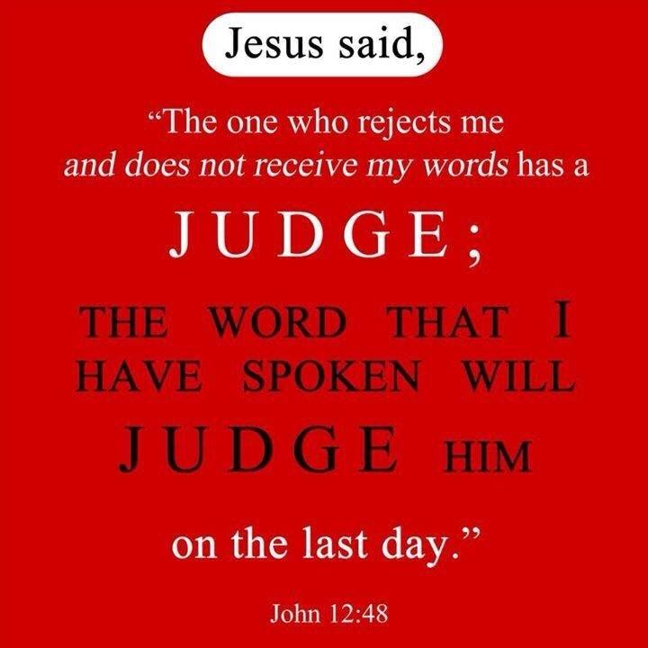
Let the Lord show you how you are “helping God” which is in essence walking in the flesh to bring forth the promise because you lack faith. Let Him reveal your heart to you and show you which covenant you are living under and whether you truly are a child of the New Covenant walking in freedom from sin or a child of the slave woman living in bondage to sin and self and all the rules.
Whom the Son has set free, they are free indeed and lawlessness isn’t abounding because people aren’t walking in the flesh but according to the spirit where there is no condemnation. The children of the bond woman or slaves to sin and “helping God” are not heirs to the promise.

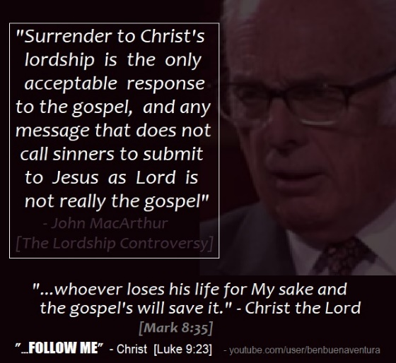

BEING CHANGED BY THE WORD OF GOD

First you have to read it yourself and not read it through the lens of what you have been taught if you want the truth and want the Lord to speak to you out of it. The Bible is alive and powerful. Then you have to be a doer of it and not a hearer only deceiving yourself. You have to believe it and I mean all of it and not just the parts you like. You have to read it and apply it to yourself and not think it is talking about someone else and what you are reading doesn’t apply to you. Even the parts you don’t like. Don’t gloss over words and read it as a vague word or sentence. Every word is placed in every verse for a reason. Read it IN CONTEXT to understand who God is talking to and what was His point. Don’t take a scripture here and a scripture there, OUT OF CONTEXT, and come up with a whole doctrine. Recognize when other teachers have done that. Try the fruit of anything being taught. If it doesn’t produce the peaceable fruit of righteousness and glorify God and not man, you have a false doctrine.

Take the once saved always saved doctrine of eternal security for instance that leaves out most of the New Testament in order to believe that doctrine. It has people remaining in their sin because they believe themselves to be saved by doing something that isn’t even in the Bible as a way to be saved and then declaring them eternally secure no matter how they live, when Jesus died to deliver them from slavery to sin in order for them not to be judged by continuing in sin. All who live in sin are under the law the New Testament says. Those who are under grace have ceased from a lifestyle of sin because they are utilizing the grace received by faith that empowers them not to sin. Therefore they are not under the law but under grace or empowerment.

For if god did not spare the natural branches, he will not spare you (Christians), either. Behold then the kindness and severity of God; to those who fell, severity, but to you (Christians), God’s kindness, IF you continue in his kindness; otherwise you also will be cut off (in the same way Israel was cut off).

Jesus confirms the right gospel with signs and wonders. This is why we haven’t been seeing them. We are an apostate end time church that Jesus warned about right before He returns. Will you be a contributor to presenting to Him a bride without spot or wrinkle who made herself ready, or one that offends Him by causing others to remain in their sins, that He died to deliver them from? He removes out of His kingdom all who offend and all workers of iniquity. The rampant sin in the church is proof the right gospel has not been preached and the blood of all those remaining in their sins that sit under your teaching will be on your hands. My hands are clean! Please wash yours as well. When He comes, I want to be found doing what He called me to do in preparing His bride. What will you present to Him?

A VOICE CRYING OUT IN THE WILDERNESS MAKING STRAIGHT THE PATHS! COMING IN THE SPIRIT OF ELIJAH! AS IT WAS THE FIRST TIME, SO IT IS THE SECOND!

For speaking engagements call 813-393-9384. Our website is www.latter-rain.net



IntroductoryYouTube Video below with more to follow:

https://youtu.be/E_PrFVmefXc

