Fresh Rain
Latter Rain Ministry

Preparing a Bride without  spot or wrinkle |  | August, 2020

Let No Man Deceive You By Any Mean

Prepare Ye the Way of the Lord
I have read all through Matthew in my morning coffee and Bible reading after which I share what the Lord is giving me. These are usually weekend teachings where I just give out what the Lord is giving me and I learn in the process. Many of these teachings end up in newsletters that come from months of these weekend bible studies that get posted. I started in Mark this morning and I only get to verse 2 and the Lord asks, “Why does the way need to be prepared before me or before I come”? Hmmm! Never thought of the why? Obviously He asks questions in order to provide an answer or revelation so here we go. We will learn together.

In Mark 1:2 it was John the Baptist who came in the spirit and power or anointing of Elijah Luke 1:17 to prepare the way for the Lord to come and bring His kingdom to earth. John started off preaching repentance while telling people the kingdom of God is at hand or here to be

received but something must happen first for it to be made manifest or revealed so that you could receive it. What were those things and are we to be doing the same things today in order to prepare the way of the Lord so the kingdom of God can be received by the people. The answer is yes because in Malachi 4:5, Isaiah 40:3 and Joel it states in end times, the same spirit and power or anointing will be sent before Jesus returns to prepare Ye the way of the Lord and make straight His paths. Basically the Bible is stating get everything out of your way and life that would get in the way of receiving the kingdom of God that is here to be received. The Covid lockdown has taken care of a lot of that hasn’t it? If we don’t get everything and every idol and sin out of the way that we place above God, He will do it for us worldwide in one fell swoop and use the devil to do it because your eternity is at stake. Drastic times call for drastic measures because the stakes for humanity is high and time is running out. The Lord’s alter call will be one of

repent and be baptized. Not every head bowed and let’s say our little prayer, which isn’t even found in the bible, as a way to be saved or born again. Jesus never taught that. The disciples never taught that. The same answer applies today in what must I do to be save? Repent and be baptized everyone of you. Not some but everyone!
Sports gone, entertainment, jobs, churches, income and anything in this world that would distract us from eternity and where we are to spend it because time is short and He is returning so everything that can be shaken will be shaken out of your life that is an idol that you place above God in your life. It has happened worldwide in order to get your attention so you will prepare Ye the way of the Lord in your life, turn your hearts back toward your families and disciple them instead of letting the corrupt educational system indoctrinate them to the New World Order that Trump is holding back. It is time for fathers to be priests in their homes instead of delegating everything to the church and Sunday school. Fathers need to take their rightful place in the home and lead.

“The voice of him that crieth in the wilderness, Prepare ye the way of the Lord, make straight in the desert a highway for our God. Every valley shall be exalted, and every mountain and hill shall be made low: and the crooked shall be made straight, and the rough places plain: And the glory of the Lord shall be revealed, and all flesh shall see it together: for the mouth of the Lord hath spoken it.”Isaiah 40:3-5‬ So what is the way of the Lord that we are to be preparing? The answer is holiness! Any unclean thing, sin or idol needs to go now if you are to enter into the kingdom of heaven.

“And a highway shall be there, and a way, and it shall be called The way of holiness; the unclean shall not pass over it; but it shall be for those: the wayfaring men, though fools, shall not err therein.” Isaiah‬ 35:8‬ KJV‬‬‬‬‬‬‬‬‬‬
‬
The way of the Lord is the way of HOLINESS! This is why John the Baptist, who came in the spirit and power of Elijah preached repentance or turning away from your sins and being baptized for the remission or the sending away of your sins in order to receive the kingdom of heaven. The path being made straight is the path of holiness because without holiness NO ONE shall see the Lord. This is what Zechariah prophesied of his son John under the inspiration of the Holy Spirit as to John’s purpose in preparing the way:

“And thou, child, shalt be called the prophet of the Highest: for thou shalt go before the face of the Lord to prepare his ways; To give knowledge of salvation unto his people by (or through) the remission of their sins, Through the tender mercy of our God; whereby the dayspring from on high hath visited us, To give light to them that sit in darkness and in the shadow of death, to guide our feet into the way of peace.” Luke‬ 1:76-79‬ KJV‬‬‬‬‬‬‬‬‬‬‬
‬
So in preparing the way of the Lord the Elijah anointing and power, which also comes before Christ comes again, will give knowledge of salvation by or through the remission of their sins. You don’t obtain this knowledge without true repentance and the sending away of your sins that you have confessed and repented of prior to being water baptized which remits or sends your sins away. Then you get the knowledge of salvation. There are many who believe grace is license to sin and repentance and obedience are not required. This is why they don’t understand the true knowledge of salvation or the way to be truly saved or born again. These people still live in darkness, enslaved to sin. 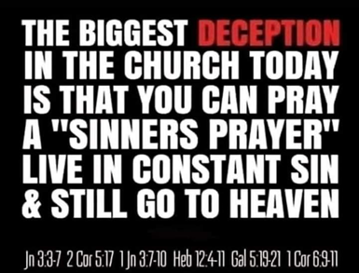
John the Baptist also claimed to be the voice of one crying in the wilderness as said by the prophet Isaiah. John 1:23. Make way or make straight His path is an interesting term the Lord kept pointing out to me so I looked it up. It is a verb or action word which is something you do and God is not going to do it for you. It means to purge, cast out, lighten the ship, to shoot out, and when used in the context of transgressing the law, which is the definition of sin, it is clear what you are to be getting rid of to prepare the way of the Lord in order for us to receive His kingdom and have the REAL and TRUE knowledge of salvation revealed to you so you can come out of darkness and enter into His glorious light. This is why the true knowledge of salvation has not been revealed to the apostate church who don’t think repentance is required, something you do or can’t be done until after you accept Jesus. You can’t receive Jesus until this is done. Jesus isn’t going to tell you to do something you can’t do or without equipping you to do it. Every head bowed and repeating a sinner’s prayer is nowhere in the Bible as a way to be saved. Repent and be baptized everyone of you is and this is precisely why and what the Lord is revealing here. You must be born again of water in baptism and baptized in the Holy Spirit which is the born again of water and the Holy Spirit part. Jesus is the one who baptizes in the Holy Spirit and He only baptizes those who will obey and if you can’t obey in the first things He gives you to do, which is repent and be baptized, why would He baptize you in the Holy Spirit? If your heart is twisting scripture out of context in order to disobey what Jesus commanded and did Himself and we are to do if we are followers (definition of Christian) of Him, you are in so much deception and darkness you can’t be helped unless you receive love of the truth. You will NEVER have the true knowledge of salvation as the Bible states as long as you are looking for loopholes to disobey and be in rebellion which is as witchcraft. That is why Jesus said unless you are born again of water and the Holy Spirit in this way, you won’t see, understand or grasp the kingdom of heaven and the true knowledge of salvation. As John said, he preached to them repentance and water baptism for the remission of their sins so that they may obtain the TRUE KNOWLEDGE OF SALVATION. If you don’t meet the requirements of repentance and water baptism, you can’t have the knowledge of salvation and the kingdom of God revealed to you! That is why people are preaching that anything you doin obedience is “works salvation” or born again of water is where you come out of the water sack at your natural first birth. They have NO CLUE ABOUT THE TRUE KNOWLEDGE OF SALVATION because they do not teach nor have met the true requirements in order to receive it. Beware of any false preacher or teacher who tells you otherwise or that baptisms, plural, aren’t necessary for salvation. They obviously haven’t obeyed and don’t want you to so you have blind guides leading the blind down the wide path that leads to destruction. According to the Bible they have no knowledge of real salvation without it. If there is anything the devil wants to keep you from is this. Baptism in the Holy Spirit empowers you to enforce the devil’s defeat. You receive the baptism in the Holy Spirit only if you are obedient and not looking for loopholes in order to skip what Jesus commanded.

So how are the paths made straight to prepare the way of the Lord according to scripture? Let’s look at what the Lord said to Jeremiah about it:

“See, I have this day set thee over the nations and over the kingdoms, to root out, and to pull down, and to destroy, and to throw down, to build, and to plant.” Jeremiah‬ 1:10‬ KJV‬‬‬‬‬‬‬‬‬‬‬‬

There is going to be a whole lot of pulling down, rooting out, throwing down and destroying of mental strongholds or lies people have believed and taught from their beginnings in order to build and plant afterwards. Strongholds are a fortress of wrong thinking, deception or beliefs taught by an apostate church of false teachers and preachers who will not receive the love of the truth that they might be saved and as a result they will be removed in order to make the path straight for the coming of the Lord, for His bride who made herself ready. Strongholds are highly fortified and defended and won’t allow anyone in who is a threat to their fortification and beliefs. This is exactly why people like me aren’t invited to churches that want to remain in deception. Pulling down and rooting out is messy. They would rather have messed up paths, not receive the Lord and be willfully deceived. In our churches today we lock Jesus out. He stands at the door outside knocking. Jesus had more freedom preaching in the synagogues of the people who crucified Him than He has in our churches today.

Deception and deceivers will be exposed with truth as it is being pulled down, thrown down and destroyed. Once this is done, the path has been plowed, rocks removed and planting and building of the true kingdom of God can take place. Jesus will have removed out of His kingdom ALL who offend and ALL workers of iniquity. That doesn’t sound like eternal security to me. That is why you see the secret sins of church leaders being exposed and they are locked up or resign. Judgment starts in the house of the Lord and it starts at the top and will come to everyone’s house, so repent now. False teachers and preachers are being exposed. False prophets and their circus tricks are being exposed. People need to stop being so gullible and read the Bible for themselves. A man who lifts up himself seeks his own glory. We must stop with the self promoting and the promoting of “our” ministries and decrease so He can increase. It is not about us but Him.

In the preparing of the way of the Lord in these last days, sin will be confronted and exposed. This is not judging by man. The fear of the Lord will return to HIS house. Deception in an apostate church is going to be thrown down, rooted out, pulled down and destroyed because the gates of hell will not prevail against the church and things are going to get messy during this necessary process in preparing the way of the Lord. Fiery John the Baptist preaching shall be heard. I like Luke’s description of John the Baptist’s fiery preaching and the results it produced.

People were DEMANDING of John what they must do to flee the wrath to come and receive the kingdom of God. The Roman soldiers even were scared out of their wits and the ones demanding and they got water baptized by the way. Just threw that in there for those who like to throw Cornelius in there as a loophole to not be water baptized, assuming falsely that he and his house were not prior to being baptized in the Holy Spirit. Stop making false assumptions and stop looking for loopholes. Your heart is rebellious and witchcraft is operating when you are looking for what IS NOT necessary to obey and still be okay and negate what Jesus commanded.

“And he came into all the country about Jordan, preaching the baptism of repentance for the remission of sins; As it is written in the book of the words of Esaias the prophet, saying, The voice of one crying in the wilderness, Prepare ye the way of the Lord, make his paths straight. Every valley shall be filled, and every mountain and hill shall be brought low; (people who exalt themselves and their ministries will be humbled) and the crooked shall be made straight, and the rough ways shall be made smooth;

And now also the axe is laid unto the root of the trees: every tree therefore which bringeth not forth good fruit is hewn down, and cast into the fire. And the people asked him, saying, What shall we do then? He answereth and saith unto them, He that hath two coats, let him impart to him that hath none; and he that hath meat, let him do likewise. Then came also publicans to be baptized, and said unto him, Master, what shall we do? And he said unto them, Exact no more than that which is appointed you. And the SOLDIERS likewise DEMANDED of him, saying, And what shall we do? And he said unto them, Do violence to no man, neither accuse any falsely; and be content with your wages. And many other things in his exhortation preached he unto the people.” Luke‬ 3:3-5, 9-14, 18‬ KJV‬‬‬‬‬‬‬‬‬‬‬
‬
Noticed John’s fiery preaching was called exhortation. In the church today exhortation is nothing more than feel good flesh patting. John was EXHORTING people to repent and flee the wrath to come and he wasn’t very nice about it. So much so that people were publicly confessing their sins in front of everyone and DEMANDING what fruit needed to be shown through their actions so that they would not be hewn down and cast into the fire because the kingdom of God is at hand and the axe is being laid to the root of the tree that says but does not and shows no fruit.

Today fake Christians are going to be calling anyone preparing the way of the Lord a false prophet or teacher, legalistic, heretics or judgmental while telling them they are not to cast stones because they love their sin more than they love the Lord. Lovers of pleasure more than lovers of God. Having a form of godliness but denying the power or empowerment thereof that would make them Holy. Grace isn’t the license to sin but the power of God given to you not to through the baptism of the Holy Spirit. Your freedom in Christ comes from no longer being a slave to sin. Jesus died to deliver us from the power of sin over us and thus the wrath as well. You are only delivered from the wrath if you are no longer a slave to the sin that brings it after being empowered not to sin and being given everything to live Holy in Christ Jesus our Lord. You are only in Christ where there is no condemnation if you are led and controlled by the Holy Spirit through an act of your will in submitting to Jesus as Lord. Jesus told Peter, now you are clean through the words I have spoken. Why? Peter received what Jesus said. Those who don’t receive it, it is used as a testimony against them.

I pray this message has torn down some mental strongholds and you recognize what it looks like to prepare the way of the Lord in order that you may have the true knowledge of salvation instead of being like the church today that is ever learning but NEVER able to come to the knowledge of the truth. Repentance and walking in the light He has now provided in our dark state or deception is necessary to prepare ye the way of the Lord and even have the true knowledge of salvation and how it is to be worked out.

LET NO MAN DECEIVE YOU BY ANY MEANS

Jesus’ own words, not man’s false doctrine that negates what Jesus commanded:

“And he said unto them, Go ye into all the world, and preach the gospel to every creature. He that believeth and is baptized shall be saved; but he that believeth not shall be damned. And these signs shall follow them that believe; In my name shall they cast out devils; they shall speak with new tongues; They shall take up serpents; and if they drink any deadly thing, it shall not hurt them; they shall lay hands on the sick, and they shall recover.

And they went forth, and preached everywhere, the Lord working with them, and confirming the word with signs following. Amen.” Mark‬ 16:15-18, 20‬ KJV‬‬‬‬‬‬‬‬‬‬‬‬‬‬‬
‬
Baptism in water and the Holy Spirit is the born again of water and the Holy Spirit experience Jesus spoke of that was needed to enter the kingdom of heaven. All who believe and are baptized will be saved. There is something really wrong with someone’s heart if they read scripture looking for loopholes as to why they do not have to obey and then shame others for actually believing and obeying, calling them the heretics. Believe is a verb or action word and not a noun. It acts upon what it believes and thus they obey all that Jesus commanded out of love.

“Jesus answered, Verily, verily, I say unto thee, Except a man be born again of water and of the Spirit, he cannot enter into the kingdom of God. John3:5‬ KJV ‬‬‬‬
This water birth is not the first natural birth coming out of the mother as some teach falsely. That is the first birth. We are talking about the second birth and the pattern for that is found throughout the bible. Jesus did it, he commanded us to do it and teach it to all nations. No getting around it. You either believe Jesus or you don’t. If you don’t, you are calling Him a liar.

Jesus’ warning in end times is to take heed that NO MAN deceive you with their false doctrine and teachings. Jesus asked if He would even find true faith upon the earth when He returns.

Jesus followed this salvation pattern and it is found throughout the whole Bible. He commanded his disciples to follow and teach it. Beware of anyone teaching something other than what Jesus Himself said and search for loopholes to not obey or minimize it as just a nice thing to do. This is how you become Born Again, without which no one enters the kingdom of heaven. The whole pattern of salvation can be found throughout the whole bible.

The Israelites believed they were going to be saved or delivered while still in Egypt. Were they saved when they first believed? No. Jesus died to deliver us from the power of sin over us and thus its wrath. Are we immediately free from its power when we first believe? No! When the Israelites believed, it aligned them to follow Moses just as our believing should align us to follow Christ. Next the Israelites at Passover painted the blood of a lamb on their door posts but not the lower threshold where it would be trodden upon. They were to eat the lamb. Jesus said He was the sacrificial lamb, we are to eat of my body and drink of my blood (in communion which is symbolic of the wedding proposal) in order to remember Him and that He is returning as our groom who went away to prepare a place for us. The Israelites remained safe from the wrath of God’s judgment as long as they obeyed and remained under the blood. If they disobeyed and came out, from under the blood they suffered the same judgment. Next the Lord led them to the Red Sea where they were water baptized. What water baptized them slammed down shut and killed off what used to enslave them and then they were led through the wilderness of life by the Holy Spirit who appeared as a cloud by day to shelter them from the sun and a pillar of fire by night to guide them in darkness. As long as they followed the leading of the Holy Spirit they would make it to the promised land of heaven. Just as we are to be led and controlled by the Holy Spirit through the wilderness of life until we reach the promised land where in the end we receive eternal life Romans 6:22. You are not saved when you first believe. We have got to stop telling people that lie. It isn’t true. Paul told Timothy to lay hold of eternal life by finishing the race. Believing aligns you to follow Jesus and all He commanded. The definition of Christian is follower of Christ. If you are not following, you are not a Christian. You are deceived by man’s false doctrine.

Being water baptized baptizes you into the body of Christ where you are pledging to be dead to sin and self and alive unto righteousness IN ORDER THAT you be raised as Christ was raised. Being baptized in the Holy Spirit empowers you to keep that pledge. Jesus wasn’t led into the wilderness to be tempted by the devil until after being water baptized and baptized in the Holy Spirit. If He needed this empowerment in the face of temptation what makes us think we don’t, especially if He is our example we are to follow. No wonder sin is so rampant in the church. We are denying the power or empowerment of the baptism of the Holy Spirit. From such people, we are to turn away. They may not outright deny it but they will say things like “You have all the Holy Spirit you will ever need since you believed”. Yet Acts 19 clearly states that Paul asked believers if they had received the Holy Spirt since they believed and they replied no. They were then baptized into the body of Christ and baptized with the Holy Spirit. When you first believe you are sealed in the Holy Spirit. That means you were given a deposit or earnest with the intent to fully purchase, redeem and occupy. If the deal falls through, the deposit is returned. It doesn’t mean signed, sealed and never to be broken. I am in the process of closing on a house this week and I put down a deposit, but I am not living in the home yet because it is not yet mine. The deal or covenant hasn’t been solidified or closed. Until that time, I can’t move in. It is same thing when you first believe.

Grace, translated empowerment in all but two places, isn’t the license to sin but the power of God given to you not to through the baptism of the Holy Spirit. Your freedom in Christ comes from no longer being a slave to sin which was the whole purpose of Christ’s death and resurrection. Those under grace have ceased from a lifestyle of sin the Bible says. Those still enslaved to sin are still under the law the Bible says. The law was to show us we couldn’t keep it in our ability and needed this empowerment. Thus you are doing everything in His power and not your own and He gets the glory so it isn’t “works salvation”. It is no longer you who live, you doing the works, you getting the glory because you are dead. Dead men don’t get credit for “works”. It is Christ alive in you the hope of glory. Jesus said “Apart from Me you can do nothing”, so how is it about “works salvation” if you are dead to sin and self and that it is no longer you who live but Christ in you? You are just submitting to Jesus as Lord because you believe and you have allowed Him to wash you. Jesus said if you don’t allow me to wash you then you have no part with me. No part means no part. Your will is involved in submitting to the washing process. When Jesus said it was finished on the cross that word finished is translated perfected. What the law could not do but show you your inability to keep it, grace or empowerment perfected or completed what the law could not in delivering you from sin’s power. Since sin is the transgression of the law the Bible says, God’s moral law has not been done away with or there would be no sin we need to repent and confess in order to be forgiven and cleansed of all unrighteousness as Jesus said He does after His death and resurrection.

The Bible’s biggest warning in the last days is let NO MAN DECEIVE YOU and there would be those false teachers and preachers in the church that have a form of godliness but deny the power or empowerment thereof. From such we are to turn away. You won’t endure until the end in order to be saved if you don’t have it. Do not be deceived. Obey the words of the Lord and preach the TRUE gospel unto ALL NATIONS.

“And Jesus came and spake unto them, saying, All power is given unto me in heaven and in earth. Go ye therefore, and teach all nations, baptizing them in the name of the Father, and of the Son, and of the Holy Ghost: Teaching them to observe all things whatsoever I have commanded you: and, lo, I am with you alway, even until the end of time”. Matthew‬ 28:18-20‬ KJV This is Precisely what I am trying to do while exhorting you to do the same in preparing the way of the Lord. ‬‬‬‬‬‬‬
‬‬

Turning The Hearts of the Fathers

A Facebook Friend had this to say about the following article I wrote and shared

~ Word of Wisdom for Men & Women of God~
Joanne Armstrong has written an article below my comment here.

Hmmmm. Finally. Another Christian woman WHO GETS IT!!! The utter EXCUSES supposed “men of Holy God” give us, NEVER MATCH THE WORD OF GOD, in it’s “original greek/latin/Aramaic forms.” It is used to LORD THEMSELVES over women. That is NOT...NOT...NOT what Jesus Christ and Jehovah God MEANT! Joanne uh WOWSER sis. Reposting. If a man truly loves his wife he will treat her ALWAYS..not sometimes, not every now and then, BUT ALL THE TIME...greater than himself. Seldom SEEN hm sister? Yes I know EXACTLY what you are saying!!! Sharing. I think you are about THE ONLY CHRISTIAN woman I know who “GETS THIS!!” Great scriptural backup as well Joanne Armstrong!!! 💋🎚🙏🔥👀👆👀👀👀💨💨💨

TURNING THE HEARTS OF THE FATHERS

The Lord is birthing another newsletter and it will be called “Let No Man Deceive You”. It is going to get into turning the hearts of the fathers toward the children and family lest He come and smite the earth with a curse. This is end time scripture.

“And he shall turn the heart of the fathers to the children, and the heart of the children to their fathers, lest I come and smite the earth with a curse.” Malachi‬ 4:6‬ KJV‬‬‬‬‬‬‬‬‬‬

This starts with loving and respecting the mother that birthed them. We need to stop being like Adam and Eve after the fall where everyone blamed someone else for what they do and stop living under the curse that Jesus died to deliver us from. We still have churches that insist women are beneath them and not as good as and God is a respecter of persons in how He uses them in these end times where His spirit is poured out on all flesh and your sons and DAUGHTERS will prophesy. That word prophesy is translated, to give a verbal discourse by divine inspiration”. If you cannot receive from a woman because you insist on “ruling” over women, which is part of the curse God pronounced upon Adam and Eve when they were kicked out of the garden, you will have a woman “desire” you. The word rule is translated, to hinder, oppress, keep beneath, squash, to harm or hurt”. It is basic misogyny or hatred of women and is practiced in the name of the Lord from scripture taken out of context without knowing the original translation. As a result of the man ruling over a woman or a woman desiring a man, it is a what came first scenario of the chicken or the egg, the woman will desire the man. That doesn’t mean she will think you are hot guys because remember this is part of the curse Jesus died to deliver us from. It means she will bring you down low and destroy you! That is how the women’s lib movement started as part of the curse. Jesus’ answer to that was the opposite and that was to love her like Christ loved the church and gave Himself for her esteeming her as the weaker vessel. Weaker vessel is translated as something delicate and precious, like “fine china” and not something that is less than, not as good as, beneath you or of less importance. In fact, Jesus was saying treat her as more important which is the definition of esteem. If you do that as leader, showing your sons how to treat women as an example, you won’t have a problem with submission from your wife because she isn’t going to have that desire to destroy you and bring you down because you esteem and love her as something precious and fine as well as delicate. A word about submitting that is directed at a woman will never have to be uttered from your mouth in order to control her because you are being a doer of the word and a follower of Christ in serving her as Christ did the church and not expecting to be served and esteemed which is part of the curse. This is how Jesus produces a bride without spot or wrinkle. You can tell the character of a man by the countenance of his wife. If you love the Lord you keep His word. You will not be degrading women and treating them like objects for your gratification by checking women out constantly, which your family notices, as you lead as an example and you won’t be watching porn if you esteem women as daughters of the most high God who are joint heirs in Christ. You are discipling your sons by your disrespect for women in insisting on living under the curse. This boys will be boys attitude in disrespecting women and blaming her for your disrespect because you feel “entitled” to rule over her because she is “less than” (definition of disrespect) must stop and your hearts need to turn toward your children by first showing love and respect to their mother. Stop blaming her. Even if you hate her because she desired you or destroyed you for ruling over her. Take responsibility men and fathers and repent. If you are living under a curse, this is where the repentance and confession need to begin to get out from under it. Men your prayers are hindered by how you treat your wife. With over 68% of men in the body of Christ, including pastors, viewing porn regularly and with Jesus getting ready to remove out of HIS KINGDOM ALL WHO OFFEND and ALL workers of iniquity, you need to get free NOW! Judgment starts in the house of the Lord before the world is judged. 68% are the ones that actually admitted to it. Watching porn is fornication or adultery if you are married and fornicators and adulterers do not enter the kingdom of heaven. Period, plain and simple. Fornicate comes from the Greek word pornia where we get the word porn. The main spirit behind porn is a spirit of divination. A peeping Tom, or observing others from a hidden place for your gratification is a manifestation of a spirit of divination as found in the bible. These reality shows like the Bachelor were birthed out of the same spirit. And so called Christians have no business tuning in to these shows. Do you even get convicted? You don’t even want to open your life up to this spirit. It is also called a python. A python slowly wraps around its victim and crushes it before devouring it. It will get into every aspect of your life and finances and destroy everything. Poverty is also a manifestation of this spirit. It is the spirit behind witchcraft, rebellion, the occult and is a major spirit with many demons it assigns to you and others in your life. Men, you need to get delivered from this now and it needs to be addressed from the pulpit. When Jesus said men would be lovers of pleasure more than lovers of God in these last days before He returns, this is what He is talking about, You have to ask yourself if your porn watching and lust are worth going to hell for, especially since we are so close to Jesus’ return.

I hear women all the time who are single and Christian say things like godly REAL Christian men aren’t out there. They are weak, carnal, oppressive of women or seeking to rule over her which is part of the curse Jesus died to deliver us from, or obsessed with sex and fornicators or expecting sex outside of marriage and expecting the blood of Jesus to cover it. Jesus said to the church that fornicators won’t enter the kingdom of heaven. These men quickly disappear when a woman knows who she is in Christ and doesn’t compromise because she cares more about not offending Him than receiving fake love from a selfish carnal man masquerading as a Christian. A woman who knows she is fine china won’t allow you to treat her like a disposable paper plate. Women we must teach other women they are fine china and not deserving of paper plate behavior toward them. That is why controlling men who live under the curse must convince you that you have no value in order to treat you poorly and disrespect you and they will even use scripture twisted out of context to do so. Once you become property that they rule over, you can expect to be treated like trash as they now feel entitled to be submitted to, which they Lord over you like the Nicolations did which God hated.

Here is the pronouncement of the curse when Adam and Eve were kicked out of the garden:
“Unto the woman he said, I will greatly multiply thy sorrow and thy conception; in sorrow thou shalt bring forth children; and thy desire shall be to thy husband, and he shall rule over thee. And unto Adam he said, Because thou hast hearkened unto the voice of thy wife, and hast eaten of the tree, of which I commanded thee, saying, Thou shalt not eat of it: cursed is the ground for thy sake; in sorrow shalt thou eat of it all the days of thy life; Thorns also and thistles shall it bring forth to thee; and thou shalt eat the herb of the field; In the sweat of thy face shalt thou eat bread, till thou return unto the ground; for out of it wast thou taken: for dust thou art, and unto dust shalt thou return.” Genesis‬ 3:16-19‬ KJV‬‬‬‬‬‬‬‬‬
‬
So fathers ask yourself this question. Are you still going to live under the curse Jesus died to deliver us from or are you going to turn your hearts back to your family and off yourself and stop insisting on them idolizing you and start loving them like Christ loved the church and gave Himself for them and step up and be a true leader through serving them and not insisting on being the one served and esteemed?

Sorry, not sorry! This is a word of the Lord and it is a verbal discourse under divine inspiration calling men to be true followers of Christ by example as true leaders, by turning their hearts toward their family and stop focusing on themselves in idolatry! Please act upon this before He smites the earth with a curse. Don’t let any MAN DECEIVE YOU. Ladies included: Don’t let any man deceive you! You are fine china and not a paper plate to be used and trashed. It is time the lukewarmness stops in the home starting with the fathers.

SONS OF PERDITION REVEALED
Judas was called a son of perdition. By definition this is a son of God who goes away into eternal damnation. It is not referring to the anti Christ although I am not saying there isn’t an anti Christ. The term itself implies this person once belonged to God and I don’t believe the anti christ ever did. This term references those who fell away from the faith and became apostate as 2 Thes. 2 states in the context of the church. Read everything in context. So to DISCERN who these last day apostate Sons of Perdition are, let’s take a closer look at Judas who God called a son of perdition. The Bible interprets itself so let’s look at another son of perdition for interpretation. Judas was also referred to as friend by Jesus but the term Jesus used for friend in regards to Judas is the Greek word “hetairos” That word means a fake or phony friend or one who attaches themselves to another for selfish purposes or for what they can get. They seek His hand and not His face. They want the gifts and blessings but not the gift giver and following Him and walking in His footsteps. They want the promises of God without meeting the conditions on which the promises are given. When they read the Bible they don’t even see the “if you” .........then “I will” parts because they have been taught that just believing, in the form of giving mental ascent and acknowledging Jesus’ existence and what He died to do now ENTITLES them to the promises. Believe and confess and it is all yours and you escape hell. What a deal! No obedience required. No becoming holy as He is holy without which no one shall see the Lord. No reason to even read the Bible. Just believe all the false TV preachers that tell you that you can have your best life now and you can be prosperous. Everything is about you and you being blessed with these Judas preachers who have attached themselves to Jesus for selfish purposes and for what they could get. Remember Judas was the one holding the money bag and JESUS LET HIM so the disciples could buy what they needed as they traveled around. Even if it is a plane they need to travel around to spread the gospel instead of equipping the flock to go out and spread the gospel which is what God called them to do if they are truly called to the five fold ministry. You will find the modern day Judas’ also carrying around the money bag, teaching gain is godliness or God’s stamp of approval on you. The Bible says not to think gain is godliness for a reason. But be content with what you have. Those who seek after gain or wealth have erred from the faith or became apostate and pierced themselves through with many sorrows. Forget the lies these prosperity teachers sell you to get your money from your pocket into theirs by manipulating the word of God and preaching a different Jesus than the one found in the Bible. The Bible says those whose hearts are clean and free from covetousness will escape the lies of the false prosperity preachers and teachers that have you buying what Jesus died to freely give. This is what the Bible ACTUALLY says about them and how they are to be treated and esteeming them and giving to them is not an option. 2 Thes. 2:6 says in context of these sons of perdition being revealed or exposed before Jesus snatches away His bride, now you know what to withhold from them now that they have been revealed or exposed for who they really are. They are a son of perdition who attached themselves to Jesus for what they could get while they held the money bag. These people would betray Christ and you while kissing you and saying hello. Judas kissed Jesus in order to betray Him saying HAIL (hello) Master translated Lord. They will call Jesus Lord but not do what He says.
“Perverse disputings of men of corrupt minds, and destitute of the truth, supposing that gain is godliness: from such withdraw thyself. But godliness with contentment is great gain. For we brought nothing into this world, and it is certain we can carry nothing out. And having food and raiment let us be therewith content. But they that will be rich (covet) fall into temptation and a snare, and into many foolish and hurtful lusts, which drown men in destruction and perdition. For the love of money is the root of all evil: which while some coveted after, they have erred from the faith, and pierced themselves through with many sorrows.”1 Timothy‬ 6:5-10‬ KJV‬‬‬‬‬‬
These verses are about the sons that go into perdition or destruction who were once in the faith but have erred or fallen away from it because of the love of money and the things it will buy. You have to be in something in order to err or fall away from it. Once saved always saved is the biggest damnable heresy found in the church today. I can give you pages and pages of scripture that will refute it and I have in many of my newsletters posted on my web site. These newsletters have gone to these prosperity teachers so the Lord can warn them and give them time to receive the love of the truth that they might be saved and to my knowledge only two have publicly repented and renounced what they used to teach because the blinders were removed. Those who don’t repent will betray you and Jesus and it would be better for them that they had not been born. The Bible says Jesus will bring upon them swift destruction and consume them with the spirit of His mouth and the brightness of His coming. When Jesus returns, it is bad news for these apostate preachers who did not receive the love of the truth that they might be saved and for this reason God sent them what they wanted and that is STRONG DELUSION upon them and those (plural) who follow their (plural) pernicious ways that they all (plural) might be damned who believed not the truth but had pleasure in unrighteousness. So you see, the son of perdition is not one man or “The Anti Christ” we are to be looking for. It is the fake and phoney friend prosperity teachers who once belonged to God but have erred or become apostate in this way in end times right before the return of Christ. They are being revealed in order to give them time to repent and be saved. In the end we receive eternal life Romans 6:22. These people will be the foolish virgins who ran out of oil and will be locked out of the wedding feast of the Lamb. They were called but chose not to receive the love of the truth that they might be saved.
Judas was also a zealot which means he was one of those looking to over throw Roman rule over the Jews. In his mind and in the mind of the disciples, Jesus was there at that time to do just that. Things weren’t progressing fast enough toward that goal according to Judas so he thought he could manipulate the circumstances and back Jesus into a corner by being taken captive to do just that and he could make a little money in the process. Judas’ will be manipulative and exploit situations. If Jesus was captured, in his mind, He would be forced to fight and set up His kingdom by overthrowing the current Roman kingdom. After all, Jesus was always talking about His kingdom and preaching it so they had a false, preconceived idea of what that looked like, just as we do about who the son of perdition is in 2 Thes. 2. This isn’t the anti christ being talked about here in reference to before Jesus returns and the church being so apostate at this time in history. If you look at a teaching I recently did in FB you will learn more about this definition of apostate. The definition of falling away or becoming apostate is a person who will separate themselves from true believers if it means being associated with them will incur some sort of danger or persecution or to associate yourself with Christ to incur the benefits and blessings. Today, you will see these Judas’ out marching with the George Soros backed Black Lives Matter terrorist groups. They will distance themselves from Christians if it benefits them and draw near when it benefits them.
The whole Covid 19 shutting everything down is exposing who is real and who is a son of perdition. Sons of perdition won’t speak from their pulpits on repentance, sin, hell or voting for biblical values in this upcoming election because it might offend their high donating liberal pew sitters, or those wanting to have their flesh patted and ears tickled. They don’t want to risk the association of preaching the FULL GOSPEL because the offerings might be dramatically affected by so doing. They serve mammon and not God and they have sold their souls and inheritance like Esau for a Morsel of food.
My friend, this is what is being revealed and exposed, which this Covid hoax is revealing and this is why these preachers are silent or out marching with the BLM groups funded by Soros.
Look up saints. For your redemption draws nigh. The mystery of iniquity from 2 Thes. 2:7 has been revealed and is no longer a mystery. The son of perdition or Judas’ have been revealed. Bible prophecy is happening before our very eyes and the biggest warning Jesus gave about these end times was “Let no man deceive you”! Be the bride who makes herself ready. He is on the way.
THE DOGS and PIGS IN THE PULPITS WILL BRING UPON THEMSELVES SWIFT DESTRUCTION

Did you know we have dogs and pigs preaching and teaching from the pulpits and on TV? Would you know them or be able to discern who they are or are you following their pernicious ways? Maybe you are one of them! DON’T SHOOT THE MESSENGER HERE. It is not me you are rejecting so prepare yourself. I just give out what He gives me and it is going to get really deep at the end of this newsletter so hang in there. Your mind may be blown. Mine was!

Jesus died to deliver us from the power of sin. The hyper false grace message of eternal security leaves man in their sin all the while believing they are saved and eternally secure while remaining in their sin because their form of belief is just the same as Satan’s. Their form of Grace produces no holiness in this present world as the Bible says true grace will. Their hyper false grace gospel leaves man in their sins with a false sense of security that isn’t there. These pulpit dogs and pigs must be exposed and destroyed if they don’t repent in order to save those millions who believe their damnable heresies. The Elijah anointing is going to expose the true from the false so people can choose whom they will serve. God or mammon. Self and the flesh or God and righteousness. Choose this day whom you will serve. The trumpet is about to be blown. Not much time is left. Those who rape and pillage the people of God and feed themselves and not the flock for gain are going to be dealt a swift and public supernatural blow that only God can take credit for. The Lord will fight them with the sword of His mouth and they will choke and vomit on their own words as they are leaving their mouth. Don’t ask me how this is going to look or take place? I don’t know. I just know it is soon and their temple tables are going to be flipped along with their script. If you think Jesus was upset in His day when He created a whip and drove the money changers and profit seekers out of His house, how much more so now! You haven’t seen anything as judgment starts in the house of the Lord.

If you give to the poor you give to God. If you rob from the poor using feigned, translated carefully crafted words to manipulate another, words to extract money from their pocket into yours, you are robbing God and shall bring upon yourself the greater damnation. As Jesus said about Judas, it would be better that you have never been born than to know the way of truth and betray His people for money and prostitute the gospel and His bride and rape her and sell her out for your gain. Jesus said before He returns that He will gather out of His kingdom all who offend Him and all workers of iniquity, which is willful sin that you know is wrong. Any truth you have rejected will be used as a testimony against you if you do not publicly repent and renounce the lies you have taught and show forth fruit that you have repented by selling all you have and giving back to God by giving back to the poor you robbed from. It was the priest being called God robbers in Malachi, not the people, because the priests were not giving their tithe of food to the poor. Today pastors call the poor “God robbers” for not tithing to them and thus they are robbing God. To give to the poor is to give to God. A church not helping the poor or calling the poor “God Robbers” and thus shutting up the kingdom of God to them are the “God Robbers”. God said this is one thing He does not change in and a curse is pronounced upon those pastors and churches. I will not give a dime to those churches that take scripture out of context and manipulate the word of God for their gain while expecting their flock to have faith in God to meet their needs that they don’t even possess or they wouldn’t have to manipulate the word of God to get you to give. I prefer to give to the poor and needy. That is how I give to God and I am a very generous person. My mom died on Christmas Eve about a year and a half ago. I got her Christmas card the Monday after Christmas and in it she wrote about how I had grown to be a very generous and kind woman because I am a lavish giver. I enjoy being generous and giving to those in need. Come to find out that my parents, who lived a very modest lifestyle, shocked myself and my siblings by leaving us millions. My portion is going back into meeting the needs of others or to ministries that are actually doing the work of God with integrity and not operating in unbelief and therefore they have to manipulate people with the word of God to get them to give with their “Jesus’ blood plus your money delivers you from the curse of the law” doctrine. We have so many single mothers who can’t even put a meal on the table or roof over the kid’s heads today and they are being called “God Robbers” by greedy men living in multi million dollar homes flying around in jets.

The full gospel of truth must be preached which includes both the kindness and severity of God. His severity is about to show up because you have rejected His kindness and mercy. 2021 is a new year where things will be cleaned up after 2020 brought the exposing in both the church, the government and the Luciferian pedophilia rings involving people in high places who are going to be brought low, dug up and destroyed in order to make straight the paths of the Lord to prepare ye the way. There is going to be simultaneous destruction and chaos along side revival and glory for the remnant who have not been intimidated into silence in the year of the mouth. God is going to raise up platforms for those truth speakers who will be the sword of His mouth as His angels, translated human messengers, who will gather out of His kingdom all who offend. Don’t look for invisible winged beings. John the Baptist was called an angel who made straight the path and pronounced judgment upon those who would not repent. His message was SO PIERCING that people, even Roman soldiers and non Jews rushed to the river banks to be baptized while openly confessing their sin and DEMANDING what fruit they needed to exhibit in order to not be left out of the kingdom of God which demands submission to its king. The Roman soldiers understood submission to authority and the consequences of not doing it. Below, please find the word of the Lord regarding these dogs and pigs in the pulpit that He calls spots and wrinkles that He is not coming for. I have some fine ministries on my mailing list who have been saying the same things. They are part of the remnant that God is using as a testimony against these sons of perdition that are being revealed.

“But there were false prophets also among the people, even as there shall be false teachers among you, who privily shall bring in damnable heresies, even denying the Lord that bought them, and bring upon themselves swift destruction. And many shall follow their pernicious ways; by reason of whom the way of truth shall be evil spoken of. And through covetousness shall they with feigned words make merchandise of you: whose judgment now of a long time lingereth not, and their damnation slumbereth not. For if God spared not the angels that sinned, but cast them down to hell, and delivered them into chains of darkness, to be reserved unto judgment; And spared not the old world, but saved Noah the eighth person, a preacher of righteousness, bringing in the flood upon the world of the ungodly; And turning the cities of Sodom and Gomorrha into ashes condemned them with an overthrow, making them an ensample unto those that after should live ungodly; And delivered just Lot, vexed with the filthy conversation of the wicked: (For that righteous man dwelling among them, in seeing and hearing, vexed his righteous soul from day to day with their unlawful deeds;) The Lord knoweth how to deliver the godly out of temptations, and to reserve the unjust unto the day of judgment to be punished: But chiefly them that walk after the flesh in the lust of uncleanness, and despise government. Presumptuous are they, selfwilled, they are not afraid to speak evil of dignities. Whereas angels, which are greater in power and might, bring not railing accusation against them before the Lord. But these, as natural brute beasts, made to be taken and destroyed, speak evil of the things that they understand not; and shall utterly perish in their own corruption; And shall receive the reward of unrighteousness, as they that count it pleasure to riot in the day time. Spots they are and blemishes, sporting themselves with their own deceiving while they feast with you; Having eyes full of adultery, and that cannot cease from sin; beguiling unstable souls: an heart they have exercised with covetous practices; cursed children: Which have forsaken the right way, and are gone astray, following the way of Balaam the son of Bosor, who loved the wages of unrighteousness; But was rebuked for his iniquity: the dumb ass speaking with man's voice forbad the madness of the prophet. These are wells without water, clouds that are carried with a tempest; to whom the mist of darkness is reserved for ever. For when they speak great swelling words of vanity, they allure through the lusts of the flesh, through much wantonness, those that were clean escaped from them who live in error. While they promise them liberty, they themselves are the servants of corruption: for of whom a man is overcome, of the same is he brought in bondage. For if after they have escaped the pollutions of the world through the knowledge of the Lord and Saviour Jesus Christ, they are again entangled therein, and overcome, the latter end is worse with them than the beginning. For it had been better for them not to have known the way of righteousness, than, after they have known it, to turn from the holy commandment delivered unto them. But it is happened unto them according to the true proverb, The dog is turned to his own vomit again; and the sow that was washed to her wallowing in the mire.”
2 Peter‬ 2:1-22‬‬‬‬
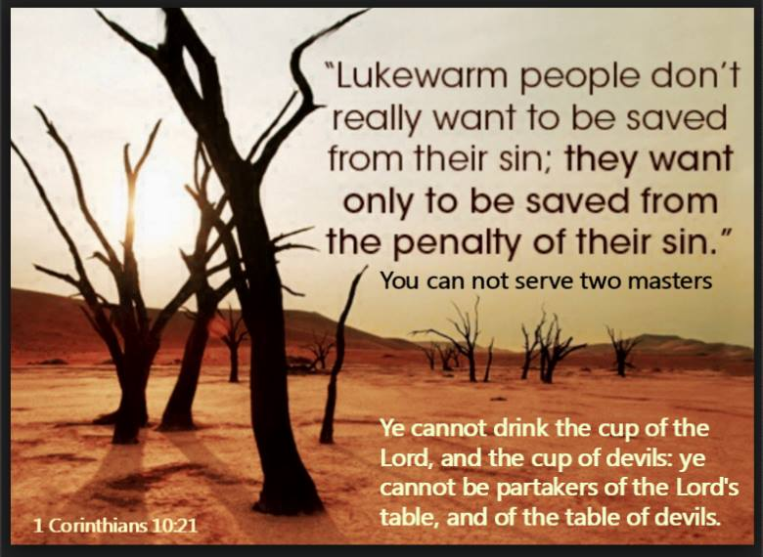
Before the truth sets you free, it is going to make you angry. The way you can identify someone who is immature is that they live in their feeling which they make their god. If they are offended by truth, they unfriend you because their feelings are their god and they never grow up or get set free of deception or sin. Jesus said if you are ashamed of ME and MY WORDS I will deny you before the Father. Be careful not to reject truth because you are offended in your immaturity, because you are rejecting Jesus who will deny you before the Father.
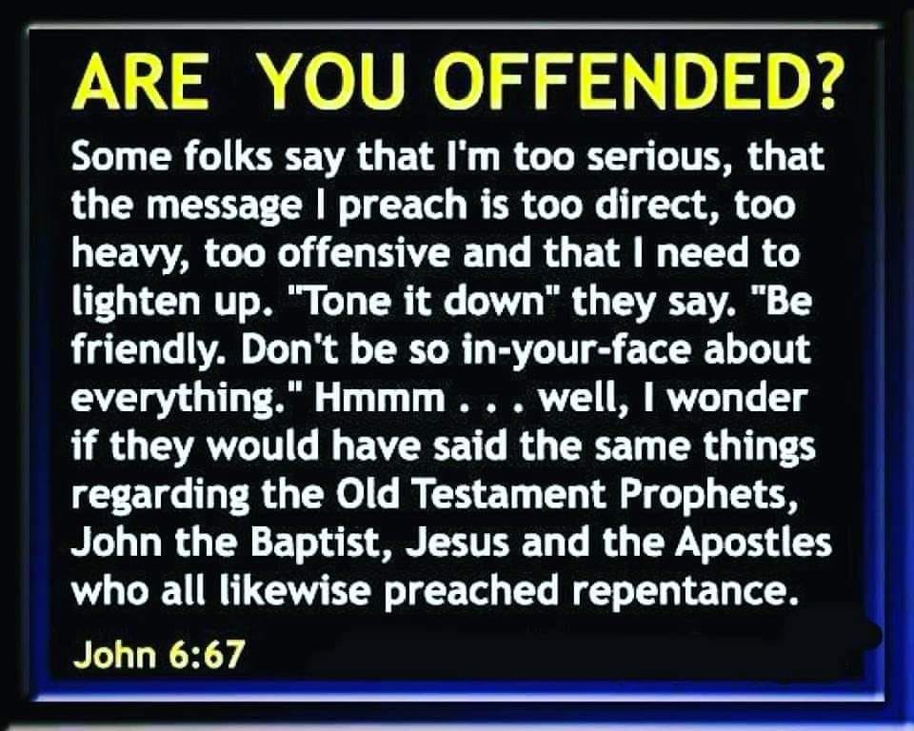

The revelation or discernment I am about to disclose is the spirit behind Covid and the spirit behind dogs in the pulpit who return to their vomit. This spirit preaches a different Jesus and another gospel in the church. This blew my mind and it is hard to wrap your head around but hear me out. We wrestle not again flesh and blood and this enemy we are wrestling against has been revealed and it is time for war in the spirit for our nation and the world.
JESUS IS THE TRUTH

ANUBIS SPIRIT BEHIND COVID

There is nothing hidden that shall not be revealed. Look at these Covid vans below that remove the dead from hospitals or transport Covid patients. Look at the symbol on the van. It is the picture of the Spirit of Anubis.
Please read about this spirit behind this pandemic because it is in video games your children or even adults are playing. It is also in other things that you are bringing into your homes and thus giving it legal access to your lives. It is the spirit of death and the afterlife. It is the spirit of the occult, witchcraft, rebellion and sensuality. It poses as a shepherd and guide and thus counterfeits the Holy Spirit and Jesus. It carries a shepherd's staff and a crooked hook stick to pull back those that would try to escape him that are entrapped in his cult.

It is the spirit behind the Luciferian worshippers being exposed through Epstein’s fantasy island of pedophilia, death and satanic worship. That is why these monsters have no guilty conscience in the taking of lives. They think they are the enlightened ones that have been granted special powers and are granted special benefits in being escorted into the afterlife. Listen to Tom Hank’s speech he gave at college commencements and at Guantanamo Bay prior to his presumed execution in May for his crimes associated with Epstein's fantasy island crew. Trump is rounding them up behind the scenes after gaining the cooperation of world leaders with some arm twisting before he launched his clean up plan into action of these pedophile Anubis worshipers.

This spirit is also found in churches in a more subtle way that preach "another Jesus" and the bible says let them be accursed. It is the spirit of self promotion, wealth, fame, power and mega churches or followings which is what it promises to the celebrities who are recruited into its worship services. In the church it will sit in the seat of God proclaiming to be God with its self exaltation and fist shaking at God's call to repentance after being exposed. Thus they reject the real Jesus that purchased them with His blood. These are the sons of perdition that are being exposed. This goes deep people. These people are willfully deceived or stupid on purpose and many people follow their pernicious ways of whom the way of the truth is evil spoken of. Those who are clean escape this nonsense prosperity, "have your best life now" gospel of me and its carnality that has a person remaining in their sin rather than free from its powers because they have a false sense of eternal security that this "false Jesus" gives them regarding the afterlife. It is the gospel of what I can get by association with Jesus that they don't know is "another Jesus" that is being exposed. This is the "another Jesus" of the dead and of lost souls in Eygyptian mythology. Egypt is symbolic of the world. You are lost if you follow this false Jesus and do not repent. This is the god of the sons of perdition that is being revealed.

The word occult means hidden in plain sight. Look at all the places this spirit can be found hidden in plain sight and get rid of it out of your life. AND DON'T TAKE THE VACCINE that comes from this spirit who has a goal of depopulating the earth.

Anubis is a false shepherd and provider as well as a herbologist (witchcraft is also pharmacology) and so called preserver of the dead in the Luciferian religion worshipers being exposed today in the pedophilia rings of celebrities. An amorphous character, Anubis was not only associated with embalming and death but also with secrets beyond the ken of human beings, as he was well-versed in the mysteries of the afterlife. It was for his special knowledge that Anubis was perceived more as a trusted guide than as the taker of lives and thus the Luciferian worshipers venerate him as such and as a shepherd and guide.

This spirit has lost its headship or place of leadership and its head has been replaced with that of a dog. See my earlier writings on those who are dogs and have returned to their vomit and lose their headship.

Please notice the crucifixes in the picture of Anubis. This is your "another Jesus" folks. THIS IS A HUGE REVELATION!
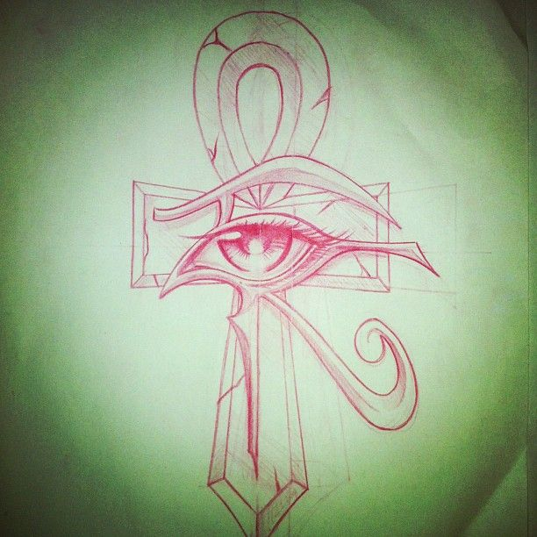
The meaning of the name Anubis is "royal child". He is not the royal child of God. He is a counterfeit Jesus. It is the job of Anubis to weigh the souls of the dead, and determine whether they were worthy of admittance to the underworld. If the soul was found unworthy for paradise, it was sentenced to the second death and handed over to Satan. He is the spirit of death, ushering in of death, spirit of lost souls and the keeper of the underworld or hell.

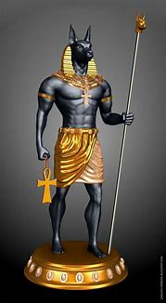

His fur on his head was generally depicted as black in drawings because black was associated with fertility, and was closely linked to rebirth in the afterlife. Thus the sexual and carnal manifestations in Luciferian worship, pedophilia and the religion of death. Anubis is also associated with Isis, false religion and false gods.
The eye of Anubis is also known in the illuminati or occult world as the all seeing eye, also found on our dollar bills with its association with money and wealth. It is also associated with the millennium or millennials. I am not making this stuff up! These are all associated and not a coincidence. Why are our young people called millennials today? I am a baby boomer. There are no coincidences! The more I dig the more I find hidden in plain sight.

There was even a TV show from 2011 to 2013 on Nicolodian called The House of Anubis which was aimed at teens in order to influence the young. This spirit is in all kinds of video games, jewelry etc. It is everywhere. This is the spirit we are doing battle with folks. The enemy has been exposed. We are not fighting against flesh and blood, but against principalities and powers in high places. This spirit has lost its headship which it is seeking to restore through the new world order. He has been cast out as a “royal child” and dethroned and seeks to have God’s children cast out and dethroned as “royal children”. He is a persecutor of Christians unto death.

Wait, there is more! Anubis is also the patron of lost souls, including orphans with the abduction of children or the fatherlessness of children in our society. He is the author of broken homes and marriages, many times through video game addiction and porn. This is why the hearts of the fathers need to return toward the children and families and God is restoring fathering to His church. People with an orphan spirit cannot hear or receive correction without perceiving it as condemnation. During the Greek period, he was associated with Hermes who was known as a messenger of the gods (demonic forces) and Anubis was the one who led people to these satanic messengers appearing as an angel, translated messenger, of light or false prophets and teachers. He is a ruler that possess super human or occult powers that he promises to those that he leads to satanic or Luciferian worship or doctrines of demons in the church. Wealth, power, fame and youth are all part of what he offers. Youth because he was associated with preserving the human body though mummification. The Luciferian worship that celebrities are practicing and being exposed for, involves the use of obtaining the blood from children who are tortured because the trauma cause the adrenal system to produce chemicals into the blood, that when consumed, slows down the aging process. If you don’t know about this, please educate yourself because a lot of well known people are involved in this and are being arrested. Tom Hanks and his wife are two such people as these pedophile rings are being broken up.
Order through chaos is its motto. Hidden in plain sight. The riots we are seeing are instigated by this spirit. It is a major ruler with many demonic forces under its rule over nations. This is the strongman that needs to be exposed and dealt a blow. This is why men in the pulpit who are preaching another Jesus must repent of their gospel of me and what I can get and the hearts of the fathers must return toward the children and the home.

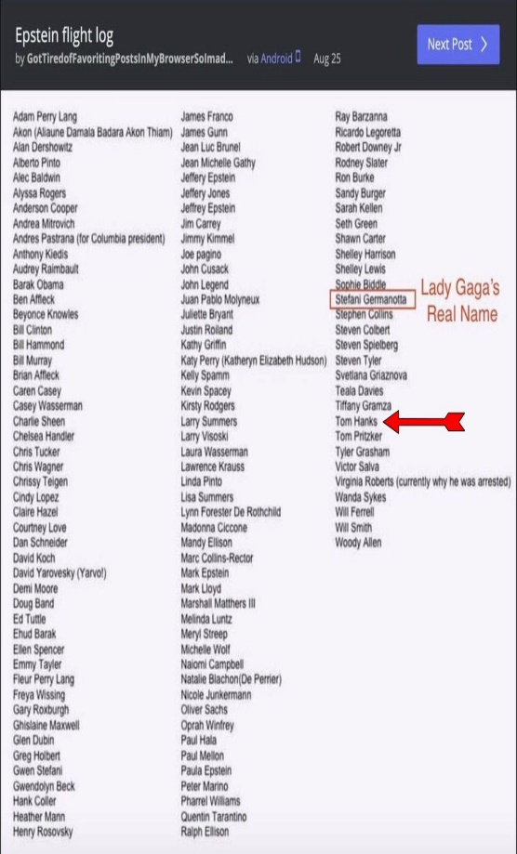
This is Jeffrey Epstein’s flight logs on his airplane that flew some of these elites to his island to participate in these evil atrocities against children. More will come out later. You can find this online if you can’t read this one.

I never heard of this spirit before today! God is revealing it. He has an answer to it. Part of which is a fathering movement and turning the hearts of the fathers toward the children lest He smite the earth with a curse. The weapons of our warfare are not carnal but mighty remnant saints. This “other Jesus” will once again be dethroned and lose its headship in the house of God as the Lord overturns some temple tables of who have turned the gospel into a business by shepherds who have gotten fat off the flock instead of feeding them. These “sons of perdition” or “royal children” as Anubis is called are the lost souls who like Judas betrayed Jesus for money and they have gone the way of Balaam who sold God’s children out for wealth. Fake Jesus producing fake royal children by those preaching “another Jesus” that is not found in the bible.
This is the fruit of the false once saved always saved eternal security damnable heresy in the church. Sinners remaining in their sin instead of being delivered from its power which is what Jesus died to do, so this is totally against Christ or anti christ.

Jesus came not to call the righteous to repentance but sinners. He came to seek and to save the lost but they need to come to the realization that they are indeed lost, while believing they are eternally secure in order to save them. Search the scriptures, because in them you think you have eternal life which is really obtained in the end Romans 6:22. We have had it all wrong for a very long time about how true salvation really works because many aren’t even water and Holy Spirit baptized and they have never repented and kept that repentant spirit. The Lord is exposing things in my heart all the time. I don’t want Him to stop. I want that junk out of there. Many times our sin is a result of wounds and when the wound is healed, the sin goes away so emotional and mental healing are also part of ministry to free people from sin. These newsletters are not for condemnation but to seek and to save the lost and call prodigals home and to equip the church to discern and know our enemy because right now he knows his time is short and he is pouring it all out to wear us down and deceive us in order to take back his headship. We need to be equipped to enforce his defeat.

EVANGELIZING THE EVANGELICALS
Robert Weller

It is amazing how Christendom has evolved over the last 50 years. As immorality has become ramped in America, it has turned most denominations into liberal ear-tickling dead churches. Most denominations were somewhat conservative 50 years ago, but now they are indifferent to calling sin, sin. They don't want to offend their customers. Because preachers have refused to REPROVE, REBUKE, EXHORT, with GREAT patience, their customers are unable to ENDURE SOUND DOCTRINE. 2Tim.3:1-4 These ministers are conceded and understand NOTHING when they refuse to teach the doctrines of the Lord Jesus Christ and doctrine that conform with GODLINESS (god-likeness). 1Tim.6:3-4

Most in the church of Sardis thought they were alive but Jesus said they were dead. He told them to strengthen the things that were about to DIE spiritually. Rev.3:1-2 The most loving thing that you can do for a sinner is to confront him or her about their sins. My brothers, if anyone among you wanders from the truth and someone brings him back, let him know that whoever brings back a SINNER from his wandering will SAVE his SOUL (not his body) from death and will cover a multitude of sins. James 5:19-20
As I prayed today, I felt that the church also needs discernment on those exposing things in the church in order to call people to repentance in order to seek and save and those who have a critical, negative accuser of the brethren, fault finding spirit. I call these people those eating from the tree of the knowledge of good and evil instead of the tree of life. They are all about the letter of the law and miss the whole spirit of it. Thus the Lord gave me a teaching on that today which I posted. The word Laodecia means the pointing of the finger, which produces lukewarmness in the body of Christ so these people must also repent. Let’s explore.

THE LETTER OF THE LAW KILLETH
“People bound in religion repent for breaking rules. People walking in love repent for breaking their Father’s heart.”
-Jeremiah Johnson
I find many with a legalistic religious lying spirit don’t understand the spirit behind the scriptures they are reading and they miss the whole point God was trying to make. All they see is the “RULE” and they miss the purpose or message behind it. In focusing on the rule and condemning those who don’t obey it and being only rule focused, it creates a hardness in your heart toward others who don’t keep the rules and they look down upon those rule breakers. They think they are pleasing God with their rule keeping. In reading scripture they miss the forest for the trees because they are not reading it with Holy Spirit enlightenment that gets to the heart of the matter as to why rules were given in the first place. I will give you a few examples.
Old Testament says not to have tattoos, don’t eat certain things or do certain things and no one asks why? They see the rule and not the reason or spirit behind it. They didn’t have microwaves, refrigerators, ovens or alcohol to sterilize things back then. God had to preserve the Jewish race through which He would bring the Messiah so he didn’t want them eating things that contained micro organisms that would wipe out the race. Micro organisms that were deadly could be transmitted by tattooing. God fed ts he Israelites manna in the desert daily for this very reason. Those who ate manna from the previous day after being told not to, ate the worms that had contaminated it. When they wanted something other than manna, God sent in quail and they died by contaminated quail while the quail flesh was even still in their teeth. Sometimes, when you complain enough God will give you what you want even if it kills you. That is the only way some people learn. This is the reason God forbade the eating of certain animals way back then because they didn’t know about micro organisms and He wasn’t going to explain it to them since they had no way of cooking to kill them or refrigeration to preserve things. Today, people who are legalistic letter of the law people with a religious lying spirit look down upon and condemn people with tattoos and those that eat pork or shrimp without having a single clue about the reason behind the rule. Every holiday you see them condemning Christmas trees or something or other on Valentines Day. I personally will have nothing to do with Halloween because it celebrates the spirit of Anubis and death and children are sacrificed on Halloween so I see absolutely no reason to be celebrating such things Jesus died to deliver us from. What a slap in the face to our Lord.
Let’s take it to the New Testament about women cutting their hair. Again they follow the letter that kills while missing the whole point given to one group of people ONLY. IN CONTEXT of those times in that community, there was a temple to a false god. The temple had priestesses who during worship in that temple had sex with followers. These temple priestesses had their heads shaved which was a symbol of immorality. Women were not to be associated with anything immoral in the Christian church. As the gospel spread and these temple priestesses came to the Lord and worshipped in Christian churches, they were told to cover their heads, especially if they had then married Christian men, so as not to embarrass their husbands by their former life of immorality and to be pleasing to God. Basically short hair or a shaved female head was the “sexy” thing back then and considered provocative as was the wearing of jewelry etc. To each his own I guess but that was what the standard was in that region only and these were commands to that church only in regards to women cutting their hair so as not to be associated in any way with immorality. Today’s application could be a whole host of different attire that is skin tight and showing of flesh in order to gain the wrong type of attention. This is yet another example of the letter of the law that killeth because you miss the whole spirit or reason behind it in appearing wholesome. Today we have legalistic churches who forbid women from wearing pants or cutting their hair and they comply because they think they are pleasing the Lord and these churches look down upon those who don’t comply and condemn you by throwing the letter of the law at you. They have no clue the spirit behind it. I went to one of these churches in Texas. If you cut your hair or wore pants or jewelry after you were told not to, they didn’t want you coming and they would tell the rest of the congregation you were waste in the toilet that needed to be flushed. I am not kidding. They did more scattering than gathering. They are focused more on how things look externally than how things really are inside regarding your heart.
These same people are the ones who crucified Jesus. They followed Him around looking at all the ways He wasn’t keeping the letter of the law. He healed on the Sabbath. The law said you were not to work but rest and to the legalistic people that meant you were not to even do good to another in loving your neighbor as yourself on the Sabbath day. That was never the spirit behind the rule or law. Thus they condemned Jesus for healing on the Sabbath.
When you read your Bible, read it in context. Ask yourself what God’s point was.
Let’s take the rich young ruler. He came to Jesus wanting to know how to inherit eternal life. He called Jesus good. Jesus responds by saying only God is good, which a ruler would know. Jesus was basically saying by calling me good you are acknowledging that I am God. Jesus asks him what the scripture says and he replies that you must love the Lord your God with your whole heart mind and soul and your neighbor as yourself. He told Jesus he had done that since his youth. In order to prove to the rich young ruler that his own heart was deceiving him about who he actually was inside, Jesus told him to sell all he had and give to the poor. That is the loving your neighbor as yourself part. Then he told him to come and follow Him which was the love God above all else part since he had just acknowledged Jesus as God by calling Him good. The rich young ruler went away sad. Legalistic people miss the whole point of this encounter and tell people they have to sell everything to follow Jesus. What others may love more than God could be their porn, video games, job, a person or something else they could not give up if Jesus asked. For many it is your cell phones.
So you see, you can tell those who scatter rather than gather because they are all about rule keeping and miss the spirit behind the rule or law. They can’t see the forest for the trees and they go around condemning everyone else because their hearts are hard toward those who don’t keep the rule. Jesus avoided those people and went and spent time with those who already knew it was impossible to keep the law or rule in their ability and needed instead forgiveness and empowerment not to sin through the baptism of the Holy Spirit.
Grace isn’t the license to sin but the power of God given to you not to through the baptism of the Holy Spirit. Your freedom in Christ comes from no longer being a slave to sin as a result.
You need to read the Bible with the Spirit of God showing you what was really going on and the purpose for the rule that might have other applications to you, or today.

Josephus the historian reveals that the rich young ruler was Nicodemus, who later came to Jesus in the night asking the same question. Why did he expect a different answer this time? Because he had sold all he had and was now trying to follow Jesus covertly because of the fear of man. This is when Jesus gave him a different answer in that he must be born again of water and the Holy Spirit. When the rich young ruler walked away sad after his first encounter with Jesus, it says Jesus looked on him with love. The freaked out disciples upon seeing this rich young ruler turning away said “Who then can be saved”? If this guy can’t we are doomed. Jesus turned to them and told them with God everything is possible. Jesus knew this rich young ruler named Nicodemus would be the one buying the hundred pounds of oil to anoint his body for burial while enlisting his rich friend, Joseph of Arimathea to go and get Jesus’ body to put in Joseph’s tomb. Nicodemus, being rich, would have had his very own tomb but had sold it so he had to borrow one from his rich buddy. These were not old men to carry such heavy weights in oil and the body of Jesus. They call it dead weight for a reason. That is why Jesus looked upon him with love saying, with God all things are possible but it starts with telling people the truth first. I pray that after exposing the enemy that is seducing God’s people, Jesus can also look on some of you with love because you have done what the rich young ruler, Nicodemus, did in order to inherit eternal life. Sell all you have, give to the poor and follow Him. With God all things are possible and in interceding for all of you, I will be reminding the Lord of that as I do battle in the spirit against the enemy of your soul that the Lord has exposed.
Please join me in spreading the word about this evil spirit because God exposes it so we can enforce his defeat. We need to take back our country and over throw this spirit globally. He is seeking to save while there is still time.

If my people will repent, humble themselves and pray and seek my face and not my hand, I will hear from heaven and heal their land. Don’t just pray. Repent and humble ourselves. We are living in the last days as end time prophecy is happening before our very eyes.
GET THEE BEHIND ME SATAN!

If the devil can’t confuse you or debate you using scripture, he uses people to accuse you as the accuser of the brethren on external things that don’t matter. It is so laughable. He will use the fact that you drink coffee while you read the Bible in the morning and criticize it as being a drug. Really? Yes really! That is how weak and lame he is. He has nothing else to throw at you but that. The devil focuses on how things look externally instead of how things are internally. The accusers of the brethren have no discernment and scripture is twisted and read to confirm their bias against women or coffee drinking while they consume huge amounts of sugar in their birthday cakes the size of which I have never seen. Sugar is a drug or addiction too and for some people their god is their belly or pleasure. That’s truth. But for those of us who can enjoy things without it being our god, stop with the pointing of the finger, which is the definition of Laodecia by the way. People become lukewarm because others are being used by the devil to focus on external things or things that make no difference at all while excluding things that do. They need to remove the plank out of their own eye because they truly aren’t seeing very clearly according to the spirit of God.

I just saw the post about coffee directed at me and laughed. Not the first one about coffee slung at me either. If that is all you got devil I am doing good. I laughed and pointed at it and asked the Lord if He noticed it. He laughed and said “Yes! They called me a drunkard and wine biber”! And by the way if wine was non alcoholic back in those days as some teach, why would they make such a claim? Jesus made good wine at the wedding in Canna. If you have an addiction to anything and it is your god, repent and stop pointing the finger. For those of us who don’t, let us enjoy those things that God gave us to enjoy. Nice try devil. I will expose your every tactic every time. Get thee behind me. You are a joke!
GIVING OUT WHAT GOD GIVES YOU

Let’s face it. Not everyone understands the things God reveals to you. That doesn’t mean you shouldn’t sow the seed of the revelation of the word He has given. Yes some of that seed hits wayside hearts where the devil steals it. Some hits hard hearts where it is received with joy and sprouts up quickly but the minute affliction or persecution comes as a result of the word they are offended and fall away from the faith. There is no eternal security once you first believe. You have to endure until the end to be saved. Then you have those people with thorny hearts where the seed of the word was sown. The cares of the world, the deceitfulness or riches and the lust of other things choke out the word and it becomes unfruitful. These would be your prosperity teachers and preachers. Those no longer producing fruit are cut off from the vine or are hewn down by the Father. You have to be grafted into the vine to be cut off from it for not producing anything. Therefore keep producing fruit! Let nothing become your idol and don’t let the devil steal the word. Endure until the end and give out what He has given you, even if you get it from another. I share stuff all the time from other ministries that are giving out what God gave them. Don’t sit on it. SOW. Otherwise you are being a hearer of the word and not a doer of it deceiving yourself.

Those who have the word sown on good heart soil receive it, give it out and bring forth much fruit Those who don’t just like and don’t share and keep moving on to the next post. God sees it all and this is His perspective of it.

If you are not getting your own revelation from God, this is why. You won’t give it out and share. That is Bible truth. Mark 4:21-25 states it.

“And he said unto them, He that hath ears to hear, let him hear. And when he was alone, they that were about him with the twelve asked of him the parable. And he said unto them, Unto you it is given to know the mystery of the kingdom of God: but unto them that are without, all these things are done in parables:

And he said unto them, Is a candle brought to be put under a bushel, or under a bed? and not to be set on a candlestick? For there is nothing hid, which shall not be manifested; (revealed) neither was any thing kept secret, but that it should come abroad (be exposed). If any man have ears to hear, let him hear. And he said unto them, Take heed what ye hear: with what measure ye mete (give out), it shall be (Given) measured to you: and unto you that hear (and give out) shall more be given. For he that hath, to him shall be given: and he that hath not, from him shall be taken even that which he hath.”

So if you do not give out any revelation God gives you, you will lose what revelation you used to even have. If you do not get or understand things, it is time to start sowing into others and give out what it is you do understand so that you can bear fruit, increase in the knowledge of the mysteries of the kingdom and stop being a person that is without the kingdom that needs to be spoken to in parables so you won’t get it. Because you are judged according to what knowledge you received and what you did with it. Therefore, those who don’t quite get it because they don’t understand the parable, are judged less harshly because they didn’t quite understand

The light God gives you isn’t intended to be hidden but put on a candlestick to reveal or make manifest things kept secret in the dark. Flip the switch and oh my! Everything gets exposed for everyone to see or that it should “come abroad” is the Biblical term.
So take heed what ye hear from the spirit of God. What measure or amount you give out, which I do in these coffee and bible study times and through newsletters and books, more shall be given you. You keep the flow of revelation and the mysteries of the kingdom going by giving out and sowing on the hearts of others the revelation God has given you. For to him that hath and gives out, shall more be given. If you don’t give it out, what you did have will be taken away.

Just a side note on the scriptures in Mark I posted above. I thought it was just the disciples Jesus was explaining this stuff to, but if you read it again in Mark 4:9 it states, and the Lord pointed this out to me, “And when He was alone, they that were about Him WITH THE TWELVE, asked of Him the parable. To ALL these people with Him and the twelve Jesus said, Unto you it is given to know the mysteries of the kingdom of God. These are the people who kept following Jesus after all the crowds went home. They were hungry and wanted more and thus they were given the mysteries or revelation that others did not get. They are spending time with Jesus after church hours when the crowd is gone. They are getting their spiritual food themselves and not depending on pastors to feed them. These are the good ground, remnant, hungry for God people, keeping His commandments out of love and not religious duty.

Take heed what you hear. For those who have ears to hear, stop just hitting like and share the heck out of stuff Jesus is giving to you through others so that you may sow on the hearts of others that are perishing. If you don’t care about those perishing, you are probably perishing yourself for lack of fruit bearing. Be a doer of the word and not a hearer only deceiving yourself. The storms of life will take you out. The disciples started by giving out what they heard Jesus say just like I do. If you have a relationship with Him and are truly born again of water and the Holy Spirit, you should be hearing from Him and giving out as well. You are the light of the world in these dark days. Don’t let the devil steal the seed sown on your heart. Make sure it produces something.

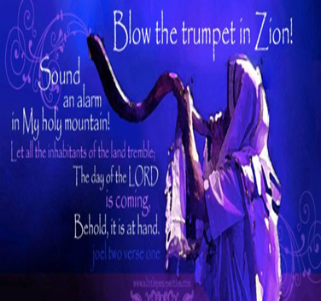

A VOICE CRYING OUT IN THE WILDERNESS MAKING STRAIGHT THE PATHS! COMING IN THE SPIRIT OF ELIJAH! AS IT WAS THE FIRST TIME, SO IT IS THE SECOND!
For speaking engagements call
813-393-9384

Our website is www.latter-rain.net

Preparing a Bride without spot or wrinkle.

Joanne Armstrong
Latter Rain Ministry

