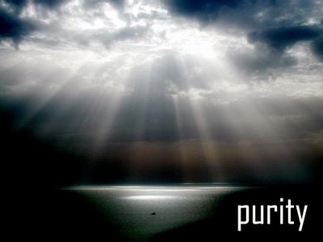
  Fresh Rain
  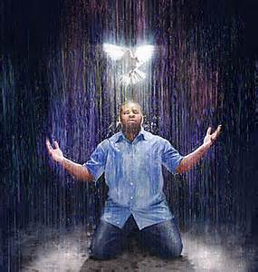
  Latter Rain Ministry
Preparing a Bride without  spot or wrinkle |  | AUGUST, 2022
MYSTERY BABYLON

The word mystery in this verse blew me away. It is translated secret society through the idea of silence imposed by initiation into a religious rite. That is the Free Masons who take a vow of silence into their Luciferian religion. I recently posted a lot on Free Masonry being everywhere and listed the signs, symbols and posted a video by a high up free mason who encountered Christ and became a Christian. So you see God is leading me on this journey to reveal or expose mystery Babylon or the free mason Illuminati secret society of Luciferians.

I wrote an article regarding Nimrod and Babylon and the seed of the serpent. Much of that came by total revelation and I sat down to write. When I went back to study it out, it was accurate. That was purely revelatory because I had no knowledge of that information prior and just gave out what He gives me. That seems to be happening a lot lately. Today I woke up knowing I had to read the scriptures on Mystery Babylon. It is a mystery because revelation about it has not been disclosed until the Lord determines the time. I am going to give the chapter and insert what the Lord showed me to reveal the mystery. Things in quotes are generally from the original translation.

“And there came one of the seven angels which had the seven vials, and talked with me, saying unto me, Come hither; I will shew unto thee the judgment (condemnation or decision passed on) of the great whore that sitteth upon many waters: (Many waters are many nations and people. It is global in nature).

With whom the kings (someone in power) of the earth (global) have committed fornication (translated idolatry, pornia or porn, or to legalize or indulge in unlawful sex, homosexuality, pedophilia, sex slavery) and the inhabitants of the earth have been made drunk with the wine of her fornication.

So he carried me away in the spirit into the wilderness: and I saw a woman sit upon a scarlet colored beast, full of names of blasphemy (against God, railing against God, removing the knowledge of God from everything through tyranny which Nimrod did) having seven heads (spheres of influence) and ten horns (rulers). And the woman was arrayed in purple and scarlet color, and decked with gold and precious stones and pearls, having a golden cup in her hand full of abominations (disgusting things) and filthiness of her fornication: And upon her forehead was a name written, MYSTERY (A SECRET SOCIETY, THROUGH THE IDEA OF SILENCE IMPOSED BY INITIATION INTO A RELIGIOUS RITE WHCH IS FREE MASONRY or the ILLUMINATI)) BABYLON THE GREAT, THE MOTHER OF HARLOTS AND ABOMINATIONS OF THE EARTH.

And I saw the woman drunken with the blood of the saints (over centuries), and with the blood of the martyrs of Jesus: and when I saw her, I wondered with great admiration. And the angel said unto me, Wherefore didst thou marvel? I will tell thee the mystery of the woman, and of the beast (empires both past and future) that carrieth her (cause her to move forward and keep going) which hath the seven heads and ten horns. (This spirit or secret society has been around for thousands of years).

The beast that thou sawest was, and is not; and shall ascend out of the bottomless pit, and go into perdition: and they that dwell on the earth shall wonder, whose names were not written in the book of life from the foundation of the world, when they behold the beast that was, and is not, and yet is.

And here is the mind which hath wisdom. The seven heads are seven mountains (family, religion, economy, governments, education, media and entertainment). These free mason Luciferians have infiltrated all the mountains) on which the woman sitteth. And there are seven kings (rulers): five are fallen, and one is, and the other is not yet come; and when he cometh, he must continue a short space. And the beast that was, and is not, even he is the eighth, and is of the seven, and goeth into perdition. And the ten horns which thou sawest are ten kings, which have received no kingdom as yet (future); but receive power as kings one hour with the beast. These have one mind (one world government, resolve, goal, objective, or counsel) and shall give their power (abundance, means, might, sovereignty) and strength (freedom, privilege, rights, authority, jurisdiction, liberty) unto the beast. These shall make war with the Lamb (Christians), and the Lamb shall overcome them: for he is Lord of Lords, and King of kings: and they that are with him are called, and chosen, and faithful.

And he saith unto me, The waters which thou sawest, where the whore sitteth, are peoples, and multitudes, and nations, and tongues. And the ten horns (rulers) which thou sawest upon the beast, these shall hate the whore, and shall make her desolate and naked (lay her bare, reveal her, bring her down by exposing) and shall eat her flesh (remove that which is carnal, remove frailties, stripped of fleshly nature, to remove the external to reveal true nature) and burn her with fire.

For God hath put in their hearts (10 rulers or kings) to fulfil his will (in bringing down the whore or secret society), and to agree, and give their kingdom unto the beast (they once were part of the secret society and new world order mindset) until the words of God shall be fulfilled. And the woman which thou sawest is that great city, which reigneth over the kings of the earth.”
Revelation‬ 17:1-18‬ ‬‬‬‬
‬
We are living this right now. Ten World rulers or influencers who were once indoctrinated into the new world order system, like Putin who went into Ukraine to free the people from the Natzi’s regime who were killing their own people, and take control of the bio labs before other bio weapons could be released on the world, Elon, maybe China’s leader if he takes the bio labs out in Taiwan, and others will turn on the beast system and bring it down. Watch who they start attacking with their main stream media propaganda folks. These are the leaders who God has put it in their hearts to fulfill His will in the time we are currently living. We live in some exciting times and the good news is, Jesus wins, and they that are with Him are called for such a time as this, chosen and faithful. Those who are against Him have no clue what is going on and will attack the leaders that God has put in their hearts to turn against the whore and beast system in order to bring her down. Watch who you condemn and criticize in this hour of world history. You could be fighting against God and not for Him as you imagine because you are believing the propaganda and brainwashing of those who are part of the whore system or mystery Babylon. Many of which are leaders in the church.

So these Luciferian Free Masons can be found in the government, entertainment industry, sports, educational systems, families, media and last but not least, in our pulpits and mega churches preaching and placed into positions to manage the crowds in order to help facilitate this new world order. You know who you are, God knows who you are and many are on this mailing list. People do as well, as people become well educated on the symbols and hand signs used to identify your solidarity to the secret societies where you took your vow of silence or die, if you expose anything. Many are 33rd degree masons and you have to do some pretty despicable things to get to that level.

The ask Jesus into your heart, say a sinner’s prayer, accept Jesus as your Lord and Savior and all this other non biblical nonsense taught in the apostate church today was brought into the church by these free mason Luciferias mascarading as angels of light and ministers of righteousness. The biggest names out there were 33rd degree masons. Some are dead and held the biggest crusades deceiving people into believing they are born again and eternally secure because they said a sinner’s prayer, asked Jesus into their hearts or some other non biblical nonsense not found in the bible. Do your research. It doesn’t matter what else you teach as long as you can deceive people into believing they are saved and eternally secure when they are not. The hardest people to get to become biblically born again are the ones deceived into thinking they already are.

Many of our Christian music artists are deeply involved in these secret societies. Many have lost (sacrificed) a child for a career, money and fame. Look at who has had a child die and look at the symbols on their albums or CD covers. The all seeing eye and other occult symbols are blatantly displayed if you know what they are. Same with mega church pastors or evangelists who are part of mystery Babylon and placed on the religion sphere of influence or one of the seven mountains. Familiarize yourself with their symbolisms and hand gestures. The same is true in the pulpits. Child sex trafficking and sacrifice are a part of these secret societies. The entertainment and music industry doesn’t even try to hide it anymore because the church is so weak and they mock the church with the “in your face” demonic songs, symbols and blatant sexuality. Adrenochrome is the drug and children are the victims. This is all about to be exposed by the Lord along with those in His house who are involved in it. Judgment starts in His house before it starts in the world.
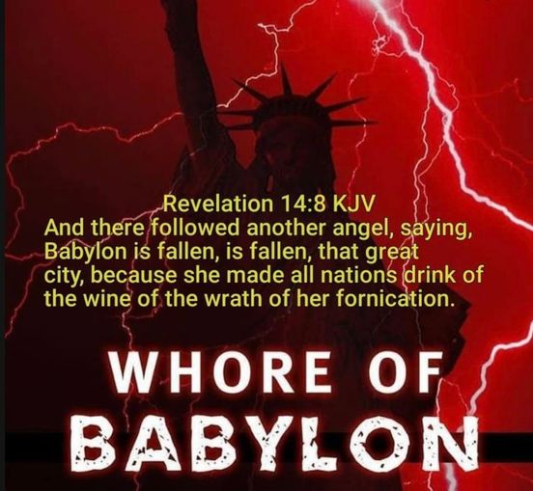
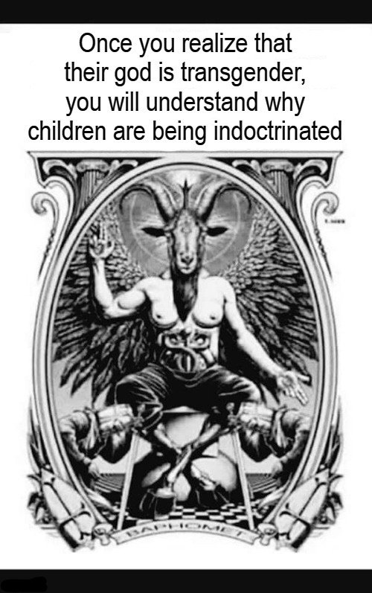

MUSTARD SEEDS AND LEAVEN

I want you to really let this sink in what the Lord is saying here. This just hit me hard and I never saw it in scripture but it is obvious in real life today. Ready?

The mustard seed that grew over time is the church, which started as a small seed with the original ACTS gospel. Fowls of the air in scripture are demons or devils. The fowls of the air steal the seed from people’s hearts. Jesus said they were devils.

So the kingdom of Heaven is likened unto a mustard seed, which is the smallest of all seeds. It grows up over time to become a great big tree and the fowls of the air or devils lodge in its branches. Devils have taken up residence in the church is basically what Jesus is saying.

Next verse after that says Jesus likens the kingdom of heaven to leaven, which is sin in the Bible, which a woman took and hid in three measures of meal (bread) until all was leavened or full of sin.

The sin overtaking the church is a result of fowls that have taken up residence in the church and teach doctrines where:

1. Grace is license to sin.
2. Once saved always saved so live
as you like.
3. Just believe and you are saved
and no obedience is necessary.
4. Jesus doesn’t have to be Lord in
order to be savior.
5. The blood of Jesus causes sin to
be overlooked rather than
something you are freed from
slavery to.
6. Water baptism and baptism in
The Holy Spirit, which
empowers you not to sin, is not
necessary, from people who have
a form of godliness but deny the
empowerment thereof.
7. Repentance is not necessary,
something you are capable of
doing and isn’t ongoing.
8. You don’t have to endure until
The end to be saved.
9. You have all the Holy Spirit you
will need once you believe.
10. Being sealed with the Holy
Spirit means it can’t be broken.
Sealed is translated earnest or
Deposit like one would put down
on a house with the intent to
fully purchase. If the deal falls
through the deposit is returned.
That is why we are sealed until
the full day of redemption
because we have not been fully
redeemed. You have your part
to play.
11. Ask Jesus into your heart or give.
your life to Jesus and all the
other non biblical nonsense
being taught as a way to be saved
which deceives people into
believing they are biblically born
again when they are not.
12. Believe and faith are nouns and
not verbs or action word that are
ongoing until the end.

Any doctrine taught that does not instruct unto holiness, stress doing the will of the Father in order to enter into the kingdom of God, leaves you unempowered and enslaved to sin, doesn’t stress sanctification and belief in the truth 2 Thes 2:13 as necessary for salvation, has you believing you are saved when you first believed like it is a done deal (eternal life is received in the end Romans 6:22 and saved is translated delivered from slavery to sin and made whole), hell isn’t taught, the path to heaven is broad and many are saved, restoring a brother caught in sin is judging, Jesus doesn’t gather out of His kingdom ALL who offend and ALL workers of iniquity (willful sin) Matt 13:41, your name can’t be removed from the lamb’s book of life, come from a fowl or devil that has lodged itself in the branches of the church after it had been around awhile and grown large. As a result, the church has become apostate or fallen away from the one true faith and leaven or sin is in the church to the point all have been leavened through deception. Sin permeates the church until all are leavened believing they are saved and eternally secure.

“Then said he, Unto what is the kingdom of God like? and whereunto shall I resemble it? It is like a grain of mustard seed, which a man took, and cast into his garden; and it grew, and waxed a great tree; and the fowls of the air lodged in the branches of it. And again he said, Whereunto shall I liken the kingdom of God? It is like leaven, which a woman took and hid in three measures of meal, till the whole was leavened.

Then said one unto him, Lord, are there FEW that be saved? And he said unto them, Strive to enter in at the strait gate: (many today would call that works salvation) for many, I say unto you, will seek to enter in, and shall not be able. When once the master of the house is risen up, and hath shut to the door, and ye begin to stand without, and to knock at the door, saying, Lord, Lord, open unto us; and he shall answer and say unto you, I know you not whence ye are: Then shall ye begin to say, We have eaten and drunk in thy presence, and thou hast taught in our streets. But he shall say, I tell you, I know you not whence ye are; depart from me, all ye workers of iniquity. There shall be weeping and gnashing of teeth, when ye shall see Abraham, and Isaac, and Jacob, and all the prophets, in the kingdom of God, and you yourselves thrust out.

And they shall come from the east, and from the west, and from the north, and from the south, and shall sit down in the kingdom of God. And, behold, there are last which shall be first (because they overcame when deception was the greatest with the mustard seed tree full of devils teaching and sin that has overtaken the church), and there are first which shall be last.”
Luke‬ 13:18-21, 23-30‬ KJV‬‬‬‬‬‬
‬‬‬‬‬‬‬‬
This my friend is the context of these parables. That is why Jesus warned the most about deception in end times before He comes for His bride who made herself ready. Only those who are without spot or wrinkle get into the kingdom of heaven because He has given us everything to live godly in this present world through the baptism of the Holy Spirit so we are without excuse. That is why Jesus said, “When I come will I even find true faith upon the earth”?

But Jesus said the gates of hell will not prevail and thus others like myself are still here to help prepare a bride without spot or wrinkle until the door is shut and those remaining in sin are locked out of the kingdom of heaven because they have been gathered out. That is the only reason I am left here and I will tell you time is running out! Jesus won’t confirm the present day apostate gospel with signs and wonders because it is coming from devils that have lodged themselves in the mustard tree.

If you care even a little about where people spend eternity, please share this so that the Lord can find you doing His will at His coming and you will be called a good and faithful servant.
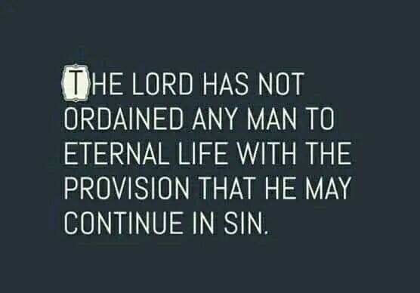
THEY CALL JESUS A LIAR

By denying the baptism in water and baptism in the Holy Spirit and telling people all you need to do is just believe. Believe in the Bible is a verb or action word and not a noun. It is the same Greek word as obey. Yet they call that works salvation if you are a doer of the word and not a hearer only deceiving yourself.
“Jesus answered, Verily, verily, I say unto thee, Except a man be born of water and of the Spirit, he cannot enter into the kingdom of God.”
John‬ 3:5‬ KJV‬‬‬‬‬‬‬‬
‬‬
They tell you to ask Jesus into your heart, accept Him as your Lord and savior and lead you in a sinner’s prayer, none of which any of this nonsense is found in the Bible as a way to enter the kingdom of heaven. Repent and be baptized everyone of you is!

“Now when they heard this, they were pricked in their heart, and said unto Peter and to the rest of the apostles, Men and brethren, what shall we do? Then Peter said unto them, Repent, and be baptized every one of you in the name of Jesus Christ for the remission of sins, and ye shall receive the gift of the Holy Ghost.” Acts‬ 2:37-38‬ KJV‬‬‬‬‬
‬
“And he said unto them, Go ye into all the world, and preach the gospel to every creature. He that believeth and is baptized shall be saved; but he that believeth (translated obey) not shall be damned.”
Mark‬ 16:15-16‬ KJV‬‬‬‬‬‬‬‬
‬‬
“Therefore whosoever heareth these sayings of mine, and doeth them, I will liken him unto a wise man, which built his house upon a rock: and the rain descended, and the floods came, and the winds blew, and beat upon that house; and it fell not: for it was founded upon a rock. And every one that heareth these sayings of mine, and doeth them not, shall be likened unto a foolish man, which built his house upon the sand: and the rain descended, and the floods came, and the winds blew, and beat upon that house; and it fell: and great was the fall of it.”
Matthew‬ 7:24-27‬ KJV‬‬‬‬‬‬‬‬
‬‬
“But be ye doers of the word, and not hearers only, deceiving your own selves.”
James‬ 1:22‬ KJV‬‬‬‬‬‬‬‬
‬‬
Many claim to know Jesus but in their deeds or lack of them, they deny Him by calling Him a liar and saying all you need to do is just believe (as a noun giving mental ascent) and obedience is works salvation. You don’t do anything in your ability after being biblically born again. You are dead. It is no longer you but Christ in you, the hope of glory who is performing any good deeds as you submit to Jesus as Lord and get out of the way so you don’t get the glory, He does. How can a dead man perform His way into heaven. If Jesus isn’t Lord, He can’t be savior.

“They profess that they know God; but in works they deny him, being abominable, and disobedient, and unto every good work reprobate.”
Titus‬ 1:16‬ KJV
‬‬‬‬‬‬‬‬‬‬
Disobedience is as witchcraft the Bible says.

So are you going to believe the witches and warlocks appearing as ministers of righteousness who call Jesus a liar by saying all you have to do is believe or give mental ascent as a noun, or believe Jesus who said you MUST be born again of water and of the Holy Spirit in baptism as stated above in order to enter the kingdom of heaven. The hardest people to become biblically born again are the ones who are deceived into believing they already are. The Bible states that these apostate people in the end time church will not receive the love of the truth that they might be saved. Might be, will be, shall be saved are all future tense for anyone who believes and is baptized. The Bible never pronounces one as saved when they believe. Becoming biblically born again empowers you to be saved or delivered from slavery to sin, is the translation, as you are changed from the inside out and you work out your salvation with fear and trembling. In the end you receive eternal life Romans 6:22.

Stop believing these delusional people who say all you need to do is just believe which is just the first step. Faith without works is NOT the saving kind of faith. Righteousness was not imputed unto Abraham and justification pronounced until he acted upon what he believed (as a verb). Because you believe, you obey.
“What doth it profit, my brethren, though a man say he hath faith, and have not works? can faith save him? Even so faith, if it hath not works, is dead, being alone. Yea, a man may say, Thou hast faith, and I have works: shew me thy faith without thy works, and I will shew thee my faith by my works. Thou believest that there is one God; thou doest well: the devils also believe, and tremble. But wilt thou know, O vain man, that faith without works is dead? Was not Abraham our father justified by works, when he had offered Isaac his son upon the altar? Seest thou how faith wrought with his works, and by works was faith made perfect? And the scripture was fulfilled which saith, Abraham believed God, and it was imputed unto him for righteousness: and he was called the Friend of God. Ye see then how that by works a man is justified, and not by faith only.”
James‬ 2:14, 17-24‬ KJV‬‬‬‬‬‬‬‬‬‬

Once saved always saved is also one of the biggest damnable heresies in the church brought in by these same people. Jesus said He will gather out of His kingdom ALL who offend and ALL workers of iniquity. The word iniquity is translated you knew it was wrong and you did it anyway. Matthew 13:41. You have to be in His kingdom in order to be gathered out. You can have your name removed from the lamb’s book of life the Bible says. These people repeatedly call Jesus a liar with their false doctrine and damnable heresies and because they won’t receive the love of the truth that they might be saved, God will give them what they want which is strong delusion. Don’t believe delusional people who are hearers of the word and not doers, deceiving themselves.

Believe Jesus! He doesn’t lie or go against His own word like these delusional people do while calling Him a liar. Your eternity depends upon it.

If you believe Jesus, share with the deluded so that maybe even one might be pulled from the grips of these disobedient witches who rebel against the word of the Lord. They are against Christ and all He died to do in freeing us from slavery to sin by empowering us not to sin through the baptism of the Holy Spirit so that we do not incur the wages of sin which is death. They are preaching another gospel and a non biblical Jesus. The Bible says let these people be accursed. Don’t be accursed with them.
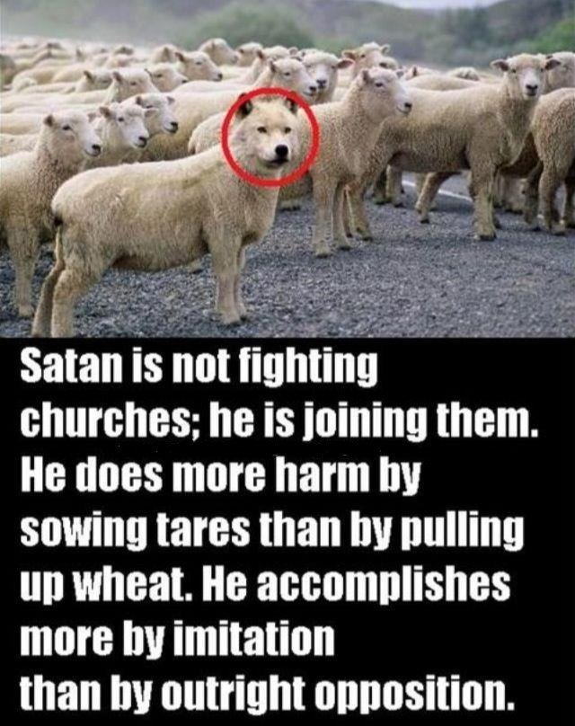

SEDUCING SPIRITS

“Now the Spirit speaketh expressly, that in the latter times some shall depart from the faith, giving heed to seducing spirits, and doctrines of devils; speaking lies in hypocrisy; having their conscience seared with a hot iron;”
1 Timothy‬ 4:1-2‬ KJV‬‬‬‬‬‬‬‬
‬
Like just give mental ascent (their definition of believe) and you are saved and eternally secure. The biblical definition of believe is a verb or action word that produces works. Abraham was justified by his works and righteousness was imputed unto him because of his works that stemmed from genuine faith. The Bible is clear that faith alone does not save. You shall be, will be, might be saved is future tense and it means you have been given the ability to be saved through the baptism of the Holy Spirit. Your freedom in Christ comes from no longer being a slave to sin but a slave to righteousness instead. What you do with that ability is called working out your salvation with fear and trembling. You must endure until the end in the one true faith and not be led astray, and be sanctified (made holy) by the Holy Spirit and belief in the truth.

APOSTASY OR DEPARTING FROM THE ONE TRUE FAITH

You are not saved when you first believe. You have been given the power or ABILITY to be saved. That is why you work out your own salvation with fear and trembling.
Being water baptized is baptizing you into the body of Christ where you are pledging to be dead to sin and self IN ORDER THAT you be raised as Christ was raised. Baptism in the Holy Spirit empowers us to keep that pledge. The Holy Spirit is called the gift. All gifts must be opened and utilized or used. If someone gives you a car, you would be a fool not to benefit by it by driving it. Same with baptism in the Holy Spirit. Jesus only baptizes those in the Holy Spirit who obey the Bible says. If you won’t obey in the first things given which is repent, then be water baptized, why would He baptized you in the Holy Spirit? Water baptism remits or sends away your old sins. You are now a clean vessel in order to be occupied by a Holy Spirit who empowers you to not sin, because sin separates you from God.

Being baptized is not works salvation as the demonic heretics teach. Faith without works is NOT the saving kind of faith. Abraham was justified by his works that stemmed from his faith and it was because of his WORKS, righteousness was imputed unto him and he was called a friend of God. The saving kind of faith produces works that demonstrate that your belief is genuine.

The Bible definitely clears up the faith and works issue unless you want to be deceived. It is the VAIN or prideful man who believes faith alone saves according to the Bible. The Bible says people will be willfully deceived or be stupid on purpose in end times and they will not receive the love of the truth that they might (future tense) be saved. Shall be, might be, will be saved are all future tense and is translated you have been given the ability to be saved. What you do with that empowerment or ability is up to you and your free will, which God won’t go against. You can’t save yourself which is why you need this empowerment and that was the purpose of the law; to show you that you couldn’t keep it in your ability which was to lead you to Christ and His ability. Grace is translated empowerment in all but two verses. His grace is sufficient and grace teaches us to live godly in this present world the Bible says. If you don’t see godly living, that person has not received the biblical definition of grace, which is why the devil tries to redefine it.

A rich man gives a man a check for a trillion dollars. This guy believes the rich guy is good for the money and shoves the check into his pocket and rides away. That is faith but not the saving kind. The second guy is given a check or gift for a trillion dollars. Because he believes the rich man is good for the money, he endorses the check (water baptism or being born again of water) and then deposits the check into his account (baptism in the Holy Spirit) so he can access the gift in times of need. Endorsing the check and depositing it doesn’t make the gift any less free. It is the devil who wants you to believe all you need to do to be saved is just believe and shove that check into your pocket and ride away unempowered and unsaved because you willfully remained deceived that endorsing the check and depositing it in order to access the funds that lead to salvation, translated freedom from slavery to sin or delivered, is works salvation. You have received a different gospel preaching another Jesus (anti christ) if you think you can be saved or delivered from slavery to sin on your own apart from the empowerment of the Holy Spirit. Believing is the first step to receiving the ability to be saved. Jesus said you MUST BE born again of water in baptism and of the Holy Spirit through baptism in order to even enter the kingdom of heaven. The apostate church today is calling Jesus a liar by saying all you need to do is just believe and you are eternally secure. Search the scriptures because in them you THINK you have eternal life when you don’t. It is received in the end based on utilizing the free gift given in order to be delivered from slavery to sin Romans 6:22. Because we have been offered the empowerment not to sin we will be without excuse on judgment day!

The Bible states that the end time church will be apostate or will have fallen away from the one true faith. You have to be in something in order to fall away from it. Those who are deceived will not receive the love of the truth that they might be saved and for this reason God will give them what they want which is strong delusion. 2 Thes. 2:10-12. This just believe and you are saved and eternally secure damnable heresy has people remaining in their sin, rather than being delivered from its power or saved, because being born again through water in baptism and being baptized in the Holy Spirit are taught as works salvation. Mark those people because they will damn you with that heresy. If you can’t be damned as a believer, how can damnable heresies be brought into the church?

Things believers can do:

1. Fall from grace - Gal 5:1-4, 13
2. Be led away with error - 2 Peter
3:17
3. Err from the truth - James 5:19-
20
4. Weak brother may perish - 1 Cor.
8:11
5. Fall into condemnation
(judgment) - James 5:12
6. Be moved away from the hope –
Col 1:21-23
7. Deny the Lord who bought them
2 Peter 2:1
8. Depart from the living God – Heb
3:12
9. Can be castaway - 1 Cor 9:27
10.Can be accursed children
2 Peter 2:14
11. Can be judged (permanently cut
off) by God - Hebrews 10:26-31

I could give you pages and pages of scripture that refute the “you are saved when you first believe” and the “once saved always saved” damnable heresy. You can’t lose what you do not yet possess and are still working out. In the end you receive eternal life. Search the scriptures because in them you THINK you have eternal life which is received in the end Romans 6:22 based upon how you worked out your own salvation with fear and trembling after being empowered not to sin. Now we are without excuse for remaining in a lifestyle of sin. If we do sin, we confess it and He is faithful and just to forgive it and cleanse us from all unrighteousness, but a lifestyle of sin leaves a person under the law and will be judged by it because they haven’t learned the lesson yet that the law was designed to teach. The Bible clearly says those living a lifestyle of sin are under the law and those under grace, or empowerment not to sin, have ceased from a lifestyle of sin because they are utilizing the empowerment and are therefore no longer under the law but grace! Narrow is the way that leads to eternal life and FEW there be that find it. Satan has duped them into believing all they need to do is just believe and they are eternally secure and no matter how they live their life they get into heaven. It gives them alternative ways of being born again that can’t be found in the Bible and if you trace back those origins you will find that they were brought into the church by Illuminati free mason devil worshippers disguised as evangelists. But Jesus said the gates of hell won’t prevail against His church because He is faithful to bring truth into our deception in order to save. It is up to us to reject or accept that truth because truth is who Jesus is. To reject truth is to reject Jesus.

Before Jesus returns, He will gather OUT OF HIS KINGDOM ALL WHO OFFEND and ALL WORKERS OF INIQUITY. You have to be in His kingdom in order to be gathered out. The word iniquity is translated you knew it was wrong and you did it anyway. Why? Because you were deceived into believing you are eternally secure and can live as you like and still enter the kingdom of heaven. Once saved always saved is a damnable heresy because it teaches you are saved and have already received eternal life because you merely believe, and you can’t lose it despite how you live. If we teach that you are already saved, we won’t have people enduring until the end and abiding in the vine because we are teaching it is already a done deal and we are part of teaching a damnable heresy we will be held accountable for along with all the souls in hell we led astray by pronouncing them saved. The Bible is clear you are not saved when you first believe and eternal life is received in the end and you must endure until the end to be saved.

“The Son of man shall send forth his angels, and they shall gather out of his kingdom all things that offend, and them which do iniquity;”
Matthew‬ 13:41‬ KJV‬‬‬‬‬‬‬‬‬
‬
You have to be in His kingdom to be gathered out. You have to be in the faith to become apostate or fall from the one true faith. Not everyone caught in the fishnet of evangelism are kept. The bad are thrown back. Matthew 13:47-50. Don’t be one by being willfully deceived because you did not receive the love of the truth that you might be saved.
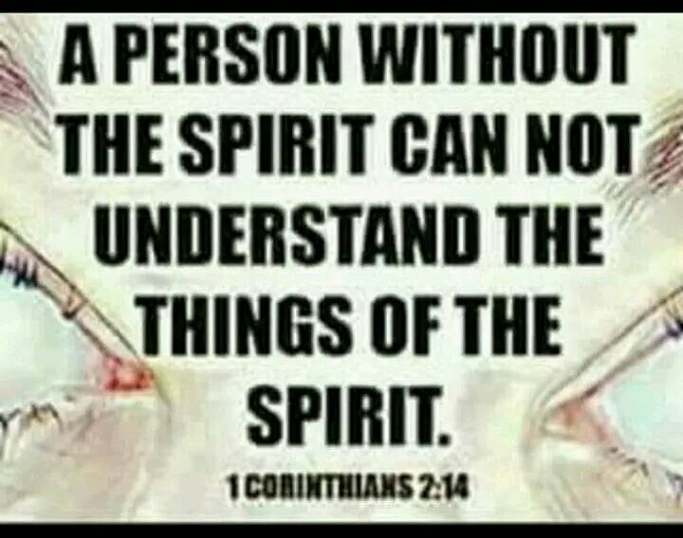And you, child, will be called the prophet of the Highest; For you will go before the face of the Lord to prepare His ways, To give knowledge of salvation to His people By the remission of their sins (through water baptism).

This is about John the Baptist Luke 1:76-77. Knowledge of salvations comes through the remission of sins at baptism and prepares the way of the Lord for baptism in the Holy Spirit. A person without the Holy Spirit cannot understand the things of the spirit because spiritual things are spiritually discerned, which is why satan wants people to believe this is unnecessary, and works salvation, and these people don’t understand true salvation, nor can they.
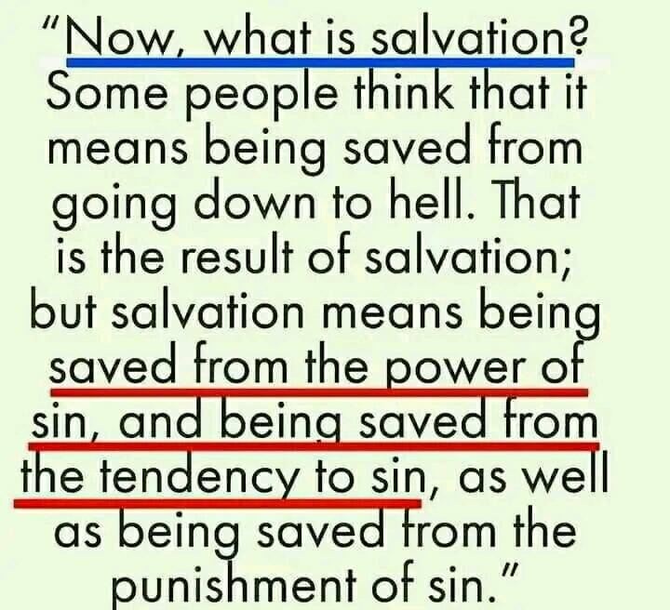

The Bible says “by which also (Jesus) he went and preached unto the spirits in prison; (after He died and descended into hell) which sometime were disobedient, when once the longsuffering of God waited in the days of Noah, while the ark was a preparing, wherein few, that is, eight souls were SAVED BY WATER. The like figure whereunto even BAPTISM DOTH ALSO NOW SAVE US (not the putting away of the filth of the flesh, but the answer of a good conscience toward God,) by the resurrection of Jesus Christ: who is gone into heaven, and is on the right hand of God; angels and authorities and powers being made subject unto him.”
1 Peter‬ 3:19-22‬ KJV‬‬‬‬‬‬‬‬‬‬

Jesus was symbolic of the ark that the people in Noah’s day wouldn’t enter. Noah and his family were saved by water after being in Christ. Just as baptism doth also now save us! Anyone who is subject to Jesus as Lord, gets baptized as an act of their free will. Faith without works isn’t the saving kind of faith. Don’t let anyone tell you baptism isn’t necessary. You’ll be left standing outside the ark when judgment comes. You must be born again of water and of the Holy Spirit through baptism in both. Repent and be baptized everyone of you is still the biblical answer to what must we do to be saved. The Bible states you won’t even have the knowledge of TRUE salvation unless you are. You won’t get it and will still be walking in spiritual blindness.

Satan’s biggest deception is telling people they are saved or born again by just believing, asking Jesus into their hearts, saying a sinners prayer and all this other nonsense that isn’t even in the Bible in order that they might not have the true knowledge of salvation that comes from being water baptized and baptized in the Holy Spirit. Even Satan believes. He doesn’t obey!
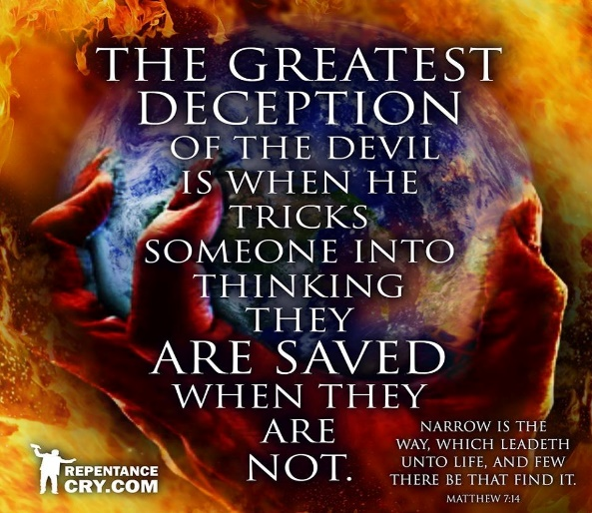
Salvation Pattern

The pattern of salvation that Jesus followed can be found throughout the Bible. The Israelites believed they would be saved while still enslaved in Egypt. Were they saved when they first believed? No. Egypt is symbolic of the world. Believing aligned them to follow Moses just as our believing should align us to follow Christ. Next they painted the blood of the lamb on their doorposts and were told to remain under the blood covering. If they disobeyed and came out from under the blood covering, the same judgment that was to come upon the world (Egypt) would come upon them, which was death. Next, they were water baptized in the Red Sea and led through the wilderness of life by the Holy Spirit who was to get them to the promised land which is symbolic of heaven. Some died in the wilderness, even though they were water baptized and led by the Holy Spirit for a time, as an example to us. If that can’t happen to us, how could it be an example? The wilderness walk is our life and it is designed to get the world out of us. We may have physically left Egypt but mentally and spiritually it has to be removed from us. This is the sanctification process and without it, you don’t enter the kingdom of heaven who has a king you must submit to. Jesus was tempted by the devil in the wilderness prior to starting His miracle ministry after being water baptized and baptized in the Holy Spirit as our example. Jesus followed this pattern of salvation and commanded his disciples to teach the same. None of this ask Jesus into your heart nonsense that isn’t even found in the Bible.
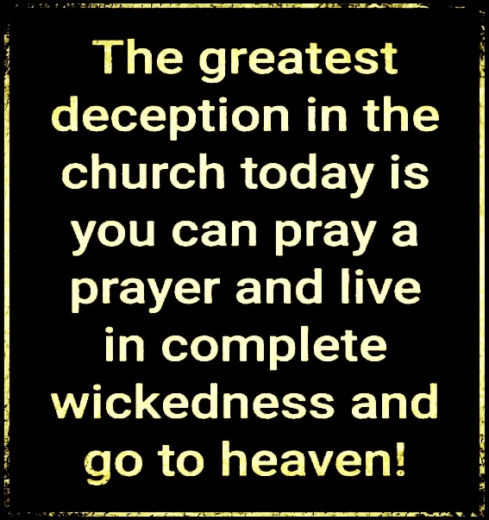
WORKERS OF INIQUITY DON’T ENTER THE KINGDOM OF HEAVEN!

In fact, they don’t even know the real Jesus because they have believed a different gospel preaching another Jesus. The word iniquity is translated you knew it was wrong and you did it anyway. That is willful sin. Usually coming from the once saved, always saved damnable heresy camp where all you need to do is believe or give mental ascent to who Jesus is to be saved. Even Satan believes. After that they believe you are eternally secure and can live as you like. Believe and faith are actually verbs or action words that are ongoing until the end. That means you will see works because faith without works isn’t the saving kind of faith.

Only those on the narrow path enter the kingdom of heaven. Many believe they are saved or who are born again who aren’t. That is why Jesus told them to depart from Him, He never knew you!

So to answer Peter’s questions, yes, there are FEW that will be saved. This gospel of easy believism and then you are eternally secure is the damnable heresy the Bible speaks about brought in by deceived preachers used by Satan to deceive the masses. Yet we idolize these preachers over God and His word. The Bible says the church will be so apostate or fallen away from the one true faith before Christ returns that most will not receive the love of the truth that they might be saved and as a result, God will give them what they want which is strong delusion. I pray you won’t want to be deluded over believing the one true gospel that delivers you from the power of sin rather than leaves you enslaved to it like the once saved always saved damnable heresy does.

The fowls of the air have lodged themselves in the branches of the mustard tree, which is likened to the kingdom of God, after the tree has grown and been there awhile. Don’t go to church’s that have fowls leading it. That is not forsaking the assembly, nor give to those ministries. You are supporting doctrines of demons and enabling evil.

Jesus died to free us from slavery to sin so that we do not incur the wages of sin which is death. He does this through the baptism of the Holy Spirit. Your freedom in Christ comes from no longer being a slave to sin but a slave to righteousness instead. This is why these fowls in the mustard tree tell you that you have all the Holy Spirit you will ever need since you believed, yet Acts 19 says the opposite. Jesus wasn’t led by the Holy Spirit into the wilderness to be tempted by the devil until He was first water baptized and baptized in the Holy Spirit. If He needed this empowerment in the face of temptation what makes us think we don’t.

“He said unto them, Have ye received the Holy Ghost since ye believed? And they said unto him, We have not so much as heard whether there be any Holy Ghost. And he said unto them, Unto what then were ye baptized? And they said, Unto John's baptism. Then said Paul, John verily baptized with the baptism of repentance, saying unto the people, that they should believe on him which should come after him, that is, on Christ Jesus. When they heard this, they were baptized in the name of the Lord Jesus. And when Paul had laid his hands upon them, the Holy Ghost came on them; and they spake with tongues, and prophesied.”
Acts‬ 19:2-6‬ KJV‬‬‬‬‬‬‬‬‬
‬
This is why we are to put away from us anyone who has a form of godliness but deny the power thereof. You must be born again of water in water baptism which baptizes you into the body of Christ where you are pledging to be dead to sin and self in order that you are raised as Christ was raised.
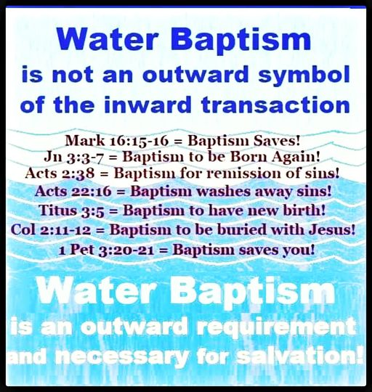
We need to stop lying to people about water baptism and it being optional. You aren’t born again without it.

Baptism in the Holy Spirit empowers you to keep that pledge. You are now equipped in order that you might be saved and in the end receive eternal life Romans 6:22. Now you work out your salvation with fear and trembling and you are without excuse if He has given us everything to live godly in this present world.
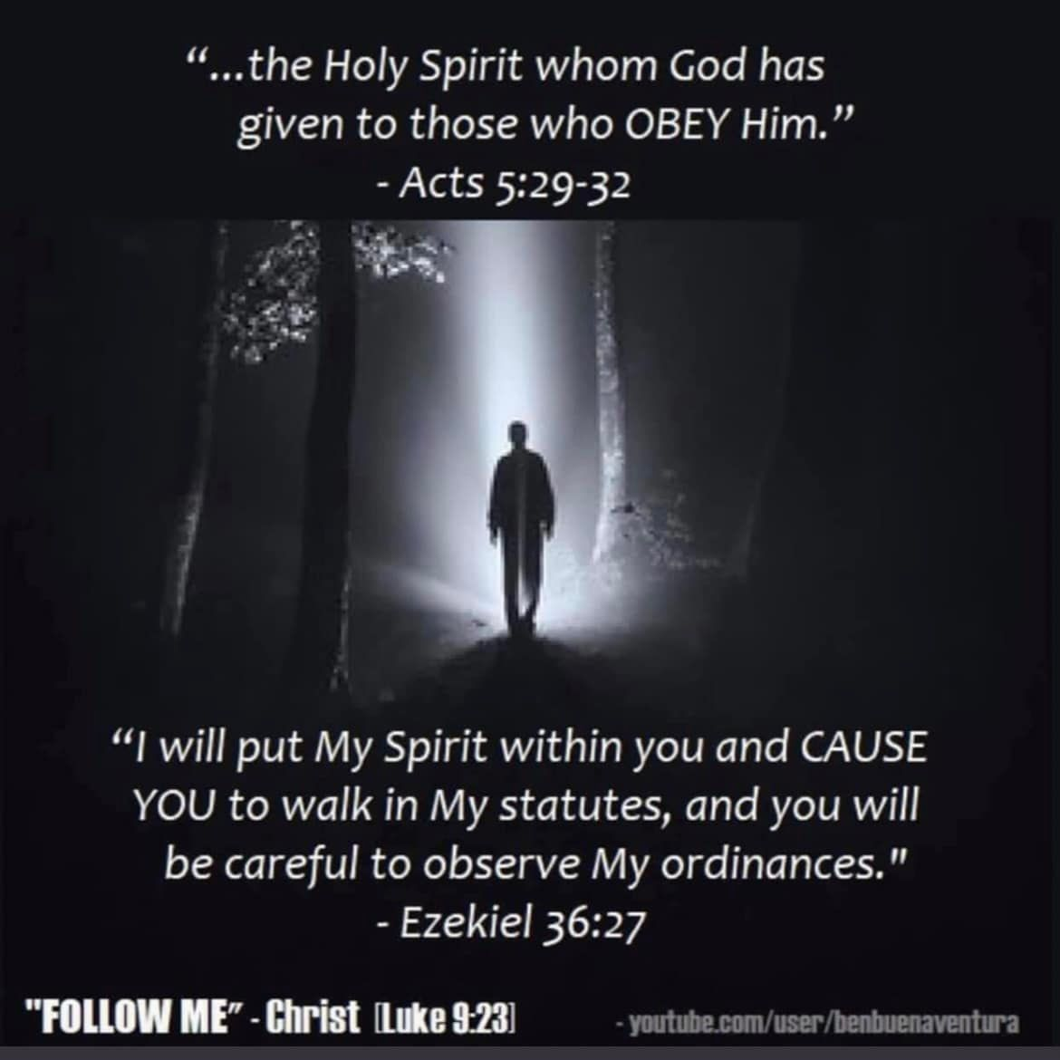
The Bible says Jesus will gather out of His kingdom all who offend (translated scandals) and all workers of iniquity or those who knew it was wrong and did it anyway. Matthew 13:41 said in the same context as the end time mustard seed tree full of the fowls of the air. So workers of iniquity won’t enter the kingdom of heaven. We have seen a lot of scandals in the church and this is why. There is nothing hidden that shall not be revealed. God warns them and gives them space to repent. Judgment starts in the house of the Lord before it starts in the world. You are going to see more scandals exposed as judgment takes place in the house of the Lord before the world is judged.

Repent if you have received a different gospel preaching another Jesus and be water baptized into His body and be baptized in the Holy Spirit. Repent and be baptized everyone of you is still the answer to what must we do to be saved. Then start utilizing that empowerment not to sin and be set free from slavery to sin so that you do not incur the wages of sin which is death. Stop believing the same lie Satan told Eve which is she wouldn’t die if she disobeyed God. Jesus can’t be savior if He isn’t Lord. Make sure you aren’t on that broad path of easy believism that leads to destruction where the wages of your sin is death. Make sure you are one of the few who are on the narrow path that leads to eternal life by forsaking your sin and utilizing the free gift of empowerment not to sin that equips you to be saved (translated delivered from slavery to sin or made whole) and in the end, eternal life.

YOU MUST WALK ACCORDING TO THE SPIRIT FOR THERE TO BE NO CONDEMNATION

The end time apostate church has taught that you are in Christ Jesus just by believing as a noun, or saying a sinner’s prayer or accepting Jesus as your Lord and savior. None of these things are even in the Bible as a way to be saved or to be in Christ Jesus where there is therefore now no condemnation. Even Satan believes as a noun and he isn’t in Christ Jesus. The word believe and faith are verbs or action words that are ongoing until the end.

This is the whole basis of the once saved always saved damnable heresy that has people walking in their flesh, condemned to death, rather than being led and controlled by the Holy Spirit and alive unto righteousness. The law has gone from being written in tablets of stone to being written upon our hearts as we are changed from the inside out.
“There is therefore now no condemnation to them which are in Christ Jesus, WHO WALK NOT AFTER THE FLESH, but after the Spirit. For the law of the Spirit of life in Christ Jesus hath made me free from the law of sin and death. For what the law could not do, in that it was weak through the flesh, God sending his own Son in the likeness of sinful flesh, and for sin, condemned sin in the flesh: That the righteousness of the law might be fulfilled in us, WHO WALK NOT ACCORDING TO THE FLESH, BUT ACCORDING TO THE SPIRIT. (Notice it is ONLY for those who walk not according to the flesh). For they that are after the flesh do mind the things of the flesh; but they that are after the Spirit the things of the Spirit. For to be carnally minded is DEATH; but to be spiritually minded is life and peace. Because the carnal mind is enmity against God: for it is not subject to the law of God, neither indeed can be. So then they that are in the flesh cannot please God. But ye are not in the flesh, but in the Spirit, if so be that the Spirit of God dwell in you. Now if any man have not the Spirit of Christ, he is none of his. And if Christ be in you, the body is dead because of sin; but the Spirit is life because of righteousness. But if the Spirit of him that raised up Jesus from the dead dwell in you, he that raised up Christ from the dead shall also quicken your mortal bodies by his Spirit that dwelleth in you. Therefore, brethren, we are debtors, not to the flesh, to live after the flesh. For if ye live after the flesh, YE SHALL DIE, but if ye through the Spirit do mortify the deeds of the body, ye shall live. For as many as are led by the Spirit of God, they are the sons of God.”
Romans‬ 8:1-14‬ KJV‬‬‬‬‬‬‬‬‬‬

This chapter explains very clearly who the sons and daughters of God are and who isn’t. You must be born again of water and the Holy Spirit in order to walk according to the Spirit. Water baptism baptizes you into the body of Christ, remits your old sins, while you are identify or pledging to be dead to sin and self IN ORDER THAT you be raised as Christ was raised. Baptism in the Holy Spirit empowers us to keep that pledge. Put away from you anyone who denies this empowerment that enables you to be saved. Grace teaches us to live godly in this present world. If you don’t see godly living, that person has not received the biblical definition of grace. Grace isn’t the license to sin but the power of God given to you not to through the baptism of the Holy Spirit. Your freedom in Christ comes from no longer being a slave to sin but a slave to righteousness instead. The New Testament states that those still living a lifestyle of sin are still under the law and it’s judgments. Those who are in Christ Jesus have ceased from a lifestyle of sin because they are utilizing the free gift of grace or empowerment and are therefore no longer under the law but grace (empowerment).

Can you see why the current apostate church has fallen so far from the original gospel taught by Jesus and the apostles? Yet many in the apostate church will not receive the love of the truth that they MIGHT BE (future tense for all who believe) saved.

You are not saved when you first believe. You must endure until the end to be saved. You work out your salvation with fear and trembling after being empowered not to sin through the baptism of the Holy Spirit. You don’t even stand a chance of being saved without the grace or empowerment that the baptism in the Holy Spirit brings, which is why we are to put those pastors and teachers away from us who deny this empowerment. They are ever learning and never able to come into the knowledge of the truth. They might give out and preach what they are ever learning but don’t be fooled by that. If they haven’t come into the knowledge of the truth regarding the biblical way to be saved, anything coming out of their mouth is smoke and mirrors and the devil’s distraction to keep you enslaved to sin and eternally damned. Jesus died to free us from slavery to sin so that we wouldn’t incur its wages, which is death. In the end we receive eternal life Romans 6:22 as a result. You cannot lose what you do not yet possess (salvation) and are still working out!

“God forbid. How shall we, that are dead to sin, live any longer therein? Know ye not, that so many of us as were baptized into Jesus Christ were baptized into his death? Therefore we are buried with him by baptism into death: that like as Christ was raised up from the dead by the glory of the Father, even so we also should walk in newness of life. For if we have been planted together in the likeness of his death, we shall be also in the likeness of his resurrection: (Your resurrection is dependent upon being planted in the likeness of His death to sin) Knowing this, that our old man is crucified with him, that the body of sin might be destroyed, that henceforth we should not serve sin. For he that is dead is freed from sin. Now if we be dead with Christ, we believe that we shall also live with him: Likewise reckon ye also yourselves to be dead indeed unto sin, but alive unto God through Jesus Christ our Lord. Let not sin therefore reign in your mortal body, that ye should obey it in the lusts thereof. Neither yield ye your members as instruments of unrighteousness unto sin: but yield yourselves unto God, as those that are alive from the dead, and your members as instruments of righteousness unto God. For sin shall not have dominion over you: for ye are not under the law, but under grace (empowerment not to sin). Know ye not, that to whom ye yield yourselves servants to obey, his servants ye are to whom ye obey; whether of sin unto death, or of obedience unto righteousness? But God be thanked, that ye were the servants of sin, but ye have obeyed from the heart that form of doctrine which was delivered you. (The right doctrine will have you being free from slavery to sin, not still enslaved to sin which is the fruit of the once saved always saved heresy). Being then made free from sin, ye became the servants of righteousness. I speak after the manner of men because of the infirmity of your flesh: for as ye have yielded your members servants to uncleanness and to iniquity unto iniquity; even so now yield your members servants to righteousness unto holiness. For when ye were the servants of sin, ye were free from righteousness. What fruit had ye then in those things whereof ye are now ashamed? for the end of those things is death. But now being made free from sin, and become servants to God, ye have your fruit unto holiness, and the end everlasting life. For the wages of sin is death; but the gift of God is eternal life through Jesus Christ our Lord.”
Romans‬ 6:2-8, 11-14, 16-23‬ KJV‬‬‬‬‬‬‬‬‬

The fruit of holiness that comes from no longer being a slave to sin allows you to obtain eternal life IN THE END!

Being born again of water and the Holy Spirit and utilizing the empowerment of grace that comes from the baptism of the Holy Spirit is absolutely essential for holiness that leads to eternal life! Put away people from you who deny this empowerment and please share if you care about where people spend eternity. God will hold those teachers accountable for all the souls in hell because they taught they were saved because they just believed.
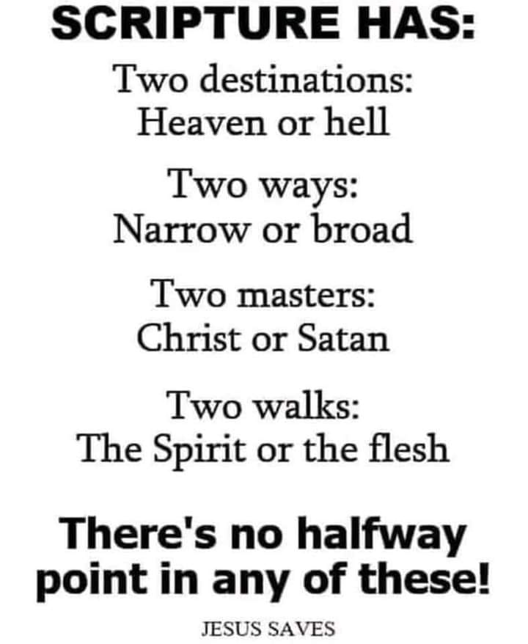
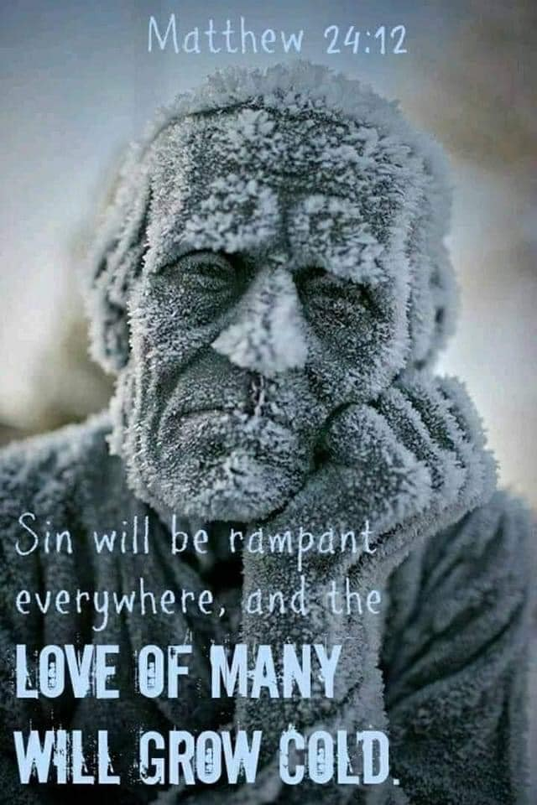

Most Christians think that they can trust in the Death, Burial and Resurrection without actually Dying, Being Buried and Resurrected themselves.
WE WOULD NOT HAVE JESUS REIGN OVER US

What happens if you don’t give out what Jesus gives you? Regarding revelation, even the revelation you have will be taken from you. When you give it out, He gives you more, which is why I give it out.

What happens when you don’t use your gifts and talents to increase the kingdom of heaven?

“He said therefore, A certain nobleman went into a far country to receive for himself a kingdom, and to return. And he called his ten servants, and delivered them ten pounds, and said unto them, Occupy till I come. But his citizens hated him, and sent a message after him, saying, We will not have this man to reign over us. And it came to pass, that when he was returned, having received the kingdom, then he commanded these servants to be called unto him, to whom he had given the money, that he might know how much every man had gained by trading. Then came the first, saying, Lord, thy pound hath gained ten pounds. And he said unto him, Well, thou good servant: because thou hast been faithful in a very little, have thou authority over ten cities. And the second came, saying, Lord, thy pound hath gained five pounds. And he said likewise to him, Be thou also over five cities. And another came, saying, Lord, behold, here is thy pound, which I have kept laid up in a napkin: for I feared thee, because thou art an austere man: thou takest up that thou layedst not down, and reapest that thou didst not sow. And he saith unto him, Out of thine own mouth will I judge thee, thou wicked servant. Thou knewest that I was an austere man, taking up that I laid not down, and reaping that I did not sow: wherefore then gavest not thou my money into the bank, that at my coming I might have required mine own with usury? And he said unto them that stood by, Take from him the pound, and give it to him that hath ten pounds. (And they said unto him, Lord, he hath ten pounds.) For I say unto you, That unto every one which hath shall be given; and from him that hath not, even that he hath shall be taken away from him.
But those mine enemies, which would not that I should reign over them, bring hither, and slay them before me.”
Luke‬ 19:12-27‬ KJV‬‬‬‬‬
‬
Jesus must be Lord in order for Him to be savior!
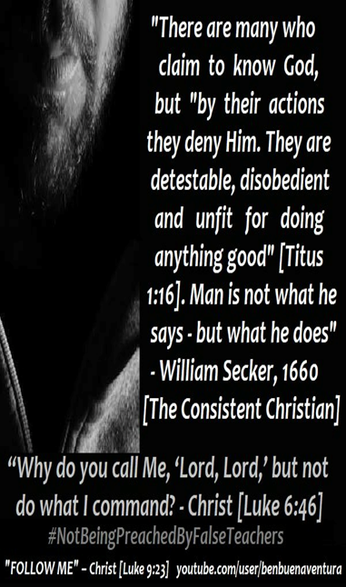
CAN’T BE PLUCKED OUT? AT WHAT TIME CAN YOU NOT BE PLUCKED?

“My sheep hear my voice, and I know them, and they follow me: and I give unto them eternal life; and they shall never perish, neither shall any man pluck them out of my hand.”
John‬ 10:27-28‬ KJV‬‬
Let’s notice first that Jesus is talking about His sheep who hear His voice and follow Him in obedience. He is not talking about people who believe and are hearers only, deceiving themselves, who call Jesus a liar by saying you don’t have to be born again through water in baptism and be baptized in the Holy Spirit. Jesus only baptizes those in the Holy Spirit who obey, so if you won’t obey in the first two things He tells us to do which is repent, then be baptized, why would He baptize you in the Holy Spirit.

Context, translation and sequence are everything so this is in the context of those who hear His voice and OBEY or follow. There are a whole lot of people calling themselves Christians or followers of Christ who aren’t. Even Satan believes. He doesn’t obey or follow.

According to the above scripture eternal life is given ONLY to those who HEAR His voice and follow or obey! You must be born again of water and of the Holy Spirit in baptism in order to enter the kingdom of heaven Jesus said. Negating that is calling Jesus a liar, not obeying, not hearing His voice but following the voice of another who is trying to enter in some other way!

Jesus gives those who hear His voice and follow Him in obedience eternal life. When is eternal life received Romans 6:22.

“For when ye were the servants of sin, ye were free from righteousness. What fruit had ye then in those things whereof ye are now ashamed? for the end of those things is death. But now being made free from sin, and become servants to God, ye have your fruit unto holiness, and the end everlasting life. For the wages of sin is death; but the gift of God is eternal life through Jesus Christ our Lord.”
Romans‬ 6:20-23‬ KJV‬‬

Eternal life is received in the end as a result of you no longer being a slave to sin but a slave to righteousness instead and having fruit unto holiness. The only way to no longer be a slave to sin is by the empowerment not to sin which comes through the baptism of the Holy Spirit. Jesus wasn’t led into the wilderness to be tempted by the devil until He was first water baptized and baptized in the Holy Spirit. If He needed this empowerment in the face of temptation what makes us think we don’t? Freedom from slavery to sin is the expectation for receiving eternal life in the end. If you occasionally mess up and sin, you confess it and He is faithful and just to cleanse us from all unrighteousness, but you do not remain in a lifestyle enslaved to sin. Jesus empowered us not to sin through the baptism of the Holy Spirit so we would not incur the wages of sin which is death. Freedom from slavery to sin and having fruit unto holiness is the requirement for receiving eternal life in the end of your life.

If context, translation and sequence are imperative for understanding and interpreting scripture, after you have received eternal life IN THE END, and have passed from this life to the next, you can’t be plucked out of His hand.

You aren’t even in His hand if you do not hear His voice and OBEY or follow. Without being born again of water for the remission of past sins in order to be clean in order to receive a HOLY SPIRIT, you have no ability within yourself to be free from slavery to sin and alive unto righteousness and have the fruit of holiness in order to receive eternal life in the end. The Holy Spirit will not remain in a person who continually grieves Him. That is why we are instructed not to grieve the Holy Spirit wherewith we have been sealed. Sealed is translated earnest or deposit like one would put down on a house with the intent to fully purchase (redeem) and occupy. He seals us until the FULL DAY of redemption indicating we are not yet fully redeemed. If the deal falls through the deposit is returned and you become a foolish virgin who doesn’t enter into the wedding feast even though you believe and are waiting for the groom.

Can you see how apostate the end time church has become with its ear tickling, flesh patting, sugar coated, everyone gets in because all they have to do is just believe. Believe is a verb and translated OBEY and the devil has duped people into believing obedience is works salvation rather than genuine faith in operation.

STRIVE to enter into the narrow gate, Jesus said. Many would say striving is works salvation. They have obviously believed another gospel preaching another Jesus. Once you are born again, the battle with your flesh starts and you are striving to continually put it to death and walk in the spirit. The devil operates in the realm of your flesh so the more flesh is crucified, the less influence the devil has in your life.

“Then said one unto him, Lord, are there few that be saved? And he said unto them, STRIVE to enter in at the strait gate: for many, I say unto you, will seek to enter in, and shall not be able. When once the master of the house is risen up, and hath shut to the door, and ye begin to stand without, and to knock at the door, saying, Lord, Lord, open unto us; and he shall answer and say unto you, I know you not whence ye are:”
Luke‬ 13:23-25‬ KJV‬‬

“Enter ye in at the strait gate: for wide is the gate, and broad is the way, that leadeth to destruction, and many there be which go in thereat: because strait is the gate, and narrow is the way, which leadeth unto life, and few there be that find it.” Matthew‬ 7:13-14‬ KJV
‬‬
ETERNAL LIFE is received in the end only by those FEW who are no longer slaves to sin but slaves to righteousness instead and have their fruits unto holiness. They have heard His voice and obeyed and were water baptized in order to be clean and receive a HOLY SPIRIT who empowers them not to sin and they are led and controlled by Him and not their flesh. As a result of being controlled by the Holy Spirit, there is no condemnation for them. There is condemnation for those who walk according to the flesh. Because there is no condemnation for them because they walk according to the Spirit and not the flesh, in the end they receive eternal life Romans 6:22 and in the end they can’t be plucked out of His hand as a result.

The end time apostate church was warned the most by Jesus about being deceived and falling away from the one true faith by false teachers who would bring in damnable heresies. If you can’t be damned as a believer, how can damnable heresies or lies be brought into the church? The Bible also teaches that most in the apostate church will not receive the love of the truth that they might be saved and as a result God will give them what they want which is strong delusion. You have to be pretty deluded to think all you need to do is just believe and live as you like and still enter the kingdom of heaven and receive eternal life. Without transformation there is no salvation!

As a result of receiving eternal life in the end that FEW receive, you can’t be plucked!
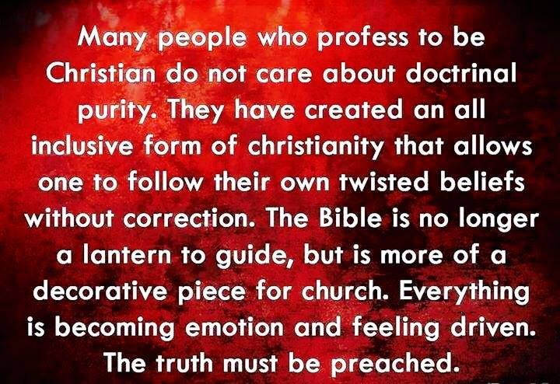
AS IT POSSIBLE FOR JESUS TO SIN? Robert Weller

Jesus was led by the Holy Spirit into the wilderness for the purpose of being tempted by the devil. It would be illogical for the Spirit of God to do this if it had no purpose. It would also be illogical to think that the devil was too stupid to know that it was a waste of time. Jesus was tempted with the lust of the flesh, the lust of the eyes and the boastful pride of life. The first Adam was tempted the same way. Jesus did not use His divine nature to resist the devil. Mat.4:1-11

Prior to Jesus' ministry, He kept increasing in wisdom and stature, and in favor (grace) with God and men. Lk.2:52 Although Jesus existed in the form of God, He did not regard equality with God a thing to be grasped (comprehended), but He emptied Himself (laid aside His privileges ), taking the form of a bond-slave (to the Father) and being made in the complete likeness of men. Phil.2:6-7

If Jesus sinned, He would not have been able to save us, or would He been able to have saved Himself. If Jesus did not have the ability to sin, He would not be qualified to be our Savior. That is exactly what the writer of Hebrews goes on to say. In the days of His flesh, He offered up both prayers and supplications with loud crying and tears to the One who was able to Save Him from death, and He was heard because of His piety. Although He was a Son, He learned obedience from the things that He suffered. And having been made perfect, He became to all those who obey Him, the source of eternal salvation. Heb.5:7-9 This is the inspired word of God that many professing Christians hate.

For we do not have a high priest who cannot sympathize with our weaknesses, but One who was tempted in ALL THINGS AS WE ARE, yet without sin. Heb.4:15 Because He was tempted in all things as we are, He is able to come to the aid of those who are tempted. Heb.2:18 No temptation has overtaken you but such as is common to man, and God will not allow you to be tempted beyond what you are able, but with the temptation will provide the way of escape also, so that you will be able to endure it. 1Cor.1o:13

Prior to the coming of Jesus we had an excuse for sin. We could say that we are poor sinners saved by grace because of the first Adam; And God would be unfair if He were to judge us. This is exactly why all judgment has been given to Jesus. God overlooked the sins prior to the cross because it was the times of ignorance. Ac.17:30-31 Jesus said that prior to His coming, we would not have sin, but now we do not have an excuse for sin. Jn.15:22 The Reformed theologians teach that we can continue in willful sin and still go to heaven. They teach that Jesus overcome the world by His divine nature, therefore we have an excuse to continue in sin. 1Ti.6:3-4

Most cults teach that Jesus came in the flesh. (JW's, Mormons, Muslims, etc.) John stated that it is those who teach that Jesus did not come in the flesh, they are the spirit of the anti-christ. 2Jn.7, 1Jn.4:1-3 The reform theologians teach that Jesus came in the flesh, but He overcame the world by His divine nature. This is Gnosticism. Augustine was a Gnostic and he Christianized Gnosticism. Calvin coped him. Isn't this exactly what John was talking about? They teach that Jesus was God (which He is and was) and that because of this, they say,” God can't sin.” God can't die either. It is the last hour. Come Lord Jesus!

We are saved by grace through (because of) faith in the truth, Thy word is true.

IS LEADERSHIP' the PROBLEM??
by Andrew Strom & Others
Over the years we have discussed many times the crisis that the
modern Western church seems to find itself in. Below are a
sampling of insightful replies from all over the world that I have
received on this topic-
JIM writes: 'There are many of us who are "loners", but not by
choice. I have been to many "churches" in my area looking for the things you mention and believe me, it is not there. Talk about
apostasy, it is everywhere, along with a good deal of deception to
boot. I would appreciate knowing where one might find the type
of church that would make up a Body as described that I could
get involved with. It certainly doesn't seem to be any of the
mainstream churches, and I have tried many smaller unknown
ones too, and been even more disappointed....'
Several people also sent me a list of the types of leaders they
have found in their area, and asked me which of these they should
sit under? - (1) Non-Spirit-filled - no anointing, (2) Controlling,
(3) Casual about sin in the congregation, (4) High-handed and
domineering, (5) Never preaches on repentance or holiness,
(6) Word of Faith - Prosperity, (7) A lot of 'hype' but little love,
(8) Preaches endlessly on 'money' and tithing, etc, etc.
CHRISTINE wrote: "I can't even find one Holy Spirit led
church anywhere in my area. It's the same old saga every
place you go. Man-made agendas, programs that bore you
to sleep, obsession with money & growth, and who will boast the
loudest this Sunday about their ministries & gifts from God?
"This is the main reason things have come unglued. So many
good saints are tired & crushed by lukewarm, compromising
preachers and lack of order & accord in the body...We are hungry
for the right order as the Lord ordained, but the leaders are out of
order in MOST instances. Many of us have spent genuine time
before the Lord, not making waves, trying to be obedient to leaders
who are completely oblivious to the voice of the Lord... In many
places there is corruption you wouldn't believe, and I was in four
fellowships that were totally dismantled by the hand of God for
similar reasons in the past 15 years. We want to obey and commit
and follow the leaders earnestly, but given the choices we have,
we are sick and tired of trying. I think the shepherds need to go
back to Christianity 101 and start over. They need to repent and
re-commit to Christ before attempting to tend the sick and
scattering sheep.
"You can't just blame the saints in this situation. You must ask
yourself WHY? Why are the saints scattering, looking for greener
pastures? Because like the book of Amos said in ch. 8, "There
would be a famine in the land, one of hearing the word of the Lord."
"Right now I know many, many, on hold because we are caught
between a rock and a hard place. We have no sense of belonging
anywhere because of the intense hypocrisy and game playing...
We want so much to please the Lord, and have NO problem
submitting to leadership, but where are the men of God who are
supposed to LEAD THE SHEEP? I think someone needs to
address them first. We are disgusted with dead shepherds &
sermons. These people pleasing, non-offensive ministries are
draining the life out of the saints.... Where's the Holy Spirit? Give
us something to go to and be a part of... At this point, staying
home is better, at least we can seek the Lord without any pretense.
"Many of us have no intention of being deliberately rebellious. But
who would want to sit in a dead service led by self-centered
ministers who rub shoulders with others like them? If we could
find a Holy Spirit motivated Pastor and flow as the New Testament
church was intended to, we'd be there whenever the doors opened...
We are not against assembling together as long as it's according
to the Bible.
"If I hear one more person say, "there is no perfect church", I think
I'll scream! We aren't looking for a "perfect church." We are
looking to find CHRIST in the center again, and to become more
CHRIST-LIKE ourselves!!!
"What are we supposed to be a part of? Cake sales, yard sales,
watered down sermons, program after boring program, lectures
about giving more money and "a form of godliness denying the
power thereof?" This is happening all across the USA. The sheep
are going to be only as good as the shepherd who leads them... If
the leaders are playing games, what do you expect the sheep to
do? Some may be content to follow the crowd, but the Lord has
called others to Himself for a meaningful relationship with Him,
and the local churches aren't hearing the marching orders of the
Lord! The Lord does have a remnant who are seriously determined to follow Christ and obey!"
JEFF writes: "I have been "Out-of-Church" for some time now, and
have been wanting to - and being led by the Lord to - have a house
church in my home. Recently I found a local expression of the
Body of Christ that is meeting in a home. Their entire purpose is to
have a home church, and raise up the men to be leaders, so that
eventually, THEIR home becomes a meeting place for a home church.
"While there is and are leaders, the emphasis is on each man
bringing something to the meeting. Instead of just one man being
the one who "brings the Word of the Lord".
"Just after a few weeks after "assembling together" with this group,
God had led other people to my family, and us to others, that will
soon be assembling in my home.
"The problem with sitting in a "traditional church"... is just that. The men just SIT. The men are to be leading, or learning to, and
exercising leadership. If they just passively SIT, they are not doing
what God wants them to. In my opinion, they might as well be "Out-of-Church."
"God does not want MEN to SIT. He wants them to Lead. He wants
them to Lead their family, and He wants them to lead others to Christ.
"One big church, with one man doing the leading, does not allow
other men to grow into leadership. Small groups of men, (families)
afford each man the opportunity to be obedient to the Scripture:
1 Cor 14:26- "How is it then, brethren? Whenever you come
together, each of you has a psalm, has a teaching, has a tongue,
has a revelation, has an interpretation...." (-NKJV).
"In our meetings, we always start off with a potluck dinner. Each
one brings something to eat.. and there is plenty for everyone. The
rest of the meeting is no different. Each man brings some spiritual
food to eat... and there is always plenty for everyone to be exhorted.
"Remember the REASON for assembling is to EXHORT ONE
ANOTHER. You go to bless them.. not to be blessed by them.
This requires you to bring something to the Body of Christ. This
has not changed since the time the Israelites were at the Mountain
of the Lord after they came out of Egypt.
"I encourage each one who reads this, to consider either joining a
home church in their area, or starting one...."
ANDREW again: Some real food for thought in each of these
comments above. This does indeed seem to be an enormous
crisis right across the Western world. We need REVIVAL and
great REFORMATION!

IF LEADERSHIP IS THE PROBLEM, WHAT IS GOD’S ANSWER TO THE PROBLEM?

So what is the Lord’s answer to the
fowls lodging in the mustard seed tree as leaders, besides gather them out of His kingdom if they don’t repent. Judgment starts in the house of the Lord. This is what He showed me.

9 Then began he to speak to the people this parable; A certain man planted a vineyard, and let it forth to husbandmen, and went into a far country for a long time.

10 And at the season he sent a servant to the husbandmen, that they should give him of the fruit of the vineyard: but the husbandmen beat him, and sent him away empty.

11 And again he sent another servant: and they beat him also, and entreated him shamefully, and sent him away empty.

12 And again he sent a third: and they wounded him also, and cast him out.

13 Then said the lord of the vineyard, What shall I do? I will send my beloved son: it may be they will reverence him when they see him.

14 But when the husbandmen saw him, they reasoned among themselves, saying, This is the heir: come, let us kill him, that the inheritance may be ours.

15 So they cast him out of the vineyard, and killed him. What therefore shall the lord of the vineyard do unto them?

16 He shall come and destroy these husbandmen, and shall give the vineyard to others. And when they heard it, they said, God forbid.

17 And he beheld them, and said, What is this then that is written, The stone which the builders rejected, the same is become the head of the corner?

18 Whosoever shall fall upon that stone shall be broken; but on whomsoever it shall fall, it will grind him to powder.

The TV stations and churches will be given over to true men of God teaching the truth, who will reverence His son, open their eyes to truth and receive correction and who can be trusted with those whom He died to save. He has been raising up those men and leaders for such a time as this. The gates of hell will not prevail against His church and there will be a final harvest after the roosting fowl are gone.



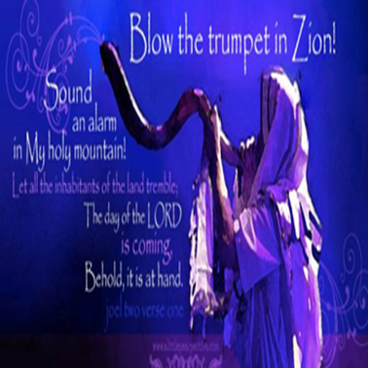

A VOICE CRYING OUT IN TH WILDERNESS MAKING STRAIGHT THE PATHS! COMING IN THE SPIRIT OF ELIJAH! AS IT WAS THE FIRST TIME, SO IT IS THE SECOND!

If you go to my YouTube channel, I have some pretty interesting videos caught on my indoor ring camera of angelic activity in my home. For some reason the Lord wanted me to know they are there. We have had violent storms go through in FL and after one such storm I went back into the room shown in the videos and a string of battery operated lights on my fireplace mantle were on. They aren’t plugged in to anything and you have to press a button pretty hard to get them to turn on. The lights surround. angel figurines I left up since Christmas. I just like them. When I opened the door and saw them on, I just started laughing. This was after they were caught on video as seen on my channel. I also have one of my cats interacting with an angel as newsletters were printing. The cat is asking for kisses just like he does with me and can be seen trying to climb up on it, like he does with me. This cat is afraid of his own shadow, but is not regarding his angelic friends. My cats are often seen watching and interacting with angels. I have videos of them doing so.
The night the videos were taken, my cats kept trying to get into that room. The doors were shut. The angelic avtivity went on all night until almost 5:00 a.m. In the morning I walked into the room and you could feel a holy presence in the room. I call it a holy awe with extreme peace and the air was almost electric. I showed the videos to people at work and someone sent me a video from a year ago of a prophetic pastor here on Florida’s east coast who caught almost the same thing on his indoor ring camera. It was on the news. These videos are best watched on a big screen TV for more detail. As my brother said, “That’s impressive”. Enoy!

For speaking engagements call
813-393-9384.

Our website is www.latter-rain.net



https://youtu.be/E_PrFVmefXc

YouTube Channel is Joanne Armstrong

