
  FRESH RAIN MAY 2018
  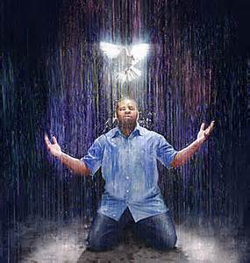
  PREPARING A BRIDE WITHOUT SPOT OR WRINKLE
[;’pcx cqxxxxxxxxxxxxxxxxxxxxxxxxxxxxxxxxxxxxxxxxxxxx
Let Me Show You My Faith By My Works

Being filled with the Holy Spirit makes all the difference in the world in reading the Bible. The Holy Spirit teaches you out of it. He opens your eyes to things you never noticed before that you thought you knew. The word without the spirit is dead just as faith is without works. You need to read the word inviting the Holy Spirit in as you do. Then be a doer of it if you expect to be founded upon a rock when the storms come. Otherwise, you are only deceiving yourself. Obedience is not works related salvation, but a response to what you believe in your heart. What you believe, you do or act upon. If you believe what the word says about believers laying their hands on the sick and they will recover, a true believer will be laying hands on the sick. If you don't believe it, you won’t and will find excuses not to do it.

You can know the word of God and not know, translated experience intimately, the God of the word. I see so many posts in different groups starting with the question, “ Is it a sin to.....? It is all about the rule and rule keeping to obtain Gods favor. The focus is on you or man. These people are eating from the forbidden tree of the knowledge of good and evil that got Adam and Eve kicked out of Eden. It was never intended for us to eat from this tree and it only produces two kinds of evil fruit like pride if you see that you are better than someone else, or condemnation if your sin is revealed. If either of these fruits are produced, you are eating from the wrong tree and may be perceiving truth through this faulty lens or stronghold that would keep you from receiving the truth. We are to eat from the tree of life. That tree is Jesus who is the way, the truth and the life. It is those three things the devil attacks or distorts to damn a person and obtain them as his trophy in Hell.

Jesus as the Way: The devil says you don’t need Jesus to get into heaven. Jesus died for all so all are saved even if you don’t believe. You are not a bad person. You haven’t murdered anyone. Reincarnation can eventually get you in if you live multiple lives good enough. There are other gods and other religions and we all worship the same one. These are all demonic lies attacking Jesus as the only way to the Father because we have all sinned and come short of the glory of God. God is righteous and must judge and punish sin. God can’t be righteous and holy without judging sin, but He is also merciful in that Jesus became our substitutionary sacrifice for our sin. This is the kindness and severity of God that we were commanded to observe or behold. You can’t have one without the other. Because of the severity of God who is righteous, holy and just and must punish sin with His wrath out of His just and righteous nature, we get to experience His kindness in sending Jesus as our substitutionary sacrifice that bore His wrath for our sins. Jesus took that punishment as our substitute so our faith in Him is what allows us to come unto the Father. All other things place the focus on man obtaining heaven through what we do. The saving kind of faith that results in works taught in the bible will be viewed as works salvation only because you are eating from the wrong tree. Not because it isn’t true.

Jesus as the truth: We can be led astray into heretical doctrine and fall away from the truth and be deceived. Thus we become apostate and have believed damnable heresies or lies that will damn you and this was said to believers in the bible. Jesus warned the most about watching out for deception, especially in end times because it would look so authentic that even the elect can and are being deceived. But Jesus is faithful to bring truth in our deception to set us free. The definition of deception is you don’t know you are wrong and think you are right. You think that you are so right that you won’t even research the truth Jesus brings you in your deception to see if it might be true. That is why we must be meek and teachable because to reject truth that Jesus faithfully brings us in our deception is rejecting Christ and our will and pride comes into play at this point. No one choked to death by swallowing their pride but their pride comes before their fall. We can willfully choose not to accept and search a matter out when Jesus reveals our deception, because pride and saving face by admitting our whole life’s ministry was built around a once saved always saved heresy, or any heresy for that matter, has become more important than admitting and accepting the truth, repenting and start teaching the real truth. The Bible calls that willfully deceived or stupid on purpose because we are making a choice to reject Jesus, submit to Him and what He died to do and we will be held more accountable to God, and the blood of those lost will be on our hands. TV stations who allow these false teachers and money hucksters on the stations will also be accountable to God for the truth given them that they rejected or ignored because the ear tickling deceivers are friends or bring ​​in the money.
The TRUTH will EXPOSE rebellion that’s for sure. But those that LOVE the TRUTH will REPENT, not RUN from it!

We must worship God in spirit and in truth. You can’t cut truth out of worship because it doesn’t suit you and think you worship God. Those are the kind of worshippers God seeks that worship God in spirit and in truth.

Abel was a prophet of God because the Bible states that the blood of all the prophets from Abel to Zacharias will be required of Jesus generation. Abel spoke truth and offered an acceptable sacrifice to God. Abel’s sacrifice was a blood sacrifice which he learned about through his parents, Adam and Eve. God slew the first animal from the garden to COVER the sins of Adam and Eve. Cain brought the works of his own hands, as a sacrifice to God which was the fruit of a cursed ground he was required to toil as a result of the curse. The first murder was over truth and what was acceptable before God. Someone who eats from the tree of the knowledge of good and evil does so out of a need to feel superior to others and any form of not measuring up produces jealousy and murder. Anyone jealous over another ministry has this issue of being focused on man and each other and the feeling of being inadequate or superior. Eating from the wrong tree!

The word martyr also means witness. If you want to be a witness as Abel was, you might be a martyr. Truth is salt that was put on a sacrifice to preserve some flesh of the animal and what wasn’t burnt up in the sacrifice became food for the priest to eat. We are to be salt in the earth that preserves people so that they can endure until the end and not fall away and become apostate. There will always be a price to pay for being salty and worshipping God in spirit and in truth. Your witness may cost you your life at the hands of those who hate truth and seek to kill you thinking they are doing God a favor. Those who think truth is hate speech, judging or legalism instead of salt sent to preserve, will hate the truth, Jesus, thus rejecting their only way to the Father. If the salt has lost its flavor it is no good but to be cast out. Stay salty at any cost as a witness.

Jesus is the life: We don’t give our life to Jesus, we get our life from Jesus. That life is the empowerment that is given through the baptism of the Holy Spirit as given at Pentecost. It is not the same as being “sealed” with the Holy Spirit. The word sealed translated from the original language means deposit or earnest, like putting a deposit or earnest money on a house with the intent to fully purchase it. If the deal falls through, the deposit is returned. It is the equivalent of becoming engaged in Jewish culture with the intent to marry. Jewish engagements could only be broken by a legal judgment due to the virgin being unfaithful before the groom came for her. So it is with us. Willful sin and deception or apostasy can bring Gods judgment and the deposit of the Holy Spirit is returned just as with the foolish virgins who ran out of oil and didn’t make the wedding feast. Only the wise virgins did because they made themselves ready. I don’t care how much you want the word “sealed” to mean something other than what it does, it won’t make it true. There are many churches that do not believe or teach in the baptism of the Holy Spirit and they teach this sealing or mere deposit is equivalent to the full and over flowing immersion of the baptism of the Holy Spirit where you are endued with power. The Bible clearly states that there will be those who deny this empowerment or enduement of power or life and from such biblical teachers we are to turn away. They only have a form of godliness but deny this power to live a life as empowered by the Holy Spirit in being dead to sin, self, our will and way and submitting to Jesus as Lord. To reject this life or empowerment is to reject Jesus and what He died to do to deliver us from sin. Sin is no longer being covered up as it was in the Old Testament. This is why the devil distorts or deceives people on these three levels because they end up rejecting Jesus and blaspheming the Holy Spirit and worshipping a false Jesus and preach a different gospel and the Bible says that those that do so, let them be accursed. They don’t know the real Jesus, even though they know the word of God, and just like the Pharisees they crucify the real Christ and true remnant followers out of their willful deception.

One last thing on faith without works that these heretical people teach. They are so far in the ditch that Jesus did it all that they don’t submit or nothing is no longer required of them that they have the faith that does not save. They proudly proclaim “faith only” and the Lord Jesus, who is truth wants to make this clear. That is not the kind of faith that saves you.

Example: a wealthy Person gives you a check for a trillion dollars as a free gift. One person just merely believes that the gift giver is good for the funds and hangs onto the check. That is not the saving kind of faith, although it is faith. They believe it but do not act upon what they believe and therefore do not have the ability to access the provision in time of temptation or need.

People who have the saving kind of faith take the check to the bank and make the deposit so the provision can be accessed in time of need. Depositing the check doesn’t make the gift any less free and is not works. It is acting upon or responding to something because you truly believe it is true. If you believe what Jesus said about believers laying their hands on the sick and they will recover, you act upon that by laying your hands on sick folks. By mere fact that you don’t do it tells that you really don’t believe it. True saving faith elicits action of obedience that God honors with power and answered prayer. The Trillion dollar check is the Holy Spirit that is given because you believe the penalty for your sin was paid or your debt was paid and you are making the deposit in you as the bank so that His empowerment or translated grace, can be accessed in time of need to empower you not to sin and thus be delivered from it, not just covered as in the Old Testament. Jesus told Paul in relation to his thorn in the flesh that he requested Jesus to remove, “My grace (translated empowerment) is sufficient for you to deal with your thorn”! Grace is only translated unmerited favor two times. All other times it is translated empowerment or “I will supply that which is needed”. This empowerment deposited in you now leads and guides you. Teaches you. When you sin, you access the grace or empowerment of forgiveness through confession and repentance as you yield to the conviction, reproof or rebuke of the Holy Spirit. In doing so, you just swiped your debit card and wiped out that debt. When you deny, hide, make excuses for or minimize your sin, the Bible says to believers that you are now grieving and blaspheming the Holy Spirit and that sin will never be forgiven you either in this world or the next unless you turn, repent and confess. To blaspheme the Holy Spirit means to throw back into the face of. When you are convicted, rebuked by someone God sent to restore you or reproved and you justify, make excuses for or ignore the Holy Spirit, you are throwing back the course correction He is trying to get you to take, back into His face and this is blasphemy. That sin can be bound to you and this is said in the context of binding and loosing. You can bind a sin to a person or loose it as a follower of Jesus who is seeking to restore a person who is in deception or gone back into a lifestyle of sin. As believers, if we catch our brother in a sin, we are to restore them in a spirit of meekness, considering ourselves first or judging ourselves making sure we aren’t in the same sin. We are commanded to judge, but not hypocritically or doing the same thing we are seeking to restore the other from. Thus we are to remove the beam from our own eye before we can see clearly to remove the speck from a brothers. But we are to judge among our brethren with the motive to restore. This was the purpose in the Old and New Covenant of going to a brother who trespassed against you yourself privately. If they heard you, you gained a brother. If they did not, you were to go to them again with two or three witnesses for the purpose restoration, not condemnation. If they still would not listen, you were to take it before the church. If they still would not listen, you were to count them as a publican and sinner or outside of the family of God. That sin and the consequence of it were bound to them. If they repented and confessed, they were loosed and forgiven.

Back to the free gift that is deposited in you through faith that you acted upon in obedience. The free funds are there but don’t do any good if not accessed. That is why the Bible states that if you believe and are baptized both in water and the Holy Spirit, you will be (future tense) saved. A person who truly believes will act by being baptized or taking the check to the bank. It is a fearful thing to fall into the hands of The almighty. Behold the kindness and severity of God.

As a result of the Baptism in the Holy Spirit, grace is not the license to sin, but the power of God given not to. Your freedom in Christ comes from no longer being a slave to sin.

Once justified, we move on to sanctified. Justification gets you to the starting line of the race. Sanctification gets you to the finish line. We all must finish our race. To drop out means to no longer finish or endure until the end because we became apostate. Our salvation must be worked out with fear and trembling as the bible states.

2 Thes 2:13 states God chose real believers to be saved (future tense) through the sanctifying work of the Holy Spirit and through belief in the truth. He wants all men to be saved and come to the knowledge of the truth. Yet the Bible states about believers in the end times that many will not receive the love of the truth that they might be saved. Truth and receiving it when deception is exposed is part of the salvation and sanctification process. Romans 6 states; and in the end we receive eternal or everlasting life. If Jesus did everything He could do in being the way, the truth and the life, which is who He is, rejecting or deny any of these is rejecting Jesus and our access to the free funds deposited in our account that lead to eternal life because of an act of our will. That is why death to self, sin, our will and way are necessary to be saved and Jesus can’t be savior if He isn’t Lord. It really boils down to choice or submission, not works for salvation because the work has been done and the free gift and empowerment provided. If you believe that, you act upon it in obedience. What will you choose to do with it? Faith without works is dead and it isn’t the saving kind of faith. Let me show you my faith by my works because if I truly believe something, I will act upon it!

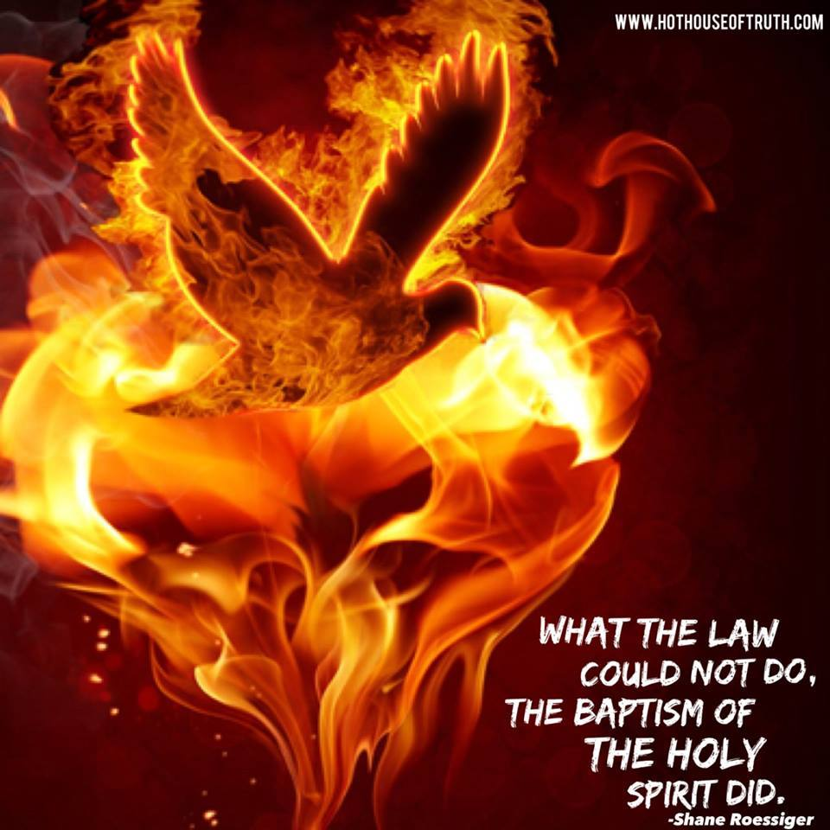
The purpose of the 10 commandment moral law was to show us our inability to keep it and therefore needed the empowerment or baptism in the Holy Spirit. The law is not bad nor has it been done away with as Jesus Himself said. He fulfilled it by empowering us to live righteously and deliver us from the power of sin we were enslaved to. We can either submit our members as slaves to sin or slaves to righteousness. Jesus can’t be savior if He isn’t Lord. Therefore, it is not works salvation but who will you serve as an act of your will after being empowered by the Holy Spirit not to sin or as Hebrews 10 states, despite the Spirit of Grace or empowerment. Judgment happens as a result of a believer who had the knowledge of the truth and knew Christ and went back into a lifestyle of sin despite being empowered not to sin or despite the Spirit of Grace or empowerment. Read Hebrews 10:26-31. This is one who fell away and went back into a lifestyle of sin or became apostate, not one who committed one sin and repented and confessed. Jesus will leave the 99 to go and woe you back, but you must not remain in a lifestyle of sin. He will always seek to save and restore you, but you have a free will.

You can’t live in a slave to sin mentality and get a promised land blessing. There was a reason for the wilderness. Moses led the slaves out of Egypt, which symbolized the world. God had to get the slave mentality out of them before they entered the promised land and those who remained in their sin and unbelief or the kind of faith that did not save, died in the wilderness and never made it to the promised land. God gives us POWER or GRACE to become sons. Those Sons of God are mature and only sons can be trusted with the keys to the kingdom or the miraculous power of God and His authority. We are to no longer be a slave to sin. Our freedom in Christ come from no longer being a slave to sin because we have been empowered not to sin through the power of the Holy Spirit as given at Pentecost. Let’s stop marching around in circles in the wilderness enslaved to sin due to false doctrine in the church that omits repentance and obedience in the name of grace only.


Romans 6
1.What shall we say then? Shall we continue in sin, that grace may abound

2 God forbid. How shall we, that are dead to sin, live any longer therein?

3 Know ye not, that so many of us as were baptized into Jesus Christ were baptized into his death? (Water baptism here folks. Water baptism baptizes us into Christ where there is no condemnation if we walk as He walked dead to sin and alive unto righteousness, not reciting a prayer. Obedience is not optional and is a sign that one has the saving kind of faith. They just swiped their debit card and accessed the free gift or funds by obeying and being baptized as an act of their will.)

4 Therefore we are buried with him by baptism into death: that like as Christ was raised up from the dead by the glory of the Father, even so we also should walk in newness of life.

5 For if we have been planted together in the likeness of his death, we shall be also in the likeness of his resurrection:

6 Knowing this, that our old man is crucified with him, that the body of sin might be destroyed, that henceforth we should not serve sin.

7 For he that is dead is freed from sin.

8 Now if we be dead with Christ, we believe that we shall also live with him:

9 Knowing that Christ being raised from the dead dieth no more; death hath no more dominion over him.

10 For in that he died, he died unto sin once: but in that he liveth, he liveth unto God.

11 Likewise reckon ye also yourselves to be dead indeed unto sin, but alive unto God through Jesus Christ our Lord.

12 Let not sin therefore reign in your mortal body, that ye should obey it in the lusts thereof.

13 Neither yield ye your members as instruments of unrighteousness unto sin: but yield yourselves unto God, as those that are alive from the dead, and your members as instruments of righteousness unto God. (An act of your will not works.)

14 For sin shall not have dominion over you: for ye are not under the law, but under grace or the empowerment not to sin.

15 What then? shall we sin, because we are not under the law, but under grace? God forbid.

16 Know ye not, that to whom ye yield yourselves servants to obey, his servants ye are to whom ye obey; whether of sin unto death, or of obedience unto righteousness? (Notice that still being a servant to sin leads to death.)
17 But God be thanked, that ye were the servants of sin, but ye have obeyed from the heart that form of doctrine which has delivered you. (Is the doctrine being delivered unto you freeing you from being enslaved to sin by teaching you are being empowered not to sin or is it strengthening sin by teaching “Once saved, always saved and nothing you can do can cause you to lose salvation or eternal life which the bible states comes in the end anyway. If there is no consequence for future sins that are not repented of, and your freedom in Christ is viewed falsely as being free to sin because all sins, past, present and future are covered under His blood, you are deceived and this has strengthened sin, not delivered you from it. Sins are no longer covered anyway in the New Testament. You are delivered from them, so if you are still a slave to them, how delivered and saved are you?)
18 Being then made free from sin, ye became the servants of righteousness.

19 I speak after the manner of men because of the infirmity of your flesh: for as ye have yielded your members servants to uncleanness and to iniquity unto iniquity; even so now yield your members servants to righteousness unto holiness.

20 For when ye were the servants of sin, ye were free from righteousness. (If you continue to serve sin believing all future sins are covered, you are not righteous.)

21 What fruit had ye then in those things whereof ye are now ashamed? for the end of those things is death (not eternal life).

22 But now being made free from sin, and become servants to God, ye have your fruit unto holiness, and the end everlasting life.

23 For the wages of sin is death; but the gift of God is eternal life through Jesus Christ our Lord.

Your freedom in Christ comes from no longer being a slave to sin because the baptism of the Holy Spirit empowers you not to sin. Therefore, you are no longer a slave to sin. If you are still being a slave to sin, it is by choice if you have been baptized in the Holy Spirit. This free gift was not available until the death and resurrection of Christ and the Holy Spirit comes to make you Holy and will only live in those who want to be Holy, not just declared holy or justified without the intent to become what was declared.

Heaven is not my destiny. My destiny is to be conformed to the image and likeness of the Lord Jesus Christ in this life so the Lord God will have an AUTHENTIC witness to His life and power in the earth!
--Don Nori Sr.

If you are eating from the “tree of the knowledge of good and evil” with this works mentality where obedience and submission is misconstrued as performance or works based when it is really a choice in who you submit to, you have missed the whole point. Just because you view it through that lens because you are eating from the wrong tree, doesn’t make it so. You are deceived. It should drive you to the tree of life where you get your freedom and empowerment not to sin by receiving truth and the power to obey and walk in it. That is life. The wages of sin is still death. The wages of walking in righteousness is eternal life in the end and bodily resurrection as Christ was resurrected. Grace without truth is license. Truth without grace is legalism. Both are in ditches and equally in error and off the right path. Neither are more in error than the other. Let’s get on the right path by receiving the Truth and loving the truth and view it as seeking to save us when we get deceived. That is who Jesus is and what He died to do and He is faithful. Will you be faithful to study the matter out and repent if you have been deceived or will you be willfully deceived or stupid on purpose? It really all comes down to your will, and who you submit to, not works.
When we first believe we are justified, which gets us to the starting line of the sanctification race of life. Justification is just the beginning of the salvation process that we must respond to by an act of our will in obedience. The bible says that those who believe and are baptized will be saved. Mark 16:16 Jesus said that you must be born of water and of the spirit in order to inherit or see the kingdom of God. This is not works, but a response to what you believe. It is an act of obedience and your faith produces works and this is the kind of faith that saves. You are taking the check to the bank and making the deposit, which does not make the gift any less free.

1 Peter 1:2 Our salvation is "through sanctification by the Spirit and through belief in the truth"

2 Thessalonians 2:13 But we ought always to thank God for you, brothers loved by the Lord, because from the beginning God chose you to be saved through the sanctifying work of the Spirit and through belief in the truth.

You can’t have salvation if you skip sanctification and reject the truth, who is Jesus. That is why Jesus warned so much about deception in end times the most and that it would be so convincing that even the elect would be deceived and only those who love the truth and will search out a matter and admit their error so none are lost. The bible states that many would not receive the love of the truth that they might be saved and this was said to believers, not unbelievers. How can you bring in damnable heresies into the church, or lies that will damn you, if as a believer can’t be damned? Eternal judgment is still a foundational teaching of the church to believers.

1 Timoth 2:4 who wants all men to be saved and to come to the knowledge of the truth.

Jesus said “My people perish for a lack of knowledge”.

Jesus said, “If you don’t allow me to wash you, you have no part with me. Obviously you have to first believe in Jesus which is justification and then allow Him to wash you through the sanctification process.

Many things in the Old Testament the Israelites were told not to do was to preserve the race from diseases and micro organisms that could destroy the race through which the Messiah would come. They were commanded not to get tattoos, not eat this or that or clean utensils a certain way. Today we have refrigeration, microwaves, stoves and ovens and other things to sanitize utensils. This made up most of the Mosaic law that was done away with that the Pharisees kept adding on to in order to preserve a race of people. That can be a whole other teaching.

The 10 commandments or Gods moral law will never be done away with and always points us to loving God first and our neighbor as ourselves and should always lead us to grace and cause you to run to the tree of life. There is no grace without first showing you your need for it, which is the purpose of the law. You can’t keep it in your human strength or power. You will fail every time or be puffed up because you feel superior to others that you compare yourself to, always focused on yourself or man instead of Christ and the finished work of the cross. Jesus is the standard and plumb line that we should be in process of being like and it is a process and we are all at a different stage of this process if we are born again and seeking to live a life pleasing to God.

Many of our sins come from wounds that we are not aware of that until the Lord exposes and heals it, that sin will not go away no matter how much you strive in your ability to do better. You must deal with the root to stop the fruit of that sin. I saw a movie that I hope all would rent called “Leap of Faith” with Steve Martin who was a traveling huckster evangelist who used the word of God to extort money from people of faith. This is the Jesus I know. The Lord identified, point His finger on and exposed a wound in Steve Martin and he repented. Only those in denial or deceived, like the Pharisees get their sin pointed out to them because they couldn’t see it and even then it was to lead them to grace. A person who does not fear God is not teachable. A God fearing person would be mortified if God pointed out in His faithfulness that they were in some kind of deception and fall on their face and search the matter out. There is not enough Holy reverence for the Lord in the church today. We confuse Holiness with legalism and accuse those that speak of it as legalistic as well, yet God is Holy but not legalistic. He deals with the heart and mind that leads to Holy living. A legalistic Spirit is focused on behavior or how thing look on the outside with the focus on man, while ignoring the internal. The word repent deals with your mind and changing it so you see as God sees so that you will turn and walk in a different direction.

The rich young ruler thought he had kept all the rules until Jesus exposed that his idol that he worshipped above God was money. That dealt with the heart and mind because he was deceived and needed it revealed. This rich young ruler thought he loved God above all else and his neighbor as himself until Jesus asked him to do something which really revealed the rulers true heart. Your actions or lack thereof prove what is in your heart. This ruler called Jesus good. Jesus responded by saying only God is good so by calling me good, you are acknowledging that I am God. The rich young ruler then asked what he must do to inherit eternal life. Jesus asked him what the law said. Why would Jesus point him to the law first? The law is not evil but good and from God to serve a purpose.
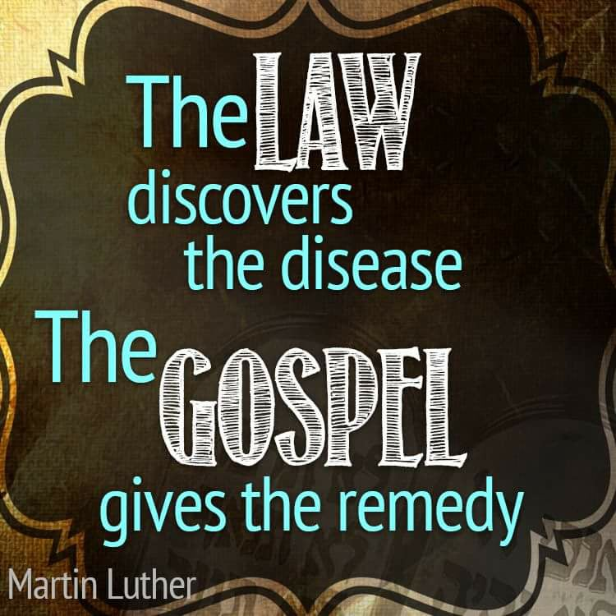
The rich young ruler responded by saying that we are to love God with our whole heart, mind and soul above all else and love our neighbor as ourselves. Then he tried to justify himself by saying he had done that since his youth. Obviously this young man believed himself to be something he wasn’t which is why Jesus pointed him to the law and then asked him to demonstrate what he believed by giving him something to do. That was to sell all he had, give to the poor and follow Jesus whom he acknowledged as God. His works were to prove that what he believed about himself was either a lie or true. What you truly believe, you act upon in obedience which shows the true condition of your heart and is not works based salvation. Our hearts are deceptive above all things the bible says. It revealed that the young man loved money more than the Lord who he acknowledged as God and he couldn’t get rid of what he loved more in order to demonstrate that God was his first love and he would be loving his neighbor as himself by giving to the poor. Works reveal what a person truly believes. Thus, let me show you my faith by my works. I wonder if the rich church leaders today could sell all they had, give to the poor and follow Jesus if asked to do the same. They might believe themselves to be something they are not as well. Only their actions will provide an answer. The kind of faith that saves, produces obedient works by taking the free gift to the bank and making the deposit in you as the bank account so the empowerment or funds can be accessed in time of need. Obedience in being baptized both in water and of the Holy Spirit is the saving kind of faith and is not works salvation. Making the deposit doesn’t make the free gift any less free. If you don’t obey in making the deposit, you don’t have the kind of faith that saves, although you do have faith. Just not the right kind. The bible says that there will be teachers and churches that have a form of godliness but deny this empowerment and that from such a ones, we are to turn away. This is why they never overcome what Jesus died to deliver them from and they are duped into believing they are saved and eternally secure.
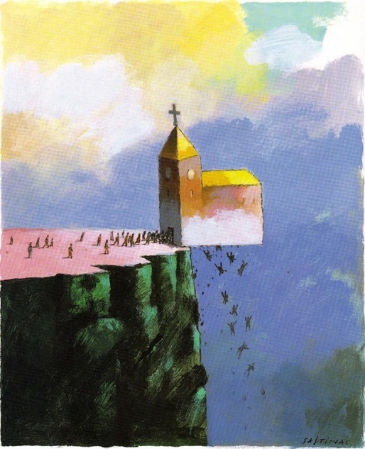
We access the empowerment or free gift deposited in us through confessing and repenting. To believers Jesus said, ‘If you confess your sins, Jesus is faithful and just to forgive your sins”. Repentance access the power. Submitting yourself to God (free will choice) and resisting the devil accesses the power. Jesus told Paul that His grace or empowerment was sufficient to deal with his thorn in the flesh. When you read the bible, substitute the word empowerment for grace, as that is the word translated from the original language and see how much more of the bible starts to make sense.
We ask the wrong question when we say “Can you lose your salvation”? It is obtained at the end of your race as a result of submitting to the sanctification process of Jesus washing you in the truth and the word because the bible says “and in the end eternal life”. Jesus said “You are clean through the word I have spoken” because we receive it and turn in the right direction. The question is not can you lose your salvation which you have not yet obtained. It is can you fall away from the faith and become apostate and the New Testament has pages and pages of scripture that say a believer can that the once saved, always saved false teachers ignore and it contradicts their false doctrine. These scriptures are said to believers. I have listed them in numerous newsletters. Let’s stop making it about losing your salvation and start addressing falling away as 2 Thes. says believers will do and become apostate before Jesus returns. Those that do not receive the love of the truth that they might be saved become “sons of perdition” as Judas was called. Jesus reveals these sons of perdition in an effort to seek and save the lost before His return because He wishes that none would perish. As the truth, He is seeking to restore those that have been deceived and became apostate as the result of a false gospel preaching a different Jesus that contradicts 2/3’s of the New Testament that speaks of believers falling away for various reasons.

Read your bibles with the focus on Jesus, not rules or other people, always knowing there is a heart matter being addressed when correction is given. Let’s be clear though that believing and sanctification means obeying and your will and way come into play. Jesus said if you don’t allow Me to wash you, you have no part with me and grace isn’t license to sin but the power of God given to you not to through the baptism in the Holy Spirit. Your freedom in Christ comes from no longer being a slave to sin.

Am reading Dr. Michael Browns book “Playing With Holy Fire”. It is a great book I wish everyone would read and speak out against these unbiblical practices and hucksters in ministry and on Christian TV. Christian TV owners will be highly judge for allowing them on air. It grieves the Holy Spirit deeply. It is a very balanced book, however I disagree with a point. Anyone operating in the supernatural that charges for their gifts, healing, prophetic word etc. is operating under the spirit of divination that counterfeits the gifts of the Holy Spirit. It is like paying a psychic for a word or soothe saying only it has slithered into the church wrapping itself in Christian language deceiving people by twisting the word of God. A spirit of divination is also called a python spirit that wraps itself around its victim and slowly squeezes the life out of it before devouring it. It gets into every part of your life including finances and relationships and destroys. It is behind porn, the reality shows and such because one of the manifestations of a spirit of divination is a peeping Tom or one who observes others from a place of concealment for their own perverted sexual gratification or fleshly purpose. We need to come together as believers against this spirit in our families and over our country. The US is the distributor of such filth to the world so guess who gets judged first as an example to the rest of the world. The word fornicators comes from the Greek word pornia which we get the word porn from and fornicators will not enter the kingdom of heaven. Jesus told believers in the context of lust, if your eye offends you, pluck it out. If your hand offends you, cut it off. Notice the correlation between the eye and the hand and He is talking about masturbation here if you haven’t caught the drift. It is better to enter heaven without all your body parts then to enter hell with them all. This is one of the greatest sins as it is a sin against your own body and the New Testament says that those who do so and take communion not discerning the Lord’s body, or what He died to provide them with, can be turned over to satan for the destruction of their flesh or death. To believers the bible says fornicators will not enter the kingdom of heaven, but most of these so called believers believe the “once saved always saved” false gospel that strengthens their sin instead of delivers them from it. I knew of a man that witnessed to his 20 year old son after watching smut together while the wife was away. He told the son that Jesus died to take the punishment for their sins and they were free to do as they liked and not feel guilty and anyone who confronted any sin was legalistic and judgmental. The 20 year old came to me asking if that were true as he scratched his head. Yet that is what the church today believes because of this “once saved, always saved” false gospel that strengthens sin instead of delivers you from it. That is the fruit of it. Jesus’ blood is viewed as only covering sin instead of delivering us from it and it is counted as an unholy thing and is trodden upon despite the Spirit of Grace or empowerment not to sin. Many will say that these people were never saved to begin with, yet they followed the current biblical teachers’ instructions to a tee as to how to be saved.
Therefore, there is either something wrong with your teaching on how to be born again and people are not really being born again because you are not teaching them the biblical way to do so, or the once saved, always saved doctrine produces fruit that strengthens sin, or both.

This spirit of divination is also behind the name it and claim it, blab it and grab it and the more modern form of declaring and decreeing something God has not spoken because “we are gods” in the temple declaring ourselves to be gods and our words have power. Sounds like the anti christ or against Christ spirit in 2 Thessalonians’. We are to be led and controlled by the Holy Spirit. We don’t lead and control the spirit realm. If God speaks something to you in a Rhema word, declare it because it originated from Him. When you go to a psychic, they operate under the influence of a spirit of divination and what they speak, they are assigning demons to you to carry it out. It may even be a good word to hook you in, keep taking your money and damn your soul. I don’t think these hucksters in the church are operating in their own God given gifts and callings. Where the Bible says the gifts and callings of God are without repentance, it is in the context of Israel, Romans 11:29 rejecting their messiah in order that the gentiles could be saved. God is saying that He is not sorry for calling or literally translated inviting Israel to be delivered. Delivered is the translation of gift. They are still His chosen people that will be grafted back in and their rejection of Jesus came in part so that mercy could be shown to the gentiles. It has nothing to do with the call or gifts or the invitation to be delivered on believers. So if the gifts and callings mean an invitation to be delivered, this has nothing to do with an anointing on a preacher, although a false preacher is being invited to be delivered of his deception. So these pulpit puppeteers are not operating in the gifts and calling of the Holy Spirit but of a demonic one. This is a good book to pass along and hopefully we will start to stand up against these hucksters and stop giving money to them.
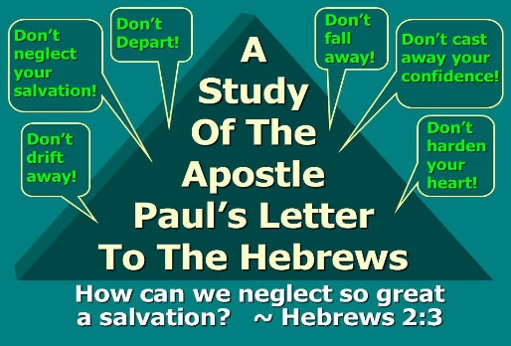
If you get a chance, go see the Paul the Apostle movie. I am preaching to myself when I say this and our church today. After watching, I really understood how the lukewarm church today would cause Jesus to vomit us out of His mouth and why we make Him sick Revelation 3:16. The early Christians suffered and died for believing in Christ. It cost them everything. In Rome Nero used Christians as street lights by placing them on posts that lined the streets, doused them in flammable liquid and burnt them alive. Christians were used in the Roman games in the coliseum where bets were being placed on how long they would live against the lions or gladiators. Even children! They had enough evidence to convict them of being a follower of Christ and they gave their lives for what they believed. Their faith had works because no one dies for something they do not believe in.
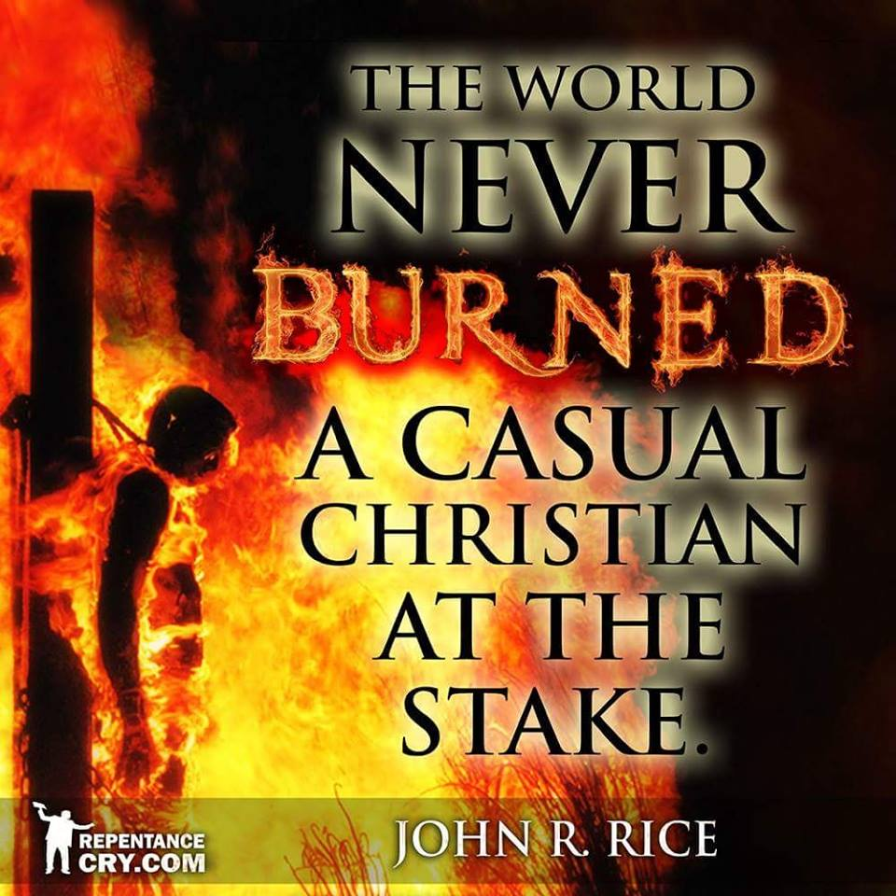
Today many profess being a Christian with no evidence to show for it and they would never be convicted in a court of law for being a Christian. In fact, I would even guess that if given a choice between martyrdom or losing everything for Jesus and the sake of the gospel, we would renounce Christ to save ourselves and our “stuff”. We can’t even give up our cell phones, watching football, video games, favorite food or beverage, money and the things it will buy for our creature comforts. Most so called Christians today would take the chip of the anti Christ in order to buy and sell because we won’t give up anything for the faith we claim or Jesus. We don’t have the saving kind of faith, which is why our gold will be tried in fire to determine who we serve, which will result in a free will choice. This is why Jesus proclaimed before He returns, “Will I find faith upon the earth”? Who has the kind of faith that saves that results in losing your life, starving or being martyred for what you believe. As I entered the movie theater, which I had to drive a long distance to because most theaters won’t show the Christian movies, I commented to my friend in jest that they even put the 3 Christian films in the very back worst theatres where you had to walk a long distance to get to and it was separated from the rest of the other theatres. It was an observation I made. After watching the movie, I again made a joking comment about how we Christians today are so persecuted because we have to endure walking so far and be put in the worst theatre. Whaaaaa! (Crying baby sound)

This was my attempt at dealing with the conviction in my heart and my friends, that made me uncomfortable about how little we really suffer for Christ and our beliefs and how much we complain and whine about being persecuted or having our rights infringed upon. It is going to get worse. This is nothing and we cry about that. I left convicted about ever complaining and being supremely grateful for anything God has graced me with, including the ability to write on a laptop in a clean environment to reach the lost globally, preaching the real gospel to all nations because Jesus will soon return. Paul wrote from a dark prison with open lash wounds on his back and people who had never met Christ in the flesh risked their lives to obtain what he wrote and smuggle it out of Paul’s prison to spread the word to the other churches. Today, if someone writes a convicting newsletter prompted by the Holy Spirit, we love our flesh patted and ears tickled so much that we hit the delete button without ever searching out a matter to see if what they are saying might be true so we can make a course correction in our walk with the Lord before it is too late.
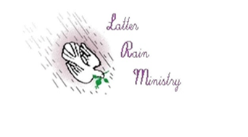
You will notice that Jesus stood outside the Laodicean church asking for someone to hear Him and let Him in! The Laodicean Church was a wealthy breeding ground for sin because in Laodicea, there were 2 aqua ducts. One carried cold water where germs could not breed and this water was refreshing to drink from on a hot day. The other aqua duct carried hot water where germs could not breed and it was good for bathing and sanitizing things. Where the 2 aqua ducts met, the water was lukewarm and a breeding ground for death causing micro organisms. That is why the Laodicean church makes Jesus sick and He vomits us out. That is why He stands outside the church door knocking asking to come in. We don’t want conviction, repenting and turning from our sins, or exchanging our newest fashions for a plain white robe of righteousness. Our money and the things it provides is our God in our idolatrous lukewarm churches. We love other things more than we love the Lord. If there is something in your life Jesus asked you to give up, what would you struggle with letting go of. It is an idol. Our gold is going to be tried in fire because the current gospel preaches that gain is godliness or Gods stamp of approval on you. We will have to actually put on white robes instead of just confessing we are already righteous and wearing them because we don’t want to go through the sanctification process after being justified. Justification starts the process of salvation through sanctification. The Laodicean church was naked. No white robes of linen. Then you are going to have to wake up to your true spiritual state once your things are gone that you love more than God because everything that can be shaken will be shaken and you are left naked. That is when you realize what you loved more than Jesus has stood in your way of hearing Him knock as He stood outside your door asking to come in and you kept ignoring the conviction and those He sent by silencing them with “Don’t judge”, “You are legalistic and I am under grace now” statements that are really meant to silence the person who is removing the cloak that covers your sin. Jesus said He was hated without a cause for removing the cloak that covered people’s sin and He also said that if we hate a brother or sister who does the same, you are in danger of judgment. He said this to believers. People believe God is good only. There is no severity in God. That is blaspheming the Holy Spirit by the way and that sin will never be forgiven you either in this world or the next the Bible says TO BELIEVERS. You can keep silencing the conviction, throwing the newsletters in the trash or hitting the delete button or you can hear what He is saying, open the door, sit down and eat with Him and overcome. Grace isn’t the license to sin but the power of God as given at Pentecost through the baptism of the Holy Spirit not to sin. Your freedom in Christ comes from no longer being a slave to sin. And to those that overcome, He will grant them to sit with Him in His throne room. Even as He overcame and sits next to the Father in His throne room. As I reread this the Lord showed me something I never noticed before. Jesus has a throne room and the Father has one. Read Revelation 3:14-22. That will be something He will expound on later and will end in a teaching I am sure as that is how He starts me on a journey. Until then, he that has an ear, let him hear and share with others what the ​​Spirit saith unto the churches.

"Modern Christianity has been watered down until the solution is so weak that if it were poison it would not hurt anyone, and if it were medicine, it would not cure anyone."
~A W Tozer

Interesting as yesterday I heard “Seventh Seal” and “Prayer of the Saints” as being connected and felt an urgent need for Gods people to pray. I went to Revelation 8 which is about the seventh seal, which when the Lord opened, all of heaven went silent for half an hour. I always took that as anticipation or dread as to what was going to take place but the Lord showed me that heaven went silent because everyone was listening to the prayers being sent up, which an angel then mixed with incense at the alter before the throne of God and the prayers went straight before Him. Heaven went silent listening to us. If that doesn’t make you want to pray in this hour, nothing will. There is also a time limit on this window of prayer time and I believe we are all being moved to prayer and intercession at this present time not only for those lost in our pews but for the harvest field, which would include those lost in our pews. Not that it is a real time half hour but that the period had a time frame in which to pray. These prayers was then placed in a golden censor and thrown to the earth, where God’s judgment begins. Judgment begins in the house of God before the world is judged and we need to intercede and pray for the lost sheep in the house of God. There are many who think they are saved but are not the biblical way. I am enclosing a newsletter on the foundational teachings of the church on how to be born again biblically. You can’t invite people to be saved and delivered until you first reveal to them that they are not and they have a need for it. God sits on His throne at this time listening for the prayers of His remnant before those prayers are mixed with incense and thrown to the earth as judgment. We are at a time when we have His ear for the lost in the house of God and in the earth. He is inviting us to pray and intercede.

Deception and heresy are serious issues that must be dealt with and exposed and certainly if one is not open to re examining what they have been taught and teach, in light of other scripture, they are not meek, teachable and have a pride issue and will be more severely judged for what they did with the truth given them once their deception has been exposed. Jesus said He will come and fight these deceivers with His mouth, which is people He speaks through. It is not them you are rejecting. Let’s get back to the foundational teachings of the church and lay it again under the church. Anything built upon a faulty foundation will only fall.

Truth is a person named Jesus. He reveals deception and our own hearts to us because the Bible says our own heart will deceive us. The spirit of truth is ALWAYS faithful to reveal heresy, some of which is damnable to believers. It is not arrogant to expose heresy if you truly love people who have believed another spirit preaching another gospel and another Jesus. Jesus said that He will keep revealing Himself and Truth which is who He is, up to the point you start rejecting it, which is rejecting Christ. After that, the Bible says you will lose what revelation you used to have. Truth will be given to those that receive and give it out and more is then given. You are judged on what you do with the truth given you. Jesus came not to bring peace but a sword which will cause division, because some will not receive the love of the truth that they might be saved and will persecute those the Father speaks through, because it is not they that speak but the spirit of the Father that speaks through them the Bible says. Be careful to search the scriptures, because foundational doctrine and salvation was paid for by the blood of Christ and to reject any truth Jesus gives, is to reject the Lord who purchased you with His blood. Demonic doctrine in the church is a cancer in His body that needs to be eradicated not tolerated in the name of unity and peace.

False gospel: Jesus died to make our lives pleasing to us.

True gospel: Jesus died to make us pleasing to God.
As I read the bible today, the Lord keeps revealing the same concept of sanctification to me. Revelation 19:7-9 Let us be glad and rejoice and give honor to Him for the marriage of the Lamb is come, and His wife hath made herself ready. Then the Lord asked me as I read this. Who made the wife ready? She did! That debunks the “Jesus does everything and we do nothing” false doctrine that would characterize this as works salvation. Then He said, “What was the result of her making herself ready”? She was arrayed in fine linen, clean and white: for the linen is the righteousness of the saints. If you just want to be in the front of the line of justification and cut out sanctification and making yourself ready, you are deceived and have believed a half truth. Justification got you to the starting line of the race. Sanctification in this life gets you to the finish line, and in the end, eternal life.


When fishing for men, we need to use live bait. We are the bait! We are a gospel read of men that when read, should attract them to Christ. We are the only Christ they may see. Therefore our faith must be alive and not lacking power or life because we abide in the vine and apart from Christ we can do nothing. You catch the best and biggest fish with live bait. The only thing that Satan can offer when fishing for men is a dead worm on a hook that he has to wiggle around in the water to make it appear alive. Satan fishes for men too. The fake signs and wonders often referred to as revival or miracles manifesting in gold dust, feathers and mist claiming to be Gods glory are dead worms on a hook being wiggled around to trick you into believing you will be dinning on live bait. Problem is there is no life in gold dust, jewels, mist and feathers and it doesn’t attract the best and biggest fish. In fact this comes from a spirit of divination that has masqueraded into the church as an angel of light with the grave sucking stuff as well. Getting the anointing without paying the price. The discerning can smell dead bait. The gullible go for the dead worm. Maybe only because there isn’t any live bait available and they are so hungry that a dead worm wiggled around makes them miss the hook that ensnares them.

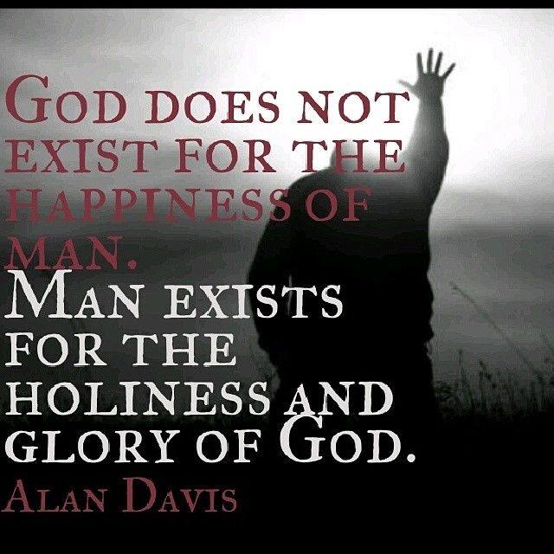

That is about to change. The Lord is about to release men and woman who are so consumed with the Holy Ghost and fire that they are totally dedicated to loving people enough to snatch them from the gates of hell into the throne room of heaven. Right now, people who claim to be Christians don’t care if their neighbor spends eternity in hell. If you had the cure for cancer and your neighbor had cancer, how can you say you love them without sharing what you know? Maybe you ate the dead worm wiggled in front of you thinking you have eternal life and your lack of love and faith are also an indicator of your lack of eternal life so you have nothing to offer to hungry fish because you lack life that comes from abiding in the vine. Either way, true disciples are about to be sent out as live bait catching the biggest and best, the hungry and duped. Those that went for the dead worm wiggled in front of them so as to make it appear live, are about to feast on the genuine that has true life. Maybe you were one, which is why you care so little about where others spend eternity. If you really believed the Bible and you are intimately connected to the God of the word that died a gruesome death to save them, how can you not be consumed with laying down your life as well to save them and be live bait? You either chomped on a dead worm offering life where there was none, or you consumed live bait that brought you life as well so that you in turn become the live bait to fish for men. If you went for the dead wiggled worm on a hook, your choice of food is about to get better because live bait produces life because the bait that attracts you is the one who loves you enough to lay his life down for you, just as the vine did that he abides in.

When Jesus heals what is broken, you finish the race. That is why he binds up the broken hearted, he heals the sick, a bruised reed will He not break and a smoking flax will He not quench. Satan comes to stop you from running. Jesus comes to keep you in the race and on the narrow path and straight gate. Many of our sins come from wounds. When Jesus heals the wound, the sin goes away. Only those in denial or who are blind in an area get their sin or deception pointed out to them.

Jesus said this is eternal life that they may know Him and the Father. Do you see why the devil wants to teach another Jesus and bring another gospel? Eternal life comes from knowing the real Jesus and the Father, not a demonic twisted one. So that we would never come to know and experience the one true God. Let those that preach a non biblical Jesus and a non biblical gospel denying its power, let them be accursed and we are to put them away from us. So why aren’t we? Why are they on TV? Why are they on the radio? Why are we speaking not a word when people are deceived, going to hell and we are not being doers of the word in bringing biblical discipline to the heretics that make merchandise of His bride? What of the hyper grace and those practicing witchcraft in the church to new babes with no discernment. Would you let something deadly be taught to you children? Why are we not just as protective of the spiritual babes?

A genuine article or thing doesn’t mind being examined to see if it is the real deal. The examination will only testify to the fact that it is. By the same token, anything not genuine, will not want to come under examination because it will reveal a fake or counterfeit of the real deal. People who are defensive and don’t want light and truth shed upon their true heart condition and beliefs do so because they don’t want the truth revealing a lie they want to continue to believe. They don’t want the cloak removed that covers what they don’t want others or themselves to see. Jesus said this is why they hated Him. He also said that if we hate another who does this, you hate them without a cause and are in danger of judgment. Being willfully deceived or stupid on purpose is not a spiritually safe place to be.
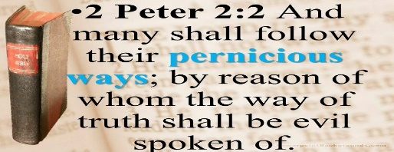
If the gospel you are preaching is not turning people from darkness to light or from the power of satan unto the power of God and if it strengthens sin by duping people into believing they are eternally secure and their sin has no eternal consequence because they are eternally secure by asking Jesus into their heart (which isn’t even in the bible) and you don’t repent, you will behold the severity of God.

Hebrews 10 deals with the willful sin of a believer that knows Christ and the truth. It states that if you willfully sin or go back into a lifestyle of sin after coming into the knowledge of the truth and you have done this despite the spirit of grace or empowerment not to sin, there remains for you nothing but a fearful looking for the judgment of the Father. That word judgment means crisis, or the time it is determined when you will be cut off forever. You have sinned despite the spirit of grace or empowerment not to and trodden under foot the blood of His son counting His blood an unholy thing. It is a fearful thing to fall into the hands of the Almighty. Your name can be removed from the Lamb’s book of life. Any name not found in the Lamb’s book of life will be thrown in the lake of fire. BEHOLD THE KINDNESS AND SEVERITY OF GOD!
He wishes that none would be lost, no not one. This is an exhortation to repent and turn from darkness unto light and from the powers of satan unto the power of God! We have a false concept of the prophetic anointing as well under the new covenant. We think it has to be all goose bumps and uplifting, yet John the Baptist was said to exhort people and he exhorted them to repent and turn from sin. Today, that would be called negative and not from God. Agabus who was a prophet, wrapped Paul’s belt around his own arms and told Paul that if he went to a certain place, this would be done to him. Today with our false teaching on what prophecy is and what the prophetic anointing is designed to do as God directs, this would have been said to not be of God because it wasn’t uplifting. Maybe our idea of what prophecy and the prophetic is does not line up with the word as it is designed to mature or perfect the saints and warn, not pat flesh. It is designed to be a watchman on the wall who sees the tricks of the enemy and warns people verbally of the tricks of the devil. If people heed the warning, they have saved themselves. If they do not, their blood is on their own hands. If the watchman sees and does not tell, the blood of those who perish is on his hands. So tell they must and in most cases it gets them killed or hated. Therefore, Jesus said before He returns, He will send the spirit or anointing of Elijah, which John the Baptist possessed. Just as it was before His first coming, so it shall be before He returns for His bride. This anointing brings truth that equips the bride to make herself ready and be arrayed in fine white linens of righteousness. This is the call or anointing upon this ministry to prepare such a bride ready and arrayed for His return. A Bride Without Spot or Wrinkle.
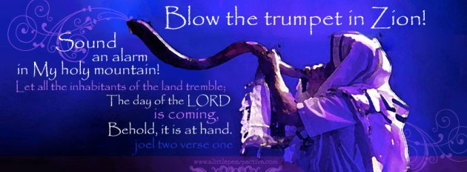
A VOICE CRYING OUT IN THE WILDERNESS MAKING STRAIGHT THE PATHS! COMING IN THE SPIRIT OF ELIJAH! AS IT WAS THE FIRST TIME, SO IT IS THE SECOND!John 3:1-13: “There was a man of the Pharisees named Nicodemus, a ruler of the Jews. This man came to Jesus by night and said to Him, "Rabbi, we know that You are a teacher come from God; for no one can do these signs that You do unless God is with him." Jesus answered and said to him, "Most assuredly, I say to you, unless one is born again, he cannot see the kingdom of God." Nicodemus said to Him, "How can a man be born when he is old? Can he enter a second time into his mother's womb and be born?" Jesus answered, "Most assuredly, I say to you, unless one is born of water and the Spirit, he cannot enter the kingdom of God.
The bible makes it perfectly clear that water baptism and baptism in the Holy Spirit are essential to being born again. It is not an option but a means to becoming born again and a response to the gospel of the kingdom of God and how to enter into it. I find more people searching out scripture in order to avoid and disobey water and spirit baptism which reveals something in that heart that really needs to be addressed. Why would someone make excuses to disobey the word or claim it is not necessary in order to be saved? They have been taught heresies.

www.latter-rain.net
For speaking engagements call 813-393-9384.

