
  Fresh Rain
  
  Latter Rain Ministry
Preparing a Bride without  spot or wrinkle |  | DECEMBER, 2019

Where are you?

The Lord gave me the title to this newsletter from Genesis 3:9 After Adam and Eve ate the fruit from the Tree of the Knowledge of Good and Evil. “But the Lord God called to the man ‘Where are you’? The Lord didn’t call out to Adam because He didn’t know where he was, but because He was trying to “locate” Adam spiritually or get Adam to notice where he was and admit it. The question was designed to make Adam think about where he was, just as this newsletter is designed to get you to think about where you are and where you need to be. Thus this newsletter will be designed, using the word of God as the mirror, to locate people spiritually because our hearts are deceptive above all things. We like to think we are something we are not. Locating us is necessary to get you from where you are to where you need to be and it starts with telling people the truth. People who don’t want to be located will blame others, or their circumstances just as Adam blamed Eve and God. They seek to cover their true state and not come to the light because they love the darkness and their sin more where they can hide. The figs leaves of human solutions will not cut it when we stand before God. There will be no excuses because he will remove them all by locating us with the truth. But to be sure, it is God’s nature to seek after you, pursue you and locate you because He came to seek and to save the lost. First you have to prove to the lost just where they are in relation to where they need to be. The hardest people to become born again are the ones who think they already are because they have been deceived. This is so that they might receive the knowledge of the truth that they might be saved. Some will not receive it. The purpose is to seek and save, not condemn. Many see God in His interaction with Adam and Eve in the garden as an angry God cursing them and slamming the door shut behind them instead of God graciously seeking the hiding sinner and provide for their restoration. He promises them victory over the tempter and sin. He graciously seeks, confronts and offers reconciliation to the guilty sinner and provides truth in our deception because that is who He is. We are to deal with our guilt and deception, not by hiding from Him or covering up and making excuses, but by coming to Him and acknowledging our sin and deception. Allow Him to pull down our mental strongholds with the truth and receive His forgiveness through confession, repentance and walking in the light He has now provided in our dark state or deception.

How you view God and the conviction and confrontation of sin and deception or Him removing the cloak that covers our state, is dependent upon what tree you eat from. You are either eating from the Tree of the Knowledge of Good an Evil or the Tree of Life. When eating from the Tree of the Knowledge of Good and evil you hear the Holy Spirit’s conviction as condemnation. That is why the bible says to be careful HOW you hear. It is your responsibility to determine if you hear conviction and truth as condemnation or correction out of love and protection in order to save your soul. This tree produces two kinds of fruit. Condemnation or pride and it is one of comparison. You either don’t measure up and feel condemned or you feel prideful because you aren’t as bad as others. Your feelings of condemnation have you hiding, blame laying, rationalizing, defending, excusing, giving your intent, explaining away and throwing it back in the face of the Holy Spirit through those techniques. That is the definition of blasphemy. That is why that sin is never forgiven you either in this world or the next. That is why it is unpardonable. You won’t acknowledge, confess and repent of it. Defending, making excuses or hiding your sin is the opposite of confessing and repenting. Only those sins repented of and confessed are forgiven. As long as you are covering it up, that sin is bound to you. If you confess and repent it is loosed. That is the context of binding and loosing. Your future sins are not automatically forgiven. Jesus counts you as righteous as long as you are making the trip and allowing Him to transform and sanctify you. Even as a believer the bible states, if you confess your sins He is faithful and just to cleanse us from all unrighteousness and loose us from that sin or you can bind it to you by blaspheming the Holy Spirit through defending, blame laying, explaining, giving your intent, justifying or covering up your sin when the cloak is removed and thus exposing it. Obviously all future sins are not forgiven if you have to confess and repent of them in order to be forgiven and cleansed. Don’t let false teachers tell you they are. That is not biblical. So someone who is eating from the Tree of the Knowledge of Good and Evil, which we were never intended to eat from, will exhibit blasphemous behavior and throw back in the Holy Spirit’s face the conviction at a time He is seeking to restore you to fellowship with God. Your sin separates you from God. That is His job. The bible says to be careful HOW you hear. Many times the Lord will send someone to you and someone eating from the Tree of the Knowledge of Good and Evil will deflect the attention off them and attack you. They will say “Don’t judge” which really means shut up and let me sin in peace. “Everyone sins” is another favorite to deflect away from them and minimize what the Lord is trying to deliver them from. They simply mean “What is the big
deal? Leave me alone”. If they attack you, the bible calls them a pig. Don’t cast your pearls before swine or they will trample the pearls in the mud and turn on you and tear you apart.
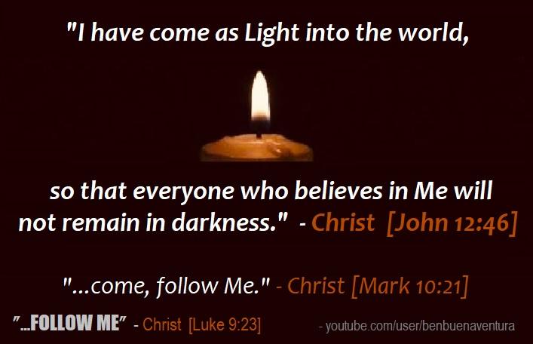
When eating from the Tree of Life you view conviction and confrontation as seeking to save because He loves you and you trust Him with your salvation, which means He provides truth in your deception and doesn’t allow you to remain in your sinful or deceived state so He is intervening to save or rescue, not condemn. He is seeking to not allow you to become apostate or fall away from the truth through damnable heresies brought into the church by deceived but well intentioned teachers. James 3 states “My brethren (believers here), be not many teachers or instructors, knowing that we shall receive the greater condemnation (judgment or verdict against)”, if we teach doctrines of demons, heresies or a false gospel preaching another Jesus or if we are deceived and He brings us truth and we reject it. Our judgement and condemnation will be far greater and severe. This is spoken to believers about believers. We need to fear God a little more in these last days as the greatest warnings were about deception and the apostasy of the church before the rapture. God is faithful and just to reveal our deception and try to pull down our mental strongholds with the truth. It is up to us if we will search a mater out and your eternity depends upon how meek and teachable you are and whether you will receive the love of the truth that you might be saved. If you love other things more, you won’t be.

James 5:19-20 states “Brethren (believers), if any of you do err from the truth, and one convert him, let him know, that he which converteth the sinner from the error of his ways shall save a soul from death and shall hide a multitude of sins”. This is the proper way to hide or cover up sin. Notice that a believer or brethren can err from the truth and the consequence of that is death of their soul, not body. This eternal security because you first believed and confessed is heresy. Be converted from error to truth through acknowledging, confessing and repenting of it and to those who have been affected by your error so they don’t go to hell as well because their blood will be on your hands. Notice in this verse that you once had to know the truth in order to err from it. This is not talking about unbelievers you are saving their souls from death.
Let’s Clear Up Some Confusion on the Faith and Works Issue

In the book of James 2:14-26 the Lord hit me with this one word: dead. Emphasizing it repeatedly through His eyes. “What does it profit my brethren though a man say he hath faith and have not works? Can faith alone save him? (Answer is of course not). Even so faith if it has not works is dead, translated like a corpse or a body without its spirit, being alone. There are many who falsely believe that any works are legalism instead of having a faith that is alive and not dead. Any mention of works gets you called a heretic and false teachers because they don’t understand the difference between dead or corpse like faith and faith that is alive and acting upon what it believes. Dead works that we are to repent of or works of the flesh, are works you do to gain God’s favor and blessings like giving to get. Works of the Spirit are brought about as a result of being led and controlled by the Holy Spirit and submitting to Jesus as Lord as He performs the works through you. We are to be exhibiting these works of the spirit as a natural outgrowth of our walking in the spirit, just like children are a natural ocurence of a woman and man joined in marriage becoming one flesh,

Here is the biblical translation of faith in these chapters. Being fully persuaded by truth or the truthfulness of God, especially reliance upon Christ to deliver you from the power of sin (salvation), in an ongoing fashion and having a lifelong ongoing constancy in that profession or persuasion in truth itself and fidelity to it. It is a verb or action word and not a noun, just like the word believe. It is not dead.

Now let’s look at the translation of works in these chapters. To toil, an act, deed, labor or work. Places where this word is used are “Work out your salvation with fear and trembling” and “Strive or work to enter in the narrow gate for many I say will seek to enter in and will not be able”! So given these definitions and uses of works and their biblical translations, are works an expected outcome of a saving kind of faith? Absolutely! Is there such a thing as faith that does not save? Again, absolutely!

Vs 17 “Even so faith, if it has not works is dead (like a corpse just like the body without a spirit) being alone”. Faith alone isn’t the saving kind of faith. Vs 18 “Thou believest that there is one God, thou doest well: the devils also believe and tremble. But wilt thou know oh vain man that faith without works is dead”? Faith without works is the kind of faith devils have and it does not save or deliver you from the power of sin.

Let me go back to this analogy the Lord gave me that most today will understand. A rich man gives you a check for a trillion dollars. One man believes the rich man is good for the funds and shoves the check in his pocket. That is faith but not the saving kind. The next guy is given a check for a trillion dollars. He endorses the check through water baptism being born again of water and deposits the check into his bank account to be accessed in time of need. Making this deposit is the baptism of the Holy Spirit who is called the gift and He empowers you not to sin and is accessible any time you need. Endorsing the check and depositing it in your account doesn’t make the funds or gift any less free. In water baptism you are baptized into the body of Christ pledging to be dead to sin and self, which going under the water is symbolic of or being buried in the grave IN ORDER THAT you be raised as Christ was raised. Being raised as Christ was raised is conditional. Baptism in the Holy Spirit empowers you to keep that pledge. This is how Jesus fulfilled the law. He didn’t do away with God’s moral law. Jesus was water baptized and baptized in the Holy Spirit prior to being led into the wilderness to be tempted by the devil as our example. Christian is defined as follower of Christ so a true Christian will do as He did and as He commanded and He commanded these baptisms in being born again of water and of the Holy Spirit. Unless you are born again in this way, you will not enter the kingdom of heaven. You will not see or understand the word of God. Your faith needs to be active and producing actions or works because if you believe what Jesus said and commanded and trust Him to save you from the power of sin, you act upon what He says in obedience. This is the saving kind of faith and not the same faith that even Devils have. Only those that will obey will be baptized in the Holy Spirit the Bible says which is why repentance is a requirement for salvation or deliverance from the power of sin.

Please share because there are people going to hell because they have the same faith the devil has and not the saving kind of faith that is active and acts upon what it believes because it relies on Jesus to deliver them from the power of sin so they follow His example and do as He commanded. Pull down their mental stronghold with the truth. If you really believe Jesus is the way, the saving kind of faith has you following and doing as He did and commanded. If you really believe He is the truth and will save you from deception, when shown your deception, you will fear Him enough to search the matter out instead of being obstinate and digging your heals in and rebelling. If you believe Jesus is the life, you will run to the tree of life to get what you need and stop eating from The Tree of the Knowledge of Good and Evil and hide. Remember there were two trees in the garden. What tree you eat from will determine how you hear and the fruit produced in your life.

Verse 24 You see then how that by works a man is justified and not by faith only. Many are walking around thinking they are justified in the Father’s sight just because they have the same faith the devil has and they have been duped into thinking any works is legalism instead of an outward acting upon what you are truly persuaded of. They are not “saved” at all.

Grace, translated empowerment, isn’t the license to sin, but the power of God given to you not to through the baptism of the Holy Spirit. Your freedom in Christ comes from no longer being a slave to sin. If you are still a slave to sin, how saved are you? Jesus died to deliver us from the power of sin. When Jesus said “It is finished” on the cross, it is translated perfected. What the law could not do except show you your sin and your inability to be free from it, empowerment translated grace, perfects what the law could not. If you are still a slave to sin, the bible says you are still under the law.
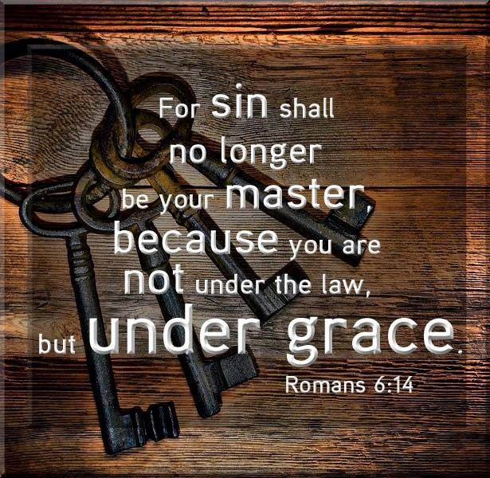
I don’t care how much you believe and confess. Your faith is the same as the devils and dead as a doornail. Those who are being saved by grace, have ceased from a lifestyle of sin and are slaves to righteousness instead and submitting to the sanctification of the Spirit and belief in the truth.
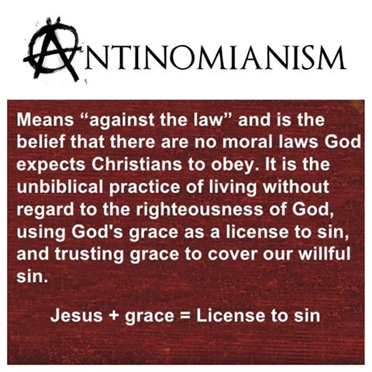
1 Peter 2:24 Who His own self bare our sins in His own body on the tree, THAT WE BEING DEAD TO SINS, should live unto RIGHTEOUSNESS: by whose stripes ye were healed.

This right here is the purpose for Christ’s death. This is the reason He came. So that we would be free from the power of sin over us, be dead to sin and self and alive or living unto righteousness because His stripes have cured us or made us whole is the translation of healed.

Has Jesus fulfilled His purpose in you? Jesus can’t be savior if He isn’t Lord. Water baptism as an adult is symbolic of you being dead to sin and self and buried in the grave, which is the going under the water part IN ORDER THAT you be raised as Christ was raised. It is a pledge you are making because you have repented or turned away from your sins. Water baptism baptizes you into the body of Christ. This is the “being born again of water” part. Being baptized in the Holy Spirit empowers you to live out what you just pledged in water baptism. That is the “being born again of the Holy Spirit” part. Unless you are born again you cannot enter the kingdom of heaven. This kingdom has a king that you submit to. Water baptism was part of the evangelical message of the first church as seen when the eunuch asked Phillip if there was anything preventing him from being water baptized. Phillip then baptized him in water. Peter told the people in response to their question “What must we do to be saved” repent and be baptized EVERYONE OF YOU. We have got to stop telling people they are born again and saved or that they came to Christ if they are not meeting the requirements to enter the kingdom of heaven. If they respond favorably in a crusade to the gospel that doesn’t mean they are born again. By telling people that, we are part of the enemy’s plan in deceiving people. We pronounce them as born again and eternally secure when they have not pledged to be dead to sin and self and baptized into the body of Christ and empowered to keep that pledge by being baptized in the Holy Spirit. After that you work out through active faith, not corpse like faith that the devil has, your salvation with fear and trembling. You don’t work out what you already have. The Bible says in the end we receive eternal life Romans 6:22, not when we first believed. The word believe is a verb and not a noun or one time act of believing. It means it is ongoing until the end resulting in you following Christ, doing as He did and doing what He commanded. That is the definition of Christian because even the devil believes. Only those that do the will of the Father enter the kingdom of heaven. Without holiness no one will see the Lord. Jesus did the will of the Father by being baptized both in water and the Holy Spirit prior to being led into the wilderness to be tempted by the devil. If Jesus needed this empowerment in the face of temptation while living in a fleshly body, what makes us think we don’t? Being a Christian does not mean you go to church or believe in Jesus and what He did historically. It means you follow Him doing all He did and commanded. Unless you do that, you are not saved at all or Christian at all. You don’t need a pastor or priest to water baptized you either. Water baptized each other. The Israelites were water baptized in the Red Sea and what water baptized them also slammed the door shut on what used to enslave them. They were led through the wilderness of life by following the Holy Spirit to the promised land. They believed while still enslaved in Egypt but they weren’t free or saved immediately after believing. They had to follow Moses out of slavery into being water baptized and being led by the Holy Spirit just as we have to follow Christ out of slavery to sin by being water baptized and baptized in the Holy Spirit in order to make it to the promised land of eternal life. The whole pattern of salvation is seen throughout the whole Bible and Jesus followed that pattern for us to follow. So if you are a follower of Christ, translated Christian, you will do what He did as our example and do as He commanded or you don’t meet the requirements that the title implies. We are to be led and controlled by the Holy Spirit through the wilderness of life which is the purpose of being baptized in the Holy Spirit. We can’t put the cart before the horse in trying to get people baptized in the Holy Spirit without them pledging to be dead to sin and self and being water baptized I have seen this so many times in churches and discouraged people leave because they are not being baptized in the Holy Spirit because they are not following the biblical pattern or having the purpose explained to them. They must first repent, be water baptized and Jesus only baptized those who will obey Him. If you aren’t willing to obey, He won’t baptize you in the Holy Spirit because you would continually be grieving the Holy Spirit. What is the point if you won’t submit to the purpose.

If the gospel you have heard isn’t preaching repentance, submission to Jesus as Lord, being dead to sin and self IN ORDER THAT you be raised as Christ was raised, you haven’t heard the real gospel at all which is the power of God unto salvation or freedom from the power of sin.
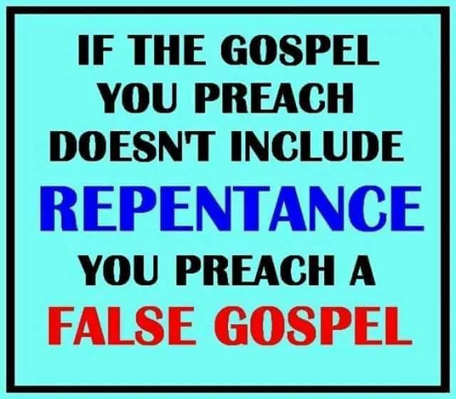
The Bible says not to have anything to do with those who have a form of godliness but deny this empowerment. They may deny it by saying you already received it when you first believed. Read Acts 19. The Bible says He gave us POWER to become sons and daughters. You are not automatically a son or daughter when you first believe any more than the Israelites were free from slavery when they first believed. You have to move out into obedience which He is ever willing to empower you to do so. He has given us everything to live godly in Christ Jesus our Lord so we are without excuse. Please let us stop preaching another gospel that preaches a different Jesus, that leads us to believe the lie Eve believed stating “Go ahead and do that. You shall not surely die. Grace is license. God is merciful only and loves you. Nothing will happen if you continue in sin instead of dying to it. All you have to do is believe and confess and you are in and good to go, forever eternally secure”. That is a lie from the pit of hell and Eve fell for it so don’t you or you will hear “Depart from me you worker of iniquity”! Iniquity is translated “you knew it was wrong and you did it anyway. You believed a different gospel preaching a different Jesus and the Bible says let them be accursed who do that.

Again the whole purpose of the death of Jesus was so we would be dead to sin and self and alive unto righteousness, by whose strips we have been cured and made whole. If Jesus has not fulfilled His purpose in you, how saved are you? Salvation or eternal life is obtained in the end of your life as a result of Jesus fulfilling His purpose in you, not because you have the same kind of faith or belief as the devil. Jesus said if you don’t allow me to wash you (sanctify) you have no part with me. No part means no part. We are saved through sanctification and belief in the truth the bible says. See last newsletter.
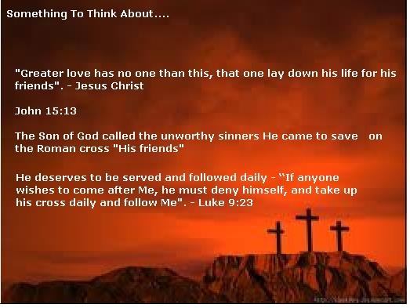

IN VAIN DO THEY WORSHIP ME, TEACHING AS DOCTRINES OF GOD, THE PRECEPTS OF MEN”

Robert Weller

It is amazing how many little religious sayings have been coined by misleading Christians. For example, if someone teaches a disciple to obey all that Jesus commanded, they are frequently accused of teaching, ”works righteousness” or they are called, “legalistic”. Most of those who make these accusations have a distorted concept of Eph.2:9 “Not as a result of works, so that no one may boast.” Paul was using an expression that all Jews and few Gentiles understand. Our fleshly ability to obey the law of Moses does not contribute to our salvation in any way.

The power to obey all of God's commandments comes as a gift. It is by the power of the Spirit. Jesus said that you will receive power when the Holy Spirit comes on you and this power enables all believers to obey all that Jesus commanded. Romans plainly states this in chapter eight. Verse three states, “For what the law (written law) could not do, weak as it was through the flesh, GOD DID, Jesus condemned sin in the flesh, v.4 So that the requirements of the LAW (of Moses) might be fulfilled IN US, who do not walk according to the flesh but according to the Spirit. This is what it means to live by faith.

The gospel is the power of God for salvation to everyone who believes. There is no power for the unbelievers. Rom.1:16-17 The righteous man shall live by FAITH. My faith is not my righteousness. It is the means to it. This power was not made available to anyone prior to the cross of Jesus. This Power is only available by the word of the cross. 1Cor. 1:18, 1:24, 2Cor.2:2-5 Because God gives us this power, we do not have an excuse to continue in sin. God has not done away with any of His law. Rom.3:31,

Rom.6:14-15, Sin is lawlessness (no Law) No one who abides in Him sins, No one who sins has seen Him or knows Him. This is why the sons of God and the sons of the devil are obvious. Anyone can recognize them. The sons of the devil sin and the sons of God don't. 1Jn.3:4-10 Lawless (no law) sinners are not saved. Mat.13:41-43, Mat.7:21-27. Power over sin is conditional to abiding IN Him and His word. Jn.8:31-36
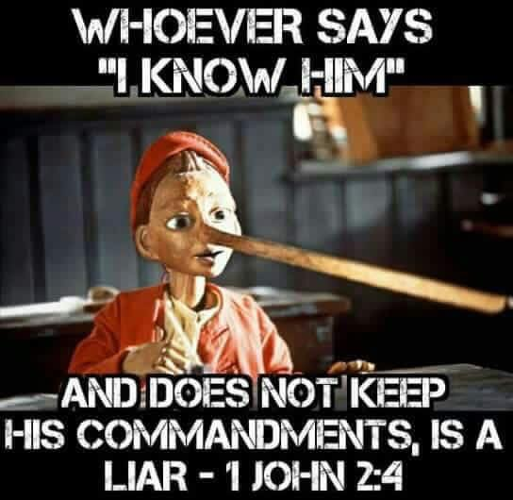

THE NARROW DOOR AND THE NARROW ROAD ARE YOUR CHOICE.

Robert Weller

The scriptures repeatedly tell us that it is ONLY those who DO the will of God that will be saved. Matt.7:21, Matt.12:50 , 1 Jn.2:17 It is God's will for all to be saved AND come to the KNOWLEDGE OF THE TRUTH. 1Tim.2:3-4, 2 Pt.1:2-4 It is God's will for all to be sanctified. 1 Thes.4:2-3 It is God's will for all men everywhere to repent (quite sinning). Acts 17:30, 2 Pt.3:9 Repentance LEADS TO salvation. Acts 11:18, 2 Cor.7:10

Jesus will not STRIVE or force you through the narrow door. Lk.13:24 He will not force you to go down the narrow road that ENDS in life. Mat.7:13-14 God will not force you to be sanctified. 1 Thes.4:7-8 God will not repent or endure to the end for you. Acts 3:19-23, Col.1:23, 1 Cor.15:1-2, Mat.10:22, Heb.3:6, 12-14 He gives His POWER to obey all that He has commanded by His Spirit. But it is only those who are willing to OBEY Him that receive His Spirit. Acts 5:32, Acts 2:28

Many people know the truth but they never love the truth.

“Bring forth the blind people that have eyes, and the deaf that have ears. Thus saith the Lord, which maketh a way in the sea, and a path in the mighty waters;

Remember ye not the former things, neither consider the things of old. Behold, I will do a new thing; now it shall spring forth; shall ye not know it? I will even make a way in the wilderness, and rivers in the desert.

I, even I, am he that blotteth out thy transgressions for mine own sake, and will not remember thy sins. Put me in remembrance: let us plead together: declare thou, that thou mayest be justified.”
‬‬‬‬‬
Over and over again through various ways and scriptures the Lord is telling me not to look back at the past. To make memories and live in the moment. He is doing a new thing. He is fighting my battles.

Gather the blind that want to see and the deaf that want to hear. Those who want their eyes opened shall see spiritually. Those who have ears to hear shall hear. There has to be a willingness to have your blind eyes opened and ears as well. Some are willingly deceived or stupid on purpose. When the Lord says to put me in remembrance He is saying to remind the people of Me. Put Me in their remembrance or don’t let those who have eyes to see and ears to hear forget about Me amidst all the false doctrines that bring damnable heresies in the church. God doesn’t need to be reminded of anything as others have taught. Put me in remembrance (to the people) and let us plead together to the people and declare truth so that their blind eyes are opened and their deaf ears hear. God will make a way where there is no way. That is His specialty. Just as He led them out from slavery in Egypt, He will lead the blind and deaf out of slavery to sin. He will part the Red Sea and close the door on what enslaved them. He will provide Rivers in the desert and blot out their transgressions for His own sake and remember them no more. Let us declare this together so that we can be justified.
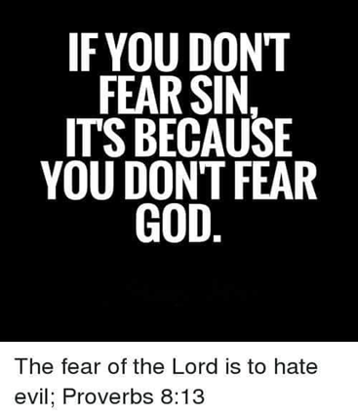

I posted a video on the origins of the sinners prayer, which is nowhere in the Bible, in order to be saved. What I found interesting was the confess with your mouth part which the modern day church has taken out of context. People in Paul’s day were killed for being a believer and follower of Christ. We do have fake Christians who believe they are saved when they are not biblically. The true test Paul was giving in regards to confessing with your mouth to prove you were a true Christian was this and in this context. Romans soldiers would go around with an alter to Cesar. They would make people come over to the alter to worship Cesar and proclaim Cesar is Lord. The unbelievers would proclaim Cesar as Lord as well as the FAKE or those thinking they were saved, Christians. When the soldiers came to a true believer asking them to proclaim Cesar as Lord, they would confess with their mouth that Jesus was Lord and be killed. That is what identified them as a true believer because deceived fake Christians won’t do it. We have made the “believe in your heart and confess with your mouth that Jesus is Lord” into an instantaneous pronouncement of being saved and eternally secure when the true test is will you confess Him as Lord if it means you would be instantly killed for doing so. Most of us can’t give up our cell phones or other pet idols and sins let alone their life. Jesus said if you lose your life in this world for His name sake you will find it in the life to come after death.
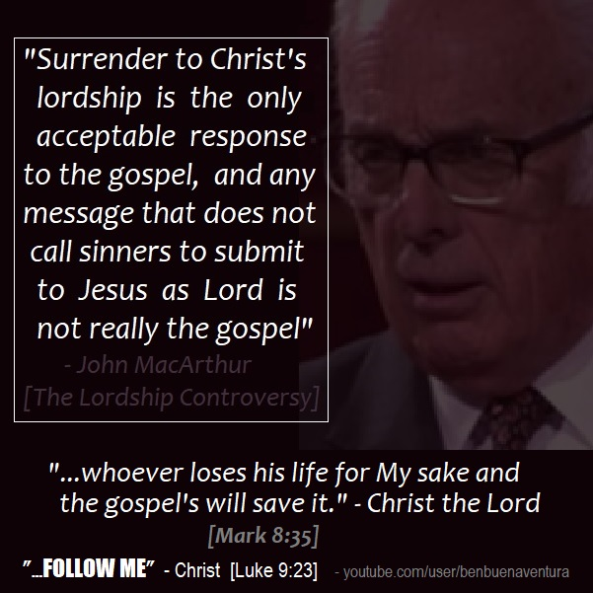

What does it profit a man if he gain the whole world and lose his soul?
Is there something or someone in your life that you cannot give up if the Lord asked you to? These are idols in your life that will keep you out of heaven. Repent now and give them up in order to be saved.

Fake Christians won’t confess Jesus is Lord if it cost them something they love. True Christians will. That is what Paul was referring to when he spoke of believing and then you will confess with your mouth that Jesus is Lord even if it cost you your life, and you will be saved. The modern day church has turned this into a formula instead of a laying down your life for Jesus as it was intended.
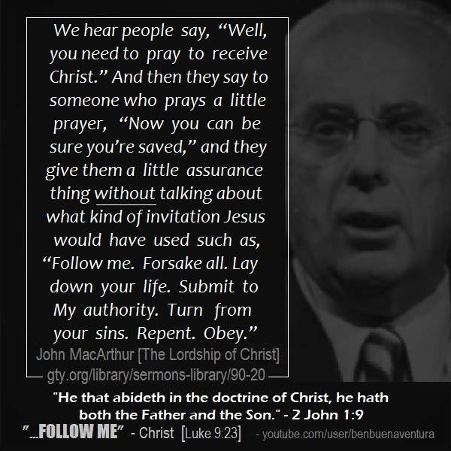

The rich young ruler had come to Jesus asking Him what must he do to inherit eternal life. He had called Jesus good. Jesus replied that only God is good which a ruler would know. Basically Jesus was saying you just acknowledge I am God by calling me good. Jesus asked him what the scriptures say and he replied, to love the Lord God with your whole heart, mind and soul and your neighbor as yourself. He told Jesus he had done this from his youth. Jesus told him to go sell all he had and give to the poor, which is the loving your neighbor as yourself part, and follow me, whom you just acknowledged as God. The rich young ruler couldn’t do it and went away sad. As he walked away, Jesus looked on Him with love. What Jesus was showing this rich, young ruler was that money was his idol and he placed it before God and if he truly wanted to inherit eternal life, he would have to repent and give up his idol before he could inherit eternal life. Jesus just revealed to him the true condition of his heart and located him spiritually in order to get him from where he was to where he needed to be. Our churches today would have led him in a little pray and pronounced him saved and eternally secure. Jesus and John the Baptist never would. Why do we do this? We are truly ignorant on the very basics of what it takes to be truly born again. It isn’t even scriptural to pray a little prayer to be saved, especially when you don’t meet any of the requirements in order to inherit eternal life.

Jesus didn’t lie to the rich, young ruler. He told him straight up what he needed to do to prove he was repentant, because he truly thought he had kept all the requirements of the law since his youth and loved the Lord above all else and others as himself. When Jesus told him he had to get rid of his idol and give it to those he claimed to love as himself, it shed light on the real condition of his heart. He didn’t love the Lord above money and what it provides. Let me ask all of us something? Is there something in your life that comes before God? You spend more time in this activity then you do with the Lord. Your very life, video games, social media, money, a relationship, work, porn, pleasure or whatever. If the Lord asked you to give up something in order to even inherit eternal life, what is the thing you struggle to give up? Is it worth going to hell for or suffering the wrath of God? The good news is that when the rich young ruler went away sad, the disciples were beside themselves and said, ”Who then can be saved?” Jesus replied that with God, all things are possible, but it starts with telling the person the truth. In order to understand this, you have to realize that this rich, young ruler was a religious leader of the highest rank. It said that Jesus loved him and when you love someone, you tell them the truth. Such and such will keep you from inheriting eternal life. Give it up. The writings of Josephus, a historian, names who this rich, young ruler was. He was Nicodemus. I always thought of Nicodemus as an old man. He came to Jesus a second time asking what he needed to do to inherit eternal life. It said he came to Jesus at night because he was afraid of the Jews or other leaders and what they thought. What had changed for him to come to Jesus expecting a different answer? Jesus now told him what he needed to do and that was to be born again of water (water baptism for the remission of past sins he had repented of) and be baptized of the Holy Spirit. By now, he had sold all he had, was a closet disciple and was expecting a different answer. He was pressing in, seeking the Kingdom of God and asking the right questions. Would he have done this if Jesus hadn’t loved him enough to tell him the truth the first time and locate him and show him he wasn’t who he thought he was. He didn’t seem to be put off the first time his heart was revealed to him when Jesus told him to sell all he had and give to the poor, even though the bible says he went away sad. At least he knows he wasn’t who he thought he was and he knew what he had to do to get what he wanted. John 3 talks about this where Nicodemus came to Jesus in the night secretly. Jesus told him, “Art thou a master of Israel and knowest not these things?” The Lord would say to us in the five fold ministry, “Art thou a master, teacher, pastor, prophet, apostle and know not these things?” These are basic to salvation and we don’t have the basics right. We are a church that is ever learning but have never come to the knowledge of the truth. Later we find Nicodemus and Joseph of Aramathia going to Pilot to claim the body of Jesus. Nicodemus went and got the 100 lbs. of oil and spices for Jesus’ body which tells me he wasn’t an old man because he had to lift this and Joseph went to claim the body of Jesus which had to be lifted. There is a reason you call it dead weight. Jesus would have to be buried in Joseph’s tomb because Nicodemus had sold his. That is why he had to team up with Joseph who would have also been wealthy. This is why Jesus had looked on him with love as he walked away sad. Jesus knew the outcome and that with the Father anything is possible, but it starts with locating the person spiritually in order to show them where they are, to get them to where they need to be. Let me ask the rich prosperity preachers living in your million dollar mansions, driving your expensive cars and traveling on you jets, can you sell all you have and give to the poor and follow Jesus?

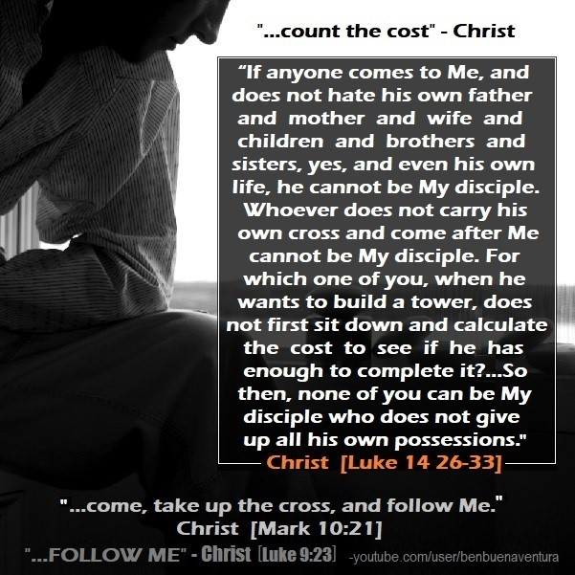

Jeremiah Johnson

While I was recently studying Matthew 7:22-24 and asking God for increased revelation, I had one of the most disturbing prophetic dreams of my life. The Scripture I was studying in Matthew says, "Many will say to Me on that day, 'Lord, Lord, have we not prophesied in Your name, cast out demons in Your name, and done many wonderful works in Your name?' But then I will declare to them, 'I never knew you. Depart from Me, you who practice evil.'"

In the prophetic dream, I was taken to hell where I saw all these ministers and individuals who had performed miracles, cast out demons and prophesied. What I was shown next I will never forget. The Holy Spirit showed me long lines of people behind all of these ministers and individuals. He immediately revealed to me that these were all the people that had received the miracles, prophecies and had been at one time delivered. As I gazed at the people in these lines, He said to me, "Did they not receive miracles, prophecy and deliverance, yet I never knew them?"

I woke up from the dream alarmed and startled. I said to the Holy Spirit, "So there are not only people that will perform signs, wonders and miracles who will be sent to hell, but also people who received all these things who will also be in hell. Why?"

Immediately the Holy Spirit spoke again to me and said, "Because those who worked miracles, prophesied and cast out demons never preached the full gospel of Jesus Christ, which is the message of repentance. They were so in love with the gifts I had given them that people became trophies and souvenirs to them. When My power would manifest in their ministries, they would tell people that I loved them, but never that they needed to repent for their sins. I tell you that a great deception will sweep over the signs and wonders movement in the earth. Beware of the ministries where miracles and prophecies will flow, but the message of repentance is a no-go. You have been warned."

Will you pray with me today that ministers and individuals who move in God's power will not only live a lifestyle of repentance but also preach it? What if people getting healed, delivered and prophesied to, and told God loves them isn't the full gospel message? What if repentance and holiness are the full gospel message too?

The bible says only those that do the will of the father enter the kingdom of heaven. Are you doing the will of the Father? Without holiness, no one shall see the Lord. Are you being transformed and sanctified and letting Jesus wash you? He said if you don’t allow me to wash you, which means submission to Him, you have no part with Him. No part means no part. The word Christian means follower of Christ. Are you doing what He did and what He commanded or coming up with excuses not to, like using the thief on the cross to disobey Jesus in being water baptized? The thief died under the old covenant and paradise wasn’t heaven. Jesus told the thief, this day you will be with me in paradise, yet three days later Jesus told Mary not to touch Him because He had not yet ascended to the Father. There is something entirely wrong with your heart if you look for reasons to discount anything Jesus commanded. That is why He is called the way. You follow. If you are not, you don’t qualify as a Christian, no matter what you say you believe. What you do proves what you believe. Jesus is the truth. Do you still hang onto false teaching and mental strongholds even when He has sent someone to you with truth using the word to discount the lies you believe? You are rejecting Jesus when you reject truth that He brings in your deception. Pride is usually the root.
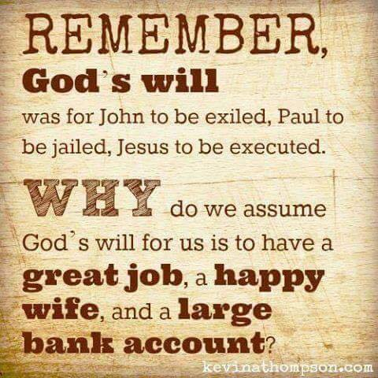
Not everyone who hears and receives the word of God receives eternal life. It depends on the heart condition that the seed was sown on. Some seed or truth of the word falls by the wayside and the devil comes and devours it or eats it right up. It produces nothing in the heart of the one who hears it. Some seed or the word of God falls on stony places and the person receives the word with joy. They say their little salvation prayer and attend church for a while and they have been pronounced saved and eternally secure but because there wasn’t much good ground for the seed to take root, it sprang up quickly and wilts when the heat is on. These folks can’t take persecution because of their belief in Christ. Some seed falls on a thorny ground heart and the cares of the world and the DECEIPTFULNESS OF RICHES or the prosperity gospel come and choke out the word and they become unfruitful. Those who are clean, or are not covetous, don’t fall for this deception in the church. The one who receives the seed in good ground is he that has EARS TO HEAR the word and UNDERSTANDS IT and bears fruit. Just because you hear or receive the word, doesn’t mean you will endure until the end in order to be saved. The strategy of the devil is to cause you to fall away. Only those that are doers of the word and not hearers only have a firm foundation that will withstand the storms of life. Are you a hearer only or do you actually do what the word of God says?
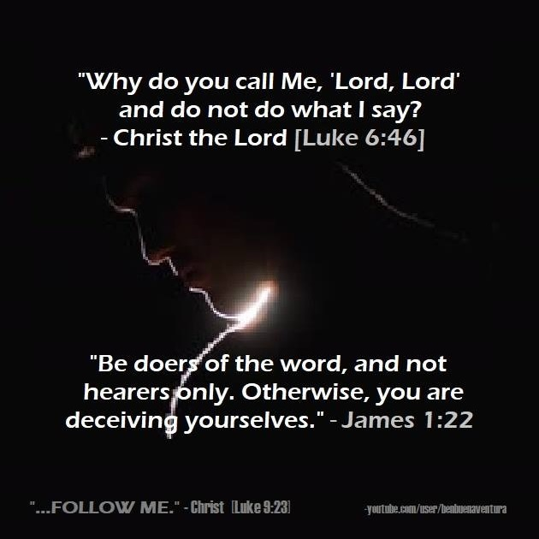

Then we have dogs that return again to their sinful lifestyle or the bible says they return again to eat their vomit. We have the pig, where if you give them truth or teach them something or correct them, they attack you. They can’t use the word to dispute anything you just said, so they attack you as a person. The pig tramples the pearls under their feet because they don’t value them and they turn on you to rip you apart while calling themselves a Christian. They are deceived.

Then we have wheat and tares. They look exactly alike until they mature. A tare sucks the life out of the wheat and reaches for the sun. The wheat dies and bows low to the ground because it is heavy with seed. Tares are toxic and wheat nourish.

You have the worker of iniquity who thinks he is a Christian because he believes grace is license to sin. He has believed a different gospel preaching a different Jesus and he will hear “Depart from Me you worker of iniquity. I never knew you”! The word iniquity means you knew it was wrong and you did it anyway. You have to really be deceived to believe that Jesus died so you could remain sinning. In the fishnet of evangelism, the bad fish are thrown back.

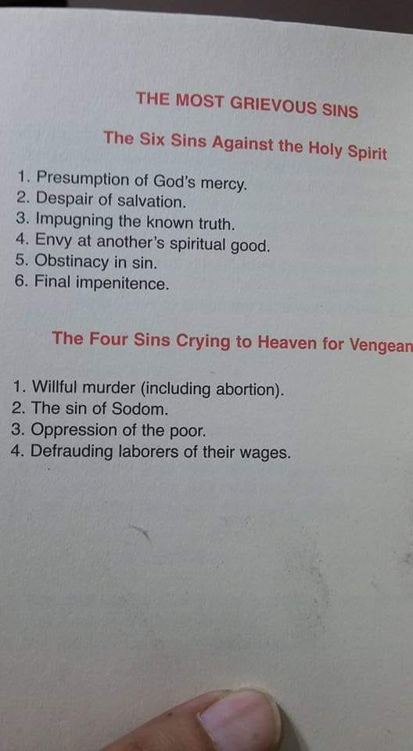

John 15:14 Ye are my friends, if ye do whatsoever I command you. There are a whole lot of people singing “I am a friend of God” who don’t do what He cammanded and they are deceived.
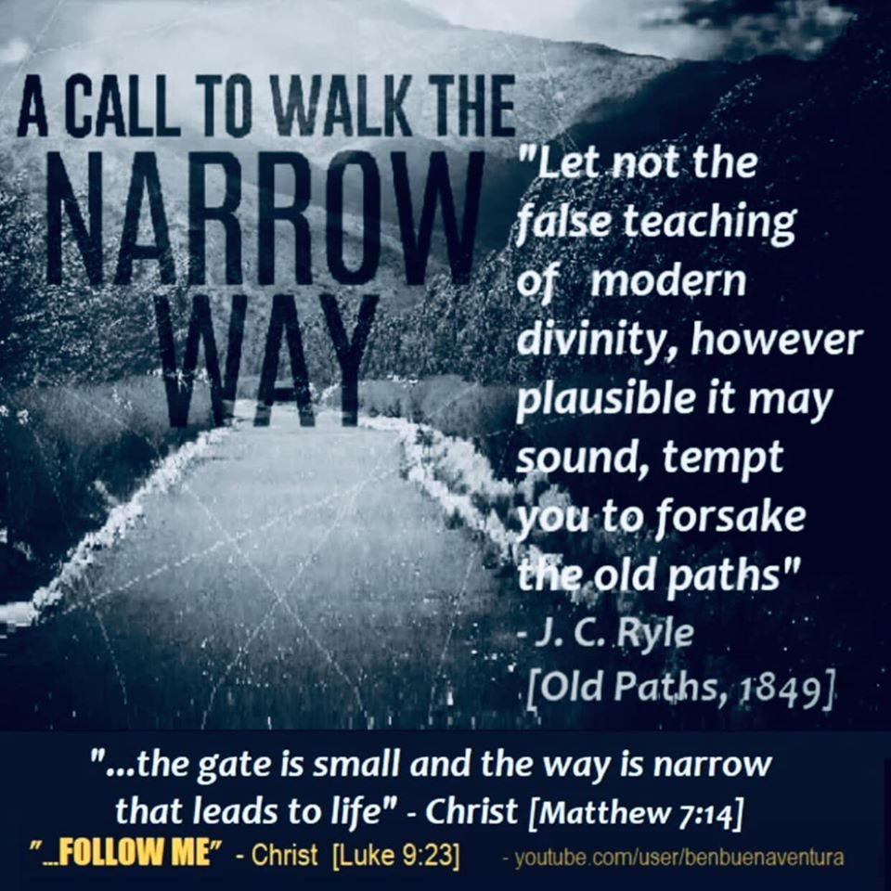

Matthew 7:13-14 Enter ye in at the straight gate for wide is the gate and broad is the way that leadeth to destruction and many there be which go in thereat:

Because strait is the gate and narrow is the way which leadeth unto life and few there be that find it.

Which gate and way are you headed? Is grace license to sin as you abuse His grace and trodden under your feet the blood of Christ and count it as unholy? Or have you counted the cost, repented, being a doer of the word and not a hearer only with active, ongoing faith that results in works and ends in eternal life?

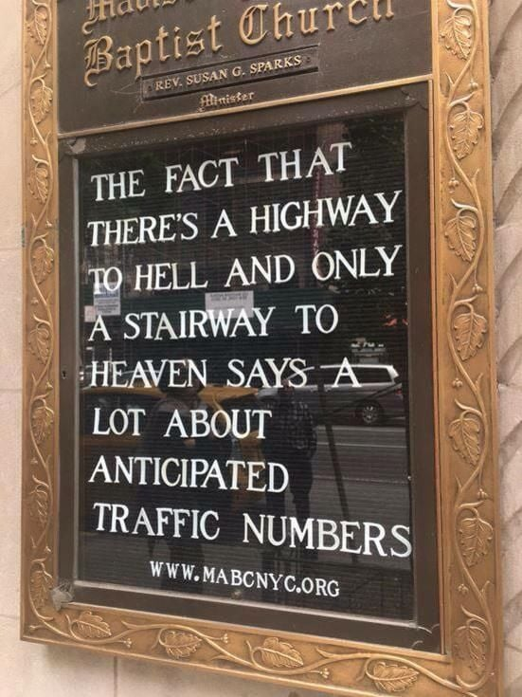
This is why many people do not experienced the God of the word and He does not manifest Himself to certain people while others He does no matter how much they claim to love Jesus.

John 14:21 He that hath my commandments, AND KEEPTH THEM, he it is that loveth me and he that loveth me shall be loved of my Father, and I will love him and will manifest myself to him.

Are you willing to obey? How do you know what His commandments are if you don’t read the bible. How do you know what the will of the Father is if you don’t read the bible? Jesus must be Lord in order to be savior and you need to be eating from the Tree of Life. Your conscience serves a purpose in convicting you of sin in order that you can be sanctified. Respond to the conviction by repenting and confessing so that you may be forgiven and cleansed from all unrighteousness. Any sin that you hide will be revealed. Don’t try to pull the cloak back over it and blaspheme the Holy Spirit by denying, justifying, explaining, giving your intent, minimizing or blaming others or your circumstances. This indicates that you love darkness more than light and will not come to the light that your deeds can be reproved that they were wrought in darkness. That sin will be bound to you when the Lord is trying to loose you from it and its power. That is what He died to do in your life. If you say you trust Him for your salvation, translated deliverance from the power of sin and deception, you need to respond to it in a biblical way in order to apply His blood to it in order to hide or cover it the proper way. This is an ongoing, lifelong process through the wilderness of life until you enter into eternal life at the end Romans 6:22. Without transformation and sanctification, there is no salvation and you really aren’t understanding what it means to trust Him alone for salvation. It is a relationship of working together to be mature and formed into His image and likeness and be holy as He is holy, without which no one will see the Lord. Your sins aren’t covered in the New Covenant as they were in the Old. They are removed because you are delivered from their power and sin has no more dominion over you.

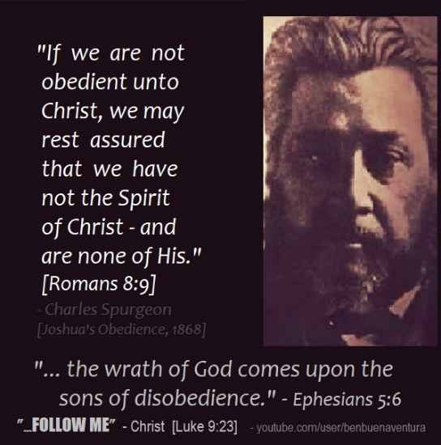

Here is an eye opener! I love reading my Bible with the Lord. In Peter 3:1-2 it says “Likewise ye wives, be in subjection to your own husbands so that if any obey not the word, they also may without the word be won by the conversation of the wives; while they behold your chaste conversation coupled with fear”.

Couple things here. First I find it funny that this verse had to specify whose husband you are to be in subjection to: your own husbands ☺

Second it was the word conversation that the Lord emphasized to me so I looked it up. It means behavior not talk. So to confess, it is talking about your behavior not what comes out of your mouth. Hmmmmm

Wait there is more. In Romans 10:9-10 it says in the context of righteousness that comes through faith and not the law that because the word is right there already in your heart and mouth because you already believe that Jesus is the messiah and LORD that if you confess, translated acknowledge with your mouth what you already believe in your heart you are thus entering into covenant submitting to Jesus as Lord which will be evident by your behavior and leads toward salvation or deliverance from the power of sin.

For with the heart man believeth unto righteousness and with the mouth confession, or entering into covenant by verbal expression of already believing Jesus is Lord, is made and it is expected that in this covenant you are submitting to Jesus as Lord because that is what you believe and are confessing to, confession is made unto or toward salvation, translated deliverance from the power of sin.

Salvation isn’t an instantaneous thing because you just confessed. If you confessed because you believe He is Lord in your heart, by faith, and are thus entering into covenant with Him as Lord, your behavior will show that because you are submitting to Jesus as Lord in this covenant unto or which results in salvation or deliverance from the power of sin. Without holiness no one will see the Lord.

The church has turned this into a formula and pronounced people as saved and eternally secure because they confessed with no evidence of them ever submitting to Jesus as Lord or them being free from the power of sin, cured or made whole, translated saved.

Basically if you believe it in your heart you will confess it and live like it by submitting to Jesus as Lord. If the actions do not line up with the confession, you didn’t believe it in your heart and you are deceived into thinking you are saved just because you confessed.

Satan has so duped the church and the world because people don’t understand how salvation works. They think confessing and not submitting to Jesus as Lord is all that is required. If you believe He is Lord and acknowledge that through confession, you submit to Him in obedience in a covenant which eventually leads to your being free from the power of sin and alive unto righteousness and your behavior will show forth that is what you believe in your heart. If you don’t see behavior that one is submitted to Jesus as Lord, they aren’t saved or in covenant nor do they believe it in their heart. They are duped and deceived.

Why do you call or confess me as Lord Lord and don’t do what I say. Because He isn’t Lord of your life and if He isn’t Lord, He isn’t able to save you and you are not in covenant with Him. No transformation, no salvation.



HOW HERETICAL DOES A TEACHING NEED TO BE BEFORE IT IS DAMNABLE?

If anyone advocates a different doctrine and does not agree with sound words, THOSE OF OUR LORD JESUS, and with the DOCTRINES CONFORMING TO GODLINESS (God-likeness), he is conceited and understands NOTHING; but he has a morbid interest in controversial questions and disputes about words, out of which arise envy, strife, abusive language, evil suspicions, and constant friction between men of depraved mind and deprived of the truth, who suppose that godliness is a means of gain. 1Tim.6:2-3

Anyone who goes too far and does not abide (continue) in the teaching of Christ, does not have God; the one who abides in the teaching, he has both the Father and the Son. If anyone comes to you and does not bring this teaching, do not receive him into your house, and do not give him a greeting; for the one who gives him a greeting participates in his evil deeds. 2Jn.9-11

Go therefore and make disciples of all the nations, baptizing them in the name of the Father and the Son and the Holy Spirit, TEACHING THEM TO OBEY, OBEY ALL THAT I COMMAND YOU; and lo, I am with you always, even to the end of the age.” Mat.28:19-20

And stretching out His hand toward His disciples, He said, “Behold My mother and My brothers! FOR WHOEVER DOES THE WILL OF MY FATHER who is in heaven, he is My brother and sister and mother.” Mat.12:49-50

Nowadays you will be called legalistic or self righteous, or teaching WORKS salvation if you quote Mat.28:19-20. Most churches will not call sin, sin. They do not teach people that repentance LEADS TO SALVATION. 2Cor.7:10 We are at the LAST of the LAST DAYS. COME LORD JESUS.
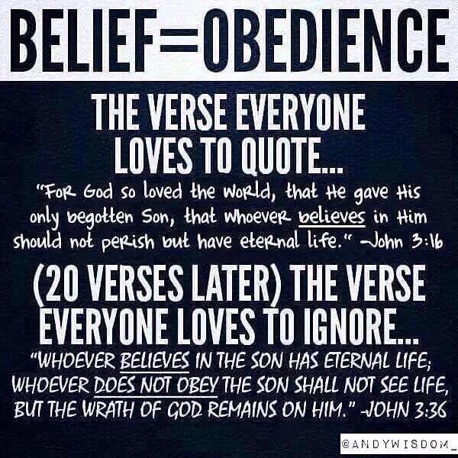
We need to preach the whole gospel or there is an unbearable eternity that is before us and we will be held more accountable with a more severe destiny by not responding appropriately as He seeks to save us in our sin and deception. The choice is yours. As for me, I will allow Him to use me to convert a sinner in error and save his soul from death and cover a multitude of sins. Allow Him to do it in you first and then after that won’t you join me in converting others who are on the highway to hell believing they are on the stairway to heaven?



God is faithful to bring truth in our deception and send someone to you because that is who He is and what He does. In bringing Truth, He is saying “Where Are You” to get you to see where you are in order to get you to where you need to be.

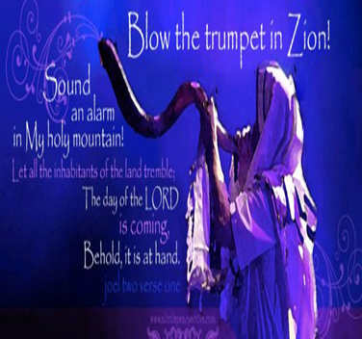
A VOICE CRYING OUT IN THE WILDERNESS MAKING STRAIGHT THE PATHS! COMING IN THE SPIRIT OF ELIJAH! AS IT WAS THE FIRST TIME, SO IT IS THE SECOND!
For speaking engagements call
813-393-9384

Our website is www.latter-rain.net

Preparing a Bride without spot or wrinkle.

This last page was an after thought and something I learned after the newsletter printed, but something I felt the Lord wanted me to share. I posted this on FB. I belong to several groups on FB and got an accolade I thought awesome: You created the most engaging posts in Christian Singles Living 4 Jesus ❤ in the past month.

☺

Whoa here is something that I never
noticed in the Bible that I bet most have not.

1 Peter 3:19-21. This is in reference to Jesus dying on the cross and descending into the lower parts of the earth preaching unto the spirits in prison who had died during the flood of Noah. Catch this now. Don’t miss it!!!!

By which also he went and preached unto the spirits in prison which sometime were disobedient, when once the long suffering of God waited until the days of Noah, while the ark was a preparing, wherein few, that is, eight souls were saved BY WATER, “the like figure whereunto”, translated COUNTERPART or REPRESENTATIVE, even BAPTISM doth also now SAVE US.

Don’t ever say baptisms, plural, aren’t necessary for salvation! That is totally against the word of God and baptisms are part of the foundational doctrines of the church. Noah and his family going through the flood was the counterpart to water baptism that saved them. Their obedience led them to baptism. No wonder the devil tries to negate water and Holy Spirit baptism so hard. People are duped!

Along the same context in 1 Peter 4:5-6 it says Who shall give account to him that is ready to judge the quick, translated living, and the dead. For this cause was the gospel preached also to them that are dead (who never heard the full gospel in life) that they might be judged according to men in the flesh, but live according to God in the Spirit. This is talking about the dead who died not knowing the full gospel. They do have it preached to them after death so that they might live according to God in the Spirit in eternity. How comforting.

This answers a question for me that I have been asking the Lord. What of those who died not hearing the FULL GOSPEL and thus have never really rejected the full gospel they never quite heard. It is always hard to preached the full gospel to people who have lost relatives who never really knew all of it before dying. If you have had it preached in life and you reject it, you are judged according to what knowledge you have been given and what you did with it. That is why Jesus spoke in parables because if people didn’t quite get it or understand, they wouldn’t have been judged as severely. Likewise if He is speaking plainly in life or after death, it is because He is going to judge you on what truth you now have so that you can live according to God in the Spirit. Make sense?
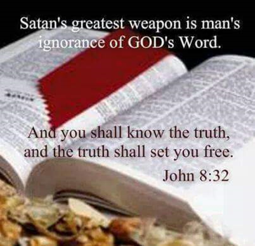

IF THE SON SHALL MAKE YOU FREE, YOU SHALL BE FREE INDEED John 8:36

Robert Weller

You are either a slave of the devil or you are a slave of Christ. You are a slave to sin or you are a slave to righteousness. Rom.6:15-23 Jesus did not go to the cross to save you in your sins, but from your sins. MANY are denying the POWER of godliness because they love their sins. 2Tim.3:5 Choose for yourselves this day who you will serve. Jos.24:15, Deut.30:19-20

Jesus owns you. He paid for you with His blood.1 Corinthians 6:19-20 Or do you not know that your body is a temple of the Holy Spirit who is in you, whom you have from God, and that YOU ARE NOT YOUR OWN? For you have been bought with a price: therefore glorify God in your body. Acts 20:28 Be on guard for yourselves and for all the flock, among which the Holy Spirit has made you overseers, to shepherd the church of God which He purchased with His own blood. Jesus even purchased the false teachers who are unsaved. 2Pt.2:1

