
  Fresh Rain
  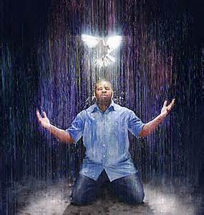
  Latter Rain Ministry
Preparing a Bride without  spot or wrinkle |  | december 2021
YOU HAVE NOT LAMENTED

“Where unto shall I liken THIS generation for well did my prophets prophecy about you? For I have piped unto you and you have not danced. I have mourned unto you and you have not lamented. I have knocked outside MY church that I purchased with MY blood and you have not answered and let ME in. I have removed the stars or leaders out of some of the candlesticks or churches and I am going to remove more for I hold the keys to death and hell and the door you refuse to answer will not keep ME from using those keys. The list has already been written in heaven, and permission granted to remove the stars who have not lamented or answered when I knocked. The stumbling blocks are being removed that teach doctrines that keep people enslaved in sin rather than set them free from slavery to sin. For this is the spirit of anti-Christ or against what I died to do. How many stars have fallen asleep in the shaking as an example to you? How many more will have to fall asleep before you mourn and answer MY knock. Did I not say that judgment starts in my house? Did I not say that I will remove out of MY kingdom all who offend or cause others to stumble or remain in sin, and the workers of iniquity (willful sin) before I return? Why have you not believed MY word? Have you not perceived that it pertains to you when I was faithful in bringing you truth? For many think you are something you are not like the rich young ruler who said he loved ME above all else, and his neighbor as himself, until given works to prove he was who he claimed to be and he could not do them. I am not first in your life, neither am I Lord, although you call ME Lord Lord. There is nothing hidden that shall not be revealed and nothing done in secret that shall not be shouted from the housetops. For many more will fall asleep for I will have to pour new wine in new wineskins and remove the old who refuse to have ears to hear and eyes to see because you are willfully deceived and will not allow ME to pull down your mental strongholds with the truth. Many have attributed my truth and warnings to the devil and have blasphemed the Holy Spirit as a result by throwing it back in His face. Did I not tell you to behold both MY kindness and MY severity but many refused MY kindness by being unwilling to repent and you did not have a love of the truth that you might be saved and so I turned you over to Satan and the strong delusions you desired. You have not been humble before ME. You have given platforms to those who preach damnable heresies and doctrines of demons, turning my house into a den of thieves rather than a house of repentance, prayer and deliverance. You have exalted the workers of darkness in your midst and given them platforms, rather than expose them because you have been too long in the dark yourself by proximity and you have called MY enemies your friends. Come out from among them. What fellowship has light with darkness? Your eyes have grown accustomed to the dark by calling friends those whom I call enemies who are against all I died to do in freeing man from slavery to sin. Your false doctrines keep them enslaved and thus their blood will be on your hands.

I have poked holes in your walls to reveal what was hidden and the holes will weaken your structure before collapse and reveal what you have hidden. There is nothing hidden that shall not be revealed and what was spoken in secret will be shouted from the housetops because I have seen it all. Therefore, I will overturn your platforms and tables and remove the stars or leaders out of their places and replace them with those that have ears to hear and who will answer when I knock. There is still time to repent before more fall and great will be their fall because their platforms are large. I have warned and have been patient these years, but I must now act because the harvest is ripe and I will not bring the harvest into barns to rot and become lukewarm and twice the slave to sin and self that also will not receive the love of the truth that they might be saved. It is not the church that people have fallen away from, but the truth which I was faithful to bring unto you and you chose to be willfully deceived and deluded. That choice has a consequence when rejecting ME. I AM the Way, the Truth and the Life and you have left ME standing outside MY own door when I wanted to come in and sup with you but you would not have it. I have given you space to repent. I have turned some over to Satan already for the destruction of their flesh because they have not repented, as an example to you. Therefore, I will remove those stars or stumbling blocks out of MY kingdom because you stand in the way of what I want to do, and I will place others there that I hold in my hand and have been preparing, who will feed my sheep and not fleece the flock and turn MY house into a house of merchandising. There is coming a shake up for those who shake down MY people for money and manipulate MY word to do it. For I have compassion on the people for they are without true shepherds to tend to them. I will strive with you no longer but will bring forth judgment unto truth as the cup of iniquity is full in MY house and the fear of the Lord will return for I am not done with this land nor the people and you stand in the way of the mighty work I want to perform in this land. The axe is being laid to the root and the fowls of the air (devils) will no longer roost among your branches”.




I have sat on this newsletter for awhile because the word was strong, somber, weighty and it brought fear to my heart for those it is intended for. The purpose of discipline is to bring repentance and restoration so that judgment does not have to take place. If repentance does not transpire, judgment occurs. God always warns before He judges. For many, this is not the God you preach because you only believe in the God of kindness and love and not His severity. You preach another gospel and another Jesus, which is why these newsletters have been sent by Him in an effort to bring repentance as He has tried to reveal Himself to you. They have been progressive. If you are new to this ministry, go back and read some of the other newsletters that have gotten us to this point in history. The same Holy fear intended for those He is still trying to extend kindness and mercy to, fell on me as He reminded me that the blood of those who fall will be on my hands if I do not yet speak again, so here I am. He has confirmed this word multiple times in multiple ways. Please know that I personally don’t know of any pastors or leaders who have died during this shaking because I no longer get or listen to Christian TV or very many media sources. Evidently DayStar is no longer on my Amazon stick. My year has been spent preaching the word to drug addicts, the fearful and witches and water baptizing them in my pool while watching the Lord baptize them in the Holy Spirit while they were still in the pool and raising their hands to the Lord in thanksgiving and praise. I have seen demons manifest right before water baptizing someone because they have to go. I have had a witch fly down from the New York area to hear the gospel and be water baptized after water baptizing her family members earlier in the year and she brought her daughter with her, praise God. The ex drug addict who had a demon manifest has now filled out physically and is working and is totally free of drugs still. God is moving and this is happening outside the church. I continue to give out what He gives me in various short teachings where I get taught as I am teaching. It has been an incredible year.


I STAND OUTSIDE THE DOOR AND KNOCK

The Lord has given me this strong image of Him outside the present day apostate church knocking and this strong word came forth today.‬‬

You will notice that even in Jesus day they let Him teach and preach in the church or synagogue. He preached the gospel of the kingdom of heaven and He commanded us to preach the gospel of the kingdom of heaven. This gospel has a king that requires submission and there is freedom and precious promises to those who submit and obey, like healing, deliverance and provision. You will find in the Bible that the promises are conditional with statements from the Lord starting with “If you….then I will”. We have falsely been taught that the promises belong to us because we simply believe. If you read your Bible you can’t come up with that conclusion but most don’t read their Bible and are easily deceived by false teachers placed in the church appearing as angels of light. The temple tables are being over thrown because the Lord’s apostate end time church has become a den of thieves who peddle their wares to build their kingdom not His, while He stands outside the church door knocking.

“And unto the angel of the church of the Laodiceans write; These things saith the Amen, the faithful and true witness, the beginning of the creation of God; I know thy works, that thou art neither cold nor hot: I would thou wert cold or hot. So then because thou art lukewarm, and neither cold nor hot, I will spew thee out of my mouth. Because thou sayest, I am rich, and increased with goods, and have need of nothing; and knowest not that thou art wretched, and miserable, and poor, and blind, and naked: I counsel thee to buy of me gold tried in the fire, that thou mayest be rich; and white raiment, that thou mayest be clothed, and that the shame of thy nakedness do not appear; and anoint thine eyes with eye salve, that thou mayest see. As many as I love, I rebuke and chasten: be zealous therefore, and repent. Behold, I stand at the door, and knock: if any man hear my voice, and open the door, I will come in to him, and will sup with him, and he with me. To him that overcometh will I grant to sit with me in my throne, even as I also overcame, and am set down with my Father in his throne. He that hath an ear, let him hear what the Spirit saith unto the churches.”
Revelation‬ 3:14-22‬ KJV‬‬‬‬‬‬‬‬‬‬‬‬‬‬‬‬‬‬‬‬‬
‬
The present day apostate church is lukewarm, makes Jesus want to vomit, believes it has everything including the truth, while Jesus sees us as naked, blind, wretched, poor and miserable. We believe we are something we are not like the rich young ruler who thought he loved God above all else and his neighbors as himself yet when Jesus gave him something to do to prove who he thought he was, he went away sad because his image of himself was brought to the light by his lack of works and obedience to Jesus command. If he loved Jesus whom he acknowledged as God above all else he could have sold everything he had to follow Him. If he loved his neighbor as himself he could have given to the poor before following Jesus. Jesus just revealed to him that he wasn’t who he thought he was by giving him something to do to prove he was who he said he was. He is doing the same to us in our end time Laodecian state where we think we are great, highly favored and in right standing with Him and have it all but in essence He wants to spew, translated vomit, us out of His mouth. Most of us would be shocked to know we make Jesus sick as He rebukes us in His love and continues to stand outside the door of our churches knocking saying “I am here. Open the door and let me into MY own church body that I purchased with MY blood”! Yet church leaders refuse, so what will become of them? They are worse than the Pharisees who allowed Jesus to preach and teach in the synagogue. This is why many stop going to church. They have tried them that say they are pastors, apostles, prophets and teachers and found them liars according to the Bible and the remnant want to vomit as well. Their platforms are going to be removed. The TV stations that places them on the air toppled like temple tables like a giant hand wiping the chess pieces off the chess boards. Jesus drove these people out of the temple after fashioning a whip and driving them out, toppling their tables and throwing their money making wares everywhere. The people weren’t afraid of Him and followed Him outside the temple to hear Him preach where He cast out devils, healed the sick and raised the dead. If we won’t let Jesus in the church and we leave Him outside knocking asking to come in, the tables get overturned and the preaching and teaching goes outside our beautiful mega church buildings where we call the poor the God robbers for not giving to the upkeep of the beautiful buildings while the poor can’t put a roof over their head and feed their families. The Lord was calling the preachers God robbers in Malachi, not the people because the preachers were to be tithing and their tithe was to go to feed the poor, widow, fatherless and strangers in the land. The Bible says if you give to the poor you give to God. Therefore, if you don’t provide for the poor, you are robbing God. Today the pastors call the poor God robbers for not giving to them, like giving to them and their church kingdom is the same as giving to God that they leave outside at the door knocking and not letting in. If you truly want to give to God, give to the poor and not the churches who leave Him standing outside, not preaching what He gives them to preach. Then watch the windows of heaven open because the context and God’s point was to provide for the poor, not tithe, and it was said to the preachers not the people. Today we call the poor “God robbers” and shut up the kingdom of heaven against them by so doing so the temple tables are getting tossed, leaders removed through swift destruction and TV or radio platforms leveled that allow these false teachers.

Meanwhile, right after Jesus fashioned a whip and over turned the temple money changers, Jesus looks upon the harvest field outside the church saying “But when he saw the multitudes, he was moved with compassion on them, because they fainted, and were scattered abroad, as sheep having no shepherd. Then saith he unto his disciples, The harvest truly is plenteous, but the laborers are few; Pray ye therefore the Lord of the harvest, that he will send forth laborers into his harvest.”
Matthew‬ 9:36-38‬ KJV‬‬‬‬‬‬‬‬‬‬‬‬‬‬‬‬‬‬‬‬‬‬

And this is when you will see Him do this OUTSIDE the present day apostate churches “And when he had called unto him his twelve disciples, he gave them power against unclean spirits, to cast them out, and to heal all manner of sickness and all manner of disease.”
The remnant and disciples OUTSIDE the Laodecian churches will be anointed and endued with power because Jesus was moved with compassion on the people who have no true shepherd because the present day apostate church has made the house of God a business and not a house of prayer. A body that has been turned into a business is a prostitute and the Lord will not have His bride prostituted any longer for the greed and gain of men who build their own kingdoms in His name while leaving Him outside knocking. ‬‬‬
Pray for harvesters because truly the harvest is ripe and He has compassion on the people who do not have true shepherds who love the sheep and will lay down their lives for them. They only get fat off the flock. He is ready, willing and able to endue true harvesters with power who preach the gospel of the kingdom, that has a vetting process that goes beyond just believing because even Satan believes. This kingdom has a king which requires submission and who slays before Him all who do not that He should rule over them. That is the Jesus of the Bible and we are commanded to behold or look at both the kindness and severity of the Lord. Kindness to those who obey and have ears to hear and severity to those who will not receive the love of the truth that they might be saved and this was said to the present day apostate church before He comes for His bride who made herself ready Rev. 19. Judgment starts in the house of the Lord and He will gather out of His kingdom all who offend, translated scandals or those who causes people to remain in their sin by telling them they are saved and eternally secure and can live as they like, when Jesus died to free us from slavery to sin through the baptism of the Holy Spirit who empowers us not to sin so that we do not receive the wages of sin which is death and God’s wrath. There is no false doctrine more anti-Christ than once saved always saved that has people remaining in their sin while believing themselves to be saved and eternally secure. Yet people are so blind to it and will not receive the love of the truth that they might be saved and thus the Lord sends them strong delusion and gives them what they want which tickles their ears because they hate sound doctrine and they leave out the foundational doctrines of the first church. They are willfully deceived the Bible says about these end times believers who won’t be saved at all. You must work out your salvation with fear and trembling after being empowered not to sin and endure until the end free from slavery to sin and free from deception, to be saved. Jesus is faithful to bring truth in our deception to those professing to trust Him with their salvation but they don’t really or they wouldn’t reject the truth without studying the matte People say they believe all the bible but their actions prove they don’t. They only believe the parts they like that tickle their ears and pat their flesh.

Be a harvester after proving yourself to see if you are really in the one true faith yourself and He will endue you with power and send you forth. This is why you don’t see miracles today. The Lord won’t confirm the gospel being preached today that preaches another Jesus so the devil performs lying wonders and miracles of gold dust, fake jewels and feathers. Don’t be deceived. Not everything supernatural is of God.

DO YOU HAVE SPIRITUAL EARS TO HEAR AND EYES TO SEE

Do you understand the Bible when you read it? The Bible says unless you are born again of water in baptism and born again of the spirit by being baptized in the Holy Spirit, you won’t see, understand, perceive or have the spiritual ears to hear and eyes to see what the Lord is saying or doing, so that is the first step in having them.

What happens if you don’t have spiritual ears to hear or eyes to see? Any revelation or truth you do have will be taken from you. The fowls of the air (devil) comes and steals the word that you don’t act upon or live by because you are a hearer of the word only deceiving yourself. You must be a doer of the word in order to build your house upon the rock.

It really comes down to a heart condition of being teachable and acting upon what the Holy Spirit teaches you as you read the word. Don’t trust what is being taught in today’s end time apostate churches that have fallen away from the one true faith because they are teaching what they have gotten second hand from the previous generation. They will not receive the love of the truth that they might be saved, because they think they already are and eternally secure. This was said to believers ABOUT END TIME APOSTATE BELIEVERS. Because they would not receive the love of the truth that they might be saved, because you aren’t saved when you first believe, GOD SENDS them strong delusion that they will believe the lies and will not receive the love of the truth that they might be saved. If you want to be deceived, God will give you what you want so you must search the scriptures for yourself always believing you may be deceived so He can give you the truth. The Bible says we are saved through sanctification of the spirit and belief in the truth. What you believe determines whether you will be (future tense) saved so being teachable and reading the Bible for yourself is essential. Eve was deceived because she got her information second hand from Adam about what God really said about the tree and garden. If you get your biblical information second hand you are ripe for deception. Satan comes to deceive because in deceiving you, he can damn you if you choose to believe his lies and act upon them instead of what the Bible says IN CONTEXT. This is why he tries so hard to deceive and places his messengers in the pulpit who got their information second hand from the previous generational pastors or stars.

Let’s look at Jesus words on having ears to hear and why He taught in parables. Notice only true disciples pursued Him further on the meaning behind the parables. True believers press in and are doers of the word.

“And the disciples came, and said unto him, Why speakest thou unto them in parables? He answered and said unto them, Because it is given unto you to know the mysteries of the kingdom of heaven, but to them it is not given. For whosoever hath, to him shall be given, and he shall have more abundance: but whosoever hath not, from him shall be taken away even that he hath. Therefore speak I to them in parables: because they seeing see not; and hearing they hear not, neither do they understand. And in them is fulfilled the prophecy of Esaias, which saith, By hearing ye shall hear, and shall not understand; and seeing ye shall see, and shall not perceive: For this people's heart is waxed gross, and their ears are dull of hearing, and their eyes they have closed; lest at any time they should see with their eyes, and hear with their ears, and should understand with their heart, and should be converted, and I should heal them. But blessed are your eyes, for they see: and your ears, for they hear.”
Matthew‬ 13:10-16‬ KJV‬‬‬‬‬‬‬‬‬‬‬‬‬‬‬‬‬‬‬‬‬
‬
Notice that more biblical revelation is given ONLY to those that have ears to hear and eyes to see. Notice that the revelation increases more abundantly when you have ears to hear and eyes to see what the Lord is saying. The purpose of the revelation is to understand with your heart and be converted, which is translated to repent and turn, in order to be healed which is translated saved or made whole. So only those that have spiritual ears to hear and eyes to see will be saved in the end and receive eternal life in the end Romans 6:22. When you stop having that, even any revelation you used to have is taken away and God will send you STRONG DELUSION because you reject Jesus, who is the truth, that you claim to trust for your salvation, yet when He brings truth in your deception you reject the one you claim to trust to save you and keep you from the deception that will damn you. If you can’t be damned as a Christian, how can damnable heresies be brought into the church? People don’t trust Jesus for their salvation throughout their lifetime because they were taught that it is a one time event when they first believed and the trust goes out the window after that because they are now saved and eternally secure. How stupid does it sound to tell an Israelite who still remains in Egypt enslaved, that he is free? Jesus came to deliver us from slavery to sin through the baptism of the Holy Spirit so that we do not receive the wages of sin, which is death. Past sins are forgiven when you repent and are water baptized and are now clean in order to receive the baptism in the Holy Spirit. We must utilize this empowerment after receiving it because future sins can be judged if we remain in them by choice. This is where working out your salvation with fear and trembling comes in, which requires death to sin and self, picking up your cross and following Him, doing all He commanded. The Israelites had to come out of Egypt, which is symbolic of the world, be water baptized and led through the wilderness of life in order to reach the promised land. Some died before reaching it because of disobedience and sin.

We are not saved when we first believe. You must endure until the end to be saved. You must work out your salvation with fear and trembling. You cannot lose what you do not yet possess and are still working out. It is not about losing your salvation because you aren’t saved until the end. People won’t endure until the end to be saved if they are falsely told they already are. It is about enduring in the one true faith because you continued to have ears to hear and eyes to see so that you have understanding in your heart, and you remain teachable because in these end times even the elect can be deceived. Jesus warned the most about deception in these end times. Search the scriptures because in them YOU THINK you have eternal life which is really received in the end Romans 6:22.

I pray you all have ears to hear and eyes to see by obtaining them firstly by being born again of water in baptism and baptized in the Holy Spirit. He wishes that none would perish.

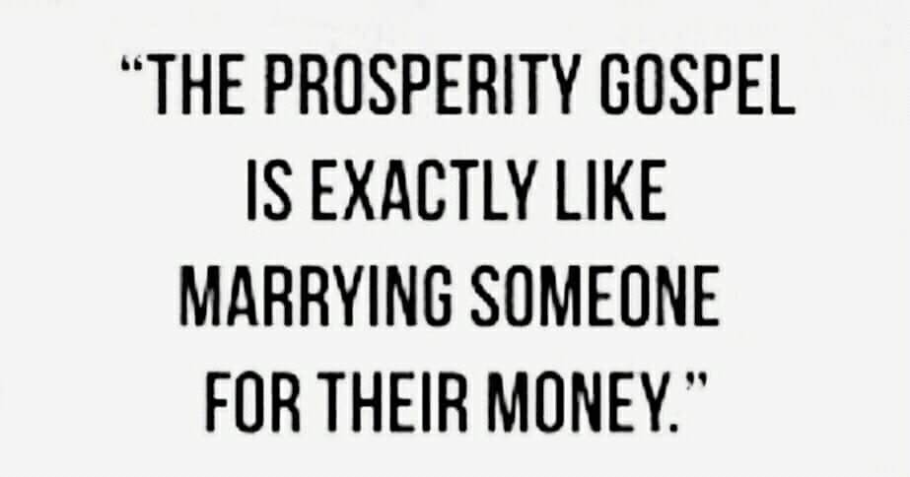

DID JESUS HAVE FEMALE DISCIPLES?

This will screw with a lot of ya’lls misogynistic theology. Here is what the Lord just showed me.

“Then one said unto him, Behold, thy mother and thy brethren stand without, desiring to speak with thee. But he answered and said unto him that told him, Who is my mother? and who are my brethren? And he stretched forth his hand toward his DISCIPLES, and said, Behold my MOTHER and my brethren! For whosoever shall do the will of my Father which is in heaven, the same is my brother, and sister, and mother.”
Matthew‬ 12:47-50‬ KJV ‬‬‬‬‬‬‬‬‬‬‬‬‬‬‬‬‬

There were women among His disciples. Notice also that those in the family of God do the will of the Father.

‬‬
WHAT IS THE PURPOSE OF MIRACLES OR MIGHTY WORKS

Let’s examine: “Then began he to upbraid the cities wherein most of his mighty works were done, because they repented not: Woe unto thee, Chorazin! woe unto thee, Bethsaida! for if the mighty works, which were done in you, had been done in Tyre and Sidon, they would have repented long ago in sackcloth and ashes. But I say unto you, it shall be more tolerable for Tyre and Sidon at the day of judgment, than for you. And thou, Capernaum, which art exalted unto heaven, shalt be brought down to hell: for if the mighty works, which have been done in thee, had been done in Sodom, it would have remained until this day. But I say unto you, that it shall be more tolerable for the land of Sodom in the day of judgment, than for thee.”
Matthew‬ 11:20-24‬ KJV‬‬‬‬‬‬‬‬‬‬‬‬
‬‬‬‬‬‬‬‬
Mighty works and miracles are demonstrated to reveal the power of the kingdom of heaven and bring people to repentance. Will Jesus confirm the word being preached with mighty works and miracles if the message of repentance is not preached then? Not likely. This is why we don’t see Him confirming the word. Church leaders don’t want to talk about sin, repentance and hell. The devil may display the supernatural in our midst with foolish signs like feathers, gold dust and jewels that benefit no one. Not everything supernatural is of God.

So if repentance is not seen after demonstrations of mighty works, judgment day is going to be horrible for the unrepentant. If repentance is not taught, Jesus won’t confirm the word with signs following if the purpose is to bring people to repentance. So regarding demonic doctrines in the church, repentance will be omitted or people will be told it is not necessary for salvation or it is not something you can do. Jesus wouldn’t command something from us that we were unable to do or that He hasn’t equipped us to do.

Let’s get back to preaching repentance so Jesus can confirm the word, demonstrate the kingdom of heaven and so people can be biblically born again of water and the Holy Spirit through baptism in both after repenting. Repent and be baptized every one of you is still the answer to what must I do to be saved.
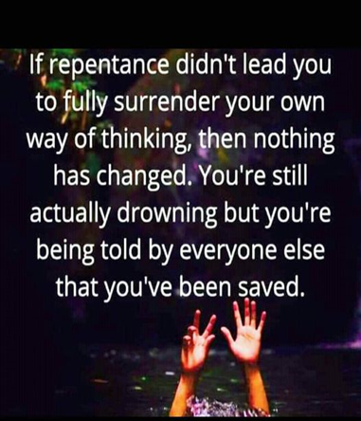
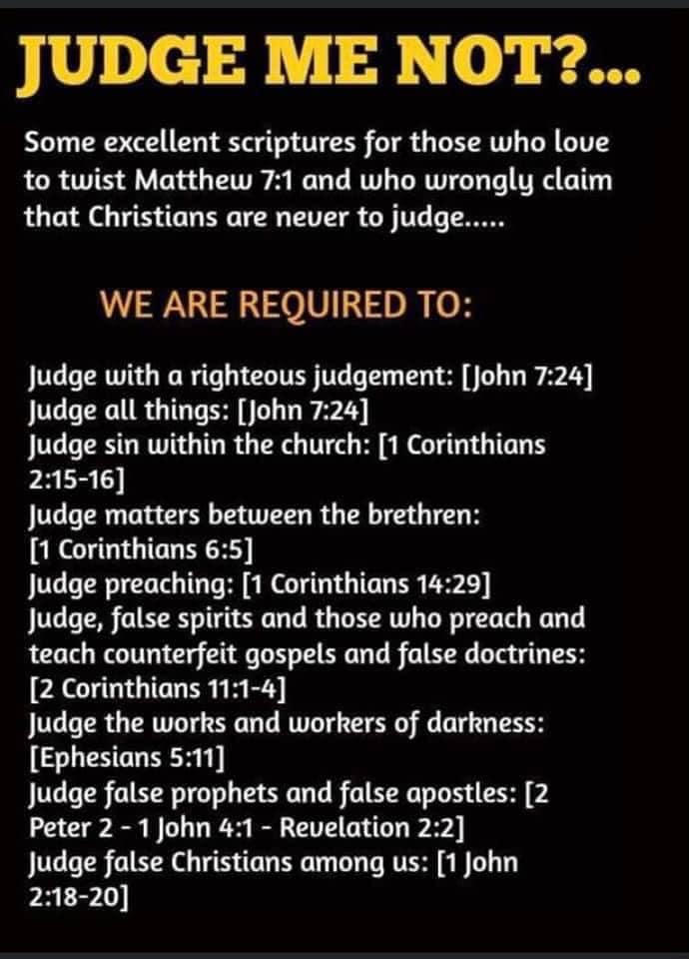

JESUS IS THE DOOR

The porter opens the door so others can enter into the kingdom. Many have climbed in another way. The porter says what Jesus said. You must be born again of water and the Holy Spirit in baptism in both. Others say, just believe and you are eternally secure. The porter says repent and be baptized every one of you. Others say just believe, ask Jesus into your heart or accept Jesus as your Lord and savior which is nowhere in the Bible. Repentance and baptism are works salvation the false teachers claim. The porter says faith without works is dead and was not Abraham justified by his works and not his faith only. What the porter says brings life because he opens up the door to eternal life through the word and Jesus is the word. False words and lies, bring death when you try to enter in any other way except through the door and what the door said in following Him, doing all He did and commanded us to do.

Be a porter that opens the real Jesus up to others so they can enter the kingdom of heaven His way, since it is His kingdom that has a vetting process.

THERE IS COMING A SHAKE UP TO THOSE WHO SHAKE DOWN THE PEOPLE!
2022 IS GOING TO BE AN INTERESTING YEAR!

HARVEST

As I look over my landscaping or in being a gardener and tending the crop, I have come to realize that the same rain that causes my garden or landscaping to grow, also causes the weeds to grow that strangle out the crop before harvest. It is the same thing in the kingdom of God. Sometimes I get tired of toiling in pulling weeds in order to see a greater more healthy harvest. Just when you think you have it under control you let a week pass and there you are out there weeding again but you don’t dare ask the Lord to hold back the rain that brings the harvest just because of the weeds, as numerous as they seem to be. You ask Him to remove the weeds or tares that were sown amongst the wheat. The tares think they are wheat though and don’t know the enemy has sown them. The mustard seed tree that grew up and was large over time, ended up having the birds live in it. The tree is the church and the fowls of the air in the bible are devils sent to steal the seed of the word of God that was preached by the first church. The end time church has a lot of these fowls roosting in her branches that have caused the true church to fall away from the truth, not the church.

Years ago when the Lord gave me the name of my ministry, which is NOT connected to any other movement or group that people lump me into in order to discredit me, He also gave me the translation for it. The translation is also the purpose for the ministry that brings the rain, that brings the end time harvest. It blew my mind when He showed me this back in 1990’s. Latter Rain Ministry is translated “A teacher of righteousness (right living) according to righteousness”. Righteous teaching or truth, brings the latter rain or out pouring of God’s spirit in order to bring in the final end time harvest.

The rain also brings weeds, tares, false teaching that promotes unrighteousness or unholy living like the just believe and you are now eternally secure and can live as you like damnable heresy that has people remaining slaves to sin instead of freeing them from slavery to sin like Jesus died to do. That heresy will damn you if you believe and live by it and it is anti-Christ or against Christ and everything He died to do.

Wheat and tares look exactly alike until they mature and you can’t tell them apart. The purpose of the church leaders is to mature the Saints and equip THEM for ministry so the difference will be obvious, but the church pulpits has been invaded by weed seed sowers that are discouraging to those who tend the garden and crops and it appears the true wheat seeds sown are few. Therefore, the Lord won’t reap a harvest only to bring them into churches that will choke out His wheat. The old guard or stars that has not listened and has given platforms to those teachers that tickle the ears, pat the flesh and teach doctrines of demons that leave people enslaved to sin, rather than freeing them from slavery to sin like Jesus died to do, will be gathered out of His kingdom, have their temple tables overturned, and have the people following after those the Lord sends to do the upsetting in order for them to hear righteous teaching that calls sin what God calls it, calls people to repent from it because the kingdom of heaven is at hand or here to be received, and they walk in the power of that kingdom with signs following as the Lord works with them confirming the word.

Expect some shake ups and downfalls and exposures of church leaders coming up, and the platforms they use to be taken down as leaders are removed. This is the pulling of the weeds that have grown amongst the garden sown by the enemy to choke out that which God planted. He will gather out of His kingdom all who offend and all workers of iniquity before He returns for His bride who made herself ready. Look up. The harvest is ripe as people have been waking up all over the world to the deception they have been living in and refuse to live in it any longer. Pray for harvesters and others who will pull weeds that sprang up from the rain now that the harvest is ripe and the difference between the two is obvious. There is nothing hidden that shall not be revealed. Brace yourself! Things are about to be shouted from the housetops. Let him who has ears hear. If you know, you know! If you don’t, you will soon.
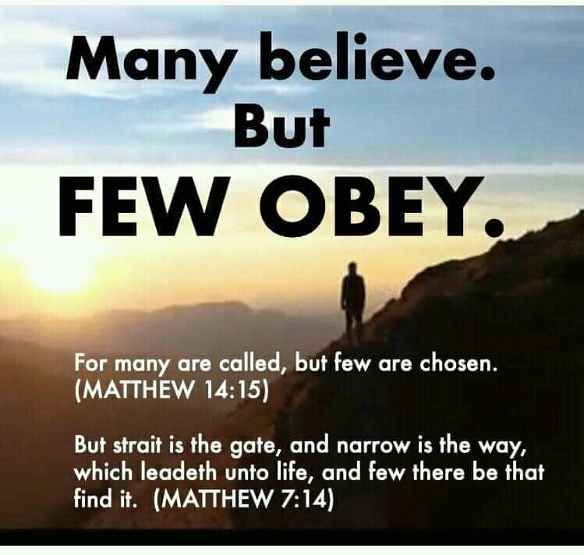
If the gospel you are preaching makes it easy to get in to heaven and has everyone who believes making it there, then you aren’t preaching the right gospel. FEW FIND THE STRAIGHT AND NARROW GATE! Even fewer with the once saved, always saved, you are saved when you first believe damnable heresy.

WHAT DOES IT MEAN TO DENY CHRIST

More than you think it means from the original translation. Could you be denying Him and not know it and thus you are being denied before the Father which is in heaven and not seeing answers to prayer? Let’s examine.

“Whosoever therefore shall confess me before men, him will I confess also before my Father which is in heaven. But whosoever shall deny me before men, him will I also deny before my Father which is in heaven.”
Matthew‬ 10:32-33‬ KJV‬‬‬‬‬‬‬‬‬‬‬‬‬‬‬‬‬‬‬‬‬‬

Let’s start with the phrase “shall confess” which is translated to be in covenant with and living by the conditions of that covenant, to acknowledge said covenant, to give thanks for said covenant that delivers promises. Confession is not just speaking with your mouth, but living according to the tenants of covenant conditions in order to receive the promises of the covenant. Therefore if you shall confess or acknowledge with both your mouth and live your life meeting the conditions of the covenant as empowered to do so before man, Jesus will also confess or acknowledge you before the Father as your mediator and high priest to insure you receive the promises of the covenant you entered into with Him. That is why the scriptures are full of “If you…….then I will” verses where Jesus is making a promise if you confess or acknowledge the covenant through both words and actions. If you meet the conditions of the covenant through obedience to the instructions as empowered to do so through the baptism of the Holy Spirit and confess them, you receive the promise because Jesus is acknowledging you before the Father who grants or administers the promise Jesus made to those who follow Him. Christian means follower of Christ. If you are not following, doing all He did and commanded you aren’t one because even Satan believes but does not follow. There are too many people calling themselves Christians who are not. The term is used too loosely because of a watered down gospel that tickles ears that tells people you are saved by only believing. You are either on the broad path that leads to destruction or the narrow path that leads to eternal life and FEW there be that find that path. The present day apostate church teaches a gospel where grace is license and only believing gets you in and has you remaining eternally secure. That is not what the Bible says. The Bible says He will remove out of His kingdom all who offend and all workers of iniquity. Offend is translated scandals or causing others to stumble or remain in sin like the once saved always saved false teaching does and the word iniquity is translated you knew it was wrong and you did it anyway. It was the believer who heard Jesus say “Depart from Me you worker of iniquity! I never knew you”. These people have believed a different gospel preaching another Jesus and not the one from the Bible. They have created an idol of Jesus as how they want Him to be instead of how the biblical Jesus really is. These people won’t receive the love of the truth that they might be saved as the Bible describes end time believers and God will give them what they want by sending them STRONG DELUSIONS so you must love truth in these end times in order to escape this delusion and be lost. This is said to believers about believers.

These are the ones who deny Jesus before man and thus get denied before the Father. The word deny is translated to contradict. What you say you believe and how you live contradicts itself. You call yourself the righteousness of God while your actions and lifestyle contradict yourself. You don’t act upon what you say you believe and thus you contradict with your actions what you confess with your mouth. Deny is also translated refuse. Many call themselves Christian and deny or refuse Jesus lordship over their lives. The Bible says those who do that will hear Him say, “Bring those before Me that would not that I may rule over them and slay them before Me”! Jesus can’t be savior if He isn’t Lord and you allow Him to rule over you by the empowerment not to sin received through the baptism of the Holy Spirit. All who are in Christ Jesus have ceased from a lifestyle of sin and thus they are under grace, translated empowerment and utilizing this empowerment to no longer be a slave to sin but a slave to righteousness instead. The law is for sinners and those still enslaved to a lifestyle of sin are under the law and will be judged by it even if they think they believe, just as Satan is. He also believes remember. To deny also is translated to reject. To reject truth in your deception is to deny or reject Jesus and He will also deny you before the Father who in turn gives you what you want by sending you STRONG DELUSION so you won’t be saved. Jesus is always faithful to bring truth in our deception but we must be faithful in receiving it by searching the scriptures to see if we are in the one true faith so that you don’t hear “Depart from me I never knew you. You who work iniquity”! You have to be strongly deluded to believe you can continue in known sin, that Jesus died to deliver you from slavery to, by empowering you not to sin so that you don’t receive the wages of sin, which is death and judgment. Repent and search the scriptures because in them you THINK you have eternal life which is received in the end Romans 6:22. Work out your salvation with fear and trembling. You don’t work out what you have already received. You can’t lose what you do not yet possess. So the question isn’t about losing your salvation but about being the FEW who find it in the end because they are on the narrow path that leads to eternal life, because they have confessed Jesus before man in both their words and lifestyle and not denied, refused His Lordship or rejected Him by their deeds, lifestyle or works.

If you are in covenant with Jesus, you have to live according to the covenant conditions set forth or you don’t receive the covenant promises. One of which is eternal life. If you don’t know what those covenant conditions are you need to pick up your bible and read it and be a doer of it and not a hearer only deceiving yourself. Stop listening to false teachers who have brought damnable heresies into the church who deny the Lord who bought them with His blood. Eve could only be deceived because she heard the instruction about what God said third hand through Adam. If you are getting your information about what the Bible says through man and not firsthand yourself through God, you are an easy target for deception.

Seek ye first the kingdom of God and His righteousness. Only those that do the will of the Father enter the kingdom of heaven. Without holiness no one shall see the Lord and you can’t be holy in your ability which the law was designed to reveal to us. You can only be holy through the empowerment that comes from the baptism of the Holy Spirit, which even Jesus required when facing temptation by the devil in the wilderness. We are told to put those believers away from us who have a form of godliness but deny this empowerment. That is how important baptism in the Holy Spirit is to you receiving eternal life in the end. When you first believe you are sealed with the Holy Spirit. That word sealed is translated earnest or deposit like one would put down on a house with the intent to fully redeem or purchase it and occupy it. If the deal falls through, the deposit is returned. That is why we are told not to grieve the Holy Spirit with whom we are sealed. He will depart.

By this we know that we are IN Him. 2:3-5 3) The one who DOES the will of God lives forever. 2:17 4) The sons of God and the sons of the devil are obvious. The sons of the devil sin and the sons of God don't. 3:3-10 5) We know that we have passed out of death and into life, because we love the brethren. 3:13-16 6) Those that are in the world talk like the world. He who knows God listens to us (apostles). 4:5-6 7) By this we know that we love the children of God, when we love God and keep His commandments. 5:2-3

About 95% of Americans think they are going to heaven. Yet Jesus said that MANY will be deceived and only a few will continue down the narrow road that LEADS TO LIFE. Matt.7:13-14 What road are you on? The road ends at the END. 1Pt.1:9, Matt.10:22 , Heb.3:13

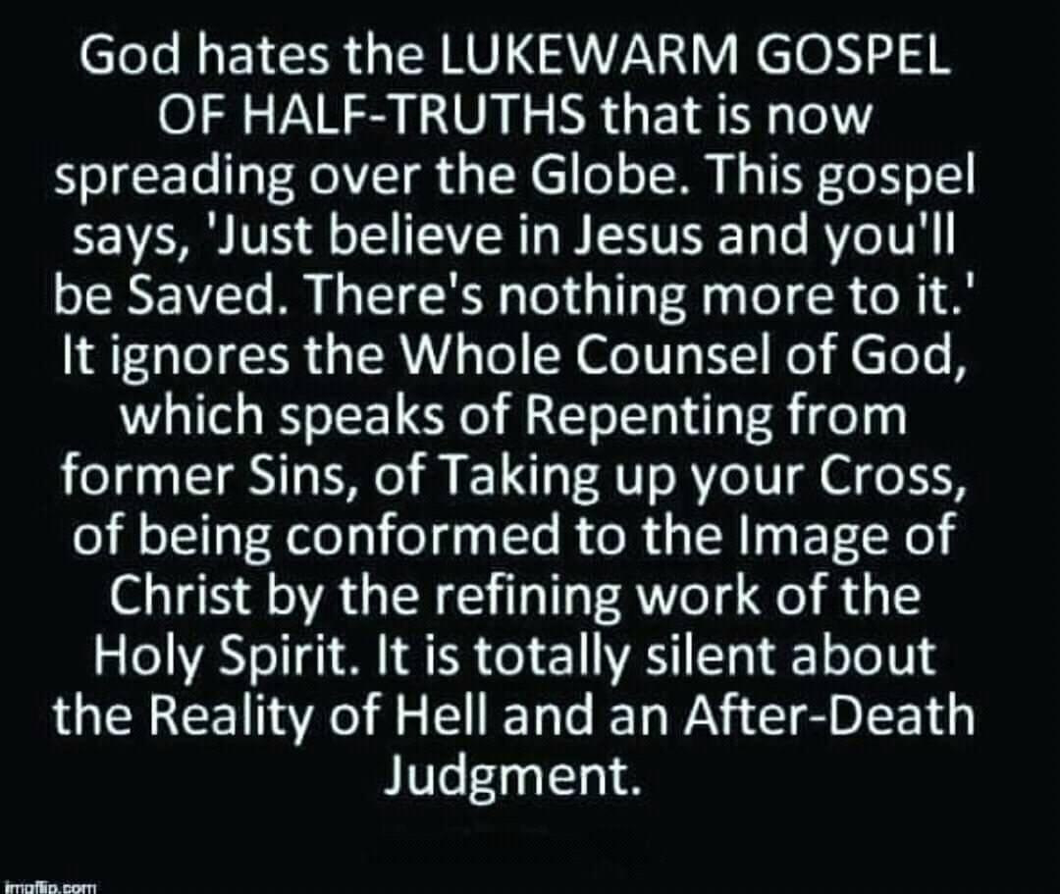

ENDURING UNTIL THE END TO BE SAVED

“And the brother shall deliver up the brother to death, and the father the child: and the children shall rise up against their parents, and cause them to be put to death. And ye shall be hated of all men for my name's sake: but he that endureth to the end shall be saved. The disciple is not above his master, nor the servant above his Lord. It is enough for the disciple that he be as his master, and the servant as his Lord. If they have called the master of the house Beelzebub, how much more shall they call them of his household? Fear them not therefore: for there is nothing covered, that shall not be revealed; and hid, that shall not be known. What I tell you in darkness, that speak ye in light: and what ye hear in the ear, that preach ye upon the housetops. And fear not them which kill the body, but are not able to kill the soul: but rather fear him which is able to destroy both soul and body in hell. Are not two sparrows sold for a farthing? And one of them shall not fall on the ground without your Father. But the very hairs of your head are all numbered. Fear ye not therefore, ye are of more value than many sparrows. Whosoever therefore shall confess me before men, him will I confess also before my Father which is in heaven. But whosoever shall deny me before men, him will I also deny before my Father which is in heaven. Think not that I am come to send peace on earth: I came not to send peace, but a sword. For I am come to set a man at variance against his father, and the daughter against her mother, and the daughter in law against her mother in law. And a man's foes shall be they of his own household. He that loveth father or mother more than me is not worthy of me: and he that loveth son or daughter more than me is not worthy of me. And he that taketh not his cross, and followeth after me, is not worthy of me. He that findeth his life shall lose it: and he that loseth his life for my sake shall find it. He that receiveth you receiveth me, and he that receiveth me receiveth him that sent me. He that receiveth a prophet in the name of a prophet shall receive a prophet's reward; and he that receiveth a righteous man in the name of a righteous man shall receive a righteous man's reward. And whosoever shall give to drink unto one of these little ones a cup of cold water only in the name of a disciple, verily I say unto you, he shall in no wise lose his reward. ”Matthew‬ 10:21-22, 24-42‬ KJV‬‬‬‬‬‬‬‬‬‬‬‬
‬‬‬‬‬‬
‬The word endure is translated: to stay under, to remain and not fall away through sin or deception, to bear up under trials, to have fortitude, to persevere. If you must endure until the end to be saved, the devil will try to do everything to get you not to endure then won’t he? Thus the parable of the seed and sower. Some of the seed fell by the wayside and the birds ate it. Some fell among the thorns and the cares of this world choked off what grew from those seeds. Some seeds fell on rocky soil and was received with joy but when persecution and difficulty came as a result of the word springing up, those people withered away because the ground of their heart is hard. Then there is the deceitfulness of riches and the prosperity gospel that bring covetousness and cause men to fall away. The covetous don’t enter the kingdom of heaven. All these things are written in the Bible to show you the tools the devil uses to get you not to endure until the end in order to be saved. Not all fish caught in the fishnet of evangelism are kept. Some are thrown back. Read the gospels. If the gospel you believe and preach makes the vetting process for the kingdom of heaven easy then you have believed a different gospel preaching another Jesus and the Bible says let them be accursed. Broad is the path that leads to destruction and most are on that path. Narrow is the way that leads to eternal life and FEW there be that find it. Those few endure until the end and in the end receive eternal life Romans 6:22. You are not saved when you first believe like the end time apostate church has taught. Saved is always in future tense. Being empowered to endure until the end is entirely necessary through the baptism of the Holy Spirit because you can’t do it in your ability which is why we are to put away from us anyone who has a form of godliness but denies this empowerment thereof. They will tell you that you have all the Holy Spirit you will ever need once you believe but that is not what the Bible says. Read Acts 19 where Paul asks them if they received the Holy Spirit since they first believed. They hadn’t so Paul water baptized them into the body of Christ and laid hands on them to receive the baptism in the Holy Spirit needed to endure until the end.
Shall be saved is future tense and translated: to deliver, to protect, to heal, to make whole, to preserve (for kingdom entry).

You must lose your life for Jesus sake in order to inherit eternal life in the end. You must take up your cross daily and follow Him or you are not worthy of Him. If you love anyone or anything more than Jesus you are not worthy of Him. The Bible states men in the last days will love pleasure more than the Lord and will be damned. It doesn’t say they don’t love the Lord. It says they love their pleasure more which is why they remain addicted to porn where over 70% of professing Christian men watch porn regularly. Including those men preaching from the pulpit. They will be damned if they die in their sins so the devil brings in the once saved always saved damnable heresy to deceive people into believing they are already saved and eternally secure when they are not and thus they hear “Depart from me you worker of iniquity”. Iniquity is translated you knew it was wrong and you did it anyway. They believed a different gospel preaching another Jesus and they will be accursed. The Bible says we are saved through sanctification of the Holy Spirit and belief in the truth. Without transformation and believing the truth, there is no salvation. That is why end time apostate believers are said to not receive the love of the truth that they might be saved. Saved is again future tense. The word apostate means you have fallen away from the original teachings of Jesus and the disciples and are not believing what they taught and lived by. Grace isn’t the license to sin but the power of God given to you not to through the baptism of the Holy Spirit. Your freedom in Christ comes from no longer being a slave to sin but a slave to righteousness instead. The Bible states that sinners are under the law and will be judged by it. Those under grace or empowerment are utilizing that empowerment and are no longer living a lifestyle of sin and that is why they are no longer under the law but grace, translated empowerment. The apostate church has taught lawlessness by abusing the grace of God by redefining it. Thus people remain in sin, instead of being delivered from its power which Jesus died to do. If you have been delivered from the power of sin you no longer receive the wages of sin which is eternal death and God’s wrath.

So to preach the gospel of the kingdom of heaven as Jesus commanded, where you must endure until the end to be saved, is to preach freedom from the power of sin through the baptism of the Holy Spirit after being water baptized into the body of Christ where you are pledging to be dead to sin and self IN ORDER THAT you be raised as Christ was raised the Bible says. Baptism in the Holy Spirit empowers you to keep that pledge. Then you work out your salvation with fear and trembling, being led and controlled by the Holy Spirit and not the flesh. This is where denying self and picking up your cross happens. It is no longer about your will and way and living a life enslaved to sin.

Go back to the foundational doctrines of the church. If a correct foundation is not laid, what is built upon it crumbles. Baptisms, plural are in there. You won’t endure until the end without them.
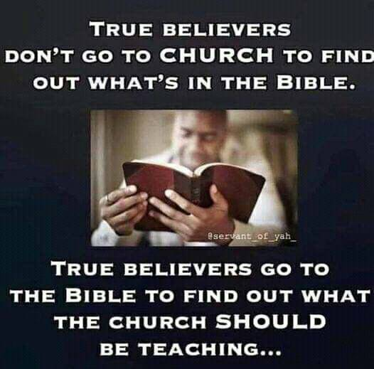
GRACE THROUGH FAITH

What does that mean? Grace is translated empowerment or “I will supply that which is needed when it is needed”! That could be strength when you are weary or comfort when you are grieving. We have been taught that it is only translated unmerited favor but that is the translation in only two verses. When Paul asked Jesus about removing his thorn in the flesh, Jesus told him that His grace was sufficient for him to deal with it. That word grace is NOT translated unmerited favor in this instance but power or empowerment. This is what it means to be dependent on the Lord throughout your whole life to supply that which is needed. Truth in your deception, comfort when sad, teaching when needing knowledge because His people perish for a lack of knowledge. Healing a broken heart, healing your body etc. Whatever it is you need when you need it, grace supplies it. What good is a gift of a new car if you don’t drive it or put it to good use? We have really cut ourselves off from never ending grace by believing it is a one time act of unmerited favor and it keeps us from experiencing the God of the word by being dependent upon Him, and looking for Him to supply that which is needed.
So the phrase grace through faith is about empowerment not to sin received through faith, which is a verb or an action word that is ongoing. It is NOT a one time act of believing just as utilizing grace or empowerment is not a one time act but ongoing. Paul repeatedly relied on grace to do everything, including dealing with his thorn in the flesh. If you trust Jesus as your Lord and savior you have to believe that His grace, given through the free gift of the Holy Spirit received through baptism in the Holy Spirit, will keep you from deception. That means you must receive truth in your deception. Deception means you think you are right but you are not. Strongholds are pulled down with truth. The Bible states that end time believers will not receive the love of the truth that they might be saved and God will give them what they want which is strong delusion. These are people confessing that they trust Jesus as their Lord and savior but through their actions they don’t because they think it is a one time act and not a lifelong process. The end time church is apostate or so far from the truth the first church taught it isn’t funny.

So we are saved by empowerment not to sin that is received through faith that was acted upon in obedience to being water baptized into the body of Christ IN ORDER THAT you be raised as Christ was raised the Bible says. In water baptism you are pledging to be dead to sin and self. Baptism in the Holy Spirit empowers you to keep that pledge. This is what it means to be born again of water and the Holy Spirit receiving empowerment (grace) through faith (verb) which acts upon what it believes. Faith without works is dead or not the saving kind of faith. Ephesians 2:8 where it says we are saved (future tense) by empowerment (grace) received through acting upon what you believe (faith) or you don’t really believe it do you, it is in the CONTEXT of being changed into a new creation by this empowerment through the Holy Spirit now that we are born again of water and the Holy Spirit which gives us access to the Father.

Let’s explain it in today’s terms for understanding. A rich man gives one guy a check for a trillion dollars. He believes the rich man is good for the money and shoves the check in his pocket and rides away. The second guy is given a check for the same amount and he also believes the rich guy is good for the money so he acts upon what he believes by endorsing the check, which is water baptism in this case, and deposits the check in his bank account, which is baptism in the Holy Spirit, so he can access what has been deposited in time of need. Endorsing the check and depositing it doesn’t make the gift any less free. That is why Jesus told Paul, my grace or empowerment, which has been deposited in you, is sufficient to meet your needs in dealing with your thorn in the flesh. Jesus wasn’t led into the wilderness to be tempted by the devil until He was first water baptized and baptized in the Holy Spirit. If He needed this empowerment not to sin while in the flesh, what makes us think we don’t? The Bible says there will be many in end times in the apostate church who will have a form of godliness but deny this empowerment thereof. From such people we are to turn away from them. They have believed a different gospel preaching another Jesus and the Bible says let them be accursed. Grace to them is license to sin rather than empowerment not to. Our freedom in Christ comes from no longer being a slave to sin but a slave to righteousness instead.

So what did Jesus save us from? He saved us from slavery to sin in order that we do not receive the wages of sin which is death eternally. The Bible says the law is for sinners. Those who are under grace or empowerment have ceased from a lifestyle of sin and are no longer under the law but grace by accessing and utilizing this empowerment or grace received by faith, which is a verb or action word, that is ongoing until the end where we receive eternal life Romans 6:22. You must endure until the end to be saved, which is why saved is future tense. Thus you work out your salvation with fear and trembling now that you have been empowered not to sin.

The law was to show us we could not keep it in our ability and needed this empowerment. When Jesus said it was finished on the cross that word finished is translated perfected. What the law could not do except show us our inability to keep it, empowerment (grace) perfected or equips us to live godly in this present world and keep God’s moral law in His ability or empowerment received through faith by acting upon what you believe in order to receive. The purpose of grace or empowerment is to teach us to live godly in this present world, created to do good works and walk in them. Becoming part of a Holy temple and having access to the Father through the baptism of the Holy Spirit. Without holiness no one shall see the Lord. Only those that do the will of the Father enter the kingdom of heaven. The Father confirmed Jesus’ son ship and pleasure when Jesus was water baptized and baptized in the Holy Spirit.

Translation, tense and grammar make all the difference in the world in accurately dividing the word.

“For by (empowerment) grace are ye saved through faith; and that not of yourselves: it is the gift of God: For we are his workmanship, created in Christ Jesus unto good works, which God hath before ordained that we should walk in them. For through him we both have access by one Spirit unto the Father. And are built upon the foundation of the apostles and prophets, Jesus Christ himself being the chief corner stone; in whom all the building fitly framed together groweth unto a holy temple in the Lord: In whom ye also are builded together for a habitation of God through the Spirit.”
ONE OF THE GREATEST DECEPTIONS AMONG BELIEVERS IN OUR TIME IS THAT FAITH HAS REPLACED OBEDIENCE!
[Cite your source here.]
THE WAY MORE PERFECTLY

Apollo’s was zealous in preaching Jesus to others yet he had to have the way of salvation preached to him more perfectly by Precilla and Aquilla. Notice that Apollo’s preached the gospel of grace and proved Jesus out of the scriptures to the Jews and was traveling around doing so, yet he needed salvation preached in its entirety because he did NOT have the COMPLETE gospel of the kingdom of God preached to him in order to receive it. Therefore, he was lacking because there was more to it than just believing. Believing is the first step and you can be excited and zealous in preaching the first step but that does not mean you are BORN AGAIN of water and the Holy Spirit in order to enter the kingdom of heaven. Jesus said you must be born again of water and the Holy Spirit. Peter told the crowds to repent and be baptized every one of you when asked “What must we do to be saved”? Most people today need the way preached to them more perfectly because they have been falsely taught that all you need is to just believe and they are too proud to hear or accept that there is more to salvation than believing. You must be born again of water and the Holy Spirit in baptism of both.

“And a certain Jew named Apollos, born at Alexandria, an eloquent man, and mighty in the scriptures, came to Ephesus. This man was instructed in the way of the Lord; and being fervent in the spirit, he spake and taught diligently the things of the Lord, knowing only the baptism of John. And he began to speak boldly in the synagogue: whom when Aquila and Priscilla had heard, they took him unto them, and expounded unto him the way of God more perfectly. And when he was disposed to pass into Achaia, the brethren wrote, exhorting the disciples to receive him: who, when he was come, helped them much which had believed through grace: For he mightily convinced the Jews, and that publically, shewing by the scriptures that Jesus was Christ.”
Acts‬ 18:24-28‬ KJV‬‬‬‬‬‬‬‬‬‬‬‬‬‬‬‬‬‬‬‬‬‬

“And it came to pass, that, while Apollos was at Corinth, Paul having passed through the upper coasts came to Ephesus: and finding certain disciples, He said unto them, Have ye received the Holy Ghost since ye believed? And they said unto him, We have not so much as heard whether there be any Holy Ghost. And he said unto them, Unto what then were ye baptized? And they said, Unto John's baptism. Then said Paul, John verily baptized with the baptism of repentance, saying unto the people, that they should believe on him which should come after him, that is, on Christ Jesus. When they heard this, they were baptized in the name of the Lord Jesus. And when Paul had laid his hands upon them, the Holy Ghost came on them; and they spake with tongues, and prophesied.”
Acts‬ 19:1-6‬ KJV‬‬‬‬‬‬‬‬‬‬‬‬‬‬‬‬‬‬‬‬‬
‬
Jesus said His people perish for a lack of knowledge. Don’t let your pride in thinking you know it all and are right, keep you from being born again of water and the Holy Spirit in baptism in order to enter the kingdom of heaven. You can believe and be zealous and still not enter in. Please receive the way more perfectly now that it has been explained to you.

REPENTANCE

“But when Jesus heard that, he said unto them, They that be whole need not a physician, but they that are sick. But go ye and learn what that meaneth, I will have mercy, and not sacrifice: for I am not come to call the righteous, but sinners to repentance.”
Matthew‬ 9:12-13‬ KJV‬‬‬‬‬‬‬‬‬‬‬‬‬‬‬‬‬
‬‬‬‬‬
Jesus called sinners to repentance. Today’s false apostate teachers leave this out and it is a prerequisite to even entering the kingdom of heaven. I heard the once saved always saved false preacher state we are incapable of repenting before coming to Christ. Would Jesus tell us to do something we are incapable of doing or that He has not empowered us to do? Don’t believe these false teachers who contradict the word of God and what Jesus commanded.

“Now when they heard this, they were pricked in their heart, and said unto Peter and to the rest of the apostles, Men and brethren, what shall we do to be saved? Then Peter said unto them, Repent, and be baptized every one of you in the name of Jesus Christ for the remission of sins, and ye shall receive the gift of the Holy Ghost. Then they that gladly received his word were baptized: and the same day there were added unto them about three thousand souls.”
Acts‬ 2:37-38, 41‬ KJV‬‬‬‬‬‬‬‬‬‬‬‬‬‬‬‬‬
‬
Notice that water baptism was for the remission or sending away of past sins in order for them to receive the GIFT of the Holy Spirit. Notice that after receiving Peter’s word, they were baptized. Baptism immediately followed receiving the word and believing. I don’t wait to baptize people. They aren.t born again until they are baptized in both water and in the Holy Spirit. Today, we tell people they are born again or saved by believing. Their blood will be on our hands. We have got to stop telling people they are saved when they first believe or they are born again when they first believe.

The pattern of salvation is found throughout the bible and Jesus followed this pattern. The Israelites believed they would be saved while still enslaved in Egypt. Were they saved when they first believed? Believing aligned them to follow Moses just as our believing should align us to follow Christ. Next they were led to the Red Sea where they were all water baptized and they were led by the spirit through the wilderness, just as we are to be led and controlled by the Holy Spirit in our wilderness walk in life in order to get us to the promised land, heaven. Some died in the wilderness as an example to us even though they were water baptized and led by the spirit, whose whole purpose was to get them to the promised land. If the same thing can’t happen to us, how can it be an example? The purpose of the wilderness was to get Egypt, which is symbolic of the world, out of them.
‬‬
In other verses where repentance was not mentioned, repentance had already taken place or was already a known fact.

We cannot cherry pick verses we want and apply them to us. If repentance has not taken place, it is required as a prerequisite to entering the kingdom and becoming born again of water and the Holy Spirit. That repentant attitude must be a lifestyle lived until the end.

John the Baptist started his ministry calling people to repentance because the kingdom of heaven was present to be received or at hand. Even the Roman soldiers DEMANDED of John what fruit they needed to exhibit to prove they had repented before John would even water baptized them. Jesus started His ministry calling people to repentance in order to receive the kingdom of heaven. Jesus came to deliver us from the power of sin in our life because the wages of living in sin is death. You receive this empowerment by first repenting. Then you are water baptized into the body of Christ as an adult where you are pledging to be dead to sin and self IN ORDER THAT you be raised as Christ was raised. Baptism in the Holy Spirit empowers you to keep that pledge. He only baptizes those in the Holy Spirit who will obey. If you can’t obey in the first thing given which is to repent and be baptized every one of you, why would He baptize you in the Holy Spirit? Too many in the church have a form of godliness but deny this empowerment thereof and from such a ones we are to turn away from them. That is how important empowerment, translated grace, not to sin is to your salvation. Don’t listen to, fellowship or go to churches that leave out repentance, water baptism where you won’t be raised as Christ was raised without it and living dead to sin and self which you can’t do in your ability which is why baptism in the Holy Spirit is given next.
.
“What doth it profit, my brethren, though a man say he hath faith, and have not works? can faith save him? Yea, a man may say, Thou hast faith, and I have works: shew me thy faith without thy works, and I will shew thee my faith by my works. But wilt thou know, O vain man, that faith without works is dead? Was not Abraham our father justified by works, when he had offered Isaac his son upon the altar? Seest thou how faith wrought with his works, and by works was faith made perfect? Ye see then how that by works a man is justified, and not by faith only. For as the body without the spirit is dead, so faith without works is dead also.”
James‬ 2:14, 18, 20-22, 24, 26‬ KJV‬‬‬‬‬‬‬‬‬‬‬‬‬‬‬‬
‬‬‬‬‬‬
Anyone preaching a gospel that leaves out repentance, holy living, sanctification, water baptism and baptism in the Holy Spirit is not preaching the gospel of the kingdom of heaven that we were commanded to preach. This kingdom has a king who must be Lord in order to be savior. The Bible says we are saved, translated delivered from slavery to sin, made whole or healed through sanctification of the spirit and belief in the truth. To reject truth is to reject Jesus. The Bible says the end time apostate church age we are currently in, will have believers who will not receive the love of the truth that they might be saved and receive eternal life in the end Romans 6:22. You are not saved when you first believe just like the Israelites. If you are still a slave to a lifestyle of sin you are not saved. You have not yet been set free from the world, which Egypt was symbolic of. Water baptism slammed down shut on what used to enslave the Israelites so don’t negate the power of water baptism in setting one free. Demons manifest before a person is water baptized many times because a door is being slammed shut on what enslaved that person. We must endure until the end in this freedom and be sanctified and believe the truth. God will send strong delusion to the believers who will not receive the love of the truth that they might be saved. This is why it is so important to put away from us those that have a form of godliness but deny this empowerment thereof. Read the Bible for yourself and stop believing false teachers bringing damnable heresies into the church. That is lies that will damn you. You are not saved when you first believe. Therefore you cannot lose what you do not yet possess and are still working out as you work out your salvation with fear and trembling.

BABYLON FALLS

What caught my eye in reading these verses in Revelation was that the Lord told HIS people to come out from among her (Babylon) in order NOT to receive the plagues of the WRATH OF GOD that was about to be poured out.

“And I heard another voice from heaven, saying, Come out of her, my people, that ye be not partakers of her sins, and that ye receive not of her plagues. For her sins have reached unto heaven, and God hath remembered her iniquities. Reward her even as she rewarded you, and double unto her double according to her works: in the cup which she hath filled fill to her double. Therefore shall her plagues come in one day, death, and mourning, and famine; and she shall be utterly burned with fire: for strong is the Lord God who judgeth her.”
Revelation‬ 18:4-6, 8‬ KJV‬‬‬‬‬‬‬‬‬‬‬‬‬‬‬‬‬
‬That totally flies in the face of what the apostate end time church today teaches doesn’t it?

I notice that as the plagues are being poured out, it is constantly noted that they still weren’t repenting of glorifying God or repenting of their deeds. Could trouble and calamities be allowed to bring man to repentance? How far will our nation or the world have to sink before HIS people come out from among her and we repent?
This also struck me that in Rev. 18:15 it lists the things Babylon the great sells and the last two items are slaves and souls of men. Is your soul up for sale because of compromise? Something to consider. God avenges His apostles and prophets by destroying Babylon and HIS people who DID NOT come out from among her.
Those who love the world are enemies of God. You cannot serve two masters.
As calamities happen, remember that what God is looking for is repentance in order not to be recipients of His wrath and judgment.

Let’s come out from among her and repent.

Allow the Lord to pull down your mental strongholds with the truth. Giving you over to what you want, which is being deluded, has some pretty stiff eternal consequences. Don’t let your friendships with the enemies of God blind you to the truth and keep you from having ears to hear.

Avalanche Vision Given to Steve Hill http://www.stevehill.org/

This is coming to you from a man who has just passed through the valley of the shadow of death. Since my close call with eternity just a short while ago … everything has become clearer. I can hear His whisper. Unabated obedience has become my mandate. That is why I’m writing this word from the Lord.
A few days ago, after enjoying quality time with Jesus, I was surprised by an alarming vision. I saw a massive, majestic mountain covered in glistening snow. It reminded me of the Matterhorn in the Swiss Alps. Its peaks were sparkling white and I was amazed by God’s attention to detail. It was so realistic I wanted to go skiing! But I sensed that there was more that the Holy Spirit was about to reveal. As I closed my eyes, I was in a winter wonderland bustling with thousands of vacationers. The ski lodge, condos, hotels and cabins were at full capacity at this popular resort.

Day quickly turned to night as the skiers, snowboarders and sports enthusiasts were settling in. Anticipation grew as the snow began to fall. Everyone headed to bed believing tomorrow would be a day of sheer enjoyment on freshly covered slopes. For an avid skier, the exhilaration of being the first one to race down a new blanket of snow is a dream come true.
Throughout the night, winter storms dropped several feet of new snow on the slopes. The night ski patrol was put on full alert. Their mission was clear. With the potential of killer avalanches they took to their posts.

I began to weep as the vision continued to unfold along with its spiritual application. The ski patrol operated like a well-trained platoon. Some boarded helicopters manned with small bombs, others jumped on snowmobiles loaded with hand held explosive devices. What seemed to be a strategic group of sharpshooters were stationed at the base maneuvering anti-tank weapons aimed at the snow covered peaks. They fired their weapons at strategic points in the “avalanche zone” (large TV or radio ministries) to force avalanches before the snow accumulated to a life-threatening depth. Left unchecked, the accumulation of heavy, dense snow packed on top of lighter snow could easily slide down with incredible speed and force, resulting in enormous damage and loss of life.

The Lord began to speak. I trembled. The fresh, new snow represented the false teaching that is steadily falling on the ears of the body of Christ. It has been, and is, a heavy snowfall. The skiers represented believers and non-believers, trusting the resort for a safe and memorable experience. As Christians, we have been warned to be sober and vigilant (1 Peter 5:8). However, the present, awe-inspiring teachings have lulled many into a deeper sleep.

The layers upon layers of snow have been steadily covering the solid traditional truth of Christ. The truth is that foolish teaching in these days will become so fashionable even the most dedicated believer could become deceived (Matt. 24:24). It’s happening before our eyes. One spiritual leaders said the other day: “You guys are old-fashioned ‘holiness,’ we are modern day ‘grace.’ You live in bondage while we can do anything we want.

Pastors and teachers worldwide have succumbed to heretical teachings including universal reconciliation, deification of man, challenging the validity of the Word of God including His judgements, and even lifting any boundaries, claiming His amazing grace is actually “amazing freedom.” You are free to live according to your own desires. Sound familiar? “They had no king and did what was right in their own eyes” (Judges 17:6). These popular self-proclaimed ministers of the gospel are covering the “slopes” and will be held accountable for the spiritual death of millions.

Just as the ski patrol did in this vision, those who are aware of what’s happening must take swift and accurate action. Their weapons of warfare must be aimed at the peaks and the ‘avalanche terrain’ to dispel the lies. Apostles, prophets, evangelists, pastors and teachers must be willing to drop spiritual bombs, fire anti-heresy missiles, and even drive into the danger zones armed with explosive truth to confront this potential avalanche. The generals of this generation must leave the war room and put their years of experience on the front lines.

Friend, I humbly encourage you to heed this vision and take it before the Lord. I’ve written it just as it was given. My responsibility is to share with the body of Christ His words to me. The ears that hear and the hands that obey are out of my control. This is not just Steve Hill telling a story. Most of what the Lord shares with me is personal and remains in my heart. But I sincerely believe that this is a warning for this hour.

Satan is “snowing the saints” but it can be stopped. In the vision I heard explosions. I saw dedicated Christian soldiers scrambling to do anything it took to bring down this avalanche before devastation occurred. One of the most powerful weapons we possess to combat this onslaught is the tongue. Let God set yours ablaze by preaching ALL the words in RED. If we take action now the result will be a tearing down of false teaching and a remaining layer of solid, God given, biblical instruction that will save the lost, heal the sick and strengthen Christians to do the true work of the ministry.
As for me, I am clean of the blood of those who do not repent, for I have been faithful to give out what He has given me, as much as it has grieved my heart to do so.

FOLKS, I JUST GIVE OUT WHAT HE GIVES ME. eND TIME SCRIPTURE IS BEING PLAYED OUT BEFORE OUR VERY EYES. HE IS COMING FOR A BRIDE WITHOUT SPOT OR WRINKLE.

My hands are clean because I warned. How about yours?

A VOICE CRYING OUT IN TH.E WILDERNESS MAKING STRAIGHT THE PATHS! COMING IN THE SPIRIT OF ELIJAH! AS IT WAS THE FIRST TIME, SO IT IS THE SECOND!

For speaking engagements call
813-393-9384.

Our website is www.latter-rain.net


IntroductoryYouTube Video below with more to follow:

https://youtu.be/E_PrFVmefXc

