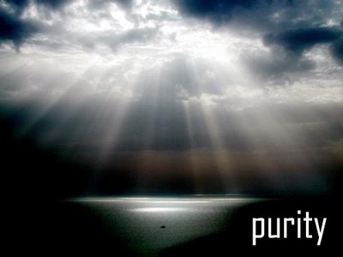
  FRESH RAIN
  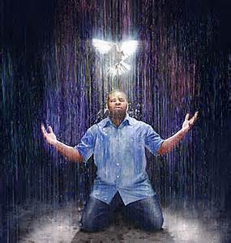
[;’pcx cqxxxxxxxxxxxxxxxxxxxxxxxxxxxxxxxxxxxxxxxxxxxx
Latter Rain Ministry  Preparing a Bride without spot or wrinkle |  | January, 2018
AND THEY ANSWERED NOT A WORD

January 13, 2018 - I love weekends experiencing the presence of the Lord. I have had something stirring inside me as I listened to His voice. This is His Word.
“The church today is in a state of deep deception as they worship another Jesus and preach another gospel. It is a gospel based on man, personalities and self. They want the blessing without the blesser. They want saving without the savior. They want deliverance without the deliverer. They want the gifts and not the gift giver. They want provision without the provider. They seek my hand and not my face. They want the way but don’t want to walk ye in it. They want a prophetic word and not THE WORD. They want life but not the one who gives it. There is no denying of self or holiness without which no man will see me. And they love it so. They have been deceived into believing they have eternal life when they, in fact, reject truth that leads them to me, the giver of eternal life. They want truth as a lamp beneath their feet but put out the flame of my fire by quenching and grieving my Holy Spirit. They will hear on that day, ‘Depart from me I never knew you’ if they do not repent. As I have revealed my true self

through my word and remnant, the leaders of my church have kept silent and answered not a word. I have brought them to the valley of decision saying, if the Lord be God, let us worship Him. But if your image of Jesus be God, let us worship him. But choose this day who you will serve and they answered not a word, though I be faithful to bring them truth in their deception. When they call upon their idol of God, He will answer them with silence. But my remnant will call upon me and I will consume with a Holy fire all their false sacrifices, lies and deception. The world will know the true from the false as the Lord God of the universe reveals Himself to all as the one true God. A shaking and a storm are coming and I will spare those that fear me. When they call upon me I hear them and will manifest myself to them and they will go forth as led by me to display my power and glory in such a way that no flesh will glory in my presence. It will all be of me for I am a consuming fire and a jealous God and the gates of hell will not prevail against my church. Then all will be able to tell the false from the real in that day as I reveal my true self upon the earth. I am both the lion of the tribe of Judah as well as the

Lamb of God. Many reject the lion because they only want the lamb but a Day is coming where the lion will lay down with the lamb in perfect unity.
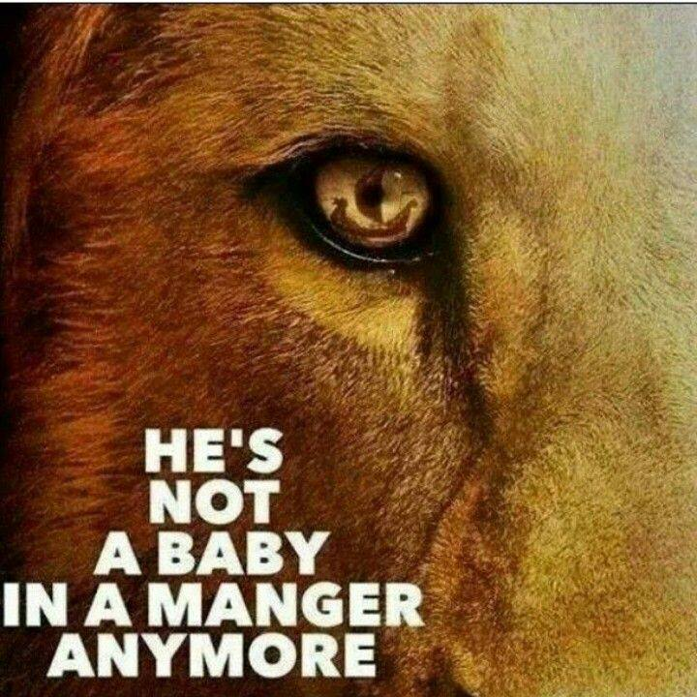
A rain cloud is forming and a storm is coming that will overcome you suddenly after this long drought of truth. My remnant will go forth as laborers bringing in the harvest in my power and might because they have harkened unto my voice and fear and obey me. The stubble will have been removed and cleansed with this fire, wind and rain saith the Lord. Then will people see the great I Am and fall on their faces and come to know Me and not just what I give and provide. Their salvation will be from the savior and redeemer of their souls that they deeply fall in love with rather than for what they can get because they will come to realize I AM is the gift that paid a great price and all they gained prior to that is as dung as I manifest myself to them as who I truly am“.
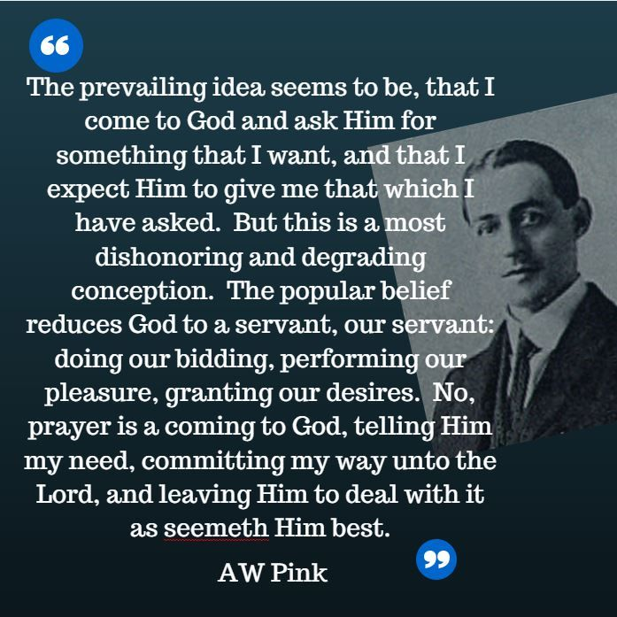
I am going to post other prophecies that have come out all saying pretty much the same things. I will also post links you can go to as the Lord is saying and preaching the same thing. The Lord said that He does nothing but that He reveal it through His prophets first.
Pastor Kent Christmas believed God wanted to him to share a lengthy word of the Lord with the church—and video of the prophecy went viral. In the video, he declares it a "year of death" for false prophets and lukewarm Christians, but also promises good developments for God's followers. Watch the full video here. https://youtu.be/_Pbzrsc44UE
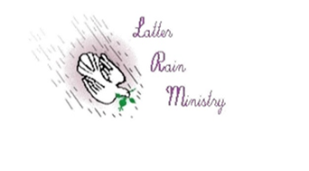Joanne Armstrong – January 7, 2018
Please notice how two prophecies by different people speak of the Lord brooding over all the earth.
Malachi 3:16-18. Then they that feared the Lord spake often one to another: and the Lord harkened, and heard it, and a book of remembrance was written before Him for them that feared the Lord, and that thought upon His name.
And they shall be mine, Saith the Lord of Host, in that day when I make up my jewels, and I will spare them, as a man spareth his own son that serveth him.
Then shall ye return, and discern between the righteous and the wicked, between him that serveth God and him that serveth him not.
As I spoke with someone yesterday we spoke of the Lord. A detailed picture flashed in my mind as we did and I knew God was saying something to us in it. The picture was of Jesus on the throne. Angels or people were milling about Him. All of a sudden He sushes the group around Him and waves one aside. He leans down and turns His ear earthward cupping His ear as if to hear better. Then He commands a book to be brought that He starts to write in as He listened.
I knew this was God so I relayed the picture to the person I was talking to. I asked if it was biblical. So I googled it as we talked and was led to the verse in Malachi. It was biblical and He was letting us know that He is taking notice of our conversation about Him and wants to remember it. Still this brought up more questions. Is Jesus forgetful? We know He forgets sin. Why would He want to remember this etc. I went back to the verse this morning in my morning coffee bible reading. I looked up the word remembrance because obviously there is a book of remembrance that is being written in. The definition in the Hebrew means momento or record. To mark so as to be recognized. To mention. To be mindful. To recount. Make to be remembered. To make noteworthy as being the most noteworthy. Hmmm.
Why would Jesus want to write this down. It is right there in the following two verses. To show everyone that they are His. To recognize them to others that they belong to Him. To recount or make noteworthy to others by bringing it up. To display as jewels. To mark them by sparing them as one spares his own son that serves him. Why? Not so Jesus can remember because He is forgetful, but so as to show others how to discern the counterfeit from the real in the days where false gospels and a different Jesus is preached and damnable heresies prevail in the church where ears are tickled and flesh is patted and there is no fear of the Lord.
When things start going through a shaking in the church and things are destroyed, ministries fall, temple tables are overturned and the church is cleansed, this is where the book gets brought out as the Lord spares those in the book of remembrance as they are exalted and others debased. It will be clearly apparent who serves God and who doesn’t. The gates of hell shall not prevail against His church. He is brooding over the earth seeking to bring life out of a lifeless, powerless church and produce an Acts church that has gone back to the foundational teaching of the church and that move in the supernatural glory of the Lord. The rain is coming. The clouds are forming and will quickly overtake the enemies of His bride. The rain will bring forth a bountiful harvest using those that He has recorded, recognized and made noteworthy as fearing Him.

Nathaniel Houston - January 16, 2018
HE THAT HAS AND EAR TO HEAR WHAT THE SPIRIT IS SAYING TO THE CHURCH:
For surely saith the Lord, as it was in the beginning so shall it be again. Even in the beginning as My Spirit hovered over this earth covered with darkness, so it is today that My Holy Spirit broods over this earth and as it was then the Word was spoken, “Let there be light”. First the natural then the spiritual, saith the Lord, as it was done then so shall it once again be done. For in the days in which you live you shall hear it with your ears, see it with your eyes, once again the Word shall be spoken “Let there be light” over this world covered with darkness, despair and confusion. For once again I shall pour out My Spirit of burning upon this place and it shall bring an purging saith the Lord for My Spirt shall go across this land as My Fire of Holiness and it shall consume the hay, the wood and the stubble that men have built upon. For which men call holy, I call hay, wood and stubble and it shall be consumed by the Spirit of Holiness upon this place and once again there shall be light where there was once darkness. For it is not over yet saith the Lord, My Work is not done, but yet shall come a day that comes quickly upon you now, saith the Lord. Some will embrace this, some will stand against it, but those who embrace this new move, this new outpouring of My Spirit of Holiness upon this nation and upon this earth, those who embrace it shall rise and they shall carry that fire wherever they go. For My Spirit of Holiness shall dwell within them, that spirit of burning shall be upon them. Just as it was on the Day of Pentecost, so shall it once again be. So do not look around and see with your eyes the things that happen in the natural and say is this all there is? There is more, saith the Lord, more is coming for the Word shall go out and it shall bring light into this place of darkness and the darkness shall flee and the light shall arise. Is it not written, arise and shine for your light has come and the Glory of the Lord is risen upon you? As it was written in times past, you shall see it manifest before your very eyes. This arising comes quickly for those who will embrace it. Run to it and not from it. They shall carry My Fire of Holiness in this place saith the Lord.
A storm is coming. The torrential rains shall fall. The waters shall rise. The floods shall sweep away all wood, hay and stubble. The violent winds will blow away all that was built irresponsibly. (Alois_Wonaschuetz)
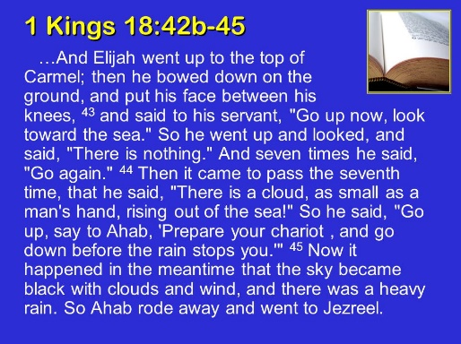
All these prophecies saying the same thing are the storm clouds forming like the mans hand coming out of the sea.
Bert Farias – January 5, 2018
Are you building your house on the rock or on the sand?
"Whoever hears these sayings of Mine and does them, I will liken him to a wise man who built his house on a rock. And the rain descended, the floods came, and the winds blew and beat on that house. And it did not fall, for it was founded a rock. And every one who hears these sayings of Mine and does not do them will be likened to a foolish man who built his house on the sand. And the rain descended, the floods came, and the winds blew and beat on that house. And it fell. And its fall was great " (Matt. 7:24-27).
"What sayings of Mine" is Jesus specifically referring to in these passages? Reading in context, Jesus began a lengthy teaching from Matthew 5-7 and the central theme of it seems to be the character of the heart of man—from the Beatitudes, to loving our enemies, to having the right motives in giving, praying and fasting. Then He goes on to teach them about the Father's care for them and not worrying but seeking first the kingdom of God. Finally, Jesus comes to the end of that teaching and speaks about hypocrisy and righteous judgment and reverting back to heart matters followed by a warning of false prophets and those who call Him Lord but don't do His will. This entire teaching is traditionally known as the Sermon on the Mount, and it ends with the parable of the wise and foolish builders.
This was one of Jesus' first and most foundational teachings. It set the tone for His public ministry. As ministers that is important for us to know. We must emphasize what Jesus emphasized. These sayings prepared the people and His disciples for what was to come. Herein we find the standard of Jesus' life and ministry for all He did and taught. The heart must be right or nothing else will be right. If the heart is not right people won't do what He says. We must build our lives on Jesus' words, especially these first words of the first lengthy sermon He preached.
Storms Test the Strength of the Foundation
Jesus was the Master Builder. When it comes to building people, He is our primary example and pattern. The apostle Paul refers to God's people as God's field and God's building (1 Cor. 3:9), and he calls all ministers his fellow laborers who plant and water the field, and who are to build on the foundation of Jesus Christ.
The image of the people as a building under construction is very interesting because it highlights the responsibility of ministers to be faithful in how they build. Ministers are like building contractors who are only permitted to build on the prescribed foundation (see 1 Cor. 3:12-15). There are both wise builders and foolish builders (Matt. 7:24-27). To build on the foundation a building of durable material (gold, silver and precious stones) means not only to teach sound doctrine but even more importantly, to be a godly example and live a sanctified life of fidelity to the truth, thus helping to mature the saints. Ministers and especially pastors/shepherds, because they live with the people, teach more by their life example perhaps than anything else.
On the other hand, to build with perishable material (wood, hay, and stubble) is to provide inadequate or unsound teaching or to compromise the truth by living a lifestyle that contradicts or falls short of modeling it. It is the quality of every builder's work and not the quantity, as seems to be much of the focus today, that shall be tested by fire, for which every builder shall give account to the Lord.
In Jesus' parable (Matt. 7:24-27) He uses a storm, signifying the pressures, hardships and trials of life, as well as the persecutions we will suffer for the gospel, as a measuring gauge for how solid our foundation is. And what is our foundation based upon? Jesus taught us that it is based upon doing His sayings. Obedience is the issue. "Not everyone who says to Me, 'Lord, Lord,' shall enter the kingdom of heaven, but he who does the will of My Father who is in heaven" (Matt. 7:21). Obedience, not lip service, is what God requires.
Have you ever thought about what gives us the strength and fuel to obey God? Why are some people obedient and some are not? Why are some doers of the Word and some are not? Why do some people stay faithful to God and remain true while others do not? Why do some start this Christian race but never finish? What is it that causes us to endure to the end (Matt. 24:13)?
It is the fear of the Lord. Obedience to the Lord is not only proof of your love for Him (John 14:21), but also of your fear of Him. There's been an emphasis on love, although we've fallen short of the full counsel of God in that area, too, but there has not been nearly as much of an emphasis on the fear of the Lord. It takes both of them to produce a strong constitution in your Christian life. Notice in the following two different translations how the love of obedience in Jesus was rooted in the fear of the Lord. They are identical. Or a better way to say it would be that the manifestation of the fear of the Lord is obedience to His Word and His sayings/commandments.
"His delight is in the fear of the Lord" (Isa. 11:3a, NKJV).
"He will delight in obeying the Lord" (Isa. 11:3a, NLT).
I love this verse of Scripture. It feeds and fuels the fear of the Lord in me and the delight to obey Him. This is our sure foundation. Since our obedience is the manifestation of the fear of the Lord in our lives, and since that is the difference between building your house on the rock or on the sand, we then could say that the fear of the Lord is what builds a strong foundation for our houses, which represent our lives. The fear of the Lord produces durable materials in our lives that will strengthen us to stand even in the midst of the storms. Can you see that?
A house is built by wisdom, and the fear of the Lord is the beginning or the foundation of wisdom/knowledge. Once again, a house represents our lives, homes, families.
"Through [skillful and godly] wisdom a house [a life, a home, a family] is built, and by understanding it is established [on a sound and good foundation]" (Prov. 24:3, AMP).
"Wisdom begins with the fear of the Lord" (Prov. 1:7a, CEB).
"Fear of the Lord is the foundation of true knowledge" (Prov. 1:7a, NLT).
If we build our lives and homes on the true wisdom and knowledge of God that comes from the foundation of the fear of the Lord, we need not fear the storm, because we will stand.
Paul's Great Desire
One of the apostle Paul's greatest burdens was this very thing: that the people He ministered to would stand firm in their faith and remain obedient to God even in the midst of the troubles and persecutions of his day. Other New Testament writers shared the same burden.
Paul's great desire was that the people he taught would not falter under pressure, lest his work be useless or his labor be in vain. Notice his great concern for the Thessalonian saints (1 Thess. 3:1-9). He had warned them of the troubles that would soon come. In his farewell speech to the Ephesian elders, he warned them of the same troubles (Acts 20:25-31). To the Galatians and the Hebrews he did the same, warning them not to turn back to the Law. He was preparing them for the storm and the persecution they would receive from preaching the cross and paying the price to follow Jesus. Warnings are such a large part of the Scriptural admonition that Paul and the other New Testament writers gave to the churches. Today there is a glaring absence of these warnings in our preaching.
Here are just some I found in the New Testament: Matthew 7:15, 10:17, 24:4-5, 24:11-13, 24:24; Mark 12:38-40; Luke 12:1, 15; Acts 20:29-31; 1 Corinthians 6:9, 10:12, 11:3; Galatians 6:7; Ephesians 5:6, Philippians 3:2, 18; Colossians 1:28, 2:8; 1 Timothy 4:16; Hebrews 2:1-3, 4:1; 2 Peter 1:10, 3:17.
Fellow minister and preacher, how well are you preparing yourself and your people for the storm? Are you teaching them the whole counsel of God or catering to itching ears? Are you including the warnings in your preaching? Are you preaching on only the goodness and mercy of God, or do you also preach on His severity, wrath and judgments? Are you only preaching on the love of God, or do you place emphasis on His holiness too? Do you ever preach on sin and repentance? Are your concepts of the love of God and the grace of God accurate and in accordance with Scripture?
If not, then you may be guilty of the blood of men: "Therefore I testify to you this day that I am innocent of the blood of all men. For I did not keep from declaring to you the whole counsel of God. .... Therefore watch, remembering that for three years night and day I did not cease to warn everyone with tears" (Acts 20:26-27, 31).
Make sure you are preparing yourselves and those whom God has entrusted to you for the storm. Oh, how much stronger our churches would be if we included these things in our preaching and teaching and living them out before the people!
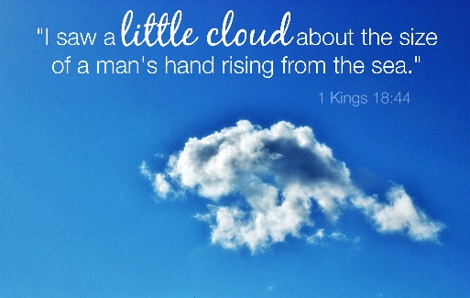
Chris Bennett – January 14, 2018
Spirit of Elijah
I believe the Lord is showing me that the Spirit of Elijah is about to fall upon the company of prophets - worldwide. This will be a new gifting or mantle especially for these end times.
I saw Elijah at Mount Carmel. I envisioned the whole scene - Israelites all gathered to one side, thousands of them. I got the impression that it was just family, clan, and tribe leaders rather than the whole of Israel. Opposite them were the prophets of Baal, and in the middle was Elijah. I saw the prophets of Baal dancing, cutting and calling upon Baal to no avail. I saw Elijah step forward and start to call out to the Lord. As he did do I saw angels surround him and a sort of mist enveloped him. I saw the fire fall on the sacrifice and that was the end of the vision.
This mist, I understand now, was the spirit of Elijah mantle made visible for me, which the Lord is now bringing to His prophets. It is a mantle of great courage and even greater power. It will have to be handled with great care and used only as directed by the Lord Himself. I don't believe that there will be many who would dare to assume such a mantle.
No-one will be able to claim this as this will come as a gift from the Lord Himself which He will make plain to the body of the church. These prophets will carry a very heavy anointing. They will be afforded great authority and respect, and they will wield the gifts of the Spirit with great power and humility - “greater gifts” as the Lord put it.
These will not be well known and respected so much as they will be accurate, forthright - to the point of bluntness, and they will certainly not seek popularity, fame, or fortune, but will rather be quieter, humble people.
“Watch”, says the Lord, “for I will raise these prophets Myself. I will show them, teach them, how to handle the anointing I will place on them. They will show themselves by their love, by their words, and by their wisdom, and miracles shall attend their ways. Man's choice may not be My choice, but these you shall know and recognize. They shall not seek recognition but it shall come to them by My hand.”, says the Lord.

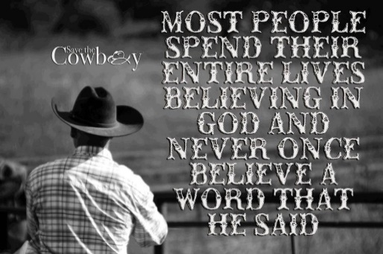
Watching Over His Word to Perform It
Did I not warn that in end times people would not endure sound doctrine? Did I not warn that they would heap upon themselves teachers to tickle their ears and pat their flesh? Did I not warn that wolves would enter into the sheepfold in sheep’s clothing to get fat off the flock? Did I not warn that false teachers would make merchandise of My bride? All this I knew, but I am not wringing my hands in worry! How BIG am I? Did I not also say that I have a remnant still in the land? Did I not say that the gates of hell would not prevail against my church? Did I not say the judgment starts in MY house? Did I not say that I will remove all who offend Me out of MY kingdom before I snatch away my bride? Did I not say that I would bring upon those heretics and merchandisers swift destruction? Did I not say the enemy has sown tares in the wheat, which I allow to remain until the time of harvest? Did I not say that I will send the former, middle and latter rain and send my laborers out into the field to reap what my rain has watered? Why do you think I warned of all these things? So you would not fret and be deceived, but pray and pick up your sickle to enter the harvest field. Everything that can be shaken will be shaken until all that remains is of Me. You can tell the harvest field is maturing for a harvest because the distinction between a wheat and tares are becoming more obvious. The tares stretch high toward the sun, while wheat in maturity bow down. I have already sent this word and I will accomplish that which I said. Be still and see the salvation of your Lord. You are about to see greater works as I send my laborers forth into the harvest field. You just pick up your sickle and do as I command and watch what great and glorious things I will do because I am faithful and I do watch over my word to perform it says The Lord.
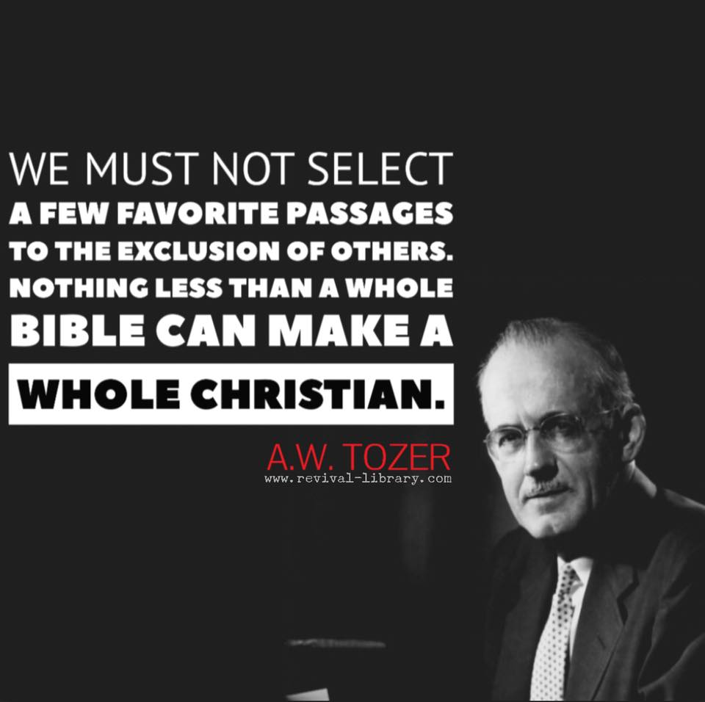
A call to intercession as I felt a weeping in my spirit by the Holy Spirit. As I prayed in tongues:
I call my remnant to prayer! The sins of my house have eaten me up. The stench has risen unto my nostrils. No longer will the blood of my Son be trodden upon by those in My house. There will be no more warnings after this! It is time to repent, get your house in order and return unto Me. There will come a mighty roar from heaven that will cleanse My house. It is time and no longer will I wink at sin. You have wearied Me by making my house your playground. You have wearied Me by trodding underfoot the blood of My Son despite the spirit of grace or the empowerment not to sin. You mock His sacrifice and blood continually with your sin. You ignore and blaspheme the Holy Spirit. You call evil good and good evil and you cannot discern between the two in My own house, where I have welcomed you and cared for you. My wrath is about to be poured out on the earth. It will also be poured out on the children who rebel and disobey Me. Have I not given you my word describing the signs in which to watch for before the great and terrible day of the Lord and yet you still do not repent and walk uprightly, despite the spirit that was given you to empower you to do so. You choose deception. You willfully sin. You heed evil spirits that have crept into my house and you love it so. You laugh and walk in a drunken stupor while judgment knocks at your door. You will soon mourn and howl at what is to come upon you if you do not repent and be holy as I am holy. You are to be set apart from the world, not loving it. You are to be a peculiar people, not a perverse people entertaining yourselves with all sorts of vile decadence, and you love it so. You worship the god of this world and thus you will be turned over to it if you do not repent. The sacrifice of My Son’s blood should cause you to realize the hatred for sin and show you that it must be judged. If you continue to willfully sin, despite the empowerment not to, you will be judged in your sin with the world. You use the blood of My Son to silence the conviction of the Holy Spirit believing you are free to sin and be secure in My sight. You misuse “don’t judge” in order to silence anyone I send to restore you so you can indulge in your sin guilt free. I said not to judge hypocritically, and those in my house are to judge and restore one caught in a sin. My Son’s blood shows the hatred for sin and that it must be judged or removed. It is never to remain. If you continue to practice a lifestyle of sin and not die to the flesh and self, you bring judgment upon yourself, despite the lies you have been taught. If you repent, return and walk in the spirit and do not fulfill the lusts of the flesh, and actually confess with your life that Jesus is Lord I will show mercy. Time is short. The groom is coming! Will He find real faith, the saving kind of faith, upon the land and in His church?
There is a fiery indignation coming upon the land. Babylon will fall. The earth will shake. Everything that can be shaken will be shaken. Calamity will come while false prophets preach peace and comfort, prosperity and ease. The whole world senses the signs of the times and how things are being set up quickly for the time of the end. Those that pollute the world with vile entertainment will howl at what is coming upon them. There will be no doubt in anyone’s mind that all that is to come upon the earth came from Me saith the Lord for the cup of My wrath is full and runs over.
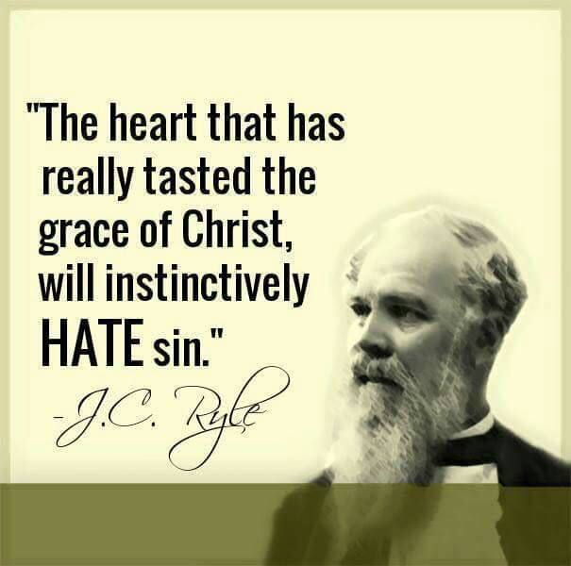
December 26, 2017 – Dawn Hill
As a young Christian, I remember driving by establishments featuring the words, "psychics" and "tarot cards" in glowing neon in windows and storefronts, and I remember, for lack of a better word, feeling agitated at the sight of these places. I was not agitated with the individuals operating in this realm so much as I was the very existence of this perversion of the prophetic. Looking back, I understand that my agitation was in large part a reaction to this counterfeit of the prophetic ministry, and it was tied to my calling as a prophetic voice.
Imagine my surprise and naiveté when I discovered and continue to discover that this counterfeit realm operates among those who profess to know Jesus Christ, and sadly, many are deceived by darkness masquerading as light. I do not pretend to believe that this is a pleasant word. What is to follow is a difficult word, but it is an issue that must be addressed in the body of Christ, and my goal is to share the truth of the Word of God and the heart of the Father on the matter. Where the Spirit of the Lord is, there is liberty, and we need Him to guide us into all truth (2 Corinthians 3:17, John 16:13).

The Counterfeited Counterfeit
In our current spiritual climate, there are many things occurring in the name of revival and Jesus Christ. Some things are within our comfort zone and understanding while other things really stretch us and challenge us. I do not pretend to have all the answers. However, when there are professed Christians taking tools utilized by the kingdom of darkness and morphing them into tools with a similar purpose but a different branding, that is a slippery slope racing to the finish line of witchcraft while preaching another Christ.
As I meditated on some things swirling in the prophetic climate right now involving this very thing, the words "counterfeited counterfeit" came to me. According to Merriam-Webster, counterfeit is "something made in imitation of something else with intent to deceive." The only things counterfeited are things of value. This is why the devil counterfeits the prophetic with such things as psychics, necromancers, horoscopes, tarot cards, astroprojection, and so on. He understands the value of authentic prophetic ministry and the office of a genuine prophet, and when the body of Christ shies away from the spirit of prophecy, he is glad to oblige the longing of people to experience the supernatural, even if it a perversion of the real deal.
The problem now is the darkness pervading the prophetic through those who willingly use the same tools with a different spin on them. Emotions and the soulish realm gauge the authenticity of the encounter instead of the gauge being the Word of God. It is a skewed form of godliness, but denying its power (2 Tim. 3:5). The power is not in the prophecy itself, but the relationship with Jesus Christ and the revelation of His heart. What happens when those professing to be part of the body of Christ counterfeit the imitation? The result is a counterfeit of a counterfeit. The result is another step away from the right Spirit, the Holy Spirit. The result is people without proper discernment being led astray by those who are also without proper discernment. A tainted prophetic flow gives the enemy what he has always wanted from the beginning: worship and exaltation.
The Lord desires a pure prophetic flow from His bride. Cleansing comes by the washing of water with the Word (Eph. 5:26). The Holy Spirit is the living water that should flow out of us. Understand that in the body of Christ, we are to judge within the church (1 Cor. 5:12). It is contradictory to the Word of God to say otherwise. We are to examine the fruit of a professed believer's life and judge it according to the Word of God. We are called upon to not believe every spirit but to test the spirits and to determine if the spirit is of God (1 John 4:1).
2 Corinthians 11:4 speaks of tolerating another Jesus or a different spirit or gospel than the one proclaimed by the true apostles. This is disturbing, and this is what is happening in the body when tools of the devil are welcomed into the place reserved for the Lord. Strange fire ensues, and division comes on the embers of divination. God wants His body operating in unity of the faith and of the knowledge of His Son. He wants us mature and not carried off by every wind of doctrine tainted with human cunning and deceitful schemes (Eph. 4:13-14).
As prophetic people, we must operate in a pure flow. We must reclaim what the enemy has perverted while using wisdom and proper discernment to not muddy the waters with his schemes and devices. We are mandated to manifest the kingdom of God. We are not mandated to counterfeit the darkness in the name of Christ. There is no inheritance in another Christ. I urge you in this hour to pray and intercede for those who are deceived by the tools of the devil, especially those who claim to know Jesus Christ. Pray that a holy conviction would come upon those who are seduced by the angel of light. Search your own heart and ask the Lord to cleanse you and to reveal any area of deception. I believe that a cleansing is upon the body of Christ, particularly the prophetic voices, and this cleansing only comes through the Word of God and the blood of Jesus. Holy Spirit, guide us into all truth!
Many people do not even know how to discern a spirit of divination that counterfeits the Holy Spirit and it gifts. We are to be led and controlled by the Holy Spirit. We do not lead and control the spirit realm. A witch recites an incantation and spirits go forth to perform what she recited in her spell. When you go to a psychic, what the psychic says, demons are being assigned to you to bring forth that which the psychic said. Divination has entered the church under different Christian terms which the devil changes up once in awhile but the concept is the same. You shall have whatever you say. The positive confession stuff. The blab it and grab it or the declare and decree it outside of hearing a rhema word from God. If anyone charges you or asks for a donation for a word, that is a spirit of divination. It is like paying a psychic. The Holy Spirit would never do this and it isn’t something you can turn on and off. This has infiltrated the church big time along with weird manifestations that are not biblical.
Many profess to be Christians but do not possess Christ. Many have a form of godliness but deny His power that comes from the Baptism in the Holy Spirit. The baptism in the Holy Spirit as given at Pentecost empowers us not to sin. The bible says that many will have a form of godliness but will deny this empowerment and that from such we must turn away. Many have the faith that does not save, but they are willfully deceived into thinking they are. Others have the saving kind of faith. How can you tell which category you fall into because you could be deceived. Even the devil believes. If you are still a slave to sin and live a life practicing it because you think all sins past present and future are covered under His blood and grace is license to walk in the flesh and do as you like, you don’t have the saving kind of faith. If your sin does not bother you, you don’t have the saving kind of faith. Grace isn’t the license to sin but the power of God given not to.
If you have been duped into believing that you give your life to Christ instead of get your life from Christ, you may not have the saving kind of faith since Jesus is the life as well as the way and the truth. This is who He is. In the garden of Eden they were to eat from the tree of life. Jesus was that tree.
You don’t have the saving kind of faith just because of knowledge, even of the Bible because the Bible says that people in end times are ever learning but never able to come into the knowledge of the truth. If you reject truth, you reject Christ. Again, Jesus is the truth, the life and the way and only way to the Father. If you believe in some other Jesus that is not in the Bible and are unwilling to accept the truth when He is faithful to give it and you lack discernment or won’t try the spirits, you don’t have the saving kind of faith.
Jesus said that His sheep hear His voice and the voice of another they will not follow.
The saving kind of faith produces works. If someone gives you a check or credit card with a trillion dollars backing it, just acknowledging that you believe the person is good for the money and will back the credit card just given you and you don’t respond the biblical way in order to access the funds, you don’t have the kind of faith that saves. The kind of faith that saves will deposit the check into their account through the baptism in the Holy Spirit so the funds can be accessed when needed through confession and repentance. The saving kind of faith acts in obedience to water baptism and living a life empowered by the Holy Spirit to be dead to sin and alive to righteousness. Going under the water is symbolic of the grave and being dead to self, the flesh and sin. As a result of living a life empowered by the Holy Spirit to do what water baptism symbolizes, you are alive unto righteousness and are resurrected with Him as Christ was. If you got water baptized without any intent of living out what water baptism is symbolic of, you just got wet and only went to a pool party. You access the funds you believe were freely given through the baptisms which are foundational teachings of the church. It the foundation is wrong, everything else built upon it is unstable. Accessing the funds by depositing them into you does not diminish the fact that the funds were free. The saving kind of faith has the works to actually prove they have faith by depositing the check into their account or running the credit card freely given to them when needed. Those not having the saving kind of faith just give mental ascent to the fact that a free gift was given and the person is good for the funds yet they never biblically access the funds or deposit the Holy Spirit into their account.
If what your say or confess with your mouth doesn’t line up with your actions, you don’t have the saving kind of faith. Jesus said, “Why do you call Me Lord, Lord, and don’t even do as I commanded you”! Because Jesus isn’t Lord of your life if your actions don’t line up with your confession.
The hardest people to get saved are the ones that truly think they are but their confession doesn’t line up with their actions and what they say they believe. I don’t say these things to judge or condemn but to seek and save those who are lost and deceived so that they can be the biblical way.
Grace without truth is license to sin. Truth without grace is legalism. Both are in error in the church if one excludes the other. Grace has a law built into it for there is no grace or forgiveness without the knowledge of sin through the law, but the law has no grace. Therefore, if we just give people the law or rule, without grace and how to access it through repentance, confession, and faith we are legalistic and are as ones having no hope. If you are not preaching on both the kindness and severity of God, you are deceiving people, are being used by the devil and are in error. One to the exclusion of the other is not the whole or true gospel. Omitting truth is deception.

Memo to those who use grace to justify sin and yell don’t judge me:
"Whoever does not practice righteousness is not of God"
(1 John3:10). You are damned.
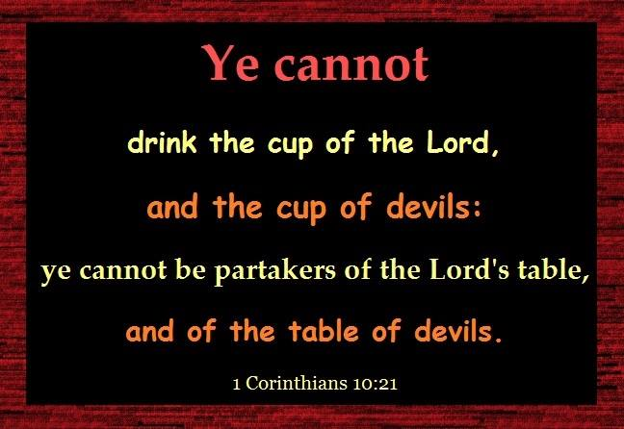
REVELATION! This is a game changers. Where the Bible says if you believe in the Lord Jesus Christ, you will be saved (future tense). The word believe comes from the Greek word pisteur and it is a VERB not a noun. That means it is ongoing and not a onetime act. It means that you believe once, to commit to believing and continuing to believe and thus you WILL BE saved because you have not fallen away, become apostate, and will endure to the end because you are continuing to Believe. It is not a onetime belief or faith that gets you instantly saved. How deceived the church is and people are going to hell because of these damnable heresies. The Lord has started taking me down this path on what the Bible says about being born again or saved. You have to be born of water and of The Holy Spirit in order to keep on believing and continuing to believe until the end. Will be and shall be saved is future tense if you finish the race. That is why you can fall away thru going back into sin, the deceivableness of riches with the prosperity gospel of me, cares of the world, persecution etc. And I am just getting started on this study. Revival is coming with the true gospel that the Lord will confirm with signs following and it isn’t going to be with phoney feathers and gold dust as well as drunken laughter and weird shaking and manifestations that are not found in Jesus’ ministry.
Major apostate teachings will also be address by the Lord and the foundation is laid again after there is a plowing, removing stone, clearing and making straight the path. With about 10,000,000 plus readers globally of www.latter-rain.net and these newsletters, the Lord will get the truth out to make sure people are born again biblically and not just deceived into thinking they are. Jesus came to seek and save the lost and the lost don’t know they are so in order to save the lost who think they are saved, you have to first show to them that they are indeed lost. Many want to remain willfully deceived and will not receive the love of the truth that they might be saved, and will want to remain in a stronghold of false beliefs. They will not allow the truth to pull down their stronghold. That is the end times that we live in and I pray you won’t be among those that are deceived because they want to be.
Some people do not find God for the same reason a thief will never find a police officer
This baptism in the Holy Spirit is called dynamos which means power. It is where we get the word dynamite. The word grace is also translated empowerment or I will supply that which is needed. Only in two places is it translated unmerited favor. This is the fulfillment of the law where we are now empowered not to sin and empowered to change and live a life pleasing to God. Grace isn't the license to sin but the power of God given not to through the baptism of the Holy Spirit as given at Pentecost. The law was to show we couldn't keep it in our ability and we needed this empowerment to live a life pleasing to God. Jesus said He didn't do away with the law but fulfilled it and the church did not start until the Holy Spirit was given at Pentecost. The Mosaic law with its 613+ rules have been done away with but God's moral law never will be. As a matter of fact the bar has been raised. If you committed adultery, you sinned. Now if you lust, you have committed adultery. If you murdered, you sinned. Now if you hate, you are guilty of murder. If you bear false witness or lie about someone, you are guilty of murder, so consider that the next time you sit around the holiday table gossiping about someone or are spreading lies and gossip when you don’t know the facts. God considers it murder and one of the top sins He hates the most.
Your freedom in Christ comes from no longer being a slave to sin. So folks, you might have a preacher who is fervent, loves the lord but just doesn't have knowledge or will not accept the way of God more perfectly after it has been expounded upon to him. Don't follow man. You need to search the scriptures yourself because in them you think you have eternal life and you may not because you are trusting in man and you can't afford to be wrong on something where your eternity and those you love, hangs in the balance.
Jesus said "My people perish for a lack of knowledge" so study the scriptures to show yourselves approved and don't rely on man. Your pastor may genuinely love the Lord, be mighty in the scriptures, instructed in the way of the Lord, and is fervent in the spirit, speaks and teaches diligently the things of the Lord knowing only the baptism of John. Some don't even adhere to the baptism of John. He may need to have the full gift of God explained to him more perfectly because the Baptism of the Holy Spirit is not something you receive when you first believe as the bible states.
Reading Acts 26:18 and like the Lord does, He shows me words to look up to reveal deeper what is being said. This is in the context and in Jesus' own words of what He called Paul to do on the Damascus road.
"To open their eyes, and to turn them from darkness to light, and from the power of Satan unto God (His power), IN ORDER THAT they may receive forgiveness of sins, and inheritance among them which are sanctified by faith that is in Me!"
There are conditions to be met in order to receive this forgiveness of sins and this inheritance. It is called repentance or turning from darkness to light and from being under the control and power of Satan to being under the control and power of God and going through the sanctification process. We don't preach this so how saved are we? The Bible even states that if a church denies this power or dynamite that came at Pentecost, you are not to fellowship with them and you are to put them away from you. This inheritance comes from being sanctified and that word sanctified means to be made Holy or pure, not just called holy and pure. Justification is where we are called righteous and sanctification is the process of making us righteous, pure and Holy. Sanctification requires the baptism of the Holy Spirit that empowers us not to sin as we crucify our flesh, die to self, pick up our cross and follow Him. Our will is involved in who we submit to and this forgiveness and later the inheritance are not given without this turn from satan's power to Gods power and control. The inheritance comes when we are made Holy or pure and this is a process when we submit to God and mature. Sons of God is translated "mature" and the mature receive the keys to the kingdom in casting out devils, healing the sick and furthering the kingdom of God. The bible states that Jesus gave us POWER to become sons of God. That is through the baptism of the Holy Spirit and sanctification part of the process of salvation that we are to work out. You can't lose what you do not yet possess and are still working out so let's stop telling people they can't lose their salvation when they don’t yet have it and are still working it out. They can fall away from the faith and become apostate.

​​
"If a man LOVE me, he will keep my WORDS: and my Father will love him, and we will come unto him, and make our abode with him."

Jesus commanded His disciples to preach the kingdom of God, not the gospel. This kingdom is to be received and that happens only after the baptism of the Holy Spirit.
John the Baptist told people to repent and be baptized because the kingdom of God was at hand or available to be received. It is so important to get back to the foundational teachings of the church and have people turn from darkness and be under the power of the Holy Spirit and mature. Jesus said, "If you don't allow me to wash you, you have no part with Me"! No part means no part. Nothing, nadda! No forgiveness and no inheritance. Our will and submitting to God and dying to self are necessary to being saved. Don't be deceived into thinking a mere prayer without repentance makes you saved or born again. Many think they are saved, but are not biblically and then they think they are eternally secure. This is a damnable heresy and people are going to hell. Search the scriptures Jesus said, because in them you think you have eternal life. Thus implying that they didn't have eternal life. Therefore, be commissioned to do what Jesus told Paul to do. Turn people from darkness to light and from the power of Satan to the power of God. Grace is not the license to sin but the power of God given not to and your freedom in Christ comes from no longer being a slave to sin. Please share because people who think they are saved are going to hell and the preachers that cause people to believe they are "saved" and eternally secure, no matter how sincere he is, will have their blood on his hands and will be held more accountable. Especially if he was taught the way more perfectly and rejected it.
If the gospel you are preaching is not turning people from the power of satan to the power of God, or turning them from darkness unto light and if it strengthens sin by telling them they are eternally secure and cannot lose salvation after repeating a prayer, you are preaching a damnable heresy. 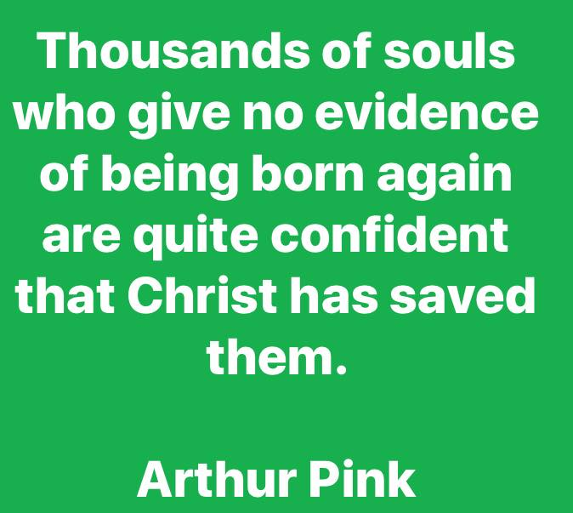
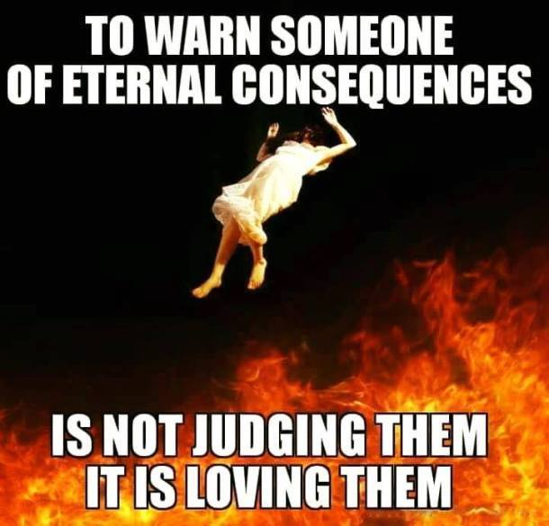
If you can’t lose your salvation (which you don’t yet possess but you think you do), you can obviously do as you please and still enter into heaven and this strengthens sin. Not only is that not found in the bible, but you will have the blood of those who die in their sins on your hands
So what is being sealed in the Holy Spirit? The Holy Spirit is referred to as the “deposit,” “seal,” and “earnest” in the hearts of Christians (2 Corinthians 1:22; 5:5; Ephesians 1:13-14; 4:30). The Greek word translated “earnest” in these passages is arrhabōn which means “a pledge,” that is, part of the purchase money or property given in advance as security for the rest. It is a down payment given to believers showing the intent to purchase. It is like giving an engagement ring with the intent to marry. If the deal falls through or in Jewish tradition if the young girl became unfaithful while her husband to be was away building a suitable home for them to live in, a legal judgment could be obtained by the husband to be, to end the engagement. Joseph was seeking to do this when he found out Mary was pregnant until an angel of the Lord told him not to. Engagements were taken seriously in Jewish tradition and a legal judgment had to take place to break it by the groom. We are only engage to Jesus. We are not married yet and the 5 foolish virgins were locked out, even though all were asleep, all had lamps with oil but some ran out because the deposit was returned or the seal broken by the husband to be. Judgment took place and the deal fell through because of their foolishness. This deposit in the heart is not the baptism in the Holy Spirit. It is like a drop of water being compared to a pool full of water. One you are fully immersed in the spirit and the other you are given a deposit or down payment, not the full price because the deal has not yet been closed. Let's not confuse the two. Having a deposit is far less than having the full deal closed. You receive this deposit upon accepting Jesus' marriage proposal.
If the foundation be destroyed, what will the righteous do? The enemy always attacks the foundation. If the foundation is destroyed, the fortress falls in upon itself.
If we do not have the foundation right in the church, it crumbles. Let’s get back to the foundational teachings in the church and lay it again because it has been so destroyed.
Jesus received these baptisms before being led by the Holy Spirit into the wilderness to be tempted by the devil. We need this empowerment as well in order to endure until the end in order that we might be saved and not fall away. Put away from you anyone that denies this empowerment. They preach another Jesus and another gospel and the bible says to let them be accursed. That is why the church is so powerless and sin runs amuck in the church as people are not even really biblically saved or empowered to stand under temptation. Then they are being told that if they recited their little prayer they can’t ever do anything to end up in hell. All lies!
Romans 6:22 clearly states that being dead to sin is what ends in everlasting life. It says, But now being made free from sin and become servants to God, ye have your fruit unto holiness, AND THE END everlasting or eternal life through Christ Jesus our Lord. Eternal life isn’t something you receive when you recite a salvation prayer which is unbiblical anyway. The gates of hell shall not prevail because the Lord is going to bring a storm upon the church where false prophets and teachers will be removed if they do not repent. There is therefore now no condemnation or judgment for those who are in Christ Jesus, WHO WALK NOT ACCORDING TO THE FLESH BUT ACCORDING TO THE HOLY SPIRIT! We love to make a doctrine out of once saved always saved based on this scripture, but clearly if you read it, those who are in Christ Jesus where there is no judgment are being led and controlled by the Holy Spirit, walking as Jesus walked and not living according to the flesh and fulfilling the lust thereof.
This is a definition of what one will look like if they are “In Him”. They are walking according to the Holy Spirit and not walking according to the flesh. There is judgment or same word translated from the Greek “condemnation” for those who walk according to the flesh.
1 John 2 talks about what it looks like to be In Him. And hereby we do know that we know Him if we keep His commandments. He that saith I know Him and keepeth not His commandments is a liar and the truth is not in him. But whosoever keepeth His word in him is the love of God perfected (matured) hereby know we that we are IN HIM. He that saith he abideth in Him ought himself also so to walk, even as He walked.
“And this is the condemnation (or why God’s judgment is brought on us) that light is come into the world, and men loved darkness rather than light (they prefer darkness), because their deeds were evil. For everyone that doeth evil hateth the light (and those that shine the light on the condition of their heart), neither cometh to the light, lest his deeds should be reproved (or discovered is the literal translation). But he that doeth truth cometh to the light, that his deeds may be made manifest that they were wrought in God. So certainly one who doesn’t like the truth and light shining on and exposing false doctrines, but prefers to have it hidden in darkness and will not allow it to be brought to the light to be examined aren’t doers of the truth, no matter how much they want to believe they are. When you defend something, you are not willing to have it examined in truth and light.
So in order to be biblically saved, a person has to repent, be water baptized and identifying with Christ’s death to self and sin in order to be a partaker of His resurrection. They have to be baptized in the Holy Spirit which empowers them to no longer be a slave to sin and they have to submit to the sanctification process. They have to believe, commit to believing and continue to believe until the end because the word believe is a verb that keeps continuing and doesn’t fall away from the faith and become apostate. You keep believing and you keep confessing until the end and in the end you shall be (future tense) or will be (future tense) saved or receive eternal or everlasting life. Jesus said that if we don’t allow Him to wash us, we have no part with Him so submitting to the sanctification process until the end is necessary to receiving life eternal. Repentance is always connected to water baptism because repentance is required to identify with Christ’s death to self and sin and therefore, AS A RESULT, be resurrected in Him to life eternal. That is what the word says. You can believe in Jesus and not be saved or enter into eternal life. Satan does. You can have faith but not the saving kind of faith because the kind of faith that saves you, will result in works and sanctification.
So can you have faith and believe in Jesus and not be saved or have the kind of faith that saves you?
There are a lot of heretics and false prophets that have gone out ... so many of them claiming to "believe in Jesus" or to "love Jesus". But claiming to love Jesus Christ without obeying His commands is a lie:
John 14:21 Whoever has my commands and obeys them, he is the one who loves me. He who loves me will be loved by my Father, and I too will love him and show myself to him." If you wonder why you don’t hear from the Lord or He is not manifesting Himself in your life, this might be it right here.
John 15:10 If you obey my commands, you will remain in my love, just as I have obeyed my Father’s commands and remain in his love.
1 John 5:3 This is love for God: to obey his commands. And his commands are not burdensome,
1 John 1:6 If we claim to have fellowship with him yet walk in the darkness, we lie and do not live by the truth.
The answer is "yes". You can believe in Jesus and not be saved or have faith that is not the saving kind.
Last words and instructions are important and this is what Jesus told His disciples while ascending into heaven:
Matthew 28:19-20 Go ye therefore, and teach all nations, baptizing them in the name of the Father, and of the Son, and of the Holy Ghost. Teaching them to observe all things whatsoever I have commanded you and lo I will be with you always, even unto the end of the world.
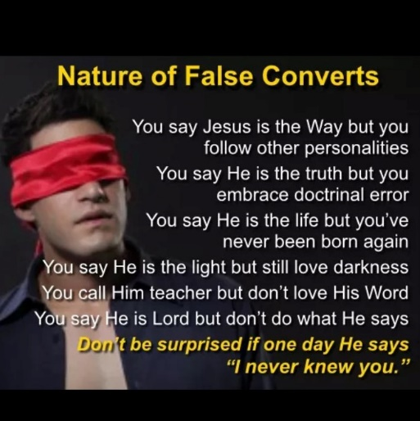
How is that not clear? Baptisms and obedience are not optional. Not make Jesus your personal savior or ask Jesus into your heart stuff and just confess it out loud and you’re in and eternally secure nonsense.
Jesus said that before He returns, He will send His angels, same word messenger and they could be born of a woman, to gather out of His kingdom all who offend and all workers of iniquity. The purpose of the message is to seek and save and cause prodigals to return and people to repent or be cut off. It is not to condemn, but it is a message to seek and save by making it apparent that you need to be. It is a message to make clear what has been hidden in darkness. To reveal heresy with the truth in order that all would turn and repent. To restore what has been lost. The consequence is becoming a son of perdition if you reject the TRUTH or your savior, which is being revealed at the appointed time, right before the rapture. Don’t be a foolish virgin. Make yourself ready for His appearing! Wake up! Look up! For your redemption draws nigh!
I saw a teaching on the Jim Baker show regarding the Laodecian church, which many agree is the church today. We miss the point regarding this church. If you lived in Laodecia, there were aqua ducts that carried water. If the waters were cold in one aqua duct it could be used as a refreshing drink on a hot day. The cold temperatures kept bacteria from living in it. The other aqua duct was hot and was good for cleansing or bathing and the washing of utensils. It too prevented bacteria from growing in it because of the hot temperature. Jesus would never wish we were cold toward Him and prefer that over a lukewarm relationship, so the mentioning of the water temperature is not in the context of the degree of love we have for Him. Where the two aqua ducts meet, the water is lukewarm. This lukewarm water is a breeding ground for bacteria, germs a diseases. When Jesus said that He will spew this lukewarm watered church out of His mouth, it is because it is full of sickening bacteria that causes one to vomit. It is a spiritual breeding ground that produces spiritual sickness. That word spew is translated vomit. This is the church of today
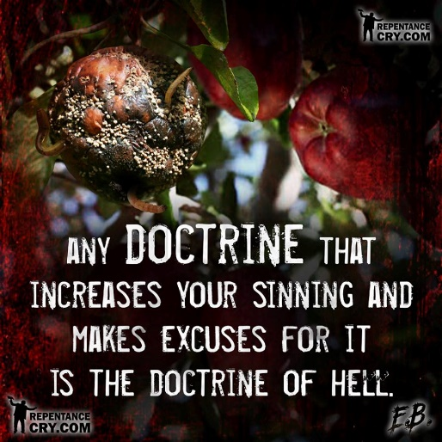
This is not the time to be delusional, willfully deceived or stupid on purpose. He stands at the door and knocks outside our Laodecian churches! He is holding all you need if you would just acknowledge your need for them and open the door because your strongholds have locked Him out! We do not love the truth that we profess to or He wouldn’t be standing outside the breeding ground for sin, disease, germs and bacteria that causes vomiting saying hhhheeeeellllloooooo! Let me in!
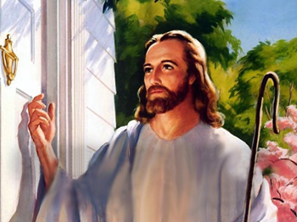
Matthew 24:45-47 Who is that good and faithful servant, whom the Lord hath made ruler over his household? to give them meat (not milk of the word meant for babies) in due season. Blessed is that servant whom His lord when He cometh shall find doing so. Verily I say unto you, That He shall make him ruler over all His goods.
The Lord has warned. He has brought truth. The false doctrine and false Jesus being preached today is going to be burnt up at the alter and totally consumed and those that have taught it as well as those who have not spoken against it will be judged and removed. The saddest words spoken in the bible when Elijah presented the false prophets with a choice on who they would serve are “They answered not a word”. Your silence and not making a choice is a choice. It is a choice you are about to regret because the prophecies that are coming forth all at once are the rain cloud forming as the hand of a man and it is about to overtake the church. Judgment starts in the house of the Lord and He will gather out of His kingdom all who offend and all workers of iniquity before He returns.
The temple tables are about to be overturned. Those that have made the house of God a den of thieves merchandising and peddling their wares instead of a house of prayer will be dealt with if they don’t repent. They have made the body of Christ a business, making her a prostitute for their gain. The prosperity pimps are called spots and wrinkles in the bible, wells without water, and clouds without rain. They promise everything, but nothing is produced. They pervert the word of God for their financial gain. Jesus isn’t coming for these spots and wrinkles. They will be gathered out of His kingdom. Just like Judas, they betray Christ and Gods people for money going the way of Balaam. Sons of perdition they are.
We have started to see them beg for funds and now claiming the tithe is not enough under the new covenant and now giving is also added on top of the tithe. Yet if you go to Malachi, the Lord was not addressing the people. He was addressing men and the temple priests. It was the priest who were called God robbers because they were not tithing their tenth of the food they received which was for the poor and hungry and those that could not tithe or give. The Lord said if they tithe their tenth of their food, there would be food in the storehouse in abundance. Now a days, the pastors call the poor God robbers for not paying their tithe to them and telling them they will be cursed if they do not tithe, thus shutting up the kingdom of heaven to the poor. The tithe was food and it was for the poor, hungry and strangers in the land and it was to come out the pastor’s pocket or his tenth. It was the pastors/priests who were the God robbers who were not feeding them with their tenth of the food tithe. The bible says when you give to the poor you give to God so not to provide for the poor and hungry is robbing God. Therefore, it was the pastors who were called the God robbers by God. If your church does not feed the hungry and meet the needs of the poor, the pastor is a God robber and his income will be cursed, which means yours will be too if you are his source of giving. If God is going to curse their finances, that means yours will be cursed as well. It is not Jesus’ blood plus your money that delivers you from the curse of the law. The blood of Jesus is sufficient and these huckster who add to the blood of Christ for your deliverance for their financial gain are going to be dealt with. They lack faith in God to meet their needs so they have to manipulate you with the word of God for money and they will be judged in what is coming. I keep seeing more and more of them begging for money and pushing the tithe etc. and I asked the Lord why because it is getting worse, not better. He told me it is because He is drying them up and their gold will be tried in fire. They don’t have faith in God to meet their financial needs but they sure want you to have it don’t they?
The Gospel is to be told, not sold!
We need preachers who will preach the sin out of people instead of preaching the money out of their pockets.

Jesus will no longer politely knock outside of His church that He purchased with His blood. He is entering His house, bringing His judgment and establishing His kingdom. He has given warnings and space to repent and they answered not a word except to mock and grieve the holy Spirit. They would not come forth saying they were wrong about this or that because of their pride. They loved darkness more than light. They would not look at the truth Jesus was faithful to give them and again the truth is who Jesus is, so to reject truth is to reject Jesus. By not saying anything and making a stand you have made your choice because You answered not a word.
I started this newsletter with a prophecy and will end it with another that the Lord gave me:
I am light saith The Lord and the darkness cannot comprehend the light. I drive out darkness by my very presence. I drive out hate by my very presence. I drive out sin by my very presence. I drive out pain and hurt by my very presence. For I AM light, love, holiness and healing. I AM that I AM. I will light your path, wipe your tears, manifest my love and draw you closer in the year ahead. There is coming a mighty shaking and wind of my very presence from my roar. The likes of which darkness is dispersed. It will blow around the world removing what displeases me and replacing it with what is pleasing to me. Don’t be afraid of this wind. Turn your face to the wind for it is my very breath, or spirit, breathing new life around the world, displacing the lies with truth, the false with the real so I can pour out my spirit upon all the earth in this latter rain. The wind or my breath will blow in the rain clouds as I pour my spirit (wind or pneumo) out upon all flesh. Turn your face into the wind and search the skies for the clouds that bring in this latter rain. Even now a cloud is forming as a man’s hand. This rain will produce a bountiful harvest but I need laborers, so turn your face into the wind and let go of all that holds you back and let my very presence and new breath of life blow off all that hinders you because I am going to send my yielded laborers out into the fields for a harvest like no other. It will come with demonstration of power that point to Me saith The Lord and My finished work on the cross. You will know the false from the real as the enemy has sown tares in my church manifesting false signs and lying wonders that do not point to me or reflect upon what I finished. False prophets prophecy out of their own spirit speaking what I have not spoken. Unbelievers seek for a sign, not believers. Believers manifest it because I am with them confirming the word that I AM who I say I am and the gates of hell shall not prevail. So turn your face into the wind of my breath or roar and yield to me and receive the former, middle and latter rain that I am about to pour out upon the earth before the great and terrible day of The Lord. I am coming soon! Come and see what God has done and what He is about to do! No flesh shall glory in my presence. With so many false prophecies, if it doesn’t point to Me and My finished work it is not from Me saith The Lord. Try the spirits and turn your face into the wind. The latter rain will follow as the wind blows in the rain clouds! The Lion and the Lamb that lay down together are both Jesus. He died as the lamb of God and is returning as the Lion of the Tribe of Juda.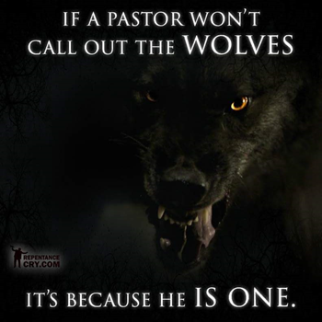
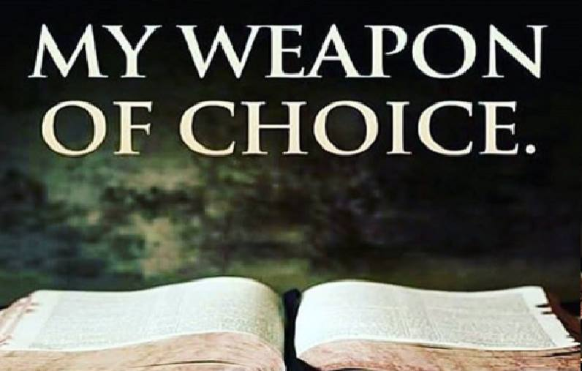
Jesus warned repeatedly the most about deception in the last days and that it would be so bad that even the elect could be deceived and we have been. He has been faithful in being the truth as well as the word which He watches over to perform. Even the parts you don’t want to acknowledge but are there. Since He is the way, the truth, the life and the word, He is my weapon of choice against all deception the enemy would bring. I don’t want to be stupid on purpose or willfully deceived and pick and choose what scripture I want to believe and which I don’t. The Father said to behold or LOOK AT BOTH the kindness and severity of God. If you have an image of Jesus and the Father that excludes parts of scripture, you are not worshiping the one true God, but a figment of your imagination that is a false idol, which is about to be torn down in the valley of decision. If your image of God be God, worship him, but if the Jesus and God of the WHOLE bible be God, worship Him. But choose this day whom you will serve. I pray that you will not be one that ANSWERED NOT A WORD.
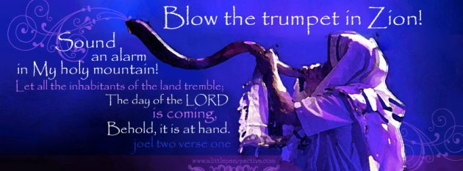
A VOICE CRYING OUT IN THE WILDERNESS MAKING STRAIGHT THE PATHS! COMING IN THE SPIRIT OF ELIJAH! AS IT WAS THE FIRST TIME, SO IT IS THE SECOND!John 3:1-13: “There was a man of the Pharisees named Nicodemus, a ruler of the Jews. This man came to Jesus by night and said to Him, "Rabbi, we know that You are a teacher come from God; for no one can do these signs that You do unless God is with him." Jesus answered and said to him, "Most assuredly, I say to you, unless one is born again, he cannot see the kingdom of God." Nicodemus said to Him, "How can a man be born when he is old? Can he enter a second time into his mother's womb and be born?" Jesus answered, "Most assuredly, I say to you, unless one is born of water and the Spirit, he cannot enter the kingdom of God.
The bible makes it perfectly clear that water baptism and baptism in the Holy Spirit are essential to being born again. It is not an option but a means to becoming born again and a response to the gospel of the kingdom of God and how to enter into it. I find more people searching out scripture in order to avoid and disobey water and spirit baptism which reveals something in that heart that really needs to be addressed. Why would someone make excuses to disobey the word or claim it is not necessary in order to be saved? They have been taught heresies.

www.latter-rain.net
For speaking engagements call 813-393-9384.

