
  Fresh Rain
  
  Latter Rain Ministry
Preparing a Bride without  spot or wrinkle |  | January, 2019
EARNESTLY CONTEND FOR THE ONE TRUE FAITH

Last night and this morning as I read the Bible I kept hearing, “Evil men and seducers shall wax or get worse and worse, deceiving and being deceived”!

I looked up the verse in 2 Timothy 3:13 and I read the whole chapter which is definitely our day and time. Verse 14 says to continue in the things that you have learned and have been assured of, knowing of whom thou hasn’t learned them, which is from God. That was direction or a Rhema for me.

Deception bothers me greatly because people go to hell because of it. What you believe matters. What you believe and think in your heart comes out in your behavior. You act upon what you believe whether you know it or not. If you believe the Bible that says believers shall lay hands on the sick and they will recover, then you go lay hands on the sick and act upon it. By mere fact that you don’t, demonstrates that you do not believe.

With that said, let’s start at the beginning of 2 Timothy 3 to see the context of evil men getting worse. The context is in end times before Jesus returns.



This know also, that in the last days perilous times shall come. For men shall be lovers of their own selves, (selfish) covetous (prosperity doctrine), boasters (self confident, braggarts), proud (wanting to appear above or better than others), blasphemers (vilify or defend yourself reviling the Holy Spirit’s correction), disobedient to parents, unthankful, unholy (wicked). Without natural affection (doesn’t love family members or brothers and sisters in Christ is the translation), trucebreakers (not keeping treaty or covenant promises), false accusers (slanderer and comes from the word diablos or Satan or devil), incontinent (powerless or without self control), fierce, despisers of those that are good (hostile to those who uphold the word of God or His moral law). Traitors, heady (rash or falling forward on ones face), highminded (to lift up, inflate, cover in smoke), lovers of pleasure more than lovers of God. Having a form of godliness (schemed piety), but denying (contradict, reject or refuse the need for) the power (baptism of the Holy Spirit) thereof: from such turn away. They are ever learning about the word of God but are never able to come to the knowledge of the truth. These are preacher! They are men of corrupt minds who resist the truth and are reprobate concerning the faith no matter how sincere or genuine they may appear. But they shall proceed no further for their folly shall be revealed unto ALL men.

The words in parentheses are the original translation of the word it is next to. Let’s read it in the translated version. Know this also, that in the last days before Jesus returns, there will come a period of time where people will be selfish and self focused, focused on money and the things it will buy or prosperity, they will be self confident braggarts boosting your self esteem and confidence with motivational speeches so you can brag as well. (Certain preacher comes to mind immediately). They will place themselves above others wanting to appear better believing gain is godliness or Gods favor on your life. They will vilify or defend themselves when correction comes through the Holy Spirit and those He sends. They are disobedient to parents, unthankful and wicked. They do not love family members or brothers and sisters in the body of Christ. The do not keep covenant promises or treaties. They slander or falsely accuse others as the devil does which is one of the top things God hates. They are powerless and lack self control. They are fierce and hostile to those who stand for truth and uphold Gods moral law. They are traitors and rash and fall flat on their face. They lift up, inflate or cover with a smoke screen their accomplishments. They love pleasure and the things of the world more than they love God. They pretend or scheme piety but they contradict, reject or deny the need for the baptism of the Holy Spirit for salvation. Run from these people. Turn others away from these people. They are always learning but never able to grasp the truth of the true gospel. They are blind to the truth and resist it. They will proceed no longer because God will reveal their stupidity (folly is translated stupid) to the world.

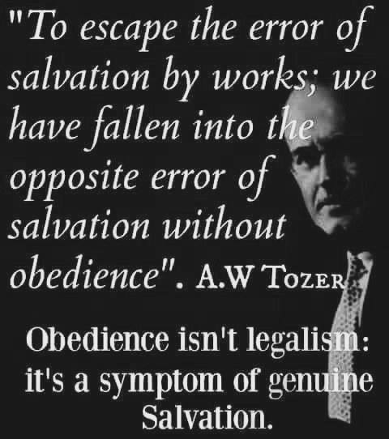
Beware of manufacturing a God of your own: a God who is all mercy, but not wrath; a God who is all love, but not holy; a God who has a heaven for everybody, but a hell for none; a God who can allow good and bad to be side by side in time, but will make no distinction between good and bad in eternity. Such a God is an idol of your own, as truly an idol as any snake or crocodile in an Egyptian temple. The hands of your own fancy and sentimentality have made him. He is not the God of the Bible, and beside the God of the Bible there is no God at all.” ― J.C. Ryle

Get to know the real Jesus by reading His word, obeying it and not believing in or creating a Jesus in your own image and likeness or as you would like Him to be. A false Jesus is being preached today which is why Jesus says, I never knew you. You can’t blame others for what you choose to believe. The bible states that if anyone preaches a different gospel and another Jesus, let them be accursed. Search the scriptures because in them you THINK you have eternal life. Make sure the Jesus you claim to know is the one in the bible and not one created by cherry picking verses out of the bible that pat your flesh and tickle your, while excluding others. Read it in context as well asking yourself who God was talking to and what was His point. He has one!


THE MOST DANGEROUS HERESY BEING PREACHED TODAY WAS CREATED BY EXCLUDING CERTAIN WORDS OR CHERRY PICKING!
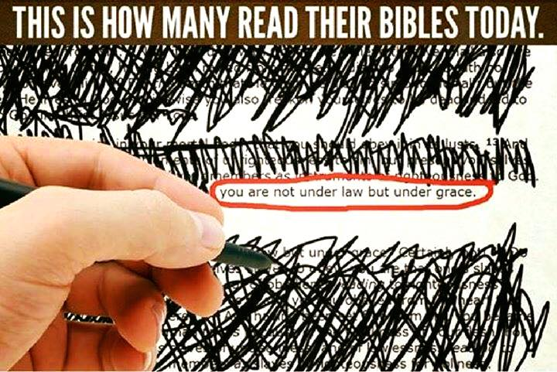

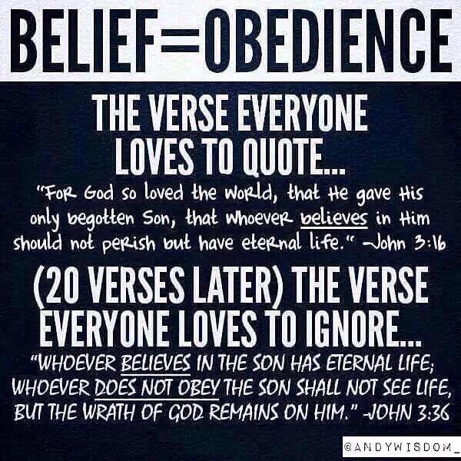

Hebrews 10:26-31. For if we sin willfully (go back into a lifestyle of sin) after RECEIVING, not rejecting, the knowledge of the truth..... the word knowledge is translated “to become fully acquainted with, to acknowledge, full discernment, to have, to know, to fully possess”. This is what you have RECEIVED. That is not an unbeliever who rejected the gospel. They RECEIVED it. I just heard the once saved always saved preacher teach this as being spoken about unbelievers who rejected the truth after hearing the gospel and he conveniently left out some words like RECEIVE and knowledge. He states this is an unbeliever who heard and rejected the gospel. He has to leave out words to fit his beliefs. He cherry picks what words he wants to see and believe or to conveniently leave out to create a God who is an idol and not the God of the bible. After all he has taught this since the 1990’s and built his ministry on his “Eternal Security” book that has duped and damned millions. Their blood will be on his hands. People are going to hell because of it because they continue in their sin. No point in repenting because you are in. You said your little prayer. He even stated you can’t repent until you are “saved” first. Why would the Lord tell us to do something we couldn’t do. When the apostles were asked what they must do to be saved the answer was repent and be baptized everyone of you. Not some but all.

Hebrews 10:26-30 is to a believer not an unbeliever as this preacher falsely preaches; the once saved always preacher.

Verse 30 states The Lord will judge His people. This talks about God judging His people in the context of willfully sinning after RECEIVING, becoming fully acquainted with, acknowledging, to have full discernment, to have and fully know and fully possess the truth. This preacher also said in this same sermon that God does not judge His people. He disciplines. Read verse 30 again. It says THE LORD WILL JUDGE HIS PEOPLE!!!!

Please read Hebrews 10:26-30 and stop listening to preachers who preach damnable heresies or lies that will damn you as a Christian and that strengthen you in your sin instead of deliver you from it. The word judge in God judging His people is translated crisis, or the time it is determined when one is cut off eternally from God or dies. You can have your name removed from the lamb’s book of life and I addressed how in other newsletters.
Once saved always saved is the worst and most dangerous heresy being preached today. We can’t be silent about it because souls are lost eternally and their blood will be on our hands. Silence is condoning and turning a blind eye to those bound for hell because they are comfortable in their sin due to the belief there is no eternal consequence. We must EARNESTLY CONTEND FOR THE ONE TRUE FAITH.

Actually heard this yesterday. Two guys from different Christian backgrounds talking to an atheist about how to be a Christian. Hyper grace guy says you just believe and all your sins forever are covered. Atheist responds “So you can go ahead sinning after you believe”? Hyper grace guy responds “Well you are not supposed to but it is covered”! Even the atheist knew that was wrong but that was his first line of attack to the hyper grace guy who is terribly deceived. Other Christian went into the baptisms and why and how the baptism of the Holy Spirit is to empower you not to sin. People who want to remain in sin don’t like that message. They like the false hyper grace message. Damnable heresies in the church and why unbelievers even question it. Of course the Lord who hates and judges sin isn’t going to leave you in that condition. This is what the church is producing and why it is powerless.

The Bible says that in end times MANY will say to Me Lord, Lord.......And I say depart from Me. I never knew you. The word MANY is translated MAJORITY. The gospel being preached today produces a MAJORITY of people rejected by Christ who are hell bound. Jesus said, When I return will I find true faith upon the earth. Saying a one time prayer of faith and believing you are eternally secure is a damnable heresy producing a lawless church instead of one without spot or wrinkle. Where lawlessness abounds, the love of many wax cold. A true sign of the end time church. Once saved always saved is not scriptural when you search out the truth. I wish it were, but that would contribute to me being lukewarm and not being “called” to confront damnable heresies in the church because I myself am willfully deceived because I have rejected the truth because of my mental stronghold. The Lord only wants those who will worship Him in spirit and in truth. To reject truth is to reject Jesus. We know where rejecting Jesus leads. Depart from Me. I never knew you and you never really knew the real Me. You have to reject most of the whole New Testament to come up with once saved always saved doctrine. Truth is not important enough to you to search a matter out. Therefore, something else is more important to you than Jesus who is the truth. Your sin or pride maybe? Jesus is the Way, the Truth and the Life. He is the only way to heaven. He is the truth in our deception so we don’t fall away and we get our life or empowerment from Jesus, not give it. That is grace.

NOT EVERYONE WHO SAYS TO ME LORD, LORD WILL ENTER THE KINGDOM OF HEAVEN BUT HE WHO DOES THE WILL OF MY FATHER WHO IS IN HEAVEN WILL ENTER Mat.7:21

Some like to quote Jn.6:29 Jesus answered and said to them, “This is the work of God, that you believe in Him whom He has sent.” But their understanding of believing is to believe in his existence or some of the historical information about Him. This is far from what the Bible teaches. Even the devil believes. They also teach that it is a one time acceptance or belief that saves them. The word believe is a verb and not a noun, which means you completely trust in Jesus to empower you and supply you with what is needed throughout your whole life until the end. It is an ongoing commitment to trust in Him so you don’t fall away and become apostate. This means He is faithful to bring truth in your deception. That is who He is. If you reject it, you reject Jesus.

Therefore I said to you that you will die in your sins; for unless you believe I AM he, you will die in your sins.” Jn.8:24 The HE is not in Greek. He gave the given name for God (yah-vah). All Jews know that if Jesus is the Messiah, they MUST OBEY ALL THAT HE SAYS OR THEY WILL BE UTTERLY DESTROYED FROM AMONG THE PEOPLE. Deut. 18:19, Acts 3:19-23

It is God's will for us to be filled with His Spirit. Eph.5:18 If it was automatic, Paul would be deceitful by saying He gives His Spirit to those who OBEY Him. Acts 5:32

It is God's will for us to be sanctified. 1 Thes.4:3 If it were automatic, Paul would be deceitful by saying this. 1 Thes.4:7-8

It is God's will for us to be saved AND come to the knowledge of the truth. 1 Tim.2:3 If it were automatic, Paul would be deceitful by saying this.
It is God's will for all to repent. 2 Pt.3:9, Acts 17:30-31 If it was automatic, Peter and Paul would be deceitful by saying this.

It is ONLY those who DO the will of God that will be saved. 1Jn.2:17, Matt.7:21, Matt.12:50. Many, translated majority, are not going down the narrow road. Matt.7:13-14 because of the damnable heresies, demonic doctrines and gospel of self and what I can get if I attach myself to Christ gospel of me stuff. They are willfully deceived or stupid on purpose. They will not receive the love of the truth that they might be saved and this is said to believers who became apostate.



The word SAVED is used so loosely in Christian circles. We have been falsely taught if we recite a prayer we are saved at that very moment but if you look up scripture regarding the word saved it is future tense. Shall be, will be etc. it is never present tense. The translation of being saved, also a future tense process means to deliver from sins and it’s power, to protect, heal, make whole, do well. We are in the process of being made perfectly whole. Grace is not the license to sin but the power of God given to you not to through the baptism of the Holy Spirit. Your freedom in Christ comes from no longer being a slave to sin. If you are still a slave to sin, how saved are you? That is why repentance is a requirement to being (future tense) saved. It is not a one time repentance but a lifelong attitude you keep. You play a part in working out your salvation with fear and trembling the Bible says. If it is something you have already obtained, why are you still required to work it out? We have this false theology where we think nothing is required of us but believing and that anything beyond just believing is works as the false grace people teach. This is such a demonic tool of the enemy to keep people enslaved to sin, believing water and Holy Spirit baptism is not required and is works and thus these people are hell bound. Scripture doesn’t support that. You have to do something with the free gift provided and access it in time of need. The gift needs to be unwrapped and used. You do the unwrapping and using.

Example: A rich man gives you a check for a trillion dollars. One person believes the gift giver is good for the funds to back the free gift check. That is faith but not the saving kind of faith. The saving kind of faith believes the rich gift giver is not only good for the funds to back the check, but makes the deposit into his bank account so he can access the funds in time of need. You are the bank account. The baptism of the Holy Spirit is the depositing of the check or free gift funds into your account so you can access the empowerment or grace when needed in life. The Holy Spirit is even referred to as the free gift or promise of the Father. Depositing the free gift doesn’t make it any less free or earned. Grace is translated empowerment in all but 2 places. It is the empowerment not to sin when tempted. It is strength when needed. It is healing and wholeness when needed. It is provided by the blood of Jesus who purchased and sent this gift to you. This gift was unavailable prior to Pentecost and that is how Jesus fulfilled the law. He didn’t do away with it. The false grace people who deny this empowerment not to sin and that all you must do is believe the gift giver is good for the funds has produced lawlessness or the breaking of God’s moral laws by people who are duped into thinking they are already saved and eternally secure. They have a form of godliness but deny the power thereof and claim there is nothing to work out in regards to salvation. They are ever learning but never able to come into the knowledge of the truth. From such turn away the Bible says.

It really comes down to your choice to be led and controlled by the Holy Spirit after you have made the deposit and have access to the funds or sow to the flesh and be led by your carnal nature and its appetites. This is why the flesh, your will and way must die in submission to Christ and doing the will of the Father. Death to self is necessary in order to be resurrected as Christ was resurrected which is what water baptism is about. The Bible says that only those that do the will of the Father enter the kingdom of heaven. Not those that merely believe and are duped into thinking they are saved and eternally secure. Actually doing the will of the Father by choosing to submit after being empowered to is what being (a process) saved is. You have been delivered from your sin. It has been removed, not covered up like the blood of lambs did. Your sin nature has been dealt with after receiving this empowerment and we are all left without excuse. It is been perfected or finished as Jesus said. Now it comes down to an act of your will and who you choose to serve. Sin unto death or righteousness unto eternal life which we receive in the end after going through the wilderness of life in order to enter into the promised land of heaven. Some didn’t make it into the promised land after being delivered from slavery, were water baptized in the Red Sea and were led by the pillars of fire and a cloud in the wilderness which is symbolic of being led and controlled by the Holy Spirit. Being delivered from slavery is your first step. The Red Sea crashing down on what enslaved you was to keep you from returning to your slavery to sin. Water baptism has a purpose. The destination is the promised land of heaven and we need to be lead and controlled by the Holy Spirit to reach that destination of being saved and entering into eternal life. The whole process of salvation is found in the Exodus of the Jews from Egypt to the promised land. Egypt was the world where they were enslaved. They received the news that they were going to be “saved” or delivered in Egypt and they believed it. They were water baptized in the Red Sea, they were led by the Holy Spirit through the wilderness of life where the law or awareness of sin was given. Many did not make it into the promised land and perished in the wilderness as our example the bible says. Joshua, who represented Jesus, led them into the promised land. Moses who represented the law or the awareness of sin and your inability to keep it could not take them into the promised land. They needed the empowerment not to sin, which came only through Jesus to those that believed and obeyed in baptism and this is how Jesus fulfilled the law. When they refused to obey and worshipped gods they made in an image they fashioned, they perished.

Do you see how the deception of the modern day church in end times was so fiercely warned about by Christ and the apostles as the modern day church seeks the things of this world and the flesh, like they are going to camp out in the wilderness in their prosperous homes and lifestyles that they will have to leave to enter in. Those who seek to preserve and save their lives here will lose it. What does it profit a man if he gain the whole world but loses his soul. Seek those things which are above.

Search out the scriptures because in them you think you have eternal or everlasting life. The implication Jesus was making was that you do not yet have it. It is entered into in the end (Romans 6:22) and when we enter into it is key and why the devil tries to deceive us about it. Having the Holy Spirit live in us is not eternal life. Romans 6:23 states “But now being made free from sin, and become servants to God, you have your fruit unto holiness, and the END EVER LASTING LIFE”! Now you see why this present church age we live in is the apostate church, or the church who has fallen so far away from the truth of the word and into deception and that it is producing “sons of perdition” who like Judas, will betray Christ for money and they have gone the way of Balaam who sold out God’s people for money. They are called spots and wrinkle and Jesus is not coming for spots and wrinkle, but for a bride that has made herself ready as Rev. 19 states. Don’t be deceived. Receive the love of the truth that you might be, future tense, saved.

For the wages of sin is death, but the gift of God is, or leads to, eternal life through Jesus Christ our Lord.



John 10:28-29 reading with morning coffee. I have read this many times and this verse is one the once saved, always saved false doctrine people use to prove you are eternally secure once you accept Jesus. That is why when we receive eternal life is key. Romans 6:22 says we receive it in the end when we pass from this life to the next. Receiving the Holy Spirit is not eternal life or perpetual on going life. Instead the Baptism of the Holy Spirit is given to get us to that destination if we are led and controlled by Him. It says in the context of Jesus’ sheep hearing His voice and following Him, “And I give unto them eternal life and they shall never perish, neither shall any man pluck them out of my hand”. Jesus tells the sheep at judgment or the separation of the sheep and goats to enter into eternal life. It is after you die and enter into eternal life in the end that you can’t be plucked.

It is interesting that there are two different words for eternal. One means perpetual or the living on forever after death and the other deals with a period of time that is specific. In this context it is a specific period of time that starts from the beginning of man in the book of Genesis to man afterwards. Jesus is saying this eternal life that one receives to live on perpetually with Him is extended back to Adam and Eve encompassing all time frames in the earth. That is very interesting. Jesus is basically saying He died for all, extending eternal life in heaven all the way back to Adam and to those born after Jesus in future generations. It doesn’t mean that your future sins have been automatically forgiven as we have been taught. It means it has been extended back to Adam and to future generations after Jesus. Prior to the cross, people didn’t go to heaven except maybe Enoch and Elijah who were raptured. This is extended to those who heard Jesus voice in past generations and in future ones. When Jesus descended into hell, Paradise or Abraham’s bosom as it was called, after He died, He preached to the souls there and led them out. Matthew 27:52-53 states some were seen walking the earth for a short time after Jesus was resurrected. Paradise, where the thief on the cross went, wasn’t heaven. It was this holding place for those who previously died until Jesus died on their behalf for their sins. When Jesus told the thief “This day you will be with me in Paradise” this is what Jesus was referring to because three days later Jesus told Mary not to touch Him because He had not yet ascended to the Father in heaven. Let’s just get rid of the false teaching of the thief on the cross as going to heaven and not needing water baptism in order to justify disobedience to what Jesus said in being born again of water and the Holy Spirit through the baptisms. He died under the old covenant as well which is why he went to paradise. The church has interpreted this word eternal life to mean all sins you ever commit, even in the future, are covered under the blood. Only sins that are confessed and repented of after the baptism of the Holy Spirit, or after being empowered not to sin are washed in the blood.

Jesus just got done telling the Pharisees they were not His sheep because they didn’t believe or hear His voice like Moses did. This perpetual on going life that was extended from the beginning of the earth from past to future generations will cause one to never be plucked from Jesus hand after passing on into eternity. The word pluck is the same word we get rapture from. It means to seize violently, snatch away immediately. It is the total opposite of being led astray one step at a time, little by little in deception, which is how Satan works in bringing in damnable heresies mixed with truth. They won’t be violently seized or snatched away against their will but be fed nibbles of poison mixed with truth until they are willfully deceived and apostate by choice. The ones who endure until the end in physical death or have already because they died, will never be eternally destroyed or perish after death and they can’t be violently seized or snatched away or raptured out of Jesus hand once they have entered into this perpetual life after death. Hmmmm!

Translation is everything as is reading the Bible with the Lord illuminating it. Mind blown. Eyes wide open! Thank you Jesus! We must remain in the truth in sound doctrine and endure until the end hearing and following His voice to receive perpetual on going life with Christ where once we have it after passing, we can never be snatched away or perish.

Perspective: the Lord gave me an illustration before I went home for my mom’s funeral, which I feel led to share. My granddaughter Emma was about 4 years old and I was watching TV with her. We watched a show where expecting couples were preparing for the birth of their child, decorating the room, doctor’s appointments etc. The camera man followed them into the delivery room for the birth, however he was positioned to the left side of the mother so you didn’t see anything graphic. The mother had her legs in the stirrups with knees bent. The Father was on the other side of the mother. The mother was pushing and I had the TV remote in my hand in the event I needed to immediately change the channel. The doctor was in position as mom pushed and the baby emerged, guided by the hands of the doctor. Emma busted out in tears of joy at the birth of the baby. Then from the perspective of a four year old, from the angle she viewed the birth, with the limited amount of knowledge and maturity she had, she blurted out “That baby came out of her knee”! I fell over trying not to laugh. Did Emma see what she saw? Yes she did! Based on her maturity and knowledge of conception and child birth, was her perspective accurate? No but she thought it was. Did she have knowledge of what was going on, on the other side of that knee and the messy details kept from her sight. No she did not! Therefore I submit to you that our perspective of things may be something we think we saw and understood in the word of God and we think we are accurate in our assessment but our maturity level at the time we saw it with the limited or no knowledge of what was going on behind the scenes when we saw it renders our perspective as that of a four year old who has no clue of what just happened and why while thinking our perspective is true and accurate. Maturity and experience should cure this but only if you are open to be schooled or teachable in the greater details of conception, childbirth and all the messy details. If you are not open to listening and having a discussion while insisting that your four year old respective is accurate, then you remain at a four year old level of maturity while you rally people around you to support your view that the baby came out of the mother’s knee. Those who get sucked into the rallying of support for your perspective enable your immaturity and hinder their own. I see this in the church as well. Unteachable and defending what you have been taught when presented with greater knowledge and understanding leaves you sucking on a milk bottle when you should be eating meat. I thought the Lords example was great and I hope it blesses someone. Time to grow up and listen and stop skipping school and hanging onto a perspective you feel is accurate because you know what you saw, and be humble enough to realize there may be a whole lot more details and information you are missing in order to make a fully accurate assessment of what you thought you knew because a lot was hidden from your sight to protect you as a four year old. You couldn’t handle the mess at that time and the reality so the hand was on the clicker to protect you. Maybe it is time to move past toddlerhood and eat meat. If you want to continue to hang on to false doctrine and beliefs when the word of God proves otherwise, you will be drinking from a bottle and feeding babies nothing but milk from a bottle as well while listening to baby’s whinning.
Time for the church to mature and grow up and not be tossed around by every wind of false doctrine.In doing research for this newsletter, God is just pouring into me. I was looking up verses on spots and wrinkles in the Bible and they pertain to the prosperity preachers who think gain is godliness. Anyway, as I was reading in 1 Timothy 6:12 when again the Lord showed me the topic of eternal life. He is punctuating this to me constantly and again I keep stumbling on more verses stating what He is punctuating.
Read 1 Timothy 6:12 with me as Paul’s instructions to Timothy. “Fight the good fight of faith, LAY HOLD ON ETERNAL LIFE, whereunto thou art also called, and hast professed a good profession before many witnesses”. In Philippians 3:13 Paul stated about himself “I count not myself to have apprehended (or laid hold on), but this one thing I do, forgetting those things which are behind, and reaching forth unto those things that are before. I press toward the mark for the prize of the high calling of God in Christ Jesus.
This raises a question as it should. If you have already received eternal life when you first believe as the present day church teaches, why is eternal life something you must lay hold on or apprehend? I looked up the phrase lay hold on and it is translated “to seize, to attain, to apprehend”. The church is missing it big time. Mind blown! We best be teachable and worship the Father in spirit and in truth. Many things we have been taught and are teaching aren’t true! That is why Jesus said to search the scriptures because in them you think you have eternal life when in reality it is something to be seized or attained and this was said to a believer. This raises even more questions. How do we seize, attain or lay hold of eternal life which we receive in the end as Romans 6 states. If we do the seizing, attaining or laying hold of this free gift, wouldn’t that be considered works or is it faith that produces works that allows us to lay hold of it? If Jesus did it all, as the false hyper grace teachers preach and all we do is just believe, we don’t participate at all in the process, how do you explain scripture regarding the bride who made herself ready, or us seizing, attaining or laying hold of eternal life? Verse 19 in I Timothy 6 uses the term “lay hold on eternal life” again. 19 Laying up in store for themselves a good foundation against the time to come, that they may lay hold on eternal life. Can you see why a good foundation is essential in order to not be deceived in the time to come in order to not fall away and lay hold on eternal life? This is why I lay the foundation again under the church in teaching and have done a newsletter on it. Please see the web site at www.latter-rain.net This is all in the context of false prosperity teachers who teach gain is godliness or God’s stamp of approval on you who are referred to as spots and wrinkles, rain clouds without rain and wells without water, promising you everything but all you get is nothing but empty promises. Those who are clean, because they have a good foundation, escape this deception. Godliness with contentment is great gain. But they that will be rich fall into temptation and a snare and into many foolish and hurtful lusts, which drown men in destruction and perdition. They have erred or become apostate from the true faith and pierced themselves through with many sorrows. These were believers who like Judas, who is called a son of perdition, betrayed Jesus for money. These sons of perdition will be revealed and this is said in the context of the apostate church before Jesus returns. Maybe we have been reading the bible from the 4 year old perspective where the angle and our lack of knowledge causes us to read it in a way where we miss all the messy details while we refuse to believe the baby didn’t come out of the knee. Just saying. Jesus said “My people are destroyed for a lack of knowledge. With the knowledge you now have, it makes more sense, as you have the details to properly read scripture in context with the proper interpretation to get the proper adult or mature perspective.
They are ever learning but never able to come to the knowledge of the truth. Willfully deceived or stupid on purpose.

ANOTHER MIND BLOWER!
Jude 1:21 KEEP YOURSELVES in the love (agape) of God, looking for the mercy of our Lord Jesus Christ unto (or until or leading to) eternal life.
I didn’t make that up or say it! Who does the keeping of yourself in the love of God? You do! The more I read seeking answers, the more questions come up. The word KEEP in this verse is translated to watch, to keep an eye on, to guard from loss, to prevent escaping. The word love in this verse is agape which is translated affection, benevolence or charity. This word agape is not translated “unconditional” as we have been taught. Obviously it is conditional if you have to guard from losing it or prevent yourself from escaping it. The word eternal in this verse is everlasting or perpetual life that has a starting point in the future (after death). How do you escape or lose the agape love of God? By being a believer who has received and come into the full knowledge of the truth and going back into a lifestyle of sin, thus trampling the blood of His son under your foot, counting it as unholy. This leads to judgement because of how you disrespected such a love and sacrifice to save you or deliver you from your sin.
FEAR GOD and work out your salvation with fear and trembling. The devil has so duped the church! But Jesus said the gates of hell will not prevail against the church. Jesus is the truth. To reject truth is to reject Jesus. This causes me to FEAR GOD. Everyone needs to know this.
The Devil Will Even Fund These Buildings. Don’t Be Deceived.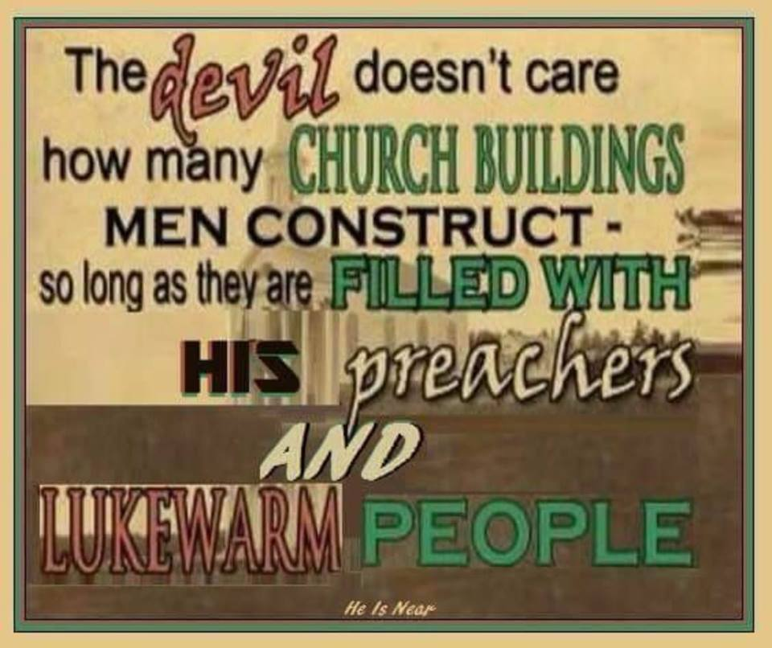
Let’s read it with the proper translation. Keep your eye on, guard from loss, watch so that you do not escape the benevolent, charitable, affection of God as you look for the mercy, because you have not yet received it so you need to look for it, of our Lord Jesus Christ to perpetual or everlasting life after death.
John 14:21-23 speaks of being in the love of God that we are to keep ourselves in. “He that hath my commandments, and keepeth them is he that loveth me: he that loveth me shall be loved of the Father, and I will love him, and will manifest myself to him. If a man loves me, he will keep my words and my Father will love him and make our abode in him.
Obedience and keeping Jesus’ word or commandments demonstrates how much we love Him and will be loved of Jesus and the Father and He will come and live inside us and reveal Himself to us. This is why many do not experience the God of the word. They are lawless. Jude 1:21 KEEP YOURSELVES in the love of God, looking for the mercy of our Lord Jesus Christ unto (or until or leading to) eternal life.
Let that just sink in! Saying a sinner’s prayer and pronouncing people as eternally secure is the most harmful, damnable heresy out there along with the prosperity gospel. The prosperity folks are the ones called spots and wrinkles, wells without water, clouds without rain that appear to contain rain or promises, but they are empty promises. You don’t get rich or get your miracle by giving to them, buying what the blood of Jesus freely purchased for you with His blood.
Study to show yourself approved. Search the scriptures because in them you think you have eternal life. The implication Jesus was making is that you don’t. The bride makes herself ready and the bride keeps herself in the love of God. You do it in His power and ability which is translated grace, so it is not dead works that you get the credit for and are to have repented of. The one thing that can separate you from the love of God is sin. I know people are going to bring up Romans 8:38-39 where nothing can separate you from the love of God and it goes on to list things, but sin is not in the list. The Bible clearly states your unrepentant sin separates you from God. There is another false assumption we make and that is that God’s love implies you have and will never lose eternal life. If agape love is unconditional, which isn’t the definition, then it means God loves Hitler who is in hell. The definition of agape is the one I just gave which is benevolent, charitable and affectionate which you must keep, (prevent from losing or escaping it, guard it carefully) yourself in. Therefore is that unconditional? Not only that but it states this love is only there when you are in Christ Jesus our Lord. Do you think God bestows affectionate love toward Hitler? Of course we don’t. Look at God’s wrath. Does He pour out wrath if He agapes everyone? So keep an eye on and guard remaining in Christ Jesus where there is no condemnation by walking in the spirit and not the flesh and being obedient and no longer a slave to sin but a slave toward righteousness. So much for you not having to do anything and Jesus did it all. So much for what we have been taught about the word agape. Studying is scaring me. But not as much as spending eternity in hell.

EARNESTLY Contend for the faith: Jude 1:3. Why? Because certain men have crept into the church unaware as preachers and teachers (lodged in stealthy, settled in alongside). They have turned the grace of our God unto lasciviousness (Wontonness, excess, outrageousness, shamelessness and insolence without any regard for the concern of others or their needs). Jude goes on to say they speak great swelling words, having men’s person’s in admiration for their advantage. Or as Joel said in a recent sermon, ditch your poor chicken friends and hang out with the rich eagles so their blessings pour over onto you. That is having men’s person's in admiration for your own advantage, although he says that is not what he is saying. He most certainly is! Joel is calling all who follow him to come out/away from those who refuse to be enlightened – who refuse to go onto the next level (great swelling words that puff you up). He kept saying, very heretically, that “God wants you to attach yourself to someone who is higher up than you so you can benefit from their blessings.” He said that anyone who doesn’t want to advance to the next level (by attaching themselves to someone of a higher level, thus gaining some of their blessings) should be shunned because he wants you to have nothing to do with those who aren’t advancing to the next level.” He is basically saying shun your poor friends and hang out with the wealthy so blessings and favor fall on you. He even encouraged other pastors to give into his ministry for that reason, so that they may obtain a following and wealth as he has. Then he boasts of how fast the growth of churches have been for pastors who did this. I will add the video link http://fresh-hope.com/thread/4515/devilish-ministry-joel-osteen. I can’t picture Jesus ditching the poor to hang with the rich for what he could get. They have turned the grace of our God unto lasciviousness (Wontonness, excess, outrageousness, shamelessness and insolence without any regard for the concern of others or their needs). Jude goes on to say they speak great swelling words, having men’s person’s in admiration for their advantage. They have turned grace into greed and covetousness, denying or rejecting the only Lord God, and our Lord Jesus Christ when correction was sent. They have gone the way of Cain, and ran greedily after the error of Balaam for a reward. Balaam was once a true prophet who sold God’s people out for money.
The Bible also calls these preachers and teachers who pervert the word of God to get your money out of your pocket into theirs, spots and wrinkles which Jesus is not coming for, rain clouds without rain, wells without water, trees whose fruit has withered, without fruit, twice dead, plucked up by the roots. Dead before they were born again and dead the second time after being judged and cut off by the Father for trampling the blood of His son under their feet for returning willfully to a lifestyle of sin. They promise you everything if you give to them and their ministry, but the promise never comes about, hence the rain clouds without rain. This is all in the book of Jude.
So were these people ever Christians. Jude 1:5 states I will remind you, even though you once knew this, how the Lord saved the people out of Egypt which is symbolic of the world and slavery to sin, afterward destroyed them. Sodom and Gomorrah are set as an example suffering vengeance in eternal fire, likewise these filthy dreamers who are raging waves in the sea, wandering stars, to whom is reserved the blackness of darkness forever. Enoch prophesied of them.

So what do we do about these false preachers and teachers as we contend earnestly for the faith? Some have compassion making a difference. Others save with fear pulling them out of the fire with the truth, hating even their garments that are spotted by the flesh. We certainly don’t defend them as they lead others to hell with them. The Bible says those who are clean escape from these covetous money grubbing charlatans. It is not about prosperity but the means by which they get it. In defending prosperity we give credence to their methods which God abhors. Do we really want to do that creating more covetous people who will not enter the kingdom of heaven and whose blood will be on our hands? If you cannot apply these scriptures to what we are seeing preached in our mega churches you better check your heart. It might not be as clean as you think.
What are you to do for yourself as you earnestly contend for the faith, saving some, because most will not receive the love of the truth that they might be saved? Like Judas who sold out Jesus for money, they are sons of perdition that go into eternal damnation.
Verse 1:21 of Jude says to keep yourself in the love (agape) of God, looking for the mercy of our Lord Jesus Christ unto eternal life. Build yourself up on your most holy faith, praying in the Holy Ghost (tongues). As I discussed in a previous post that you must keep yourself in the agape love. It is right there. I didn’t say it. Agape is not translated unconditional as we have been taught. It is translated benevolent, charitable and affectionate love which God does not lavish on the rebellious who willfully sin and trample the blood of His only son under their feet counting it as unholy and who deny or reject the truth, which is who Jesus is when correction comes. Read Hebrews 10:26-30. Looking for mercy unto or until eternal life comes in the end as Romans 6 states.
Earnestly contend for the faith, save some with compassion, save some with fear, keep yourself in the love of God because you can come out of it and it is something you must do until you enter into eternal life or the promised land in the end. Ignoring it, turning a blind eye to it and being lukewarm about it is not an option, which people are because they believe the damnable heresy of once saved, always saved, so where is the danger. Lukewarmness makes Jesus throw up. Is that something you want to do? Not me. How lukewarm do you have to be before Jesus pukes you up? I just give out what He gives me. I hope you will do the same and EARNESTLY CONTEND FOR THE FAITH which translated means to vigorously struggle or fight for the one true faith, which you will not if you are lukewarm or love something else more than the Lord like your sin, pleasure or money.
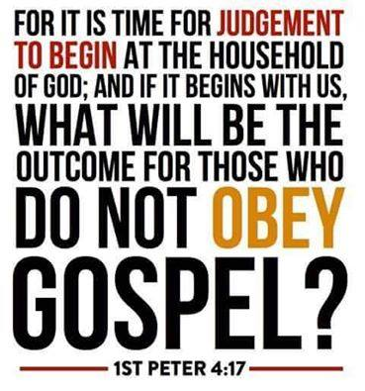
Then those who feared the Lord, talked with each other, and the Lord listened and heard, and a book of remembrance (different from the book of life) was brought and written in His presence concerning those that feared the Lord and honored His name. And they shall be mine saith the Lord of host, in the day when I make up my jewels, and I will spare them (from the tribulation) as a man who spareth his own son that serveth him. And then shall ye return and discern between the righteous and the wicked, between him that serveth Him and Him who serveth Him not. This is all in the context of the great day of the Lord
Not all who claim to be Christians are raptured and are ready. Only those that serve the Lord and make themselves ready as a wise virgin. The foolish virgins get left behind. All slept. All heard the call that the groom was coming but only half were the bride that made herself ready. Only half of all professing Christians on the earth will be raptured which is why you see the unrepentant Christian on the earth in the tribulation. Then shall ye discern the righteous from the wicked and those who serve God and those who just claim to. The rapture, which is close upon us, splits hairs between the doers of the word who do the will of the Father and the hearers of the word only or the apostate. The Lord reveals the apostate or sons of perdition just prior to the rapture in order to give them time to repent and believe the true gospel, or to reject it and go into eternal torment. The hearers only deceive themselves because they have been taught all you need to do is just believe and are left behind. Rev 19 states the bride made herself ready. You don’t want to be here during the tribulation. I am just doing what I was called and created to do. Please heed the message.
Prophecies come out about the Lord giving new revelation to writers and prophets, which really isn’t new revelation, but do we receive it when it comes. We must worship Him in spirit and in truth. Meek means teachable and the teachable inherit the earth. Jesus is restoring all things to the church. The present day church is so apostate or so far away from what Jesus and the disciples taught that we do not have revelation of the truth of the true gospel. It is not new revelation. Just new to us. We must allow what He is bringing forth to tear down our mental strongholds and not defend the heresies we have been taught. I am telling you the Lord is not messing around with sin anymore. He is coming soon. Prodigals need to return home immediately. Repentance and obedience need to be taught. Obedience is not an option. The bride must make herself ready and we must be a wise virgin in the midnight hour. The son of perdition being revealed is in the context of an apostate church. Judas was called a son of perdition. He betrayed Christ for money. Jesus isn’t coming for spots and wrinkles. The Bible describes them as the ones who betray Christ for money, perverting the word of God for money. Sadly, the majority will not receive the love of the truth that they might be saved. The Bible says that these people received the truth at one time so salvation can be forfeited. It is received in the end of our wilderness walk in life when we enter the promised land. Romans 6. Those who are in Christ Jesus where there is no condemnation have ceased from being a slave to sin and are slaves to righteousness and truth. Grace isn’t the license to sin but the power not to sin through the baptism of the Holy Spirit. That is how Jesus fulfilled the law. He didn’t do away with His moral law. The law was to show we couldn’t keep it in our ability and needed this grace or empowerment not to sin which we are save by. Jesus had to be water baptized and baptized in the Holy Spirit before being led by the Holy Spirit into the wilderness to be tempted by the devil. If He needed that when tempted, because He was like us in the flesh, what makes us think we don’t need it? Grace is translated empowerment or I will supply that which is needed. If you have been empowered not to sin and you willfully choose to do so, you are without excuse. Jesus did the will of the Father in being baptized and it pleased the Father who immediately said after Jesus was baptized, “This is my beloved son in whom I am well pleased” Only those that do the will of the Father enter the kingdom of heaven.
I was having a discussion with a friend on grace. I explained that we have such a small view of what grace is and if our view is small, we can’t tap into its depth and breath. This is what I burn with to teach people. If grace is only translated unmerited favor in only two verses in the Bible, what are we missing and not tapping into if it is this grace that saves us. We are saved by grace and if our view is narrow and small, so will be the degree to which we experience His grace and its salvation. My desire is to expand that view if I am given the opportunity. I started learning about grace one night when I was awakened from a deep sleep by the Lord calling my name. When He called my name I understood that He was instructing me to look up my name. In the Hebrew Joanne, the feminine form of John means Divine Oracle and God is Gracious or God will supply that which is needed. Sometimes that can be as a messenger. Someone who will hear and give out what He gives them. Think about this. If the nature of God is grace, why is the church so uneducated on all that grace is? If only .01% of the definition of grace is unmerited favor, and we are saved by this grace, why are we so ignorant on this grace that saves? Why has the devil so blinded us to what grace is while he dictates a false grace that has us remain in sin, rather than deliver us from it and slavery to it. And yet many will not receive the love of the truth of the depth and breath of God’s grace that they might be saved. Your need dictates the grace God will extend to you before you even need it. You need comfort, grace comforts you. You need encouragement, grace encourages you. You need forgiveness in your condemnation, God is greater than your heart and sends a clear message of His view of you which is beautiful to Him and let’s move forward. You need strength in times of temptation, his grace makes that way of escape. You need correction or truth in your deception, His grace supplies it. Whatever the need, God is gracious, or God supplies that which is needed. His grace extends far beyond unmerited favor.
The day before my mom died, the Lord ministered grace and comfort to me knowing I would need it for the very next day. My mom died just this past Christmas Eve, 2018. The day before, the Lord started ministering to me out of scripture and His tangible presence that He can be touched by our grief and sorrow and He used death as an example, knowing He would be calling my mom home the very next day. So much so can Jesus be touched by our grief and sorrow that He was getting ready to ascend to the Father after He was resurrected, but He heard Mary weeping in His tomb. He was getting ready to go into glory and sit on His throne when He heard Mary weeping. Picture this because this is the picture Jesus gave me the day before my mom passed away. Jesus is in His new resurrected body getting ready to ascend to the Father and put His blood on the mercy seat for all to access through grace. He hears Mary weeping. He looks to heaven and tells the Father to wait. Give me a minute with Mary. I can be touched by her sorrow and grief. Her weeping has touched my heart. Let Me comfort her in her sorrow and grief and let her know I am ever with her and have not forsaken her”! Jesus started comforting me the day before my mom passed because He supplies that which is needed. That is grace whereby we are saved. Grace is so much more than unmerited favor. It is trusting Jesus to supply that which is needed and putting your trust in Him to do that. Most so called Christians don’t even have a clue regarding this grace or how to tap into it. Which is why they do not experience the God of the word. Which is why He made me His divine oracle to bring all who have ears to hear into this. My name is my calling, which I didn’t pick, He did, and its definition is the message. I just give out what I have been given and I do so freely knowing that He will supply that which is needed for me financially. I get to comfort others with the comfort wherewith I have been comforted. I hope this blesses you in the year ahead and I pray God opens doors for me to share this with more so that others can tap into the abundance of His grace that saves. It has no limits and it shouldn’t be defined as just unmerited favor that keeps us enslaved to sin because we believe we need nothing more. An expanded view of grace means an expanded faith and without faith it is impossible to please God. Let’s please God by expanding our view of grace which has no limits.
2 Corinthians 12:9 KJV
And he said unto me, My grace is sufficient for thee: for my strength is made perfect in weakness. Most gladly therefore will I rather glory in my infirmities, that the power of Christ may rest upon me. Where we are weak, He is strong and He supplies that which is needed in our weakness. That is grace.
2 Peter 1 Grace and peace be multiplied unto you through the knowledge of God, and of Jesus our Lord (that we submit to). More grace and peace is multiplied with more knowledge that you act upon. According as His divine power hath given us all things that pertain unto life and godliness through the knowledge of him that hath called us to glory and virtue, so that we might be partakers of the divine nature, having escaped the corruption that is in the world through lust. Simply put, grace is not a license to sin, but it is the empowerment not to sin through the baptism of the Holy Spirit. Your freedom in Christ comes from no longer being a slave to sin. He has provided you with this empowerment or grace to live godly through knowledge of Him who has called us to glory and virtue to escape the corruption of the world through lust.
He that lacks these things is blind and cannot see afar off, and hath forgotten that he was purged from his old sins. Is that you?
Now that you know about grace being the empowerment not to sin through the baptism of the Holy Spirit, this verse can be read as God intended. The law was to reveal our sin and show our inability to keep it and we needed this empowerment to keep God’s moral law. Sin shall no longer enslave you or be your master as the law taught you because you have now been empowered or graced not to sin.
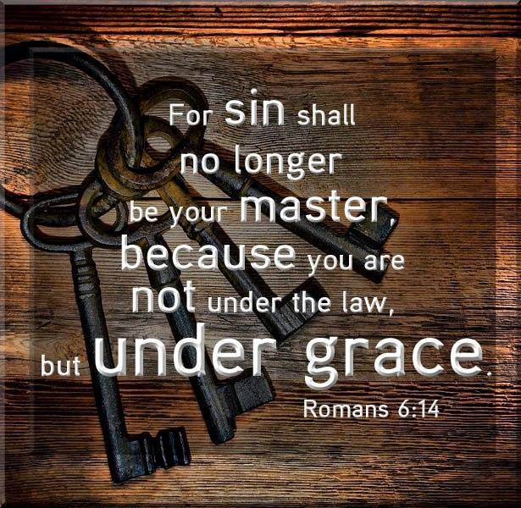
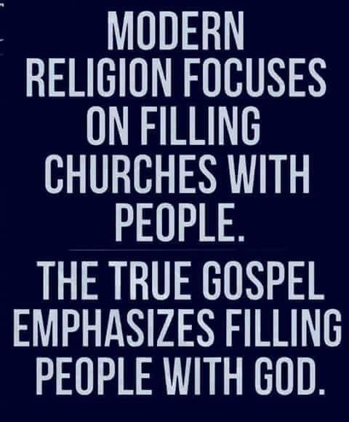
Jesus states in the book of Matthew that before He returns, He will gather out of His Kingdom all who offend and all workers of iniquity. These are the sons of perdition that will be revealed in the context of the apostate end time church in 2 Thes 2 because the time of Christ’s return is at hand. Will you be a bride that made herself ready? If you are in leadership, will you prepare the bride to make herself ready? Will you earnestly contend for the one true faith so that the blood of others are not on your hands? Judgement starts in the house of the Lord before God judges the world. Don’t deceive yourself by cherry picking scripture thinking God does not judge His people. That is against scripture and you have created an idol of God in your image or one that you created, that is not the one true God. You may hear, “I never knew you”! Behold the kindness and severity of God. He is both just and merciful. It is you who determines which side of Him you will encounter. If He will not be Lord in your life as you die to self and submit to Him, He will be judge. If we do not die to self as we are supposed to be pledging in baptism, there is no resurrection with Him. If we are led and controlled by our flesh instead of being led and controlled by the Holy Spirit, there is condemnation and we will not be found “In Him” where there is no condemnation. The present “no condemnation” teaching cherry picks and leaves out half the sentence. It reads: There is therefore now no condemnation for those who are in Christ Jesus, who walk not according to the flesh but according to the spirit. Notice that those who are in Him or in Christ Jesus do not walk according to the flesh. We have been teaching you are in Christ Jesus by merely believing. Not scriptural. The church is so apostate or so far from the biblical foundation with its ear tickling, flesh patting gospel of me instead of preaching that it is not you who live but Christ in you. You must decrease so that He may increase. You don’t get the glory, therefore, He does. The world sees and experiences Christ not you. It is Christ who does the works through you so it is not dead works to gain God’s favor that you get credit for. It is Christ doing the works and He only does the will of the Father. All who do not produce good fruit get cut off and thrown in the fire. Those that do produce fruit get pruned so they produce more. So this is not a works salvation through your effort. Let’s not misunderstand.
We are called to preach the kingdom of God to all nations, not the gospel. The kingdom has a king and subjects that do not allow Him to rule over them will be judged by Him. We are saved by His grace or empowerment not to sin and in the end we receive eternal life. This requires death to self, our will and our way. It is not we who live but Christ in us and He gets the glory. It is not in our power but His. The law was to show we had no power to keep it and needed His. He is the way, the truth and the life. We stop at preaching Him as the way because we don’t like the truth. This empowerment or grace is the life. To reject Jesus as the way, or to reject truth, or to deny the power or life is to reject Jesus. Hell is a long time to be wrong so you can save face now because He will gather out of His kingdom, which means you had to be in it, all who offend and all workers of iniquity. Iniquity is willful sin.
We need to call prodigals home before the dispensation of grace comes to an end. It is nearer than we once thought. God pursued me in my ignorance when I was a prodigal totally broken and unable to take anymore after living in domestic abuse and feeling abandoned by God. He bound up my broken heart and picked me up and pursued me tenderly. Come home while the Father still stands looking from afar off. Jesus is soon coming for His bride who is without spot or wrinkle who made herself ready.
PREPARING A GLORIOUS CHURCH WITHOUT SPOT OR WRINKLE!

A VOICE CRYING OUT IN THE WILDERNESS MAKING STRAIGHT THE PATHS! COMING IN THE SPIRIT OF ELIJAH! AS IT WAS THE FIRST TIME, SO IT IS THE SECOND!
For speaking engagements call
813-393-9384
Our website is www.latter-rain.net

