
  Fresh Rain
  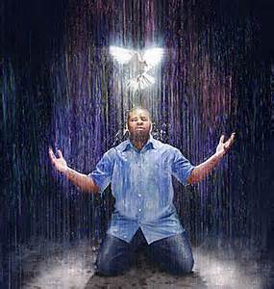
  Latter Rain Ministry
Preparing a Bride without  spot or wrinkle |  | AUGUST, 2018
BEHOLD THE KINDNESS AND SEVERITY OF THE LORD

The Lord gave me the title for this newsletter when I wrote the last one, but He had me wait on it to give church leadership a chance to digest, pray about, and have their mental strongholds of false teaching pulled down with truth before He wanted to proceed with this. I hope you have prayed about and researched what has been taught in previous newsletters He has had me write. If not you can find them at www.latter-rain.net as they are progressive. I used to believe much of what is still being taught, but no longer as the blinders have come off. Some are catching on and I have even seen some preaching from the newsletter on TV. Things that I prophesied previously have come to pass like three hurricanes and the wildfires. I have heard earthquakes, earthquakes, earthquakes three times. Afterwards, Alaska, Italy, Fiji and Indonesia have been hit with sizable earthquakes which I posted prior to them happening. Today Panama was hit. It is making its way to the US and God is warning. I have had a tsunami dream where I stood on the beach warning people who were playing with their toys in the sand that a tsunami wave was about to crash down upon them. Some heeded the warning and some went on playing in the sand with their toys as the wave crashed down upon them, ripping everything they owned away from them as the strong under tow carried it out to sea. Thus our gold is being tried in fire and our idols and possessions are being removed and everything that can be shaken will be shaken until all that is left is of God for the saving of our souls.

We are going to examine both the kindness and severity of God because like anything else, if something is taught to the exclusion of another, it becomes unbalanced. Just like if you focus only on grace and leave out repentance and judgment or God’s wrath. Focusing exclusively on one while excluding the other is error and unbalanced, leaving both sides that do that in either side of a ditch. He told us to behold both His kindness and severity so we will. The precursor to being deceived is pride.

Let’s examine forgiving the woman caught in adultery. Many people use this “don’t cast stones” verse to silence people when they don’t want the cloak removed that covers their sin. They love darkness more than light and will not come to the light that their sins can be reproved that they were wrought in darkness. They use the “don’t judge” line as well, in an attempt to shut you up or pull the cloak back over their sin. The bible tells believers to judge, admonish, restore, exhort unto righteousness as well as go to the person who has sinned and rebuke them. If they won’t listen, bring 2 or 3 witnesses. If they still won’t listen,
take it before the whole church for the purpose of restoring them. This was an Old Testament practice (Deuteronomy 17:6) that carried over to the New Testament and wasn’t abolished. Judgment or condemnation could not take place without two or three witnesses. Even when Jesus was being tried, they couldn’t find witnesses that agreed in their testimony or accusations.

The church has taken so many scriptures out of context or only use half a sentence to come up with false doctrine. That is why the Lord is laying the foundation back again under the church because if the foundation is incorrect, nothing built upon it will stand. Sometimes you have to tear down to rebuild. So in context and back to the original language we go to teach.

Matthew 18:15. Moreover if thy brother shall trespass (cross the line or boundary) against thee, go and tell him his fault between thee and him alone: if he shall hear thee, thou hast gained thy brother.

16. But if he will not hear thee, then take with thee one or two more, that in the mouth of two or three witnesses every word may be established.

17. And if he shall neglect to hear them, tell it unto the church: but if he neglects to hear the church, let him be as a heathen man and publican (or outside the body of Christ or cut off).

18. Verily I say unto you, Whatsoever (not whosoever – it is a thing, not a personality or devil) ye shall bind on earth shall be bound in heaven; and whatsoever ye shall loose on earth shall be loosed in heaven.

19. Again I say unto you, that if two of you agree on earth as touching anything that they shall ask, it shall be done for them of My Father which is in heaven.

20. For where two or three are gathered together in my name, there I am in the midst of them.

Binding and loosing are in the context of sin, not devils or demons or angels. I have heard people say they are binding Satan and loosing angels when they get together with one or more people to pray. Wrong! I have done it too. That is what I was taught until I started to read the word in context, in the original translation, with the Bible interpreting itself in other comparable scriptures and cross references.

What is being bound or loosed from a person is their sin or trespass. How they respond when the sin is confronted determines if the sin is bound or loosed from them. They are given several opportunities to get it right adding more witnesses each time. The sin is bound to them because they blasphemed the Holy Spirit by denying, justifying, explaining, giving their intent, lying or blaming others as Adam did when he said “That woman you gave me....” Adam blamed God and Eve. He did not take responsibility for his sin and blamed God and Eve when God came to “locate him” in his sin and his cover up. God will always come to locate you in your disobedience, even today. Blasphemy is what got them kicked out of the garden, not the actual sin. Blaspheming the Holy Spirit means to throw back in the face of, which you are doing by not admitting, confessing and repenting. The Bible says when you blaspheme the Holy Spirit, that sin will never be forgiven you either in this world or the next and this was said to believers. The sin and the consequences are only loosed when you confess and repent. Then Jesus is faithful and just to forgive us our sins and cleanse us from all unrighteousness. This binding or loosing is done because of the response of the sinner and they do it to themselves basically. But in our hearts, we are to forgive them just as God forgives us. It should break our hearts if they bind a sin to themselves and not appropriate the blood of Christ to it. If we do not forgive or release them in our hearts, we are enslaved to the wound they caused and to them. Forgiving from our hearts frees us and the act of confronting them turns them over to God for judgment to enact. The word forgive means you leave vengeance to God and do not take on vengeance yourself.

In both the old and new covenant you cannot condemn a person without two or three witnesses. Judgment or condemnation can take place in the new covenant using this method. Look at Ananias and Saphira. Judgment starts in the house of the Lord and grace is not the license to sin. It is the power of God given to you not to through the baptism of the Holy Spirit. Your freedom in Christ comes from no longer being a slave to sin and where the spirit of the Lord is, there is liberty or freedom from sin. That is a tool for discernment by the way. Liberty doesn’t mean free to do as you please if Jesus came to set you free from sin and the power of darkness.

Not repenting brings God’s judgment upon you and the definition of judgment as found in Hebrews 10 when speaking to believers that God will judge, means crisis, or the time it is determined that one is cut off from God eternally and goes into perdition because they have counted the blood of His Son an unholy thing and continued in sin despite the spirit of grace, or the empowerment not to sin. The definition of grace is empowerment or “I will supply that which is needed” in all but two place so His grace or empowerment not to sin is sufficient. The believers in Hebrews 10 were judged by God and that sin was now bound or retained to them as well as the eternal punishment. That sin would never be forgiven them either in this world or the next.


We need to get back to fearing the Lord, confessing our sins, foundational teaching in the church and the doctrine of eternal judgment, not eternal security once you first believe. Your salvation is to be worked out in fear and trembling and in the end you receive eternal life as Romans 6 and other places state. Your freedom in Christ comes from no longer being a slave to sin because you have been empowered not to sin by the baptism of the Holy Spirit. Now it comes down to who you submit to; Jesus as Lord, your flesh or the devil. This is where death to self, your will, way and picking up your cross come in. We have been restored to the pre Adamic, or before Adam state and it now comes down to who you choose to obey, either God and eating from the tree of life, or the devil who tells us, “Go ahead and eat of what God forbids because you shall not surely die. You are eternally secure. Nothing will happen.” Same devil. Same lie! Same results! Same blaspheming of the Holy Spirit! Same being kicked out of God’s presence after being restored to the pre Adamic state by the second Adam, Jesus. That is the fruit of the “eternal security or once saved, always saved damnable heresy that has to be the most dangerous doctrine out there that strengthens sin, not frees people from it as Jesus died to do.
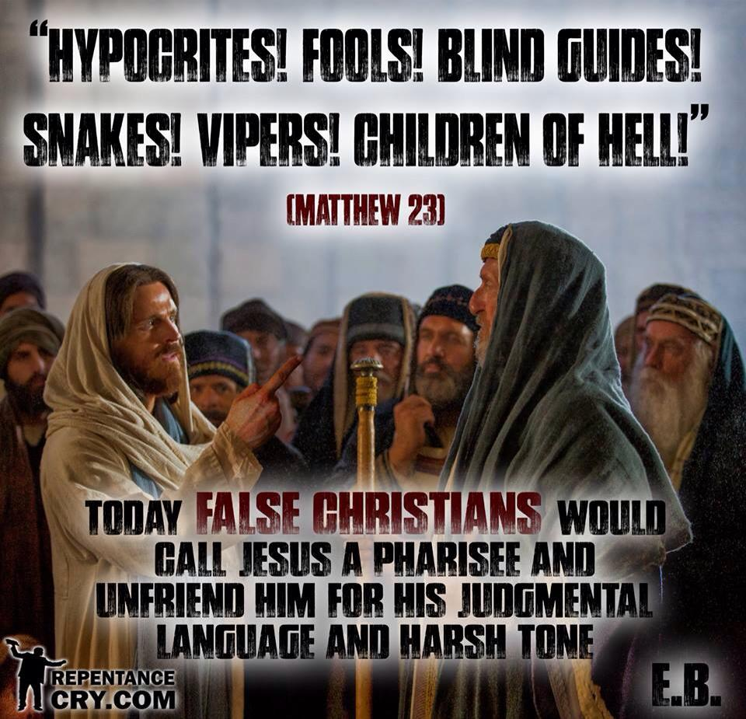
Sins that are not confessed and repented of are not remitted or they don’t have righteousness imputed to them or the blood of Jesus applied. It is a fearful thing to fall into the hands of the Almighty. Behold the kindness and severity of the Lord. Holiness and repentance are being restored to the church. Rev. 19 states that the bride made herself ready and as a result wore white robes of righteousness. Repentance keeps us under the blood. The blood keeps us in the throne room.

These false doctrines that leave you out of the equation in your response to the Lord and being a doer of the word are from the pit of hell. Jesus provided everything but it is up to us in appropriating what He provided and making ourselves ready. Five-fold ministry leaders and husbands, it is you who are charged in helping to present His bride to Him without spot or wrinkle with washing her in the water of the word in sound doctrine and helping her to appropriate that which Jesus died to provide. You will be more highly accountable for how you performed that duty and how you confronted false doctrine in the church that create a lukewarm sin laden church. Did your false doctrine of once saved always saved increase sin and the works of the flesh because there isn’t a consequence for continuing to sin because you preach eternal security which isn’t a foundational teaching of the church? Or did your doctrine produce submission to Jesus as Lord, confessing and repenting of sins in order to be loosed from the slavery to them and consequence of them? Did your doctrine preach the gospel of the kingdom of God which Jesus told us to preach where this kingdom has a king we submit to and allow to rule and reign over us? We only obtain authority over devils, sickness, death etc. when we ourselves are submitted to the one who gives us HIS authority. Does the doctrine you preach promote living in holiness, and appropriating the blood of Christ and His imputed righteousness through confession and repentance? Does the doctrine you preach empower people not to sin because of the baptism of the Holy Spirit or do you deny this empowerment and the Bible says we are to turn away from those that deny it? Is your doctrine failing to turn people from the power of satan and darkness to the power of God or is it enabling sin with a false hyper grace message that causes people to trodden the blood of Christ under their feet and count it as an unholy thing, which brings the Father’s judgment on them. Their blood will be on your hands. The present day gospel produces foolish virgins who are locked out of the wedding feast because wisdom begins with the fear of the Lord and in the absence of this fear, due to the false once saved, always saved doctrine fools are produced and that is the fruit of that false doctrine or damnable heresy.

Everything that can be shaken will be shaken upon the earth until all that remains is of Christ. The earth is groaning for the manifestation of the sons of God, which are mature children He can give the keys to the kingdom to. It is grow up time because we are in the last minute of the last hour of the church age. He wishes that none would perish. Our gold is being tried in fire as literally everything we put our trust in and all our idols that we love more than the Lord is burnt up as dross until all we have is Christ. Don’t blame the devil for what God is doing. We need to wake up and repent while we still have time. The wood, hay and stubble being burnt up is for the saving of your soul, although you will suffer loss. Behold the kindness and severity of God.

Hundreds of scripture verses denounce the once saved always saved false doctrine, yet these teachers refuse to re-examine it and they end up rejecting the truth, Jesus, and blaspheming the Holy Spirit and the blood of all those who perish will be on their hands as God in His faithfulness gave them the truth and they would not receive the love of the truth that they might be saved. Pride is the precursor to deception. They will be sent strong delusion and be removed. Some God will take by death as they leave this earth so the finished or perfected work of the cross and the kingdom of God can be manifested as the earth groans for the manifestation of the sons of God, that these false teachers stand in the way of and people go to hell because of, dying in their sins believing they are eternally secure. I cannot describe to you the urgency and strength with which this warning is coming because the hour is late and time is running out. The borders of hell are expanding with all the volcanic activity, making room for the souls of those lost both now and in the tribulation.

The Lord is cleaning house. I prophesied that. Sex scandals in the church are going to be exposed and people will be removed, either by death or resignation. Pedophiles will be exposed and arrests made. I prophesied that. With 73% of men in the church now viewing porn regularly, including those in the pulpit too, that will be exposed and dealt with as well. The blood of men who died in these sins will be on the hands of those preachers who did not warn. It is fornication and adultery and fornicators and adulterers do not enter the kingdom of heaven and this was said to believers. There is no excuse as the blood and empowerment not to sin has been given but because of false doctrine, it was never appropriated or applied to their sin because they never confessed and repented. They continued in their sin knowing it was wrong and the definition for that is iniquity. Jesus said to depart from Him you workers of iniquity. He never knew you. How deceived do you have to be to think you can continue in sin, knowing it is wrong, and still be eternally secure?
Knowing all this, helps us understand what was taking place when the adulterous woman was caught in the very act and brought before Jesus. Where was the guy by the way because both were to be stoned? The religious leaders were trying to entrap Jesus into denying the law or Torah which a Jewish Messiah would never do if he wrote the law or Torah. Jesus was brilliant in how he handled it. Jesus neither denied the law and judgment nor did he sacrifice his purpose on this earth to seek and save and call sinners to repentance. When they brought the woman before Jesus to entrap him, they had 2 or 3 witnesses or accusers present to condemn the woman which is the practice in both the New and Old Testament. Jesus stooped down and started writing in the sand. What do you suppose he was writing given what you know and with other clues given? He was writing down the religious leaders and accusers sins and they all would have known the judgment that was to be applied to those sins. Basically Jesus was saying “if you want to do judgement right here and now, we can do it”. Let you who is without sin cast the first stone. Their sins were all just written down and they had all the witnesses needed to do judgement right there. The bible says they left one by one starting from the greatest to the least. Greatest and least what? The answer to that is sins either in their severity or quantity. The guy who had the most to lose and would be judged the greatest, got out of there first. It could be age, in which case the answer would be the same because the elder would have had more sin than a younger person. Since they insisted on doing judgement that day, Jesus was like, if you want to do that we can, but we are not stopping with her. After they all left, Jesus asked the woman where her accusers were. Why would he ask such a thing? Because you can’t condemn a person in the Old or New Testament without the 2 or 3 witnesses or accusers. Jesus then told the woman that neither did he condemn her. He told her to repent because he came to call sinners to repentance so he could save them. Jesus neither abolished nor denied the law and judgment and he still called sinners to repentance. By the way the religious leader’s sins were written in the sand and easily erased. It is the same way today.

Remember all this the next time someone tries to silence their accusers by saying don’t throw stones in order to cover their sins and continue in them. Anytime anyone uses scripture to shut you up when their sins are confronted, their heart isn’t right and they are grieving the Holy Spirit wherewith they are sealed. That word sealed means earnest or deposit until the day full redemption is made. Ephesians 4:30 Obviously the day of full redemption has not taken place and a deposit of the Holy Spirit has been put down on us with the intent to purchase or fully redeem us so don’t grieve the Holy Spirit or the deposit will be returned or the Holy Spirit will depart as with the foolish virgins. People today teach that being “sealed” means signed, sealed and never able to have that seal broken when in fact it means the exact opposite. People perish for a lack of knowledge. It is like putting a deposit on a house with the intent to purchase it or giving an engagement ring with the intent to marry. It is not a seal that is not able to be broken as the once saved always saved false teachers use to prove their doctrine. The 10 virgins had oil or a deposit, yet they were not yet married to their groom. None of us are married to the groom, Jesus, yet. We are just engaged. In fact, 5 ran out and were locked out because they were foolish and the deposit was returned. In Jewish culture an engagement had to be broken by a legal judgment due to the unfaithfulness of the virgin. A judgment can take place on us, in order to free the groom from taking us as His bride. Jesus is only coming for a Bride Without Spot or Wrinkle and He has called this ministry from its foundation to prepare her and judge those who would not be prepared and make herself ready in order to wear those robes of white. Rev. 19

Whatsoever you do to another, God has to allow it to be done to you. His protective hand is removed. God will not be mocked. Whatever you do to someone else, it will be done to you. If you steal from someone and don’t make it right, don’t expect God to protect your finances.

Jesus said they hated him without a cause because he removed the cloak that covered their sins. He also stated that if you hate another without a cause because they also removed the cloak that covers your sin, you are in danger of judgment or being cut off and having that sin bound or retained to you to be punished. If he has sent someone to you, even through these newsletters, it is to judge you and retain that sin or give you the opportunity to confess and repent and receive mercy and forgiveness and thus have that sin remitted or loosed from you. So much for the demonic “once saved always saved” damnable heresy brought into the church whose fruit is blaspheming the Holy Spirit, rampant sin and lukewarmness as well as lawlessness and thus the love of many wax cold. By their fruit you will know them and try their doctrine by the fruit as well. Let’s start being salt and light and turning people from the power of satan to the power of God. Grace isn’t the license to sin but the power of God given to you not to sin through the baptism of the Holy Spirit. Your freedom in Christ comes from no longer being a slave to sin. And in the end you receive eternal life according to Romans 6. So work out your salvation with fear and trembling and if you think you are saved and eternally secure when you first believe, why do you still have to work it out?

If god is sending someone to you to confront your sin or false doctrine that you are teaching, it is your respone to it that will determine whether you receive the kindness or severity of god. the fact that they are sent means that judgment is at your door even now. judgment starts in the house of the lord, at the top, and before the world is judged in this minute before midnight in the last hour.

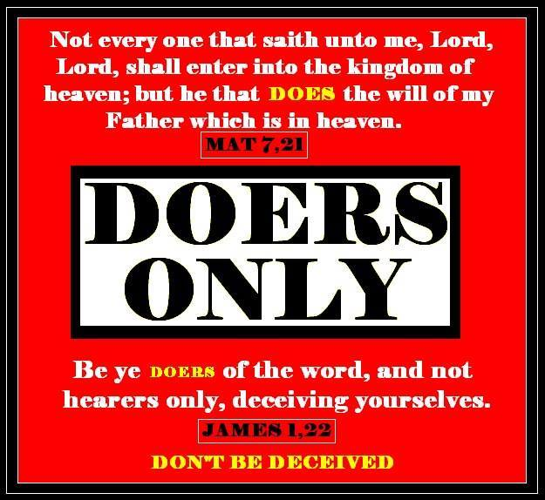
Please notice that only those that do the will of the Father enter into the kingdom of heaven. Not those that believe in their heart and confess with their mouth only.

Binding and Loosing from the biblical perspective: Sin in the bible is called bondage and something that you are a slave to. If the devil wants to steal, kill and destroy and enter your house as a thief, he must first bind you, the strongman, in sin. Then he can pillage your life by stealing, killing and destroying you. Many people think the strongman that needs to be bound is the devil when in fact the strongman that is being bound is you. The thief, who is the devil, cannot steal, kill or destroy you unless he can come into your house through deception and bind you first to sin or false doctrine. Sin is referred to as bondage and Jesus came to set the captives free and He is The Truth for a reason. His people perish for a lack of knowledge. It isn’t that He wasn’t faithful in giving it, but that we would not receive the love of the truth that we might be saved and said to believers by the way. Your freedom in Christ comes from no longer being a slave to sin because you have been empowered not to sin through the baptism of the of the Holy Spirit. So being set free from sin through this empowerment unties your hands through submission to Jesus, confession and repentance so you can kick the devil out and stop being stolen from, killed or destroyed. Satan flips the truth to mean the opposite in the church. It is not the devil being bound, but you. Binding and loosing in the Bible is in the context of sin. The church has been shouting “I bind you Satan” as he laughs because you are the one bound by indulging in your sin believing you are free to do so. You don’t cast an evil spirit out without getting the person baptized in the Holy Spirit or the evil spirit will go out and find seven more evil spirits stronger than himself and deceives you so he can enter into you, which he calls his house, binding you up again. So the baptism of the Holy Spirit empowers us not to sin and be deceived and He is needed in this life to work out our salvation and be a witness to the world.

The current watered down gospel that pats the flesh and tickles ears today doesn’t speak of repentance, the enormity of sin and its consequences and the holiness of God that extends His kindness because of His severity. You can’t point people to a savior without clearly spelling out what they are being saved from, and that entails talking about sin and deception and pointing it out.
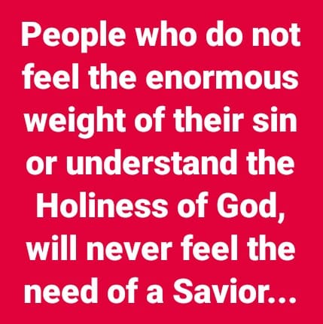
Here is another one the Lord is tackling in the church that He brought up to me again today. It is again witchcraft or a spirit of divination in the church. Remember, you have to be deceived in order to enter a strongman’s house and bind him. This python spirit or spirit of divination has entered the church with its deception cloaking its tactics in Christianese flipping the truth and serving up the lie disguised as truth. If you are resting in the Lord and are in His will, you shouldn’t be worried about word curses, python spirits or witchcraft attacking you. That whole “you curse or you create with the words of your mouth thing” comes from a python spirit or spirit of divination that you have opened up your life to by believing that lie wrapped in Christiansese. You are not gods and don’t have that power. The declare and decree it, blab it and grab it, name it and claim it, positive confession thing is witchcraft 101. It is the same as a witch reciting an incantation and the spirit realm goes out to perform what the witch said. It is the same as going to a psychic that you pay for a “word” or reading and what that spirit of divination says through the psychic, demons go forth to try and carry it out. This spirit in the church will charge or ask for donations for their services instead of freely giving out what they have been freely given. You will frequently see “school of seers” or school of this or that founded by people operating under this counterfeit evil spirit cleverly disguised as the Holy Spirit. Porn comes from this spirit as one of the manifestations found in the bible of a spirit of divination was that of a peeping Tom or observing others from a hidden place or voyeurism. The reality shows have this spirit behind it. Deal with this in your churches folks or God will. It is all about control. Jesus said apart from Me you can do nothing. You only decree a Rhema He tells you to because He will watch over His Rhema word to perform it. You use the word of God or sword of the spirit on the devil when attacked or you simply don’t receive the thought the devil inserts because your mind is renewed. Balaam couldn’t curse the Israelites as long as they were living righteously and in Gods will. My God is bigger than my mouth so stop being in fear and bondage to what you or others say about you, always looking over your shoulder in fear and breaking word curses, and then being in pride because you are such a threat to the devil that he would want to attack you all the time. He is using you, and you opened the door because of your lack of discernment and pride, as well as your need to control, opened you up to buy into his lies. Then in your puffed up state, you teach others how to break the curses and battle the devil while he is howling in laughter at your blind state as you beat the air with your words exhausting yourself in constant battle. You or others that speak curses don’t possess that power. Submit yourself to God and resist the devil and live under the shadow of the Almighty. You are exhausting yourself fighting a python spirit because you are practicing witchcraft and then you post your battles online to prove how important you are because you are such a threat to the devil and charge people to join your school of prayer to teach them witchcraft disguised as warfare prayer. If you receive something freely, freely give it out. The body of Christ has been turned into a business and that is another thing God is going to judge. Don’t sit in the temple of God declaring that you are little gods and all that, like the anti-Christ. Apart from Him, you can do nothing. This is a demonic doctrine of pride, rebellion, control and deception cloaked cleverly in Christian language causing an apostate church to sit in the temple of God proclaiming that you are little gods just like the anti-Christ or against Christ spirit which we are to be dependent on and led and controlled by. We don’t lead and control the spirit realm. That is how you discern. We are to be led and controlled by the Holy Spirit. We don’t lead and control the spirit realm and apart from Jesus you can do nothing. Witchcraft was punishable by death in the Old Testament. The spirit of python is howling in laughter at how he has deceived the church by infiltrating it cloaked in Christian language and twisted scripture using puffed up people with a need to be important and in control.
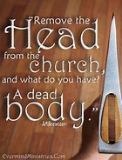
Headship: the Lord spoke that word to me in my morning bible and coffee time. He asked me why the devil was a be-header both spiritually and physically. I never thought about that. We know that what goes on in the spiritual realm manifests in the physical. We know that false religion with a religious spirit frequently chooses beheading to execute their perceived enemy. A spirit of murder is quite comfortable in the presence of a religious spirit. We are not fighting flesh and blood but evil spirits that influence people. This religious spirit conforms to legalistic lifestyles with persecution and death resulting for the one who does not submit to their headship. It is not the spirit of Christ but has often come in his name. It is the same spirit behind Islam and the same spirit that crucified Christ for breaking the man made rules and not submitting to the headship of the Pharisees. It was the same spirit in the crusades that slaughtered people in the name of Christ but it was the spirit of satan, not Jesus. These evil spirits do not die, but go on to different living people to influence to do their will.

Jesus submitted to his Fathers headship. So why beheading or cutting off the head? Without the head, the body is lifeless. It has no power, direction, voice, sight or ears to hear. It has no thoughts of its own. Everything the body needs is derived from the head. Cut off the head and the body dies. Apply this to submission to Christ as our head. If we are not submitting to him, we are without power, direction, a voice, eyes to see and ears to hear and we do not have the mind of Christ. That is why the present day gospel of easy believism and confess only and you are eternally secure, nothing is required of you because Jesus did it all gospel, lacks all of the above. Jesus said apart from me you can do nothing. You can declare and decree, but if you do that apart from Jesus and not getting a Rhema or spoken word from the Lord yourself it ain’t gonna happen. You are not submitting to His headship or leadership. Jesus can’t be savior if he isn’t Lord and if you are not submitting to him. Why do you call Him Lord, Lord and don’t do what He says. Your actions or works prove He isn’t Lord of your life despite what your mouth says. Thus the blindness, lack of hearing from God yourself, having His thoughts because you have renewed your mind in the word and allowed Him to pull down any mental strongholds with the truth. There is a lack of power and life when severed from the head, Jesus, when not submitted to him. You must be a doer of the word and do all he commanded you to do. Not parts. Not when you feel like it. He said ALL I have commanded you to do and teach others the same. Today many call that works salvation or legalism. You have no authority over anything if you are not submitted to the one who gives it or backs it up.

So the devil presents, through church headship, a different gospel preaching a different Jesus and the results are a lifeless, powerless, sin laden, spiritually blind, deaf and dumb, naked body. Are we surprised? That is fruit. By the fruits you will know them. Jesus doesn’t produce lifeless, powerless, blind, deaf, dumb, mindless nudes. The church is though. Why? Satan has planted his headship in leadership in the church. Satan also fishes for men and he does so in the church. That is in the process of changing. Don't freak out. It is happening in both leadership in the US as well as judgment starting in the house of the Lord and starting at the top. It will trickle down.

As I read through Matthew regarding the end times and the final harvest you see a repeated pattern. The tares, or weeds that look like wheat, are plucked up first and destroyed. The parable says to let the wheat and tares grow up together until the final harvest. We are in that time. Biblical end time prophecy is happening before our very eyes.
These parables in the same context of Matthew 13 always perplexed me but now when read in this context regarding headship, the wheat and tares and the final harvest it makes perfect sense. Follow me.

The kingdom of heaven, not satan’s, is like a grain of mustard seed which a man took and sowed in his field. Which indeed is the least of all seeds: but when it is grown, it is the greatest among herbs and becomes a tree so that the birds of the air come and lodge in the branches. Birds in the bible are symbolic of satan, sin and demonic influences as is leaven. That is why I never understood these verses. How could the kingdom of God be compared to tares being sown, sin and the devil at final harvest time?
The kingdom of God is like unto leaven, which a woman took, and hid three measures of meal until the whole was leavened. Jesus is called the bread of life.
Jesus is saying in these passages that in end times, before he returns and before the final end time harvest, good seed had originally been sown in the form of wheat. The devil enters the church with lies and deception that produces tares. The mustard tree is the church that the devil comes and lodges in. The leaven is sin that has spread in the church until the whole church is so full of sin because of the false doctrines and damnable heresies being taught that does not turn the people from the power of satan unto the power of God because they are not submitted to his headship.
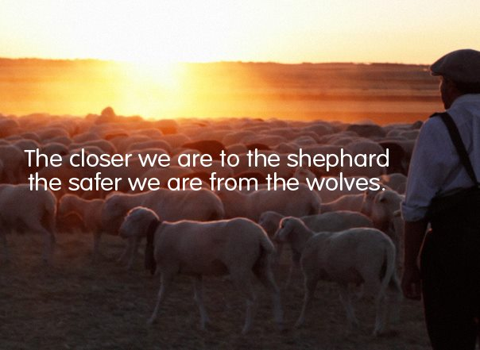
The field is the world. The good seed is the children of God. The tares are the children of the devil, the harvest is the end of the world, so we are given the time at which this occurs. The mustard seed tree is now large, which indicates a large period of time has transpired since the seed was sown to produce this church or mustard seed tree. Leaven or sin has overtaken the bread dough just prior to this end time harvest.

Matthew 13:41 now the son of man, Jesus, will send his angels forth and they shall gather out of his kingdom all who offend (scandals) and all workers of iniquity. Take a look at all the scandals in the church today with more to be exposed. This is what is going on. The word angel is translated messenger, which John the Baptist was called so don't necessarily look for winged invisible beings, but prophets God sends forth to warn before severing those that offend in order to give them opportunity to repent and turn towards God or reject truth. He is faithful to bring you truth in your deception. This has always been God’s pattern and that hasn’t changed nor does He. The Elijah anointing must first come restoring all things and this is an anointing on people, not necessarily a person. The word offend means scandals as translated from the original language or that which is stench in the nostrils of God that he will expose and remove. The Bill Hybels scandal is one such example with many others to come. The word iniquity means "you knew it was wrong and you did it anyway". There are people in the church who are doing things they know are wrong, yet they do it anyway. Why? They confessed with their mouth and now believe they are eternally secure so nothing more is needed. Jesus said "depart from me, I never knew you! You worker of iniquity"! You have believed another gospel preaching a different Jesus by satanic birds that have lodged in your tree branches that have enabled sin to grow because headship and submission to Jesus as Lord in order to be savior was omitted in being taught in the churches.
These workers of iniquity will be destroyed. Then will the righteous shine forth in the kingdom of the father. Who hath ears to hear, let him hear? And of course only those attached to the head in submission will have those ears and eyes to see and be the messenger or angel that speaks and gathers out, because when the message is rejected, judgment severs them eternally from God. They would not receive the love of the truth that they might be saved.

This all happens before the rapture because there has been a great apostasy or falling away in the church from the truth and these sons of perdition, or those who will perish in the church, will be revealed, so expect a shaking because everything that can be shaken that we put our trust in that is not of God, like our possessions or pastors telling us the truth, will be shaken. The bible even says swift destruction will come on those who pervert the word of God for money.

These verses continue in Matthew with those that hear and see, find that treasure, Jesus, in a field and give up everything to gain that field. Or the merchant man who found a pearl of great price and he gave up everything in submission to gain that pearl or eternity in heaven. Everything that can be shaken, will be shaken until all that remains is of God. That is why all the fires and disasters taking place as possession and all we put our trust in is removed in these last days in order to save our souls eternally. Our gold is being tried in fire. Our nakedness exposed. Our blind eyes having salve applied in order to set us on fire out of our lukewarm state to go forth into a final harvest field in power, life, authority and true righteousness. In the fishnet of evangelism, the bad fish are tossed back. Not everyone caught in the fishnet of evangelism is a good fish or eternally secure as they like to think. They are deceived. You must endure in sound doctrine until the end and then in the end you receive eternal life as romans 6 states. The bible doesn't contradict itself.
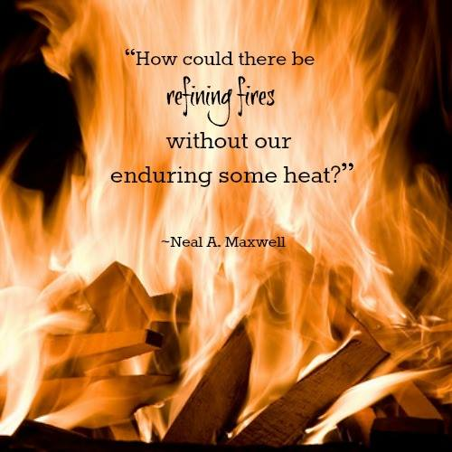
So let's submit to true headship, because the devil has beheaded or severed the head from the body of Christ, with Jesus being the head that we are to follow. That is the result of just believe and confess and repentance and submission to Jesus as Lord has been omitted in our flesh patting, ear tickling gospel. In submission to the king of the kingdom we will have the mind of Christ, ears to hear, eyes to see and a voice in a dark and dying world headed to hell. That is where we will get our power back in a powerless church and life back in a lifeless church. This is where the true signs, wonders and miracles will take place as Jesus confirms the true gospel with signs following. All true revival starts with repentance, confession, obedience and submission to Jesus as Lord in order to be Savior. Don't fear the shaking! Time is short here. Eternity is forever. The field is ripe unto harvest!
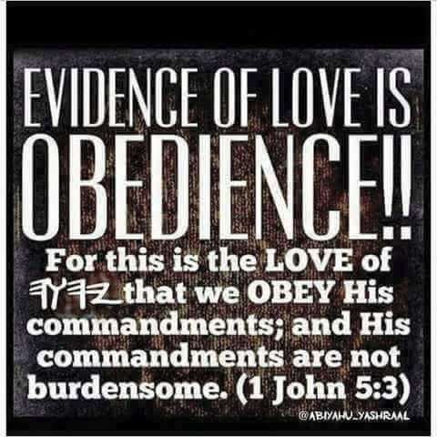
Conditions to imputed righteousness
Jesus told five of the seven churches in revelation to repent. If they did, they will overcome. If they did not, they will burn. Rev.21:7-8 they did not have imputed righteousness. Ananias and Saphira did not have imputed righteousness because they continued in sin and blasphemed the Holy Spirit when confronted by Peter. Acts 5:1-9

Hymeneus and Philetus did not have imputed righteousness. 2 Tim. 2:17-18 Alexander did not have imputed righteousness. Acts 1:19-20 the man that was sleeping with his father's wife did not have imputed righteousness. 1 Cor. 5 Judas did not have imputed righteousness. They loved their sins.

When a person turns to the Lord and puts faith in his blood (the cross) they are forgiven of their past sins. Rom. 3:25-26, 2 Pt. 1:9-10 but those who continue in rebellion (deeds of the flesh) to Jesus, they will burn. 1 Cor. 6:9-11, Gal. 5:19-21 those who belong to Christ have crucified the flesh with its passions and desires. Gal. 5:24 those who continue in known sin do not know him. 1 Jn. 2:3-5, Titus 1:16

It is true that the moment that a person turns (converts) to the Lord they are forgiven of all sin. Repentance of all known sins is part of that turning to the Lord. Acts 3:19-23, Acts 2:38, Acts 5:32 God is patient with us. He is not passive with us. 2 Pt. 2:20-23

The “if you continue” scripture is all the way through the New Testament. Now I make known to you, brethren, the gospel which I preached to you, which also you received, in which also you stand, by which also you are (being) saved if you hold fast the word which I preached to you unless you believe in vain. 1 Cor.15:1-2

He has now reconciled you in his fleshly body through death, in order to present you before him holy and blameless and beyond reproach—if indeed you continue in the only faith. Firmly established and steadfast, and not moved away from the hope of the gospel that you have heard, which was proclaimed in all creation under heaven, and of which I, Paul, was made a minister. Col. 1:22-23
For if god did not spare the natural branches, he will not spare you (Christians), either. Behold then the kindness and severity of God; to those who fell, severity, but to you (Christians), God’s kindness, if you continue in his kindness; otherwise you also will be cut off (in the same way Israel was cut off). Rom.11:21-22 what if you don't?

son of perdition revealed
Can you lose your salvation? The question is phrased incorrectly. The question should be “can you fall away from the faith?” The biblical answer is yes, you can fall away from the faith. You can become a "son of perdition" as Judas was called. Judas is not the only "Son of Perdition" referred to in the bible. Son means mature child who went away into perdition or destruction/eternal damnation. Before Jesus returns the "son of perdition" shall be revealed. We don't think we can become one because we believe the false “Once Saved Always Saved”, but can we become a son of perdition and how? Regarding the rapture of the church, the great apostasy of the church and the “son of perdition” spoken together in this context, let’s read what the bible says viewing the “son of perdition” as a child of God that has fallen away or became apostate or has departed from the truth, instead of as the Anti-Christ. Not saying there isn’t an anti-Christ. I am just saying that Jesus is returning soon and in our false “Once Saved Always Saved” gospel where one can never fall away, Jesus may be trying to expose the spiritual stronghold or state of people that believe they are saved, when in fact they have fallen away or became apostate. This He would do because He wishes that none would perish and He is trying to call these apostate ones back to Himself, but before He can, they have to indeed know they are apostate or fallen away so let’s explore this without any biblical strongholds or preconceived beliefs you may have. http://www.latter-rain.net/ Strongholds-in-the-Church
Let the TRUTH, Jesus, wash you so that no one hears, “Depart from me you worker of iniquity”. Iniquity means you knew it was wrong and you did it anyway and these were people who stood before the Lord believing they were saved. How deceived do you have to be to believe that you can knowingly do something wrong and still get into heaven, but that is the fruit of this “Once Saved Always Saved no matter what you do you will get into heaven if you asked Jesus into your heart” doctrine, which is equivalent to what the devil told Eve in the garden. “Go ahead and do that. You shall not surely die”. Nothing will happen and the source of that lie is the devil. Some believe that if you are practicing sin, you were never saved but that is not what the bible says.

II Thessalonians 2:1-6 Now we beseech you, brethren, by the coming of our Lord Jesus Christ, and by our gathering together (rapture, collection or snatching away) unto Him (There is an event in regards to something that will happen right before the rapture.)That ye be not soon shaken in mind, or be troubled, neither by spirit, nor by word, nor by letter as from us, as that day of Christ is at hand. Let no man DECEIVE you by any means; for that day (rapture) shall not come, except there come a FALLING AWAY (DEPARTURE FROM THE TRUTH OR AP0STASY) first, and that man of sin be revealed, the son of perdition”. Falling away or departing from the truth is in the context of apostasy and the church falling away from the true gospel. This produces this son of perdition and that is what is being revealed because it is something that was hidden or not known. Is this just one man who departs from the truth or a group of people? Was it the church being warned not to be deceived and why is there so many bible verses that talk about how deceptive things will be in end times just before Jesus returns, warning us repeatedly not to be deceived? Because we can depart from the truth, that is why and to be deceived means you have departed! It doesn’t mean you don’t go to church, read your bible, pray or anything else. These warnings are given to church people. You could do all that and still be deceived about what is true. To be deceived means that you don’t know you are wrong. II Thes 2 verse 6 says the son of perdition will be revealed when it is time and that time is now. Jesus is about to come for a bride without spot or wrinkle. Keep in mind Son means child of God and perdition is one who departs from the truth and is damned. Is the man, the anti-Christ a Son of God that departed from the truth? If you are a son of the devil, if you are going to depart from your father the devils beliefs, you would have to become a Christian, right? So this “son” would have to be a believer who departed or has fallen away from the truth and thus went into perdition or damnation as Judas did.

Now as you read this, notice it is plural in verse 10 and not about just one man. The word falling away comes from the Greek word apostate which means a departure from the truth and there is a strong warning not to be deceived. This is not just one man that is departing from the truth but the church. Verse 10 goes on to say “And with all deceivableness of unrighteousness in them (plural) that perish because they (plural) received not the love of the truth that they might be saved”. Also, what they are deceived about is righteousness and because of their strongholds of false beliefs (grace is a license if you can never lose your salvation or fall away) and they could be saved if they would just repent and receive the love of the truth, which is “grace” or empowerment not to sin through the baptism of the Holy Spirit. Jesus said He didn’t do away with the law but fulfilled it. The law was to show us we couldn’t keep it and the baptism in the Holy Spirit given at Pentecost is the empowerment (translated grace) to become Holy. Grace is used as an excuse not to be Holy today so people are deceived about their unrighteousness. This empowerment was not available before the resurrection of Christ. God’s moral law never changed and never will. Animal sacrifices and traditions are done away with, but not God’s moral law. It is finished. There is no more sacrifice for sin. Now you have been empowered not to sin after water baptism and baptism in the Holy Spirit who is Holy and the word Holy means set apart. The word finished means perfected. Jesus said, “It has been perfected or now made complete” when He died on the cross. Your freedom in Christ comes from no longer being a slave to sin because of this grace or empowerment. Everything has been restored to before Adam fell and we can now choose who we will be a slave to; either to sin or to righteousness. This is where death to self, your will, your way and picking up your cross and following Jesus in submission to Him while resisting the devil comes into play. Jesus can’t be savior if He isn’t Lord. Righteousness isn’t imputed apart from confessing, repenting and obedience to being baptized in water and in the Holy Spirit.

Can we know we are going to heaven? The biblical answer to that questions is yes we can know we are going to heaven. The cross is an accomplished fact. Jesus died for our sins. It is finished. There is no more sacrifice for sin. It’s a matter of faith . . .

"Eternal security” or “once saved always saved” teachers will often ask the question “what particular sin can cause someone to “lose their salvation.” The biblical response to that question is that when faith fails and love grows cold a person will fall into their old sinful lifestyle. It’s not a matter of a believer stumbling, falling into sin, and then repenting. It’s a matter of falling away from the faith entirely and falling back into their old sinful lifestyle. There is no security in sin. Repentance is not a one-time act.

I Timothy 5:11 in talking about widows who were in the church and Christians: But the younger widows refuse: for when they have begun to wax wanton against Christ, they will marry; 12 Having damnation, because they have cast off their first faith. (Fell Away or became apostate)

In the parable of the sower, Jesus taught that there would be those who would believe only for a while and endure only for a time. He said some would fall away.
Luke 8:11-15 They fall away because the devil takes the seed of the word of God from their hearts. Other methods he uses are: Temptation, persecution and trials, deceivableness of riches (prosperity doctrine), pleasure, cares and worries. Damnable heresies being taught in the church as well. If you can’t be damned, how can a lie be brought in that would damn you? A spirit of divination and witchcraft runs rampant in the church.
11 Now the parable is this: The seed is the word of God.

12 Those by the way side are they that hear; then cometh the devil, and taketh away the word out of their hearts, lest they should believe and be saved.

13 They on the rock are they, which, when they hear, receive the word with joy; and these have no root, which for a while believe, and in time of temptation fall away.

14 And that which fell among thorns are they, which, when they have heard, go forth, and are choked with cares and riches and pleasures of this life, and bring no fruit to perfection.

15 But that on the good ground are they, which in an honest and good heart, having heard the word, keep it, and bring forth fruit with patience.

16 No man, when he hath lighted a candle, covereth it with a vessel, or putteth it under a bed; but setteth it on a candlestick, that they which enter in may see the light. (This is what one looks like if they have a good ground heart)

17 For nothing is secret, that shall not be made manifest; neither anything hid, that shall not be known and come abroad.

18 Take heed therefore how ye hear: for whosoever hath, to him shall be given; and whosoever hath not, from him shall be taken even that which he seemeth to have.

This is how one falls away which means: FALL AWAY – “aphistemi” – to remove, i.e. (actively) instigate to revolt; usually (reflexively) to desist, desert, etc.: depart, draw (fall) away, refrain, withdraw self. Jesus spoke of continuing in His word.

John 8:31 Then said Jesus to those Jews which believed on him, If ye CONTINUE in my word, then are ye my disciples indeed;

CONTINUE – “meno” – a primary verb; to stay (in a given place, state, relation or expectancy):–abide, continue, dwell, endure, be present, remain, stand, tarry.

Consider also . . .

2 Peter 2:20 For if after they have escaped the pollutions of the world through the KNOWLEDGE of the Lord and Savior Jesus Christ, they are again entangled therein, and overcome, the latter end is worse with them than the beginning.

KNOWLEDGE – “epignosis” – recognition, i.e. (by implication) full discernment, acknowledgment.

2 Peter 2:21 For it had been better for them not to have known the way of righteousness, than, after they have known it, to TURN from the holy commandment delivered unto them.

TURN – “epistrepho” – to revert (literally, figuratively or morally): come (go) again, convert, (re-)turn (about, again).

2 Peter 2:22 But it is happened unto them according to the true proverb, The dog is turned to his own vomit again; and the sow that was WASHED to her wallowing in the mire.

WASHED – “louo” – a primary verb 3068; to bathe (the whole person; whereas 3538 means to wet a part only, and 4150 to wash, cleanse garments exclusively): wash.

2 Timothy 4:7 I have fought a good fight, I have finished my course, I have KEPT the faith:

KEPT – “tereo” – from teros (a watch; perhaps akin to 2334); to guard (from loss or injury, properly, by keeping the eye upon;

Knowledge of danger helps us avoid danger, and keeps us safe. Knowledge of danger is like a fence around a rooftop patio, it keeps us safe, it keeps us from falling. Knowing you are going to heaven, and the doctrine of falling away from the faith, are not contradictory doctrines, they are two sides of the same coin. Our assurance should not be threatened by this doctrine, it should be strengthened. Why? Because those that teach that repentance is a one-time act, that there is security in sin, or that a believers can never make shipwreck of their faith, are not teaching “the faith which was once delivered unto the saints” Jude 1:3 and there can be no security in that.

1 John 5:13 These things have I written unto you that believe on the name of the Son of God; that ye may know that ye have eternal life, and that ye may believe on the name of the Son of God.

1 John 5:20 And we know that the Son of God is come, and hath given us an understanding, that we may know him that is true, and we are in him that is true, even in his Son Jesus Christ. This is the true God, and eternal life.

Don’t let anyone or anything steal your faith! And don’t let anyone tell you that because you reject the unbiblical “eternal security” teaching that you do not have assurance of salvation. I pray that the Lord, through the Holy Spirit and the Word, would give all His children discernment concerning this doctrine.
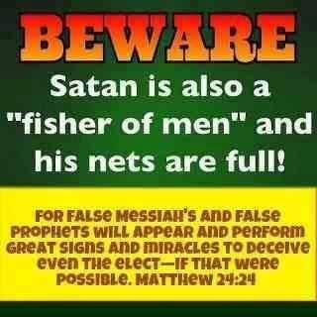
The devil brings in demonic doctrines that sound like truth to deceive Christians and this is also a way to fall away or become apostate. We need discernment. There is too much witchcraft in the church today masquerading as the Holy Spirit. Like the frog in the pot, you don't put him in boiling water right away. You put him in water that is comfortable and then slowly turn up the heat until death occurs. The devil seduces and leads one away from the faith so that they are apostate by disguising deception in truth. Once a small amount has been accepted, more is added and now you have departed so far away from what the bible teaches that you are apostate or have fallen away from the original gospel so that you don’t even recognize it and it has happened one step at a time.


Hebrews 10:26-31 talks about willful sinners after knowing Christ, being judged and cut off by God. The word "judge" means crisis or the time it is determined when one will be cut off. Jesus said that before He returns, He will gather out of His kingdom all that offends and all workers of iniquity. Rev. teaches that you can have your name removed from the lamb's book of life and if your name is not found there, you are thrown into the lake of fire. I can go on and on regarding New Testament scripture where it tells believers that if they are doing this or that, they won't enter the kingdom of heaven with one of the worst being fornicators and that word “fornicate” comes from the Greek word pornia which is where we get the word porn. Jesus warned in Matthew in the context of lust and sexual sin that if your eyes offend you, pluck it out and if your hand offends you, cut it off because it would be better for you that you enter heaven maimed then enter hell with all your body parts. Don’t let anyone tell you masturbation and porn use is not found in the bible. We might not use the same word, but the concept, in context, is there. This is a sin against one’s own body, not just adultery against one’s wife and sin against God, so pastors and leaders, if you aren’t addressing this and other sins in your church, you will BE HELD MORE ACCOUNTABLE WITH WORSE JUDGMENT. A whopping 68%-73% of men in the church struggle with porn and many are in the pulpit. When promise keepers comes to certain cities, the porn and prostitution rate rises in that city and hotels take notice. Why isn’t the church addressing this issue and we will be held accountable? I warn because no one’s blood will be on my hands. The bible says that men would be lovers of pleasure more than lovers of God in regards to perilous times before Christ returns. Broad is the way that leads to destruction and many there be that enter. Narrow is the way that leads to eternal life and few there be that find it. If your path is broad and anything is acceptable, you are on the wrong one. My ex was a porn addict who watched porn one day with his 20 year old son and he witnessed to him afterwards saying that because of what Jesus did and we can be eternally secure, we can do this and not feel guilty about it.
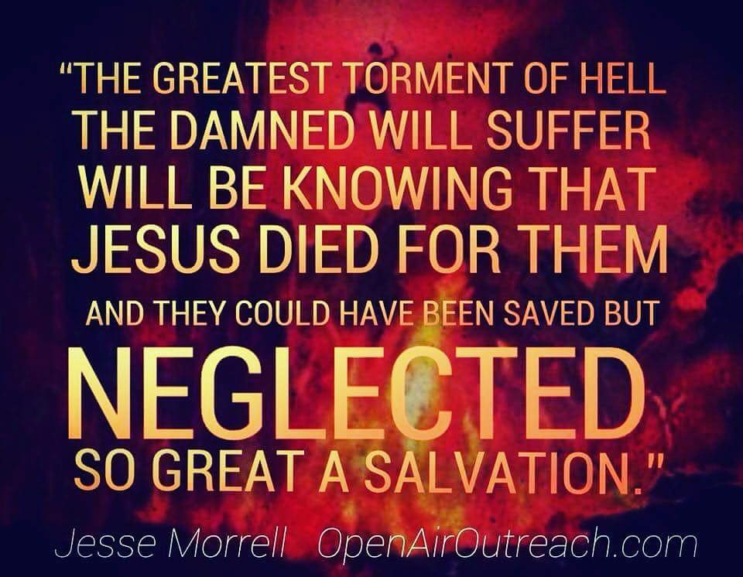
The once saved, always saved is not biblically accurate because they base everything they believe on "Grace is a license to sin" or sins past, present and future are forgiven and nothing you can do will change your eternal destiny if you just said your little prayer. Grace is the power of God given to you not to sin and the bible warns that in end times, some will deny or reject that power and its teaching and with such we are not to be associated. So, don't be deceived is a HUGE WARNING BY JESUS HIMSELF REGARDING END TIMES! CAN YOU SEE WHY? Let's teach people how to get into the faith the biblical way and remain there and come along side of them when they struggle. http://www.latter-rain.net/What-Does-It-Mean-to-be-Born-Again

The foolish virgins run out of the oil of the Holy Spirit. All ten virgins accepted the marriage proposal of Jesus and knew He was about to return. Only half received the truth in order to be saved. The reason you see Christians on the scene during the tribulation is because they were the foolish ones and they were shut out.


Don't be foolish. Read your bible and be careful how you hear. The bible even says that before God judges the world, He judges His church first before He returns. Judgment or crisis (the time it is determined when one will die eternally and be cut off) starts in the house of the Lord, so how can people claim you are eternally secure when all the biblical evidence points otherwise and they base it on half a sentence and stop reading after “no condemnation” when the sentence goes on to say that there is no condemnation for those who walk in the Spirit and are led and controlled by the Holy Spirit only. It goes on to say that this eternal security is not for those who walk according to the flesh. The Holy Spirit led group doesn’t have to worry about condemnation. But if you are practicing sin and walking in the flesh and fulfilling the lusts of the flesh, you can be sure there is no eternal security in that, only a fearful looking for of judgment or condemnation. So I pray that you receive the love of the truth that you might be saved and not reject the truth because it doesn’t conform to your stronghold or lens through which you read the bible. Jesus is faithful to warn, reveal deception so that the gates of hell do not prevail against His church, but man has free will. Will you be wise or foolish? You don’t become born again by works of the flesh to please God. You respond to Him in faith and obedience and this is not dead works. You are responding to what He has done and provided. If you willfully sin and do not repent, you are rejecting or choosing not to respond to the truth and what Jesus did. These are not works, but responses to the truth, which is who Jesus is, not what He does and your response of acceptance and obedience or rejection of Jesus determines your eternal destiny and whether you will be cut off, so choose wisely. The Holy Spirit is only given to those who choose to respond in obedience.

To be In Christ Jesus where there is no condemnation means that you are walking and being led and controlled by the Holy Spirit because you have been empowered not to sin and not your flesh and sinful old nature. Don't base a doctrine or belief on half a sentence and saying a prayer does not make one "born again". Your freedom in Christ comes from no longer being a slave to sin as John 8:34 states: Whosoever commits sin is the servant or slave of sin. Jesus is coming back for a Glorious Church and it is just around the corner. With this word and revelation and the sons of perdition being revealed, the glorious bride of Christ is about to be raptured or caught up, but He wishes that none would perish, no not one. How will you respond? The son of perdition is being revealed to give him time to repent because He wishes that none would perish. The rapture is not going to take place until this son of perdition has been revealed and this is God’s nature and mercy.
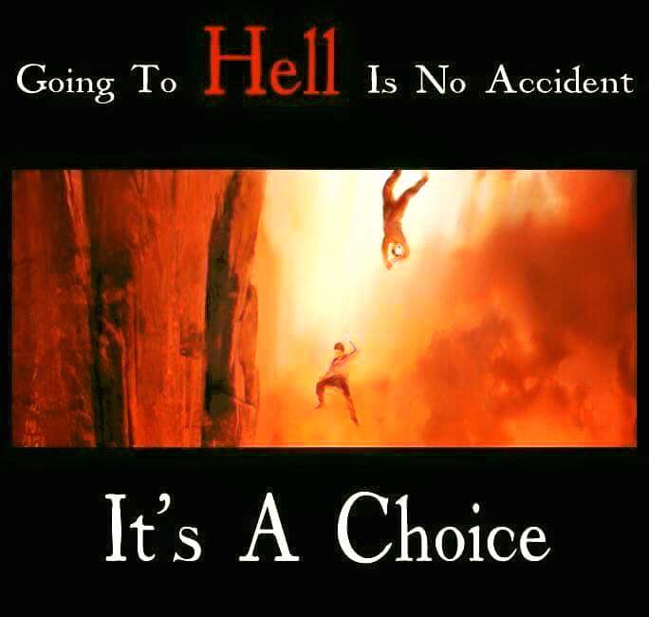

Why all the wild fires in the Redding area? Leviticus 10:1-2. Regarding the sons of Aaron offering “strange fire” before the Lord which He commanded not or it wasn’t from God but a demonic source. There went fire sent by the Lord to devour them.

A well-known church in Redding California has allowed a spirit of divination to enter. A spirit of divination counterfeits the Holy Spirit in the gifts. If the gifts were not of any value, there would be no need for a counterfeit sent to deceive you and this is sent to an adulterous generation who seek signs and wonders and words from the Lord, instead of seeking the Lord only. These churches have got to stop playing with “strange fire”, fire tunnels, weird manifestation, kundalini, grave sucking, gold dust, jewel and feather manifestations, new age practices and witchcraft through their declaring and decreeing out of their own flesh expecting the spirit realm to hop to it and be their genie because they recited their incantation, even if it was scripture. We are to be led and controlled by the Holy Spirit. We do not lead and control the spirit realm to do our bidding. That is witchcraft 101 repackaged in Christian language in church circles. Doing any of this that is not of God is called strange fire in the Bible that was offered up to God thinking it was good and of God and a suitable sacrifice. The end result was fire sent by the Lord that devoured them. This church in Redding teaches and practices what I just mentioned to the whole world, which is why this monster of a wild fire is targeted in Redding. Time to wake up church. Witchcraft and divination were punishable by death in the Old Testament. God is trying to get your attention before it is too late in these end times. A spirit of mammon operates with this spirit as well. Hence the gold dust and jewels. Never saw that in Jesus or the disciple’s ministry. We are running out of time so in Gods mercy He tries your gold in fire in order to save your soul. Verbal warnings were not heeded. The leader has not addressed these issues and a snake has slithered in. You only kill a snake that enters your home because you know the danger it brings. Perhaps you would ignore it if you think the once saved, always saved has inoculate all your sheep against any snake venom or if you are deceived into thinking it is God. None the less, he will be held accountable as fire is sent to burn up the “strange fire” that is an abomination to the Lord by sincerely deceived people who will not receive the love of the truth that they might be saved. I prophesied this happening less than a year ago. No one listened and they spoke not a word. More is on the way.
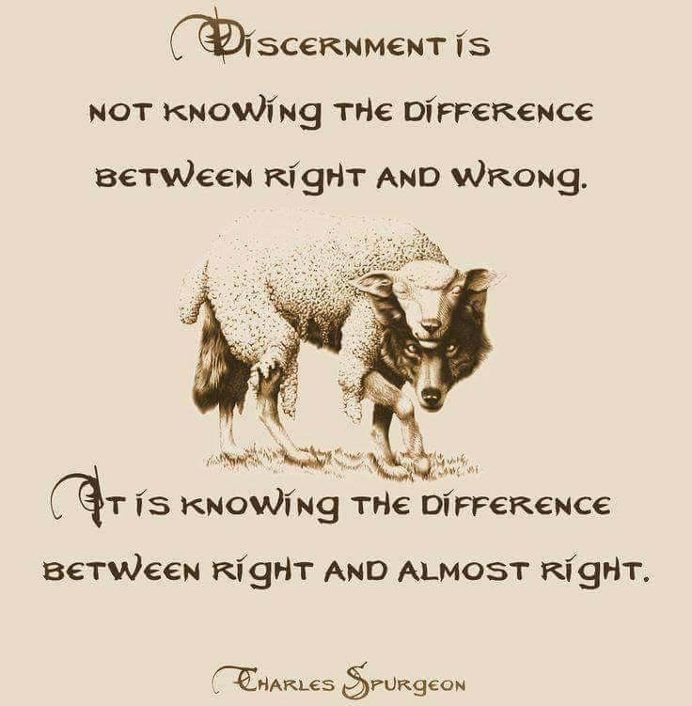
Fire is even mentioned as a method God uses so wake up church! Repent. Divination and witchcraft were forbidden by God and punishable by death. How can you escape so great a judgment which starts in the house of God. Malachi says that those who speak of the Lord and judgment are written in the book of remembrance and when these judgments shall begin to take place, you will know who really served the Lord and who just thinks they do but serve Satan. Confess and repent and return and He will hear and heal the land.

WOLVES WILL ENTER IN AMONG YOU NOT SPARING THE FLOCK. TWISTING THE WORD TO DRAW AWAY PEOPLE TO THEMSELVES. THEREFORE WATCH & REMEMBER I HAVE NOT CEASED TO WARN DAY AND NIGHT THROUGH TEARS. THEREFORE I ATTEST TO YOU THAT I AM INNOCENT OF THE BLOOD OF MEN.

Prophecy: Did I not warn that in end times people would not endure sound doctrine? Did I not warn that they would heap upon themselves teachers to tickle their ears and pat their flesh? Did I not warn that wolves would enter into the sheepfold in sheep’s clothing to get fat off the flock? Did I not warn that false teachers would make merchandise of My bride? All this I knew, but I am not wringing my hands in worry! How BIG am I? Did I not also say that I have a remnant still in the land?

Did I not say that the gates of hell would not prevail against my church? Did I not say the judgment starts in MY house? Did I not say that I will remove all who offend Me out of MY kingdom before I snatch away my bride? Did I not say that I would bring upon those heretics and merchandisers swift destruction? Did I not say the enemy has sown tares in the wheat, which I allow to remain until the time of harvest? Did I not say that I will send the former, middle and latter rain and send my laborers out into the field to reap what my rain has watered? Why do you think I warned of all these things? So you would not fret and be deceived, but pray and pick up your sickle to enter the harvest field. Everything that can be shaken will be shaken until all that remains is of Me. You can tell the harvest field is maturing for a harvest because the distinction between wheat and tares are becoming more obvious. The tares stretch high toward the sun, while wheat in maturity bow down. I have already sent this word and I will accomplish that which I said. Be still and see the salvation of your Lord. You are about to see greater works as I send my laborers forth into the harvest field. You just pick up your sickle and do as I command and watch what great and glorious things I will do because I am faithful and I do watch over my word to perform it says The Lord.
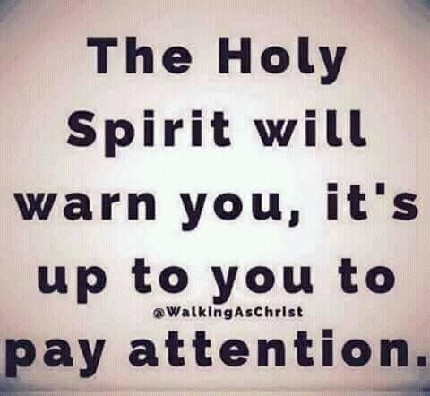
God’s kindness never negates His severity. In fact He extends kindness and grace first because of His severity. He disciplines those whom He loves so that they do not experience His wrath.
Reading through Matthew 11 with morning coffee and came to verse 29 in the context of casting out devils. The Pharisees said Jesus cast out devils because he had one. Jesus said every kingdom divided against itself will not stand. Same for households, businesses, churches, home groups etc. you have to deal directly with any division and gossip or it will fall apart. That is why at work, I don’t listen to gossip or bad talk against my boss or members of our team. I may instruct them about personalities and how best to interact with certain people to keep people from failing or being disciplined but I shut down division and counter it with the good, team work and benefits.
Jesus goes on to say if Satan cast out Satan, he is divided against himself and
how shall his kingdom stand? You see Satan has a kingdom too. Jesus goes on to say, “If I by Satan cast out devils, by whom do your children (or followers) cast them out”? Think about this. Basically Jesus is saying Satan has a kingdom with authority in it. He is called the god of this world. When you see evil, you are seeing the works of the devil operating in his kingdom authority over man. Jesus said that Satan comes to steal, kill and destroy and Jesus came to give life and give it abundantly. Satan works by influencing man to do his will and enters man. Man has a free will to choose that God does not interfere with. Through repentance, and being filled with the Holy Spirit and being led and controlled by the Holy Spirit, you shut demonic doors to the devil in your life. The Bible says if you cast a devil out of a person and that person is now clean, that devil goes and finds bigger, strong devils and brings them back to that man he was cast out of, which by the way the devil called the man “his house”, and they all enter that clean but weak powerless man and his state now is worse than the first. That is why a person needs to be filled with the Holy Spirit and His power after being set free from the devil by casting him out. This is why Baptism in the Holy Spirit is to be done right after water baptism, which remits or washes away old sins if the person has every intention of living out what water baptism is symbolic of in being dead to sin, self, your will and way, which is going under the water, in order to be raised or resurrected just as Christ was. If you have no intention of living that out, all you got was wet and the Holy Spirit won’t come to inhabit you or baptize you. You are only raised or resurrected like Christ if you have died to self as He did. People must be fully knowledgeable on what water and Holy Spirit baptism are and why. Your old sins are remitted or sent away only if you intend on dying to self in order to be raised or resurrected with Christ. Deliverances take place many times at baptism when the person is sincere and devils have to leave. After being swept clean, the baptism of the Holy Spirit is now required to live out what you believe in being dead to sin and self. This is the empowerment not to sin that enables you to work out your salvation with fear and trembling so that in the end you receive eternal life, if you continue in the faith and not fall away. That is why Jesus said you must be born again of water and the Holy Spirit in order to enter the kingdom of heaven. That is how Jesus finished, translated “perfected” or fulfilled the law. When He said “It is finished” before He gave up the ghost or died, He was saying “It has now been perfected”. The law was to prove you couldn’t keep it in your ability and you needed the baptism of the Holy Spirit or empowerment not to sin. The word believe is a verb and not a noun as many teach and it is translated to believe, to commit to continuing to believe, an ongoing state of believing until the end and living according to that belief. It is not a one-time act but a life lived through the empowerment of the Holy Spirit as given at Pentecost so you do not fall away into sin or deception. Can you see why Jesus warned so much about deception in end times?

So basically when Jesus told the Pharisees by whom do your children cast out devils? Answer: they don’t. Why: they have no kingdom or authority. So you have two kingdoms both with authority and power and Jesus and the kingdom of God has all authority over everything which He gave to His church. That is why He gave us the keys to the kingdom and said whatsoever you allow on earth, I will allow in heaven. Jesus purchased back what Adam forfeited to the devil and gave dominion back to the church. We now must exercise that power and authority by being totally led and controlled by the Holy Spirit and loving the truth and word of God.

Jesus goes on to say, “If I by the spirit of God cast out devils, then the kingdom of God is come unto you. Or else how can one enter a strong man’s house and spoil his goods, except first he binds the strong man and then he will spoil his goods.

To understand this you have to realize again, Satan calls man his house. He is the one who spoils, steals, kills and destroys. Jesus came to set the captives free from their slavery to sin. For Satan to enter man’s life and spoil his goods and house, the man has to be bound or enslaved to sin. That is why you cast the devil out. The man has to repent and be baptized for the remission or the sending away of his sins and then be filled with the Holy Spirit baptism in order to empower him not to sin and keep the devil from leaving and bringing back 7 more devils with him more powerful to entangle him again in sin spoiling his house even more.

Let’s get free and filled and exercise our God given kingdom authority over the devil freeing others as well and filling them with the Holy Spirit. Let’s stop teaching people to ask Jesus into their hearts which isn’t in the Bible or give their life to Jesus. You don’t give your life to Jesus, you get your life from Jesus because He is the way, the Truth and the Life. No one enters except by Him. You must repent and be baptized every one of you in water and of the Holy Spirit. Your freedom in Christ comes from no longer being a slave to sin or bound and entered by Satan so he can spoil your goods and household.

After all this, Jesus said, “He that is not for me and my kingdom and authority, is against Me; and he that gatherers not with me scattereth abroad”!

In the great commission before Christ ascended to heaven He said to His followers, All power is given unto me in heaven and in earth. Are you gathering as He instructed by preaching the gospel of the kingdom of God, baptizing them in the name of the Father, the Son and of the Holy Ghost. Teaching them to observe all things whatsoever I have commanded you; and lo I am with you always, even unto the end of the world.

If we don’t know whatsoever Jesus commanded his disciples to observe, how can we teach it? It was something He commanded, not suggested. Obedience is not optional nor is baptisms which are foundational teachings in the church. Notice also Jesus reference to being with us until the end of the world so these things didn’t end with the disciples. His expectation is for us to do this and He will confirm the real gospel manifesting His kingdom authority on earth when we do. This is why Satan is so against baptisms and the “confess only is required to be saved and eternally secure” false doctrine. He can come in and bind you and make you his house and spoil your goods while you are enslaved to sin. Jesus died to set you free and empower you. This is why the Lord is calling us to lay the foundation back under the church and do as He commanded. Otherwise we are scattering with false gospels and weird manifestations by an adulterous generation who seeks for signs and wonders instead of seeking first the kingdom of God and His righteousness and power and exercising His kingdom authority on earth. Acts 19 states you don’t receive the baptism of the Holy Spirit when you first believe. Paul went to Ephesus where Apollo was preaching and making disciples and Paul asked them if they received the baptism of the Holy Spirit since they first believed. They responded by saying they didn’t even know there was such a thing. Paul asked them by what baptism were they baptized. They replied that they were water baptized for the remission or the sending away of their past sins. Paul then laid hands on them and they were baptized in the Holy Spirit with the evidence of speaking in tongues. It is not something that you receive when you first believe so let’s get rid of that demonic lie that only benefits the kingdom of darkness.

True Shepherds Vs. Hirelings: Matthew 20:1-16. I hope I can articulate what I just got correctly. We have true Shepard’s who watch over the flock of sheep out of love. Then we have paid hirelings who don’t love the sheep but are in it for the money or what they can get in ministry. The context of Matthew 20 starts in Matthew 19 with the rich young ruler who went away sad because Jesus told him to sell everything and follow Him. This astonished the disciples as they said “Who then can be saved”? Most of us would have led the rich young ruler in a salvation prayer and pronounced him saved and eternally secure when he wouldn’t have been. Anyway, Jesus tells the disciples that it is easier for a camel to go through the eye of a needle than for a rich man to enter heaven. The eye of a needle was a small place at the city wall that people entered in times of war to sneak back into the city for safety. It was tiny and everything had to be removed from the camel including the bags he was carrying and the contents of its goods stripped from the camel so it could bend low and crawl through this narrow way called the eye of the needle to enter into the city safely. Jesus was implying that you can’t take it with you. You have to be stripped of everything you love more than Christ to enter in the narrow gate that leads to eternal life. Noticed eternal life isn’t immediate when you first believe. It is a destination requiring the stripping of all you love, whether job, money, relationships, churches, pastors you idolize, alcohol, video games, hobbies, football or whatever you love more than the Lord. It all must go, or everything that can be shaken will be shaken until all that remains is of God. That is what you are seeing around the world today.

Jesus told the disciples after this rich young ruler encounter after they asked, “We have forsaken all to follow thee so what shall we have therefore” that they would sit on thrones judging the tribes of Israel. Then Jesus goes on with the parable about the difference between hirelings and those that are chosen. The hirelings were hired at the beginning of the day and agreed to a contractural price for a day’s wages. They went out to the vineyard to work for the householder. About every 3 hours the householder found more laborers standing idle so he agreed to hire them saying “whatsoever is right I will pay you”! At the end of the day, the laborers who only worked one hour were first getting paid until the ones who worked all day were last getting paid. They all were paid a day’s wages no matter how many hours they worked so the ones who worked the longest and had agreed on a price for their laborers as hirelings, were angry as they supposed they should have been paid more.

What was Jesus point? The hirelings agreed on a price or the payback they would get for working for Jesus. All the others did not and left the reward of their labors to Christ to give them “whatsoever is right”! Therefore, the payment or rewards for trusting Jesus to give us whatsoever is right when we obediently go into His harvest field or vineyard will be far greater for less work than those who are in it for the money or pay back. Be careful in negotiating a price or limiting God on how He rewards you for your work. If you are a hireling in it for the money, or attach yourself to Christ for what you can get or the benefits, which are always on your mind and your hand is always out, and you do not labor because of your love for the sheep and Shepard, you are called, but not chosen. Many are the called. Few choose it leaving the reward to Christ, leaving or forsaking all to follow Him without asking or wanting to know what is in it for me. Which are you? When troubles come, hirelings flee. If the resources of the sheep dry up because of disasters as everything that can be shaken will be shaken out of our lives that we put our trust in or love more than Jesus before He returns, the hirelings will flee because there is no payment in this life for their labors and they are in it for them, not you or Christ. Many are they. Few actually choose to not know the payment and leave it to Christ to reward what is right and actually receive the greater reward. The hirelings won’t be opening their wallets or offering up rooms in their mansions to house, feed or clothe those who will lose everything in the disasters on the earth and the ones to come.

Equipping the church: Now get busy. No one is excluded. The fivefold ministry is to equip the church to go out and do these things, not bring people in so the fivefold ministry can do the church’s job. You can’t expect fireless people to set others aflame. They must be baptized with the Holy Ghost and fire and Jesus does this baptism which you receive by appropriating His blood in obedience. You have a responsibility in Gods kingdom which you will be held accountable for in how you use your gifts. If you use them, more will be given. Now go! Please do not allow people to be deceived. Go to our site and ask the Lord to reveal the truth to you! Don’t allow pride to keep you from seeking and preaching the truth. It is 11:59 and the midnight hour is fast approaching! No one calls Jesus Lord except by the Holy Spirit!
www.latter-rain.net

Foundational Teachings of the Church:

Repentance
Faith Toward God
Baptism in Water for the remission of past sins and identifying with being dead to sin and alive unto righteousness in order that you are raised with Christ. If you have no intention of living dead to sin, self, your will and your way, there is no resurrection like Christ for you. It is to be a way of life, not symbolic.
Baptism of the Holy Spirit which empowers you not to sin and be a witness for Christ. Jesus was baptized in both water and in the Holy Spirit before entering the wilderness to be tempted by the devil. We are to follow Him. Don’t point to the thief on the cross in your ignorance to show why water baptism is not necessary as many do to get out of obeying. The thief died under the old covenant. Jesus told him “This day you will be with Me in paradise”. Paradise was not heaven because Jesus didn’t ascend to the Father until He was resurrected three days later. Paradise was also called Sheol, Hades, Abraham’s Bosom and it was a place in the earth that dead departed people went until Jesus made a way for them to enter heaven. Jesus descended there after His death, preach the gospel to them, took the keys away from satan and led those people out. Many of these resurrected people were seen walking about on the earth Matthew 27:50-54 So the thief died under the old covenant and paradise wasn’t heaven. Water baptism is a requirement to appropriate the new birth and blood of Christ.
Laying on of hands to impart the baptism of the Holy Spirit or heal the sick etc.
Resurrection of the dead.
Eternal judgment, not eternal security. We will be judged for the power we were given not to sin and the gifts and truths Jesus was faithful to give. To reject truth is to reject Jesus. Romans 6 says in the end you receive eternal life after you have worked out your salvation with fear and trembling empowered by the Holy Spirit not to sin and be holy as God is holy, without which no one will see the Lord. You have been restored to the pre Admanic state by the second Adam, Jesus, and it is now a question of your will, who you submit to and obey. That will either be Jesus as Lord in order to be savior or you will fall for the same lie told to Eve when the devil told her to go ahead and do what God said not to do. Nothing will happen. You shall not surely die. You are eternally secure. Thus you are again cut off like Adam and Eve were the first time.
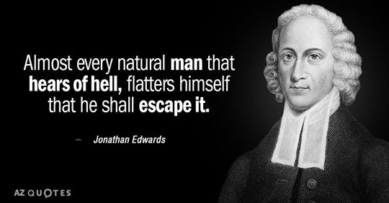
Jesus said unless you are born of water and of the Holy Spirit in these baptisms, you shall not enter the kingdom of God. It is not believe and confess only. You are to work out your salvation. The path is still narrow and few there be that find it. If the righteous scarcely be saved, what of the unrighteous or those in rebellion to God. You are to make yourself ready as the bride. You have been set free from the power of satan and sin through the baptism of the Holy Spirit so you must appropriate what Jesus died to provide you with.
You have to take your check or gift of the Holy Spirit to the bank in depositing Him in you so you can access the funds or power in time of need. You can’t just believe the gift giver is good for the funds and hang on to the check. That is not the saving kind of faith.

The Israelites left Egypt which is symbolic of the world. After leaving the world, they went through the red sea in water baptism. They were led and guided by the pillar of fire which was symbolic of the baptism of fire or Holy Spirit baptism, which is different than being sealed in the Holy Spirit, which is just a deposit when you first believed. The Israelites wandered in the desert which is symbolic of our earthly journey. Some fell away or died in the desert and never made it into the promised land or heaven. The whole course or process of salvation is throughout all the bible. You can’t skip any process in the race you run in your life. Let us go back and lay the proper foundation again under the church and submit to Jesus as Lord in order for Him to be savior. The kingdom has a King. The bible even says that in end times, the king asked his servants to bring those before him who would not have him rule over them to be slain before him. Rebellion is as witchcraft and got satan kicked out and it will keep you out as well. So behold, THE KINDNESS AND SEVERITY OF THE LORD. Remain in His kindness through repentance, confession, submission and obedience. For behold He comes quickly.

For if god did not spare the natural branches, he will not spare you (Christians), either. Behold then the kindness and severity of God; to those who fell, severity, but to you (Christians), God’s kindness, if you continue in his kindness; otherwise you also will be cut off (in the same way Israel was cut off).

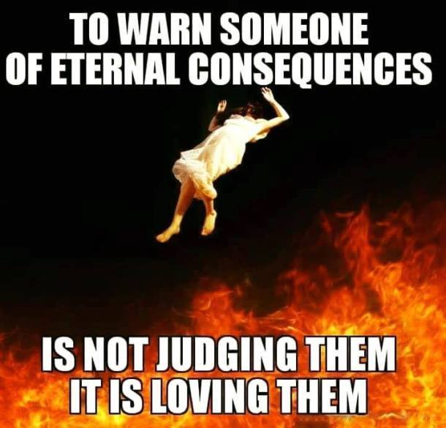

Spread the word and share. Many are perishing. We are to be salt and light and light exposes the works of darkness and salt was a preservative placed on the sacrificial meat to preserve it so the priests had food to eat. Do you really want Jesus to declare you good for nothing because you lost your savor? I don’t! We are here to preserve and expose!
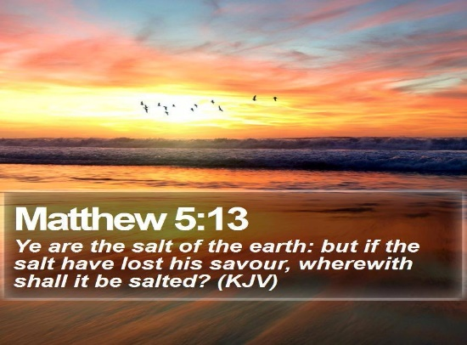


PREPARING A GLORIOUS CHURCH WITHOUT SPOT OR WRINKLE!

A VOICE CRYING OUT IN THE WILDERNESS MAKING STRAIGHT THE PATHS! COMING IN THE SPIRIT OF ELIJAH! AS IT WAS THE FIRST TIME, SO IT IS THE SECOND!

For speaking engagements call
813-393-9384
Our website is
www.latter-rain.net

