
  Fresh Rain
  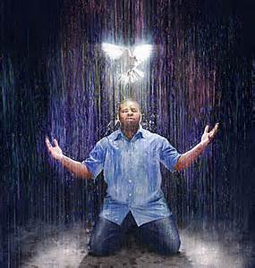
  Latter Rain Ministry
Preparing a Bride without  spot or wrinkle |  | AUGUST, 2019

SALVATION THROUGH SANCTIFICATION OF THE SPIRIT AND BELIEF OF THE TRUTH

Yes the bible actually says that. 2 Thes. 2:13 States you receive salvation through SANCTIFICATION of the Holy Spirit and BELIEF OF THE TRUTH, not just believe and confess only. Transformation through sanctification is a requirement to be saved as is accepting the truth, Jesus, in your deception. We live in the end days where the church will not adhere to sound doctrine. They just want preachers to tickle their ears and pat their flesh and tell them nothing is required of them after they first believe and confess and they are now eternally secure and can never “fall away” into deception or sin. The implication is you can sin away and nothing you do will affect your eternal destination. Thus the church is full of sin, tolerant of sin and 68% of the men, including pastors, regularly watch porn and fornicate as a result. Families are destroyed, addictions flourish, people are still slaves to sin, even though Jesus died to deliver us from our sins. They have a form of godliness but deny the power

thereof to make one holy. From such we are told to turn away, and not embrace this damnable heresy. They don’t openly deny the power or empowerment of the Holy Spirit not to sin, but say you have all of the Holy Spirit you will ever need when you first believe, thus negating the command BY JESUS to be water and Holy Spirit baptized. Acts 19 states baptism in the Holy Spirit doesn’t happen when you first believe. They claim obedience is “works” salvation. They claim you are justified by the blood of Christ, which is true, but you are only justified (your standing) while you are being sanctified (your state). Jesus doesn’t just call you holy but makes you holy through sanctification of the Holy Spirit and belief of the truth. The justification is to get you to the sanctification because it only comes through relationship with the Lord. Therefore, the purpose of your standing, or justification is to get you sanctified. To only declare you as holy without making you holy would make Jesus a liar. What

God says, He performs, but you are required to cooperate in the sanctification process. To be “saved” our state (justified) and standing (sanctified) will be one and the same through the sanctification of the Holy Spirit and belief of the truth. Jesus said, “If you don’t allow me to wash you, through the water of the word, you have no part with me”. No part means no part. This He said to Peter who was already a believer when Jesus went to wash his feet. The feet are symbolic of where we pick up the things of the world or dirt in our walk through the wilderness of life. Hopefully, after teaching biblical truth and pulling down a few mental strongholds as a result, you will be clean because you receive the love of the truth that you might be saved. This by the way in 2 Thes. 2 was spoken to believers so obviously salvation was not yet attained in their deception or apostate state. 2 Thes, 2 is the state of the apostate church, us, before Jesus returns for His bride to snatch or rapture her away for the wedding feast. We are living in that time.
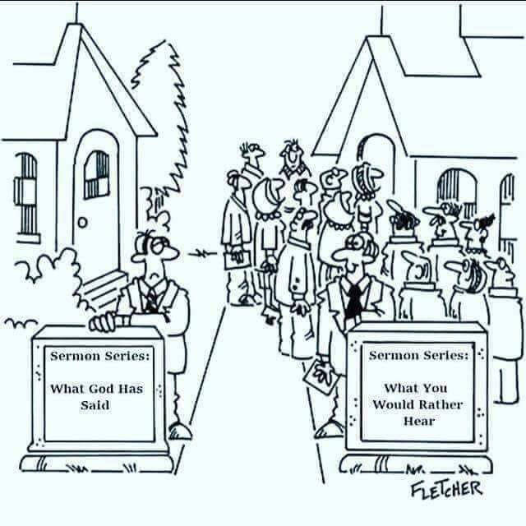
Let me also say that if you are not preaching the truth because people will leave and the collection plate diminishes, you are a hireling who believes man is your source, not God, so it is man you choose to please and ear tickle in these last days. Money is the God you serve as well as fear. You don’t have faith in the Lord to meet your needs.
The Lord gave me this prayer for well intentioned but deceived false teachers in the church and I pray it over you. We are apt to teach and be patient is the Lord’s instruction. I pray you don’t let Him grow weary in His patience.

Lord give them repentance unto the acknowledging of the truth so that they may recover themselves out of the snare of the devil who are taken captive by him at his will. 2 Timothy 2:25-26


Jeremiah Johnson writes:
“As I have recently been studying some of the great reformers of church history such as John Wycliffe, Jan Hus, Martin Luther, Ulrich Zwingli and many others, I cannot seem to get past how much of their lives were spent tearing down, uprooting, overthrowing, and destroying what their generation accepted as "status quo" or "normal".

I have a strong conviction that in the 21st century, we often try to make reformers out to be individuals who only "build" and "plant" and do not grant them enough grace to tear down, uproot, overthrow, and destroy. Sadly, I believe much of the 21st Century Church is looking for "positive reformers" only and this is a tremendous tragedy and mistake.

It was said of the great reformer Martin Luther (1483-1546) that, "he tore down the old house, but built no new one in its place". They said of Ulrich Zwingli (1484-1531), "he threw down truth against the Church like thunder strokes but erected nothing better in its place".

Is this historic commentary an accusation against these men, or is it simply revealing the nature of the assignment that true reformers carry in their generation?

Perhaps the reformers struggle and plight is that the anointing for catalytic shift and change that they carry comes with a ten ton hammer that breaks up and shatters traditions and systems and a voice that cries one octave too high against treasured structures and movements. Perhaps it's the generations that come AFTER the true reformers that are tasked with the real planting and building?

Who are the true reformers of the 21st century Church? Considering the true reformers of church history, we should be looking for the voices who are uprooting, tearing down, overthrowing, and destroying the carnality, vanity, and sinfulness of this present age. They won't be popular with the masses and they certainly won't be positive all the time. My prayer is that God would give us grace to listen to their words, no matter how deeply they pierce, and welcome them into our midst, no matter how well received they are.”

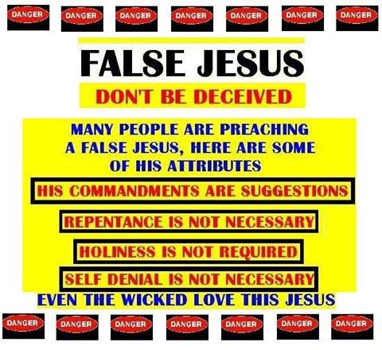
WHEN IS ETERNAL LIFE RECEIVED ACCORDING TO THE BIBLE?

1 Timothy 6:12. Fight the good fight of faith, LAY HOLD ON ETERNAL LIFE, whereunto thou art called, and profess a good profession before many witnesses.

Okay, here is a problem in one verse that totally destroys the false teaching that all you need to do is profess with your mouth and believe in your heart and you will receive eternal life or be “saved”. If you have your eyes opened or the veil removed, it is all through the Bible but some will not receive the love of the truth that they might be saved.

If Timothy already had a good profession, why does he still need to fight the good fight of faith and LAY HOLD on eternal life? You don’t lay hold of something you already have or possess. Why does he need to fight the good fight of faith if Jesus did everything and we do not participate in our working out our salvation with fear and trembling? Timothy already was a believer and pastor, yet eternal life was still something he needed to lay hold of. Working out our salvation implies that we are not yet saved. You don’t work something out that you already possess. More scripture on laying hold of eternal life:

I Timothy 6 uses the term “lay hold on eternal life” again. 19 Laying up in store for themselves a good foundation against the time to come, that they may lay hold on eternal life.

Jude 1:21 KEEP YOURSELVES in the love (agape) of God, looking for the mercy of our Lord Jesus Christ unto (or until or leading to) eternal life.

Let’s break it down. Lay hold of comes from the Greek word epilambanomai. It means to seize, to attain, to catch, or to take hold of or on. Hmmm... That poses a problem with the confess, profess after believing in your heart and you receive eternal life false doctrine doesn’t it? Timothy already had a good profession before many witnesses. He already believed in his heart, yet Paul exhorted him to flee from any doctrine that didn’t produce godliness, or that supposed that gain is godliness or God’s stamp of approval on you. Paul told him to withdraw himself from such teachers. That godliness with contentment is what is great gain and those that seek to be rich fall into temptation and a snare and into many foolish lusts which drown people in destruction and perdition and those who have coveted after have pierced themselves through with many sorrows. The prosperity doctrine is straight from Hell. Jesus warned in the parable of the sower and the seed that wealth was one thing the devil uses to cause people to fall away from the faith and become apostate. Covetousness is idolatry. Idolaters will not enter the kingdom of heaven. Paul was warning Timothy here about such men teaching in the church. Paul told Timothy to flee these things and follow after righteousness, godliness, faith, love, patience and meekness (translated humble and teachable). Does God want you sick and poor? Of course not. He wants you godly, contented, righteous, full of faith, love, patience and humility, being teachable so you do not err from the faith and become apostate. He doesn’t want you pursuing the lusts of the world and making them your god and what you follow after and chase. We are to follow after Christ who is the prize. Paul said he counted everything as dung in order to attain Christ Jesus our Lord. Paul also said that he had not yet “apprehended” eternal life but was pressing toward the mark of the high calling of Christ Jesus. Philippians 3:12 Not as though I had already attained, either were already perfect: but I follow after, if that I may apprehend that for which also I am apprehended of Christ Jesus.
In other verses where it states you have gone from death to life, it is referring to being born again. You once were dead spiritually because of the fall of Adam and now you have passed from death to life. Being born again is not receiving eternal life. You are now spiritually alive where you were once dead inside. Eternal life is something you enter into in the end. In John 5:24-29 this “eternal life” is in the context of those who have already died, and this eternal life is being extended back in time to those who believed in the Father. Jesus died and descended into this place in the earth after His death and preached to these departed souls and led them out. They were resurrected and seen walking about after Jesus was resurrected. One definition of “eternal life” is eternal life extended back in time to those who have previously died and believed in the Father. These are the past sins that are forgiven.

So laying hold of eternal life in the end requires a fight or battle because we are in a battle for our very souls. Satan will try anything to get you to fall away. Read the sower and the seed again. The cares of life, tribulation, persecution, love of money etc. even though you may have received the word of God with joy, are tactics the devil uses, that Jesus warned about, that would cause one to fall away. The whole tactic of the devil is to steal the seed or word of God from your heart, causing it to be unfruitful so we are no longer abiding in the vine. The Father is the vine dresser and if the branch stops producing or withers away, the Father cuts it off and throws it in the fire. That is why we must be aware of the enemy’s tactics and fight the good fight of faith, remain in sound doctrine and not fall away and become apostate with seducing spirits and doctrines of demons that have entered the end time church that people are so blind to. That is why we are to restore others in the faith who have fallen away into sin or deception and save them with fear hating even their garments that are spotted by the flesh. It is not judging but loving them so they don’t enter Hell. The once saved always saved teaching and you are saved or receive eternal life when you first believed and professed is a damnable heresy, or lie that will damn you if you believe it. You no longer fight the good fight of faith. You are blind to the tactics of the enemy and feel eternally secure in a salvation you do not yet possess that is received in the end of your life Romans 6:22 as a result of no longer being a slave to sin, but a slave to righteousness instead. You fight the good fight of faith and work out your salvation with fear and trembling in order to lay hold on eternal life whereunto we have been called.

If you are saved by grace for real, this is what grace is, what it does, what it teaches, why it teaches it and so on. Make sure your definition of grace is the same as the bibles. It doesn’t seem to be in the modern day church.

What is God’s grace and what does God’s Grace do? Titus 2:11-12 For the grace (translated divine influence upon the heart and its reflection in the life of, empowerment) of God had appeared (become known) to all men (though all do not walk in it or put it to use). Teaching us that denying ungodliness and worldly lusts, we should live soberly, righteously, and Godly in this present world.

Why? Looking for that blessed hope and the glorious appearing of the great God and our savior Jesus Christ who gave Himself for us, that He May redeem (translated loosen or set free) us from all iniquity and purify unto Himself a peculiar (jewels) people, zealous of good works.
These verses in Titus show us what God’s grace is, the purpose of grace, what it brings, who it appeared to, and what it is to teach as well as the fruit of those who walk in the grace or empowerment. A lot here in these verses that most people skim over and are blind to. People love to quote “We are saved by grace” yet do not have any of the manifestation of the grace they claim to have received because they have the wrong definition of grace. The implication is that their behavior or good works are not necessary in order to be saved, yet true grace that is received produces holiness and good works. They have a false assurance of their salvation based upon unscriptural ways of becoming born again. Being born again doesn’t mean you have eternal life. Eternal life comes as a result of being transformed by the divine influence upon the heart reflecting itself in the life of the one who received it by loosing (redeem) them from the power of sin and iniquity. Being filled with the Holy Spirit doesn’t mean you have eternal life. Eternal life is the end result, at the end of your life, of being led and controlled by the Holy Spirit, being transformed into the image and likeness of Christ and being freed from slavery to sin. Transformation or sanctification take time and are the result of one who has received the divine influence that loosens (redeems) them or sets them free from the power of sin. If you are still enslaved to sin you are not redeemed, translated loosened. The apostate church has taught a non biblical definition of grace that is unbiblically received keeping those enslaved to sin while believing they are eternally secure. They believe they already are saved just by believing and confessing. That is not scriptural nor is it the biblical form of grace that Jesus saved us by.

Let’s break it down according to the translation and pull down some mental strongholds with the truth and I pray people won’t be willfully deceived or stupid on purpose as Jesus, who is truth, tries to bring truth into our deception. Definition of deception is you think you are right. Let’s prove through the word of God that you are not.

What grace is and who it was made known to: Titus 2:11-14 For the divine influence upon the heart that reflects itself in the life of, or empowers you, hath been made known to all men. (Which He is trying to make known now because most don’t have a clue).

What grace teaches: Teaching us that denying ungodliness and worldly lusts, we should live soberly, righteously, and Godly in this present world.

Why it teaches this: Looking for that blessed hope (rapture or snatching away) and the glorious appearing of the great God and our savior Jesus Christ. (The bride or wise virgin makes herself ready Rev. 19)

What did Jesus and Jesus’s grace do?
Who gave Himself for us, that He May loosen or free us from being enslaved to sin and all iniquity and purify, purge, make clean or holy unto or for Himself a peculiar, set apart, beyond usual jewels, zealous and not lukewarm of good works.

Does the present day gospel produce this with over 68% of men in church, including pastors, regularly watching porn, rampant sin in the church, leaders falling, all sorts of carnality and the church looking exactly like the world still enslaved to sin instead of being beyond usual and pure or set apart? No it doesn’t and pastors and church leaders will be held accountable for the condition and the blood of those deceived and damned will be on their hands. Because the definition of grace the apostate church teaches is not the biblical form of grace that empowers and frees people from being a slave to sin in order that in the end they receive eternal life if they endure until the end walking in purity and empowerment and the sanctification and transformation that the divine influence upon the heart (grace) produces reflecting itself in the life of the one walking in it, free from slavery to sin and a slave to righteousness instead, zealous of good works.

We have got to stop telling people they are saved when they first believe. They aren’t. It is a lie. All liars are fryers as my pastor says. We have got to stop telling people they are eternally secure. They aren’t unless they endure until the end and allow Jesus to wash, transform or sanctify them. That is also a lie taught by deceived people. If you are still enslaved to sin you are not redeemed or loosed from it which Jesus died to do and it was the purpose of His whole death and resurrection. The proper definition of being saved by grace is having a divine nature transform and sanctify or make you Holy because without holiness NO ONE will see the Lord.

You are either on the broad road that leads to destruction thinking you are saved by grace while still enslaved to sin with your false assurance of salvation or on the narrow path, purified, sanctified and transformed and freed from your slavery to sin and redeemed. Many are called to salvation. Few choose to actually be saved by being dead to sin and self, free from slavery to sin and alive, transformed, sanctified, set apart and beyond usual, making yourself ready as the bride, waiting for the blessed hope of Jesus coming for His bride, without spot or wrinkle. The true teaching of grace and the true gospel has people preparing themselves for the return of Jesus by becoming holy as He is Holy in order to be one of the wise virgins raptured instead of left behind. All virgins heard the gospel. All were asleep. All knew Jesus was coming soon yet only the wise virgins had enough oil of the Holy Spirit to endure until the end. The others ran out or lost their seal, translated deposit or ernest, of the Holy Spirit that is given until the day they are fully redeemed or loosed from the power of sin and receive eternal life in the end. The deposit can be returned if the deal falls through. It is like putting a deposit on a house with the intent to fully purchase or redeem it and occupy it. It is like getting engaged and calling off the engagement because of infidelity which Joseph was attempting to do when he found out Mary was pregnant. We are only engaged to Jesus. Before He returns He will gather out of His kingdom all who offend and all workers of iniquity. These are the foolish virgins still enslaved to sin. Not all “Christians” are raptured as the modern day apostate church teaches. Only those who made themselves ready. You have a part to play and a proper response is needed to what Jesus did on the cross. If someone gives you a free gift of a car it does you no good just sitting in your garage. You have to walk in and rely on your empowerment (grace) not to sin because that is your way of escape in times of temptation. Jesus has given us everything to live Godly in Christ Jesus our Lord. Jesus can’t be savior if He isn’t Lord. If you are truly “saved by grace” you are transformed, purified, no longer a slave to sin and alive unto righteousness zealous in good works. Without the manifestation of being saved by grace which is reflected in your life, you are only deluded.

Time to wake up church. The Lord won’t confirm the present day gospel with signs following because you are so far from what scripture actually teaches, or apostate, on what salvation is, grace is and what it looks like that Jesus died a gruesome death to provide us with, that He won’t confirm that. There will not be revival, which many have a false definition of as well, or an end time harvest until we get this right. Many will not receive the love of the truth that they might be saved. They would rather be willfully deceived. Please share. People are going to hell with a false assurance of their salvation.
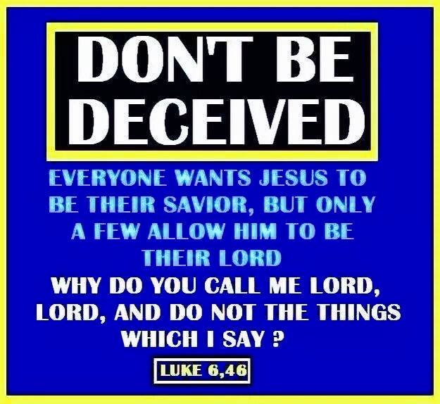
We are CALLED to eternal life. Many are called. Few actually show up to the wedding feast actually clothed in their wedding garments, without spot or wrinkle. The true bride will make herself ready. The ministry that the Lord has called me to is to prepare that bride without spot or wrinkle. My friends have jokingly referred to me as beautician to the bride. Ok then (eye roll). Jesus is worthy of such a spotless, beautiful bride who has made herself ready and dressed for the wedding is He not? I will give out what He gives me and thus He gives me more.

Making yourself ready, fighting the good fight, working out your salvation with fear and trembling, allowing Jesus to wash you and sanctify you requires active participation on your part. The house that stands in the storm is the one that is a doer of the word and not a hearer only. Those that are hearers only have it all destroyed in a storm.
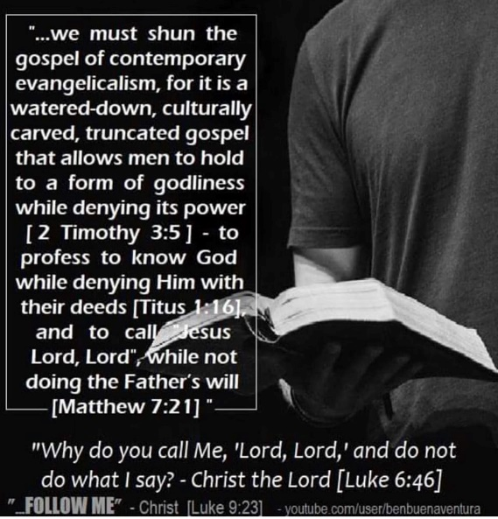
“Why do you call Me, 'Lord, Lord' and not do what I say? “Everyone who comes to Me and hears My words and ACTS ON THEM, I will show you whom he is like: he is like a man building a house, who dug deep and laid a foundation on the rock; and when a flood occurred, the torrent burst against that house and could not shake it, because it had been well built upon the biblical foundation. “But the one who has heard and HAS NOT ACTED accordingly, is like a man who built a house on the shifting sands without any foundation; and the torrent burst against it and immediately it collapsed, and the ruin of that house was great.” Luke 6:46-49
The once saved always saved profess only and you are eternally secure folks, are hearers only believing nothing more is required of them other than believe and profess to enter heaven. They believe you receive eternal life when you first believe. That isn’t in the Bible. You have to fight for it, endure until the end, contend for the one true faith, endure sound doctrine and not fall away in apostasy or sin. Once saved always saved is apostasy that causes one not to repent, fight the good fight, not be sanctified because it is not required, not abide in the vine and not follow after righteousness because they believe they already have it by just believing. They will not follow after godliness, faith, love, patience and humility (being teachable) because it is not required. Grace isn’t the license to sin but the power of God given to you not to through the baptism of the Holy Spirit. Your freedom in Christ comes from no longer being a slave to sin. If you are still a slave to sin, how saved are you? You are not living under grace or empowerment not to sin. You are still under the law until you figure out you can’t keep it in your ability and need this empowerment. That was the whole purpose of the law. Notice God’s moral law never went away. This is how it was fulfilled so don’t believe the devil appearing as an angel of light telling you that you can live as you like because you are no longer under the law but under grace. That is a demonic doctrine from Hell to damn your soul. There are none so deceived than those believing they possess something that they do not yet have or have to fight for, lay hold of, attain to and they totally disregard all scripture stating otherwise.

Any belief that negates water and Holy Spirit baptism, or being born again of water and the Holy Spirit, same thing, is from Hell. Obedience is not optional to be saved or a suggestion. It is the devil that doesn’t want you to be baptized because it equips you to enforce his defeat and empowers you not to sin. That is why we have sin so rampant in the church and most are lost the Bible says, because people think all they have to do is just believe and that is honoring Christ. Honoring Christ is showing you love Him by keeping His commandments, doing what He did and following Him. The definition of Christian is follower of Christ, not mere believing. I believe in the satan but that doesn’t make me a satanist because I am not following his ways.

Sanctification isn’t optional in order to be saved or enter into eternal life. Believing the truth isn’t optional to entering into eternal life. Pastor’s and church leaders are to equip and mature their sheep and see that they go through this process of transformation or sanctification or they won’t receive eternal life in the end and you will be held accountable.

2 Thes 2:13. Because God has chosen you to salvation THROUGH SANCTIFICATION (becoming holy without which no one shall see the Lord) of the spirit and belief OF THE TRUTH.

2 Thes. 2 is all about the condition of the apostate or fallen away from the truth of the true gospel church right before Christ comes for His bride. Right before our being gathered unto Him, if we receive the truth and teach it, the church will be so apostate or not believing and teaching what Jesus and the apostles taught, that they have fallen away in deception and they will not receive the love of the truth that they might be saved. Jesus said before He returns He will gather out of His kingdom, the apostate church, ALL who offend, and ALL workers of iniquity. Iniquity is translated you knew it was wrong and did it anyway. You have to be really deceived to think you can practice known sin and still enter into eternal life with Him. You will hear “Depart from me” instead. What has brought in this deception? Once saved always saved and eternally secure teaching that states you cannot lose your salvation once you first believe. It is a false assurance of salvation that you do not yet possess because salvation is something you work out and enter into in the end.

The Israelites believed they would be saved while still in Egypt. Were they in the promised land yet? No, of course not. Believing aligned them to follow Moses, just as our believing should align us to follow Christ. The pattern of salvation can be seen throughout the whole Bible, Old Testament included. First believe, aligns you to follow the WAY of the one you are to follow. Jesus is the WAY. He is also the truth and brings truth in your deception and tries to pull down mental strongholds of false belief with the TRUTH. To reject TRUTH is to reject Jesus whom you say you trust for your salvation. The Bible says we are saved through sanctification and belief in the truth. What you believe determines how you behave and where you spend eternity.
God then led the Israelites out of Egypt only because they first believed which aligned them to follow Moses where God then led them to the Red Sea to be water baptized and then they were led through the wilderness of life by the Holy Spirit who appeared as a pillar or fire or cloud. The Holy Spirit was to lead them to the promised land of eternal life. If they disobeyed in the wilderness they died in their sins, not making it to the promised land.
Jesus said He will gather out of His kingdom all who offend and all workers of iniquity. That doesn’t sound like eternal security to me. The word offend means scandals or giving one a cause to stumble or sin. That is what the once saved always saved teachers do; cause people to remain in their sin because they have a false assurance of salvation or already possessing eternal life which the Bible is very clear about us receiving in the end. We have to attain it, lay hold of it, obtain it, grasp it and hope for it according to the one true faith of God’s elect and the acknowledging of the truth which is after godliness or holy living. Without sanctification or becoming transformed into the image and likeness of Christ and belief in the truth, there is no salvation or entering into eternal life. If indeed you teach a false gospel that causes others to stumble or remain in their sin, you will be gathered out of His kingdom. The sons of perdition will then be revealed. The word son means child of God and perdition means going into destruction or eternal damnation. All this said in the context of an apostate church right before the Lord gathers His church unto Him and those not receiving the love of the truth that they might be saved and thus going into perdition. Judas was called a son of perdition and he is not the only one. I pray all will receive the love of the truth that they might be saved.

Whereby He called you by our gospel TO THE OBTAINING of the glory of our Lord Jesus Christ. There is there phrase again. ATTAINING, OBTAINING, LAYING HOLD OF, APPREHENDING, all indicating you do not yet possess it. Look up those words in the Bible and see what it is referencing. That will blow your false beliefs about when you receive eternal life out of the water. Don’t confuse being born again, which is going from death to life, with receiving eternal life. Many don’t see it when they read because a veil of darkness is over their minds. Truth pulls down that stronghold. Many are called. Few actually choose the narrow path that leads to eternal life. We do not yet possess eternal life, but have to both be called and choose to lay hold of it, attain it, seize it or take it by walking down the narrow path of salvation through sanctification and belief in the truth. You must worship God in spirit and in truth. If you don’t love the truth or reject it when Jesus is faithful to give it in your deception, it is Jesus you are rejecting. Many say they trust their salvation wholeheartedly on Jesus yet reject Him when He brings truth in their deception. Jesus can’t be savior if He isn’t Lord. Why do you call Him Lord, Lord and do not do what He says. Obedience from your heart, not works salvation but submission as an act of your will in allowing Him to wash and sanctify you and belief in the truth, is required in order to be saved. Grace isn’t the license to sin but the power of God given to you not to through the baptism of the Holy Spirit. This was not available before Pentecost. Your freedom in Christ comes from no longer being a slave to sin. If you are still a slave to sin, how saved are you? Whom the Son has set free from sin, they are free indeed. The bible says God gave us this power to become His sons. Does that mean we don’t become sons or daughters when we first believe? We have to walk in this empowerment. If sons then heirs and joint heirs with Jesus Christ. Many falsely think they have an inheritance too, that they do not possess because they do not utilize the empowerment given through the baptism in the Holy Spirit. That is why the Bible commands us to put those people away from us that have a form of godliness but deny this empowerment. From such we are to turn away. They may not outright say it but they will deny it by saying you have all the Holy Spirit you will ever need when you first believe or by their deeds or behavior. Jesus was both baptized in water and the Holy Spirit in obedience to the Father before being led into the wilderness to be tempted by the devil. If He needed this empowerment why do we think we are better or not in need of it? Only those that do the will of the Father enter the kingdom of heaven. You must be born again of water and the Holy Spirit. Repent and be baptized everyone of you is still the answer to what must we do to be saved (future tense). You need this empowerment to endure until the end and fight the good fight of faith and lay hold on eternal life. None of the gifts of the spirit or the miraculous occurred in Jesus’ life until He was baptized in the Holy Spirit. Your obedience should not stop at believe and confess and should extend on to repent and be baptized EVERYONE OF YOU and die to sin and self IN ORDER THAT you be raised as Christ was raised. Jesus gives the baptism of the Holy Spirit to those who will obey Him. If you are having a problem being baptized in the Holy Spirit this might be why. You might love pleasure and sin more or have idols in your life that you love and pursue more. All demons in your life have to be given permission or you have to invite them in. They come to kill, steal and destroy. Jesus came to give life and give it abundantly. Jesus said His people perish for a lack of knowledge. It isn’t that He is unfaithful in giving it. Some will just not receive love of the truth that they might be saved. If you have not made right to those you sinned against as fruit that you have repented or if you still lie about what you have done in the past instead of confessing it, you have not truly repented. John the Baptist commanded them to show fruit that they actually repented in order to receive the kingdom of heaven so they wouldn’t deceive themselves. They came openly confessing their sins and DEMANDING what must they do to prove they repented. He told them. If you still lie or cover your sins past or present, you have not repented in order to be saved and are not one willing to obey in order to receive the baptism the Holy Spirit. I pray you receive the truth, fight the good fight and lay hold on eternal life whereunto you are called.

"A man may hate sin just as a murderer hates the gallows, but this doesn't prove repentance. If I hate sin because of the punishment, I have not repented from sin. Only when you can see sin as an offense against Jesus Christ, and loathe myself because I wounded Him, then I have a true brokenness of heart!!" -Charles Spurgeon



Are There Conditions That Need To Be Met To Enter Into Eternal Life?

Yep! These are called the “IF” passages of scripture in the New Testament. They are there so let’s explore so you are not deceived and to make sure we meet the conditions that evidently the church is not teaching people about.

“IF” SCRIPTURES THAT INDICATE GOD’S PROMISES ARE CODITIONAL

Have you ever done a search on the word “if” in the bible and the biblical meaning of it? That right there should pull down any stronghold of when eternal life is received. Let’s examine.

The word “if” appears 1,670 times in the King James Version of the bible. Jesus used the word ‘if’ all the time. Almost half of the 574 occurrences in the New Testament are in the four Gospels. Jesus always put the ‘if’ on man’s side giving man the responsibility and never on God’s side. It was a condition that man must meet. The word ‘if’ is interesting. It is one of the most important words in the Bible because it speaks directly to our responsibility to God. Most promises in the Bible have conditions and the word ‘if’ speaks to those conditions. Our responses to God’s commands affect our relationship with Him and determines our receiving from Him.

The word 'if' is important when you are studying the Bible. It calls for your attention because this word is most often an indication that something significant is coming up or has happened. So when you come across this word, concentrate more and focus on what follows the text you are reading.

The Hebrew word translated “if” literally means “as a consequence of” or “because”. It means the benefits of the relationship would come as a consequence of their obedience to His commandments. The Greek word translated “if” is “ei” and is conditional because the passage speaks of requirements for salvation. “If we die with Him we will also live with Him”. Death to sin and self are requirements for salvation which do not happen when we first believe by the way. It is a process you submit to or choice you make in working out your salvation. There is another Greek word translated “if” in the New Testament. There the word translated “if” is “eige”. It’s a different word and means “inasmuch as” or “since”. So in Col. 1:22-23 Paul was saying that God has reconciled Himself to us through the death of His Son since our faith is established and firm. This states that the requirement has already occurred. There always is a requirement attached to the word “if” that either must be met or has already been met in order for the promise to be in effect. “If” is a call to action. It tells me that my actions matter and that they have consequences. “If” means that the future is not set. I can change things. To search the scriptures to see if you will inherit eternal life, search out the "if" scriptures to see if you meet the requirements. Don't be deceived. Too many people are believing they are "saved" and eternally secure and their requirements for eternal life have not been met. Search the scriptures because in them YOU THINK you have eternal life. You better make sure biblically. Paul did not teach or believe that eternal life happened at the time you first believe. He taught that it happens at the end of your life if you meet the conditions and don’t fall away into deception or sin.

“IF YOU CONTINUE” SCRIPTURES INDICATING ETERNAL LIFE IS NOT RECEIVED WHEN YOU FIRST BELIEVE AND THAT BECOMING APOSTATE OR FALLING AWAY FROM THE TRUTH DISQUALIFIES YOU FOR SALVATION.

The “IF YOU CONTINUE” scripture is all the way through the New Testament. Now I make known to you, brethren, the gospel which I preached to you, which also you received, in which also you stand, by which also you are (a verb being) saved IF YOU hold fast the word which I preached to you unless YOU BELIEVE IN VAIN. 1Cor.15:1-2 Holding fast the word after believing is a requirement for salvation after you have received it, and it causes you to stand because of it until the end. Otherwise, you have believed in vain. Most have not even heard the true gospel because it isn’t even being preached today, nor does the one preached today cause one to stand and be sanctified as well.

He has now reconciled you in His fleshly body through death, in order to present you before Him holy and blameless and beyond reproach—IF INDEED YOU CONTINUE IN THE ONLY TRUE FAITH. FIRMLY ESTABLISHED and STEADFAST, and NOT MOVED AWAY FROM THE HOPE OF THE GOSPEL that you have heard, which was proclaimed in all creation under heaven, and of which I, Paul, was made a minister.
For if God did not spare the natural branches, He will not spare you (Christians), either. Behold then the kindness and severity of God; to those who fell, severity, but to you (Christians), God’s kindness, IF YOU CONTINUE in His kindness; otherwise you also will be CUT OFF (in the same way Israel was cut off). Rom.11:21-22 What if you don't?
Receiving the kindness of God instead of His severity is contingent upon continuing in the one true faith not the false gospel being preached today full of damnable heresies.

IT IS ONLY THOSE WHO ENDURE TO THE END THAT WILL BE SAVED. This indicates that salvation or eternal life is not received when you first believe. Mat.10:22 Many have gone through the narrow door which is the body of Christ, but only a FEW are going down the narrow road that ENDS IN ETERNAL LIFE. Mat.7:13-14 Because of the false doctrine that is ramped in America, MANY HAVE BELIEVED IN VAIN (of no saving value). 1Cor.15:1-2, 1Ths.3:5, 2Cor.6:1 It is a matter of continuing, abiding or remaining to the end. The word, “IF” is usually ignored with some pretty bad eternal consequences for ignoring it and not meeting its requirements. Col.1:21-23, Rom.11:19-22, Jn.15:1-10, Jn.8:31-32
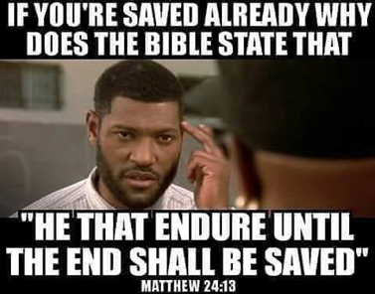

Colossians 1:23 IF YE CONTINUE in the faith grounded and settled, and be not moved away from the hope of the gospel, which ye have heard, and which was preached to every creature which is under heaven; whereof I Paul am made minister. The promise given, if you continue, here is you will be presented holy, unblameable and unreprovable in His sight. Notice also that falling away or becoming apostate or believing damnable heresies is cause for not receiving this promise.

Read all of John 15:1-10 John 15:6 says IF a man abide not in me, he is cast forth as a branch, and is withered and men cast them into the fire and they are burned. Abiding is Jesus is a requirement for not be cast forth into the fire.

John 15:7 IF ye abide in me and my words abide in you, ye shall ask what ye will, and it shall be done unto you. Abiding in Jesus and having His word abide in you is a requirement for answered prayer.

John 15:10 IF ye keep my commandments, ye shall abide in my love, even as I have kept my Father’s commandments, and abide in His love. Keeping Jesus’ commandments is a requirement for abiding in His love and the Father’s. Jude 1:21 KEEP YOURSELVES in the love (agape) of God, looking for the mercy of our Lord Jesus Christ unto (or until or leading to) eternal life. If you are looking unto eternal life, you have not yet received it.

John 15:14 Ye are my friends IF ye do whatsoever I command you. Obedience is a requirement to being a friend of God. Don’t sing “I am a friend of God” if you are not obedient. It doesn’t apply to you.
John 8:31-32 IF ye continue in my word, then ye are my disciples indeed; and ye shall know the truth and the truth shall make you free (saved). Freedom from sin is the context and no longer being a slave to it is a requirement for being a disciples, translated Christian or follower of Christ and being saved in the end IF you continue in the only true faith.

In the New Testament, Jesus spoke about half of the IF’s in it. The IF scriptures in the New Testament alone are too many to list but I trust you get the picture in that you have a responsibility in responding to the gospel, continuing in the one true faith, abiding in the vine, being established and steadfast and not being moved away from the truth as you work out your salvation with fear and trembling. He has equipped you to do so through the baptism of the Holy Spirit. Your freedom in Christ comes from no longer being a slave to sin because you have been empowered not to sin. That is what makes you “In Him” or “In Christ Jesus” where there is no condemnation. Not saying a prayer, which is nowhere in the bible as a form of becoming born again of water and of the Holy Spirit. No wonder the church is so carnal and hell bound and Jesus is trying to get her to make herself ready. He is coming soon.

2 Peter 1 Grace and peace be multiplied unto you through the knowledge of God, and of Jesus our Lord (that we submit to). More grace and peace is multiplied with more knowledge that you act upon. According as His divine power hath given us all things that pertain unto life and godliness through the knowledge of him that hath called us to glory and virtue, so that we might be partakers of the divine nature, having escaped the corruption that is in the world through lust. Simply put, grace is not a license to sin, but it is the empowerment not to sin through the baptism of the Holy Spirit. Your freedom in Christ comes from no longer being a slave to sin. He has provided you with this empowerment or grace to live godly through knowledge of Him who has called us to glory and virtue to escape the corruption of the world through lust. He that lacks these things is blind and cannot see afar off, and hath forgotten that he was purged from his old sins. Is that you? Are you blind also?
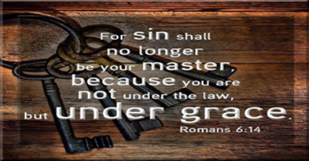

I have recently been listening to testimony after testimony of people’s accounts of hell after they passed away and were later revived. They all described unfathomable torture, pain and suffering and the screams and wailing of those there. They consistently stated Christians were there who were deceived and believed the once saved always saved heresy. The unrepentant Christians were there. The nominal or lukewarm Christians were there. The bitter unforgiving Christians were there. They don’t feel bitter. They feel justified. Those who believed Jesus did it all on the cross and nothing was required of them so they went on enjoying their life because Jesus would want them happy Christians were there. A whole lot of deceived Christians were there as well those false teachers and those who perverted the word of God for gain.

We need to preach against sin and hell. It is not unloving to do so. To warn your child to stop playing in the street because you see that semi truck barreling down the road toward them is not unloving. In fact it is an act of love to do so. If you won’t because you don’t want to offend them or “judge” them as the devil likes to say, or you don’t want them to “judge” or roll their eyes at you, you are selfishly putting yourselves first. Self needs to die.

The Bible says to save some with fear. That is the only way some come to the Lord. The Bible says to behold BOTH the kindness and severity of God. You don’t appreciate His kindness until you realize His severity. To just preach love is unbalanced and in a ditch. To just preach severity is also error and on the other side of the ditch. Preach both the kindness and severity as the Bible commands us. Just because you grew up under severity only doesn’t mean you jump into the other side of the ditch and vice versa.

If true Christians have a real grasp on Hell, you wouldn’t want your worst enemy to go there and you wouldn’t be lukewarm in your evangelism. You would be on fire. You would burn with the desire to keep yourself out of hell and work out your salvation with fear and trembling as well as keeping others from going there. I doubt most Christians today even believe in Hell. The devil doesn’t want hell preached and the confrontation of sin because it is effective or he wouldn’t work so hard at silencing it. Jesus died to keep us from going there. Jesus preached on Hell more than anyone. If we are followers of Jesus (definition of Christian) we will do as He did. To do so honors His blood sacrifice. Preaching on sin and hell needs to return. It keeps sinners out of there and ignites a fire in a lukewarm church to reach the lost and deceived. You pull down the mental strongholds of deception with the truth. I will preach the truth with fire and passion as well as preach both the kindness and severity of God as commanded. Obedience is not optional if you are to enter into eternal life. Jesus must be Lord in order to be savior. The word Lord appears more than 400 times in the New Testament as opposed to Savior which appears 15 times. We have a modern day gospel that presents Jesus as savior while excluding His Lordship or kingly rule over you. His lordship is not optional in order to be saved. Our churches are full of people calling themselves Christians and believing they are eternally secure who do not submit to the Lordship of Jesus. They are deceived because of the modern day gospel that requires nothing of them.

A man on a FB group told me to only preach on the love of God, which is what brought Him to Christ. The bible says to save SOME with fear, hating even their garments that are spotted by the flesh. I asked him, “Who is going to preach to the “SOME”? I will do what the bible tells me to do and that is to save SOME with fear. I will preach and behold BOTH THE KINDNESS AND SEVERITY OF GOD.

Stumbling Blocks In The Pulpit, TV, Radio and Pew
By Robert Weller
OFFENSES HAVE COME

The Son of man shall send forth his angels (messengers), and they shall gather out of his kingdom all things that offend, and them which do iniquity (lawless); And shall cast them into a furnace of fire: there shall be wailing and gnashing of teeth. Then shall the righteous shine forth as the sun in the kingdom of their Father. Who hath ears to hear, let him hear. Mat.13:41-43

Then said he unto the disciples, It is impossible (inevitable) but that offenses will come: but woe unto him, through whom they come! It were better for him that a millstone was hanged about his neck, and he was cast into the sea than that he should offend one of these little ones. Luke 17:1-2

The KJV frequently uses the word “OFFENSES”. It is from a Greek word that means “stumbling block”. It carries the idea of throwing something in front of a person to cause them to fall. In simple terms, it is describing a person that causes others to sin. The most obvious cause of sin is heresies that teach that a person can continue in known sin and still be saved. They may not come right out and say you can continue in known sin and still be saved, but the fruit of their false doctrine certainly implies it, like the once saved always saved damnable heresy.

A less obvious cause of sin would be things like immodest dress, especially with women. When I go to visit a church, I can tell how carnal it is by how the women dress. I have only heard one pastor address this in his church and that was in San Antonio, TX. The devil sends in these stumbling block women dressed to entice. The men have trouble hearing what is preached as they gawk and the wives and children are wounded at dad’s gawking and the fighting begins on the way home and eventually they stop going to church because of these stumbling blocks the devil sends in to destroy. Personally I think pastors should have greeters handing women who are dressed provocatively, a wrap or robe to cover themselves and tell them next week they need to meet the dress code boundary they have established for church attendance if they wish to attend. We have dress codes for work or other places. Trust me, I have seen families stop going to church because of this and when I visited churches with female friends, the first thing they would mention as they turned back for the door is that they would not even go to the service because of how the women dressed, which is an indication that the truth is not being preached and sanctification is not taking place. Women dressed provocatively cause men to stumble, which hurts the family. Pastors protect your flock.

Many denominations are teaching their congregations to love the world and the things of the world. They teach them to give in order to get while they covet and are out for self, not dead to self. The gospel of me and what I can get is the modern day gospel. Others have turned the grace of God into a license to sin. Still others teach that you are saved if you believe in the death, burial and resurrection of Jesus, (which the devil also believes) and obedience is only for rewards. It is the last hour. Come Lord Jesus.
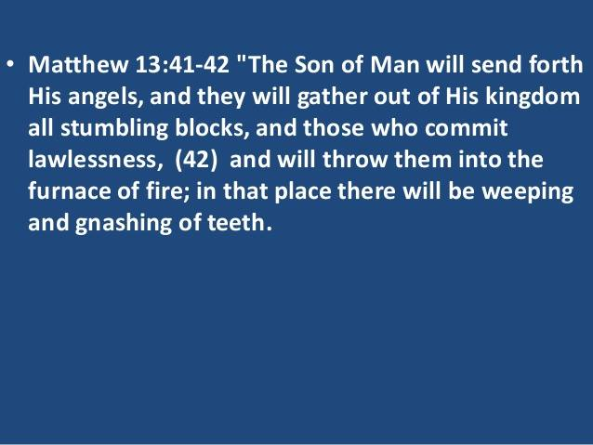
The false teachers of today, in their unbiblical world, Jesus’ blood just covers up your sin just as the Old Testament blood of lambs did instead of delivering you from sin and its power over you. This is not biblical and it was taught by people misquoting the bible out of context, not knowing the definition of words, making up a doctrine based on half a sentence because of cherry picking only what they like that confirms their bias, or just not getting the whole point the Lord was trying to make or not knowing who the Lord was talking to and why. They are blind to the truth. These teachers and preachers are stumbling blocks to people that the Lord wants to bring into the saving knowledge of the truth. We are ever learning but never able to come into the knowledge of the truth.

THE CHAPTER SIX ROMANS ROAD TO SALVATION

What shall we say then? Are we to continue in sin so that grace may increase? MAY IT NEVER BE!!!! How shall we who DIED TO SIN STILL LIVE IN IT? Verse 1-2

Knowing this, that our old self was crucified with Him, IN ORDER that our body of sin might be done away with, SO THAT WE (Christians) WOULD NO LONGER BE SLAVES TO SIN; for he who has died is FREED FROM SIN. Verse 6-7

Therefore do not let sin reign in your mortal body so that you obey its lusts (same word for coveting in 7:8). Verse 12

For sin shall not be MASTER OVER YOU, for you are not under law but under grace (empowerment not to sin).

What then? Shall we sin because we are not under law but under grace? MAY IT NEVER BE !!!!! Verse 14-15

But thanks be to God that though you WERE SLAVES TO SIN, you became OBEDIENT from the HEART to that form of teaching to which you were committed, and having been freed from sin, you became SLAVES OF RIGHTEOUSNESS. Verse 17-18

But now having been FREED FROM SIN and ENSLAVED TO GOD, you derive your benefit, resulting in sanctification, and the outcome (of sanctification), eternal life. Verse 22

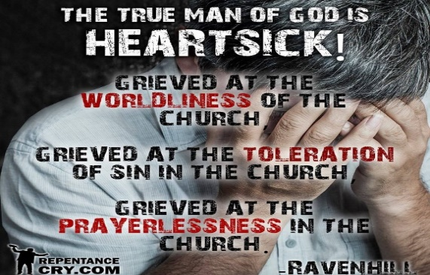

Foundational Teachings of the Church

- Repentance from Dead Works to obtain blessing or favor from God that Jesus purchased with His blood. Example: Jesus’ blood plus your money delivers you from the curse of the law. Malachi is often misquoted to do so, calling the people God robbers if they don’t tithe when in fact it was the priests God was calling God robbers, not the people, because the priests were the ones not tithing and bringing food into the storehouse to feed the poor. Today the church leaders call the poor, fatherless, stranger in the land and widows, God robbers when they are the ones who are to be partaking of the priest’s tithe in the storehouse that would provide for them. Church leaders manipulate the word of God because they lack faith in God’s provision to provide for them. Any form of manipulation or control comes from a spirit of witchcraft. They lack the faith for provision that they insist you have. It is the church that is to be providing for the poor and God says He changes not in this regard. These scriptures pulled out of Malachi to manipulate people aren’t read in context asking who was God talking to and why. The whole book of Malachi is being spoken to the men regarding domestic abuse and the priests, not the people. God changes not in that the pastors or priests are to tithe or provide for the poor in our churches or they will be the ones cursed, not the people. The Lord said if you give to the poor, you give to God. Obviously if you do not give to the poor, you rob God. That is why the Lord called the priest, not the people, God robbers. The tithe was food and it was to be brought into the storehouse to feed the poor. If your church is not providing for the poor, you are under God’s curse, as God changes not in this.
- Faith Toward God. Refer to #1. Lack of faith in God’s provision for whatever it is you need in your journey through the wilderness leads to manipulation and getting in the flesh to bring about the promise. Abraham did this when he produced a child through Hagar. Need strength? He provides it. Need healing? He provides it. Need emotional healing? He provides it. The definition of grace is “I will provide that which is needed” or empowerment to get you from when you first believed to your entering into eternal life at the end Romans 6:22. It is an ongoing journey of walking with the Lord in intimacy through the wilderness of life experientially as His grace that saves, provides for your needs through the wilderness of life so as to bring you to the promised land or eternal life.

- The Doctrine of Baptisms (plural) of both water and Holy Spirit in that pattern. Water for the remission or sending away of past sins, slamming the door shut on what used to enslave you, baptizing you into the body of Christ, which I do to people right away. We shouldn’t wait and give the devil ground. I am not above baptizing coworkers in the back of a dump truck filled with rain water after they first believed when I worked for a land grading company. I am not lukewarm and they have it fully explained to them and know what they are committing to in being dead to sin and alive to righteousness IN ORDER THAT THEY BE RAISED AS CHRIST WAS RAISED. Being raised as Christ was raised has to have certain conditions of death to sin and self met. Have you ever seen demons manifest when the person is about to be water baptized? They have to leave. It is quite the sight. After water baptism and committing their life to be dead to sin and self and their old sins are remitted, they are now clean in order to be baptized or filled with the Holy Spirit that empowers them to keep that commitment.
- The Doctrine of the Laying On Of Hands. This is done to impart blessings, healing, impartation of the Holy Spirit and His gifts as well as anointing.
- Resurrection of the Dead either to eternal life or eternal destruction where we are all judged for what we have done in the body whether good or bad. Christians included. This is not just for rewards. The scripture says whether good or bad.
- Eternal Judgement and this is said to believers and the church, not unbelievers. There is an eternal judgment for believers or the church because God DOES JUDGE HIS PEOPLE, no matter what heretics say. Behold both the kindness and severity of God. Both are His attributes and to ignore one over the other results in being on one side of the ditch or the other in error.

As I said, if the foundation on which we are established is faulty or missing something, the whole thing built upon it collapses and people fall away. Therefore, demonic doctrines will be deluding people on these foundational truths.

Let me explain it another way. A rich man gives you a check for a trillion dollars. One guys believes the rich man is good for the funds and does nothing with the check and thus it does him no good. He believes and has faith, but it isn’t the saving kind of faith. The second guy who receives the check believes the rich man is good for the funds and he endorses the check which is water baptism and then goes and deposits the check into his bank account which is being baptized in the Holy Spirit so that the funds can be transferred from the rich man’s account into his and he can have immediate access to them in time of need. This person’s faith produces action or works. Because he believes, he acts upon it. This is the saving kind of faith. Endorsing the check through water baptism and depositing the check through baptism in the Holy Spirit doesn’t make the funds any less free or is any more works than confessing. The believe and confess only people think anything beyond that is works salvation and makes the funds earned. They miss the whole point. You can’t earn what Jesus freely gives. Endorsing the check and depositing it in our bank account doesn’t make the gift any less free. The Holy Spirit is called the gift. Jesus said, “You will receive the gift of the Holy Spirit”. That implies that it is not earned, but must be received by acting upon what Jesus commanded in faith. Their faith resulted in receiving the gift through water and Holy Spirit baptism.
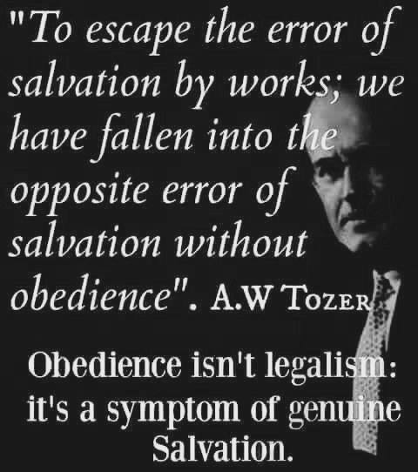
YOUR FOUNDATION DOES MATTER

TO BE CLEAR, ASKING JESUS INTO YOUR HEART, SAYING THE SINNER’S PRAYER OR ANYTHING OTHER THAN REPENT AND BE BAPTIZED EVERY ONE OF YOU IS NOT HOW TO BE BIBLICALLY BORN AGAIN OF WATER AND THE HOLY SPIRIT.


A false Jesus is being preached today which is why Jesus says, I never knew you. You can’t blame others for what you choose to believe. The bible states that if anyone preaches a different gospel and another Jesus, let them be accursed. Search the scriptures because in them you THINK you have eternal life. Make sure the Jesus you claim to know is the one in the bible and not one created by cherry picking verses out of the bible that pat your flesh and tickle your ears, and confirm your bias while excluding others. Read it in context as well asking yourself who God was talking to and what was His point. He has one!


THE APOSTASY HAS ALREADY COME
By Robert Weller

Now we request you, brethren, with regard to the coming of our Lord Jesus Christ and OUR GATHERING TOGETHER WITH HIM, that you not be disturbed either by a spirit or a message (false teacher) or a letter (new manuscript) as if from us, to the effect that the day of the Lord has come. LET NO ONE IN ANY WAY DECEIVE YOU, for it (our gathering together unto Him) will not come unless the apostasy (falling away from the only true faith) comes FIRST, FIRST, and the man of lawlessness is revealed, the son of perdition.

Most churches in America are totally dead and they do not even know it. Rev.3:1-2 We now have the Emerging Church heresy; The prosperity gospel heresy; The new age eastern mysticism heresy, and the OSAS heresy. They are unable to endure sound doctrine. 2Tim.4:3-4, 1Tim.6:3-4 They did not love the truth so as to be saved. 2Thes,2:11-12

For it is time for judgment to begin with the household of God; and if it begins with us (Peter included) first, what will be the outcome for those WHO DO NOT OBEY, THE GOSPEL of God? And if it is with DIFFICULTY that the RIGHTEOUS ARE SAVED, what will become of the godless man and the SINNER? 1Pt.4:17-18
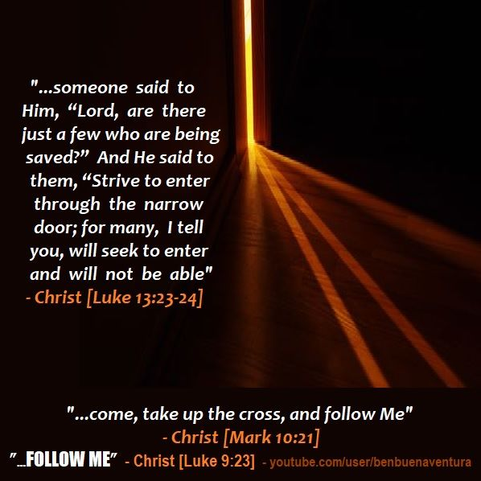
Heretics have destroyed many with their demonic lies and they will be held more accountable and the blood of those in hell, once the false teacher is confronted with the truth, will be on their hands. Jesus is faithful to bring truth in your deception. Let’s stop telling people they are saved when they first believe. It is a lie and not biblical. Let’s stop telling them they are eternally secure too. That is also lie. Once you are told by the Lord, you are now accountable.


We are saved by empowerment (grace) through (because of) faith in the truth whose name is Jesus. Thy word is truth. Jesus is the living word.

Keep yourselves in the love of God!
How? By Keeping His Word! By contending for the one true faith!

Jude, the servant of Jesus Christ, and brother of James, to them that are sanctified by God the Father, and preserved in Jesus Christ, and called:

2 Mercy unto you, and peace, and love, be multiplied.

3 Beloved, when I gave all diligence to write unto you of the common salvation, it was needful for me to write unto you, and exhort you that ye should earnestly contend for the faith which was once delivered unto the saints.

4 For there are certain men crept in unawares, who were before of old ordained to this condemnation, ungodly men, turning the grace of our God into lasciviousness, and denying the only Lord God, and our Lord Jesus Christ (because they would not receive the love of the truth, Jesus, that they might be saved).

5 I will therefore put you in remembrance, though ye once knew this, how that the Lord, having saved the people out of the land of Egypt, afterward destroyed them that believed not. (remember this is a verb meaning ongoing belief).

6 And the angels which kept not their first estate, but left their own habitation, he hath reserved in everlasting chains under darkness unto the judgment of the great day.

7 Even as Sodom and Gomorrha, and the cities about them in like manner, giving themselves over to fornication, and going after strange flesh, are set forth for an example, suffering the vengeance of eternal fire.

17 But, beloved, remember ye the words which were spoken before of the apostles of our Lord Jesus Christ;

18 How that they told you there should be mockers in the last time, who should walk after their own ungodly lusts.

19 These be they who separate themselves, sensual, having not the Spirit.

20 But ye, beloved, building up yourselves on your most holy faith, praying in the Holy Ghost,

21 Keep yourselves in the love of God, looking for the mercy of our Lord Jesus Christ unto eternal life. If you are looking for mercy unto eternal life, that means you don’t yet have it.

22 And of some have compassion, making a difference:

23 And others save with fear, pulling them out of the fire; hating even the garment spotted by the flesh.

24 Now unto him that is able to keep you from falling, and to present you faultless before the presence of his glory with exceeding joy,

25 To the only wise God our Savior, be glory and majesty, dominion and power, both now and ever. Amen

The Israelites first believed while still in Egypt, yet they were not yet free or “saved” until they followed after Moses through the Red Sea where they were water baptized, and then led through the wilderness of life by the Holy Spirit who appeared as a cloud or pillar of fire to guide the way to the promised land. Many died in the wilderness and never made it to the promised land as an example to us. They were “saved” when they entered the promised land, which is symbolic of heaven or eternal life. To make it there, they had to be obedient and be led by the Holy Spirit through the wilderness of life while following Moses. The pattern of salvation is the same in the new covenant only we follow Jesus as our example, doing what He did in carrying out the will of the Father and obeying Him, keeping His words and being a doer of them while abiding in the vine. When we stop abiding, the Father who is the vine dresser, cuts off the withered branch and throws it in the fire. You can fall away from the faith. If you do not yet have salvation because it has not yet been attained, obtained or seized, you cannot lose what you do not yet possess. So it is not about losing your salvation that you are still working out, but about falling away from the faith through deception in another gospel or sin. The old covenant was to show we couldn’t keep it in our ability and needed the empowerment to do so through the baptism of the Holy Spirit. Your freedom in Christ comes from no longer being a slave to sin. Whom the son has set free he is free indeed. The Bible says in end times lawlessness, or those not adhering to God’s moral law, will abound. Why? Because people believe they are no longer under the law and no longer have to be obedient and their freedom in Christ allows them to do as they like because all their sins, past, present and future are forgiven. Why then do we need to confess and He is faithful and just when we confess to forgive us, after believing. Even in the church you hear the false teachers preach we are not under the law but grace. If you are still practicing a lifestyle of sin and are a slave to sin, you are still under the law because the Bible says the law is for sinners to show you your lawlessness and show you that you need grace or this empowerment not to sin so you will walk in grace or empowerment so you won’t be under the law. If you are under grace or empowerment not to sin you have ceased from a lifestyle of sin. You are no longer a slave to sin but a slave to righteousness if you are no longer under the law but under grace. We have a whole lot of lawless people in the church believing they are under grace and the blood of Christ as their form of grace is license to sin, instead of the empowerment not to sin because of false teachers appearing as an angel of light bringing in damnable heresies or lies that will damn you if you believe them and this was said to believers. Once saved always saved is the biggest damnable heresy out there and not supported by the Bible. Sorry. I could list pages worth of scripture to refute it but most of those who teach it and believe it will not receive the love of the truth that they might be saved and this is said in the context of the apostate church right before the rapture of the church. Don’t follow these false grace teachers. Any doctrine of grace that has you remaining comfortable in your sin when Jesus died to deliver you from it, is a false grace heresy.

The New Testament is full of scriptures on obtaining, seizing, attaining, grasping eternal life and how you do so that these blind apostate teachers REFUSE to acknowledge. Here is another.

1 Timothy 6:17-19. Charge them that are rich in this world, that they be not high minded, nor trust in uncertain riches, but in the living God, who give them us richly all things to enjoy; that they do good works, ready to distribute, willing to communicate, translated share or let others partake of your blessings, laying up in store for themselves a good foundation against the time to come, that they may LAY HOLD OF ETERNAL LIFE. Obviously they do not yet possess eternal life as this is spoken to believers who are water and Holy Spirit baptized in the church that Timothy is pastoring.

Obviously the church is clueless in its current apostate condition before Christ comes for His bride who made herself ready.

Those who do not receive the love of the truth that they might be saved will perish, for God will give them what they want which is strong delusion that they would believe the lie that they might be damned who believe not the truth but had pleasure in unrighteousness, believing they are eternally secure. 2 Thes. 2:10-12 all in the context of the apostate church or the church who has fallen away from the faith or the one true gospel.

But we will give thanks always to God for those, brethren beloved of the Lord, because God hath from the beginning chosen you TO SALVATION THROUGH SANCTIFICATION of the Spirit and BELIEF OF THE TRUTH.
Notice salvation is obtained, attained, seized, grasped or laid hold of through sanctification or being transformed by the Holy Spirit and belief in the truth over a lie. What you believe matters as well as how you live matters after first believing. Why would anyone want to stop obeying the Lord at believe and confess and refuse to be water and Holy Spirit baptized in disobedience? I have taught on this before in other newsletters. You must be born again of water and of the Holy Spirit. Water baptism baptizes you into the body of Christ, remits or sends away your past sins after you have repented and you are now clean to receive the baptism of the Holy Spirit who empowers you to walk in that repentant state of dead to sin and self and alive unto righteousness that water baptism is symbolic of. Being immersed in the water symbolizes the grave. Coming up out of the water is symbolic of being raised as Christ was raised because we are dead to sin and self and utilizing that empowerment not to sin as we walk through our wilderness of life until we enter into eternal life in the end Romans 6:22 because we have attained eternal life. It isn’t works salvation but submitting to Jesus as Lord in order for Him to be savior because you are utilizing and submitting to the free gift of empowerment or grace He has given that frees you from your slavery to sin. Saved through sanctification and belief in the truth.

A quote from the book “The Real Salvation” by Bert Farias: The great tragedy and deception is that many think they can be Christians while rejecting every major doctrine and practice of the true Christian faith.

I would recommend this book I am just starting. Many of those teachers on Christian TV even reject many parts of the word of God and cherry pick what they want to believe and teach because it tickles their own ears. Eternal judgment is a foundational doctrine of the church for believers as is water and Holy Spirit baptism, yet many deny it as part of the born again experience necessary for salvation and the equipping to live Godly in Christ Jesus without which no one shall see the Lord. Jesus said you must be born again of water and the Holy Spirit. Without the new birth there is no salvation. Jesus commanded it and practiced it and we are to follow Him. Ear ticklers just want the believe only gospel that requires nothing from them. In fact the word believe implies obedience. It doesn’t mean to just acknowledge Jesus’ existence and what He did on the cross. The word believe is a verb and not a noun so it is not a one time act of believing but an ongoing lifetime of believing that leads to obedience because you have a new nature. No wonder the church is so powerless, lukewarm and blind. They negate water baptism and baptism in the Holy Spirit as well as eternal judgment. If the devil is going to do away with any truth, it will be the foundational truths that equips you to enforce his defeat that the blood of Christ freely purchased for you to live Holy, without which no one shall see the Lord. If any doctrine or argument leads you to disregard in disobedience what Jesus and the apostles did and commanded us to do, it is originating from a demonic force. Which means it must be a pretty powerful tool against the devil.

We are a church that is ever learning but never able to come to the knowledge of the truth. Thus sin runs rampant, ears are tickled and flesh is patted in our modern day gospel that promotes disobedience through its “believe only” no obedience required false grace gospel of the end times where lawlessness abounds.

2 Thes. 2:13 states we are saved through sanctification of the Spirit (Holy Spirit) and belief in the truth. Sanctification is required to be saved. That means to be transformed into the image and likeness of Jesus. You can’t do that without the baptism of the Holy Spirit after water baptism. Born again of water and the Holy Spirit. You either believe the whole gospel or Bible, which is truth, or none of it. You can’t cherry pick what scriptures you want to believe and apply and what you don’t. You either follow Jesus doing what He did and He commanded us to do, which is the definition of Christian or you don’t. Just believing in Jesus and what He did on the cross doesn’t make you a Christian. Even Satan believes.

Many bring up Abraham whose faith was counted unto him as righteousness. If you believe something you act upon it. Your lack of action proves you don’t really believe in your heart. Abraham still had to get up and move when God told him to with promises of a new land. He still had to have relations with Sara when God told him the child of promise would come through her. He still had to lay Isaac on the altar believing God would raise him from the dead because God promised him descendants through Isaac. If you truly believe, you obey and that is the saving kind of faith that produces works that is counted as righteousness. Abraham would have had nothing if he sat at home and never moved after God spoke to him. Many so called Christians today are the equivalent of Abraham who was called but never got up off his kiester to act upon what God had said because truth be told, they really don’t believe in their heart or they would. Imagine if Abraham said “just believe and it shall happen”. Be a doer of the word and not a hearer only deceiving your own selves. Only those who are doers of the word have their house stand when the storms of life come because it was built on the good foundational doctrines of the church. One of which is baptisms which is plural.

Faith without works is dead. It isn’t the saving kind of faith so get off the “just believe” no obedience required false ear tickling, flesh patting modern day gospel that has produced nothing but lukewarmness, apostasy, lawlessness or without the law, selfishness and iniquity as well as a powerless church getting pummeled by the devil. It breaks my heart to see this. Get equipped and get moving. Believe all of what the Bible says, not just the cherry picked scriptures the modern day preachers feed you.

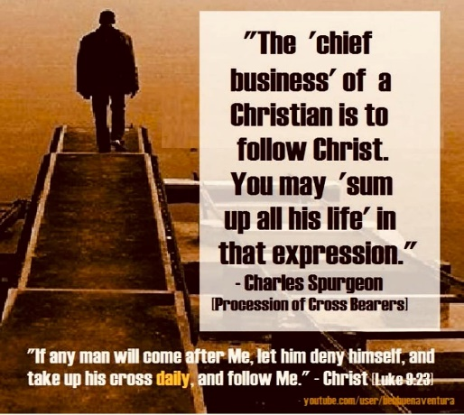
So when are you saved? “Take heed unto thyself, and unto the doctrine; continue in them: for in doing this thou shalt both save thyself, and them that hear thee.”
1 Timothy‬ 4:16‬ KJV‬‬‬‬‬‬‬‬‬‬‬‬‬‬‬‬‬‬‬‬‬‬‬‬‬

Was Timothy saved when he first believed or did he have to continue in the doctrine of the one true faith, saving both himself and those that hear him? Obviously Timothy was not yet saved according to Paul.

You can fall away from the faith and into deception with all the seducing spirits and doctrines of demons being preached today. This is called the great apostasy that 2 Thes. 2 speaks of that will happen right before Jesus raptures the wise virgins that make themselves ready. Not all Christians are raptured. If you understand THIS biblical truth you realize what Paul was saying when he said, those that wait for this blessed hope of the rapture make sure they are living Holy so that they may be counted worthy to escape what is to come upon the earth during the tribulation. The bride will have made herself ready and be a wise virgin. The foolish will be left behind. The deception regarding the rapture is that all professing Christians will go. That is why you see Christians in the tribulation and why the mid trib or post trib people argue so vehemently against the pre tribulation rapture. The rapture of the bride is not the same thing as the second coming of Christ at the end of the tribulation. Jesus doesn’t return to earth at the time of the rapture.
These things therefore I will speak, and exhort, and rebuke with all authority. The bride must make herself ready. Any form of grace that has you comfortable in remaining in your sin, that does not lead to transformation, uses the grace and blood of Christ as an excuse to sin, is not the biblical form of grace that leads to salvation or receiving eternal life in the end Romans 6:22. One is not saved when they first believe. You must endure in the one true faith until the end and not fall away into sin and apostasy. Read the parable of the sower and the seed. Not everyone caught in the fishnet of evangelism is a good fish. Some are thrown back. You can have your name removed from the lambs book of life. You are working out your salvation with fear and trembling here on this earth. You can’t lose what you don’t yet posses and are still working out. Therefore it is not about losing your salvation but about falling away from the one true faith into apostasy by deception or sin. It isn’t about one day you are saved and the next you aren’t. Next you are, next you aren’t. That deception and way of thinking all comes from the heresy being taught that you are saved when you first believe. Grace isn’t the license to sin but the power of God given to you not to through the baptism of the Holy Spirit. Your freedom in Christ comes from no longer being a slave to sin. Therefore if you have been empowered not to sin there is no excuse for you remaining in your lifestyle of sin. Jesus was baptized in the Holy Spirit before being led into the wilderness by the Holy Spirit after being baptized in the Holy Spirit. If He needed this empowerment to resist temptation in His humanity, why do we, therefore, think we don’t need it? If we are following Him, which is the definition of Christian, why do we think we do not have to do what He did in obedience? Does our obedience stop at believe and confess with your mouth or do you continue on in repent and be baptized and born again of water and the Holy Spirit? Jesus can’t be savior if He isn’t Lord. It is about submission, not works salvation. Only those that do the will of the Father enter the kingdom of heaven. The Father immediately stated His pleasure in Jesus upon being water and Holy Spirit baptized. Beware of those preachers who have a form of godliness but deny this empowerment. From such turn away. They don’t openly deny it. They say you possess all of the Holy Spirit you will ever need when you first believe. Read Acts 19:2-6 where Paul asked believers if they have received the baptism of the Holy Spirit since they first believed. They said no. They were then water baptized into the body of Christ and baptized in the Holy Spirit afterwards. Please read the Bible for yourself and stop believing false teachers who bring in damnable heresies into the church. If you can’t be damned as a believer, how can you bring in damnable lies or heresies?

“But we are bound to give thanks always to God for you, brethren beloved of the Lord, because God hath from the beginning chosen you to salvation through sanctification of the Spirit and belief of the truth:”2 Thessalonians‬ 2:13‬ ‬‬‬‬‬‬‬‬‬‬‬‬‬‬‬‬‬‬‬‬‬‬‬‬‬‬‬‬‬‬
Sanctification (being made Holy) of the Spirit (Holy Spirit) and belief in the one true gospel is a requirement for salvation. Without sanctification and remaining in the one true faith, there is no salvation. Jesus said if you don’t allow me to wash you then you have no part with me. No part means no part. Some will not receive the love of the truth that they might be saved in these apostate times we live in with all the demonic doctrines in the church. 2 Thes. 2:10. God will not go against your will. If you want strong delusion He will turn you over to what you want. In these last days most will love their sin and pleasure more than they love God.

Biblical grace causes one to become holy as He is Holy. Without holiness no one will see the Lord.

So why are so many in the pulpit or in the five fold ministry today not grieved over the rampant sin and demonic doctrines in the church if Jesus is coming for a Glorious church without spot or wrinkle and for a bride who has made herself ready? Rev. 19 Not all Christians are raptured. Only those that fear Him and honor His name and sacrifice will escape what is coming in the day of the Lord. How we live matters. Then it will be very evident who serves the Lord and who just thinks they do.

We need to have a love for the truth which is who Jesus is. We say we love Him but will not do what He says. We call Him the Truth but reject His truth when He is faithful to bring it in our deception. We reject His truth when He tries to pull down our mental strongholds that we defiantly defend due to pride. He is only doing what He died to do in saving us in our deception. We say He is the Way but do not follow Him. We say we trust in Him to be saved, yet when He provides what we need in order to save us, we reject it. Do we really trust Him if we are not even aware that He supplies that which is needed in our wilderness of life and do not recognize Him at work in order to utilize what He is providing. Most people in the church are not experiencing the God of the word. Only approximate 3% of Christians operate in the gifts of the spirit. We should all be experiencing the supernatural moves of God in our lives and be able to discern if it is God or the devil. We have not exercised our discernment in order to mature. We swallow everything but the truth and the fruit reveals it. Experiencing the God of the word should be a normal part of our everyday life, yet most do not experience Him because they are not submitted. We call Jesus Lord but do not do what He says. Our actions do not match our confession. We call Him the life, yet many do not receive His life or strength in their weakness, comfort in their sorrows, truth in their deception, provision in their needs. Living water in their dry times. Many do not even hear His voice yet claim to be in a relationship or covenant with Him. How can that be?

Why are so many in the ministry not willing to deliver up to Jesus the just rewards of His sacrifice to whom you will have to give an account? You will be judged more severely for those whom He entrusted in your care? Not everyone claiming to be a Christian actually is and we are responsible for that. The question is, what are we going to do about it?

Repent and wake up. His coming is closer than when we first believed and people are going to hell believing they are saved and that should scare and grieve all of us. If it doesn’t maybe you are the first one needing to be born again of water and the Holy Spirit.

As for me, I intend on doing what He called me to do in delivering up to Jesus the just rewards of His sacrifice. Preparing a bride who made herself ready while redirecting traffic at the gates of hell. I invite you to join me!
I realize this newsletter was a little heavy. Let me end it with a joke to make a point to lighten it. We are a gospel read of all men. What are people reading by observing how you behave? What does your fruit say about you?

A woman was driving down the road. Her car had the Christian fish symbol on it as well as other Christian bumper stickers. She could be seen frequently giving the one finger salute, shouting while banging her dashboard, and at the red light putting down the window and ripping off a few choice words at the guy in front of her who had just pulled in front of her. A cop, seeing all this pulls her over and asks for her license and registration. He verifies she is the owner of the car. Angrily she asked the officer why he had pulled her over. He told her that upon seeing all the Christians bumper stickers and observing her actions he naturally came to the conclusion that the car was stolen.

It is your behavior that determines if you are a true Christ follower or walking as Jesus walked which is the definition of Christian. Your behavior will reflect the transformation that has happened in your heart. If you are a true Christian the old man inside you is dead and all things have become new. Are you a Christian in words only while your behavior demonstrates you are of your father the devil? Are you a stumbling block to those the Lord is trying to save? Are you a hearer of the word only and not a doer, deceiving yourself? Judge yourself to see if you are really in the faith. A true Christian will be a doer of the word following in Jesus footsteps being transformed into His image and likeness. Whether you realize it or not you are preaching a gospel by how you live your life. What gospel are you preaching?

Sometimes I wonder if the false teachers and preacher today are reading the same bible I do because they sure are missing a whole lot that negates their receiving eternal life and being saved when they first believe and the OSAS or Once Saved Always Saved damnable heresy that has produced a church full of lawlessness (without the law), sin, lukewarmness and deceived people who have a false assurance of their salvation.

I have also found that when people cannot support the false belief that they want to hang on to through scripture after you have tried to pull down their mental stronghold with the truth, they attack you as a person with comments like “They think they have it all figured out” or some other attac against you. That is piggy behavior. Don’t cast your pearl before swine or they will turn on you and trample the pearls in the mud. That is a discernment tool.

A VOICE CRYING OUT IN THE WILDERNESS MAKING STRAIGHT THE PATHS! COMING IN THE SPIRIT OF ELIJAH! AS IT WAS THE FIRST TIME, SO IT IS THE SECOND!



For speaking engagements call
813-393-9384
Our website is www.latter-rain.net

