Fresh Rain
Latter Rain Ministry

Preparing a Bride without  spot or wrinkle |  | April 11, 2020
SHAKEN TO AWAKEN
Is Obedience Legalism?

It is sad when obedience to God is considered legalism and freely sinning is considered grace or a free card to do as you like. It seems that most people do not know the difference, especially the false hyper grace people who think any form of works or obedience is legalism and the law has been done away with. Let’s explore the difference. Before you can grasps any truth, you have to understand the difference. I had this thought on my mind one morning when the Lord asked me what the difference was between legalism and obedience. It is your motive and who gets the glory. Both can look similar on the surface. With legalism, you keep the rules in your ability and you get the glory and God’s favor based on your efforts. With obedience you realize you don’t have the ability and you draw closer and lean into Him to get it through submission to Him out of love and you do it in His power. He gets the glory! Disobedience always brings chastisement or judgment so obedience isn’t an option. The law was a task master meant to show you that you couldn’t keep it in your ability and thus needed this empowerment through the baptism of the Holy Spirit. With legalism you never learned the lesson of the law in order to receive the baptism of the Holy Spirit. The Bible says sin is the transgression of the law. If, in the New Testament we are told to repent of our sins and confess them in order to be cleansed of all unrighteousness, how can there be sin if there is no law or it has been done away with? It hasn’t been done away with. God’s moral law never will be. It was fulfilled by empowering us to keep it. The works of the law were rules the religious leaders added to what God commanded and we are not saved by the works of the law. Obedience is not an option and sin still is not tolerated. It still separates you from God and it is still judge if not repented of and confessed after the Holy Spirit starts dealing with you about it. This is why many people are not experiencing the God of the word even though they may know the word of God. No wonder the devil dupes people into believing that obedience is legalism and they are not under grace if they obey.

Jesus said “If you love Me you will keep my commandments” and this is the key to answered prayer. This statement from Jesus was said in the context of being baptized in the Holy Spirit which Jesus will send after He goes to the Father. Those who obey in His ability are the ones Jesus manifests or reveals Himself to. Not the clueless ones freely sinning, believing they are saved and under grace. Grace is translated empowerment. If you are under grace (empowerment) you are not sinning in His ability. You are no longer a slave to sin and you have answers to prayer and have the manifestations of His promises. Many think they have His promises while living a life of sin. Search the scriptures because in them you think you have eternal life. The law is for sinners the bible says. Those living a life of sin believing they are under grace are really still under the law. What a shock when they die and hear “Depart from Me I never knew you”!

“Jesus saith unto him, Have I been so long time with you, and yet hast thou not known me, Philip? He that hath seen me hath seen the Father; and how sayest thou then, Shew us the Father? Believest thou not that I am in the Father, and the Father in me? The words that I speak unto you I speak not of myself: but the Father that dwelleth in me, he doeth the works. Believe me that I am in the Father, and the Father in me: or else believe me for the very works' sake. Verily, verily, I say unto you, He that believeth on me, the works that I do shall he do also; and greater works than these shall he do; because I go unto my Father. And whatsoever ye shall ask in my name, that will I do, that the Father may be glorified in the Son. If ye shall ask any thing in my name, I will do it. If ye love me, keep my commandments. And I will pray the Father, and he shall give you another Comforter, that he may abide with you forever; Even the Spirit of truth; whom the world cannot receive, because it seeth him not, neither knoweth him: but ye know him; for he dwelleth with you, and shall be in you. I will not leave you comfortless: I will come to you. Yet a little while, and the world seeth me no more; but ye see me: because I live, ye shall live also. At that day ye shall know that I am in my Father, and ye in me, and I in you. He that hath my commandments, and keepeth them, he it is that loveth me: and he that loveth me shall be loved of my Father, and I will love him, and will manifest myself to him.”
John‬ 14:9-21‬‬‬‬‬‬‬

Notice that the Holy Spirit is called the Spirit of Truth who guides you into all truth as well as the gift that Jesus gives in the form of baptism in the Holy Spirit. Restoring truth back to the church is His job as well as empowering us to live Godly in Christ Jesus our Lord. Do not grieve the Holy Spirit wherewith you are sealed until the full day of redemption. That word sealed is translated deposit or earnest, like one would put down on a house with the intent to purchase and fully occupy it. If the deal falls through, the deposit is returned, as is the case with the foolish virgins. You can fall away from the faith through sin, deception, the cares of the world, the DECEIPTFULNESS OF RICHES and so on.

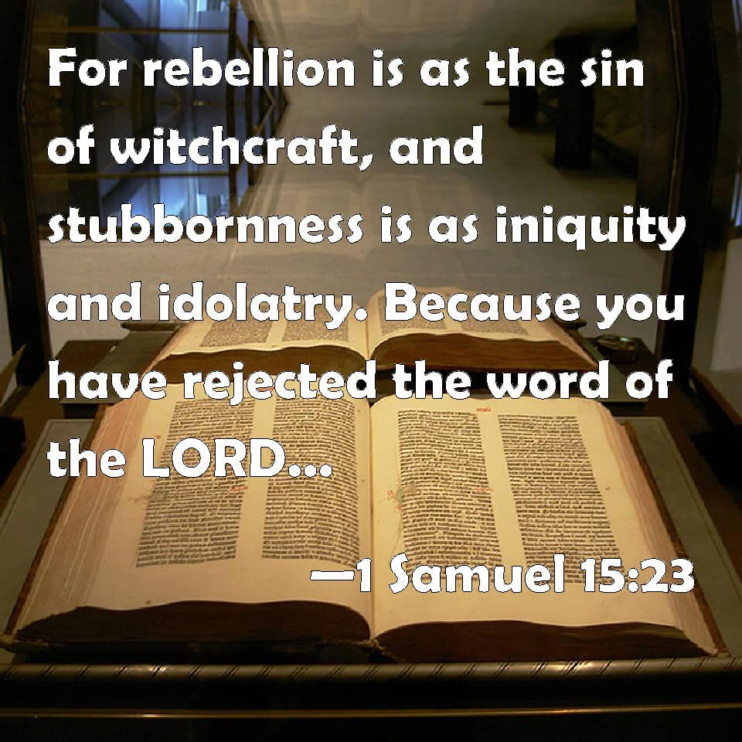

POWERFUL REVELATION

Reading through Revelation 3:7-13. More eye openers as you go back to the original translation. This one is mind blowing. The church of Philadelphia is being spoken to here. They are again praised for their works. Jesus describes Himself as Holy, true and having the keys of David. What are the keys of David? The keys of David are what unlocks the mysteries of the word of God so that they are understood. Jesus is the one who has these keys and does the unlocking for individuals. These individuals will be the ones who submit to His authority and governing rule in the kingdom. To those people He unlocks or reveals His true self so that they may go forth and reveal Him to the world as He truly is and as He describes Himself in these passages as Holy and true. Jesus opens doors by revealing Himself so that we may reveal Him to the world. He also closes doors or causes spiritual blindness to those who reject what He reveals to those he has opened the door to as they give out what He has revealed to them. Thus this revelation they reject, becomes a testimony against them. Remember judgment starts in the household of the Lord and out of the mouth of two or three witness (testimony) it is confirmed. If God starts bringing truth or discipline to the church and it is rejected after multiple attempts, a final guilty verdict is handed down and that testimony is used against them. They are to be considered outside the household of faith. This form of judgment is still to be practiced in the church today. It wasn’t done away with. The judged party are no longer a member of the body of Christ if they repeatedly reject His truth, which is equivalent to rejecting Jesus who is The Truth. That is heavy. He will remove even that revelation which they hath, causing doors to be shut to them because they have rejected His governing authority and truth as He has revealed it.

In the church of Philadelphia, Jesus commends their laboring (works) in getting the truth of the gospel of the kingdom out to the world. We are told to preach the gospel of the kingdom of God. This kingdom has a king that we submit to. The people are praised for keeping His word or obeying it and for not denying, translated rejecting, CONTRADICTING (saying one thing and doing another), or refusing His name which is translated authority and character. They allowed Jesus’ governing authority over their lives and their behavior did not contradict or refuse that authority. WOW! These are the people God reveals or manifests Himself to and opens up the scriptures in understanding, so that they can give it out to the world so that He can confirm that word with signs following. Are you getting this?

Jesus goes on to say He will make the phony people who claim to be a believer, but are really following the devil, come and worship, translated crouch or give reverence to you before your feet and to know that I have loved thee. That word loved is interesting as it is a compound word that means to love MUCH and will demonstrate that love in a social and moral setting before others. WOW!

Jesus goes on to say because they have kept the word, translated preaching or discourse in both word and actions, of my patience, translated ongoing endurance and constancy, He will also keep you from the hour, translated a specific time appointed of temptation (tribulation) translated discipline which shall come upon the whole world to try them that dwell upon the earth. These Christians go in the rapture because Jesus is Lord in their lives as they submit to His authority. These Christians are also referred to as jewels in Malachi 3:16-17 Then they that feared the Lord spake often one to another: and the Lord then hearkened, and heard it, and a book of rememberance was written before him for them that feared the Lord, and that thought upon His name, translated authority and character. And they shall be mine, saith the Lord of hosts, in that day when I make up my jewels; and I will SPARE them, as a man spareth his own son that serveth him. Why? Because they feared the Lord and thought on His authority and character (name) and submitted to His governing authority.

Not all Christians are raptured. Only those who made themselves ready and had garments of white. Some come out of the tribulation having made their garments white because they were not ready at the time of the rapture. That word discipline or try means for the purpose of making them Holy so that they do not suffer the wrath of God in the end in judgment. It basically is shaking those things off that can be shaken until all that is left is of God. We are starting into this process now in the beginning of sorrows. It is to bring people to repentance and to turn to the Lord who is to rule and reign in His authority. Behold He comes quickly. Hold on tight to the revelation and works that you have so that no man take your crown. He that overcometh will God make a pillar in the temple of God and He shall go no more out and I will write upon him the name, translated character and authority of my God and the name of the city of God which is the new Jerusalem which cometh down from heaven from my God and I will write upon him my new name. That word new is translated fresh confirmation of affinity. God will affirm you anew in His kingdom. How cool is that. That is why He had it written down in the book of rememberance to bring up and display His jewels at a later time to affirm them anew in His kingdom. Then shall ye return, and discern between the righteous and the wicked, between him that serveth God and him that serveth Him not. This trying or tribulation is actually an act of His mercy because He wishes that none would perish, no not one.

He that hath an ear, let him hear what the spirit saith unto the churches. Jesus can’t be savior if He isn’t Lord and if you reject His governing authority over your life, He will remove any revelation you used to have (shut the door) and no man will be able to open that door up to you again. Only God can. You will remain spiritually blind unless you repent and submit to Jesus as Lord.

“And to the angel of the church in Philadelphia write; These things saith he that is holy, he that is true, he that hath the key of David, he that openeth, and no man shutteth; and shutteth, and no man openeth; I know thy works: behold, I have set before thee an open door, and no man can shut it: for thou hast a little strength, and hast kept my word, and hast not denied my name. Behold, I will make them of the synagogue of Satan, which say they are Jews, and are not, but do lie; behold, I will make them to come and worship before thy feet, and to know that I have loved thee. Because thou hast kept the word of my patience, I also will keep thee from the hour of temptation, which shall come upon all the world, to try them that dwell upon the earth. Behold, I come quickly: hold that fast which thou hast, that no man take thy crown. Him that overcometh will I make a pillar in the temple of my God, and he shall go no more out: and I will write upon him the name of my God, and the name of the city of my God, which is new Jerusalem, which cometh down out of heaven from my God: and I will write upon him my new name. He that hath an ear, let him hear what the Spirit saith unto the churches.” Revelation‬ 3:7-13‬ KJV‬‬‬‬

January 13, 2018 I wrote this in the newsletter “And They Answered Not A Word”. There is such an urgency and the church needs to wake up but few are responding with a word to warn the people. Even the elect can be deceived. That is how strong and cleaver the deception will be. I have had something stirring inside me as I listened to His voice and He brought me back to that newsletter “And They Answered Not A Word”. It is precisly because many in church leadership have not responded or answered, we are being shaken. Because of their silence, we are being shaken. This is His Word given January 13, 2018.

“The church today is in a state of deep deception as they worship another Jesus and preach another gospel. It is a gospel based on man, personalities and self. They want the blessing without the blesser. They want saving without the savior. They want deliverance without the deliverer. They want the gifts and not the gift giver. They want provision without the provider. They seek my hand and not my face. They want the way but don’t want to walk ye in it. They want a prophetic word and not THE WORD. They want life but not the one who gives it. There is no denying of self or holiness without which no man will see me. And they love it so. They have been deceived into believing they have eternal life when they, in fact, reject truth that leads them to me, the giver of eternal life. They want truth as a lamp beneath their feet but put out the flame of my fire by quenching and grieving my Holy Spirit. They will hear on that day, ‘Depart from me I never knew you’ if they do not repent. As I have revealed my true self through my word and remnant, the leaders of my church have kept silent and answered not a word. I have brought them to the valley of decision saying, if the Lord be God, let us worship Him. But if your image of Jesus be God, let us worship him. But choose this day who you will serve and they answered not a word, though I be faithful to bring them truth in their deception. When they call upon their idol of God, He will answer them with silence. But my remnant will call upon me and I will consume with a Holy fire all their false sacrifices, lies and deception. The world will know the true from the false as the Lord God of the universe reveals Himself to all as the one true God. A shaking and a storm are coming and I will spare those that fear me. When they call upon me I hear them and will manifest myself to them and they will go forth as led by me to display my power and glory in such a way that no flesh will glory in my presence. It will all be of me for I am a consuming fire and a jealous God and the gates of hell will not prevail against my church. Then all will be able to tell the false from the real in that day as I reveal my true self upon the earth. I am both the lion of the tribe of Judah as well as the Lamb of God. Many reject the lion because they only want the lamb but a Day is coming where the lion will lay down with the lamb in perfect unity. A rain cloud is forming and a storm is coming that will overcome you suddenly after this long drought of truth. My remnant will go forth as laborers bringing in the harvest in my power and might because they have harkened unto my voice and fear and obey me. The stubble will have been removed and cleansed with this fire, wind and rain saith the Lord. Then will people see the great I Am and fall on their faces and come to know Me and not just what I give and provide. Their salvation will be from the savior and redeemer of their souls that they deeply fall in love with rather than for what they can get because they will come to realize I AM is the gift that paid a great price and all they gained prior to that is as dung as I manifest myself to them as who I truly am“. The storm is upon us.

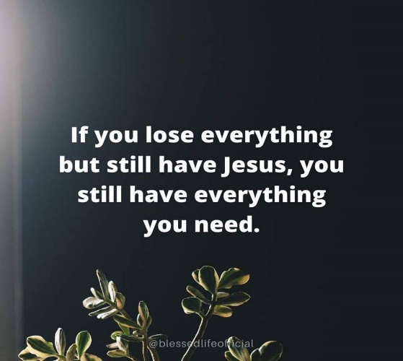

On April 4, 2020 as I prayed in my private time with Him, several songs were placed on my heart and I started to sing what He gave me. You may remember these. Lift Up Your Head All Ye Gates and Who Can Stand In This Holy Place”. Both songs come from Psalms 24 which I didn’t realize until later when I looked it up. I felt the Lord leading me to record my time with Him as I sang what He gave me and prayed in the spirit and a prophecy came forth. It started out praying in tongues and interpreting. “For the Spirit of the Lord broods over the entire earth seeking those that He can set ablaze. Thy kingdom come, thy will be done on earth as it is in heaven. Who will submit to Him so that His will is done on earth as it is in heaven? The Lord God mighty in battle is He. Who will be His hands? Who will be His feet? Who will be His mouth? Who will do the will of the Father? The spirit of the Lord broods upon the whole earth as He is ripening the harvest throughout the whole world”.

Now the prophecy:

“Did I not say that I would shake the whole earth? Everything that can be shaken will be shaken until all that is left is of me. Every idol and everything that captures the world’s attention, everything that can be shaken will be shaken. For I am calling a people to repentance. To fall on their faces and repent. Your prayers before me is an abomination without repentance. For I will not hear your prayers if you remain in your sin. For I am seeking the ones with a pure heart and clean hands who will be sanctified, who will allow me to wash them. Who will be changed in my image and likeness? Who will be holy as I am holy? For I am holy first. I am the God of kindness as well as severity. These are birth pains. These are the beginning of sorrows. And once again I will shake everything that can be shaken that you put your trust in. It will not be there for you but I will be there for you so repent and turn to me. Repent and turn to me. Because this shaking is exposing things in your heart that are idols; entertainment, sports, money and the things money can buy, even idols or gods in your churches, your celebrities, they will all be shaken. The wheat and the chaff are being separated. We will see who is real and who just claims my name for the benefits. I am searching for the one with clean hands and a pure heart. Who abides in me because you must endure until the end? My spirit is brooding over the whole earth seeking for harvesters. I am purifying those I will send into the harvest field. For this shaking will not only shake things off of you that hinder you in my kingdom, but it is also ripening the harvest. It is ripen the harvest. It is ripening the harvest because right now men’s hearts are failing them because of fear and panic. I am calling my people to repentance. I am calling my house to be a house of prayer and not a den of thieves. Without holiness no one shall see the Lord. My house will be a house of prayer, and sanctification and consecration and not the circus it has been”.

Praying in tongues and interpretation: Your kingdom come. Your will be done on earth as it is in heaven. The songs the Lord gave me prior to this fit right along with His heart and prophecy.
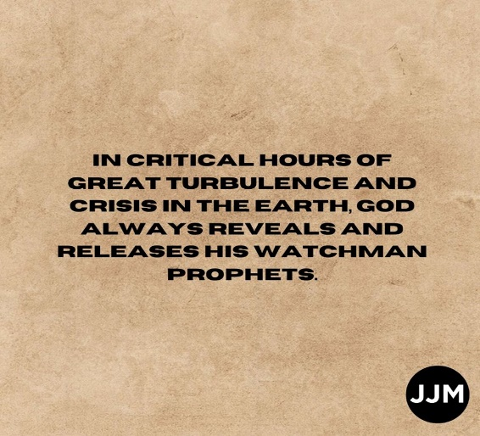

This is beginning of the end. The birth pains have begun. Labor has started because something is being birthed in this hour. Our gold is being tried in fire. Our nakedness is being exposed as well as our blindness. Truth, who is a person called Jesus, is applying eye salve. He has stood outside His lukewarm church knocking for far too long because we have shut Him out and not allowed Him in. We only want our Jesus that is different than the real one because we have received false teachers preaching a different Jesus and a different gospel and the bible says let them be accursed. He has shut down the lukewarm churches He has stood outside of and will silence those permanently who will not make a decision and who will speak not a word.

No more will the poor be stolen from by twisting the word of God and calling them God robbers for not tithing. Give to get is legalism, whether the reward is money or God’s favor. It was the priests that God was calling God robbers because they didn’t feed the poor, widows, fatherless and strangers in the land. The tithe was food that was to be brought into the storehouse to feed the poor, which the priests were not doing. Today, the pastors rob the poor to keep the lights and utilities on. Single mothers who can’t put a roof over their children’s head and can barely feed them are being called God robbers in order to fund your mega buildings in the Lord’s name. The bible says if you give to the poor, you give to God. If you rob the poor by perverting God’s word because you have no faith in God to provide, and call the needy “God Robbers” thus shutting up the kingdom of God to them, you are the ones robbing God, pastors. He is going to shut down your church buildings so there will be no utilities bills or building expenses and you will never recover from the shutdown. “The very poor you have robbed from and shut up the kingdom to, will be My sent ones saith the Lord into the harvest field. For they will become richer than you ever will be because they will inherit My kingdom. You feed yourselves and do not feed My sheep. My house has become a den of thieves and it is Me you are robbing.”

I cannot explain the strength of His anger with the above on tithing. If you are prophetic, you know that you can feel what the Lord feels when you minister. If He wants to move on someone with compassion, you feel that compassion toward someone that He brings to your attention. You feel His anger and grieving as well and this tells you how He wants to minister in a particular circumstance. I pray you heed the warnings.

You are either for the real Jesus or you are against Him. The gospel being preach today is ear tickling and flesh patting as well as sin promoting with its once saved always saved heresy that contradicts the word of God and leaves people powerless and in their sin instead of freeing them from it as Jesus died to do. It comes from the spirit of anti-Christ or against Christ and what He died to do and most of the church has been blind to it and have answered not a word. The Lord is ripening a harvest field as bible sales have gone up 143%. Online church services have recorded significant increases in those watching worldwide. Searches on the end times is one of the highest searched items ever. The field is ripe and the message going out in the harvest field is not going to be the one preached in our churches that produce a lukewarm people that Jesus wants to vomit out of His mouth. None of this accept Jesus into your heart stuff that isn’t even in the bible. It will be repent and be baptized every one of you in both water and Holy Spirit baptism as you are born again of water and the Holy Spirit.

HOW IS THIS NOT CLEAR?

“And he said unto them, Go ye into all the world, and preach the gospel to every creature. He that believeth and is baptized shall be saved; but he that believeth not shall be damned. And these signs shall follow them that believe; in my name shall they cast out devils; they shall speak with new tongues; they shall take up serpents; and if they drink any deadly thing, it shall not hurt them; they shall lay hands on the sick, and they shall recover.

And they went forth, and preached everywhere, the Lord working with them, and confirming the word with signs following. Amen.”
Mark‬ 16:15-18, 20‬ KJV‬‬‬‬‬‬‬‬
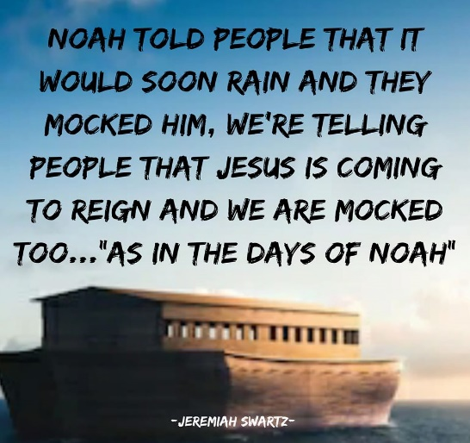

We have got to stop hitting the snooze button on the alarm clock God is setting off to wake us from our spiritual sleep before He returns. It is time for the bride to make herself ready. I am no longer looking for the signs of the times because they are all around us. I am listening for the sound of the trumpet. Pestilence, locust swarms that cause famine, wars and rumors of wars, earthquakes, tsunamis, economic collapse. I have had dreams of tsunamis where I stood on the beach warning people who were playing with their toys in the sand, so preoccupied with their toys that they didn’t heed the warning that a tsunami wave was about to crash down on them, sweeping all their toys back out to sea. It is now happening. Our toys and what we are preoccupied with is all being swept away by the tsunami the Lord is bringing upon the whole earth. This is actually His mercy and chastisement because we have not listened and harkened to His voice. We can either prepare ourselves for His coming or He will prepare us by removing all that we idolize, including a false image of who we think He is and how He operates. Is He not the same yesterday, today and forever more? There are no in betweens when it comes to following Christ. You are either all in or all out and the things coming upon us will demonstrate the difference between the two.

In the context of the chastening of the Lord we find Hebrews 12:

Wherefore seeing we also are compassed about with so great a cloud of witnesses, let us lay aside every weight, and the sin which doth so easily beset us, and let us run with patience the race that is set before us,

2 Looking unto Jesus the author and finisher of our faith; who for the joy that was set before him endured the cross, despising the shame, and is set down at the right hand of the throne of God.

3 For consider him that endured such contradiction of sinners against himself, lest ye be wearied and faint in your minds.

4 Ye have not yet resisted unto blood, striving against sin.

5 And ye have forgotten the exhortation which speaketh unto you as unto children, My son, despise not thou the chastening of the Lord, nor faint when thou art rebuked of him:

6 For whom the Lord loveth he chasteneth, and scourgeth every son whom he receiveth.

7 If ye endure chastening, God dealeth with you as with sons; for what son is he whom the father chasteneth not?

8 But if ye be without chastisement, whereof all are partakers, then are ye bastards, and not sons.

9 Furthermore we have had fathers of our flesh which corrected us, and we gave them reverence: shall we not much rather be in subjection unto the Father of spirits, and live?

10 For they verily for a few days chastened us after their own pleasure; but he for our profit, that we might be partakers of his holiness.

11 Now no chastening for the present seemeth to be joyous, but grievous: nevertheless afterward it yieldeth the peaceable fruit of righteousness unto them which are exercised thereby.

12 Wherefore lift up the hands which hang down, and the feeble knees;

13 And make straight paths for your feet, lest that which is lame be turned out of the way; but let it rather be healed.

14 Follow peace with all men, and holiness, without which no man shall see the Lord:

15 Looking diligently lest any man fail of the grace of God; lest any root of bitterness springing up trouble you, and thereby many be defiled;

16 Lest there be any fornicator, or profane person, as Esau, who for one morsel of meat sold his birthright.

17 For ye know how that afterward, when he would have inherited the blessing, he was rejected: for he found no place of repentance, though he sought it carefully with tears.

18 For ye are not come unto the mount that might be touched, and that burned with fire, nor unto blackness, and darkness, and tempest,

19 And the sound of a trumpet, and the voice of words; which voice they that heard intreated that the word should not be spoken to them any more:

20 (For they could not endure that which was commanded, And if so much as a beast touch the mountain, it shall be stoned, or thrust through with a dart:

21 And so terrible was the sight, that Moses said, I exceedingly fear and quake:)

22 But ye are come unto mount Sion, and unto the city of the living God, the heavenly Jerusalem, and to an innumerable company of angels,

23 To the general assembly and church of the firstborn, which are written in heaven, and to God the Judge of all, and to the spirits of just men made perfect,

24 And to Jesus the mediator of the new covenant, and to the blood of sprinkling, that speaketh better things than that of Abel.

25 See that ye refuse not him that speaketh. For if they escaped not who refused him that spake on earth, much more shall not we escape, if we turn away from him that speaketh from heaven:

26 Whose voice then shook the earth: but now he hath promised, saying, Yet once more I shake not the earth only, but also heaven.

27 And this word, Yet once more, signifieth the removing of those things that are shaken, as of things that are made, that those things which cannot be shaken may remain.

28 Wherefore we receiving a kingdom which cannot be moved, let us have grace, whereby we may serve God acceptably with reverence and godly fear:

29 For our God is a consuming fire.

WHO DOES SHAKING? JESUS!

- What is the purpose of the shaking? To remove our idols that preoccupy us!

- Why? So that we may be partakers of His righteousness and holiness without which no one shall see the Lord.

- Who was this spoken to? The church!

- What are we to do? Lay aside every weight and sin that doeth so easily beset us and with patience, run our race that is before us.

I have prophesied this shaking. Others have as well because those of us who speak from earth have been ignored. Now the Lord has the whole world’s attention as He speaks from heaven. Do you have ears to hear? This is all to get you ready for His return and to send harvesters out into the harvest field with the full counsel and gospel that will once again start with repent and be baptized, every one of you. If God chastens those whom He loves, does that mean there are those He does not love? Statements from the bible always bring up questions, which send me on a digging quest to unearth the diamond.
The Body of Christ is rebuking a virus when the real antidote is repentance from our wicked ways. When will individual Christians and the Body of Christ repent? When will the church actually obey and do 2 Chronicles 7:14?

[Cite your source here.]
We can’t even give up our cell phones for one day let alone give up our heads in martyrdom in order to follow Christ, or miss a meal, so we would take the mark in order to buy or sell. Who are we kidding? At the state we are in now, we would be like Esau who sold his birthright for a morsel of food. That is why He must shake these things we cling to in life and trust in so that we will be ready. THIS IS HIS MERCY! Chinese Christians are being martyred and their organs are taken from them while they are still alive to give to others as transplants and here we are hardly able to deal with a lockdown with all our gadgets focusing on family once again, staying home from carnal churches who are more about entertainment than preaching a searing word that leaves you shaken and changed and submitted to Jesus as Lord. Finances collapsing, sports shut down and all our gods being removed that has lulled us into deep spiritual sleep. This is a wake up call. Stop hitting the snooze button before it is too late.
The Body of Christ is rebuking a virus when the real antidote is repentance from our wicked ways. When will individual Christian and the Body of Christ repent. When will the church actually obey and do 2 Chronicles 7:14?

[Cite your source here.]

This removing of things is exposing our idols and addictions so get used to your idols being removed so that you will be ready at His return. This shaking is an awakening and an act of His mercy because He is returning soon. It is time to repent and humble ourselves and not just pray because we don’t think we have need of anything when we are really so dependent on so much that is not of God. We need to be dependent on Christ and by removing your sporting events and churches that have locked Him out causing Him to shut your doors, it is revealing your idols or the things of the world that we pay homage to. See how fast and easy that was for Him to do that?

Oh and all the false prophecies that have come out by well-known TV preachers, and online prophets is exposing the fact that you are a false prophet. When you call upon your God, He will not answer. You are rebuking a virus when the antidote is repentance. That is the whole point. You will be exposed for He wants the whole world to know the true from the false. For what will it profit a man if he gain the whole world and lose his soul? How about you? Will you follow Him no matter what the cost? If not, you are not worthy of Him the bible says.

If the gospel you preach has everyone on the broad road instead of the narrow path, you are preaching the wrong gospel.

It is interesting that the word judgment is translated “crisis”. The whole Covid-19 thing is not hard to figure out. When we live in willful sin, God’s hand of protection lifts and we allow the devil to attack. Is God evil in judging unrepentant sinners? He says He will. Why don’t we believe Him? Is God evil in destroying unrepentant sinners or pouring out His wrath? He says He will. Is God in control and He not allowing what is coming upon the whole earth? Does that make Him evil or is He always kind and loving over righteous and holy. It is preciously because He is righteous and Holy that He must judge sin, especially when He has provided us with everything to live Godly in Christ Jesus our Lord and we refuse to exercise that gift of the Holy Spirit in allowing Him to lead and control us. We are enslaved to what we submit to, so submit yourself to God and be a slave to righteousness instead of sin. The blood of the lamb painted on the doorposts of the Israelites in Egypt kept them from the death angel passing through, but if they were disobedient and came out from under the blood, they died. Our disobedience causes us to come out from under the blood as evil passes through. Staying under the blood keeps you in the throne room. The next time you see a crisis, think of the word judgment because that is the translation. That doesn’t mean all things are judgment when tragedy happens but when you see something global take place that shuts down all our idols in one fell sudden swoop, God now has your undivided attention, which is His intention, so it is best if we listen and obey or the birth pains will be harder than the next and come closer together. Whether this comes because He sends it, or because His protective hand has lifted because we essentially kicked Him out of everything and told Him to go away, it doesn’t matter. If He is in control as we like to preach, He is allowing it for His purposes.

One thing I have learned in this pandemic is that I operate from a place of total rest in the Lord. I remain under the blood and obey. He confirms in multiple ways what He wants me to write. He is providing for all my needs. I am working in this pandemic. I had sold my house and temporarily moved in with a friend until I could find and close on another home. She is 70 years old with some health issues and she needed surgery in April and she wasn’t comfortable with me going outside the home to work every day. I get it, but I can’t not work as an essential business especially when I am getting ready to purchase a home and all of a sudden my boss had a tenant move out of one of his properties. He offered to let me stay here. I didn’t even bring it up or know his tenant moved out. God is faithful to provide for my every need even before I knew I had one.

Funny story in all this, I am living bare bones as most of my stuff is in storage. Work has been taxing in this crisis and I will admit I was missing some human contact and really needed some encouragement. I went to the refrigerator, which is stainless steel, and the light hit the door just right to illuminate a message on the refrigerator that read: My promises my love! Signed Jesus! The exclamations had hearts for dots. I took a picture of it. Someone had written on the refrigerator at one time with a substance that didn’t quite come off. If you looked at the refrigerator head on, you couldn’t see anything. It was just when the light hit it just right that I saw it and I walked away encouraged, knowing He was providing for all my needs. This is the abundant life of dependence you live when you live in obedience, walk intimately with the Lord, abide in Him and have His word abide in you. The day when I left the home I just sold and all my things were in storage and I was driving to my friend’s house to stay, I was feeling a little down as I was thinking about past memories, many of which were painful. I stopped at a red light on a country road and here was a sign that read “Make new memories”. That was an anointed moment where the Lord was speaking directly to me through that sign. I go about half a mile down the same country road and here on the other side of the road was a sign that said, “Live in the moment”. The Lord was telling me to not look back. New memories are ahead and I am to live in the here and now. Wow! This is what my life is like walking with Him as He knows exactly what you’re feeling and comforts and encourages you along the way. That is intimacy.
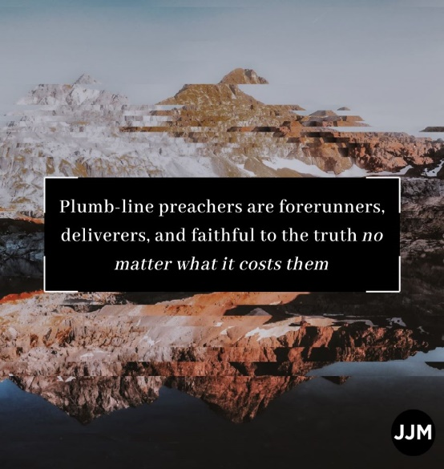
It is time to get out of the carnal churches, which God is going to shut down and get back to men and women of God who preach the whole counsel of God. We have a plague of false prophets and false hyper grace teachers among us that have created a lukewarm, sin laden people who believe they are going to heaven because of false teaching, which I have addressed in other newsletters. Go to www.latter-rain.net and scroll down to the bottom of the menu and you will see the newsletters that are progressive in their messages. If you click on the link at the top, you can download a copy with the graphics that look like what you are now viewing. Post them, send them out. Get the word out. I pray you don’t blaspheme the Holy Spirit by mocking as the Lord is throwing down and tearing up in order to later plant. A large number of the people on my mailing list are radio or TV preachers. Some of you I love, especially if you have a prophetic or teaching anointing. I love to learn and am always digging as the Lord brings words to my attention. I flow in the teaching and prophetic anointing in case you can’t tell. I just give out what He gives me. The rest of the subscribers are global from different countries, some of which I have never heard of. Israel has been one of the third highest countries logging on which excites me.

Jesus died to deliver us from the power of sin and He has given us all things to live Godly in Christ Jesus our Lord. He gave us POWER to become sons of God which the earth is longing for the manifestation of. Those churches who deny this power through the baptism Holy Spirit, we are not to have anything to do with. We don’t go to those churches, we don’t let them preach on our TV’s and radios etc. They may not outright deny it but they will say things like you have all the Holy Spirit you will ever need when you first believe. When you first believe, you are sealed with the Holy Spirit and that word sealed is translated earnest or deposit, like one would put down on a house with the intent to fully occupy. In Acts 19 the question comes up to believers if they had received the baptism of the Holy Spirit since they first believed. They replied no and then they were water baptized into the body of Christ and received the baptism of the Holy Spirt afterwards just as Jesus did. In water baptism you are pledging to be dead to sin and self IN ORDER THAT you be raised as Christ was raised. The baptism of the Holy Spirit empowers you to keep that pledge. Jesus only baptizes those in the Holy Spirit who will obey. If you can’t obey in the first thing, being repent and be baptized, why would you expect to be baptized in the Holy Spirit? This by the way is what it means to be born again of water and of the Holy Spirit. The whole pattern of salvation is throughout the bible and Jesus followed that pattern. The Israelites first believed they would be save while still in slavery in Egypt. Were they saved when they first believe? No. Believing aligned them to follow Moses just as we are to follow Jesus as the Way. The word Christian means follower of Christ. If you are not following, you don’t fit the definition. Next the Lord led the Israelites to the Red Sea where they were all water baptized and they were led through the wilderness of life by the Holy Spirit just as we are to be led and controlled by the Holy Spirit through the wilderness of life until we reach the promised land and receive eternal life in the end Romans 6:22. The New Testament says some died in the desert and didn’t make it to the Promised Land because of their disobedience and this is to be an example to us in the new covenant.
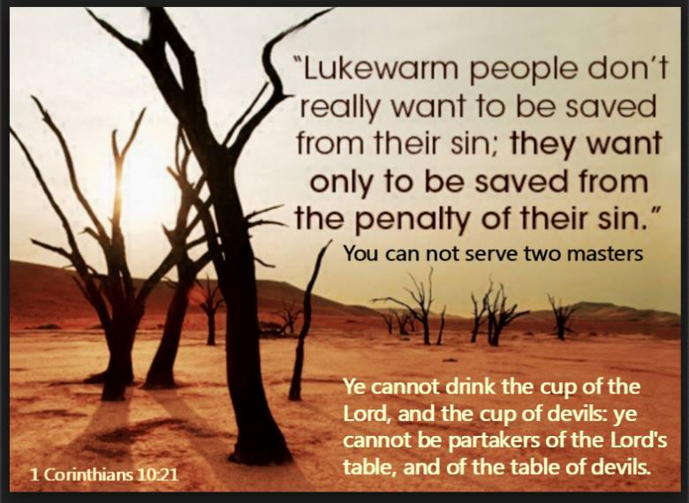
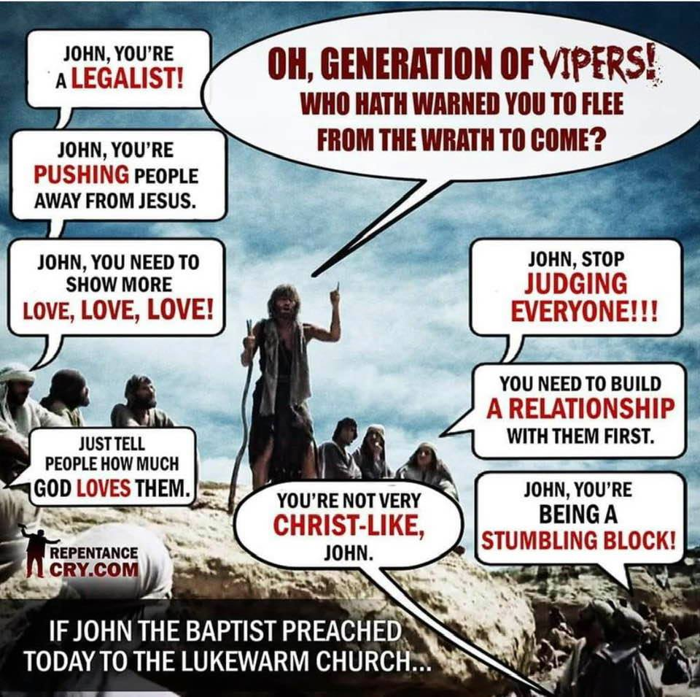

The above is exactly why we don’t allow the real Jesus into our churches. He would call for repentance. Ignoring Him isn’t going to work anymore folks. Your window of time is expiring.

Revelation 3:1-6. This is interesting as I looked up several words that illuminated it. I want to have ears to hear what the Spirit is saying to the churches, don’t you? Again the Lord mentions works right away but in a negative way instead of a positive way as He did with Thyatira. Remember the book of Revelation is the “revealing” of Christ. Many of us don’t have an accurate idea of what the true Jesus is really like because we have listened to false teachers who have preached a different gospel presenting a different Jesus than is in the word. The Bible says let those preachers be accursed. They twist scripture and cherry pick which verses they want to believe while omitting the ones they don’t like and they take things out of context. This was the case in the church of Sardis so that is why this got my attention as I went back to the original translation.

Jesus states He knows their works and that they have a name. That word name is translated character in which one derives notoriety, gratification and pleasure from being well known. This is your celebrity preachers and showmen folks. They had them way back then too! Jesus considered them dead, translated like a corpse, inside. WOW! Jesus tells them to be watchful and to strengthen what actually still remains alive that is about to die and He has not found their works perfect, translated to fully preach or perfectly supply the whole gospel in the execution of their office. WOW and WOW. It is imperative that we preach the full gospel of our Lord and Savior Jesus Christ. The consequence of not is that Jesus will come as a thief in the night, which describes the rapture because they were not watchful, and they have their name blotted out of the Lamb’s book of life. All whose names were not found in the book of life have their part in the lake of fire.

There were a few people in Sardis who had the right character (name) who had not defiled their garments by taking gratification and pleasure in notoriety by only preaching a gospel that ticked ears and patted the flesh which made them so famous and well-liked by the people. Jesus said they will walk with me in white for they are worthy. If you have ears to hear and repent and overcome you shall also be clothed in white clothes and your name will not be blotted out of the Lamb’s book of life. The Bible says if you do not have your name in that book, you have your part in the lake of fire with the devil and his angels or messengers. Jesus will confess your name before the Father and His angels, translated messengers, so it can be people the Father sent, if you repent. Angels are not always winged invisible beings. John the Baptist was called an angel or messenger of God. Basically Jesus is calling these unrepentant Sardis preachers messengers of the devil for not preaching the whole word of God which is why they will have their part in that lake of fire which is the second death. Not preaching the whole gospel is a pretty serious offense which Jesus warns about. Having the character of one who loves notoriety, their celebrity status, the titles and attention and derives pleasure and gratification from it is like a corpse that is about to be blotted out because they don’t preach the whole gospel and leave out the parts that are offensive. If this isn’t an eye opener, I don’t know what is? Please share. Maybe we can save some with fear hating even their garments that are spotted by the flesh.

I can’t ever imagine reading the Bible without the revelation given by the Lord that opens your eyes to the times we live in. No one wants to preach about Jesus and His eraser, but He has one and we don’t want Him to use it so warn!

“And unto the angel of the church in Sardis write; These things saith he that hath the seven Spirits of God, and the seven stars; I know thy works, that thou hast a name that thou livest, and art dead. Be watchful, and strengthen the things which remain, that are ready to die: for I have not found thy works perfect before God. Remember therefore how thou hast received and heard, and hold fast, and repent. If therefore thou shalt not watch, I will come on thee as a thief, and thou shalt not know what hour I will come upon thee. Thou hast a few names even in Sardis which have not defiled their garments; and they shall walk with me in white: for they are worthy. He that overcometh, the same shall be clothed in white raiment; and I will not blot out his name out of the book of life, but I will confess his name before my Father, and before his angels. He that hath an ear, let him hear what the Spirit saith unto the churches.” Revelation‬ 3:1-6‬ ‬‬‬‬‬‬‬‬‬‬‬‬
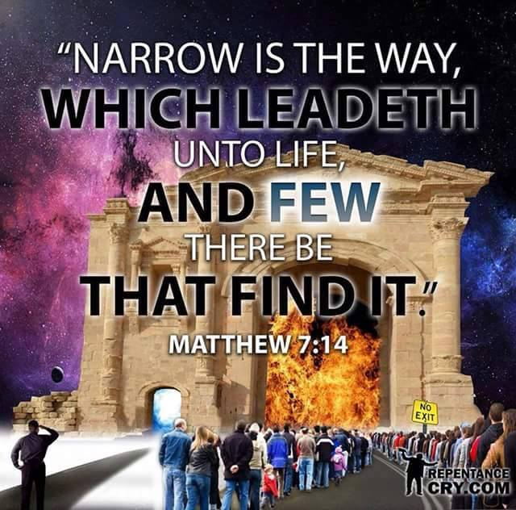

Robert Weller

THE NARROW DOOR AND THE NARROW ROAD ARE YOUR CHOICE

The scriptures repeatedly tell us that it is ONLY those who DO the will of God that will be saved. Matt.7:21, Matt.12:50 , 1 Jn.2:17 It is God's will for all to be saved AND come to the KNOWLEDGE OF THE TRUTH. 1Tim.2:3-4, 2 Pt.1:2-4 It is God's will for all to be sanctified. 1 Thes.4:2-3 It is God's will for all men everywhere to repent (quite sinning). Acts 17:30, 2 Pt.3:9 Repentance LEADS TO salvation. Acts 11:18, 2 Cor.7:10

Jesus will not STRIVE or force you through the narrow door. Lk.13:24 He will not force you to go down the narrow road that ENDS in life. Mat.7:13-14 God will not force you to be sanctified. 1 Thes.4:7-8 God will not repent or endure to the end for you. Acts 3:19-23, Col.1:23, 1 Cor.15:1-2, Mat.10:22, Heb.3:6, 12-14 He gives His POWER to obey all that He has commanded by His Spirit. But it is only those who are willing to OBEY Him that receive His Spirit. Acts 5:32, Acts 2:28

Love rejoices with truth. 1Cor.13:6, Love without truth is hypocrisy. We are to abhor (hate) that which is evil. Rom.12:9

As I read Rev. 2:18-29 I couldn’t help but notice how many times the Lord mentions the works of those in the church of Thyatira. In fact, in verse 19 He mentions it twice, along with their charity, service, faith and patience and again their works. Works are obviously very important to the Lord for those who say they aren’t. Not only that, He commends them for their last works being greater than their first.

Nevertheless, despite all these accolades, there are those in this church who allow themselves to be seduced away by a controlling spirit (Jezebel) into sin and idol worship, which is placing other things above God. This could be a person, money, addictions, a different Jesus not found in the Bible but one made from their own imaginations stemming from false teachings. It could be prosperity and covetousness, entertainment, our jobs etc. Whatever you give yourself to outside of the biblical Christ and pursue is an idol. Have you not noticed that many of these idols like sports, entertainment, the economy, church leader idol worship etc. have all been shut down in one fell swoop and our idols are being exposed to us? IT IS THE LORD’S DOING, not the devil.

Notice in verse 22 it says the Lord will cast them who are seduced away into sin and idolatry, despite their good works, patience, charity, service, faith and works that they were praised for, into the same bed with Jezebel or the controlling church leaders who cause you to stumble and fall into sin with their false doctrines. JESUS cast them all into GREAT TRIBULATION because they did not repent of their sins, despite all the things Jesus praised them for. Not only that, but JESUS said HE will kill Jezebel’s offspring with death if they don’t repent of their deeds or sinful works. Oops! So remaining in your sins when called to repent of your sinful works causes Jesus to cast you into great tribulation and brings death to those seduced into sin by a Jezebel or controlling spirit and all your good works that you are praised for by the Lord won’t stop that. Only you repenting of your sins will. You are not saved by works, although they are important and we shouldn’t negate their importance. You are saved by being holy as He is Holy, without which no one shall see the Lord. Jesus died to free us from the power of sin so that we are no longer slaves to it. Grace isn’t the license to sin but the power of God given to you not to through the baptism of the Holy Spirit. Your freedom in Christ comes from no longer being a slave to sin. If you still are a slave to sin, how “saved” are you, despite all your good works or “I’m a good person so I won’t go to hell” analogy because you compare yourself only to those far worse to elevate and justify yourself instead of being justified by Jesus and His blood by applying it through obedience to your life. That obedience is repenting and being transformed into His image and likeness and sanctified. Jesus said if you don’t allow me to wash (sanctify) you, you have no part with me. No part means no part!

When those in the church of Thyatira, who did not repent, find themselves in great tribulation, translated pressure, affliction, anguish and trouble which brings death, all the churches will know that Jesus is He which searches the hearts and reins, or what drives or controls you as reins do the steering, and give unto you according to what is in your hearts despite what your external good works say otherwise. Judgment begins in the household of the Lord. Everything that can be shaken will be shaken all over the earth and it is the Lord’s doing. Wisdom begins with the fear of the Lord. Now is the time to repent and be led and controlled by the Holy Spirit who is Holy and not a controlling spirit that seduces you away into sin through ear tickling and flesh patting doctrine that has entered the church through Satan’s messengers appearing as an angel of light.

Verse 24 Jesus says “As many of you who do not have this doctrine and have not known the depths of Satan, as they speak (as who speaks? False teachers?), I will put upon you none other burden. And he that overcometh and KEEPETH my WORKS (obedience) unto THE END, to him I give power over the nations”.

We were purchased and redeemed to overcome and endure until the end when we receive eternal life Romans 6:22. Let him who has ears hear what the spirit is saying at this time upon the earth. The tribulation, pressure, anguish and trouble will increase upon those who don’t repent.

“And unto the angel of the church in Thyatira write; These things saith the Son of God, who hath his eyes like unto a flame of fire, and his feet are like fine brass; I know thy works, and charity, and service, and faith, and thy patience, and thy works; and the last to be more than the first. Notwithstanding I have a few things against thee, because thou sufferest that woman Jezebel, which calleth herself a prophetess, to teach and to seduce my servants to commit fornication, and to eat things sacrificed unto idols. And I gave her space to repent of her fornication; and she repented not. Behold, I will cast her into a bed, and them that commit adultery with her into great tribulation, except they repent of their deeds. And I will kill her children with death; and all the churches shall know that I am he which searcheth the reins and hearts: and I will give unto every one of you according to your works. But unto you I say, and unto the rest in Thyatira, as many as have not this doctrine, and which have not known the depths of Satan, as they speak; I will put upon you none other burden. But that which ye have already hold fast till I come. And he that overcometh, and keepeth my works unto the end, to him will I give power over the nations: And he shall rule them with a rod of iron; as the vessels of a potter shall they be broken to shivers: even as I received of my Father. And I will give him the morning star. He that hath an ear, let him hear what the Spirit saith unto the churches.”

This Jesus, who is the Lion of the tribe of Juda is the one returning and He doesn’t fit our image of Jesus the Lamb. Our churches today want the Lamb to the exclusion of the Lion.

Please notice who does the blotting out, who sends the pestilence, who throws them into tribulation, who kills the children of Jezebel, who judges sin. Is this the Jesus you know? That is the trouble. You don’t know the real Jesus! That is why He is revealing Himself.

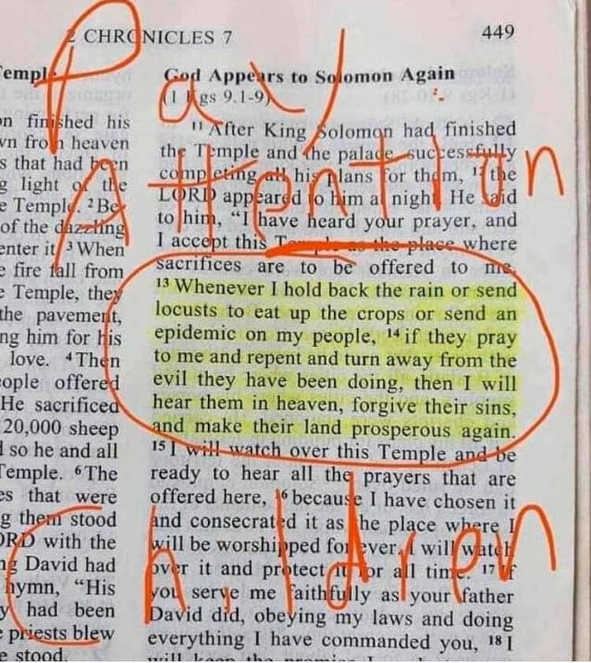
Who holds back the rain? Who sends locust? Who sends pestilence? Is God evil when He pours out wrath on unrepentant sinners? It is precisely because He is righteous and holy that He must judge sin. Especially when He has made a way of escape and we fail to apply the blood of His son to ourselves through repentance, confession and obedience. If you run across something in the bible that disagrees with something you believe, you need to assume you are the one who is wrong. Maybe your image of God, who is the same yesterday, today and forever more is not how Jesus really if.

Many believe Jesus did away with the law but did He? No, He fulfilled it or made it full. God’s moral law will never be done away with. Here is the definition of sin according to the bible: 1 John 3:4 King James Version (KJV)

4 Whosoever committeth sin transgresseth also the law: for sin is the transgression of the law.

How can you have sin that you need to confess and repent of and He is faithful and just to forgive your sin if the law has been done away with? Sin is the transgression of the law. If the law was done away with, there would be no more sin which is the transgression of it. Right?

The law has not been done away with. We are not saved by the works of the law. What are the works of the law? That is what the religious leaders added on to the law that God never had. The bible says that the law was to show us we couldn’t keep it in our ability and needed the baptism in the Holy Spirit who empowers us to live according to God’s moral law. That is how the law has been perfected or “finished”. You now keep God’s moral law in HIS ability, not your own. When Jesus said it was finished on the cross, that word finished is translated perfected. What the law could not do except show you your inability to keep it, the baptism in the Holy Spirit empowers you to keep God’s moral law in His ability. That is how the law was made full or fulfilled. Let’s stop telling people the law has been done away with implying that people don’t have to live by God’s standard and He doesn’t see their sin because they believe in Jesus. Well so does the devil. If you still live in sin believing that you are saved, you have been duped. Your blood will be on the hands of the false teachers and preachers because they repented not and they would not receive the love of the truth that they might be saved. We will be held more accountable for what we teach. Grace isn’t the license to sin, but the power of God given to you not to. Your freedom in Christ comes from no longer being a slave to sin. If you continue to live in willful sin, you are trodding the blood of Jesus under your feet and counting it as unholy. Because of that comes judgment (crisis) from the Father.
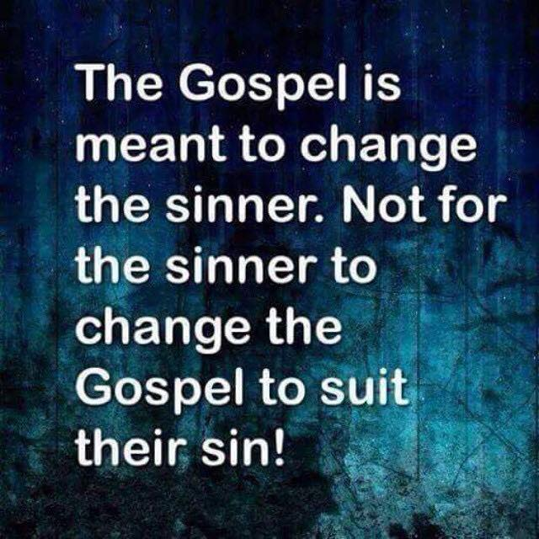

CAN YOU SEE THE SIGNS OF THE TIME?
Robert Weller

And He was also saying to the crowds, “When you see a cloud rising in the west, immediately you say, ‘A shower is coming,’ and so it turns out. And when you see a south wind blowing, you say, ‘It will be a hot day,’ and it turns out that way. You hypocrites! You know how to analyze the appearance of the earth and the sky, but WHY DO YOU NOT ANALYZE THIS PRESENT TIME? Lk.12:54-56 Jesus had fulfilled many OT prophesies and they were so ignorant of the scriptures they missed what He was doing.

Now as to the times and the epochs, brethren, you have no need of anything to be written to you. For you yourselves know full well that the day of the Lord will come just like a thief in the night. While THEY (non-believers) are saying, “Peace and safety!” then destruction will come upon them suddenly like labor pains upon a woman with child, and they will not escape, BUT YOU, BRETHREN, are not in darkness, that the day would overtake you LIKE A THIEF; for you are all sons of light and sons of day. We are not of night nor of darkness; so then let us not sleep as others do, but let us (believers) be ALERT and SOBER. For those who sleep do their sleeping at night, and those who get drunk get drunk at night. But since we are of the day, let us be sober, having put on the breastplate of faith and love, and as a helmet, the hope of salvation. 1Thes.5:1-8

The most repeated sign of the last days is an apostasy. 1Tim.4:1-2, 2Tim.3:5 & 7, 2Tim.4:3-4, 2Thes,2:1-3, 2Pt.3:3-4, Lk.17:26-33, Lk.21: Mat.24:10-11 It is not a falling away from religion; it is a falling away from truth. They do not love the truth so as to be saved. 2Thes.2:10-11
.
We are a church who is ever learning but never able to come into the knowledge of the truth, because we don’t want it. You can’t be deceive unless you want to be because Jesus is the truth and He is faithful to bring truth into your deception. We are saved by sanctification of the spirit and belief in the truth the bible says. No sanctification, no salvation. No acceptance of the truth, which is who Jesus is, no salvation. You are rejecting Jesus and what He died to do.

Does God Send Disease?

By Pastor Art Kohl

Introduction:
Let God be God! People like to reduce God and His character to their own personal opinion of Him. They will not allow Him to do anything out of the boundaries that they have drawn up for Him to obey. They are so ingrained with "God is Love" idea that they will not permit Him to be a Holy God, or Righteous or a God who insists on Justice. God is a God of Judgement, and He is known by the judgements that He makes. He is more than just a "God of Love".

For example, a local paper reported recently that only 24% of Americans believe that AIDS disease is a judgement from God upon sexual perversion. 76% do not believe it is. Where do we develop our opinion of God and how He acts from? It is either from studying the Bible, or it is left up to our personal opinion, thereby we become the god of God, and He is under our control rather than vice versa.
But I say, Let God be God, and let us study what He has said about this subject in the Bible.

1. How Did Jesus Know?

2000 years ago, Jesus answered a question that was posed to Him: "What shall be the sign of thy coming and of the end of the world? (Matthew 24:3) He answered with many indications that we could watch for, such as cults, wars, rumors of wars, famines, earthquakes, hatred, prejudice and PESTILENCES!

Pestilence is defined: "Disease that spreads rapidly, causing many deaths" according to the dictionary.

By the turn of the century, over 50 million will die in Africa from AIDS disease (that's 1/5 of America's population).

There are between 30-50 million cases in the world of venereal syphilis. 150 million cases of gonorrhea infection. 68,493 teenagers in the free world come down with a venereal disease EVERY DAY!

How did Jesus know? He knows everything! He is God! (John 10:30,14:9, I Timothy 3:16, Acts 20:28, John 20:28,29)

In a day and age where science and medicine have advanced to unparalleled levels, there is still epidemics of PESTILENCE.

2. God Promised.

"If thou wilt not observe to do all the words of this law that are written in this book, that thou mayest fear this glorious and fearful name, the Lord thy God: Then the Lord will make thy plagues wonderful, and the plagues of thy seed, even great plagues, and of long continuance, and sore sicknesses, and of long continuance. Moreover, he will bring upon thee all the diseases of Egypt, which thou wast afraid of; and they shall cleave unto thee. Also every sickness, and every plague, which is not written in the book of this law, them will the Lord bring upon thee, until thou be destroyed." Deuteronomy 28:58-61.

Who brings the plagues? How is this not clear?

Also take time to read Leviticus 26:15 & 16.

The Bible is filled with wonderful promises to those who live right, and dreadful promises to those who reject and neglect God's Word. Definitely promised is disease sent from God as a promised judgement.

3. The "Do-your-own-thing" Disease.

God promised to judge sexual sin. All sex outside of the husband-wife marriage relationship is sin. Hebrews 13:4 says "Marriage is honorable in all, and the bed undefiled, but adulterers and whoremongers GOD WILL JUDGE."

In 2 Chronicles 21 there is the story of a man names Jehoram who "caused the habitants of Jerusalem to commit fornication and compelled Judah" also. (Verse 11) The prophet Elijah was commissioned by God to write a letter to Jehoram. It said: "Behold, with a great plague will the Lord smite thy people, and thy children, and thy wives, and all thy goods: And thou shalt have great sickness by disease of thy bowels, until thy bowels fall out by reason of the sickness day by day." (vs 14,15) Shortly after, it was fulfilled. II Chron, 21:18,19, "And after all this, the Lord smote him in his bowels with an incurable disease. And it came to pass, that in process of time, after the end of two years, his bowels fell out by reason of his sickness: so he died of sore diseases. And his people made no burning of his fathers." Who smote Jehoram with an incurable disease in his bowels? God did!

"And likewise, also the men, leaving the natural use of the woman, burned in their lust one toward another: men with men working that which is unseemly, and receiving in themselves the recompense of their error which was meet." Romans 1:27

4. Why Judgement?

To bring about repentance. It is a chastisement of God to get us to turn back to Him. Study Revelation 16:7-11.

Not all disease is a judgement from God, however. Space does not allow us to study the other side of the coin at this time. Satan can afflict people with physical and mental diseases. Some diseases are the result of violating natural laws such as alcohol or cigarette smoking related diseases. Some are unexplainable. We do not pretend to have all the answers. This one thing we know, however; the Bible teaches clearly that God sends diseases upon the disobedient, especially sexually related diseases.

5. It's Not Too Late.

"If my people, which are called by my name, shall humble themselves, and pray, and seek my face, and turn from their wicked ways- then will I hear from Heaven and will forgive their sin, and will heal their land." II Chronicles 7:14

There is a penalty for sin, our worst disease and the last enemy that shall be destroyed is death. It is incurable for all have sinned and "the wages of sin is death". Christ is the antidote for sin, for He paid the penalty in full on the cross for you and me. He died, was buried and rose again and is alive for evermore and can save you from your sins today if you'll ask Him to!

God has our best in mind. He's not a kill joy in Heaven trying to ruin all of our fun. The most fulfilled and happiest people in the world are biblically born again people living by God's standards. They have love, joy, peace and everything else the world is trying to find.

Why don't you be one of them? God does love you. Yes, He's a God of Judgement, but He's a God of mercy to all who turn to Him. "Not by the works of righteousness which we have done, but according to His mercy He saved us, by the washing of regeneration, and renewing of the Holy Ghost." Titus 3:5

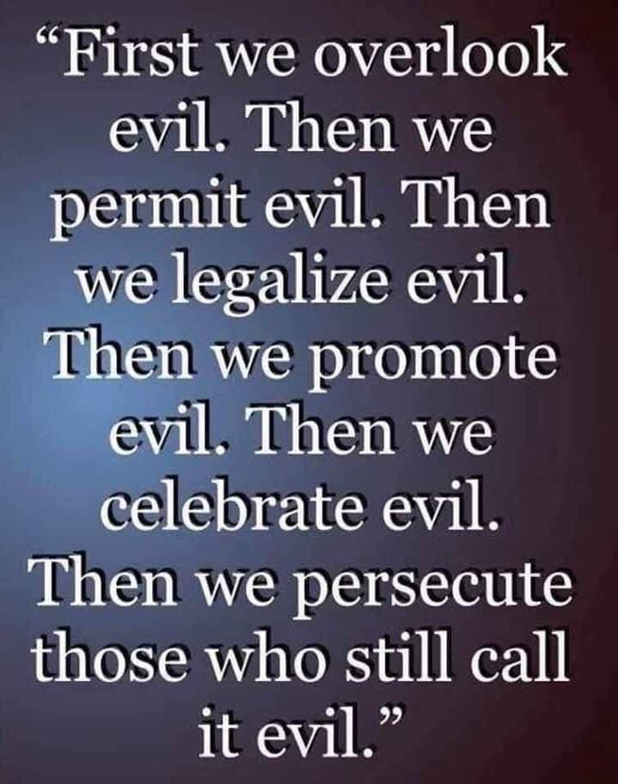

We are near the end and just as the bible says it will be, there is a great falling away from the truth right before Jesus returns and many will not receive the love of the truth that they might be saved. They love their deception and sin more. These people are the sons of perdition that the bible refers to and this is now being revealed. Jesus said He will gather out of His kingdom ALL who offend and ALL workers of iniquity. That doesn’t sound like eternal security to me. Even the elect can be deceived.

To repent, you must turn from your sin, own up to it and confess it. Don’t blame others for it. Make things right with people you have sinned against. If you have lied about them, make it right. Admit your lies to those you lied to and about. The bible says not to bring your gift to the alter until you make it right with the person you sinned against or lied about. If you can’t do that, you haven’t really repented and repenting is the very first step in being born again of water and the Holy Spirit. Don’t discount the power of water baptism. Water baptism slammed down on what used to enslave the Israelites and shut that door. Demons hate repentance and water baptism. They are being evicted. That is why you need the baptism of the Holy Spirit to keep them out after you have been swept clean through repentance and water baptism. Born again of water and the Holy Spirit in order to enter the kingdom of heaven.

You must forgive others or you won’t be forgiven. The Lord had more to say negatively about gossip and bitterness then He did adultery. That means you don’t take vengeance but you leave that to God. Vengeance is His. That doesn’t mean you won’t still feel angry, hurt or have to trust that person again or continue to have them in your life. I have purposely eradicated toxic, bitter people from my life in order to guard my own heart and not be defiled by their bitterness. I am done with all the drama.

Jesus said “If you love Me you will keep my commandments” and this is the key to answered prayer. This statement from Jesus was said in the context of being baptized in the Holy Spirit which Jesus will send after He goes to the Father. Those who obey in His ability are the ones Jesus manifests Himself to. They experience the God of the word. Not the clueless ones freely sinning believing they are saved and under grace. Grace is translated empowerment or I will supply that which is needed. If you need comfort, He supplies it. If you need strength, He supplies it. If you need wisdom, He supplies it. If you are under grace (empowerment) you are free from being a slave to sin in His ability. You have prayers answered and the manifestations of His promises. Many think they have His promises while living a life of sin. Search the scriptures because in them you think you have eternal life.

When Jesus returns, will He find real faith upon the earth with such apostasy in the end time church? If the righteous scarcely be saved, what happens to the sinner? That is up to you and what you decide to do with the truth He has now given as He has given deeper revelation into His true self. Judgment starts in the house of the Lord from the top down! He will no longer permit heresies that strengthen sin in His church when He died to free people from being slaves to it. He will no longer stand outside HIS church knocking at the door to get in and be ignored. Now will you accept Him? All of Him? Even the parts you don’t like or may not agree with? The Lion is coming to lie down with the lamb. This shaking has come to awaken you from your spiritual slumber because the groom is on His way! He is coming for a bride who has made herself ready. Don’t be the one who keeps HIS bride from making herself ready by implying HIS grace is license and everything is covered under HIS blood while HIS blood is really being trodden upon under the feet of sinners believing themselves to be saved. No wonder He wants to spew them out of His mouth or they make Him want to vomit. His blood is being counted as unholy because of the heresies and unrepentant false preachers who spoke not a word renouncing the heresies. He will no longer allow this to continue. Truth is to tear down your mental stronghold of false beliefs that you have had from the beginning. You are saved through sanctification of the spirit and belief of the truth. He has been faithful to provide you with the truth and if He is exposing and confront, He is about to judge.

Please receive the love of the truth that you might be saved! He is returning and very soon. He is coming for a glorious church, without spot or wrinkle. He is coming for a bride that has made herself ready, submitting to His authority and character and washed her robes in the blood of the Lamb. Do not trodden under foot the blood of Jesus and count it as unholy. He died to free sinners from the power of sin. If the grace you preach requires nothing of the recipient, then what do you do with all the “if” scriptures throughout the bible. Don’t let the truth be a testimony against you. A day will come when Jesus will judge you for what you did with your gifts and talents.

For I say unto you, That unto every one which hath shall be given; and from him that hath not, even that he hath shall be taken away from him.

But those mine enemies, which would not that I should reign over them, bring hither, and slay them before me.

The kingdom of God has a king and submission to His authority and character is a requirement to enter in.

As for me, I was born for such a time as this and so are you! I was called to help prepare a bride who is without spot or wrinkle and to call people to repentance and to be baptized, EVERYONE of you in order to be saved. It is up to you whether you will heed the call now, or wait until the next birth pain that brings you to your knees repenting and crying for mercy as the fear of the Lord is eventually realized and these trials or chastisements finally produce the peaceable fruit of righteousness to those who are exercised by it or put it to use.

Is the devil going to tell you to repent, be baptized in water and the Holy Spirit, which equips you to defeat him and his kingdom? Will the devil call Jesus Lord and submit to His character and authority and tell you to? Hardly! I pray you apply this eye salve so that you may see the error being taught and the souls in hell because of it, whose blood will be on your hands and you will be held more accountable. Save some with fear, hating even their garments that are spotted by the flesh the bible says.

How hard and how often do you need to be shaken to awaken you? How many times will you reach over and hit the snooze button on the alarm, just as they did in the days of Noah.

Discernment isn’t being able to tell right from wrong. It is the God given ability to tell the difference between right and almost right and there is no greater gift needed today in the body of Christ where apostasy and heresy abound.

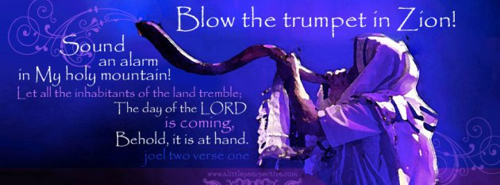

A VOICE CRYING OUT IN THE WILDERNESS MAKING STRAIGHT THE PATHS! COMING IN THE SPIRIT OF ELIJAH! AS IT WAS THE FIRST TIME, SO IT IS THE SECOND!

Preparing a bride without spot or wrinkle.
For speaking engagements call
813-393-9384. Our website is www.latter-rain.net

Sarasota, FL 34235

