
  FRESH RAIN
  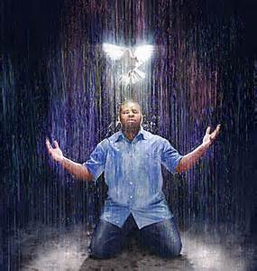
[;’pcx cqxxxxxxxxxxxxxxxxxxxxxxxxxxxxxxxxxxxxxxxxxxxx
Latter Rain Ministry  Preparing a Bride without spot or wrinkle |  | oCTOBER, 2017
THE GATES OF HELL SHALL NOT PREVAIL

The bible makes it perfectly clear that water baptism and baptism in the Holy Spirit are essential to being born again. It is not an option but a means to becoming born again and a response to the gospel of the kingdom of God and how to enter into it. I find more people searching out scripture in order to avoid and disobey water and spirit baptism which reveals something in that heart that really needs to be addressed. Why would someone make excuses to disobey the word or claim it is not necessary in order to be saved? They have been taught heresies.

REVELATION! This is a game changers. Where the Bible says if you believe in the Lord Jesus Christ, you will be saved (future tense). The word believe comes from the Greek word pisteur and it is a VERB not a noun. That means it is ongoing and not a onetime act. It means that you believe once, to commit to believing and continuing to believe and thus you WILL BE saved because you have not fallen away, become apostate, and will endure to the end because you are continuing to Believe. It is not a onetime belief or faith that gets you instantly saved. How deceived the church is and people are going to hell because of these damnable heresies. The Lord has started taking me down this path on what the Bible says about being born again or saved. You have to be born of water and of The Holy Spirit in order to keep on believing and continuing to believe until the end. Will be and shall be saved is future tense if you finish the race. That is why you can fall away thru going back into sin, the deceivableness of riches with the prosperity gospel of me, cares of the world, persecution etc. And I am just getting started on this study. Revival is coming with the true gospel that the Lord will confirm with signs following and it isn’t going to be with phoney feathers and gold dust as well as drunken laughter and weird shaking and manifestations that are not found in Jesus’ ministry.
Major apostate teachings will also be address in this newsletter by the Lord and the foundation is laid again after there is a plowing, removing stone, clearing and making straight the path. With about 10,000,000 plus readers globally of www.latter-rain.net and these newsletters, the Lord will get the truth out to make sure people are born again biblically and not just deceived into thinking they are. Jesus came to seek and save the lost and the lost don’t know they are so in order to save the lost who think they are saved, you have to first show to them that they are indeed lost. Many want to remain willfully deceived and will not receive the love of the truth that they might be saved, and will want to remain in a stronghold of false beliefs. They will not allow the truth to pull down their stronghold. That is the end times that we live in and I pray you won’t be among those that are deceived because they want to be.

Acts 18:24-28 speaks of a Jewish preacher named Apollos who was mighty in the scriptures who was instructed in the way of the Lord, and being fervent in the spirit, he spake and taught diligently the things of the Lord knowing only the baptism of John which was the water baptism of repentance. This man spoke boldly in the synagogue. He preached on what he knew and was bold and fervent in doing so but he lacked the knowledge and power of the baptism of the Holy Spirit until Aquila and Priscilla took him unto them and expounded unto him the way of God more perfectly. He was missing some pieces to the puzzle basically, yet he thought he had the whole picture until someone pointed it out.
Today we have well intentioned, fervent, bold preachers like this as well who do not believe or preach in the foundational doctrine of baptism in the Holy Spirit. They are either misinformed, believe you receive it when you first believe or reject and wish to remain willfully ignorant on the topic because it doesn't fit into their theology and they wish to remain in their stronghold or fortress of wrong thinking by explaining it away. They are not meek or teachable and to reject truth is to reject Jesus. The flaky stuff happening in our Charismatic churches have not helped the matter either. The Bible states you must be born of water and of the Holy Spirit in order to see, understand and enter into the kingdom of God. This came out of Jesus own mouth. It is not something we can be wrong on because our eternity and where we spend it hangs in the balance. If you believe any scripture that refutes what Jesus Himself said, you are missing pieces to the puzzle or ignoring some scripture to fit your false beliefs.
Acts 19:1-6 Paul went to Ephesus where Apollos had been preaching and Paul asked the disciples at Ephesus, which were under Apollos ministry, "Have ye received the Holy Ghost since ye believed"? They said unto Paul, "We have not so much as heard whether there be any Holy Ghost"! So we know Apollos was making disciples, preaching fervently but was missing the baptism of the Holy Ghost after these disciples or believers first believed. So you see it is not something you receive when you first believe as many falsely teach. These disciples stated they had only been baptized in John's baptism. Paul then laid his hands on these disciples and they were baptized in the Holy Spirit with the evidence of speaking in tongues. The baptism of the Holy Spirit has this manifestation happen with it.
This baptism in the Holy Spirit is called dynamos which means power. It is where we get the word dynamite. The word grace is also translated empowerment or I will supply that which is needed. Only in two places is it translated unmerited favor. This is the fulfillment of the law where we are now empowered not to sin and empowered to change and live a life pleasing to God. Grace isn't the license to sin but the power of God given not to through the baptism of the Holy Spirit as given at Pentecost. The law was to show we couldn't keep it in our ability and we needed this empowerment to live a life pleasing to God. Jesus said He didn't do away with the law but fulfilled it and the church did not start until the Holy Spirit was given at Pentecost. The Mosaic law with its 613+ rules have been done away with but God's moral law never will be. As a matter of fact the bar has been raised. If you committed adultery, you sinned. Now if you lust, you have committed adultery. If you murdered, you sinned. Now if you hate, you are guilty of murder. If you bear false witness or lie about someone, you are guilty of murder, so consider that the next time you sit around the holiday table gossiping about someone or are spreading lies and gossip when you don’t know the facts. God considers it murder and one of the top sins He hates the most.
Your freedom in Christ comes from no longer being a slave to sin. So folks, you might have a preacher who is fervent, loves the lord but just doesn't have knowledge or will not accept the way of God more perfectly after it has been expounded upon to him. Don't follow man. You need to search the scriptures yourself because in them you think you have eternal life and you may not because you are trusting in man and you can't afford to be wrong on something where your eternity and those you love, hangs in the balance.
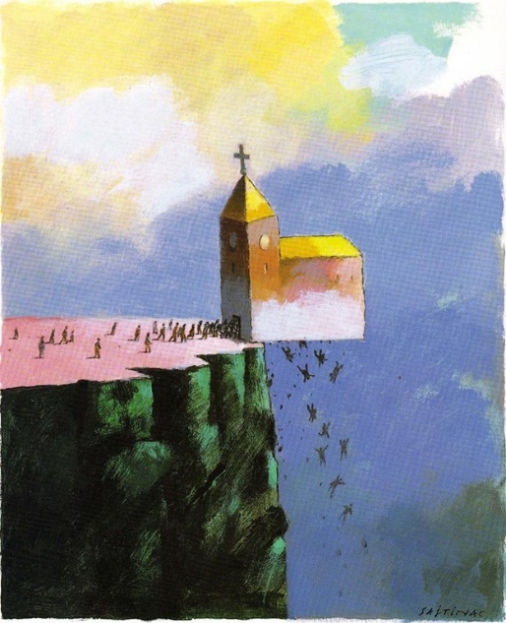
Jesus said "My people perish for a lack of knowledge" so study the scriptures to show yourselves approved and don't rely on man. Your pastor may genuinely love the Lord, be mighty in the scriptures, instructed in the way of the Lord, and is fervent in the spirit, speaks and teaches diligently the things of the Lord knowing only the baptism of John. Some don't even adhere to the baptism of John. He may need to have the full gift of God explained to him more perfectly because the Baptism of the Holy Spirit is not something you receive when you first believed. You need this baptism or dynamite power in order to enable you to no longer be a slave to sin in a fallen world. You MUST repent and be born of water and of the Holy Spirit to see the kingdom of God, understand it fully and enter into it. MUST means MUST out of Jesus' own mouth and He does not lie. If you are replacing what Jesus said you need to do in order to be born again, you are deceived. We need to stop making water baptism and baptism in the Holy Spirit "optional" or a nice thing to do. It is a MUST in order to be born again and when the crowds asked Peter what they must do to be saved, Peter never deviated from what Jesus said to do. Peter told them to repent and be baptized. These are requirements and baptisms (plural) are foundational teachings in the church. If there is one thing the devil wants to deceive people on, it is on foundational things because if the foundation is inaccurate or not all there, what is built upon it falls in on itself. As a church, we don't have the foundation right and that needs to change.
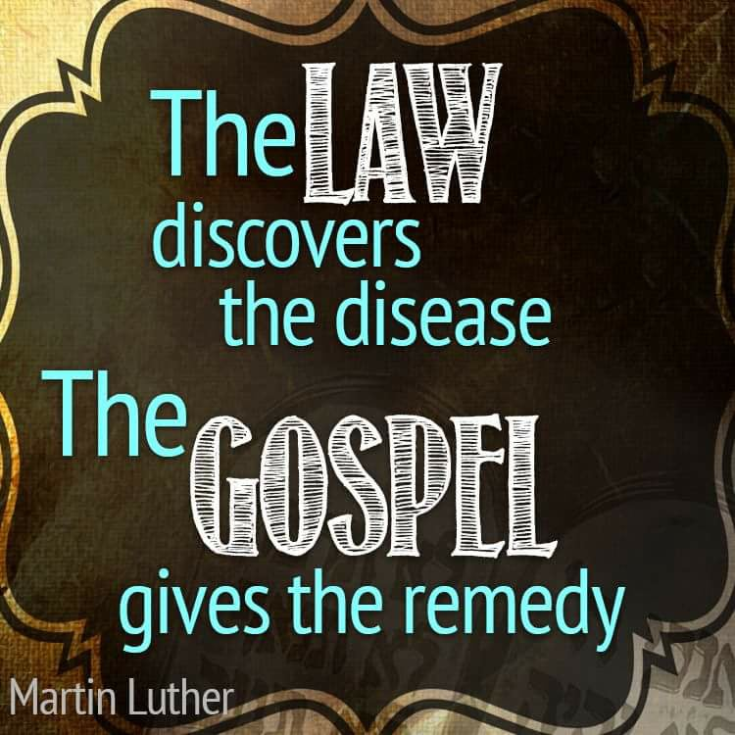
Let's tackle the thief on the cross argument that people use to "get out of" being water baptized because they would rather disobey and take a chance and call Jesus a liar than get water baptized so they look for excuses not to.
The thief on the cross died under the old covenant not the new. The new covenant did not start until the Holy Spirit was poured out at Pentecost. There was a place in the earth called Paradise, Abraham's bosom, Sheol and other terms that held the souls of the righteous dead until Christ died, descended there after death and stayed for three days preaching the gospel to those there. Then Jesus snatched the keys from the devil and let them out and these resurrected people walked the earth briefly after Jesus was resurrected. Matt 27:52. So paradise was not heaven because Jesus didn't go to heaven until after He was resurrected and Jesus told the thief "This day you will be with me in paradise"! and Jesus did meet the thief there in this holding tank in the earth for souls. The word paradise means park. Strong’s concordance defines it as “to park” or a holding spot. It is also described as a garden or park. Point is, it wasn’t heaven, where the Father resides. The day that Jesus and the thief died, they both ended up in this temporary parking spot for the dead that was in the earth and was probably park like. Jesus remained there three days/nights preaching to the dead souls and led them out and some were resurrected. Jesus did not ascend to the Father until after His resurrection three days later so “this day” he met the thief in paradise was not heaven.
And people falsely assume the thief wasn't water baptized when John had been baptizing in that area for a long time prior. The likelihood that he was is high. Only the devil points to the thief on the cross to get people to disobey Jesus' command to be born of water and of the Holy Spirit. He is in the business of deception so let's put the thief excuse to bed already and just obey. You are either calling Jesus a liar or lacking some vital knowledge if you come across something that explains away something Jesus commanded us to do. People perish for a lack of knowledge. As for me I am going to be obedient and go with, "I must be missing something in this picture" and then find out what piece to the puzzle I am missing. Then He shows me, but I don't look for excuses to disobey. We also know that Jesus hadn't been to heaven yet at the time He and the thief died because three days later after He was resurrected, Jesus ran into Mary and He told her not to touch Him because He had not yet ascended to the Father and this was 3 days later so Paradise is not heaven.
I have even heard the argument in order to excuse away what Jesus commanded us to do, and what He Himself did as an example, that water baptism was being born and coming out of the sack at your natural first birth. Really? That is the first birth and it was a natural birth and has nothing to do with your spirit being born again. Obviously, to be born again, one had to have been born before, so again, look at all the wild things the devil tells people to get them to ignore what they need to do to be "born again". Therefore, water and spirit baptism must be essential to salvation if the devil tries so hard to deceive people into explaining it away and as not needed. The heart of man is so rebellious that they look for excuses, even in the word, not to obey it. If there is one thing the devil wants you deceived on it is regarding how to be born again, so if someone wants to explain it away, even the baptism of the Holy Spirit, just recognize that as the devil deceiving people, read your bibles and put on your thinking caps. Some things are so obvious, yet we are blind to them.
Memo to those who use grace to justify sin and yell don’t judge me:
"Whoever does not practice righteousness is not of God"
(1 John3:10).
Reading Acts 26:18 and like the Lord does, He shows me words to look up to reveal deeper what is being said. This is in the context and in Jesus' own words of what He called Paul to do on the Damascus road.
"To open their eyes, and to turn them from darkness to light, and from the power of Satan unto God (His power), IN ORDER THAT they may receive forgiveness of sins, and inheritance among them which are sanctified by faith that is in Me!"
There are conditions to be met in order to receive this forgiveness of sins and this inheritance. It is called repentance or turning from darkness to light and from being under the control and power of Satan to being under the control and power of God and going through the sanctification process. We don't preach this so how saved are we? The Bible even states that if a church denies this power or dynamite that came at Pentecost, you are not to fellowship with them and you are to put them away from you. This inheritance comes from being sanctified and that word sanctified means to be made Holy or pure, not just called holy and pure. Justification is where we are called righteous and sanctification is the process of making us righteous, pure and Holy. Sanctification requires the baptism of the Holy Spirit that empowers us not to sin as we crucify our flesh, die to self, pick up our cross and follow Him. Our will is involved in who we submit to and this forgiveness and later the inheritance are not given without this turn from satan's power to Gods power and control. The inheritance comes when we are made Holy or pure and this is a process when we submit to God and mature. Sons of God is translated "mature" and the mature receive the keys to the kingdom in casting out devils, healing the sick and furthering the kingdom of God. The bible states that Jesus gave us POWER to become sons of God. That is through the baptism of the Holy Spirit and sanctification part of the process of salvation that we are to work out. You can't lose what you do not yet possess and are still working out so let's stop telling people they can't lose their salvation when they don’t yet have it and are still working it out. They can fall away from the faith and become apostate.
​​
"If a man LOVE me, he will keep my WORDS: and my Father will love him, and we will come unto him, and make our abode with him."

​​Jesus commanded His disciples to preach the kingdom of God, not the gospel. This kingdom is to be received and that happens only after repentance. John the Baptist told people to repent and be baptized because the kingdom of God was at hand or available to be received. It is so important to get back to the foundational teachings of the church and have people turn from darkness and be under the power of the Holy Spirit and mature. Jesus said, "If you don't allow me to wash you, you have no part with Me"! No part means no part. Nothing, nadda! No forgiveness and no inheritance. Our will and submitting to God and dying to self are necessary to being saved. Don't be deceived into thinking a mere prayer without repentance makes you saved or born again. Many think they are saved, but are not biblically and then they think they are eternally secure. This is a damnable heresy and people are going to hell. Search the scriptures Jesus said, because in them you think you have eternal life. Thus implying that they didn't have eternal life. Therefore, be commissioned to do what Jesus told Paul to do. Turn people from darkness to light and from the power of Satan to the power of God. Grace is not the license to sin but the power of God given not to and your freedom in Christ comes from no longer being a slave to sin. Please share because people who think they are saved are going to hell and the preachers that cause people to believe they are "saved" and eternally secure, no matter how sincere he is, will have their blood on his hands and will be held more accountable. Especially if he was taught the way more perfectly and rejected it.
IF PEOPLE IN HELL COULD RETURN TO EARTH, THEY'D BE THE GREATEST EVANGELISTS THIS WORLD HAS EVER SEEN. IT’S NOT TOO LATE FOR YOU.

If the gospel you are preaching is not turning people from the power of satan to the power of God, or turning them from darkness unto light and if it strengthens sin by telling them they are eternally secure and cannot lose salvation after repeating a prayer, you are preaching a damnable heresy.
If you can’t lost your salvation (which you don’t yet possess but you think you do), you can obviously do as you please and still enter into heaven and this strengthens sin. Not only is that not found in the bible, but you will have the blood of those who die in their sins on your hands
So what is being sealed in the Holy Spirit? The Holy Spirit is referred to as the “deposit,” “seal,” and “earnest” in the hearts of Christians (2 Corinthians 1:22; 5:5; Ephesians 1:13-14; 4:30). The Greek word translated “earnest” in these passages is arrhabōn which means “a pledge,” that is, part of the purchase money or property given in advance as security for the rest. It is a down payment given to believers showing the intent to purchase. It is like giving an engagement ring with the intent to marry. If the deal falls through or in Jewish tradition if the young girl became unfaithful while her husband to be was away building a suitable home for them to live in, a legal judgment could be obtained by the husband to be, to end the engagement. Joseph was seeking to do this when he found out Mary was pregnant until an angel of the Lord told him not to. Engagements were taken seriously in Jewish tradition and a legal judgment had to take place to break it by the groom. We are only engage to Jesus. We are not married yet and the 5 foolish virgins were locked out, even though all were asleep, all had lamps with oil but some ran out because the deposit was returned or the seal broken by the husband to be. Judgment took place and the deal fell through because of their foolishness. This deposit in the heart is not the baptism in the Holy Spirit. It is like a drop of water being compared to a pool full of water. One you are fully immersed in the spirit and the other you are given a deposit or down payment, not the full price because the deal has not yet been closed. Let's not confuse the two. Having a deposit is far less than having the full deal closed. You receive this deposit upon ​​accepting Jesus' marriage proposal.
Just found these stats on the internet regarding www.latter-rain.net. How cool is this, Latter-rain.net has a Worldwide ranking of 9,344,712 Up 4,939,023. Who knew! God is at work worldwide. The truth is getting out there
[Cite your source here.]
If the foundation be destroyed, what will the righteous do? The enemy always attacks the foundation. If the foundation is destroyed, the fortress falls in upon itself.
If we do not have the foundation right in the church, it crumbles. Let’s get back to the foundational teachings in the church and lay it again because it has been so destroyed.
Jesus received these baptisms before being led by the Holy Spirit into the wilderness to be tempted by the devil. We need this empowerment as well in order to endure until the end in order that we might be saved and not fall away. Put away from you anyone that denies this empowerment. They preach another Jesus and another gospel and the bible says to let them be accursed. That is why the church is so powerless and sin runs amuck in the church as people are not even really biblically saved or empowered to stand under temptation. Then they are being told that if they recited their little prayer they can’t ever do anything to end up in hell. All lies!
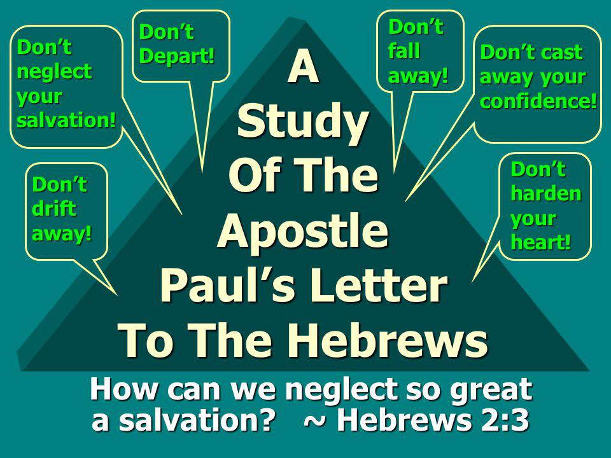
Reading Romans 6 with morning coffee. This chapter peaks of water baptism and being baptized into Jesus Christ through water baptism and identifying with Him in it. We are buried with Him into death, which is going under the water and rising with Him in resurrection coming out of the water. Again, how many Professing Christians live a symbolic, in word only faith. Our old man is to be crucified with Christ so we don’t serve sin and are not a slave to it as those who are not believers. Now he that is dead to sin and freed from it, CATCH THIS, will also live and be resurrected with Him. Jesus can’t be savior if He isn’t Lord. Resurrection is conditional and real and not just symbolic and a TRUE believer will walk in this empowerment not just profess it only. If there is no change, no matter how much one professed to be saved by grace or empowerment, they aren’t because that grace or empowerment causes you to be a slave to godly living, not a slave to sin. Sin shall not have dominion over you because grace, translated empowerment, not to sin has been freely given to you through faith in the blood of Christ and what it provides. Grace or empowerment isn’t the license to sin but the power of God given to you not too so you no longer are a slave to sin but a slave to righteousness or Holy living as led by the Holy Spirit to do so. Resurrection results in living it out, not in lip service only. If you live as a professing, lip service only, symbolic only Christian that serves sin believing you are saved by Jesus’ blood coving up all your sins so Daddy lets you into heaven you are deceived my friend. The sacrificial blood of lambs did that before Christ. Christ died to do more and that was not just to give you positional right standing with the Father, but give you power (grace) to become sons and daughters which means mature and in His image and likeness. If you were water baptized without repenting, identifying and living like sin has no power over you, all you got was wet and duped. There will be no living with Him in the likeness of His resurrection. We have got to get back to these foundational doctrines and teach them accurately or the blood of those who end up hearing “Depart from Me. I never knew you, you worker of iniquity” will be on our hands and we will be held more accountable. The Christian is a follower of Christ, doing as He did, working His works. If you live a symbolic, faith without works, lip service only form of Christianity, you are deceived and do not have the kind of faith that saves you as James stated.
Romans 6:22 clearly states that being dead to sin is what ends in everlasting life. It says, But now being made free from sin and become servants to God, ye have your fruit unto holiness, AND THE END everlasting or eternal life through Christ Jesus our Lord. Eternal life isn’t something you receive when you recite a salvation prayer which is unbiblical anyway. The gates of hell shall not prevail because the Lord is going to kick over some sacred cows in the church.
There is therefore now no condemnation or judgment for those who are in Christ Jesus, WHO WALK NOT ACCORDING TO THE FLESH BUT ACCORDING TO THE HOLY SPIRIT! We love to make a doctrine out of once saved always saved based on this scripture, but clearly if you read it, those who are in Christ Jesus where there is no judgment are being led and controlled by the Holy Spirit, walking as Jesus walked and not living according to the flesh and fulfilling the lust thereof.
This is a definition of what one will look like if they are “In Him”. They are walking according to the Holy Spirit and not walking according to the flesh. There is judgment or same word translated from the Greek “condemnation” for those who walk according to the flesh.
1 John 2 talks about what it looks like to be In Him. And hereby we do know that we know Him if we keep His commandments. He that saith I know Him and keepeth not His commandments is a liar and the truth is not in him. But whosoever keepeth His word in him is the love of God perfected (matured) hereby know we that we are IN HIM. He that saith he abideth in Him ought himself also so to walk, even as He walked.
“And this is the condemnation (or why God’s judgment is brought on us) that light is come into the world, and men loved darkness rather than light (they prefer darkness), because their deeds were evil. For everyone that doeth evil hateth the light (and those that shine the light on the condition of their heart), neither cometh to the light, lest his deeds should be reproved (or discovered is the literal translation). But he that doeth truth cometh to the light, that his deeds may be made manifest that they were wrought in God. So certainly one who doesn’t like the truth and light shining on and exposing false doctrines, but prefers to have it hidden in darkness and will not allow it to be brought to the light to be examined aren’t doers of the truth, no matter how much they want to believe they are. When you defend something, you are not willing to have it examined in truth and light.
So in order to be biblically saved, a person has to repent, be water baptized and identifying with Christ’s death to self and sin in order to be a partaker of His resurrection. They have to be baptized in the Holy Spirit which empowers them to no longer be a slave to sin and they have to submit to the sanctification process. They have to believe, commit to believing and continue to believe until the end because the word believe is a verb that keeps continuing and doesn’t fall away from the faith and become apostate. You keep believing and you keep confessing until the end and in the end you shall be (future tense) or will be (future tense) saved or receive eternal or everlasting life. Jesus said that if we don’t allow Him to wash us, we have no part with Him so submitting to the sanctification process until the end is necessary to receiving life eternal. Repentance is always connected to water baptism because repentance is required to identify with Christ’s death to self and sin and therefore, AS A RESULT, be resurrected in Him to life eternal. That is what the word says. You can believe in Jesus and not be saved or enter into eternal life. Satan does. You can have faith but not the saving kind of faith because the kind of faith that saves you, will result in works and sanctification.
So can you have faith and believe in Jesus and not be saved or have the kind of faith that saves you?
There are a lot of heretics and false prophets that have gone out ... so many of them claiming to "believe in Jesus" or to "love Jesus". But claiming to love Jesus Christ without obeying His commands is a lie:
John 14:21 Whoever has my commands and obeys them, he is the one who loves me. He who loves me will be loved by my Father, and I too will love him and show myself to him." If you wonder why you don’t hear from the Lord or He is not manifesting Himself in your life, this might be it right here.
John 15:10 If you obey my commands, you will remain in my love, just as I have obeyed my Father’s commands and remain in his love.
1 John 5:3 This is love for God: to obey his commands. And his commands are not burdensome,
1 John 1:6 If we claim to have fellowship with him yet walk in the darkness, we lie and do not live by the truth.
THE ANSWER
The answer is "yes". You can believe in Jesus and not be saved or have faith that is not the saving kind.
Many cults claim to believe in Jesus, and this brings up my first point. Is there any condition on salvation by grace alone through faith alone in Christ alone? There must be if you believe that there are cults, because by definition cults teach against one or more of the core doctrines of the Faith. You cannot be saved unless you believe in the TRUTH about Jesus Christ.
2 Thessalonians 2:10 and in every sort of evil that deceives those who are perishing. They perish because they refused to love the truth and so be saved.
2 Thessalonians 2:13 But we ought always to thank God for you, brothers loved by the Lord, because from the beginning God chose you to be saved through the sanctifying work of the Spirit and through belief in the truth.
1 Timothy 2:4 who wants all men to be saved and to come to a knowledge of the truth.
You cannot be saved and believe in another "Jesus" (2 Cor. 11:4, Gal. 1:6) as do many churches today. Why do biblical Christian believers consider church members practicing a lifestyle of sin and fleshly indulgence to be unsaved and in need of having the right Gospel preached to them? Because to be saved it matters what you believe ABOUT Jesus Christ and the plan of salvation, and not just that you believe that Jesus existed. This is one key to this whole topic I will be coming back to. Remember the word believe means to believe on, to keep believing and continue to believe because it is a verb.
One more important point we need to consider before we get into biblical examples. I know you are probably saying: "But doesn't the Bible simply say 'Believe in the Lord Jesus Christ and you will be saved - you and your household?' (Acts 16:31) Isn't belief the only criteria there is for salvation?" You are absolutely right. But look at this verse closely, one among many that talk about the terms of salvation, and you will begin to get a better picture about what "belief" in Christ is really all about.
You can see by the examples that many verses regarding salvation use the phrases "is believing", "those believing", "are believing". A person must not only believe once but continue to believe on through to the end. Belief is a commitment to believe. In fact the one who overcomes the world is one who "is believing" that Jesus is the Son of God.
1 John 5:5 who is he who is overcoming the world, if not he who is believing that Jesus is the Son of God? (YLT)
Acts 16:31 says that we must believe in the "Lord Jesus Christ". This is a very telling statement. Jesus must be Lord in your life and you must submit to Him. When we believe on the "Lord" Jesus Christ we lay down our rights and our very life, nailing them to the cross of Christ, and He becomes the complete King, President, Boss, Director of our lives. Nothing comes before Him and we are not to love anything or anyone more than Jesus. Anything we love more is an idol. It could be your porn, money, your job, your boyfriend, your parents or some other thing. If Jesus asked you to give it up and you can’t or won’t, you are worshiping an idol and not the Lord Jesus Christ. If Jesus brings truth into your life and your pride does not allow you to have your stronghold or fortress of wrong belief dismantled with the truth, which is who Jesus is, you are not receiving the love of the truth that you might be saved. Thus you are rejecting Jesus, who is the truth and is trying to save you. You have become apostate believing lies and another Jesus and another gospel.
Matthew 24:13 but he who stands firm to the end will be saved.
Mark 16:16 Whoever believes and is baptized will be saved, but whoever does not believe will be condemned.
Romans 10:9 That if you confess with your mouth, "Jesus is Lord," and believe in your heart that God raised him from the dead, you will be saved.
Why would Paul not proclaim that the jailer and his household were immediately saved like we often hear preached today? It is because Paul was teaching truth. We must continue to believe! A person has free will and, as such, they are fully capable and fully free to either submit to the Lordship of Jesus Christ and the work of the Holy Spirit in their life, or they can be "not believing" or "unbelieving". If a person is unbelieving, notice how John warns the Church, to whom Revelation was written:
Revelation 21:8 "But the cowardly, the unbelieving, the vile, the murderers, the sexually immoral, those who practice magic arts, the idolaters and all liars— their place will be in the fiery lake of burning sulfur. This is the second death."
Unbelief is obviously the state of a person before they first believe. But unbelief can also become the state of a person who shipwrecks their faith (1 Tim. 1:19) or falls away (Luke 8:13) into unbelief after they initially "believe". Let's look at one more verse for a few more necessities for belief in the Lord Jesus Christ.
Romans 10:9 That if you confess with your mouth, "Jesus is Lord," and believe in your heart that God raised him from the dead, you will be saved.
The Father raised the Son from the dead. God Himself died physically to pay the penalty of death for your sins. We must believe that Jesus Christ died as a substitutional sacrifice for our sins, and that He rose again as a guarantee of our resurrection to everlasting life.
There are many more verses regarding salvation, but suffice it to say that we must believe in the real Jesus, the real Gospel, the real Spirit to have the assurance of real salvation through repentance, the blood of Christ, justification and sanctification. You can fall away from the faith, become apostate or a son of perdition and right before Christ returns, these sons of perdition will be revealed because the church has people falsely believing they are saved when they are really on the apostate road to perdition and they will not receive the love of the truth that they might be saved thanks to the heretic preachers out there who care more about saving face than saving people, which is why they want to be deceived.

Biblical examples of people who believed but were not saved:
APOSTASY
Things Children of God Can Do:

1. Fall from grace – Gal. 5:1-4,13
2. Be led away with error – 2 Pet. 3:17
3. Err from the truth – James 5:19-20
4. Weak brother may perish – 1 Cor.
8:11
5. Fall into condemnation – James 5:12
6. Be moved away from the hope – Col.
1:21-23
7. Deny the Lord who bought them – 2
Pet. 2:1
8. Depart from the living God – Heb.
3:12
9. Can be a castaway – 1 Cor. 9:27
10. Can become accursed children – 2
Pet. 2:14

Galatians 5:4 “You have been severed from Christ, you who are seeking to be justified by law; you have fallen from grace.”

John 15:5-6 “I am the vine, you are the branches; he who abides in Me, and I in him, he bears much fruit; for apart from Me you can do nothing. If anyone does not abide in Me, he is thrown away as a branch, and dries up; and they gather them, and cast them into the fire, and they are burned.”

Romans 11:19-23 “You will say then, “Branches were broken off so that I might be grafted in.” Quite right, they were broken off for their unbelief, but you stand by your faith. Do not be conceited, but fear; for if God did not spare the natural branches, neither will He spare you. Behold then the kindness and severity of God; to those who fell, severity, but to you, God’s kindness, if you continue in His kindness; otherwise you also will be cut off. And they also, if they do not continue in their unbelief, will be grafted in; for God is able to graft them in again.”

Hebrews 6:4-6 For in the case of those who have once been enlightened and have tasted of the heavenly gift and have been made partakers of the Holy Spirit, and have tasted the good word of God and the powers of the age to come, and then have fallen away, it is impossible to renew them again to repentance, since they again crucify to themselves the Son of God, and put Him to open shame.

Hebrews 10:26-27 For if we go on sinning willfully after receiving the knowledge of the truth, there no longer remains a sacrifice for sins, but a certain terrifying expectation of judgment, and the fury of a fire which will consume the adversaries.”

Hebrews 10:38-39 “But My righteous one shall live by faith; And if he shrinks back, My soul has no pleasure in him. But we are not of those who shrink back to destruction, but of those who have faith to the preserving of the soul.”

DOCTRINAL APOSTASY

Acts 20:17,28-30 “And from Miletus he sent to Ephesus and called to him the elders of the church.” … “I know that after my departure savage wolves will come in among you, not sparing the flock; and from among your own selves men will arise, speaking perverse things, to draw away the disciples after them.”

1 Timothy 1:18-21 “fight the good fight, keeping faith and a good conscience, which some have rejected and suffered shipwreck in regard to their faith. Among these are HYMENAEUS and Alexander”

2 Timothy 2:16-18 But avoid worldly and empty chatter, for it will lead to further ungodliness, and their talk will spread like gangrene. Among them are HYMENAEUS and Philetus, men who have gone astray from the truth saying that the resurrection has already taken place, and thus they upset the faith of some.

1 Timothy 4:1 “But the Spirit explicitly says that in later times some will fall away from the faith, paying attention to deceitful spirits and doctrines of demons”

1 Timothy 6:20-21 “O Timothy, guard what has been entrusted to you, avoiding worldly and empty chatter and the opposing arguments of what is falsely called “knowledge”-which some have professed and thus gone astray from the faith.”

2 Peter 2:1 “But false prophets also arose among the people, just as there will also be false teachers among you, who will secretly introduce damnable heresies, even denying the Master who bought them, bringing swift destruction upon themselves.”

2 Peter 3:17 “You therefore, beloved, knowing this beforehand, be on your guard lest, being carried away by the error of unprincipled men, you fall from your own steadfastness”

2 John 8-9 “Watch yourselves, that you might not lose what we have accomplished, but that you may receive a full reward. Anyone who goes too far and does not abide in the teaching of Christ, does not have God; the one who abides in the teaching, he has both the Father and the Son.”

MORAL APOSTASY

1 Timothy 6:9-10 “But those who want to get rich fall into temptation and a snare and many foolish and harmful desires which plunge men into ruin and destruction. For the love of money is a root of all sorts of evil, and some by longing for it have wandered away from the faith, and pierced themselves with many a pang.”

2 Peter 2:20-22 “For if after they have escaped the defilements of the world by the knowledge of the Lord and Savior Jesus Christ, they are again entangled in them and are overcome, the last state has become worse for them than the first. For it would be better for them not to have known the way of righteousness, than having known it, to turn away from the holy commandment delivered to them. It has happened to them according to the true proverb, “A dog returns to its own vomit,” and, “A sow, after washing, returns to wallowing in the mire.””

James 5:19-20 “My brethren, if any among you strays from the truth, and one turns him back, let him know that he who turns a sinner from the error of his way will save his soul from death, and will cover a multitude of sins.

REVELATIONS

Revelation 2:4-5 “‘But I have this against you, that you have left your first love. ‘Remember therefore from where you have fallen, and repent and do the deeds you did at first; or else I am coming to you, and will remove your lampstand out of its place-unless you repent.”
Revelation 3:5 “‘He who overcomes shall thus be clothed in white garments; and I will not erase his name from the book of life, and I will confess his name before My Father, and before His angels.

Revelation 3:16-17 ‘So because you are lukewarm, and neither hot nor cold, I will spit you out of My mouth. ‘Because you say, “I am rich, and have become wealthy, and have need of nothing,” and you do not know that you are wretched and miserable and poor and blind and naked”

OLD TESTAMENT

Ezekiel 18:24-26 “But when a righteous man turns away from his righteousness, commits iniquity, and does according to all the abominations that a wicked man does, will he live? All his righteous deeds which he has done will not be remembered for his treachery which he has committed and his sin which he has committed; for them he will die. “Yet you say, ‘The way of the Lord is not right.’ Hear now, O house of Israel! Is My way not right? Is it not your ways that are not right? “When a righteous man turns away from his righteousness, commits iniquity, and dies because of it, for his iniquity which he has committed he will die.”

The fact the Bible exhorts to faithfulness proves one can be lost.

Be steadfast immovable: 1 Cor 15:58

If these qualities are yours…2 Pe 1:5-11 we will reap if we do not grow weary:

Gal 6:9 be faithful unto death and I will give crown of life:

Rev 2:10 practice these things and God will be with you: Phil 4:9

Man has a free will: Josh 24:15 to argue otherwise is nonsense and is a veiled form of existentialism.

The Bible clearly prophesied some would fall away: Acts 20:28; 1 Ti 4:1
Christians are to restore the fallen: Gal 6:1; Jas 5:19-20

If you do not forgive others, God will not forgive you! If you have a need to punish, gossip, rally support and believe lies about someone, you have not forgiven and you will not be forgiven.

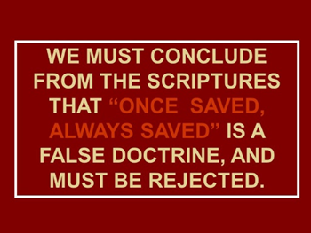
Certainly, if you want to take out one or two or a few scriptures to come up with a once saved, always saved heresy that strengthens sin and minimizes salvation to a one belief, one act event, you are missing many pieces to the puzzle because all the above scriptures and more prove otherwise and you would have to be strongly deluded with all this evidence to believe that. The question is, do you want to remain deceived and deceive others and be held accountable for their souls in hell when the Lord is faithful to bring you truth?
Here are verses with the word “believe” that is a verb or action word translated as continuing to believe and committed to continuing to believe until the end.
Mark 9:23 And Jesus said to him, ‘If thou art able to believe! all things are possible to the one that is believing;’
John 1:12 but as many as did receive him to them he gave authority to become sons of God—to those believing in his name,
John 3:15 that every one who is believing in him may not perish, but may have life everlasting,
John 3:16 for God did so love the world, that His Son—the only begotten—He gave, that everyone who is believing in him may not perish, but may have life age-during.
John 3:18 he who is believing in him is not judged, but he who is not believing hath been judged already, because he hath not believed in the name of the only begotten Son of God.
John 3:36 he who is believing in the Son, hath life age-during; and he who is not believing the Son, shall not see life, but the wrath of God doth remain upon him.’
John 5:24 ‘Verily, verily, I say to you—He who is hearing my word, and is believing Him who sent me, hath life age-during, and to judgment he doth not come, but hath passed out of the death to the life.
John 5:46 for if ye were believing Moses, ye would have been believing me, for he wrote concerning me;
John 6:35 And Jesus said to them, ‘I am the bread of the life; he who is coming unto me may not hunger, and he who is believing in me may not thirst—at any time;
John 6:40 and this is the will of Him who sent me, that everyone who is beholding the Son, and is believing in him, may have life age-during, and I will raise him up in the last day.’
John 6:47 ‘Verily, verily, I say to you, He who is believing in me, hath life everlasting;
John 6:64 but there are certain of you who do not believe;’ for Jesus had known from the beginning who they are who are not believing, and who is he who will deliver him up,
John 7:38 he who is believing in me, according as the Writing said, Rivers out of his belly shall flow of living water;’
John 7:39 and this he said of the Spirit, which those believing in him were about to receive; for not yet was the Holy Spirit, because Jesus was not yet glorified.
John 11:25 Jesus said to her, ‘I am the the way, the truth and the life; he who is believing in me, even if he may die, shall live;
John 11:26 and every one who is living and believing in me shall not die.
John 12:11 because on account of him many of the Jews were going away, and were believing in Jesus.
John 12:37 yet he having done so many signs before them, they were not believing in him,
John 12:44 And Jesus cried and said, ‘He who is believing in me, doth not believe in me, but in Him who sent me;
John 12:46 I am light to the world have come, that everyone who is believing in me—in the darkness may not remain;
John 14:12 ‘Verily, verily, I say to you, he who is believing in me, the works that I do—that one also shall do, and greater than these he shall do, because I go on to my Father;
John 17:20 ‘And not in regard to these alone do I ask, but also in regard to those who shall be believing, through their word, in me;
John 20:27 then he saith to Thomas, ‘Bring thy finger hither, and see my hands, and bring thy hand, and put it to my side, and become not unbelieving, but believing.’
John 20:31 and these have been written that ye may believe that Jesus is the Christ, the Son of God, and that believing ye may have life in his name.’
Acts 2:44 and all those believing were at the same place, and had all things common,
Acts 10:43 to this one do all the prophets testify, that through his name every one that is believing in him doth receive remission of sins.’
Acts 13:39 and from all things from which ye were not able in the law of Moses to be declared righteous, in this one every one who is believing is declared righteous;
Acts 18:8 and Crispus, the ruler of the synagogue did believe in the Lord with all his house, and many of the Corinthians hearing were believing, and they were being baptized.
Acts 22:19 and I said, Lord, they—they know that I was imprisoning and was scourging in every synagogue those believing on thee;
Acts 28:24 and, some, indeed, were believing the things spoken, and some were not believing.
Romans 1:16 for I am not ashamed of the good news of the Christ, for it is the power of God to salvation to everyone who is believing, both to Jew first, and to Greek.
Romans 3:22 and the righteousness of God is through the faith of Jesus Christ to all, and upon all those believing, —for there is no difference,
Romans 4:5 and to him who is not working, and is believing upon Him who is declaring righteous the impious, his faith is reckoned—to righteousness:
Romans 4:11 and a sign he did receive of circumcision, a seal of the righteousness of the faith in the uncircumcision, for his being father of all those believing through uncircumcision, for the righteousness also being reckoned to them,
Romans 4:24 but also on ours, to whom it is about to be reckoned—to us believing on Him who did raise up Jesus our Lord out of the dead,
Romans 9:33 according as it hath been written, ‘Lo, I place in Sion a stone of stumbling and a rock of offence; and every one who is believing thereon shall not be ashamed.’
Romans 10:4 For Christ is an end of law for righteousness to everyone who is believing,
Romans 10:11 for the Writing saith, ‘Everyone who is believing on him shall not be ashamed,’
Romans 15:13 and the God of the hope shall fill you with all joy and peace in the believing, for your abounding in the hope in power of the Holy Spirit.
1 Corinthians 1:21 for, seeing in the wisdom of God the world through the wisdom knew not God, it did please God through the foolishness of the preaching to save those believing.
Galatians 3:22 but the Writing did shut up the whole under sin, that the promise by faith of Jesus Christ may be given to those believing.
Ephesians 1:19 and what the exceeding greatness of His power to us who are believing, according to the working of the power of His might,
1 Thessalonians 1:7 so that ye became patterns to all those believing in Macedonia and Achaia,
2 Thessalonians 1:10 when He may come to be glorified in his saints, and to be wondered at in all those believing—because our testimony was believed among you—in that day;
2 Thessalonians 2:11 and because of this shall God send to them a working of delusion, for their believing the lie,
1 Timothy 4:3 forbidding to marry—to abstain from meats that God created to be received with thanksgiving by those believing and acknowledging the truth,
1 Timothy 4:10 for for this we both labour and are reproached, because we hope on the living God, who is Savior of all men—especially of those believing.
1 Timothy 4:12 let no one despise thy youth, but a pattern become thou of those believing in word, in behavior, in love, in spirit, in faith, in purity;
1 Timothy 5:16 If any believing man or believing woman have widows, let them relieve them, and let not the assembly be burdened, that those really widows it may relieve.
1 Timothy 6:2 and those having believing masters, let them not slight them, because they are brethren, but rather let them serve, because they are steadfast and beloved, who of the benefit are partaking. These things be teaching and exhorting;
Hebrews 10:39 and we are not of those drawing back to destruction, but of those believing to a preserving of soul.
1 Peter 1:8 whom, not having seen, ye love, in whom, now not seeing and believing, ye are glad with joy unspeakable and glorified,
1 Peter 2:6 Wherefore, also, it is contained in the Writing: ‘Lo, I lay in Zion a chief corner-stone, choice, precious, and he who is believing on him may not be put to shame;’
1 Peter 2:7 to you, then, who are believing is the preciousness; and to the unbelieving, a stone that the builders disapproved of, this one did become for the head of a corner,
1 John 5:1 Everyone who is believing that Jesus is the Christ, of God he hath been begotten, and everyone who is loving Him who did beget, doth love also him who is begotten of Him:
1 John 5:5 who is he who is overcoming the world, if not he who is believing that Jesus is the Son of God?
1 John 5:10 He who is believing in the Son of God, hath the testimony in himself; he who is not believing God, a liar hath made Him, because he hath not believed in the testimony that God hath testified concerning His Son;
1 John 5:13 These things I did write to you who are believing in the name of the Son of God, that ye may know that life ye have, and that ye may believe in the name of the Son of God.

Broad is the way that leads to destruction. Narrow is the path that leads to eternal life. The path is your life on earth with the prize at the end being eternal life. Not something you receive when you believe. The seed or spirit of God being placed in you is not eternal life. Eternal life or eternal damnation is at the end of your physical life based on the choices you make during your life. You enter into one or the other. Eternal life is also defined as perpetual life or ongoing life.
Last words and instructions are important and this is what Jesus told His disciples while ascending into heaven:
Matthew 28:19-20 Go ye therefore, and teach all nations, baptizing them in the name of the Father, and of the Son, and of the Holy Ghost. Teaching them to observe all things whatsoever I have commanded you and lo I will be with you always, even unto the end of the world.
How is that not clear? Baptisms and obedience are not optional. Not make Jesus your personal savior or ask Jesus into your heart stuff and just confess it out loud and you’re in and eternally secure nonsense.
Jesus said that before He returns, He will send His angels, same word messenger and they could be born of a woman, to gather out of His kingdom all who offend and all workers of iniquity. The purpose of the message is to seek and save and cause prodigals to return and people to repent or be cut off. It is not to condemn, but it is a message to seek and save by making it apparent that you need to be. It is a message to make clear what has been hidden in darkness. To reveal heresy with the truth in order that all would turn and repent. To restore what has been lost. The consequence is becoming a son of perdition if you reject the TRUTH or your savior, which is being revealed at the appointed time, right before the rapture. Don’t be a foolish virgin. Make yourself ready for His appearing! Wake up! Look up! For your redemption draws nigh!
I saw a teaching on the Jim Baker show regarding the Laodecian church, which many agree is the church today. We miss the point regarding this church. If you lived in Laodecia, there were aqua ducts that carried water. If the waters were cold in one aqua duct it could be used as a refreshing drink on a hot day. The cold temperatures kept bacteria from living in it. The other aqua duct was hot and was good for cleansing or bathing and the washing of utensils. It too prevented bacteria from growing in it because of the hot temperature. Jesus would never wish we were cold toward Him and prefer that over a lukewarm relationship, so the mentioning of the water temperature is not in the context of the degree of love we have for Him. Where the two aqua ducts meet, the water is lukewarm. This lukewarm water is a breeding ground for bacteria, germs a diseases. When Jesus said that He will spew this lukewarm watered church out of His mouth, it is because it is full of sickening bacteria that causes one to vomit. It is a spiritual breeding ground that produces spiritual sickness. That word spew is translated vomit. This is the church of today
This is not the time to be delusional, willfully deceived or stupid on purpose. He stands at the door and knocks outside our Laodecian churches! He is holding all you need if you would just acknowledge your need for them and open the door because your strongholds have locked Him out! We do not love the truth that we profess to or He wouldn’t be standing outside the breeding ground for sin, disease, germs and bacteria that causes vomiting saying hhhheeeeellllloooooo! Let me in!
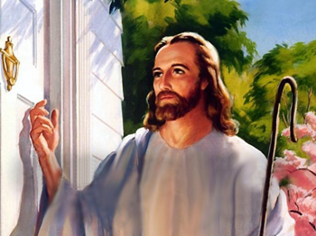
Matthew 24:45-47 Who is that good and faithful servant, whom the Lord hath made ruler over his household? to give them meat (not milk of the word meant for babies) in due season. Blessed is that servant whom His lord when He cometh shall find doing so. Verily I say unto you, That He shall make him ruler over all His goods.


www.latter-rain.net
A VOICE CRYING OUT IN THE WILDERNESS MAKING STRAIGHT THE PATHS! COMING IN THE SPIRIT OF ELIJAH! AS IT WAS THE FIRST TIME, SO IT IS THE SECOND!
Call 813-393-9384 to schedule a speaking engagement.
PREPARING A BRIDE WITHOUT SPOT OR WRINKLE!

John 3:1-13: “There was a man of the Pharisees named Nicodemus, a ruler of the Jews. This man came to Jesus by night and said to Him, "Rabbi, we know that You are a teacher come from God; for no one can do these signs that You do unless God is with him." Jesus answered and said to him, "Most assuredly, I say to you, unless one is born again, he cannot see the kingdom of God." Nicodemus said to Him, "How can a man be born when he is old? Can he enter a second time into his mother's womb and be born?" Jesus answered, "Most assuredly, I say to you, unless one is born of water and the Spirit, he cannot enter the kingdom of God.
The bible makes it perfectly clear that water baptism and baptism in the Holy Spirit are essential to being born again. It is not an option but a means to becoming born again and a response to the gospel of the kingdom of God and how to enter into it. I find more people searching out scripture in order to avoid and disobey water and spirit baptism which reveals something in that heart that really needs to be addressed. Why would someone make excuses to disobey the word or claim it is not necessary in order to be saved? They have been taught heresies.



